Name: Jie Wang
Email: JWANG326@Syr.edu
Assignment: HW5
Topic: Identify the author of disputed essays
Models/methods: Decision Tree (DT)
Date: Aug, 11,2022

Identify the author of disputed essays

The Federalist Papers were a series of eighty-five essays urging the ratification of the Constitution, which were written by Alexander Hamilton, James Madison, and John Jay for publication in New York newspapers, the essays originally appeared anonymously. The first essay was published in 1787, edited by John Mclean. The Federalist Papers are considered one of the most important sources for interpreting and understanding the original intent of the Constitution.
Within those 85 essays, 74 essays with identified authors, including 51 essays written by Hamilton, 15 by Madison, 3 essays were co-authored by both of Hamilton and Madison, and 5 essays written by Jay. The remaining 11 essays’ author are still under debate, which could either written by Hamilton or by Madison. To understand the original intent of the Constitution, historians had been trying to identify the real author of the remaining 11 essays.
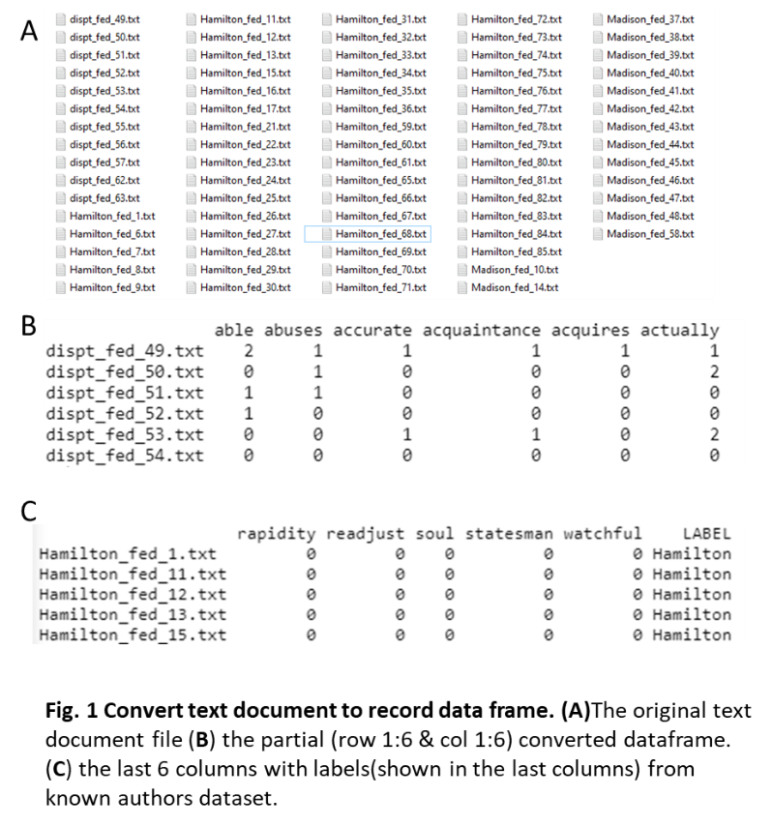
The statisticians have been trying to analysis the words distribution in the essay and drew their conclusion on the authorship of the remaining 11 disputed essays, however, more evidence is needed to solve this mystery in history. This project is focusing on identifying the author of essays, which could be either Hamilton or Madison.

Analysis
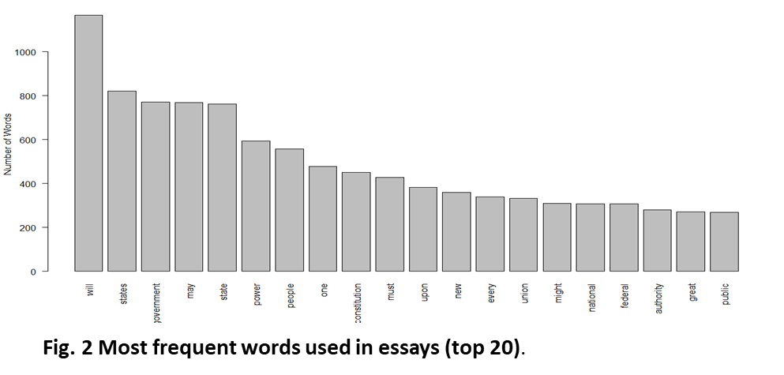
Data preparation and cleaning: original dataset is a total of 85 .txt files essays, in which 51 essays written by Hamilton, 15 by Madison, 3 by Hamilton and Madison, 5 by Jay, and 11 papers probably written by written by Hamilton or Madison. The papers written by Madison only, Hamilton only, and 11 undefined papers (Fig. 1A) were load into document, the corpus. 1) Corpus(DirSource(‘folder’)) was use to load in the documents (the corpus). 2) tm_map() function is used to remove unnecessary white space, to convert the text to lower case, to remove common stopwords like 'the', “we”, “and”. “like”, “very”, “can”, “I”, “also”, and “lot”. 3) use DocumentTermMatrix() function to convert text data to record data (Fig. 1B). 4) create a new data set with known the labels (Fig. 1C).
Data exploration: to explore the convert record data set, apply str() function on the conversed data frame, it shows that there are total 77 observations and 8081 variables. All the variables are numeric values. Fig. 2 shows the word use of the most frequent words (top 20) from the dataset.
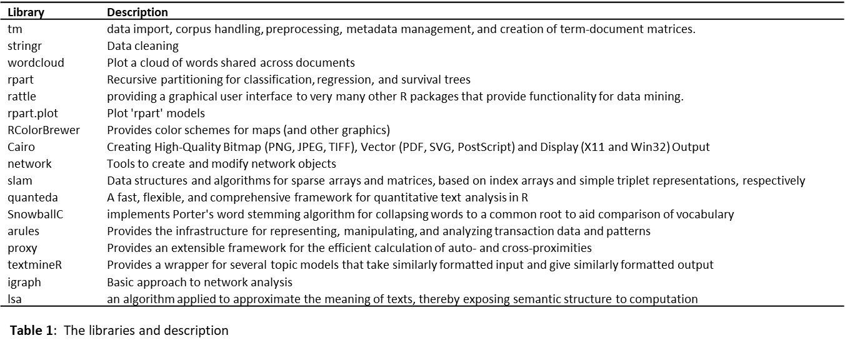
Methods: multiple libraries were used for data mining, decision tree building, model prediction, and data visualization (Table 1). With the converted record data, 1) use wordcloud() function to present the most frequent words used by author Hamilton and Madison. 2) apply rpart approach to build a decision tree and predict the model accuracy. 3) used the decision tree model to predict the disputed essays authors.
Analysis goals and Parameters: The goal of this project is to identify the potential authorship of remaining 11 essays using decision tree, to this end, there are total 3 models were built with varying parameters. Different prediction factors set were used by setting the word length from 3~15 to 4 ~9.

Results

The most frequent words used by Hamilton and Madison in the essays
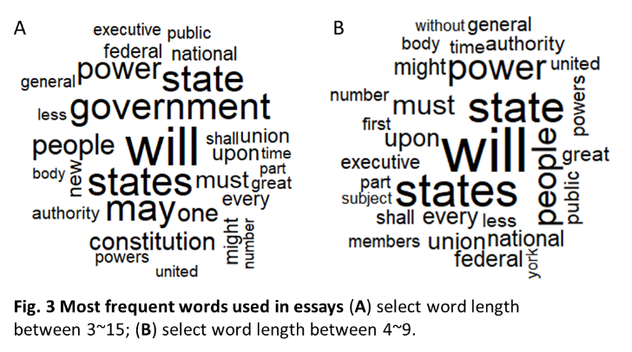
To get a first overview of the words-distribution of the overall essays. WordClouds were generated with the word length between 3~15 letters (Fig. 3A) and with the word length between 4~9 letters (Fig. 3B), both of which represent the most frequent words have been used in essays wrote by Madison and Hamilton. Words ‘will’, ‘government’, ‘state’, ‘states’, and ‘may’ are most appear among word length between 3~15. While ‘will’, ‘people’, ‘power ‘, ‘state’, and ‘states’ are most frequent in word length 4~9. It has to be noted that words ‘government’ and ‘may’ are excluded from the most frequent word set when select the word variables at length 4~9, while word ‘people’ is less frequent in the word sets with word length range from 3 to 15. therefore, word length setting would significantly affect the downstream model prediction.

DT with most frequent words (Top 100) length between 3~15
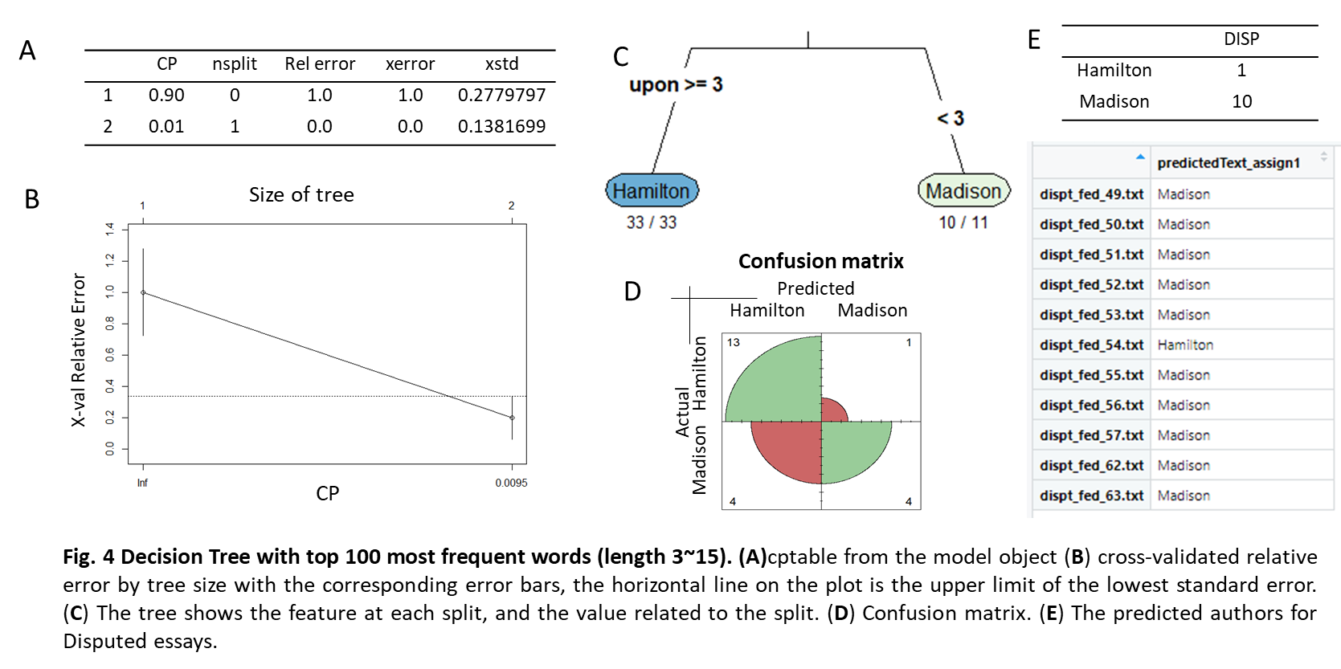
To predict the author(s) of the remaining 11 essays, a decision tree model first was built using the known Madison’s essays and Hamilton’s essays, the text words distribution in these essays will be considered as prediction factors. Given that different word length chosen may significantly affect the prediction factors data set, most frequent words (top 100) with word length between 3~15 were initially chosen as decision tree model prediction factors. The response is called ‘Label’, which represents the either Madison or Hamilton. The labeled dataset is slightly unbalanced, with 15 essays labeled as ‘Madison’ and 51 essays labeled as ‘Hamilton. The train/test labeled datasets were split using indexes, with the tain data set, a decision tree model was built (Fig. 4). Fig. 4A is an interesting table, showing that 1 split produced the lowest error on the full dataset and on cross-validation. This table was then visualized in Fig. 4B, showing that the cross-validated relative error by tree size with the corresponding error bars. The horizontal line on the plot is the upper limited of the lowest standard error. Fig. 4C is the tree plot, which shows the feature at each split and the value related to the split. There is only one split in the tree with the feature ‘upon’. If the upon >= 3 then those observations end up in a terminal node called Hamilton, otherwise end up in a node called ‘Madison’. To predict the accuracy of the mode, a test labeled dataset was used to value the model, the confusion matrix (Fig. 4D) shows that among 14 Hamilton essays, one essay was mislabeled as ‘Madison’; while in 8 Madison’s essays, half of the essays were mislabeled as ‘Hamilton’. The accuracy of this model based on top 100 most frequent words with length 3~15 is 77.27%; while the accuracy here is a bit misleading, as this is an unbalanced dataset. The recall of Madison is only 0.5. With this prediction decision tree model, 1 disputed essay was assigned as Hamilton(dispt_fed_54), while the rest of the 10 disputed essays were assigned as Madison (Fig. 4E). Based on the confusion matrix table discussed above, this model is not good as expected, the author assignment for the 11 remaining disputed essays are still questionable.

DT with long words length between 10~20
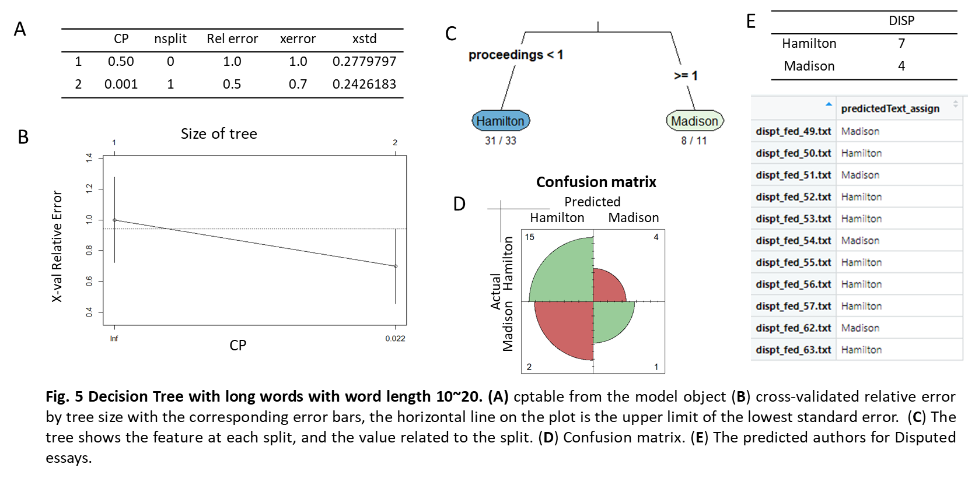
To further improve the prediction model, the interest was focused on the long words the author would prefer using in the essay, to this end, all the text word length between 10~20 was chosen as decision tree model prediction factors, there are total 2414 words were selected. The response is called ‘Label’, which represents the either Madison or Hamilton. Data set label and Data set split were described as above. Fig. 5A-B shows that 1 split produced the lowest error on the full dataset and on cross-validation. Fig. 5C is the tree plot, which shows the feature at each split and the value related to the split. There is only one split in the tree with the feature ‘proceedings ‘. If the ‘proceedings ‘< 1 then those essays are written by Hamilton, otherwise if ‘proceedings’ > =1 are written by Madison. To predict the accuracy of the mode, a test labeled dataset was used to value the model, the confusion matrix (Fig. 5D) shows that among 19 Hamilton essays, 4 of them were mislabeled as ‘Madison’; while in 3 Madison’s essays, 2 of the essays were mislabeled as ‘Hamilton’. The accuracy of this model based on the words with length 10~20 is 72.72 %; while the accuracy here is a bit misleading, as this is an unbalanced dataset as discussed above. The recall of Madison is only 0.33. With this prediction decision tree model, 7 disputed essays were assigned as Hamilton, while 4 disputed essays were assigned as Madison (Fig. 5E). Again, this model is not good as expected as well, the author assignment for the 11 remaining disputed essays is still questionable.

DT with words length between 4~9
The models predicted above with either most frequent words (Fig. 4) and the rare long words (Fig. 5) did not work well based on the confusion matrix. Therefore, a new model with prediction factor word length between 4~9 was applied, word length in this range represents average words in English. There are over 5000 words are used, as shown in Fig. 6, word ‘latter’ is identified as a main feature of this new decision tree (Fig. 6 A-C). With this model, the accuracy is almost 100%, 8 Hamilton essays were all predicted as Hamilton; and all 2 Madison’s essays were all predicted as Madison (Fig. 6D). However, it has to be mentioned here, the unbalanced the dataset with limited training samples may mislead the prediction result. This model is much better than the two models predicted above, with this model, 9 disputed essays are predicted as Hamilton, which include dispt_text_49, dispt_text_50, dispt_text_52, dispt_text_53, dispt_text_54, dispt_text_56, dispt_text_57, dispt_text_62, and dispt_text_63. And dispt_text_51 and dispt_text_55 are probably written by Madison (Fig. E).

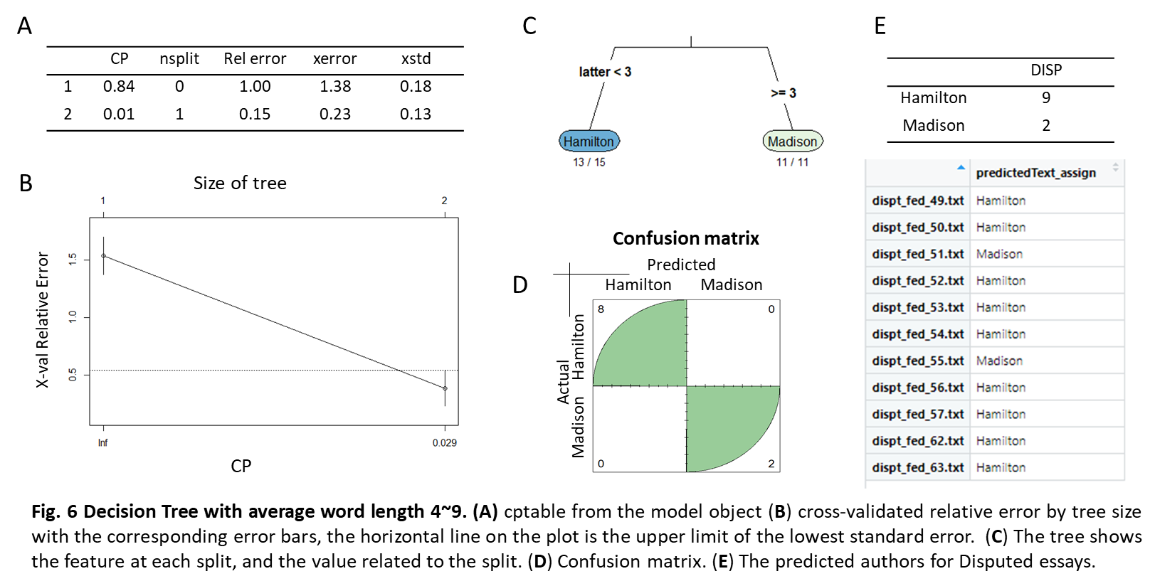

Conclusions
The aim of this project is to identify the author who wrote the remaining disputed essays urging the ratification of the Constitution, based on the known authorship of the other essays in the Federalist Papers. Different authors have different writing styles, in this case, the essays from Hamilton and Madison are different regarding the words use.
This study showed that the frequent of words used by Madison or Hamilton are varying based on the word length. It could possible that authors would preferring using rare professional long words, while some authors would prefer using common short words. In this case, Hamilton uses more “upon” in his essays than Madison, while Madison uses more short word ‘latter’ and long word ‘proceeding’ in his essays. And with that, it is more likely that essay dispt_text_49, dispt_text_50, dispt_text_52, dispt_text_53, dispt_text_54, dispt_text_56, dispt_text_57, essay dispt_text_62 and dispt_text_63 are more likely written by Hamilton, and while dispt_text_51 and dispt_text_55 are probably written by Madison.
Even though different author may have different writing style, it has to be noted that other factors may affect the essays classification. For example, when Madison and Hamilton were focusing on a very similar (or same) specific topic, then they would more likely use the same key words. Alternatively, editors’ comments and editing may also affect the word use in finial published version. At last, the limited essays from Madison may mislead the disputed essays’ author prediction. Taken together, even though some progress has been made for identifying the authorship of disputed essays by multiple approaches, the disputed essays’ authorship still could be final confirmed.

