Trifolia-on-FHIR

**Table of contents**

Introduction 3

Welcome 4

What's New 4

Additional Help 5

Login 5

Navigation 5

Authoring 6

Getting Started 6

Guidelines and Best Practices 8

Value sets 10

Binding values to elements in a profile 11

Code Systems 11

Narrative Pages 11

Publishing 12

Pre-Publishing Errors 13

IG Version 14

Generating Snapshot 15

IG Package ID 17

Terminology Server Connection 17

Dependency 18

Export/Import 19

Export 19

Import 20

GitHub Integration 21

Validation 21

Walk-through 22

Security and Permissions 22

Glossary 23

FAQ 24

Technical Details 25

System Requirements 25

FHIR Versions 25

REST API 25

Security and Permissions 26

**Welcome**

Trifolia-on-FHIR is a FHIR resource editor that uses a FHIR server natively as its back-end. All STU3-compliant FHIR servers work with Trifolia-on-FHIR.

### Core Features

* Edit conformance resource types:
  + ImplementationGuide
  + StructureDefinition(Profiles/Extensions)
  + ValueSet
  + CodeSystem
  + CapabilityStatement
  + OperationDefinition
  + Questionnaire
* Import and view any resource in the FHIR specification (e.g., Observation, MedicationStatement).
* Validate any resource in the "Validation" tab editing screen, which uses [FHIR.js.](https://github.com/lantanagroup/fhir.js)
* Export:
  + Implementation Guides and associated resources
  + Bundles
  + FHIR IG Publisher packages
* Import resources or transaction bundles.

### Support Request

* Support requests are captured using JIRA Service Desk, located here: <https://trifolia.atlassian.net/servicedesk/customer/portal/3>.
* JIRA will require you log-in with an Atlassian account before you can submit or review support requests. If you do not have an Atlassian account, you will receive a prompt to register.
* Additionally, the FHIR Zulip chat has a channel dedicated for Trifolia-on-FHIR questions and announcements, located on chat.fhir.org in the [#trifolia-on-fhir](https://chat.fhir.org/#narrow/stream/186812-trifolia-on-fhir) channel.

**What's New**

Release 1.10.0

**Select a Published Implementation Guide (IG) as a Dependency**

We have added a new icon to the dependency list. Users can select dependencies from existing IGs.

* Click the hand icon to display IGs from fhir-ig-list.json.
* Select an IG, and then select the IG version.

**Display Successfully Published IGs**

When opening a new file (project), users are now able to see the publishing status of each IG on the server based on the status of last publishing attempt. The status will be based on last IG publisher running, which IGs finished with a code of 0, and which IG finished with a code of not-zero.

### Development Log (16)

#### New Features

* [[TRIFFHIR-336](https://trifolia.atlassian.net/browse/TRIFFHIR-336)] - Users can select a published IG as a dependency
* [[TRIFFHIR-365](https://trifolia.atlassian.net/browse/TRIFFHIR-365)] - Display Implementation Guides that have successfully publish (based on last publish attempt)

#### Resolve Defects

* [[TRIFFHIR-388](https://trifolia.atlassian.net/browse/TRIFFHIR-388)] - ValueSet 'Add' button in inactive
* [[TRIFFHIR-337](https://trifolia.atlassian.net/browse/TRIFFHIR-337)] - Importing examples (i.e. not Structure Definitions) doesn't set permissions on those examples

**Additional Help**

## Additional Formats

The help documentation is available in several formats:

* CHM
* DOCX
* PDF
* EPub

## Real-time Introduction (Guided Tour)

Click the "i" (information) button in the top-right corner of ToF to begin a real-time introduction to the screen. This introduction will walk you through the important elements of your screen and present a brief description of each element. If you open multiple tabs, the introduction will only describe the elements in the current tab.

**Login**

# Login

Click the "Login" button on the top right side of the screen. Trifolia-on-FHIR (ToF) re-directs users to the identity provider to either register or login. If you do not have an account, you may register via this screen. After you have registered and logged-in with the identity provider, your browser will redirect to the ToF homepage.

If this is your first time logging-in to ToF, you must create a profile (represented by a Practitioner resource in ToF's FHIR server) for ToF to identify you as the author of resources and associate your profile with audit records when changing resources. If you configure ToF with multiple FHIR servers, you may need to create a new profile for each FHIR server.

Users can click their name at the top right side of the screen to further edit the profile for their user on the selected FHIR server.

**Navigation**

# Navigation

The main navigation bar is on the top of the screen. Some menu items are hidden pending log-in.

* File
  + Home - This is the first screen users see after login. It presents high-level information about ToF.
  + Open from computer - Users can open a resource directly from their computers, either an XML file or JSON file, and edit the resource in ToF without saving the resource to the FHIR server. When saving, the browser prompts users to re-download the updated resource as an XML or JSON file depending on the format when opened.
  + Documentation - Opens this help documentation in HTML format.
  + Request Support - Opens the support page for ToF, where users can submit support requests (defects, new ideas for features/improvements and general questions).
  + Settings - This opens the settings window for ToF.
* Browse/Edit - Search, select, delete, and create new resources depending on the resource type selected in the sub-menu.
  + Implementation Guides
  + Profiles
  + Capability Statements
  + Operation Definitions
  + Value Sets
  + Code Systems
  + Questionnaires
* Import - Import resources from other locations into ToF.
* Export - Export implementation guides from ToF in various formats (i.e., bundles, FHIR IG Publisher package, GitHub, etc).
* Publish - Publish your implementation guide using the FHIR IG Publisher.

On the right-side of the navigation menu, users will find:

* A label indicating the currently selected FHIR server. You may click on this label to open the settings for ToF and select a different FHIR server. This is the same as clicking on the File > Settings menu.
* A label indicating the user that is currently logged in. You may click on your name to edit your profile. A user is represented as a FHIR [Practitioner](http://www.hl7.org/fhir/practitioner.html) resource.
* An icon for logging out of GitHub (if you are logged into GitHub within ToF).
* An icon for logging out of ToF (if you are logged into ToF).
* An icon for getting real-time guidance on how to use each screen. When clicked, a tour of the page will be started, highlighting key points of interest. *Note: not all screens support "tour" functionality.*

## FHIR Versions in the UI

Depending on the FHIR server and the version it supports, the screens for editing resources may appear (e.g., STU3 vs. R4). The screens in ToF reflect the changes between STU3 and R4 resources. In STU3, for example, ImplementationGuide has "packages" with "resources" inside each package. In R4, ImplementationGuide has "resources" parallel to "packages," and each resource *references* a package.

**Getting Started**

## IG Design Overview

1. Create/Open an ImplementationGuide (Project).
2. Create ValueSets and CodeSystems in the UI.
3. Create profiles (StructureDefinition resources) in UI. Create elements and constrain them to value sets created in step #2.
4. Import images into the IG to insert into narrative.
5. Create narrative pages for the IG.
6. Mark example resources as “example” with optional subject/context.
7. Publish the IG.
8. Review the published IG.
9. Review the QA results and resolve errors.
10. Export as HTML package and store in GitHub.

## Create Implementation Guide

1. Open and log into Trifolia-on-FHIR.
2. Select File > New Project.
3. Specify an ID that is unique to your IG (e.g., test-ig).
4. Specify a URL unique to your IG (e.g., http://test.com/fhir/implementationguide/test-ig). The last leaf/level of the URL should match the ID to prevent errors during publishing.
5. Specify a name for your IG. This is the computable format of the name, used similarly (but not the same) as the ID.
6. Specify a title for your IG. This is what is displayed to readers of the IG.
7. Specify a Package ID. If developing an HL7 IG, you will receive this information pending PSS approval.
8. Define permissions using the “Permissions” tab.
9. Save the IG. It is now set as the project you are working on.

## Create Terminology

Create a new value set or code system:

1. Select Browse/Edit > Value Sets and/or Code Systems.
2. Select the blue “+” button in the top-right to create a new value set or code system.
3. Specify the details of the value set and/or code system.
4. Save the value set or code system. The value set or code system is automatically associated with your IG.

Locate existing value sets or code systems:

1. Select Browse/Edit > Edit Implementation Guide.
2. Select the “Resources” tab.
3. Select the “hand/pointer” icon in the top-right to add an existing resource.
4. Un-check “Showing resources for the “Test IG” implementation guide.”
5. Filter/Find then select the value set or code system.

Import a ValueSet from VSAC:

1. Select “Import” on the top navigation bar
2. Select the “VSAC” tab
3. Specify your VSAC credentials  
   Your credentials are never sent to ToF servers, they are used only by your browser to communicate with VSAC; they do not leave your computer, aside from being sent to VSAC for authentication.
4. Specify the OID for the value set you would like to import.
5. Click “Import”.
6. Assuming the value set is found, it will be imported and automatically associated with your IG.

## Create Profiles

1. Select Browse/Edit > Profiles/Extensions.
2. Click the blue “+” icon in the top-right of the screen.
3. Indicate the URL for the profile. The beginning of the URL should match the IG’s URL (e.g., http://test.com/fhir/structuredefinition/my-profile if the IG is http://test.com/fhir/implementationguide/test-ig).
4. Verify the ID matches the end of the URL. This should auto-populate when you enter the URL  
   (e.g., “my-profile” for the above URL example)
5. Specify a name and title, which the published IG will display.
6. Indicate the “type” of resource this profile constrains (e.g., “Patient”).
7. You may want to build your profile based on another profile. Specify a “Base Profile” that exists in the system.
8. Click “Save.”
9. Click the “Elements” tab.
10. Select an element to constrain.
11. Click “Constrain Element” in the right panel.
12. Re-define the element in the right panel to specify the difference between the element and the base definition.
13. Repeat for all constraints.
14. Define a description for the profile, which the published IG will display to the reader.
15. Save the profile.

## Import Images

1. Click the “Import” menu from the top navigation menu.
2. Drag-and-drop image files from your computer to the import window.
3. Click “Import.”

## Create Narrative Pages

1. Click Browse/Edit > Edit Implementation Guide.
2. Select the “Narrative/Pages” tab.
3. Provide a high-level description of the implementation guide, if desired. If no narrative pages are specified (see Step 4), then the IG’s home page will use this description.
4. Scroll to the bottom and click the “Add Narrative Page” button. This will create an index page that represents the home page for your IG. When you edit this page, ToF can automatically generate the content for the home page (index) based on the description of the IG. You can also specify custom content displayed on the home page.
5. Click the “+” on the index/home page to create child pages.
6. The “Downloads” template is available to add to your IG and customize, which will provide default content for a “Downloads” page.
7. Select “Show on top navigation bar” and specify a navigation menu name for the pages you want to appear on the top menu of the published IG.
8. When editing a page, you can click the icon that represents multiple images to insert imports.

## Identify Examples

1. Click Browse/Edit > Edit Implementation Guide.
2. Select the “Resources” tab.
3. Click “Edit” next to an example resource.
4. Select “Example = Yes” or select a profile to set an example.
5. Click “Done.”
6. “Save” the IG after updating resources.

## Publish

1. Click the “Publish” menu from the top navigation menu.
2. Select the options for your publication.
3. HL7 requires the latest IG publisher for ballots. The IG publisher updates occasionally include bugs, which leads to errors. You can select “No” pending resolution.
4. Selecting “No” for “Use terminology server” can quicken the publish execution, assuming you’re not worried about terminology.
5. Indicating “Yes” for “Download?” will offer the entire published package as a download to your computer when complete.
6. Click “Publish.” This process can be time-consuming, depending on the size of your IG. Please be patient. Once published, you can view the IG with the link on the status screen. Alternatively, you can select Browse/Edit > View Implementation Guide.

**Guidelines and Best Practices**

# Guidelines and Best Practices

Trifolia-on-FHIR has the functionality to allow users to completely customize resources. By following these guidelines, users can ensure the FHIR publisher successfully processes the Implementation Guide.

## Implementation Guide

An implementation guide (IG) is a set of rules about how FHIR resources are used (or should be used) to solve a particular problem, with associated documentation to support and clarify the usage. Classically, FHIR implementation guides are published on the web after they are generated using the FHIR Implementation Guide Publisher.

The ImplementationGuide resource is a single resource that defines the logical content of the IG, along with the important entry pages into the publication, so that the logical package that the IG represents, so that the contents are computable. In particular, validators are able to use the ImplementationGuide resource to validate content against the implementation guide as a whole. The significant conformance expectation introduced by the ImplementationGuide resource is the idea of Default Profiles. Implementations may conform to multiple implementation guides at once, but this requires that the implementation guides are compatible.

* The URL of the Implementation Guide must be in the format of http[s]://xxx.yyy/zzz/aaa/ImplementationGuide/my-ig-id. For example: http://myproject.com/someRoot/ImplementationGuide/myproject-ig
* The "id" of the implementation guide must align with the URL of the implementation guide. For example: If the URL of your implementation guide is http://myproject.com/someRoot/ImplementationGuide/myproject-ig, the id must be "myproject-ig". Users can select the "Change this resource's ID" button on the "Browse Implementation Guide" screen.
* The Implementation Guide should have a description. The main screen of the FHIR IG Publisher export displays the description.
* All contacts in the Implementation Guide appear as authors in the FHIR IG Publisher export.
* ToF only exports resources referenced directly within the Implementation Guide resource. Confirm the Implementation Guide resource references all resources.

## Resources

## The FHIR specification defines a set of resources, and an infrastructure for handling resources. In order to use FHIR to create solutions for integration requirements, implementers must map their problems to resources and their content.

* All resources within an Implementation Guide need URLs in one format. Based on the example above, if your implementation guide's URL is http://myproject.com/someRoot/ImplementationGuide/myproject-ig then all profiles (StructureDefinition resources) within the Implementation Guide must have URLs that start with <http://myproject.com/someRoot/StructureDefinition/>.

## Structure Definitions(Profiles)

A profile is a definition of a FHIR structure and is used to describe the underlying resources, data types defined in FHIR, and also for describing extensions and constraints on resources and data types.

The StructureDefinition resource describes a structure - a set of data element definitions, and their associated rules of usage. These structure definitions are used to describe both the content defined in the FHIR specification itself - Resources, data types, the underlying infrastructural types, and also are used to describe how these structures are used in implementations. This allows the definitions of the structures to be shared and published through repositories of structure definitions, compared with each other, and used as the basis for code, report and UI generation.

* The Name should be usable as an identifier for the module by machine processing applications such as code generation. The name must start with a capital letter, have at least two characters, and cannot contain spaces or special characters.
* When creating a new Structure Definition, user must specify the resource Type

### Element Definition

* The profile editor loads the elements from the snapshot of the “base definition” profile.
  + If the base definition represents a profile that does not yet have a snapshot, it attempts to create a snapshot for the base definition profile.
  + If the base definition has other base definition profiles that are not in the system, the snapshot it returns will simply be the core FHIR profile for the “type” selected (ex: the underlying profile for “Observation”)
  + The “Base Definition” field should allow you to select pre-existing profiles that are based on a matching “type”, or the core FHIR specification’s profile *for* the underlying type.
* Cardinality
  + Users can set the cardinality of an element to an invalid value, but a Warning will appear in the Element Definition form and a Validation Error appears in the Validation tab if the user.
    - selects a min cardinality less than the base element's min cardinality.
    - selects a max cardinality greater than the base element's max cardinality.
* Maximum Field Length
  + maxLength can only be entered when the ElementDefinition.type is a primitive type, with the exception of “boolean” (instant time date dateTime decimal integer string uri base64Binary code id oid unsignedInt positiveInt markdown url canonical uuid).

**Value sets**

A ValueSet resource instances specifies a set of codes drawn from one or more code systems, intended for use in a particular context. Value sets link between CodeSystem definitions and their use in [coded elements](terminologies.html). When using value sets, proper differentiation between a code system and a value set is important. This is one very common area where significant clinical safety risks occur in practice.

* Value sets used by an implementation guide *should* have a "compose" defined which asserts either the enumerated codes that should be included in the value sets, or asserts other value sets that should be included (making the value set a "wrapper" of sorts).
* Enumerated codes are shown/edited in the "Compose" tab's "Concepts" section. This section is paged, showing five (5) codes at a time. You may search for a concept by either the code or display values by entering text in the "Code (search)" and "Display (search)" fields shown at the top of the table.
* Additional fields (such as the "Designations") may be modified for each concept by clicking the "Edit" button.

Below the table of (at most) five (5) concepts is a set of buttons which allow you to control which page you are viewing/editing.

* The << button returns you to the first page of concepts
* The >> button moves you to the last page of concepts
* The < button moves you one page backward
* The > button moves you one page forward
* Selecting a number will bring you to that specific page number

The "Value Sets" section allows you to indicate what value sets should be included in this value set. Each entry in the "Value Sets" section represents the canonical URL of the value set (ValueSet.url).

When publishing an implementation guide which has a value set that references other value sets, those *other* value sets must be available to the FHIR IG Publisher via one of the following methods:

* Included in the implementation guide itself (via a resource referenced in the ImplementationGuide resource)
* The ValueSet is publicly available by the URL of the value set (e.x. putting the URL of the value set in a browser should return the ValueSet in either XML or JSON format)
* The terminology server used by the FHIR IG Publisher (tx.fhir.org) has the value set pre-loaded

**Binding values to elements in a profile**

## To create a fixed binding for an element in a profile:

Starting from the profile editor's "Elements" tab:

1. Select the element you want to bind to the fixed value.
2. Select the "Binding" tab in the properties of the element on the right side of the screen.
3. Check the checkbox next to "Fixed."
4. Select the associated "type" for the element (e.g., "CodeableConcept" or "string," depending on the data type of the element).
5. Edit the value of the fixed binding according to the instruction for the implementer.   
   In some cases, more complex data types (e.g., CodeableConcept) will show an "Edit" (pencil) icon next to the type you selected in Step 4, which opens a dialog box to enter the information.   
   Types that are simple (e.g., "code" or "string") simply show a text field to enter the value.

**Code Systems**

The CodeSystem resource is used to declare the existence of and describe a code system or code system supplement and its key properties, and optionally define a part or all of its content.

* Code systems define which codes (symbols and/or expressions) exist, and how they are understood. Value sets select a set of codes from one or more code systems to specify which codes can be used in a particular context.
* The CodeSystem resource may list some or all of the concepts in the code system, along with their basic properties (code, display, definition), designations, and additional properties.
* Code System resources may also be used to define supplements, that extend an existing code system with additional designations and properties.

**Narrative Pages**

An implementation guide can (and should) contain narrative pages that explain the use-case for the implementation guide as well as special requirements. You can add these narrative pages in the "Edit Implementation Guide" screen under the "Narrative/Pages" tab.

The content of the pages is markdown. The ToF user interface provides a WYSIWYG editor based on markdown syntax. The WYSIWYG editor supports basic markdown syntax, such as bold, italics, underline, and headings. More advanced markdown functionality (e.g., tables) may not display correctly in the editor, but will be supported during the publish process. The WYSIWYG editor doesn't show the tables; however, they may appear as tables after you publish your implementation guide.

## Navigation Menus

You can associate each page in the implementation guide with a top-level navigation menu. Edit the page and specify a name for the top-level navigation menu. When you edit additional pages and begin typing the same menu name, the existing menu name will appear as a suggestion. After publishing the implementation guide, each unique page name will appear as a top-level navigation menu with all pages associated with that menu appearing as options within that menu.

The top navigation menu *does not* reflect the hierarchy of the pages. The table of contents *does* reflect the hierarchy of the pages. The table of contents is automatically generated during the publish process.

## Images

To add one or more images to pages in your implementation guide:

1. Import your images via the "Import" screen. You may drag-and-drop the images into the "File" tab.  
   ToF will import these images as "Media" resources. The "id" of the Media resource will be based on the filename of the image. The exact file name will be stored as an "identifier" in the Media.
2. Ensure your newly imported Media resources are added to the IG's "resources".  
   Make sure they are *not* marked as an example. Leave the "Example" field either "Undefined" or "No". Otherwise, your Media resources will be an example preserved during the export process, which may produce errors during final publication.
3. Open the page(s) where you want the image to appear and place your cursor where you want the image. Select the "Insert image from predefined list" option in the Markdown editor.
4. Select the image.
5. Text will appear at your cursor for the image you selected.

Note: ToF supports the following image types:

* .JPG
* .GIF
* .PNG
* .BMP

## Technical Notes

During the IG export and publish processes, the pages in the IG have to be in a specific order. The first/root page of the IG *has* to be an index.html file. If the first page in an IG is *not* an index.html file, then ToF automatically adds one and makes the root page of the IG a child page of the new index.html page.

If the ImplementationGuide resource does not have properties for storing the content of each page, ToF creates contained Binary resources within the ImplementationGuide resource.

**Publishing**

An implementation guide (IG) is a set of rules on how FHIR resources are used to solve a particular problem, with associated documentation to support and clarify the usage. The FHIR Implementation Guide Publisher generates an IG for online publication.

The HL7 IG Publisher tool is developed by HL7 and is not part of Trifolia-on-FHIR (ToF). Questions related to the execution of the HL7 IG Publisher should be directed to [chat.fhir.org](https://chat.fhir.org/login/).

The main screen of the FHIR IG Publisher export displays the description of the Implementation Guide. The main page of the IG publisher executes the HL7 IG Publisher.

* The **Options** tab allows users to specify options you would like to use for the export.
* The **Validation** tab lists any validation issues returned by the FHIR server's $validate operation. These validation issues may vary depending on the implementation of the FHIR server.
* The **Status** tab allows users to monitor the status of the publication process (the FHIR IG Publisher)

To publish your IG, follow these steps:

1. From the top navigation menu, click **Publish**.

2. Select the options for your publication.

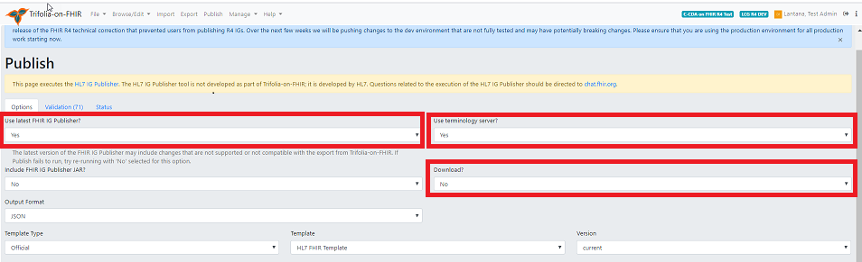

a. In the **Use latest FHIR IG Publisher** field, select **Yes**.

**Note**: HL7 requires the latest IG publisher for ballots. The IG publisher updates occasionally include bugs, resulting in errors. You can select **No** pending resolution of the bugs.

b. In the **Use terminology server** field,

* + Select **No** if the IG does not require connection to the terminology server. This speeds up up the publishing process.
  + Select **Yes** if the IG needs to connect to the terminology server to check terminology bindings.

c. In the **Download?** field, select **Yes** to download the entire published package to your computer when complete.

3. Click **Publish**.

**Note**: This process can be time-consuming, depending on the size of your IG. Once published, click the link on the status screen to view the IG or Select **Browse/Edit** then select **View Implementation Guide**.

**Pre-Publishing Errors**

***Common Pre-publishing Errors***

A pre-publishing error has occurred when the string of codes results in IG Publisher finished with code 1. This means that there’s an error in your implementation guide (IG) that needs to be resolved before Trifolia-on-FHIR can publish the IG. This guide provides the steps for resolving these pre-publishing error examples:

* IG Version
* Generating Snapshot
* IG Package ID
* Terminology server connection
* Dependency

For other pre-publishing errors, go to [chat.fhir.org](https://chat.fhir.org/login/).

***Identifying the Error***

To identify the type of error, follow these steps:

1. In the Publishing Status text, find the phrase, “Publishing Content Failed.”

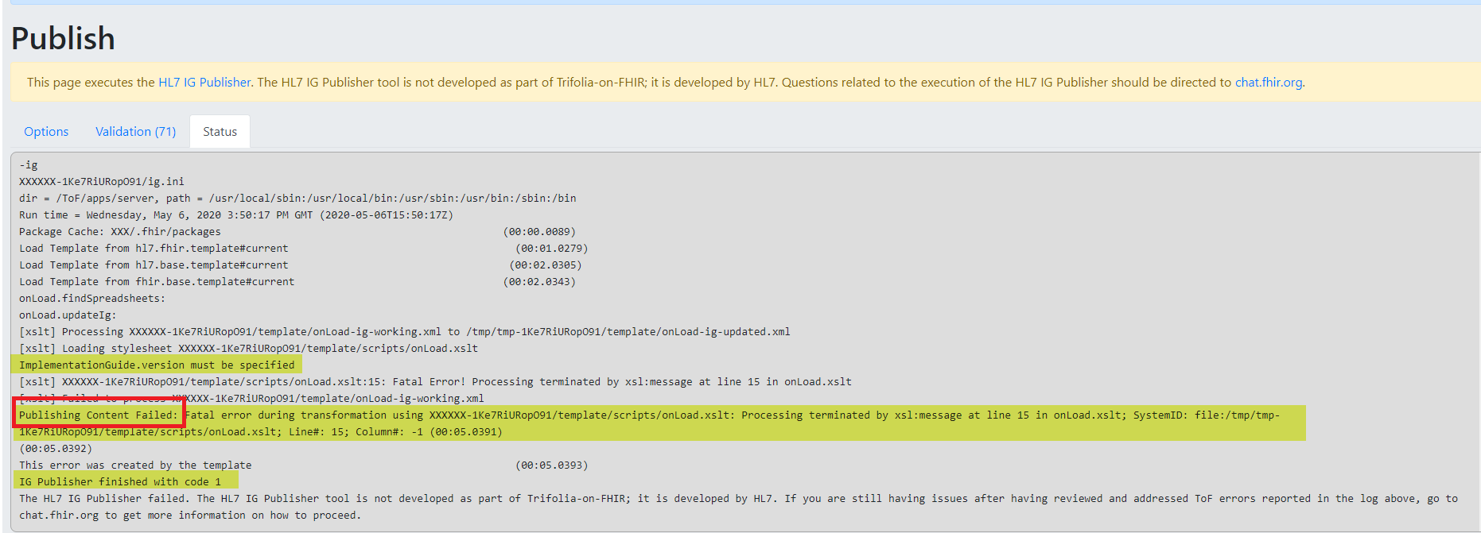

2. Look at the error message that follows this phrase to determine the type of pre-publishing error.

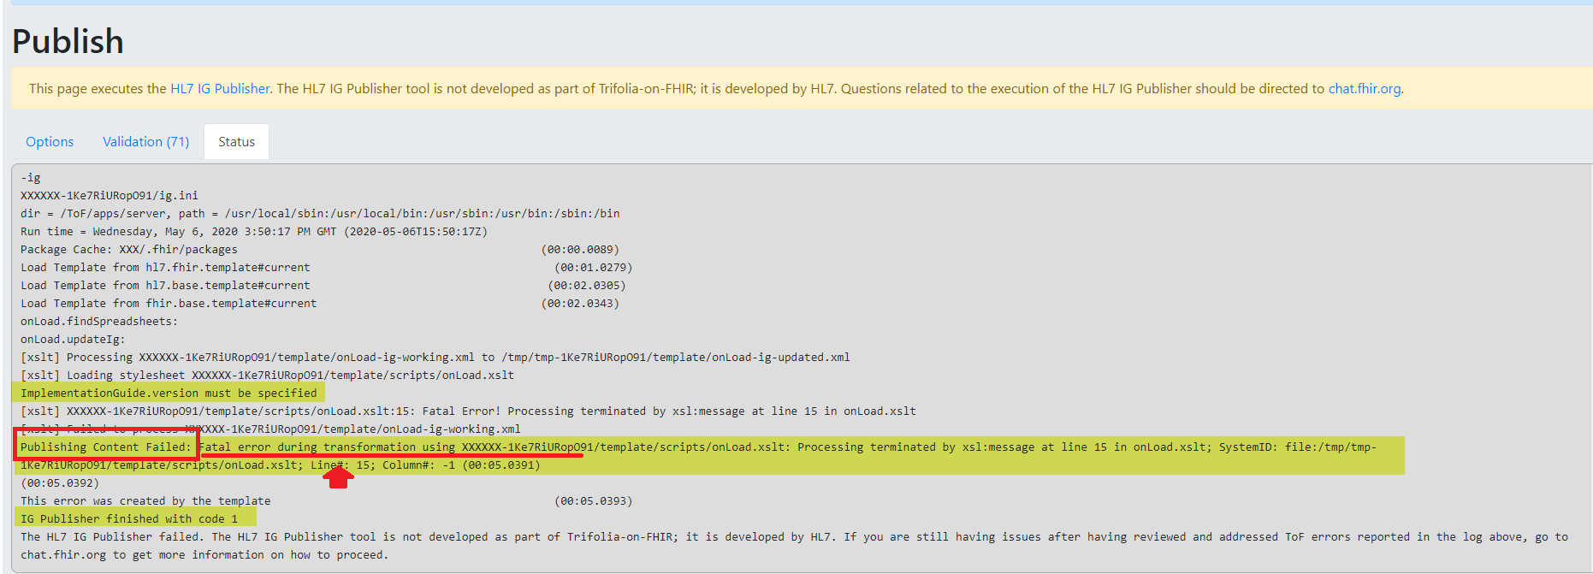

**Note:** IG Version and IG Package ID errors have similar error codes. Look at the numbers and letters bolded for emphasis to determine which error is occurring.

|  |  |
| --- | --- |
| **Error Message** | **Type of Pre-publishing Error** |
| Fatal error during transformation using XXXXXX-**1t1UQG0X5t3Cm** | IG Version |
| Error generating snapshot | Generating Snapshot |
| Fatal error during transformation using XXXXX-**1lBB6wlpjUFlB** | IG Package ID |
| Unable to connect to terminology server | Terminology Server Connection |
| The package “hl7.fhir.us” has no entry on the current build server | Dependency |

**IG Version**

**IG Version Error**

To resolve an IG Version error, follow these steps:

1. Open the IG in Trifolia-on-FHIR IG Editor
2. In the **General** tab, in the **Version** field, enter the IG version, e.g, 1.0.0.

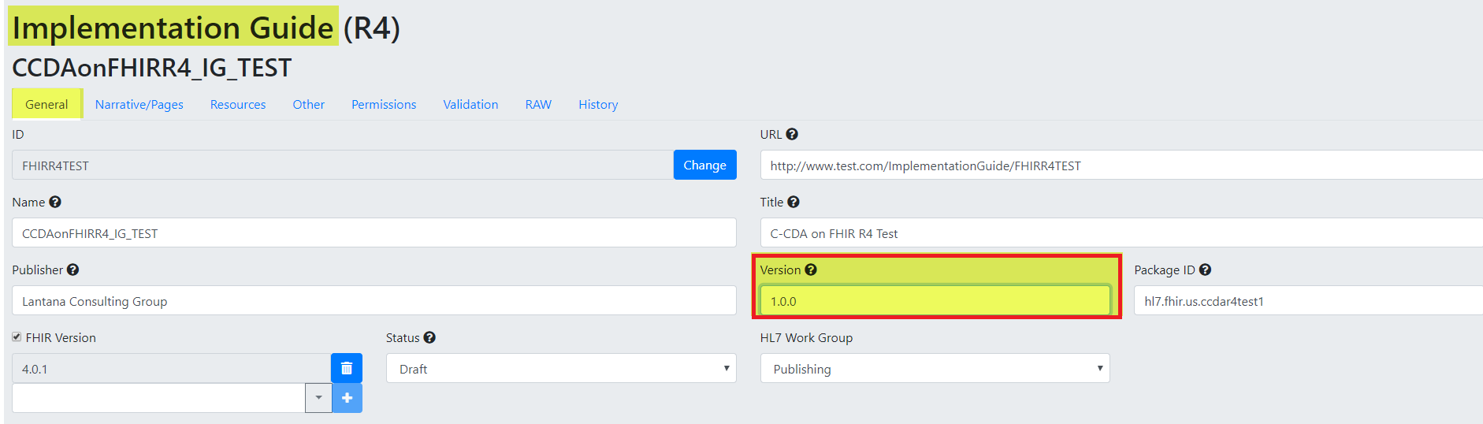

3. Click **Save** and then publish.

**Generating Snapshot**

**Generating Snapshot Errors**

Generating Snapshot is a category of errors that have different root causes. This section provides the steps to resolve two types of Generating Snapshot errors: Base Definition and Authorization.

To determine the type of Generating Snapshot error, look at code next to the phrase, “Publishing Content Failed.”

* **Base Definition error code**: Cannot find or generate snapshot for base definition
* **Authorization error code****:** Unable to generate snapshot for [resource URL]

Example resource URL: https://trifolia-fhir-dev.lantanagroup.com/structure-definition/ccda-authorization-extension

**Base Definition**

To resolve a Base Definition error, follow these steps:

1. In the Publishing Status text, look at the code to identify the resource causing the error. The screenshot shows an example of a resource that might be causing the error.

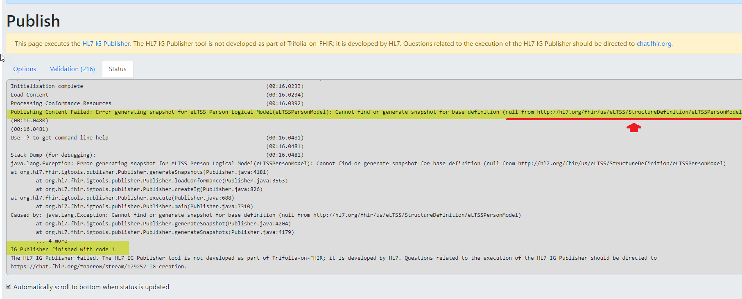

2. In Browse-Profiles, check that a profile exists for the resource in the error.

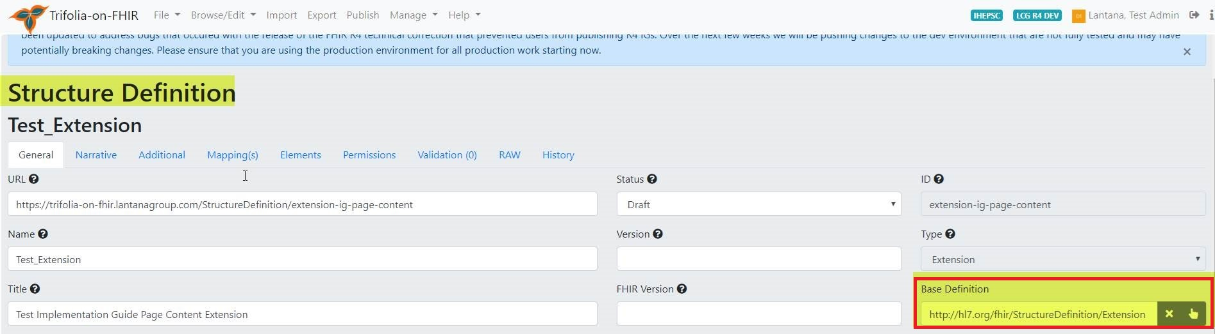

3. In the [HL7 resource list](https://www.hl7.org/fhir/resourcelist.html), search for the correct base definition URL.

4. In the **Base Definition** field, paste the correct base definition URL.

5. Click **Save** and and then publish.

**Authorization**

To resolve an Authorization error, follow these steps:

1. Find the profile causing the error by looking in the Publishing Status text for the phrase “Caused by.”

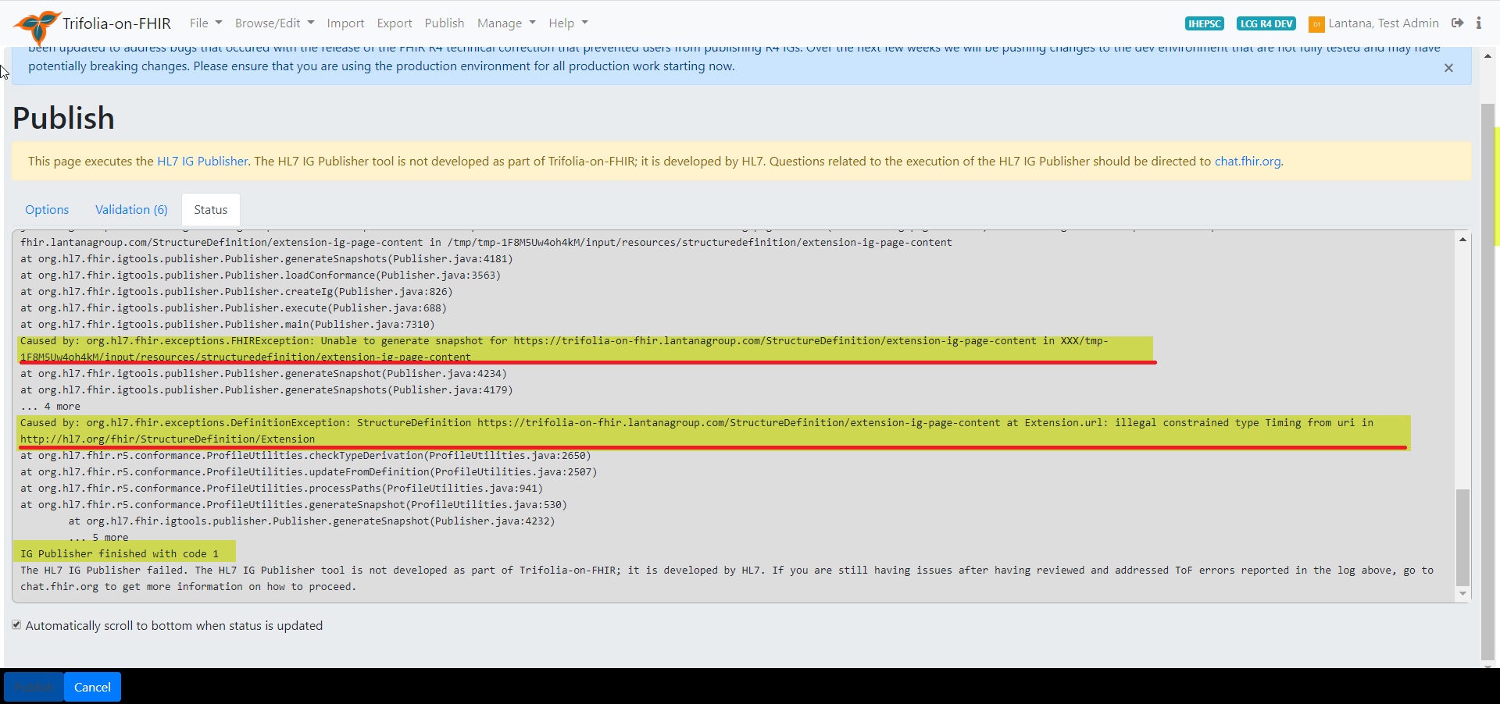

2. Using the Profile Editor, open the profile causing the error identified in step 1.  
3. In the **Elements** tab, confirm the **Type** for each constrained element is correct. If not, correct any errors.

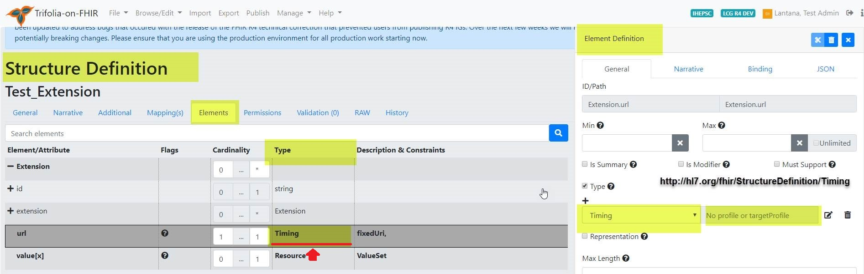

4. For each constrained element, confirm the Type profile URL is correct. If not, correct any errors.

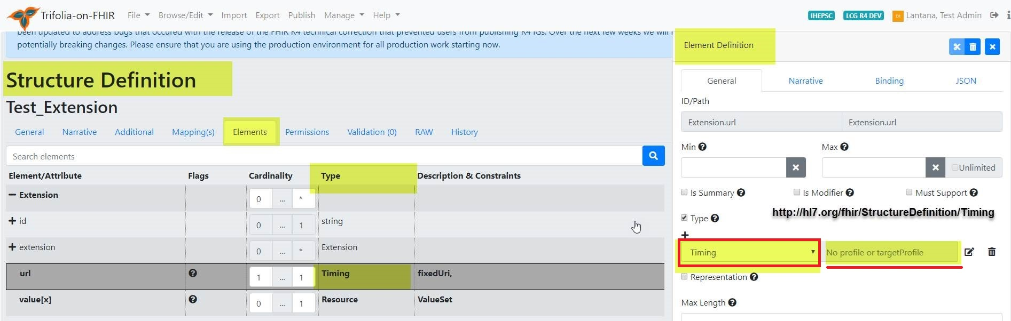

5. In the [HL7 resource list](https://www.hl7.org/fhir/resourcelist.html), search for the correct element type URL.  
6. In the **Element Definition** form, in the **Type URL** field, paste the correct element type URL.  
7. Click **Save** andthen publish.

**IG Package ID**

**IG Package ID Errors**

This example shows the text indicating the cause of this IG Package ID error: the ID doesn’t begin with hl7.

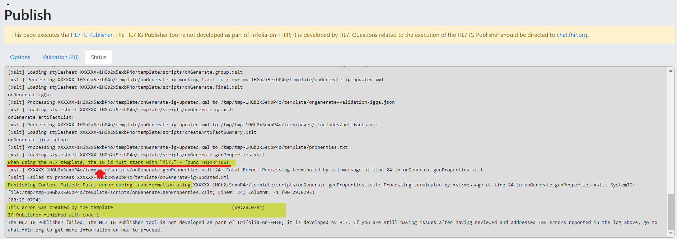

To resolve the IG Package ID error shown in this example, follow these steps:

1. In the IG Editor, open the IG.
2. In the General tab, in the **Package ID** field, enter a package ID that begins with “hl7.” (e.g., hl7.fhir.us.mytestig).

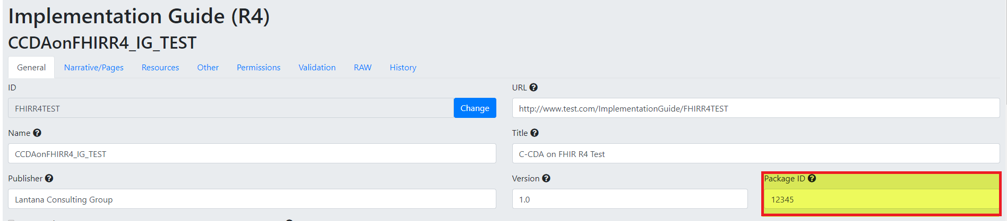

3. Click **Save** and thenpublish.

**Terminology Server Connection**

**Terminology Server Connection Error**

The Terminology Server Connection error means that the VSAC terminology server is temporarily down.

|  |  |
| --- | --- |
| **If:** | **Then:** |
| The IG requires a VSAC check, | Wait and try to publish again in 1 to 2 hours. |
| The IG does not require a VSAC check, | In the **Use Terminology Server** option, select **No**. |

**Dependency**

**Dependency Error**

To resolve a Dependency error, follow these steps:

1. Go to https://fhir.github.io/auto-ig-builder/builds.html.
2. Search for the HL7 / US-Core-R4 in the list of IGs.



3. Click on the **gh** option.



4. Double-click on the US-Core-R4/package-list.json file.

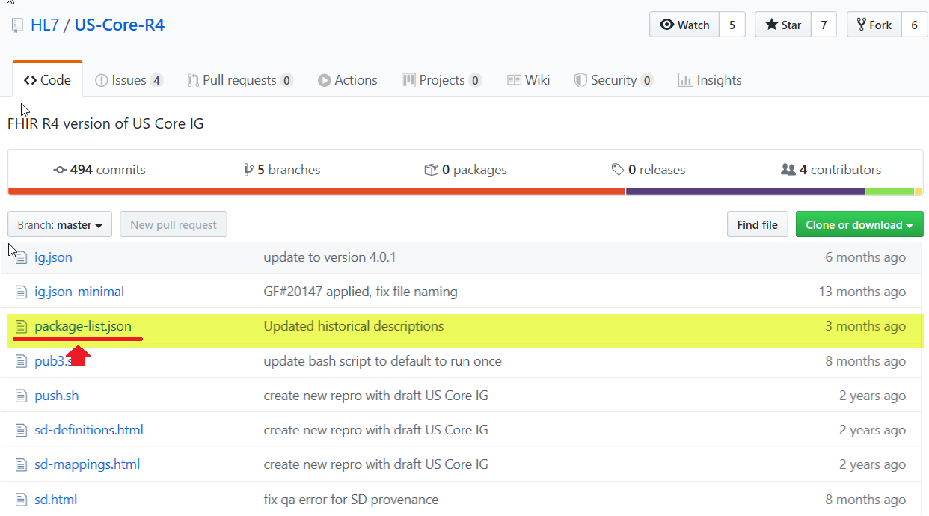

You will need the information from these fields:

* Canonical value
* Package-id value
* Title value
* Version value

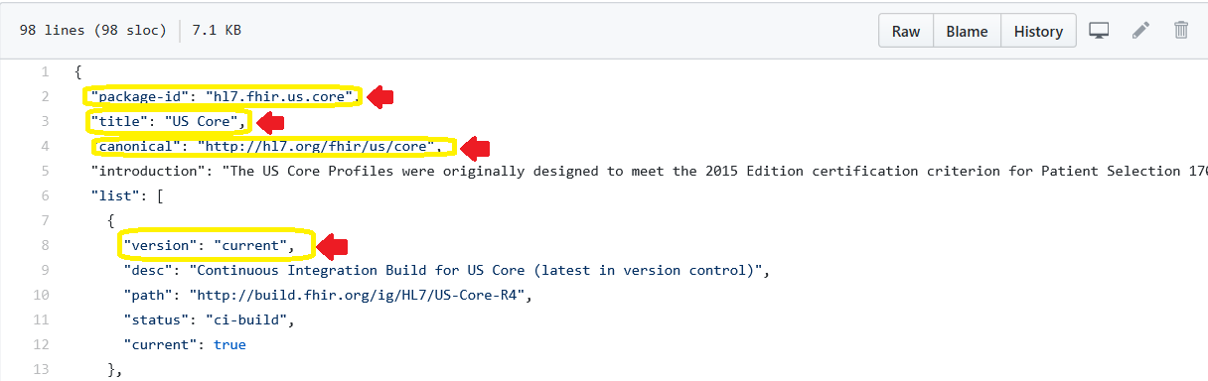

5. In the IG Editor, open the IG.

6. In the **General** tab, scroll down to the **Dependencies** section

7. In the **URI** field, enter the canonical value from the package-list.json.

8. In the **Package ID** field, enter the package-id value from the package-list.json file.

9. In the **Name** field, enter the title value from the package-list.json.

10. In the **Version** field, enter the version value from the package-list.json.

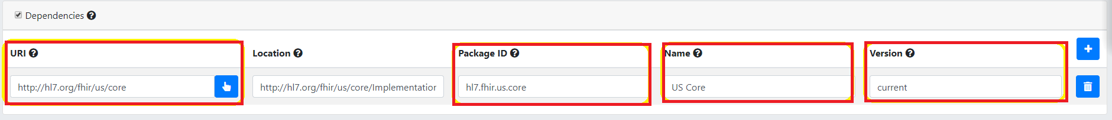

11. Click **Save** and then publish.

**Export**

# Export

Select Export in the tabbed tool bar on the top of the screen.

in order to export artifacts, you must first select the Implementation Guide(IG).

The Export page contains form fields that allow users to specify the details of their exports. Users can export the Implementation Guides (IGs) saved under the Browse/Edit tab at the top right side of the screen. Users can export IGs as bundles or HTML with the IG Publisher. Once the form fields are complete, select the Export button on the left side of the scrolling tab at the bottom of the screen.

1. The "IG Publisher Package" generates a package using the published version of the IG to be used with the FHIR IG Publisher.
   * Users can select either JSON or XML format for the output
   * The "FHIR IG Publisher JAR" can be included in the export package
   * The Export tool will take a few minutes to process. The length of time is correlated with the size of the export.
   * After completing the process, the export will automatically download to users' computers in a compressed folder, and tthe user is prompted to download a ZIP package of all files necessary to execute the FHIR IG publisher.
   * When the IG Publisher is executed, the output from the IG Publisher is copied to a public location in Trifolia-on-FHIR for preview.
   * HTML exports produce a package (ZIP file) for use with the FHIR [IG Publisher](http://wiki.hl7.org/index.php?title=IG_Publisher_Documentation).
2. The "Bundle" export format is a Bundle of all resources referenced by the selected implementation guide, including the implementation guide resource
   * Bundle exports produce a single download (pretty quickly) as a single XML file. This XML file is a FHIR [Bundle](http://hl7.org/fhir/bundle.html) that can be used to import the resources for the implementation guide in another FHIR environment.
   * Users can select the type of output, JSON or XML, the bundle will be exported in.
3. The "GitHub" export format places all the resources within the IG into the specified GITHub repository/branch
   * Only resources that have a repository, branch and path will be exported to GitHub. At least one resource must have GitHub location information specified to export
   * If the file already exists in GitHub, it will be completely overwritten by this export
   * When this tab is selected from the Export page, the user will be prompted to enter their GitHub credentials. If the user does not log into GitHub initially, the "Login to GitHub" button can be selected before the export is commenced.
   * After a user has selected an Implementation Guide, the user must enter a commit message that will be associated with the IG on GitHub.

**Import**

# Import

ToF allows users to import files, text, VSAC and GitHub content.

* **File** imports allow users to drag-and-drop FHIR resources (e.g., StructureDefinitions, ValueSets, CodeSystems) and Excel-based value sets directly from your computer to ToF.
  + Users can drag-and-drop files from their computers File Explorer directly into the Import screen, or select the "Click to Select" link to select the files they wish to import.
  + Once the user has selected the files in Explorer, the list of files to be imported will be displayed in the Import screen.
  + Users can click the **trash** icon to remove file(s) from the list of files to be imported.
  + Imported resources are sent directly to the ToF server as a transaction bundle. ToF displays an excerpt of the JSON or XML bundle of the file prior to uploading.
  + The **Results** tab displays the outcome of importing from the **Files** tab
* **Text** importsallows users to copy/paste JSON or XML content directly into Trifolia-on-FHIR to have it imported.
* **VSAC** imports allows users to import value sets and code systems directly from VSAC into ToF.
  + Imported value sets and code systems can be referenced by Structure Definition resources.
  + The VSAC mports require users' VSAC credentials, which are not persisted on the ToF server. If users select 'Remember VSAC Credentials,' the tool will store this information as cookies in the users' browser.
* The **GitHub** tab allows users to import resources directly from GitHub into ToF.
  + After selecting the "GitHub" tab, the user will be prompted to login to GitHub using their GitHub credentials.

**Note:** Users who upload more than 20 resources at once may experience a timeout error notification. In the event of a timeout error notification, users should reduce the size of the resource import. Users can edit resource numbers based on individual needs.

## Excel Value Sets

In the "Files" tab you may import excel spreadsheets (XLSX) that represent value sets. The spreadsheet document must have these columns, in this specific order (note that that row 1 is expected to contain the below column headers, not the first value in the ValueSet):

* ID - This is the ID of the value set. This value in this column is repeated for each code/row. The value must be formatted as a [valid ID](https://www.hl7.org/fhir/resource.html#id). Ex: 2.16.840.1.113883.42.3.1
* Name - The name of the value set. This value in this column is repeated for each code/row.
* URL - The URL of the value set. This value in this column is repeated for each code/row. Ex: http://some.com/test/fhir/valueset
* Code - The code representing the concept. Ex: 900000000000073002
* Display - The display representing the concept. Ex: "Sufficiently defined concept definition status"
* System - The system URL that owns/maintains the code. Ex: http://snomed.info/sct

**GitHub Integration**

## Authentication

The import and export screens both contain options for GitHub. As soon as the GitHub option is selected in either screen, you are prompted to login with your GitHub credentials. Once logged in, your GitHub authentication token is stored in cookies so that you do not have to login every time you select "GitHub" under the import/export screens.

After you have logged into GitHub, a GitHub icon appears in the top-right corner of the all screens. When clicked, this icon logs you out of GitHub within ToF.

ToF uses a pop-up window to authenticate with GitHub. If your browser blocks the pop-up window, ToF will not be able to authenticate with GitHub and you will receive an error.

*NOTE: If you select "Remember Me" when logging into GitHub, and want to change to a different GitHub user, you will need to open github.com in a separate window and logout of your GitHub account, then have ToF forget the GitHub login using the GitHub icon mentioned above. Once this is done, when you attempt to login to GitHub via ToF, it will ask you which account you would like to use with GitHub.*

## Work Flow

The work flow within ToF for GitHub is to

1. Import resources from a GitHub repository into the selected FHIR server
2. Edit the resources using ToF
3. Export the resources back to the GitHub repository after they have the desired changes

## Extensions

When importing resources, two extensions are added to each resource representing the location within GitHub for where the resource came from. This enables ToF to know where in GItHub to export the resources back to.

If you are exporting *new* resources to GitHub, these extensions will not yet exist and you will need to specify where the resources should be stored during the export (which will create the two extensions on the resource).

## Limitations

* Trifolia only exports the individual resources associated with the implementation guide, and does not include the entire IG Publication package. For example, the "framework" (html templates) folder is not included in the export.
* Trifolia only allows importing FHIR resources. Trifolia-on-FHIR allows the user to select any JSON or XML file from GitHub. If the user selects an XML or JSON file that is not a FHIR resource, the import will fail.
* GitHub does not allow retrieving/updating very large files. For example, if attempting to import/export a large ValueSet resource, GitHub may fail with a "Payload too large" error.

## Signing Out

When you sign out of GitHub within Trifolia, this clears your GitHub session only within Trifolia. GitHub maintains its own session within your browser. To sign out of GitHub entirely, you will need to go to github.com and click "Sign out".

**Validation**

***Validation***

Trifolia-on-FHIR uses three validation methods to provide as much feedback to IG authors as possible:

1. **Real-time UI Validation**  
   This validation checks the base FHIR specification requirements (i.e., cardinality, terminology bindings, value set requirements). This validation occurs as each field in ToF is changed to update and render to the user in real-time.
2. **Pre-publish Validation**  
   When publishing an implementation guide from the "Publish" screen, the FHIR server's [$validate operation](https://www.hl7.org/fhir/operation-resource-validate.html) is executed for each resource in the implementation guide. This is specific to the FHIR server in Trifolia-on-FHIR for this IG (e.g., HAPI, the FHIR server instance default).

Please see the FAQ page, *Publishing with the FHIR IG Publisher* section for examples of errors and steps to resolve.

1. **HL7 IG Publisher Validation**  
   The FHIR IG Publisher executes this validation step automatically *during* the publishing process. Validation checks for relationships between all resources and pages within this IG package. This includes all applicable IG resources, profiles, extensions, value sets, etc. FHIR IG Publisher validation also validates HTML links within the package. You cannot execute this validation step externally/independently of the publish process for an entire IG.

**Walk-through**

The purpose of this page is to guide new users through Trifolia-on-FHIR:

1. Create account and Login
2. Select FHIR Release version (gear icon in top right)
3. Create new Implementation Guide
   * Option A: Create IG from scratch. Navigate to Browse Implementation Guides > click the "plus" + button at top IG list/table.
   * Option B: Import IG from a file. Import IG.xml from your computer ("Import" button at top and either drag-and-drop the IG.xml file into the "Files" tab or copy/paste the contents of IG.xml into the second tab).
4. Modify IG. Be sure to always *Save* (bottom left)

**NOTE**: When creating and ordering pages, you can only pivot a page's position with pages that are siblings with one another. Pages that are children of the page you're trying to move or children of a page that's not the parent of the page being moved can not be swapped.

1. Create/import additional templates/profiles
   * Option A: Create Profile from scratch. Navigate to Browse Templates/Profiles > click the "plus" + button at top of Profile list/table.
   * Option B: Import profiles from directories on computer
2. Modify and constrain the templates/profiles to use case
3. Resolve all Validation errors and warnings on Validation (tab) within each profile
4. Export selected IG package. Suggested settings for initial export:
   1. Export Format: HTML (IG publisher)
   2. Run the IG Publisher: Yes
   3. Run the latest version of the IG Publisher: No
   4. Use terminology server: Yes/No (Suggest No if IG uses large standard codesets)  
      Selecting Yes will verify applicable value sets and code systems externally
   5. Download: Yes
   6. Output format: XML
5. Confirm build logs against CI-publisher on Zulip > Notifications

**Security and Permissions**

## Authentication

ToF is designed with minimum requirements for user authentication to access the data stored on the FHIR servers ToF is configured to use. Additional permissions may be required depending on the configuration of the ToF installation.

## Permissions

If the ToF installation is configured to require permissions, only data that the user has been permitted to view/edit will be access to them in the user interface. The remainder of this section presumes that permissions are enabled in the installation.

Permissions are maintained for each individual resource in the system. For example, permissions may be different for an instance of an ImplementationGuide compared to a StructureDefinintion that the implementation guide references.

Each edit screen contains a "Permissions" tab which allows the user to define the permissions for the resource. The user may search for users and groups, and add read and/or write permissions to the resource for the selected users/groups.

The user may select a different resource to copy permissions, either:

1. Select a resource type and type search criteria in the text field. Suggestions will present below the text field. Select one of the suggestions and press the "Copy" button.
2. Click the "Search" button next to the text field to select a resource using the advanced search pop-up window. Click the "Copy" button after you identify and select a resource.

If you have permissions to a resource via a group and that resource has other associated groups and you *aren't* a member, the name of the group will not appear and the "Permissions" tab will only display the ID of those other groups.

If you do not have permissions to edit a resource, you cannot click the "Edit" button on the resource from the browse screen. Future enhancements may allow the user to access the "Edit" screen in a disabled state when the user doesn't have edit permissions to the resource.

## Managing Groups

All users can create/manage their groups. A group may only have one manager.

To create/edit/delete groups, click your name in the top-right of ToF, and select the "Groups" tab. Changes to the "Groups" tab are persisted immediately. The "Save" button only applies to editing information for your profile.

When you create a group, you are automatically added as a member to the group. You cannot remove yourself as a member from the group.

## Importing Resources

When importing *new* resources, the permissions for those new resources default to allow the user performing the import view/edit access. To allow additional permissions, edit each resource and grant additional permissions.

## Implementation Guide Permissions

You may copy permissions for an implementation guide to resources within the implementation guide. This functionality is primarily for scenarios where the permissions to the implementation guide have changed, and those changes need to be propagated down to the resources within the implementation guide.

Note: You cannot change permissions for a resource you don't have access. If you don't have access to one or more of the resources within the IG, you cannot copy permissions from the IG to that/those resources.

To do this:

1. Open a project.
2. Select Browse > "Edit ImplementationGuide."
3. Select the "Permissions" tab.
4. Click the "Copy" button in the "Copy IG Permissions" panel.
5. After ToF copies the permissions, you will be prompted to indicate the number of resources changed as part of the request.

**Glossary**

|  |  |
| --- | --- |
| **Acronym** | **Definition** |
| ToF | Trifolia-on-FHIR |
| FHIR | Fast Healthcare Interoperability Resources |
| VSAC | Value Set Authority Center |
| IG | Implementation Guide |
| VS | Value Set |
| CS | Code System |

**FAQ**

**My implementation guide has pages, but the table of contents is empty?**

On the **Table of Contents** page, in the **Auto Generate Table of Contents?** field, select **Yes**.

**Why is the Home Screen stuck on Loading?**

Based on your web browser storage settings, Trifolia-on-FHIR (ToF) may “hang" or "stall" at the Loading page with the orange circle. Clearing browser history typically resolves this issue.

Follow these steps based on the web browser you use to access ToF; if clearing your browser history does not resolve the issue, submit a ticket and specify the browser you use.

**Chrome:**

1. Select **Options**, the three vertical dots to right of the URL address bar within Chrome, and select **History**.
2. From the menu, select **History**.
3. On the **History** page, from the left pane, select **Clear browsing data**.
4. Refresh the page.

**Internet Explorer:**

1. Select the gear icon (to the right of the URL address bar within IE) and select **Internet Options**.
2. On the **General** tab, under **Browsing History**, click **Delete**.
3. Click **Apply**.

**Safari:**

1. Select **Develop** and then select **Show JavaScript Console** (or Option-Command-C).
2. Select the **Storage** tab.
3. Highlight Local Storage - trifolia-fhir.lantanagroup.com and Application Cache.
4. Select each of the key values, and click **Delete** to remove each of them.
5. After deleting each key/value pair, refresh the page.

**Microsoft Edge:**

1. Select the three horizontal dots (to the right of the URL address bar within Edge).
2. Select **History** and select **Clear Browsing Data** (Ctrl + Shift + Delete).

**Technical Details**

**System Requirements**

# System Requirements

## End-Users

End-users will need a modern browser (e.g., Chrome, Firefox, Internet Explorer, Safari) to use Trifolia-on-FHIR.

## Administrators

Administrators must ensure the following requirements to install Trifolia-on-FHIR in their individual servers:

* **Windows *or* Linux**
* **Java 8+** (to execute the publish process using the FHIR IG Publisher)
* **Jekyll** (to successfully complete the publish process using the FHIR IG Publisher)
* **FHIR Server** (STU3 or R4)
  + Must support creating resources via a PUT with an ID
  + Must support the [$validate operation](https://www.hl7.org/fhir/operation-resource-validate.html)
  + Must support the [$meta-delete operation](https://www.hl7.org/fhir/operation-resource-meta-delete.html)
  + Must support ImplementationGuide search query parameters:
    - resource
    - global
  + Must support _has (reverse chaining) search criteria. For example: GET /StructureDefinition?_has:ImplementationGuide:resource:_id=<IG_ID>
  + Must support _include search criteria to get a list of all resources related to an implementation guide. For example: GET /ImplementationGuide?_id=some-ig-id&_include=ImplementationGuide:resource&ImplementationGuide:global

**FHIR Versions**

# FHIR Versions

Trifolia-on-FHIR supports multiple versions of the FHIR standard. ToF currently supports STU3 and R4. Users can select a FHIR server with the drop down menu at the top right of every screen.

**REST API**

## Multiple FHIR servers

If the ToF installation is configured to support multiple FHIR servers, the first FHIR server is the default in the REST API. If you want to perform REST API operations on a different FHIR server, you must specify a **fhirserver** header in each request. The value of the **fhirserver** header must align with the **id** of one of the FHIR servers returnved by **/api/config**.

## FHIR Server Proxy

An **/api/fhir** end-point in the API represents a "proxy" to the FHIR server(s) available within the ToF installation. The proxy endpoint supports GET, PUT, POST, DELETE requests for individual resources, as well as [batches](http://www.hl7.org/fhir/http.html#transaction). Transactions are *not* supported by this proxy.

### Authentication

Authentication is required to access the REST API. To get an authorization code to use the REST API, log into the ToF web application and open the settings screen, where the "Authorization Code" is displayed. Attach the authorization code in an "Authorization" header prefixed with "Bearer ". For example: "Authorization: Bearer XXXX" where XXXX is your authorization code.

### Multiple FHIR Servers

The default FHIR server for this proxy endpoint is the first FHIR server available in the drop-down of FHIR servers in the settings screen of the application.

If you do not want to use the default/first FHIR server, specify a "fhirserver" header in each request where the value of the header is the id of the FHIR server according to the settings screen in the application.

The settings screen presents an example of a request using curl for whichever server you have selected.

## Trifolia-on-FHIR Native API

ToF's REST API is documented using Swagger. The publicly available installation exposes custom API documentation at [https://trifolia-fhir.lantanagroup.com/api-docs](https://trifolia-fhir.lantanagroup.com/api-docs/). The API described by **/api-docs** is the same API the web application (i.e., user interface) uses.

**Security and Permissions**

Permissions for resources are stored in Resource.meta.security. A custom code is created for three types of permissions:

* Everyone - Anyone with a user account in the installation.
* Group - One or more users (Practitioners) represented as a single group. Use a group to represent a team of users.
* User (Practitioner) - A single person with access to the installation. ToF requires every user create a Practitioner that represents their user login to open ToF to a specific FHIR server for the first time.

Two levels of permissions:

* Read - Allows the user to search/view the resource
* Write - Allows the user to update/delete the resource

WIth these concepts combined, the resource may have several security codes. For example:

{  
 resourceType: "ImplementationGuide",  
 meta: {  
 security: [  
 // Everyone has access to read/wite  
 **{ system: "https://trifolia-fhir.../security", code: "everyone^read" },**  
 **{ system: "https://trifolia-fhir.../security", code: "everyone^write" },**  
 // Members of group test-group-id have access to read/write  
 **{ system: "https://trifolia-fhir.../security", code: "group^test-group-id^read" },**  
 **{ system: "https://trifolia-fhir.../security", code: "group^test-group-id^write" },**  
 // A specific user (Practitioner) with id test-practitioner-id has access to read/write  
 **{ system: "https://trifolia-fhir.../security", code: "user^test-practitioner-id^read" },**  
 **{ system: "https://trifolia-fhir.../security", code: "user^test-practitioner-id^write" }**  
 ]  
 }  
}

When a user searches for ImplementationGuide resources, ToF sends a search request to the FHIR server that includes a _security parameter with all possible variations applicable to the active user. For example:

// un-encoded for readability  
https://some-fhir-server.com/fhir/ImplementationGuide?_security=<system>|everyone^read,<system>|group^test-group-id^read,<system>|user^test-practitioner-rid^read  
// encoded  
https://some-fhir-server.com/fhir/ImplementationGuide?_security=https%3A%2F%2Ftrifolia-fhir...%2Fsecurity%7Ceveryone%5Eread%2Chttps%3A%2F%2Ftrifolia-fhir...%2Fsecurity%7Cgroup%5Etest-group-id%5Eread%2Chttps%3A%2F%2Ftrifolia-fhir...%2Fsecurity%7Cuser%5Etest-practitioner-rid%5Eread

When a user clicks the "Edit" button on a resource, ToF retrieves a single/specific resource. The ToF server verifies whether the persisted resource grants the active user permissions to view the resource before sending the resource to the user's browser for viewing.

Similarly, when a user clicks "Save" or "Delete," the ToF server retrieves the instance of the resource persisted on the FHIR server, verifies whether the user has permissions to modify the resource, and rejects the request with a 401 Unauthorized response if the user does not have permissions. Otherwise, the resource is updated on the FHIR server according to the request.