Hemorrhagic Shock

Hemorrhagic shock is a clinical syndrome resulting from decreased blood volume (hypovolemia) caused by blood loss, which leads to reduced cardiac output and organ perfusion. Blood loss can be external (e.g., externally bleeding wound) or internal (e.g., internal bleeding caused by ruptured aortic aneurism). The severity of hemorrhagic shock and associated symptoms depends on the volume of blood that is lost and how rapidly it is lost. Generally, a blood loss of <15% of total blood volume leads to only a small increase in heart rate and no significant change in arterial pressure. When blood loss is 15 to 40%, mean arterial and pulse pressures fall, and heart rate increases, with the magnitude of these changes being related to how much blood is lost. If the hemorrhage is stopped, the arterial pressure slowly recovers and heart rate declines as long-term compensatory mechanisms are activated to restore normal arterial pressure. The time for recovery is longer when there is a greater loss of blood. Resuscitation efforts, which include the administration of fluids to increase blood volume, can speed up this recovery. A greater than 40% blood loss is life threatening, and resuscitation is generally essential for survival because prolonged, severe hypotension leads to organ failure and death.

**Compensatory mechanisms.** The reduction in blood volume during acute blood loss causes a fall in central venous pressure and cardiac filling. This leads to reduced cardiac output and arterial pressure. The body has a number of compensatory mechanisms that become activated in an attempt to restore arterial pressure and blood volume back to normal. These mechanisms include:

• Baroreceptor reflexes

• Chemoreceptor reflexes

• Circulating vasoconstrictors

• Renal reabsorption of sodium and water

• Activation of thirst mechanisms

• Reabsorption of tissue fluids

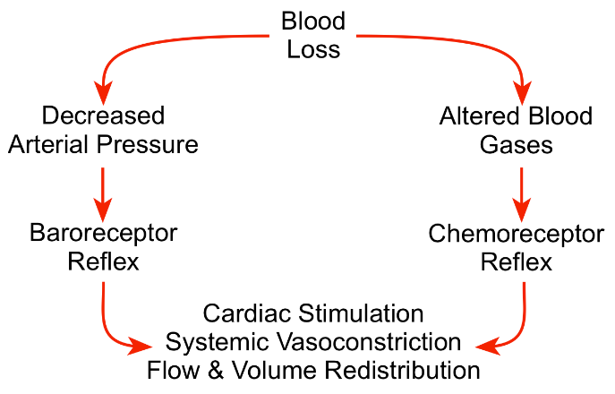

The body can quickly sense a fall in blood pressure through its arterial and cardiopulmonary [baroreceptors](https://www.cvphysiology.com/Blood%20Pressure/BP012), and then activate the sympathetic adrenergic system to stimulate the heart (increase heart rate and contractility) and constrict blood vessels (increase systemic vascular resistance). Sympathetic activation has little direct influence on brain and coronary blood vessels, so these circulations can benefit from the vasoconstriction that occurs in other organs (particularly in the gastrointestinal, skeletal muscle and renal circulations) that serve to increase systemic vascular resistance and arterial pressure. In other words, cardiac output is redistributed from less important organs to the brain and myocardium, both of which are critical for survival. Reduced organ blood flow caused by vasoconstriction and reduced arterial pressure, leads to systemic acidosis that is sensed by [chemoreceptors](https://www.cvphysiology.com/Blood%20Pressure/BP014). The chemoreceptor reflex further activates the sympathetic adrenergic system thereby reinforcing the baroreceptor reflex. When the hypotension is very severe (e.g., mean arterial pressures <50 mmHg) and the brain becomes ischemic, this can produce a very intense sympathetic discharge that further reinforces the other autonomic reflexes.

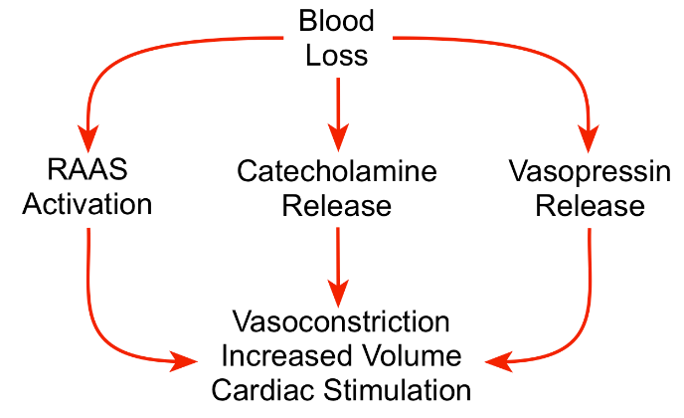

The combined effects of arterial hypotension and sympathetic activation lead to activation of humoral compensatory mechanisms. Sympathetic stimulation of the adrenal glands stimulates the release of [catecholamines](https://www.cvphysiology.com/Blood%20Pressure/BP018) into the blood, which reinforce the effects of sympathetic activation on the heart and vasculature. The kidneys release more renin following hemorrhage leading to increased circulating levels of [angiotensin II and aldosterone](https://www.cvphysiology.com/Blood%20Pressure/BP015). This causes vascular constriction, enhanced sympathetic activity, stimulation of [vasopressin](https://www.cvphysiology.com/Blood%20Pressure/BP016) release, activation of thirst mechanisms, and very importantly, increased renal reabsorption of sodium and water to increase [blood volume](https://www.cvphysiology.com/Blood%20Pressure/BP025). This renal mechanism is particularly important in the long-term recovery from blood loss.

Hypotension, combined with constriction of precapillary resistance vessels (small arteries and arterioles), causes a fall in capillary hydrostatic pressure. This pressure normally drives [filtration of fluid](https://www.cvphysiology.com/Microcirculation/M010) from the blood, across the capillary endothelium, and into the interstitial space. When capillary hydrostatic pressure is reduced, less fluid leaves the capillaries, and when the pressure falls sufficiently low as occurs following moderate-to-severe blood loss, net reabsorption of fluid can occur from the tissue interstitium back into the capillary plasma. Although this reabsorbed fluid does not contain cells, it does contain electrolytes and some protein, and therefore increases the plasma volume. This reabsorbed fluid leads to hemodilution of the blood; therefore, red cell hematocrit falls in response to this fluid shift. This mechanism can cause up to 1 liter/hour of fluid to be withdrawn from interstitial spaces back into the plasma.

**Decompensatory mechanisms.** If compensatory mechanisms are unable to sufficiently restore arterial pressure, irreversible shock can occur. Circulatory decompensation is defined as failure of neurohumoral compensatory mechanisms and resuscitation to maintain a critical level of arterial pressure sufficient to perfuse vital organs, which leads to irreversible shock and death. This is observed when prolonged shock leads to resuscitation failure even when blood volume is completely restored by blood transfusions. Many mechanisms contribute to decompensation, some of which are summarized below:

Cardiogenic shock

• Impaired coronary blood flow resulting from hypotension causes myocardial hypoxia and acidosis, which depress cardiac function and cause arrhythmias.

Sympathetic escape

• Accumulation of tissue metabolic vasodilator substances impairs sympathetic-mediated vasoconstriction, which leads to loss of vascular tone, progressive hypotension and organ hypoperfusion

• Loss of precapillary vascular tone increases capillary hydrostatic pressure and capillary fluid filtration, which reduces plasma volume

Cerebral ischemia/hypoxia

• Loss of sympathetic outflow from a hypoxic medulla leads to vasodilation, which further reduces arterial pressure and cerebral perfusion

Metabolic acidosis

• Acidosis depresses cardiac muscle and vascular smooth muscle contraction, which further decreases arterial pressure

Rheological factors

• Reduced microcirculatory flow causes blood viscosity within tissues to increase, which further reduces perfusion

• Plugging of the microcirculation by leukocytes and platelets, and intravascular coagulation reduce organ perfusion

Systemic inflammatory response

• Endotoxins released into systemic circulation from the ischemic gastrointestinal tract lead to cytokine production, and enhanced formation of nitric oxide and oxygen free radicals, which cause vasodilation, cardiac depression, and organ injury