 | 
ASTANA IT UNIVERSITY
Educational programme Software Engineering
Group SE-2409

MedPredict Diploma Project Report
Development of an Intelligent System for Predicting Medical Indicators Based on Neural Networks
24 October 2026

Prepared by
Sanat Bogenbayev Frontend and user experience
Ali Baimen Data analysis and machine learning
Oralkhan Seilkhan Backend and integration

Project supervisor
Marzhan Kabdykalievna Turarova
Astana 2026

Project Resources and Repository Links
The following links identify the project organisation, component repositories, design prototype and current tracker. The GitHub organisation is an entry point rather than a single source repository. The inspected local ONNX integration and current published repositories represent different versions; their status is documented in Sections 9–10 and Appendix C.
Project organisation
Documentation
Frontend source
Backend source
ML and AI repository
Figma design prototype
Jira MED board
The three interview links below open separate sections of the published research document. Jira use is permitted as confirmed by the team. README and editable-diagram improvements prepared for this revision remain local until published. The empty public ml-ai and older backend main do not reproduce the retained local ONNX integration.
Interview 1 third-year medical student
Interview 2 fourth-year medical student
Interview 3 trainee nurse

Abstract
MedPredict is an educational research prototype for reproducible neural-network comparison and transparent software integration of numerical medical indicators. This report addresses the eleven areas required for the 24 October 2026 diploma checkpoint: proposal, relevance, literature, related systems, technologies, requirements, architecture, prototype, evaluation, management and supervision.
The verified local implementation is M2, a current systolic blood-pressure estimator trained on NHANES and integrated through React, Spring Boot and ONNX Runtime Java. The corrected internal experiment retains 3,318 participants, including 497 test participants. The selected MLP has weighted MAE 11.225 mmHg versus 11.268 for Ridge. All 42 test observations at or above 150 mmHg are underestimated, and no reliable neural superiority or clinical suitability is established. The corrected v2 follows a previously viewed withdrawn test. M1 diabetes progression and M3 glucose forecasting remain independent proposed modules.
The report uses fourteen scientific publications, four related systems across eight criteria and three technology decisions with three alternatives each. It includes source-derived diagrams, genuine prototype screenshots, fresh software checks, three linked interview sections, seven participant-associated commits and a substantive peer comment. Team-reported review tasks are followed by completed documentary responses. Remaining evidence concerns interview corroboration, direct supervisor confirmation, broader peer review and a canonical submission version. The public backend and empty ml-ai repository do not reproduce the retained local ONNX implementation.
Keywords: medical indicator estimation; neural networks; NHANES; reproducibility; software verification; research prototype.

Contents
Project Resources and Repository Links 2
Abstract 3
Introduction 5
1 Project proposal 6
2 Evidence of relevance 8
3 Literature review 9
4 Comparison of existing systems 12
5 Technology selection and comparison 14
6 Requirements specification 16
7 System architecture 19
8 User experience and prototype 24
9 Verification and evaluation plan 37
10 Project management and risk analysis 41
11 Supervisor review points and team response 53
Conclusion 55
Appendix A Implementation and verification record 56
Appendix B Checkpoint compliance matrix 58
Appendix C Evidence access and unresolved items 59
References 61
Abbreviations: BMI body mass index; BP blood pressure; CGM continuous glucose monitoring; MAE mean absolute error; MLP multilayer perceptron; NHANES National Health and Nutrition Examination Survey; ONNX Open Neural Network Exchange; RMSE root mean squared error; SBP systolic blood pressure; UI user interface; UX user experience.

Introduction
MedPredict investigates whether neural networks can estimate or forecast clearly defined numerical medical indicators within a reproducible software system. The diploma topic is Development of an Intelligent System for Predicting Medical Indicators Based on Neural Networks. The project belongs to the Software Engineering programme at Astana IT University, group SE-2409, and combines data analysis, model evaluation, interface engineering and backend integration. Its purpose is educational research; it does not provide a diagnosis, a clinical measurement or a basis for changing treatment. [1]
At the 24 October 2026 checkpoint, the strongest available implementation evidence concerns M2, an experimental estimator of current systolic blood pressure trained on NHANES. Local source, aggregate experiment records, an ONNX artifact and archived Java integration records support this implementation. M1, one-year diabetes progression, and M3, future glucose forecasting, remain separate proposed modules. The fixed demonstration response of 134.2 mmHg is independent of the model and is excluded from experimental results. [2] [3]
The central research finding is qualified. The corrected M2 experiment achieves a weighted mean absolute error of 11.225 mmHg on 497 internal test participants. Ridge regression achieves 11.268 mmHg and performs better on weighted root mean squared error. All 42 participants with observed systolic pressure of at least 150 mmHg are underestimated by the MLP. These findings establish an engineering and research prototype, while preventing a claim of clinical reliability or neural-network superiority. [3]
The checkpoint requirements prescribe eleven areas of analysis and design, a literature review using at least twelve sources including eight scientific publications, comparison of three to five systems across six to ten criteria, and three technical decisions with two to three alternatives each. They also require genuine user evidence, traceable individual contributions, editable architecture diagrams and supervisor review. A completed application is not required at this checkpoint. This report addresses each area and distinguishes documentary completion from evidence that remains outstanding. [4]
Evidence was reviewed at four levels: the supplied planning and requirements documents; the actual local implementation and machine-readable records; the current GitHub, Jira and Figma interfaces; and external scientific or official technical sources. Conflicting older statements are retained as historical context rather than silently treated as current facts. In particular, the work plan's assertion that no model is connected is superseded for the local integrated M2 only. It remains relevant to the older published backend inspected on 24 October. [1] [5] [2]

1 Project proposal

1.1 Project identity and responsibilities
The project examines prediction as a complete engineering process: define a target, establish data provenance, compare models, preserve preprocessing during export, validate requests and responses, and present the result with its actual meaning and limitations. Predictive validity and software integration require separate evidence. [1] [2]
The project is developed at Astana IT University within Software Engineering, group SE-2409. Sanat Bogenbayev leads frontend and UI/UX; Ali Baimen leads data analysis and machine learning; Oralkhan Seilkhan leads backend and integration. The supplied supervisor is Marzhan Kabdykalievna Turarova. The immediate checkpoint is 24 October 2026. [1]
The English names above are working transliterations of the supplied names, not verified passport spellings. Responsibility assignments do not independently prove individual implementation contributions. Such contributions require identifiable artifacts and review records. [1]

1.2 Problem statement and target audience
Medical prediction tasks differ in target scale, observation time and intended use. One-year disease progression is an outcome after baseline; current systolic pressure is a cross-sectional measurement target; glucose forecasting predicts a later observation from a longitudinal history. Treating these as interchangeable outputs would invalidate both evaluation and user interpretation. MedPredict addresses the narrower engineering problem of keeping these definitions consistent from data preparation to the displayed result. [6] [7] [1]
The initial audience is students, researchers and participants in supervised demonstrations. Medical students and a trainee nurse are represented in the supplied interview records, but independently corroborated consent and participant confirmation were not available for review. Patients are therefore not treated as a validated deployment audience. Clinical decision support would require a different evidence base, governance process and validation programme. WHO guidance reinforces transparency and accountability; it does not certify this prototype. [8] [9]

1.3 Aim objectives and research questions
The aim is to design, implement and evaluate a reproducible research prototype that compares neural networks with suitable baselines for defined numerical medical indicators and preserves their semantics in an integrated web workflow.
The objectives are to establish the audience and research basis, specify testable requirements, document architecture and journeys, compare models without leakage, preserve preprocessing during integration, and verify software and numerical equivalence. Each objective requires a reviewable artifact, including negative results and limitations. [1]
RQ1 asks whether the selected neural network improves the prespecified regression metric over appropriate baselines under a shared protocol. RQ2 asks whether exported inference preserves reference outputs within an explicit numerical tolerance. RQ3 asks whether intended users distinguish a fixed example, a model estimate, an actual measurement and a future forecast. RQ4 asks which data and interface changes are needed before additional modules can be evaluated independently.

1.4 Scope and expected outcomes
M1 is a proposed one-year Diabetes progression regression on the dataset target scale. M2 is the locally implemented current-SBP estimator, supported by corrected experiment records, a model artifact and retained integration evidence. M3 remains conditional on longitudinal data, access rights, sampling and a defined forecast horizon. The separate 134.2 mmHg demo is fixed and is excluded from experimental results. [2] [3]
Expected outcomes are a reproducible experiment, baseline comparison, versioned bundle, checked HTTP boundary, accessible result flow, PDF export and evidence trail. A negative comparison remains reportable. [2] [3]
Diagnosis, medication advice, autonomous treatment, clinical certification, continuous learning from requests, electronic medical records and production patient-data collection are outside the bounded prototype. Authentication, persistent history and account deletion exist as disabled interface concepts, without completed backend workflows. The optional AI-assistant item in Jira concerns discussion of scope; it is not an approved chatbot feature or an implemented external AI integration. [2] [10]

2 Evidence of relevance

2.1 Public health and engineering relevance
The World Health Organization estimates that 1.4 billion adults aged 30–79 had hypertension in 2024, and that approximately 23% of adults with hypertension had it controlled. These global estimates establish the importance of blood-pressure assessment; they do not demonstrate demand for this application or validate estimating pressure from indirect tabular factors. Direct measurement remains distinct from the model's research task. [11]
For a software engineering diploma, relevance also comes from a reproducibility problem: a deployed prediction may change meaning when feature order, units, category encoding or preprocessing differ from training. MedPredict makes these boundaries explicit through metadata validation, a versioned artifact and output checks. The engineering value is assessable even when predictive results are modest. Reporting and risk-of-bias literature requires transparent target definitions, data handling, validation and applicability rather than a single favourable accuracy number. [12] [13] [2]

2.2 Supplied discussion records
The checkpoint requires three to five discussions with prospective users or a substantive agreement with a real customer. The documentation repository contains three attributed text interview records dated 21 October 2026, recorded by Ali Baimen: a third-year medical student, a fourth-year medical student and a trainee nurse. Their published sections and direct links were verified on 24 October. The report summarises roles without reproducing correspondence or health information. [4] [8]
Interview 1: third-year medical student transcript.
Interview 2: fourth-year medical student transcript.
Interview 3: trainee nurse transcript.
The records describe dispersed educational information, uncertainty about fasting status and units, and a need to display model version and limitations. These themes support a single clearly labelled input/result workflow, field-level validation and data minimisation. Respondents also distinguish an estimate from a cuff measurement. Such concept responses do not establish clinical usefulness or safe use. [8]
The source states that permission was for a transcript and that no recording was made. Original correspondence, separate consent evidence and participant confirmation of the final transcript were not inspected. Older project documents also describe interviews as pending. Accordingly, three supplied records are acknowledged, but full compliance with the authenticity and consent requirement remains to be confirmed. AI-generated profiles and synthetic interview material elsewhere in the repository are not counted as user evidence. [8] [14]

2.3 What the evidence supports
These records support provisional interface requirements, without establishing clinical outcomes or safe use. Follow-up evaluation should use synthetic tasks and participant-approved summaries, recording first interpretations and linking each requirement change to its source.

3 Literature review

3.1 Review method and analytical scope
This is a focused critical review, not a systematic review or meta-analysis. Sources were selected for direct relevance to tabular regression, physiological forecasting, evaluation validity, reporting and model integration. Primary publisher pages, conference proceedings, official dataset documentation and institutional resources were used to verify source identity. Papers about classification of diabetes are not treated as evidence for numerical one-year progression; studies using ECG or PPG are not transferred to a five-field tabular SBP estimator.
The scientific review contains fourteen publications: twelve from 2021–2026, including ten from 2022–2026, and two retained foundational works. The review therefore exceeds the required eight scientific publications and uses a majority from the five-year period ending 24 October 2026. Dataset, product and framework documentation are additional sources and are not counted as scientific publications. Table 1 identifies each paper's contribution and limitation; Sections 3.2–3.5 connect them to the project decisions. [4]
Table 1. Structured analytical review of fourteen scientific publications
Publication | Task or contribution | Critical implication for MedPredict
Efron et al. 2004 [15] | Numerical Diabetes progression; LARS and regularised regression. | Foundational M1 target and baseline; small cohort does not establish diagnosis or transportability.
Grinsztajn et al. 2022 [16] | Tree and neural models on 45 tabular benchmarks. | Retain strong tree baselines; benchmark rankings do not predetermine the NHANES result.
Hollmann et al. 2025 [17] | Tabular foundation-model learning including regression. | New neural progress qualifies older generalisations; not implemented or clinically validated here.
Hrytsenko et al. 2024 [18] | Continuous blood-pressure phenotypes with clinical and genetic predictors. | Useful nonlinear comparison; different population and richer inputs prevent importing accuracy.
Najafi-Vosough et al. 2023 [19] | Longitudinal pressure modelling in heart-failure hospitalisations. | Distinguishes repeated follow-up from M2; patient separation is unclear in the reported random split.
Sun et al. 2026 [20] | Sequence glucose forecasting with teacher–student distillation. | Define horizon and inference-available inputs; paper results are not M3 implementation evidence.
Robles Arévalo et al. 2021 [21] | Curation of ICU glucose and insulin events. | Timing, source and alignment matter; sparse ICU observations are not automatically dense CGM.
Clarke et al. 1987 [22] | Consequence-aware glucose error grid. | Foundational complement to numerical error; monitoring framework alone does not certify forecasting.
Collins et al. 2024 [12] | TRIPOD+AI reporting guidance. | Report data, target, modelling and evaluation transparently; completeness is not a validity certificate.
Moons et al. 2025 [13] | Quality, risk-of-bias and applicability assessment. | Appraise participants, predictors, outcome and analysis; no completed formal audit claimed.
Efthimiou et al. 2024 [23] | Step-by-step development of clinical prediction models. | Define intended task and simple alternatives first; guides M1/M2 development choices.
Riley et al. 2024 [24] | External validation of a fixed prediction model. | Independent setting, calibration and uncertainty differ from an internal split and parity test.
Kapoor and Narayanan 2023 [25] | Leakage mechanisms in machine-learning science. | Protect preprocessing, sampling and selection boundaries; does not prove this project leaks.
Finlayson et al. 2021 [26] | Clinical AI under dataset shift. | Population and context changes constrain transfer; no Kazakhstan validation follows from runtime equality.

3.2 Numerical progression and tabular modelling
The Diabetes example accompanying least angle regression contains a numerical disease-progression outcome one year after baseline. Its small cohort and standardised variables make it appropriate for a bounded reproducibility exercise, while limiting clinical interpretation and the amount of capacity justified for a neural model. M1 should compare a mean predictor, regularised regression and a compact MLP on a frozen partition. The target must retain the dataset's scale; it is neither glucose in mmol/L nor a probability of developing diabetes. [15] [6]
Tabular benchmarks challenge the assumption that a neural network is automatically preferable. Grinsztajn and colleagues show the strength of tree-based methods on common tabular settings. Hollmann and colleagues provide newer evidence for a foundation-model approach on small tabular datasets. Together these results justify testing a neural hypothesis while retaining strong, inexpensive baselines. They do not identify the winning method on NHANES without a project experiment. [16] [17]
M2 reflects this principle: its MLP and Ridge errors are very similar, and different metrics favour different methods. Model selection must therefore follow the registered validation rule, with the complete test comparison retained. It would be misleading to use the diploma's reference to neural networks as a reason to suppress a competitive linear baseline. [3]

3.3 Cross sectional pressure and temporal glucose
NHANES provides examination and laboratory measurements together with survey design information. It can support a cross-sectional regression target derived from the same examination. It cannot by itself establish future blood-pressure forecasting. The current M2 predictors do not include physiological waveforms, repeated home measurements or a patient's full medication and clinical context. Publications using richer predictors consequently inform limitations rather than establish expected accuracy for this application. [7] [18]
Glucose forecasting requires temporally ordered data, an observation window, a defined horizon, valid units and a treatment of missingness. Sun and colleagues study sequence forecasts, while Robles Arévalo and colleagues describe the difficulty of aligning ICU glucose and insulin records. Repeated glucose observations are a different input type from a one-time fasting laboratory value. Longitudinal modelling must separate subjects and prevent overlapping windows from crossing evaluation boundaries. M3 cannot be created by relabelling M2's single glucose input. [20] [21] [25]
The development gate for M3 is therefore evidence of a suitable dataset and permitted access, followed by a persistence baseline and an appropriate sequence model. A sophisticated architecture is premature until the dataset, horizon and partition are fixed. Results from a forecasting publication cannot substitute for a MedPredict experiment on its own approved data.

3.4 Validation reporting and applicability
Kapoor and Narayanan describe leakage as a threat to machine-learning-based science. In MedPredict this translates into participant-level partitions, training-only preprocessing, a frozen validation rule and strict separation of model development from final assessment. The documented XPT-reader correction also shows that a reproducible code path can contain a data-decoding error; provenance and independent reader checks are part of validity. [25] [3]
TRIPOD+AI provides a reporting framework for prediction-model studies, while PROBAST+AI addresses quality, bias and applicability. Efthimiou and colleagues connect intended use with development choices; Riley and colleagues explain independent external evaluation. These works support disclosure of setting, target, missingness, model selection, error distribution and intended use. MedPredict has not completed a formal checklist assessment or prospective clinical evaluation; the frameworks guide its future evidence collection. [12] [13] [23] [24]
Dataset shift further constrains interpretation. A model learned from U.S. survey participants is not automatically valid for Kazakhstan. Feature sensitivity describes the fitted model, not causal physiological effects, and does not repair poor performance in an important subgroup. The project should report errors across prespecified groups and seek independent evaluation before any broader applicability claim. [26] [24] [3]

3.5 Research gap and resulting design
The research gap is a transparent educational experiment that preserves each target's meaning through evaluation and integration. The contribution is a reviewable method and baseline comparison, without claiming market uniqueness or clinical superiority.
Next steps are a frozen M1 benchmark, independent M2 evaluation without tuning on the viewed test, and M3 data feasibility. Shared obligations are versioned metadata, reproducible preprocessing, runtime equivalence and clear output semantics. Negative results and justified deferral remain reportable.

4 Comparison of existing systems

4.1 Selection and common criteria
Four related systems were selected because they expose different relationships between medical inputs, calculated outputs and user action: AHA PREVENT, ESC HeartScore, OMRON connect and Tandem Control-IQ. They are not interchangeable clinical competitors. The comparison uses eight common criteria, retained with the same numbers across Tables 2 and 3. Official product and professional documentation support capability descriptions; no comparative usability, security, accuracy or latency experiment was performed.
Table 2. Related cardiovascular systems across eight criteria
Criterion | AHA PREVENT | ESC HeartScore
1 Purpose and users | Primary-prevention risk discussion between clinicians and patients | Clinical cardiovascular risk reduction
2 Inputs | Cardiovascular, kidney and metabolic factors; optional UACR, HbA1c and social deprivation index | Risk factors used by SCORE2 and SCORE2-OP; complete interactive form not audited
3 Output and time | Ten- and thirty-year cardiovascular risk under applicable equation and age rules | Ten-year fatal and non-fatal cardiovascular event risk
4 Method evidence | Published equations; licensed source access documented | SCORE2 and SCORE2-OP publications identified by ESC
5 Interface and access | Official online clinician calculator; embedded workflow not fully inspected | English web version for four risk regions; no login required
6 History and privacy | Retention and account history not established in this review | Data-storage Full Version ended in April 2022; current logging not audited
7 Export and integration | Licensed source access; public API or export not established | Public API and export not established
8 Relation to MedPredict | U.S.-derived future event risk; not an estimate of current SBP | European regional future event risk; not a current-SBP estimator

Sources for Table 2 are the AHA PREVENT overview and the ESC HeartScore overview, current access page and qualifiers. An unverified capability is recorded as not established rather than assumed absent. The comparison does not apply clinical treatment thresholds or infer local validation from a region selector. [27] [28] [29] [30]
Table 3. Measurement and automated-treatment systems across the same eight criteria
Criterion | OMRON connect EMEA | Tandem Control-IQ
1 Purpose and users | Personal measurement tracking and presentation | CGM-informed automated insulin delivery
2 Inputs | Compatible-device BP, pulse, weight and body-fat observations; activity-app data | Continuous glucose measurements and active personal-profile settings
3 Output and time | Recorded history and daily, weekly or monthly averages | Thirty-minute glucose prediction used to adjust insulin delivery
4 Method evidence | Dashboard and trends; a forecast algorithm not established | Manufacturer explains increase, maintain, reduce and stop actions; full algorithm not audited
5 Interface and access | Smartphone app and compatible devices; free and premium features | Compatible pump and CGM system under manufacturer instructions
6 History and privacy | Registration for storing and viewing health data, including phone storage | Retention and privacy implementation not assessed
7 Export and integration | PDF and CSV reports; named health-app connections | CGM–pump integration documented; third-party API and export not assessed
8 Relation to MedPredict | Presents measurements; app does not provide an individual diagnosis | Hardware treatment-control system beyond MedPredict's research-only scope

Sources for Table 3 are the official regional OMRON page and the manufacturer article describing the named Control-IQ technology. The latter is not a statement about every indication or feature of later Control-IQ+ products. [31] [32]

4.2 Implications for the project
The comparison supports displaying the predicted variable, units and time meaning explicitly. A cardiovascular event probability, a measured blood pressure, an estimated current SBP and a future glucose value answer different questions. Consequently, MedPredict's MAE in mmHg cannot be ranked against a cardiovascular risk percentage or insulin-treatment outcome.
OMRON's reporting workflow is relevant to export design, but it does not justify adding persistent storage to MedPredict. Control-IQ demonstrates that forecast-informed treatment requires a specialised, safety-critical system; its existence is not a rationale for adding treatment recommendations to a student prototype. The bounded opportunity is a reproducible educational workflow with clear limitations, not replacement of established measurement or clinical tools.
Prepared Kazakhstan and international analyses support Done for MED-54 in this report. Jira remains To Do; team approval is unverified. [14] [10]

5 Technology selection and comparison

5.1 Decision method
The following comparisons cover three major decisions, each with three alternatives. Selection is assessed against current implementation, integration cost, validation needs and operational complexity. Framework capabilities come from official documentation; statements about project fit are engineering judgements. Alternatives were not implemented or benchmarked against one another. Installed local versions are recorded in Appendix A to separate the evaluated environment from dependency ranges. [2]

5.2 Frontend decision
Table 4. Frontend alternatives
Criterion | React with TypeScript and Vite | Vue 3 | Angular
UI model | Function components, JSX and state-driven events | Declarative components and reactivity; single-file components | Components with integrated routing, forms and dependency injection
Existing project fit | Current pages, hook, adapters and tests retained | Port interface, state and tests | Rework interface, state and tests around Angular APIs
External contract | Runtime JSON checks complement TypeScript | Same HTTP contract could be retained | Same HTTP contract could be retained
Main cost or risk | Continue maintaining the existing form and result flow | Rewrite without a measured project benefit | Rewrite without a measured project benefit
Decision status | Implemented selection | Documented alternative | Documented alternative

React is retained because the repository already contains the required interface and checks. This minimises integration change; it does not establish an intrinsic performance or safety advantage over the alternatives. Accessible labels, focus, error association and request cancellation remain application responsibilities in every framework. [33] [34] [35]

5.3 Backend decision
Table 5. Backend alternatives
Criterion | Spring Boot and Java | FastAPI and Python | ASP.NET Core and C#
HTTP capability | Annotated controllers and JSON responses | Declared endpoints with OpenAPI and schema support | Controller-based and minimal HTTP APIs
Validation | Bean Validation and application checks | Pydantic-backed declared-data validation | Endpoint-specific validation must be configured and checked
Model route | Existing local Java ONNX provider | Native Python inference is possible | Requires a .NET inference design
Project fit | Preserves current backend contract and ownership | Changes serving architecture while aligning with training language | Introduces another implementation language and runtime
Decision status | Implemented backend choice; integrated local variant verified | Documented alternative | Documented alternative

Spring Boot is retained to preserve the existing service and its validation behaviour. Python remains the experiment environment. Public backend main and the local ONNX integration are different inspected versions; selection of Spring Boot does not imply that the integrated version is published. [36] [37] [38] [5] [2]

5.4 Inference integration decision
Table 6. Inference integration alternatives
Criterion | ONNX Runtime in Java | Python inference service | PMML with JPMML
Representation | ONNX graph executed through JVM binding | Python model exposed by a stable HTTP contract | Compatible PMML model and transformations
Deployment | Java backend and native runtime; no Python serving process | Additional process and service failure boundary | JVM evaluator and compatible exporter
Compatibility | Operator and export support must be verified | Retains Python-specific model behaviour | Exporter and transformation coverage must be verified
Required checks | Feature order, shapes, embedded preprocessing, SHA and reference parity | API, reference parity, failures, timeouts and model provenance | Missing values, categories, transformations and reference parity
Material limit | Format does not itself guarantee safe or correct artifacts | Dependency management and unsafe loading risks for pickle-based artifacts | Compatibility and licensing review required
Decision status | Implemented locally for M2 | Contingency alternative | Contingency alternative

The existing M2 graph embeds feature scaling and inverse target transformation, and reference checks support its Java execution. ONNX is retained while this compatibility holds. A Python service is a reasonable fallback for a future model that cannot be exported faithfully; PMML is another candidate subject to compatible transformations and licensing. None is added merely for flexibility. Numerical equivalence establishes technical fidelity, not clinical quality. [39] [40] [41] [3]
Section 9 evaluates the model and dataset choices. Persistent storage is excluded by the current scope and FR-11; user submissions do not feed training. [3] [2]

6 Requirements specification

6.1 Roles priorities and assumptions
The demonstrator is the primary application actor. The model researcher prepares and evaluates artifacts offline; the backend developer maintains the serving boundary; the reviewer examines evidence and limitations. These are responsibilities, not implemented authenticated access roles. No administrator or clinician permission system is claimed. Must denotes an obligation for the stated stage, Should denotes a useful prototype capability, and Later denotes work outside the bounded implementation.
The tables preserve FR-01–FR-13 and NFR-01–NFR-09 from the project specification. Implemented means supported in the local snapshot; it does not mean clinically accepted, deployed or uniformly present in all remote repositories. Acceptance criteria describe observable behaviour, and Section 9 identifies executed checks separately from planned verification. [42]

6.2 Functional requirements
Table 7. Functional requirements and acceptance criteria
ID and requirement | Priority and state | Observable acceptance criterion
FR-01 Purpose and mode | Must; implemented | Landing, form and result identify research use; fixed demo and trained estimate are distinguishable
FR-02 Metadata-driven form | Must; implemented for M2 | Submission remains unavailable until valid metadata arrives; fields, order, units and domain follow metadata
FR-03 Input validation | Must; implemented | Client and server reject missing, non-finite, wrongly typed and invalid-category values; client errors are linked to fields
FR-04 Explicit checked request | Must; implemented | One POST follows one submit; duplicate submission is blocked; invalid JSON, units or semantics never become a result
FR-05 Cancellation and freshness | Must; implemented | Cancel, edit or navigation invalidates the active result and ignores a late response; a new request needs user action
FR-06 Recoverable errors | Must; implemented | Field errors focus the first invalid field; network, timeout and service failures preserve input; no real-to-demo fallback
FR-07 Contextual result | Must; implemented | Show checked value, unit, response version, input snapshot and limitations; editing hides the old result
FR-08 Local PDF | Should; implemented | Export the existing response and input snapshot with units, mode and disclaimer; no repeated POST
FR-09 Languages and navigation | Should; implemented | RU, KK and EN application text is available; in-session navigation retains input; reload clears it
FR-10 Real model path | Must for M2; local implementation | Validate bundle schema, SHA, feature encoding and shapes; serve true ONNX output or explicit failure; parity within 0.01 mmHg
FR-11 Account and history boundary | Later; disabled | Disabled controls cannot simulate successful login or saving; enable only after access, storage and deletion requirements
FR-12 Module selection | Must for multi-module stage; planned | Agreed module selection changes schema and units, clears stale state and blocks unavailable modules
FR-13 Availability and limits | Multi-module stage planned; M2 readiness present locally | Distinguish planned, unavailable and ready states; current M2 readiness must not imply readiness of M1 or M3

FR-02–FR-07 form the core request lifecycle. FR-10 adds a separate technical condition: using HTTP real mode alone does not prove a trained provider is ready. A backend in explicit demo profile still returns a demo, while the default unavailable provider returns an error. The current single-model contract does not contain an implemented general module catalogue. [2]

6.3 Non functional requirements
Table 8. Quality requirements and verification conditions
ID and requirement | Priority and state | Acceptance condition
NFR-01 Data minimisation | Must; implemented locally, hosting audit open | No indicators in web storage, URL, analytics or application payload logs; PDF only by explicit export
NFR-02 Trust boundaries | Must; implemented | Validate external JSON and units; independently validate server input; reject incompatible artifacts and non-finite output
NFR-03 Accessibility | Must; partially verified | Keyboard access, visible focus, labels, associated errors and announced state; record manual screen-reader and contrast review separately
NFR-04 Responsive layout | Should; existing checks and captures | Main flow remains readable without horizontal overflow at agreed desktop and narrow viewports in all three languages
NFR-05 Bounded waiting | Must; implemented | Default HTTP timeout 15,000 ms; distinguish cancel and timeout; no hidden POST retry or demo fallback
NFR-06 Reproducibility | Must for each experiment; M2 artifacts available | Preserve source hashes, split, training-only transforms, seeds, candidates, selection, corrections and test limitations
NFR-07 Honest medical meaning | Must; continuing obligation | No diagnosis, treatment advice or accuracy percentage; preserve current-estimate meaning and major error limitations
NFR-08 Operational security | Must before production; local controls present | CORS allowlist, safe errors and no-store; separately accept TLS, hosting, access and log policy; no secrets in client variables
NFR-09 Measured response time | Must before performance claims; planned | Record at least 30 successful warm requests, all attempts and failures, p50/p95 and separate cold timing against an agreed budget

The 0.01 mmHg conversion tolerance is technical, the 15-second timeout is a waiting limit, and screenshots are partial interface evidence; none establishes clinical quality, an SLA or full accessibility. [42] [2]

6.4 Data and interface requirements
Table 9. Current local M2 feature and artifact contract
Element | Verified definition
Feature order | age, sex, bmi, totalCholesterol, glucose
Age and sex | Age in years, integer 18–79; male encoded 0 and female 1 according to model metadata
BMI | kg/m²; artifact domain 15.4–74.8
Total cholesterol | mmol/L; artifact domain 1.97–11.53
Glucose | Fasting plasma glucose in mmol/L; artifact domain 2.94–25.0
Target | Mean of at least two valid same-examination oscillometric SBP readings, mmHg
ONNX input and output | features float32[batch,5]; predictedValue float32[batch,1]
Response semantics | estimated_current_measurement; trained M2 demo=false; fixed example explicitly marked demo

The numerical bounds in Table 9 are artifact-specific training-support limits, not medical reference ranges. They must come from the configured server metadata rather than a second frontend definition. The five features must not be reused as an assumed M1 or M3 schema. Patient identifiers, names and contact details are unnecessary for the current request. [2] [43]

6.5 Use cases and traceability
UC-A covers purpose and language (FR-01/09); UC-B entry and correction (FR-02/03/06); UC-C checked estimation (FR-04/07/10); UC-D cancellation or revision (FR-05/06); and UC-E export (FR-08). Future UC-F depends on FR-12/13. T01–T08 provide verification. Results retain their submitted snapshot; cancellation does not guarantee server termination, and export creates a local copy. [42] [2]

7 System architecture

7.1 Architectural boundary
The current local vertical path is React → HTTP → Spring Boot → ONNX Runtime Java → checked response → result and optional local PDF. Training runs offline in Python. The explicit demo path returns a fixed example and does not invoke the model. No database, authentication service, continuous-learning service or external commercial AI API is part of this implemented path. [2]
Figures 1–4 document the inspected local M2 integration. Dashed components denote planned modules; the UML include dependency denotes mandatory validation. Editable-source access is recorded in Appendix C.

7.2 System context
The demonstrator submits metadata-defined indicators; offline research supplies a versioned bundle. Requests do not feed training, and exported PDFs do not constitute server-side history. Figure 1 shows these boundaries.
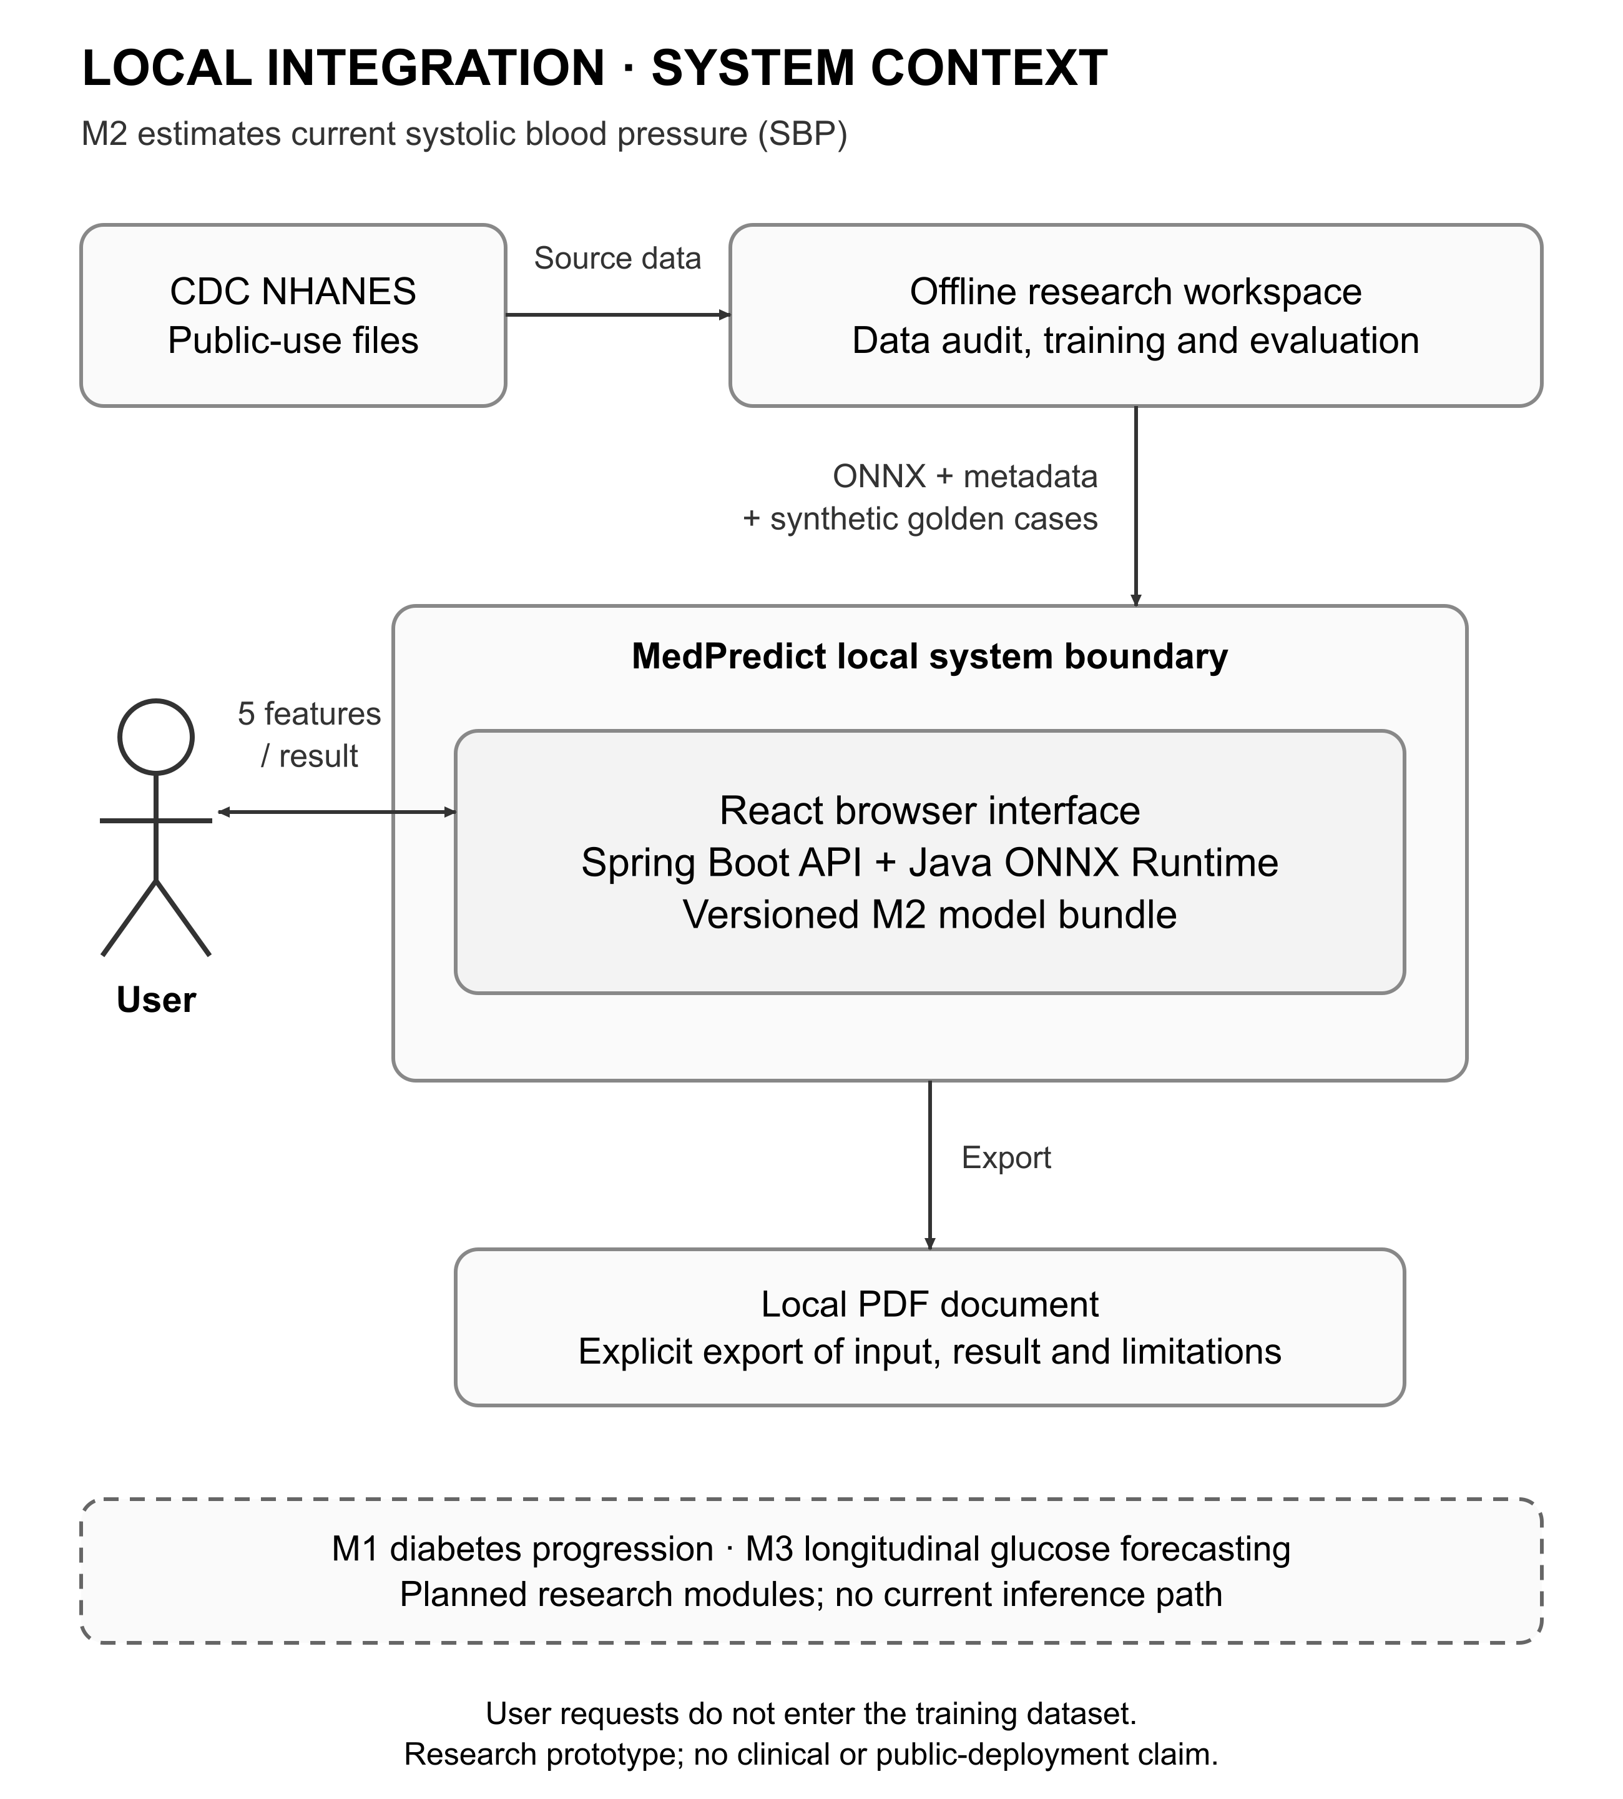
Figure 1. System context of the verified local M2 integration and planned modules. Derived from source and metadata inspected on 24 October 2026. [2]

7.3 Use case model
The use-case boundary distinguishes actions available to the demonstrator from the future module catalogue. Validation is included in the request scenario. Error correction and cancellation remain normal user journeys, not exceptional implementation details. Account, login and persistent-history concepts do not appear as completed capabilities.
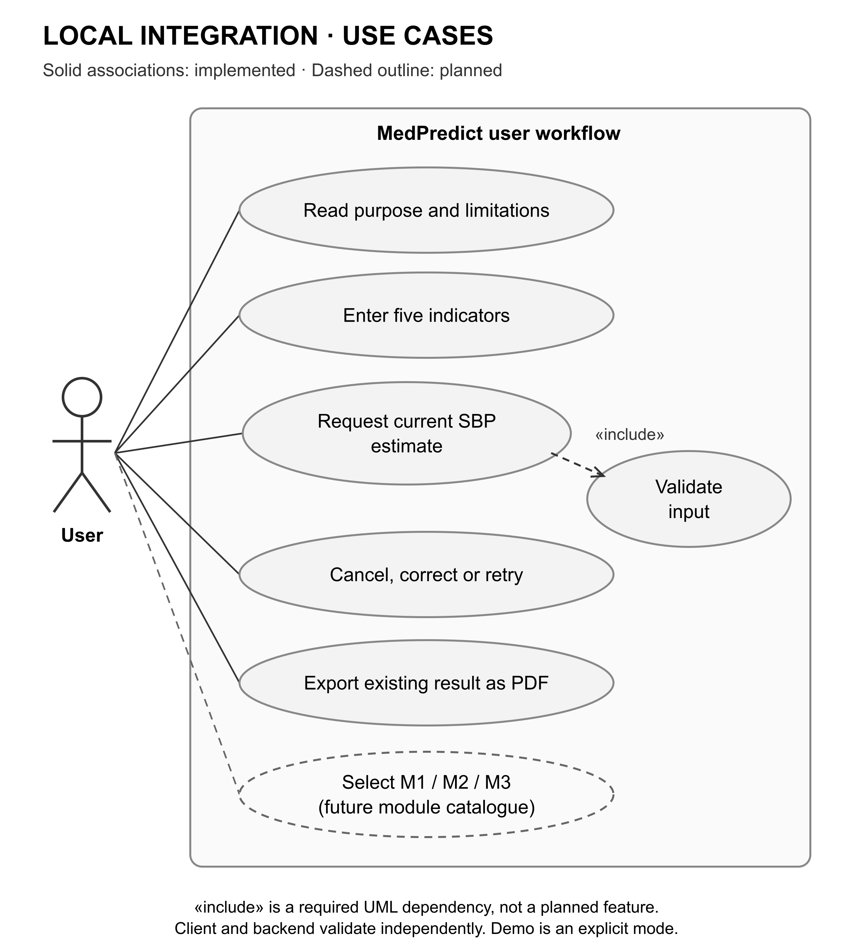
Figure 2. Use-case model for the local research prototype. Solid user capabilities are implemented; module selection is planned. [42] [2]

7.4 Component responsibilities
The React pages and shared fields delegate scenario state to usePrediction. The hook holds the input snapshot, request identity and cancellation logic. The HTTP adapter owns transport concerns; contract parsers reject malformed metadata and responses; the result component displays only an accepted response. PDF generation uses the existing result and does not make another prediction request. [2]
On the server, controllers delegate to a service boundary that validates metadata, input and result semantics. The ONNX provider loads a compatible artifact and runtime session. Model metadata and schema checks establish ordered features, units, category encoding and tensor names and shapes. SHA-256 protects consistency between declared and loaded bytes, while provenance and review remain separate obligations. A checksum alone does not establish that a model is trustworthy. [2] [40]
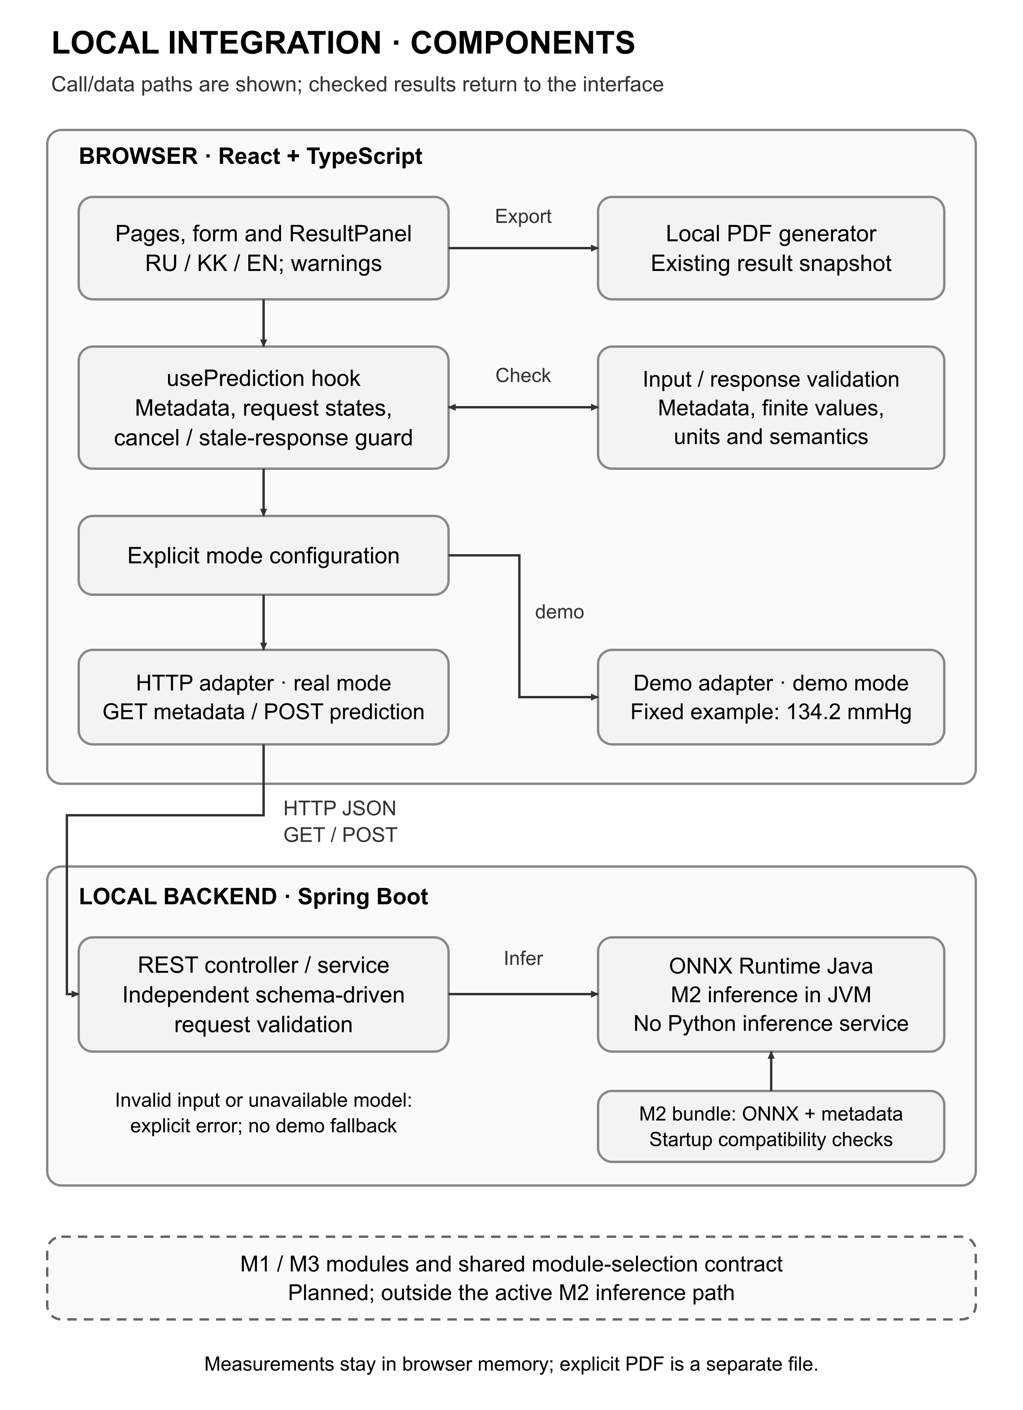
Figure 3. Component architecture of the local M2 integration. The fixed demo branch is separate from Java ONNX inference; M1 and M3 remain planned. [2]

7.5 Request and failure sequence
At startup, the ONNX profile attempts to load the model bundle and verifies its schema, checksum, version and tensor contract. An unavailable bundle yields an explicit unavailable state. The client first obtains model metadata; failure prevents form submission and exposes an explicit retry. After valid input, one POST creates an immutable result snapshot. The server independently validates types and domain, orders five float32 features and executes the graph. The client checks the returned unit, finite value and optional semantics before display. [2]
Default backend configuration without a provider returns MODEL_UNAVAILABLE. The explicit demo profile returns the fixed example. The local ONNX profile returns trained inference only when ready. Invalid artifacts, invalid outputs and failed real requests never fall back to the demo. Process liveness is distinct from model readiness and both are distinct from clinical validity.
Cancel, edit and navigation invalidate the active request and hide its result. Late responses are ignored, preventing a plausible old value from being paired with new input. [2]

7.6 Offline learning and deployment model
The research pipeline joins official NHANES tables by participant identifier, validates the cohort and units, freezes participant partitions and fits transformations only on training data. Candidate selection uses validation weighted MAE. The selected model and preprocessing are exported together; fixed reference vectors check export and runtime equivalence. Deployment never retrains weights on a request. [3]
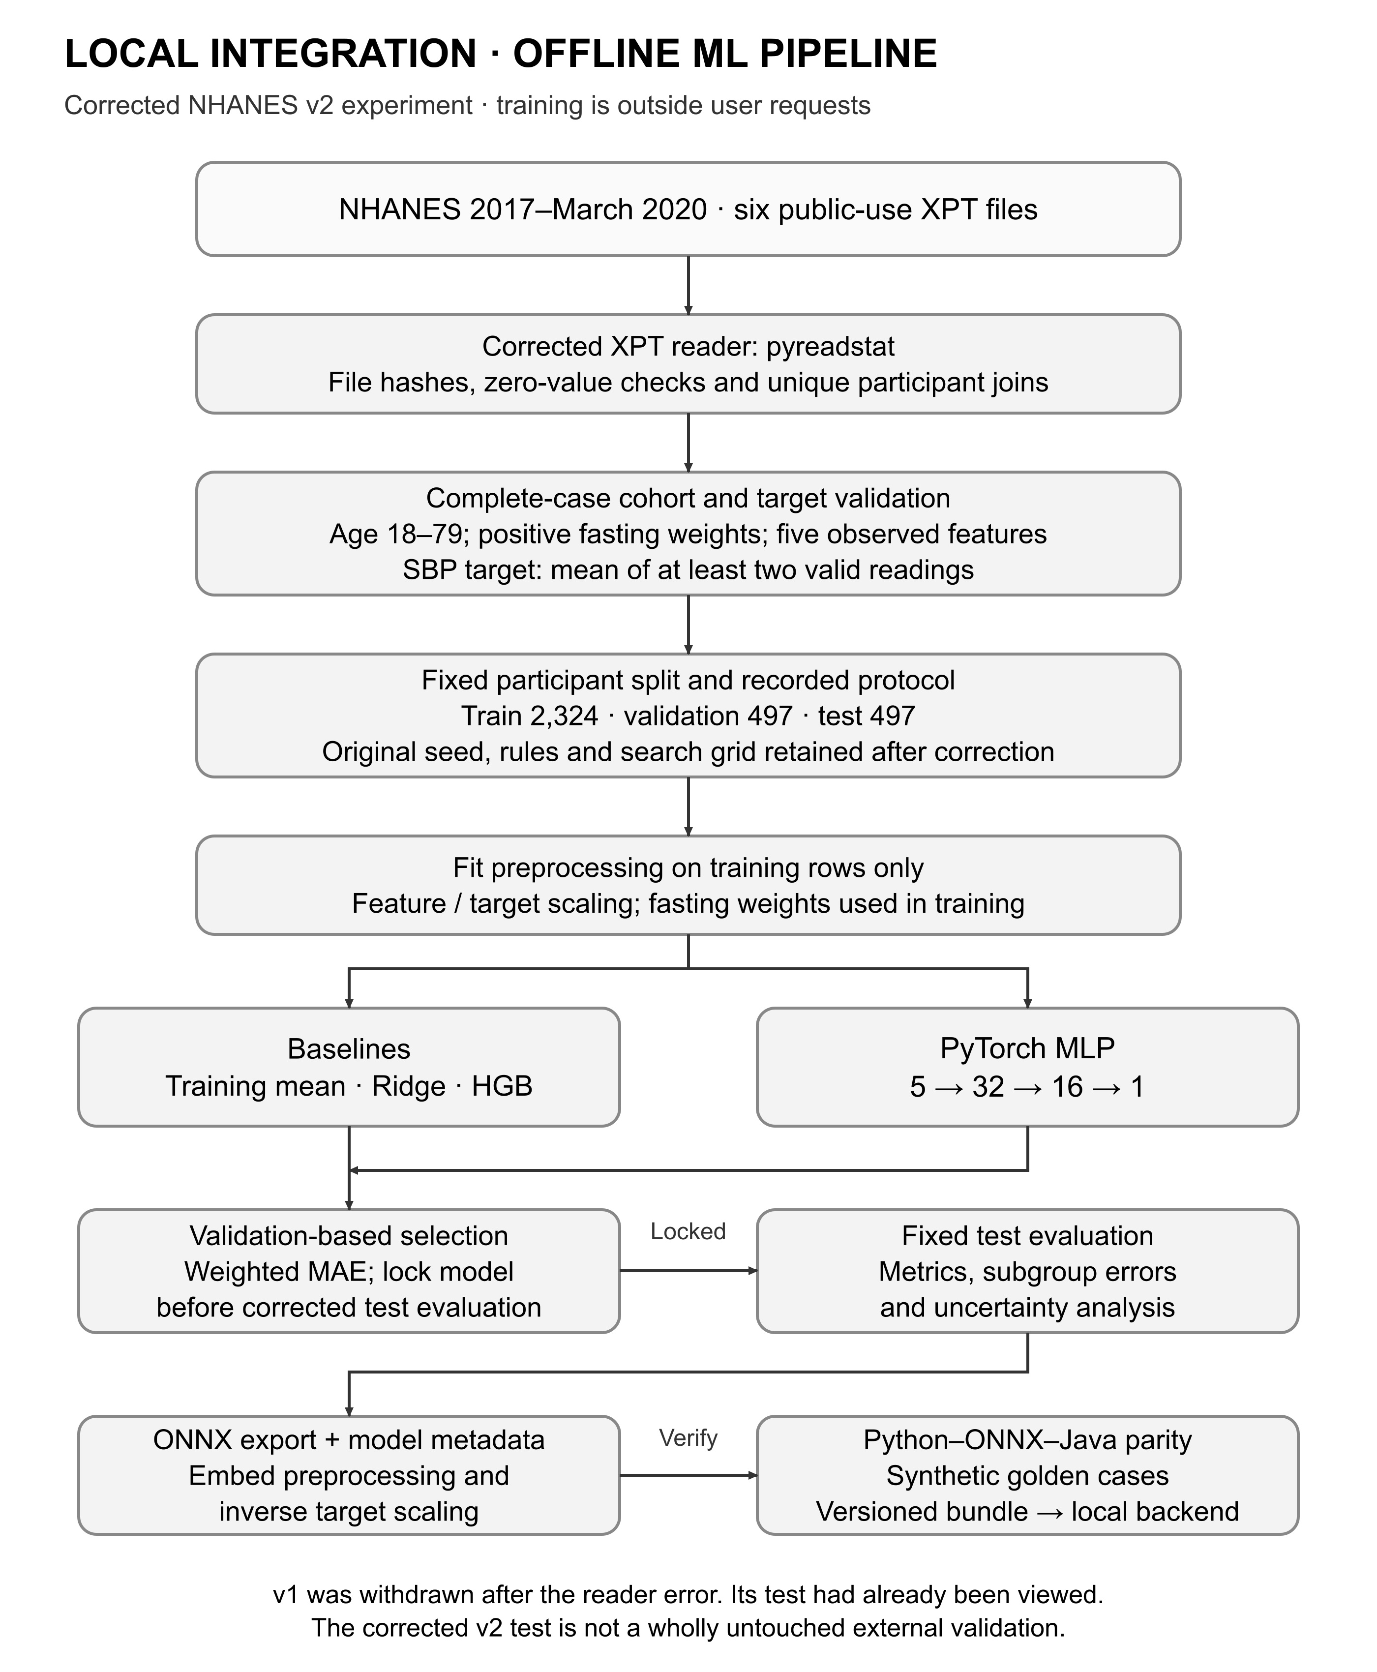
Figure 4. Offline M2 research and export pipeline. The corrected v2 evaluation is internal and follows a previously viewed withdrawn test. [3]

8 User experience and prototype

8.1 Design overview and implementation boundary
The Figma file defines the intended visual system and screen families. Figure 5 shows the overall design; the focused exports that follow preserve the original frame resolution so individual controls can be read. These are design prototypes, not evidence that every illustrated service exists. The local application evidence in Section 8.4 is separate. [44]
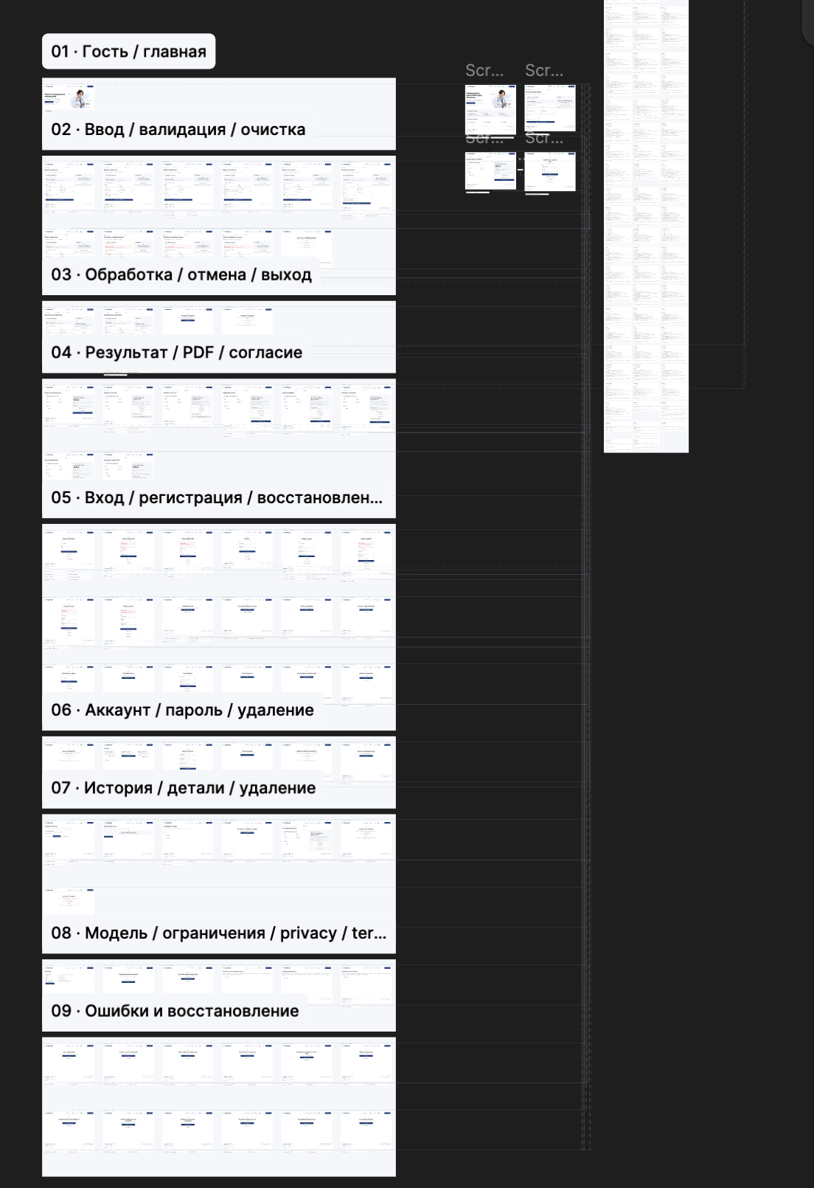
Figure 5. Supplied Figma scenario overview with nine numbered groups covering the main interaction flows. This canvas view establishes scope; focused frames provide readable interface detail. [44]
The component library in Figure 6 brings together the palette, shared header and footer, button variants and field states. The canvas labels document the design system; they do not establish independent approval or measured accessibility compliance. [44]
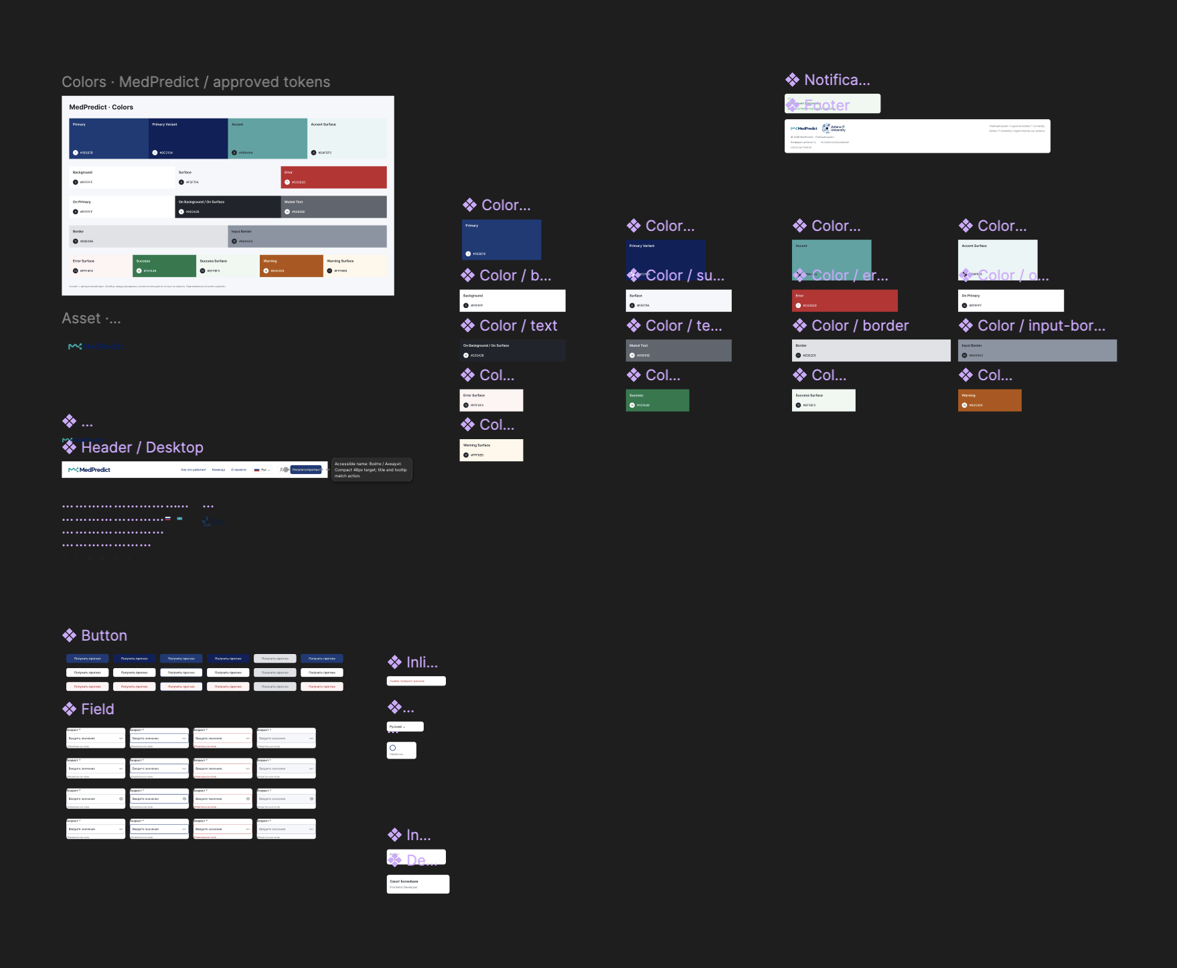
Figure 6. Supplied Figma component library showing color tokens, shared navigation, button variants and input states. These are prototype assets. [44]

8.2 Focused design screens
The guest landing in Figure 7 establishes navigation, purpose and entry into the demo. The input and processing frames in Figures 8 and 9 show error correction and controlled waiting. All three are Figma design states. [44]

Figure 7. Figma guest landing hero and navigation. The prototype introduces the research purpose and fixed-demo entry point; it is not a deployed application capture. [44]
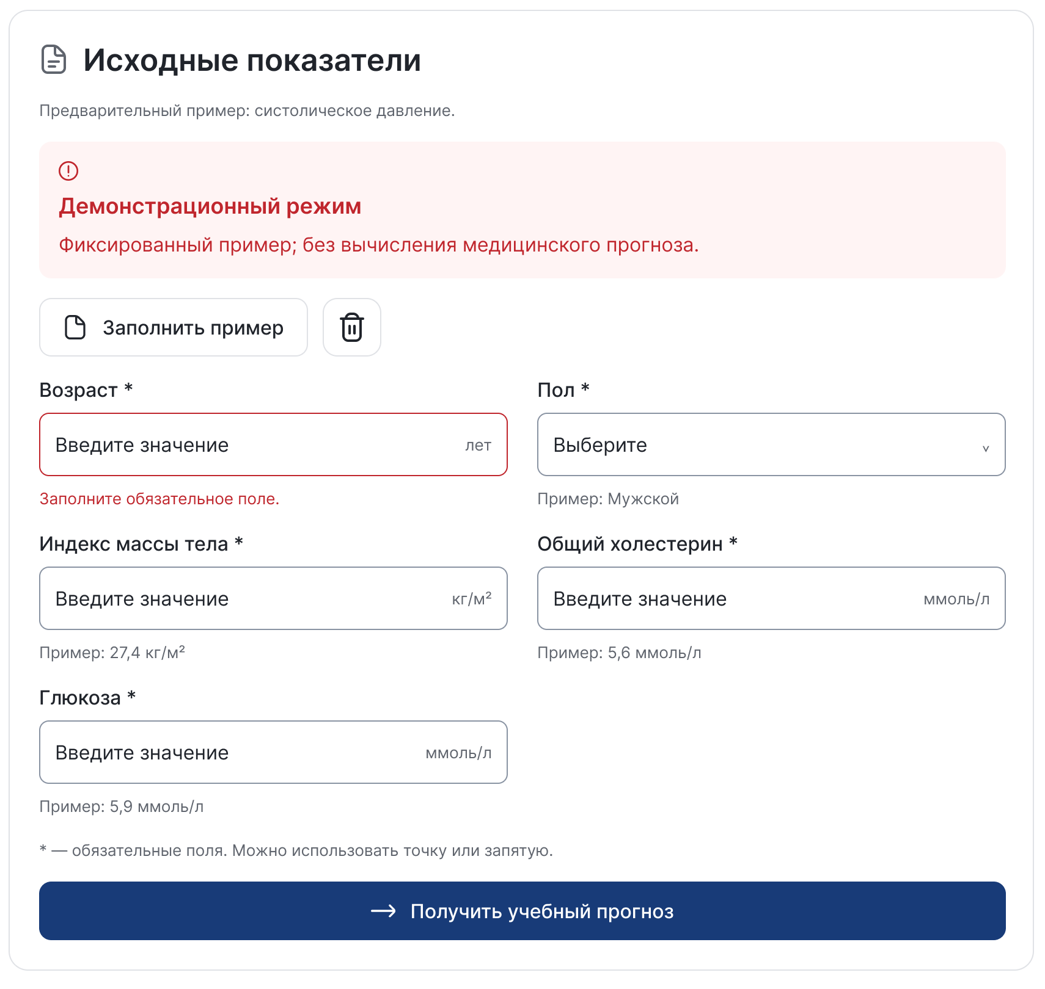
Figure 8. Figma input and validation design. The focused form shows units, a required-field error and submission controls for the proposed entry journey. [44]
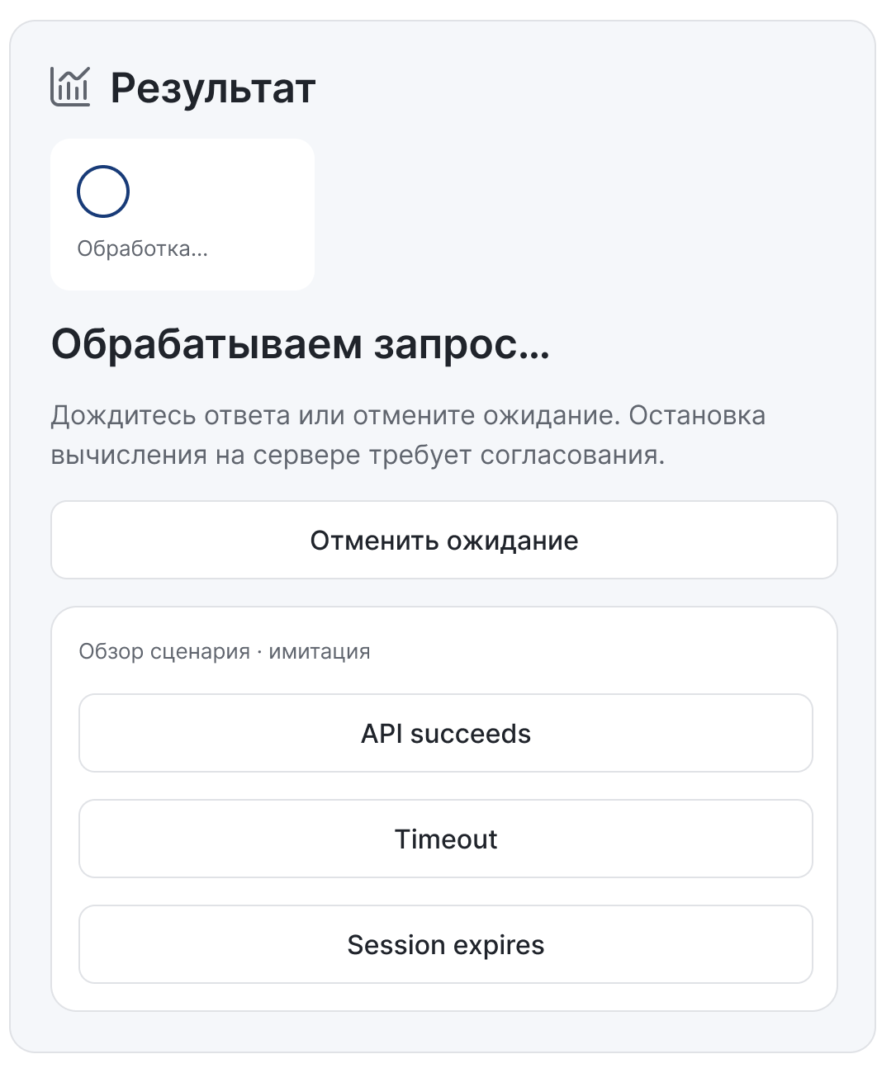
Figure 9. Figma processing and cancellation design. Simulated API-outcome controls belong to the prototype and do not prove a running inference service. [44]
The result design in Figure 10 uses a literal API-value placeholder, with output context and export controls. The sign-in design in Figure 11 illustrates the extended access journey; authentication is unavailable in the implemented server scope. [44] [2]

Figure 10. Figma result, PDF and consent design. The displayed API-value placeholder is not an actual prediction; history-consent controls remain a design concept. [44]
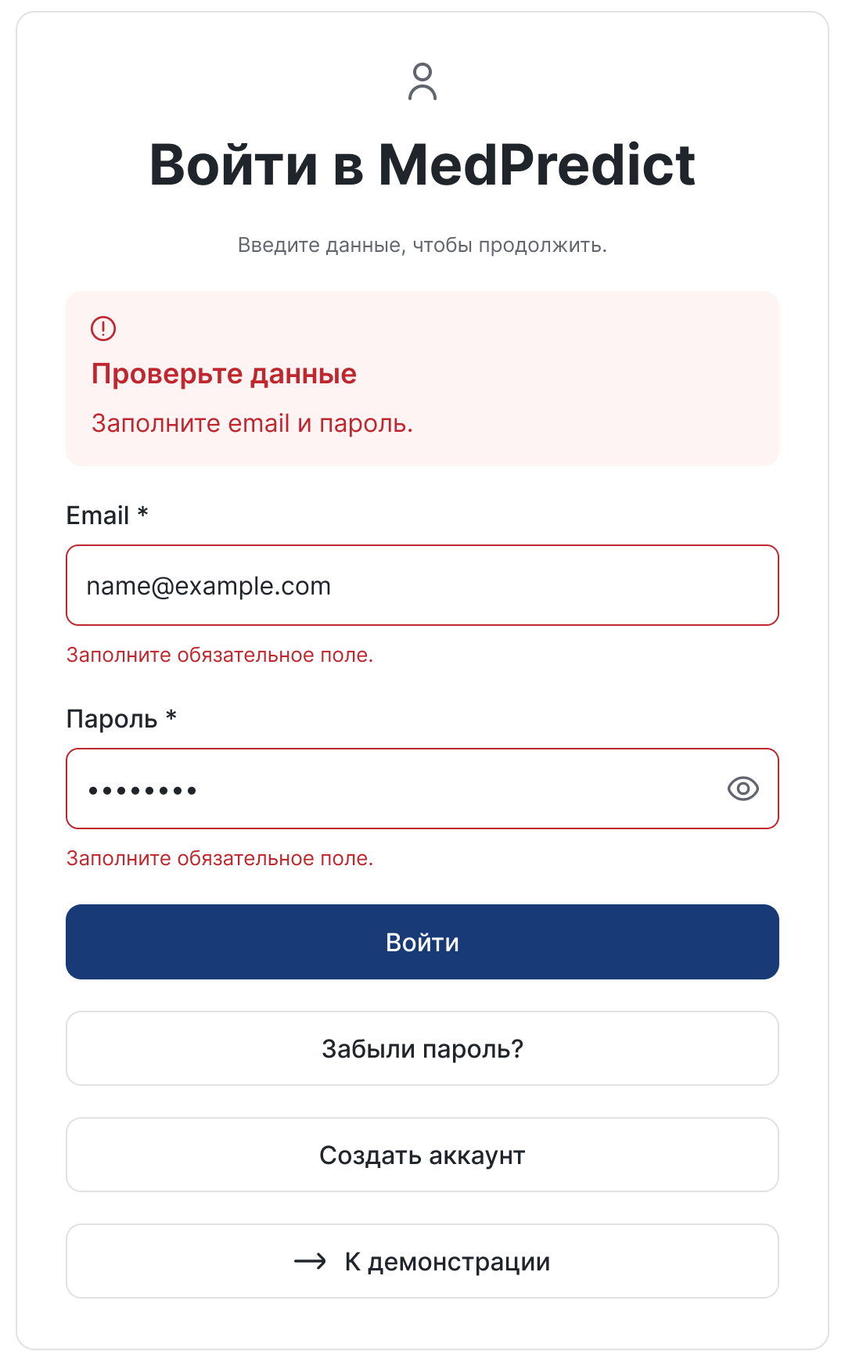
Figure 11. Figma authentication design with validation. It represents a planned sign-in flow, not successful implemented authentication. [44]
Figures 12 and 13 show the extended account and history concepts. The profile uses a synthetic example identity; the history record is explicitly synthetic and contains API/date/version placeholders. These screens do not demonstrate persistence. [44]

Figure 12. Figma account overview design with password, history and sign-out controls. These server workflows are not completed implementation. [44]

Figure 13. Figma history-list design with a synthetic example record. It illustrates navigation and review, not saved application data. [44]
The information design in Figure 14 still contains historical pending metadata, so the model card governs current technical facts. Figure 15 proposes recovery from model unavailability without a fabricated output. [44] [3]

Figure 14. Figma model-information design. Historical pending fields are retained as genuine design evidence and are not substituted for current experiment records. [44]

Figure 15. Figma model-unavailable and recovery design. The error state directs the user to information or the home screen instead of displaying a prediction. [44]

8.3 Implemented interaction and accessibility
The implemented path is landing → metadata-driven input → checked request → result or explicit failure → optional local PDF. Input labels state units, validation associates errors with fields, and focus moves to the first error or accepted result. Cancel, edit and navigation invalidate stale responses. RU, KK and EN text, a skip link, visible focus, responsive layout and reduced-motion support are present; full screen-reader, contrast and cross-browser assessment remains separate. [2]
Account, sign-in, saved history and deletion designs exceed the completed server scope. Their actual controls remain disabled and do not simulate success. Prototype roles and older labels are not used to establish current responsibilities; the supplied work plan governs those assignments. [1] [2]

8.4 Actual local application workflow
The following sequence was captured from the running local application using its explicit demo mode and synthetic built-in example. It demonstrates implemented interaction, not trained inference. Figure 16 shows the entry point and the preset illustration. Figure 17 shows the genuine empty result before submission. [45]
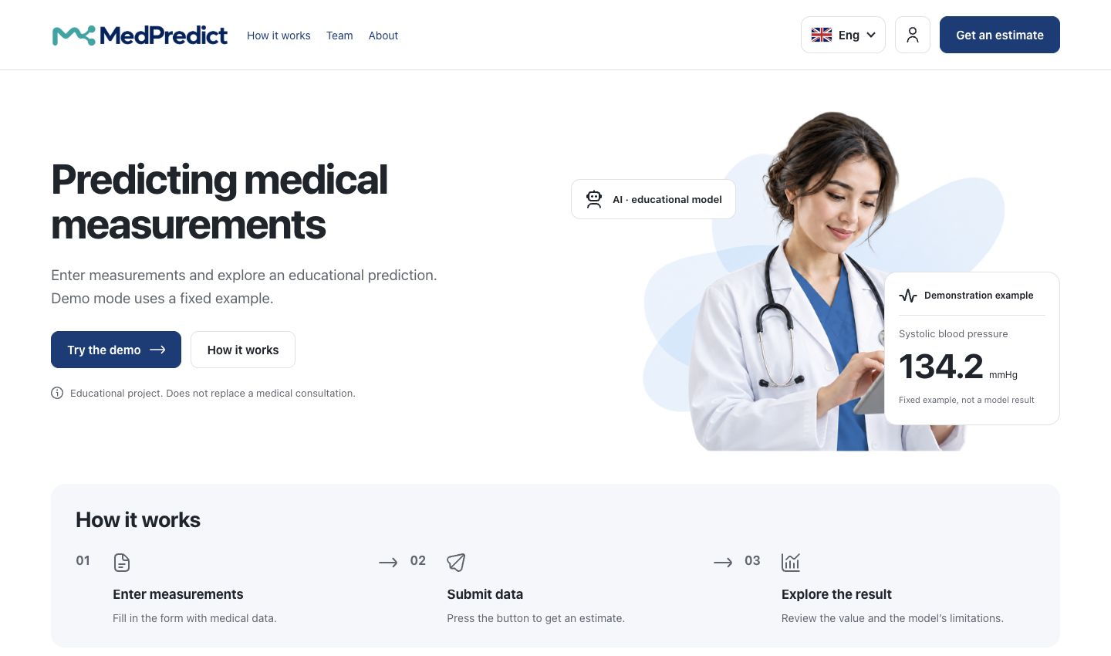
Figure 16. Running local application in English with the landing page and explicitly fixed demonstration illustration. [45]
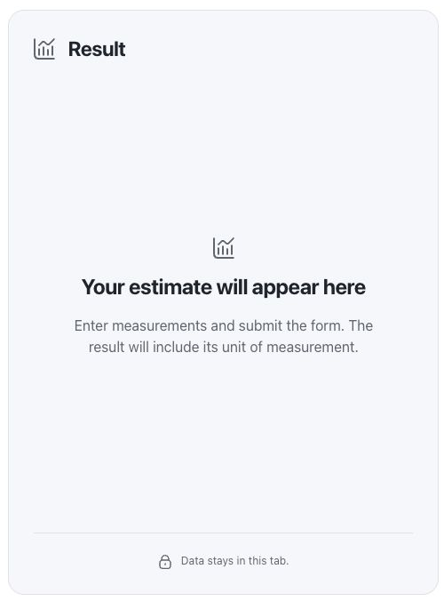
Figure 17. Detail of the genuine empty result panel before a request. No prediction has been generated; this is implemented application behaviour. [45]
Figure 18 shows the synthetic values before submission. Figure 19 records the resulting fixed-demo screen: 134.2 mmHg, version demo-example. The visible label distinguishes this preset from MedPredict-SBP-mlp-v2; the value is excluded from experimental metrics. [45]
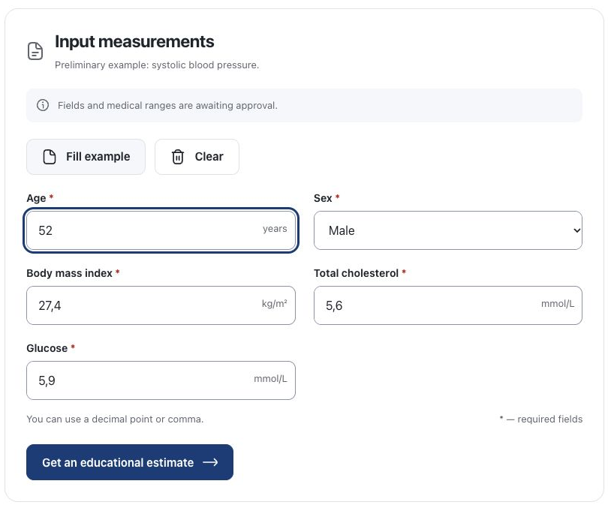
Figure 18. Synthetic example entered in the actual local form before submission; the result remains ungenerated at this stage. [45]
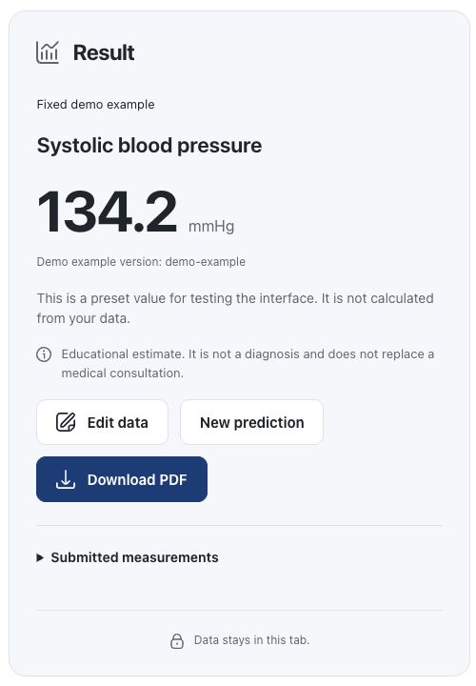
Figure 19. Actual result panel in explicit demo mode. The 134.2 mmHg result is fixed demonstration content, not an ONNX prediction. [45]

8.5 Actual PDF export
The export was produced by the application from the existing accepted demo response. Figure 20 is a rendered page of that downloaded PDF, showing its actual input snapshot, result, mode/version and limitations. The artifact was not recreated for the report. Export demonstrates reporting functionality without establishing predictive quality. [45]
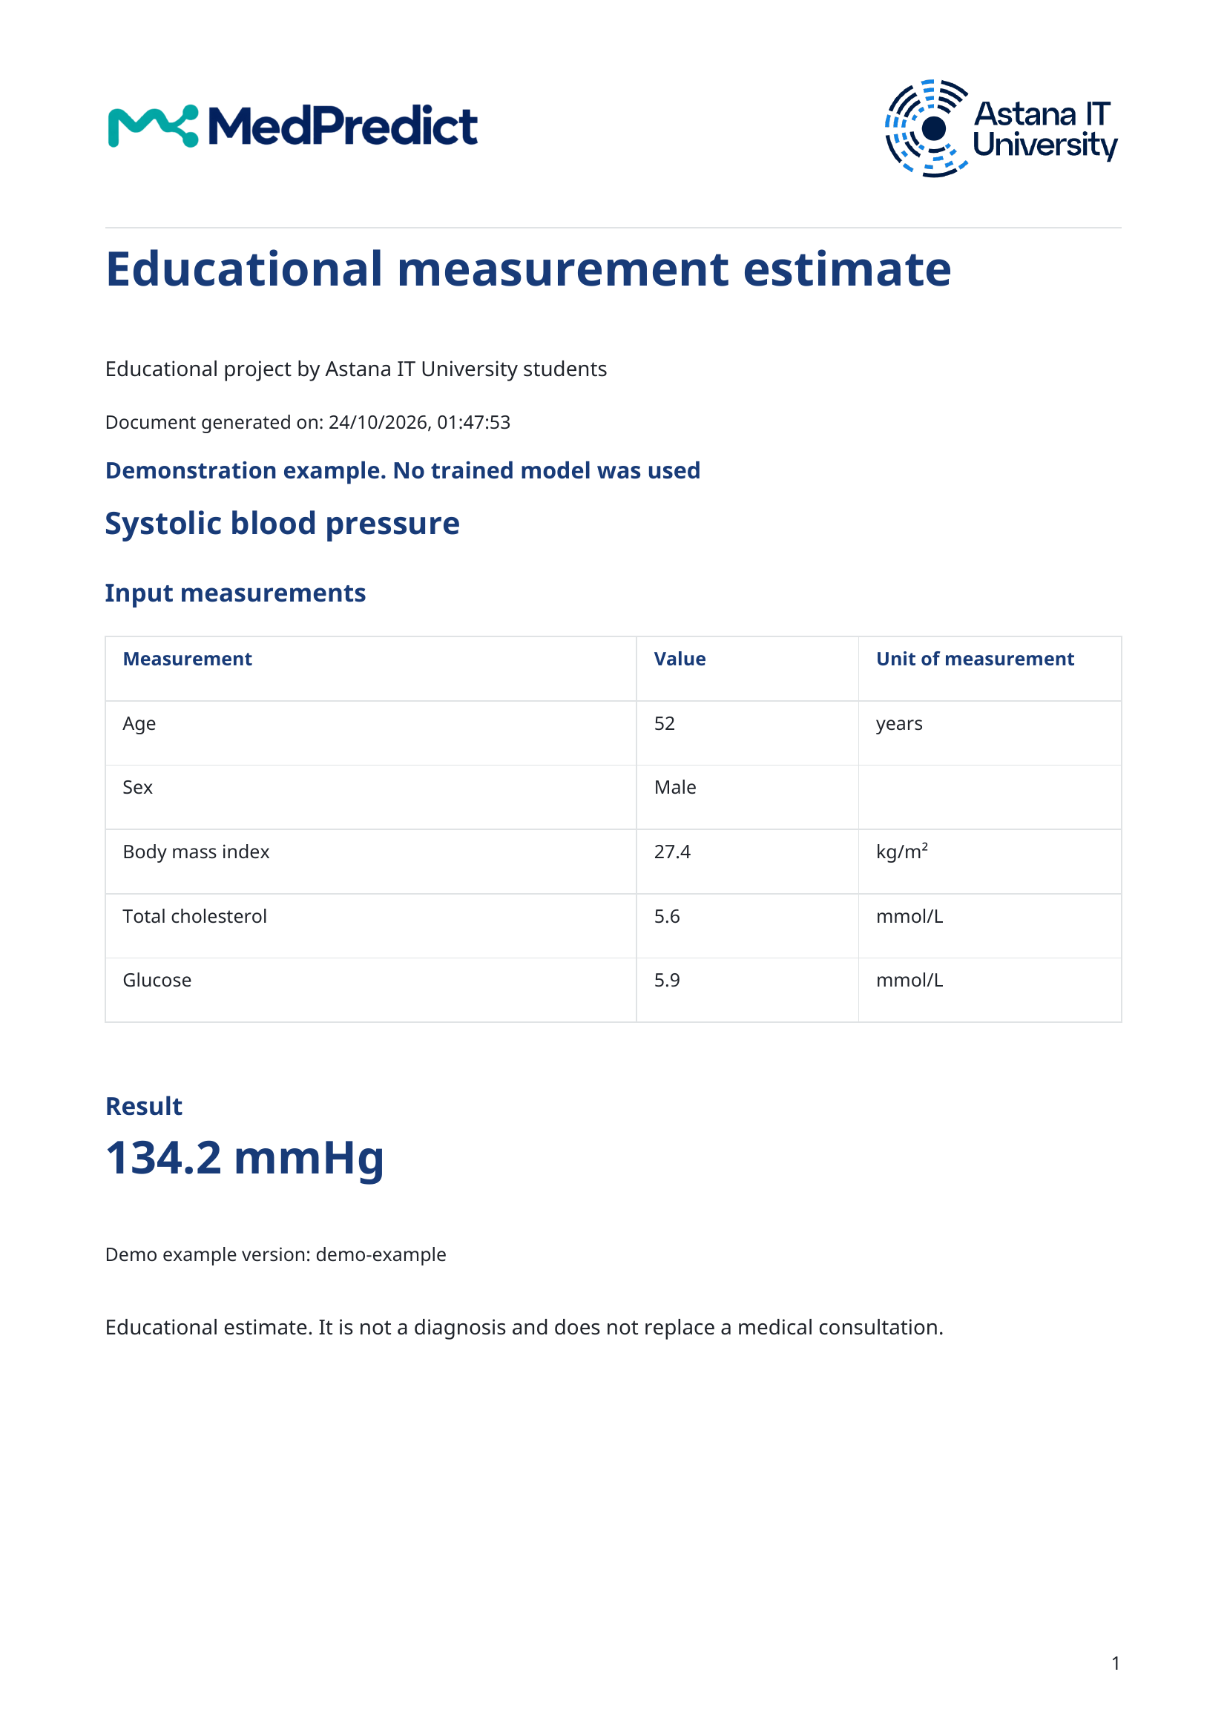
Figure 20. Actual PDF downloaded from the local application after the synthetic fixed-demo workflow. The page retains the demonstration label and research limitations. [45]

8.6 Privacy and proposed usability assessment
Indicators remain outside browser storage, URLs, analytics and application payload logs. Real requests use the configured backend; PDF export creates a user-controlled copy. Hosting policies require separate review. [2]
A proposed three-to-five-participant study should record completion, help, errors and first interpretations across the shown stages. Any diagnostic or treatment interpretation requires wording revision and reassessment before a usability claim.

9 Verification and evaluation plan

9.1 Evidence already available
Software correctness, runtime equivalence and predictive validity answer different questions. Passing unit tests does not establish model quality; matching Java output does not establish safe medical interpretation. Table 10 separates fresh checks performed during report preparation from prior recorded executions. No training or new evaluation of participant-level test outcomes was performed for this report. [2]
Table 10. Executed verification and its limits
Evidence | Observed result | Status and interpretation
Frontend typecheck, lint and build | All passed | Fresh 24 October local working-tree checks
Frontend unit and PDF tests | 96 passed across six files | Fresh Vitest run; not a new browser or server integration run
ML data and model unit tests | 13 passed | Fresh narrow non-training checks
Synthetic Python ONNX smoke check | Four vectors passed; maximum difference 0.0000076294 mmHg | Fresh CPU check against stored references; tolerance 0.01 mmHg
Archived Python–ONNX comparison | 501 vectors; maximum difference 0.0000152588 mmHg | Stored report: 497 test inputs and four synthetic vectors; not rerun now
Archived Java verification | 48 tests, zero failures, errors or skips; four synthetic parity cases | Stored XML and JSON records inspected; Java not rerun
Historical frontend browser record | 56 Playwright scenarios; four real ONNX desktop/mobile scenarios recorded | Earlier integration record; not fresh execution on the current publication

The fresh commands were npm run typecheck, npm test -- --reporter=dot, npm run lint and npm run build. The narrow ML command selected test_data.py and test_model.py with pytest cache disabled. Current source hashes matched the frozen training-source records. Backend ports 8080 and 8081 were not listening during the audit, so a fresh complete HTTP-to-Java-to-browser acceptance run was not claimed. [2]

9.2 Corrected M2 experiment
The official NHANES 2017–March 2020 pre-pandemic cohort is joined one-to-one by SEQN. The filtering record starts with 15,560 demographic records, limits age to 18–79, requires positive fasting weights, at least two valid oscillometric SBP observations and five finite complete predictors. It retains 3,318 participants, partitioned into 2,324 training, 497 validation and 497 test participants. Missing outcomes and feature values are not imputed in this experiment. [3] [7] [43]
The target is mean SBP at the same examination. Weighted feature and target scaling use training data only. The comparison includes a weighted-mean baseline, four Ridge settings, two histogram-gradient-boosting variants and three MLP configurations across three seeds. The architecture is selected by mean validation weighted MAE across seeds; seed 2026 is the prespecified representative. The selected MLP has layers 5 → 32 → 16 → 1, ReLU activations, dropout 0.1 and 737 trainable parameters. [3]
An earlier experiment was withdrawn after a pandas SAS XPT zero-decoding issue admitted invalid positive fasting weights. Corrected v2 uses pyreadstat and regression checks. Because the withdrawn test had already been viewed, the corrected v2 is an internal re-evaluation, not a wholly untouched final test or independent validation. The report retains this limitation rather than presenting a technical correction as a new external result. [3]
Table 11. Corrected internal M2 test results on 497 participants
Model | Weighted MAE | Weighted RMSE | Weighted R² | Ordinary MAE | Ordinary RMSE
Weighted mean | 13.231 | 17.140 | −0.00003 | 14.024 | 18.462
Ridge | 11.268 | 15.149 | 0.219 | 12.399 | 16.425
Histogram gradient boosting | 11.698 | 15.732 | 0.158 | 12.515 | 16.455
Selected MLP | 11.225 | 15.309 | 0.202 | 12.396 | 16.381

All MAE and RMSE values in Table 11 are in mmHg. The MLP weighted-MAE advantage over Ridge is approximately 0.043 mmHg, and no paired uncertainty interval for that difference was calculated. Ridge performs better on weighted RMSE and weighted R². Accordingly, statistically reliable neural superiority is not established. R² of approximately 0.20 is not 20% accuracy. [3]
Table 12. Prespecified descriptive MLP errors by observed target range
Observed SBP in mmHg | Participants | Weighted MAE in mmHg | Weighted signed error in mmHg
Below 110 | 124 | 12.152 | +12.036
110 to below 130 | 223 | 5.932 | +1.563
130 to below 150 | 108 | 12.730 | −12.520
At least 150 | 42 | 41.366 | −41.366

All 42 cases in the highest observed range are underestimated. These ranges are research bins, not diagnostic categories. The overall error conceals the severity of this failure, which rules out treating the estimator as a substitute for direct measurement. Descriptive age, sex and medication-group errors are also recorded in the model documentation, but their differences are unadjusted and not causal findings. [3]
The stored 1,000-replicate stratified masked-PSU bootstrap gives a conditional nominal 95% weighted-MAE percentile interval of 10.141–12.221 mmHg, using the 2.5th and 97.5th percentiles for the fixed MLP and complete-case test set. It is not full survey-population variance, an individual prediction interval or external validation. Fasting-subsample selection, missingness and survey design restrict representativeness. No Kazakhstan cohort has been evaluated. [3] [46] [24]

9.3 Planned software and integration acceptance
Table 13. Verification scenarios linked to requirements
ID and responsibility | Procedure | Acceptance and retained evidence
T01 Oralkhan and Sanat | Real metadata and POST, valid and unavailable provider | Correct fields, units, semantics and version; command, artifact and HTTP record
T02 Oralkhan and Sanat | Missing values, wrong categories, strings, non-finite values, extra or duplicate keys | Independent rejection; safe machine code; field association where applicable
T03 Sanat and Oralkhan | Delay, cancel, edit, navigation, timeout and malformed response | No stale result, duplicate POST or automatic demo fallback; input remains correct
T04 Ali and Oralkhan | Same artifact and reference vectors through Python, ONNX and Java | Every finite output within prespecified tolerance; retain SHA and environment
T05 Oralkhan and Sanat | Future module selection and unavailable modules | Separate schemas, units and state; no fabricated output from a planned module
T06 Sanat | Export existing result in RU, KK and EN; simulate font/resource failure | Correct provenance and warnings, no new POST, explicit export recovery
T07 Oralkhan and Sanat | Synthetic network/storage review plus deployment configuration | No indicator persistence or payload logging; approved origins and TLS policy
T08 Whole team | User-task and interpretation study | Record first explanations and all critical misunderstandings; revise and reassess

T01–T04 and T06 have existing software or archived integration evidence; the table is the acceptance plan for a selected submission version, not a claim that every scenario was rerun now. For M2 the technical tolerance is 0.01 mmHg. Four Java synthetic cases are useful but do not satisfy an earlier proposed twenty-case reference set; expanding the independent set remains open. [47] [2]

9.4 Future model evaluation
For M1, document the exact Diabetes source, target definition and feature scaling, then freeze a split before tuning. Compare mean, regularised regression and a compact MLP using MAE and RMSE on the dataset target scale. Keep preprocessing within each training fold when cross-validation is used, retain all tuning choices and report the uncertainty and limitations of the small cohort. A neural model is not required to win for the comparison to be informative. [15] [6] [23]
For M3, first establish longitudinal access, timestamp semantics, sampling, window and forecast horizon. The PhysioNet ICU glucose-management resource is only a candidate; its files require credentialing, training and a data-use agreement. Sparse ICU observations must not be described as already available outpatient CGM. Split by subject and time, fit transforms on training data, prevent cross-boundary windows and compare persistence with the chosen sequence method. [48] [21] [25]
M3 should report MAE and RMSE in a single declared glucose unit, separately by horizon. A clinical error-grid analysis may complement statistical errors where appropriate, with explicit interpretation limits. Clarke's original monitoring framework does not certify a forecast or authorise insulin adjustment. Any use of future events in offline teacher training must be distinguished from the information actually available to the deployed forecast. [22] [20]
Independent M2 evaluation should apply a frozen artifact to a separately justified cohort with harmonised measurements and units. The current test must not become a tuning set for repeated attempts to reduce the observed error. A new temporal U.S. cohort would still not establish Kazakhstan clinical validity. Acceptance should require reproducible evidence and honest interpretation; no arbitrary clinical-quality threshold is invented here. [24] [26]

9.5 Performance and measurement conditions
Before a response-time claim, agree an environment and p95 budget B, then record CPU, RAM, operating system, runtime versions, artifact SHA, payload, concurrency, origin and timing boundaries. Measure at least thirty successful warm POST requests, retain every attempt and failure, and report cold calls separately. Count failures in the denominator of the error rate. Time from request initiation to completely read and checked response; separate model-only timing from transport and rendering. [47]
The stored ONNX CPU microbenchmark records p50 0.005458 ms and p95 0.005833 ms over 1,000 single-row calls after loading. Those values exclude HTTP, startup and UI, and are not a service guarantee. The acceptance budget B remains pending. Demo delays, local runtime equality and the 15-second timeout cannot substitute for a measured end-to-end protocol. [3]

10 Project management and risk analysis

10.1 Current tracker and resource state
The active tracker is Jira MED, board 2. It was inspected directly on 24 October through an authenticated browser session. The board showed 37 To Do, two In Progress, zero In Review and twelve Done main cards. A dated 22 October reconciliation records 52 list items, including a subtask, explaining the difference from 51 main cards. The report does not infer completion of task acceptance criteria from column membership. [10] [49]
The work plan and university document name YouTrack. The team confirms that using Jira was permitted; Jira is therefore the accepted tracker for this report. Historical YouTrack records remain evidence of an earlier process, and their numerical identifiers must not be automatically remapped to Jira. [1] [4] [49]
Figure 21 records the supplied board view. Figures 22–25 reproduce the four supplied list portions. Together they contain all 52 unique task IDs; overlapping rows preserve continuity. Full summaries and assignees were read from Jira because several labels are truncated in the images. The complete register below records both the observed tracker state and the work evidenced by this report. [10]

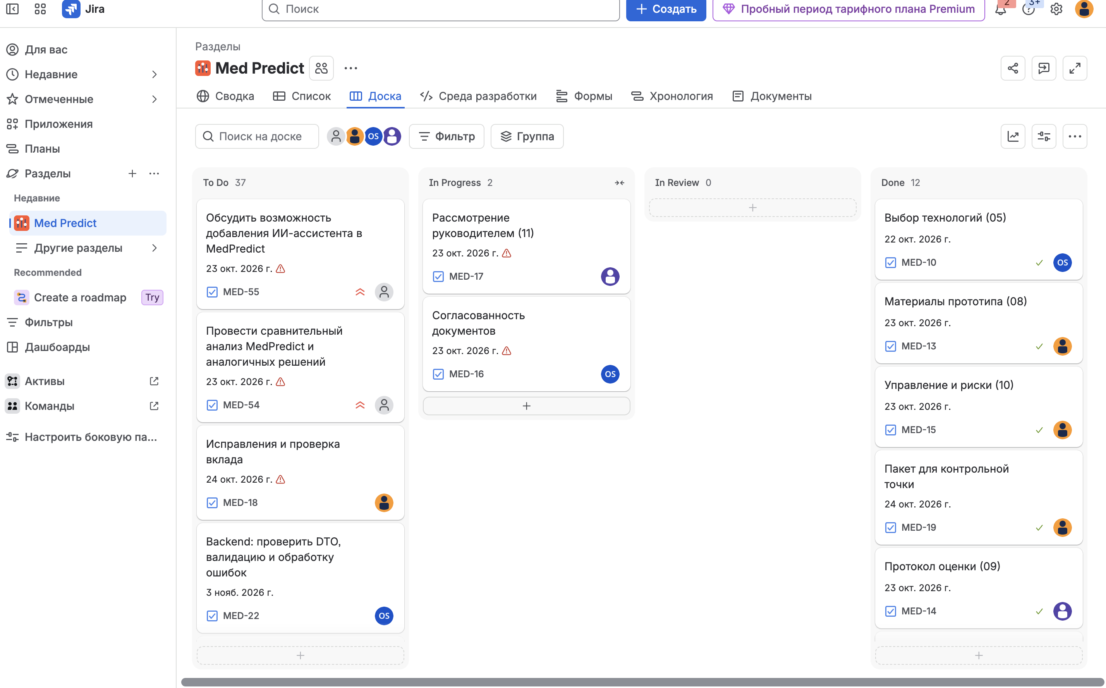
Figure 21. Supplied Jira MED board showing genuine To Do, In Progress, In Review and Done columns. The screenshot retains the source workflow states. [10]

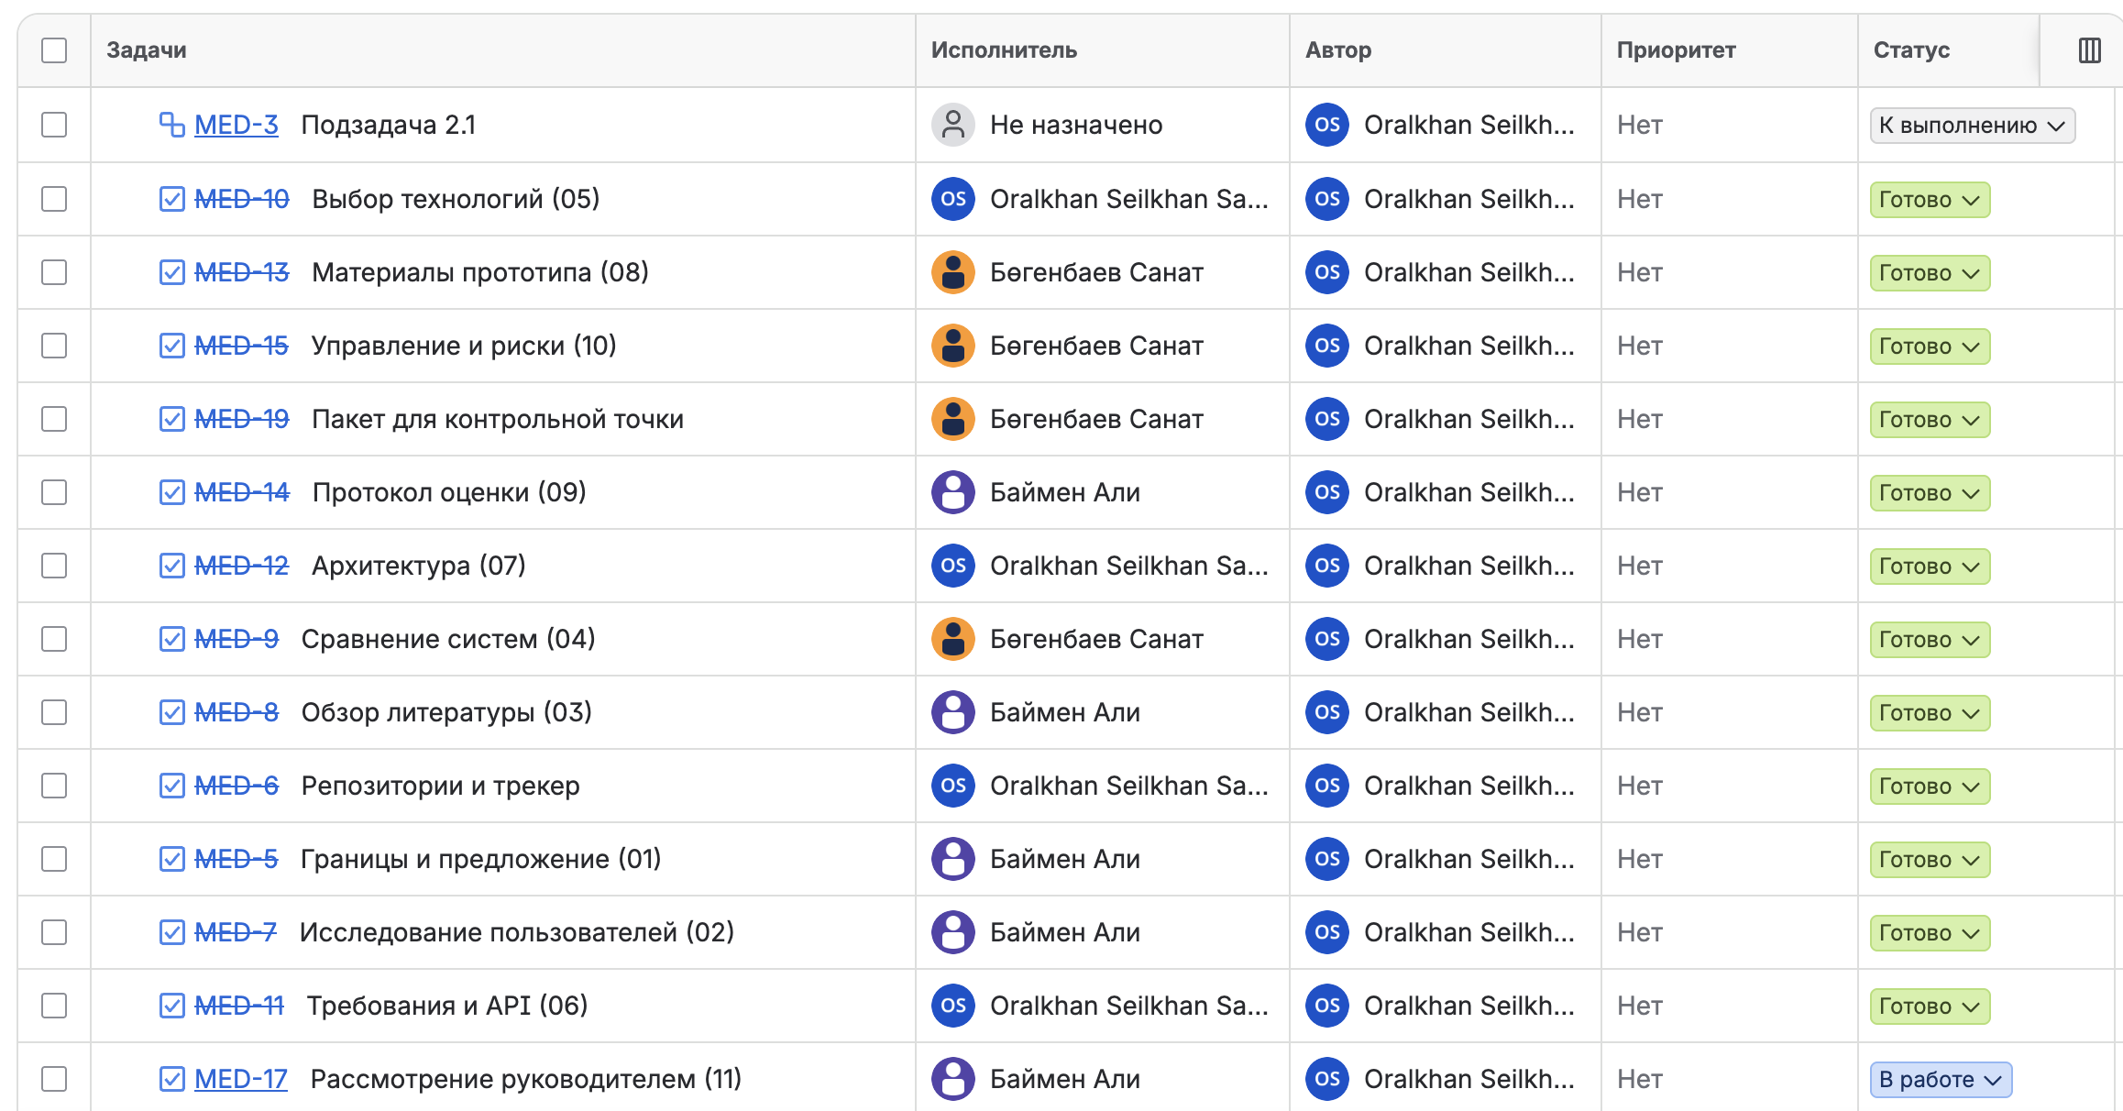
Figure 22. Supplied Jira list portion 1 with the document tasks, twelve Done records and the supervisor-review task In Progress. MED-3 is the additional subtask. [10]

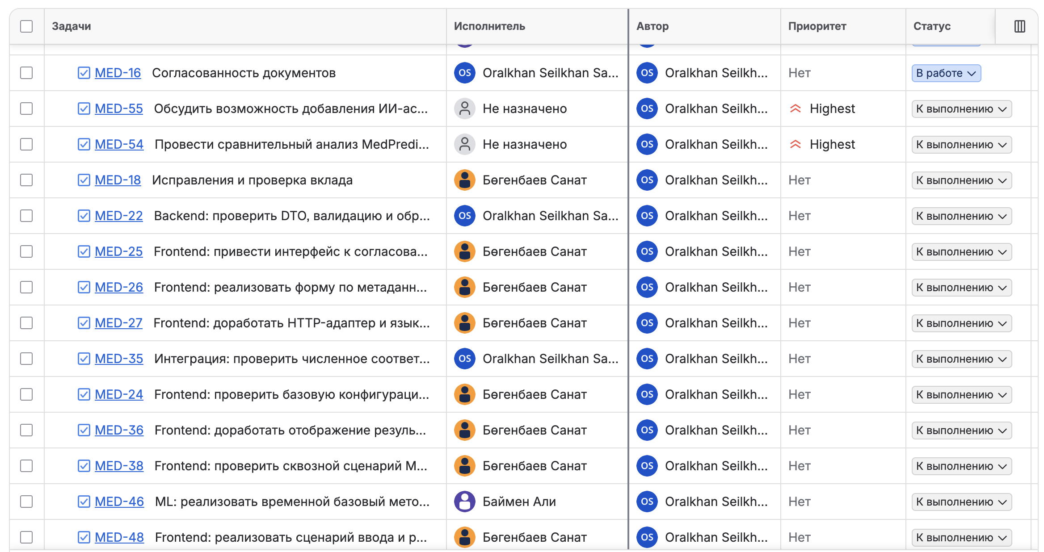
Figure 23. Supplied Jira list portion 2 with document consistency, comparison, contribution review and implementation tasks. Displayed statuses are preserved. [10]

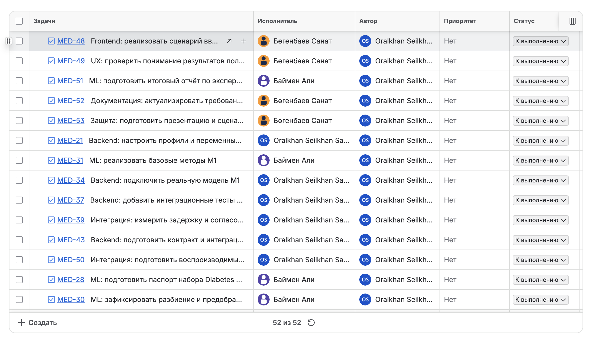
Figure 24. Supplied Jira list portion 3 with planned M1, M3, testing, documentation and demonstration tasks. Overlapping rows connect the adjacent portions. [10]

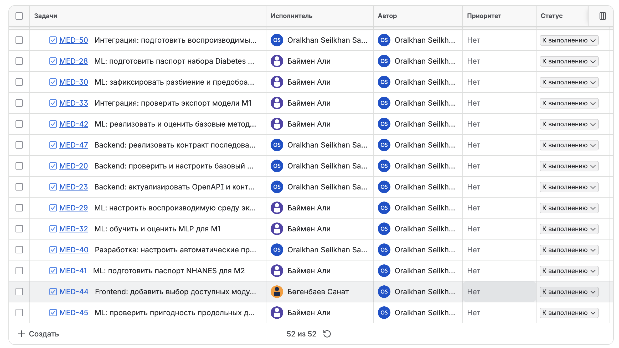
Figure 25. Supplied Jira list portion 4 completing the 52-item inventory, including remaining model, integration and frontend work. The footer shows 52 of 52 items. [10]

The earlier 24 October source audit found frontend main e649926 with 22 commits, backend main 3588c363 with three commits, and documentation main 914ec539 with nine commits; each root displayed zero tags. The public ml-ai repository was empty. These differ from local frontend HEAD a644714 with existing changes and the retained ONNX backend e90d980. A repository link therefore does not establish publication of the integrated model. [50] [5] [51] [52] [2]
The later contribution audit on 24 October found frontend main 7eddeffd with 25 commits: PR 3 had merged at 02:30 Asia/Almaty. Section 10.3 uses the actual commit objects and review comment from that later audit. This frontend change does not establish that the local ONNX backend or ML bundle is present in the current remote backend and ml-ai repositories. [50] [53]
The university asks for one continuous repository with source, documentation, editable diagrams, tests, configuration, identifiable accounts and reviewed changes. The current multi-repository arrangement and empty ml-ai require an agreed submission entry point and reproducible version map. Zero displayed tags and the local absence of pre-defense-1 leave the required checkpoint tag unresolved. No tag, commit, push or task update was created during report preparation. [4] [50] [5] [51] [52] [2]

10.2 Complete task register as of 24 October
Table 14 lists every Jira item, including MED-3 and MED-5–MED-55. Task summaries are translated into English without changing their module scope. Owners are the actual Jira assignees; Ali, Sanat and Oralkhan refer to the team members named on the title page. [10]
The report records 28 Done, 7 In Progress and 17 To Do items as of 24 October 2026. Done means that the stated document or current local implementation deliverable is evidenced. It does not record a Jira transition, supervisor acceptance, publication or clinical approval. The Jira column preserves the source snapshot: twelve Done, two In Progress and thirty-eight To Do items, including the subtask. No external task state was changed. [10] [2] [3]
Table 14. Complete Jira inventory and evidenced report completion as of 24 October 2026
ID and task | Owner | Report status | Jira snapshot
MED-3 — Subtask 2.1 | Unassigned | To Do | To Do
MED-5 — Project scope and proposal (01) | Ali | Done | Done
MED-6 — Repositories and tracker | Oralkhan | Done | Done
MED-7 — User research (02) | Ali | Done | Done
MED-8 — Literature review (03) | Ali | Done | Done
MED-9 — System comparison (04) | Sanat | Done | Done
MED-10 — Technology selection (05) | Oralkhan | Done | Done
MED-11 — Requirements and API (06) | Oralkhan | Done | Done
MED-12 — Architecture (07) | Oralkhan | Done | Done
MED-13 — Prototype materials (08) | Sanat | Done | Done
MED-14 — Evaluation protocol (09) | Ali | Done | Done
MED-15 — Management and risks (10) | Sanat | Done | Done
MED-16 — Document consistency | Oralkhan | In Progress | In Progress
MED-17 — Supervisor review (11) | Ali | In Progress | In Progress
MED-18 — Corrections and contribution review | Sanat | To Do | To Do
MED-19 — 24 October submission package | Sanat | Done | Done
MED-20 — Backend: verify and configure the base Spring Boot project | Oralkhan | Done | To Do
MED-21 — Backend: configure profiles and environment variables | Oralkhan | Done | To Do
MED-22 — Backend: verify DTOs, validation and error handling | Oralkhan | Done | To Do
MED-23 — Backend: update OpenAPI and the REST API contract | Oralkhan | Done | To Do
MED-24 — Frontend: verify base configuration and application structure | Sanat | Done | To Do
MED-25 — Frontend: align the interface with the agreed prototype | Sanat | In Progress | To Do
MED-26 — Frontend: implement the model-metadata form | Sanat | Done | To Do
MED-27 — Frontend: improve the HTTP adapter and error language | Sanat | Done | To Do
MED-28 — ML: prepare the Diabetes data card for M1 | Ali | To Do | To Do
MED-29 — ML: configure a reproducible experiment environment | Ali | Done | To Do
MED-30 — ML: freeze the M1 split and preprocessing | Ali | To Do | To Do
MED-31 — ML: implement M1 baselines | Ali | To Do | To Do
MED-32 — ML: train and evaluate an MLP for M1 | Ali | To Do | To Do
MED-33 — Integration: verify M1 model export | Ali | To Do | To Do
MED-34 — Backend: connect the real M1 model | Oralkhan | To Do | To Do
MED-35 — Integration: verify numerical agreement between Python and Java | Oralkhan | Done | To Do
MED-36 — Frontend: improve result display and PDF export | Sanat | Done | To Do
MED-37 — Backend: add API and model integration tests | Oralkhan | Done | To Do
MED-38 — Frontend: verify the M1 end-to-end scenario and accessibility | Sanat | To Do | To Do
MED-39 — Integration: measure latency and agree its budget | Oralkhan | In Progress | To Do
MED-40 — Development: configure automated repository checks | Oralkhan | In Progress | To Do
MED-41 — ML: prepare the NHANES data card for M2 | Ali | Done | To Do
MED-42 — ML: implement and evaluate M2 baselines and an MLP | Ali | Done | To Do
MED-43 — Backend: prepare the M2 contract and integration | Oralkhan | Done | To Do
MED-44 — Frontend: add selection of available M1 and M2 modules | Sanat | To Do | To Do
MED-45 — ML: assess longitudinal data suitability for M3 | Ali | To Do | To Do
MED-46 — ML: implement a temporal baseline and model for M3 | Ali | To Do | To Do
MED-47 — Backend: implement the M3 sequence contract | Oralkhan | To Do | To Do
MED-48 — Frontend: implement the M3 input and result workflow | Sanat | To Do | To Do
MED-49 — UX: assess users’ understanding of results | Sanat | To Do | To Do
MED-50 — Integration: prepare reproducible system startup | Oralkhan | In Progress | To Do
MED-51 — ML: prepare the final experiment report | Ali | In Progress | To Do
MED-52 — Documentation: update requirements, architecture and the guide | Sanat | Done | To Do
MED-53 — Defence: prepare the presentation and demonstration scenario | Sanat | To Do | To Do
MED-54 — Compare MedPredict with analogous solutions | Unassigned | Done | To Do
MED-55 — Discuss adding an AI assistant to MedPredict | Unassigned | To Do | To Do

Document tasks MED-5–MED-15 and MED-19 are prepared deliverables. MED-7 refers to the three supplied research records; their independent corroboration and consent remain unresolved. MED-6 denotes the resource register, not an accepted release. The risk register documents unresolved risks rather than closing them. [14] [8]
Local implementation supports Done for MED-20–MED-24, MED-26–MED-27, MED-29, MED-35–MED-37 and MED-41–MED-43. These records concern the retained M2 source, model and checks described in Sections 7–9. Python–Java parity is supported by four synthetic Java cases; the Java suite is an archived execution. Future M1-specific tasks are not completed by analogous M2 work. [2] [3]
MED-52 is Done for the requirements, architecture and operational guidance updated in this report; synchronising older canonical documents remains MED-16. MED-54 is Done for the prepared comparative analysis in Section 4 and the supplied 22 October Kazakhstan comparison. Preparation does not imply team approval or established superiority. [14] [2]
The seven In Progress items are MED-16, MED-17, MED-25, MED-39, MED-40, MED-50 and MED-51. Their remaining work is respectively document synchronisation, genuine supervisor review, full prototype conformance, an agreed end-to-end latency budget, verified repository-triggered checks, clean-source reproduction and the final multi-module experiment synthesis. No M1/M3 implementation, user interpretation study or assistant discussion is marked complete without its evidence. [2] [54] [47]

10.3 Work distribution and milestones
The complete register uses the assignees read from Jira: Ali Baimen, Sanat Bogenbayev and Oralkhan Seilkhan; MED-3, MED-54 and MED-55 remain unassigned in the tracker. The report marks MED-54 comparative analysis Done because the analysis is prepared, while its observed Jira state remains To Do. MED-16 document synchronisation and MED-17 supervisor review remain In Progress; MED-18 contribution review and MED-55 AI-assistant discussion remain To Do. [10] [2] [14]
Table 15 separates each participant's responsibility from identifiable committed work. Commit authors and changed files were inspected through the public GitHub API; dates below use Asia/Almaty. The account bsanat identifies Sanat Bogenbayev and uses the Git author alias juniorqazaq. Oralkhan-coder and alishka4242 are mapped to Oralkhan and Ali by project attribution; their public profiles do not independently show full names. [53]
Table 15. Participant responsibilities and identifiable repository contributions
Participant and responsibility | Committed work and artifact | Review and verification evidence
Sanat Bogenbayev — frontend, UX, localisation, PDF and browser checks | Localised PDF and tests: f598ba1, 20 October. Typed model integration: 4d9428c, 21 October. Version-gated model information: 93aa09a, 21 October. | Integration appears in frontend PR 1. Model information appears in frontend PR 3, with a substantive review comment by alishka4242 before merge.
Oralkhan Seilkhan — backend, REST contract, validation and integration | Model boundary, DTO/error handling and tests: 3a35c99, 21 October. OpenAPI, localisation and validation: 3588c36, 21 October. | Changes include controller, validators, exception handling and API tests. No substantive peer-review record for these two commits was found in the inspected PR records; code presence does not establish their independent review.
Ali Baimen — data and ML methodology, literature, interviews and documentation | Published eleven checkpoint Word documents and diagram exports: a8005f8, 21 October. Uploaded the interview document: e86940b, 22 October. | Review comment on frontend PR 3, 21 October: checks the v2 information/limitations scope and recommends merge. This is review evidence, not a new independent test execution.

The current Jira duty correspondence is MED-26/MED-27/MED-36 for Sanat's form/API/PDF work, MED-20–MED-23 for Oralkhan's backend work, and MED-7/MED-8/MED-14 for Ali's research, literature and evaluation duties. These are report mappings by content; the commits do not establish links to these current Jira keys. The historical Med-7 in frontend PR 3 refers to YouTrack and is not Jira MED-7. [10] [53]
The contribution record distinguishes publication from sole authorship: uploading the document package does not establish that Ali alone wrote it. No inspected ML-code commit was attributable to alishka4242; the retained local ML commits and historical backend ONNX integration use juniorqazaq/bsanat. They are therefore not reassigned to Ali or Oralkhan solely because of their roles. The linked review comment is substantive peer feedback, while all seven inspected formal PR-review endpoints contained no APPROVED review. [53]
The supplied plan provides the proposed dates below; actual local M2 work has already overtaken several future implementation milestones. [1] [49]
Table 16. Proposed stages and dependency gates
Period or gate | Proposed deliverable | Dependency and acceptance
24 October checkpoint | Report, diagrams, prototype, source map and open-evidence register | Team review of the actual submission versions and access
26 October–8 November | M1 passport and baseline comparison in the supplied plan | Confirm target, partition and scale before training
9–22 November | First accepted integration milestone in the supplied plan | Reconcile already available local M2 with planned M1 work and Jira dates
23 November–6 December | M2 stage in the original plan | Decide whether this now means reproduction, independent evaluation or transfer to canonical repositories
7–20 December | Conditional M3 feasibility and experiment | Suitable longitudinal data, rights and horizon; otherwise defer explicitly
Date to be agreed | Multi-module interface and final assessment | Separate contract, reviewed artifacts, feedback and agreed calendar

These dates are proposals from the team plan, not a confirmed university calendar. The sequence is stale where it schedules an M2 implementation already present locally. Jira MED-41–MED-43 also retain future dates for M2-related work. The team and supervisor must decide the intended new outcomes rather than close tasks solely because files exist. [1] [49]

10.4 Risk register
Table 17. Risks mitigations and ownership
Risk and current evidence | Likelihood and impact | Mitigation and owner
R1 Output mistaken for measurement or diagnosis | Plausible; high | Preserve semantics and warnings; test user interpretation; Sanat and whole team
R2 Severe high-SBP underestimation | Observed; high | Research-only use, direct-measurement warning, independent evaluation; Ali
R3 Leakage or repeated test-driven tuning | Plausible; high | Preserve locks and fixed protocol; new independent assessment; Ali
R4 Local and published versions diverge | Observed; high | Freeze version map and artifact hashes; review canonical submission; Oralkhan and team
R5 Incorrect feature order units or preprocessing | Plausible; high | Metadata validation, embedded graph transforms and parity; Oralkhan and Ali
R6 M3 data or horizon unavailable | Open; high | Feasibility gate and documented reduced scope; Ali
R7 Health data retained in logs or future storage | Plausible; high | Synthetic tests, no payload logs, hosting audit before use; Oralkhan and Sanat
R8 Interview provenance or consent incomplete | Open; high for checkpoint | Verify permitted evidence without public correspondence; Ali
R9 Supervisor feedback missing | Observed; high for checkpoint | Obtain actual review and link changes to re-review; whole team
R10 Submission version and repository access unresolved | Observed; medium to high | Verify a single README entry point, tags and reviewer access; Jira use is permitted; team
R11 AI-assistant scope expansion | Open; medium | Keep MED-55 a discussion until purpose, safety, data flow and acceptance agreed; team
R12 Accessibility and browser coverage incomplete | Open; medium | Manual screen-reader and contrast checks, agreed browser matrix; Sanat

Likelihood labels are qualitative planning judgements, not estimated probabilities. Mitigations do not close risks until evidence is recorded. Dependency owners should link each accepted result to the corresponding task, artifact version, check and reviewer decision. The absence of a completed model improvement does not justify concealing a failed hypothesis or replacing it with a fixed demonstration.

11 Supervisor review points and team response

11.1 Review points reported by the team
The team relayed three review tasks for this revision: compare MedPredict with related applications and identify missing capabilities; consider adding an AI assistant; and develop the literature review. The entries below record these tasks and our completed documentary response. Marzhan Kabdykalievna Turarova is the supervisor named in the project plan. The original feedback form awaits direct supervisor confirmation; these responses do not record her acceptance of the revised report. [1] [54]

11.2 Comparison of related applications
Review point: Find applications or websites similar to MedPredict, compare their capabilities and identify what MedPredict lacks.
Team response completed: We compared four related systems across eight common criteria in Section 4, distinguishing cardiovascular risk calculators, measurement tracking and automated diabetes treatment from our current-SBP estimation task. The separately prepared Kazakhstan comparison extends this analysis to local workflows and records sixteen gaps by priority. These materials identify the need for independent local validation, better high-pressure performance, evidence of user understanding and a demonstrated benefit over direct measurement. [14] [3]
We retained authentication, stored history, trends, imports, device synchronisation and clinician workflows as conditional extensions. Their presence in an analogue does not establish that every extension belongs in this diploma prototype. The implemented PDF, responsive layout and three interface languages are existing capabilities. The comparison supports prioritisation without claiming clinical equivalence or superiority.

11.3 Consideration of an AI assistant
Review point: Discuss whether an AI assistant should be added to MedPredict.
Team response completed: We documented a bounded assistant concept for explaining field units, the input workflow, PDF export, model version and stated research limitations. Answers would use approved project documentation, point to the relevant source and acknowledge when the material does not answer a question. The assistant would not diagnose disease, recommend medication or modify the numeric model output. This separation follows the research-only scope and transparency requirements. [9] [2]
The proposed first evaluation would use synthetic questions about units, fasting glucose, estimate-versus-measurement meaning, missing evidence and unsafe requests. A useful response must match an approved source; a diagnostic or treatment instruction, invented citation or disclosure of entered indicators would fail the check. Personal indicators should not be sent to an external assistant service as part of this concept.
Our recommendation is to retain this as an optional documentation assistant after agreeing its purpose, data flow, cost and evaluation set. The written scope assessment is complete; a team meeting, supervisor decision and deployed assistant are not claimed. MED-55 remains open for the actual discussion and decision.

11.4 Literature review
Review point: Expand the literature review and explain how the selected studies influence the project.
Team response completed: We prepared a critical review of fourteen scientific publications, with twelve from 2021–2026, exceeding the required eight scientific works. Section 3 and its analytical table connect each source to its contribution, limitation and resulting project decision. The text covers numerical Diabetes progression, tabular baselines, cross-sectional pressure, temporal glucose, leakage, reporting, external validation and dataset shift.
The review informed the use of Ridge and tree baselines, participant-level partitioning, training-only preprocessing, explicit input units, versioned export and qualified interpretation. It explains why the observed 0.043 mmHg MAE difference does not establish reliable neural superiority, and why a U.S. internal experiment does not establish applicability in Kazakhstan. [3] [24] [26]

11.5 Repository presentation and verification of corrections
Team response completed: We added commission navigation, architecture previews and editable diagram links to the component README files, linked the three published interview sections directly, and recorded participant responsibilities alongside identifiable commits and review evidence in Section 10.3. These documentation edits are local until the team publishes them; preparation does not create a release tag or a new GitHub commit.
Supervisor confirmation should identify the reviewed version, actual date, any further comment and the decision on these responses. Until confirmation is received, MED-17 remains In Progress. [54] [10]

Conclusion
MedPredict has a coherent local M2 research path from NHANES preparation and model comparison to ONNX, Java, a typed web workflow and PDF output. Software checks, runtime equivalence and genuine interface evidence support different parts of that path. The current public repositories do not yet reproduce the retained local integration.
The MLP has no established superiority over Ridge and seriously underestimates high SBP. Corrected v2 remains an internal re-evaluation after a viewed withdrawn test, without external or Kazakhstan validation. M1 is planned within this report's application scope; M3 depends on longitudinal data and a new contract. This revision links three published interviews, seven participant-associated commits and a substantive peer comment. Remaining evidence concerns interview corroboration, direct supervisor confirmation, broader peer review and an accepted release version.

Appendix A Implementation and verification record

A.1 Local source and artifact identity
The local frontend folder is /Users/admin/MedPredict, HEAD a6447142cb11173ff0b78779658295c59932461c with pre-existing changes. The retained backend integration at /private/tmp/medpredict-backend-ml-20261021 is e90d98036ee2a6db81757cee0fd25fdfa97c54d9; the older IdeaProjects checkout is 3588c363e3d34946d86ce75be39a5695a8073176.
The 4,733-byte ml/artifacts/model.onnx is MedPredict-SBP-mlp-v2, marked researchOnly and experimental. Its SHA-256 is 3a4be6a1746f4230a5dba7346e3948e56cabc400540c91b0fbcd7882299dbe2a. Metadata SHA-256 is b703e5f6cc3eda95c24b44633aa619d2d6562c623bee17f049243ca4af42edc8. [2]
The dirty-tree qualification is material: a commit identifier alone does not reproduce all the inspected files. Existing unrelated work was preserved. Before submission, the team should select and review a concrete source snapshot and retain the same artifact identities. No private participant rows, application inputs or correspondence are reproduced here. [2]

A.2 Environment and endpoints
Installed local frontend packages inspected during the audit were React and React DOM 19.3.0, TypeScript 5.9.3, Vite 7.3.7, jsPDF 4.2.1, Vitest 4.1.11 and Playwright 1.64.1. These differ from some package.json ranges and are not statements about the newest available releases. The retained backend integration targets Java 17, uses Spring Boot 3.5.16 and ONNX Runtime Java 1.24.3. The archived Java run records OpenJDK 21.0.8 and Maven 3.9.16 on macOS arm64. [2]
GET /api/v1/model/info describes the active input and output schema. POST /api/v1/predictions accepts flat JSON indicators and returns a finite result with its unit, version and supported semantics. GET /api/v1/health/live checks the process; /api/v1/health/ready and /api/v1/model/status describe current model readiness. Invalid input returns 400; unavailable inference returns 503 MODEL_UNAVAILABLE without fallback. [2]
These endpoints describe the retained integrated backend. The inspected published backend main lacks the verified ONNX provider and full readiness path. A request to a default or explicit demo server must not be represented as trained M2 inference. [2] [5]

A.3 Verification records and reproduction limits
Fresh checks are identified in Table 10. The four-vector synthetic smoke-check result and read-only audit dossier are retained under tmp/final-report-2026-10-24. Source files supporting the claims include src/api/contract.ts, src/api/http.ts, src/hooks/usePrediction.ts, src/validation.ts, src/pdf/report.ts, ml/src/medpredict_ml/data.py and ml/src/medpredict_ml/model.py. Aggregate records are ml/reports/data_audit.json, test_evaluation.json, onnx_verification.json and java_verification.json. [2] [3]
Report preparation did not rerun training, Java, the full browser acceptance suite or external/clinical evaluation. The local capture did run the actual synthetic demo and its PDF export, without implying broader acceptance coverage.

A.4 GitHub organisation and repositories
Figures 26 and 27 show the MedPredicts organisation, project branding and five public repository entries. The separate source and test audit appears in Sections 9–10 and Appendix A.1. [55]
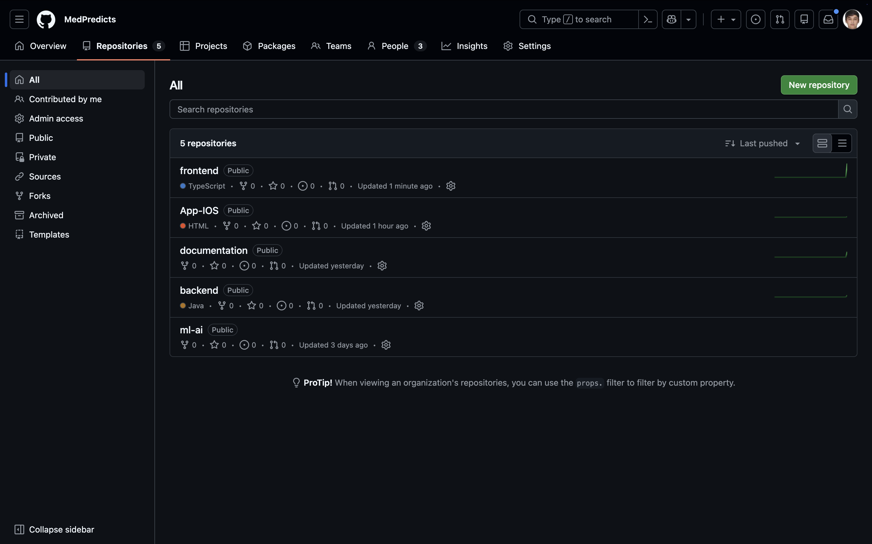
Figure 26. Supplied MedPredicts organisation repository list showing frontend, App-IOS, documentation, backend and ml-ai. [55]
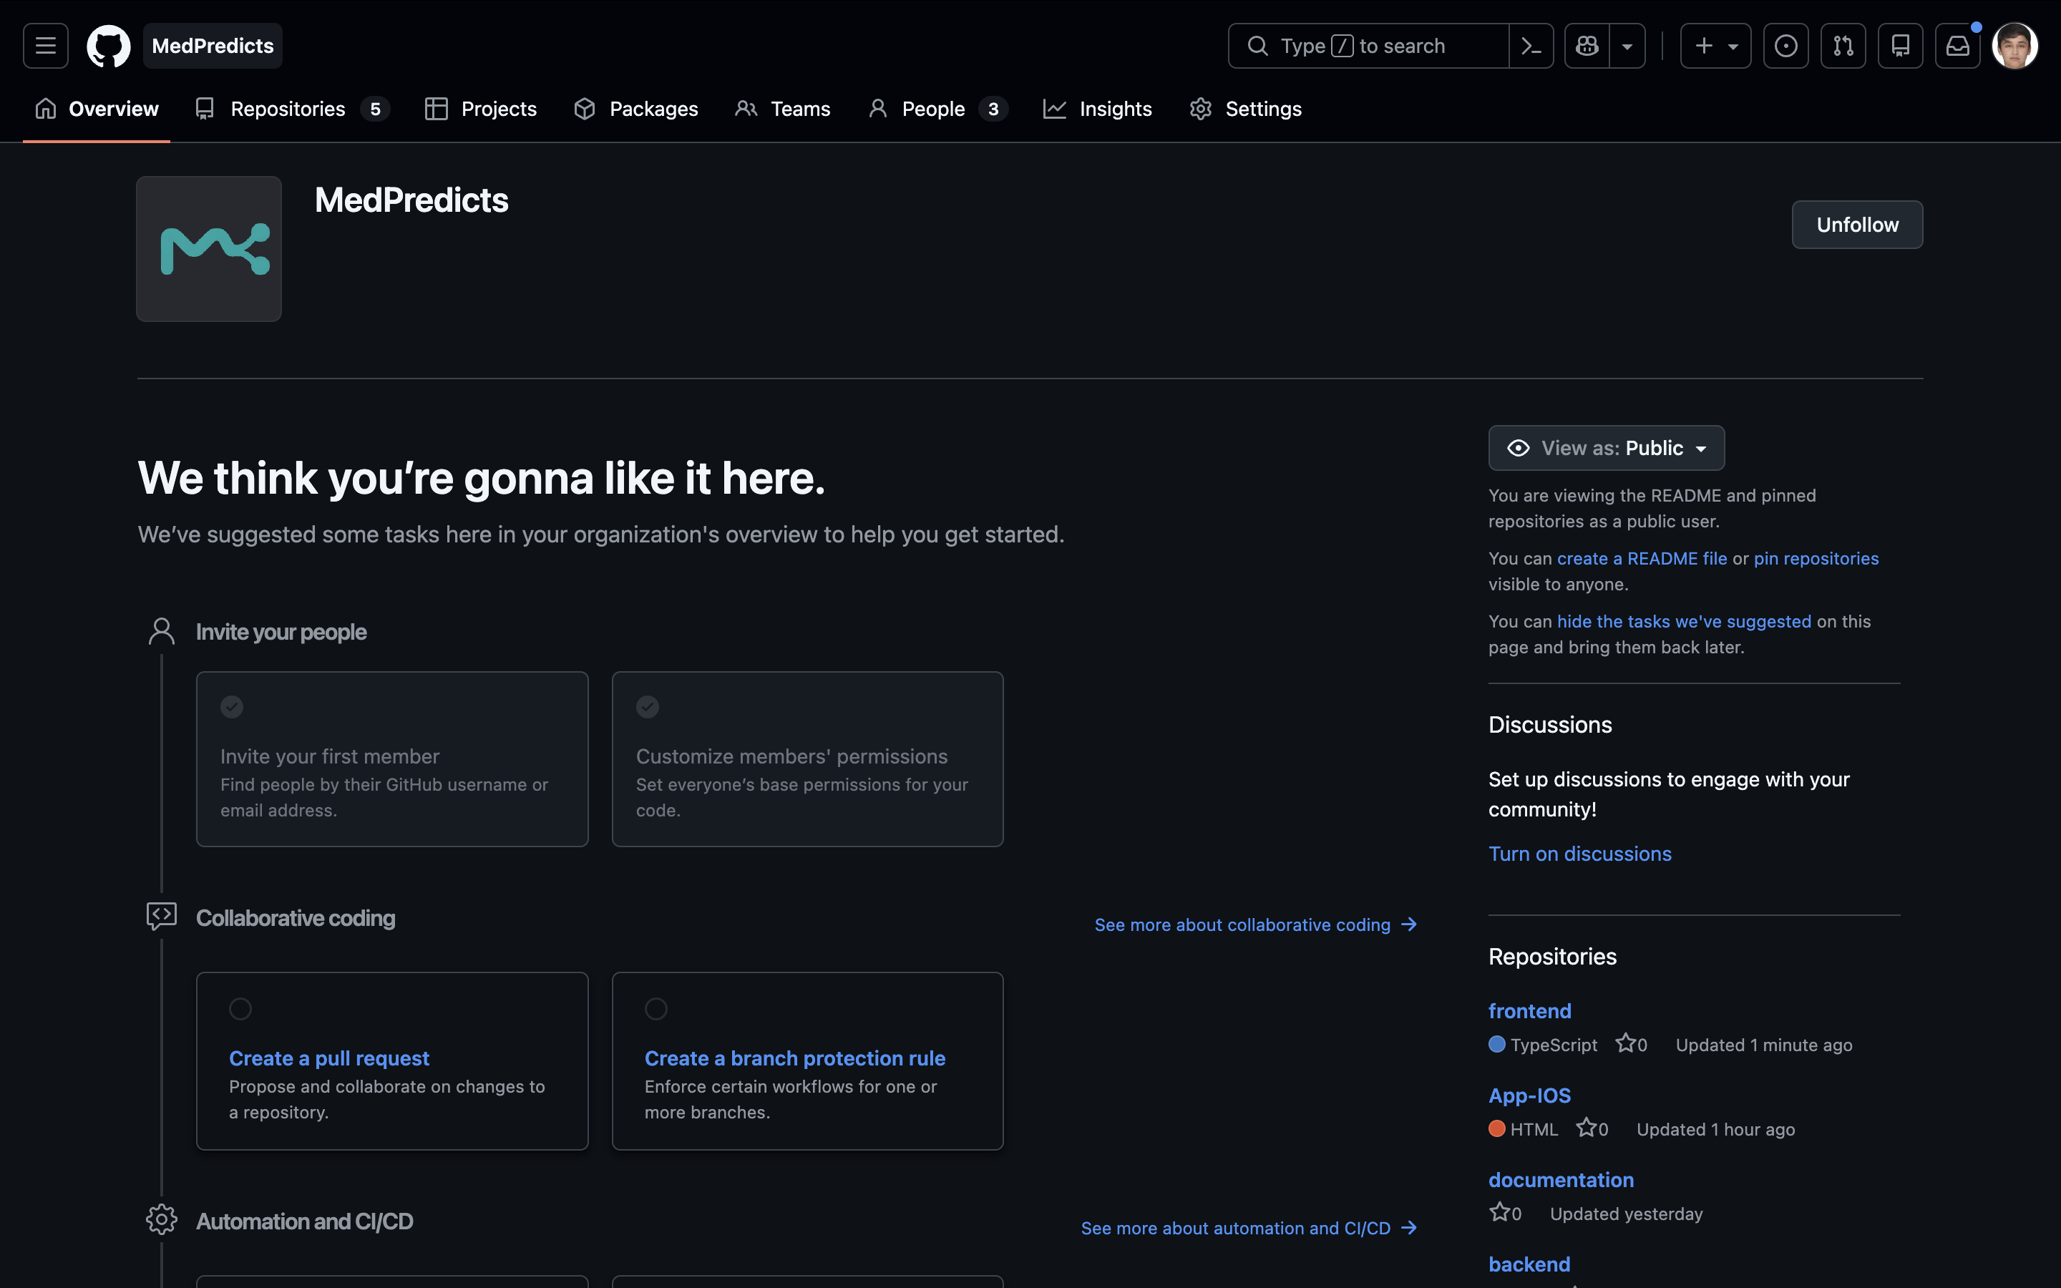
Figure 27. Supplied MedPredicts GitHub organisation overview with project branding and repository links. [55]

Appendix B Checkpoint compliance matrix
Table B1. Required report and evidence coverage
University component | Report coverage | Remaining evidence or decision
1 Project proposal | Section 1; identity, aim, scope, objectives and boundaries | Confirm canonical scope and supervisor acceptance
2 Evidence of relevance | Section 2; WHO context and three supplied discussion records | Corroborate authenticity, consent and participant confirmation
3 Literature | Section 3 and references; fourteen scientific papers plus official sources | Formal systematic-review completeness is not claimed
4 Existing systems | Section 4; four systems and eight common criteria | No experimental product ranking; further local comparison remains open
5 Technologies | Section 5; three major decisions with three options each | No comparative framework benchmark performed
6 Requirements | Section 6; thirteen FR and nine NFR with acceptance criteria | Team and supervisor approval; future module contract
7 Architecture | Section 7; context, use-case, components and offline ML pipeline | Canonical publication of editable sources and current implementation
8 UX and prototype | Section 8; live Figma inspection and genuine demo screenshots | Confirmed user-task evaluation and full accessibility review
9 Evaluation plan | Section 9; baselines, metrics, conditions, tests and actual internal results | Independent data, broader Java references and end-to-end timing budget
10 Management and risks | Section 10; live Jira, version map, owners, stages, commits and risks | Publish README changes, verify release tag and remaining peer reviews
11 Supervisor feedback | Section 11; team-reported review tasks and completed responses | Direct supervisor confirmation and re-review

Repository obligations include a continuous history, complete README, source, tests, configuration and editable diagrams; individual accounts; task ownership and acceptance links; reviewed changes; an immutable pre-defense-1 tag; and commission/supervisor access. The local materials cover much of the technical structure, but canonical publication, release identity and individual review evidence remain unresolved. A source review of current privacy controls does not replace a full release or hosting audit. [4]
The compliance matrix distinguishes document coverage from outstanding human review and submission evidence. The revised README files now provide navigation to the documents, three interview sections and editable diagrams; publication and the release identity remain separate checks. [4]

Appendix C Evidence access and unresolved items

C.1 Documentary sources and conflicts
The three named starting documents were located and read: the exact work-plan filename in the supplied Telegram temporary folder; EquipPulse__Report.docx in Desktop/Final-Report; and the exact requirements filename ending in (2).docx in Downloads. The separately attached requirements variant without (2) was also available. The exact requested version governed the compliance matrix; no silent substitution was required. EquipPulse was used for its academic structure, title page, contents, numbered tables and figures, and appendices only. Its project claims, results and text were not reused. [4] [1]
The documentation folder on Desktop contains newer Markdown alongside preserved Word originals. Its Jira reconciliation explicitly identifies stale statements about YouTrack, the M1-first sequence, no connected model and missing editable diagrams. The report resolves factual status through current code and live inspection, while keeping genuine unknowns open. The source plan is not treated as an instruction to implement every future milestone or modify external systems. [14] [49]
Local source, reports, Word materials, diagrams and the Final-Report folder were inspected. The earlier source audit accessed the GitHub organisation and four requested repository roots, including the empty ml-ai repository; the later supplied organisation images show five repository entries including App-IOS; a full remote-code or permission audit was not performed. Jira board/list views and the Figma canvas were accessible through existing sessions, but not every task comment, transition or prototype interaction was examined. Live YouTrack retrieval remained unavailable. [2] [52] [10] [44]
External research used primary pages, official PDFs and metadata. Some BMJ HTML requests were blocked, so publisher PDFs and primary copies were used; Clarke full text was paywalled. PhysioNet public metadata were inspected, while credentialed files were not accessed. These access limits do not imply completion of restricted-data studies. [48]
Initial automated web retrieval did not expose the project GitHub, Jira and Figma pages. Existing browser sessions subsequently provided the access described above; those resources are therefore not reported as wholly inaccessible. GitHub CLI authentication was unavailable and was not configured. No external integration, permission change or publication was needed to produce the report.

C.2 Items requiring team or supervisor input
The immediate evidence decisions are to confirm the canonical submission version and reconcile local ONNX with published main; provide permitted corroboration for the three published interview records; obtain direct supervisor confirmation of the recorded responses; complete contribution and peer-review evidence; and establish the checkpoint tag and reviewer access. The team has confirmed that Jira use is permitted.
Research decisions are to approve independent M2 evaluation without tuning against the current test, confirm M1 target and partition, assess M3 data rights and temporal suitability, and decide whether AI-assistant discussion changes the bounded scope. Operational decisions are the deployment privacy policy, latency budget and manual accessibility coverage. None is represented as already approved.

C.3 Diagram and screenshot provenance
The four English diagrams were created from the inspected local architecture and contract. Their editable SVG files and PNG exports are retained in tmp/final-report-redesign-2026-10-24/assets. Existing project drawio sources remain at docs/architecture/diagrams/context.drawio, use-cases.drawio and components.drawio. Newly rendered English diagrams do not establish that those sources are published in documentation main.
For commission navigation, the three project drawio sources and their existing previews were also placed in the documentation checkout at architecture/diagrams and in the backend and standalone ML-AI checkouts at docs/architecture/diagrams. The frontend, backend, ML-AI and documentation root README files now link their source and preview locations. The documentation README additionally links this report in Word and PDF under report/. These are local submission preparations; no publication, commit or tag is implied.
The revised application sequence was captured at an explicit 1440 × 1000 browser viewport in English using synthetic data and explicit demo mode. It includes landing, an empty result, filled input before submission and the fixed demo result. The PDF image is rendered from the file actually downloaded through the application; no reporting feature was recreated. Figma focused images are original frame exports; its overview and Jira board/list captures retain their source context. Crops remove irrelevant margins without changing task data, labels or results. Original-language design and task labels remain documentary evidence. Capture notes and originals are retained with the revision assets. [45] [44] [10]
The current revision additionally uses nine team-supplied screenshots captured on 24 October 2026: the Jira board and four list portions at 02:32–02:33, two GitHub organisation views at 02:31, the Figma component library at 02:35 and the nine-group Figma overview at 02:37. These originals replace the earlier GitHub image and Jira views. They are inserted without changing labels, task states or image content. Full Jira summaries and statuses were re-read at 02:43 Asia/Almaty; report completion is assessed separately. [55] [10] [44]

References
[1] MedPredict team, “Diploma Project Work Plan MedPredict,” supplied editable Word document, planning period 8–24 October 2026, inspected 24 October 2026.
[2] MedPredict team, “Local implementation source and verification records,” working tree at a644714 with existing modifications; retained backend e90d980; source and fresh checks inspected 24 October 2026; evidence locations in Appendix A.
[3] MedPredict team, “Corrected M2 experiment results and model card,” docs/ml/experiment-results.md; docs/ml/model-card.md; ml/reports/test_evaluation.json, onnx_verification.json and java_verification.json; local aggregate records inspected 24 October 2026.
[4] Astana IT University, “Diploma project and preliminary defence requirements,” supplied Russian translation, exact filename variant ending in (2).docx, located in Downloads; inspected 24 October 2026.
[5] MedPredicts, “Backend repository,” main 3588c363e3d34946d86ce75be39a5695a8073176, browser inspection, accessed 24 October 2026. Available: https://github.com/MedPredicts/backend
[6] scikit-learn developers, “Diabetes dataset,” scikit-learn documentation, accessed 24 October 2026. Available: https://scikit-learn.org/stable/datasets/toy_dataset.html#diabetes-dataset
[7] CDC and NCHS, “NHANES 2017–March 2020 Blood Pressure — Oscillometric Measurement (P_BPXO),” Data Documentation, Codebook, and Frequencies, May 2021, accessed 24 October 2026. Available: https://wwwn.cdc.gov/Nchs/Data/Nhanes/Public/2017/DataFiles/P_BPXO.htm
[8] MedPredict team; recorded interviewer A. Baimen, “User research interview records,” published documentation file 02_Интервью.md, sections 3–5, version 2.1, 21 October 2026; transcripts and section anchors verified 24 October; original correspondence and independent consent not verified. Available: https://github.com/MedPredicts/documentation/blob/main/02_%D0%98%D0%BD%D1%82%D0%B5%D1%80%D0%B2%D1%8C%D1%8E.md
[9] World Health Organization, “Ethics and governance of artificial intelligence for health WHO guidance,” Geneva, 2021, ISBN 9789240029200, accessed 24 October 2026. Available: https://www.who.int/publications/i/item/9789240029200
[10] MedPredict team, “Jira MED board 2 and complete task register,” 52 task summaries, assignees, statuses and dates read 24 October 2026 at 02:43 Asia/Almaty; supplied board/list screenshots retained without changing their states. Available: https://medpredict.atlassian.net/jira/software/projects/MED/boards/2
[11] World Health Organization, “Hypertension,” fact sheet, 25 September 2025, accessed 24 October 2026. Available: https://www.who.int/news-room/fact-sheets/detail/hypertension
[12] G. S. Collins, K. G. M. Moons, P. Dhiman, et al., “TRIPOD+AI statement: updated guidance for reporting clinical prediction models that use regression or machine learning methods,” BMJ, vol. 385, art. e078378, 2024, doi: 10.1136/bmj-2023-078378. Available: https://doi.org/10.1136/bmj-2023-078378
[13] K. G. M. Moons, J. A. A. Damen, T. Kaul, et al., “PROBAST+AI: an updated quality, risk of bias, and applicability assessment tool for prediction models using regression or artificial intelligence methods,” BMJ, vol. 388, art. e082505, 2025, doi: 10.1136/bmj-2024-082505. Available: https://doi.org/10.1136/bmj-2024-082505
[14] MedPredict team, “Checkpoint documentation package,” local Desktop/Final-Report/documentation-main 2 and docs/pre-defense; preserved Word originals and dated Markdown versions inspected 24 October 2026.
[15] B. Efron, T. Hastie, I. Johnstone, and R. Tibshirani, “Least angle regression,” The Annals of Statistics, vol. 32, no. 2, pp. 407–451, 2004, doi: 10.1214/009053604000000067. Available: https://doi.org/10.1214/009053604000000067
[16] L. Grinsztajn, E. Oyallon, and G. Varoquaux, “Why do tree-based models still outperform deep learning on typical tabular data?,” Advances in Neural Information Processing Systems, vol. 35, 2022. Available: https://proceedings.neurips.cc/paper_files/paper/2022/hash/0378c7692da36807bdec87ab043cdadc-Abstract-Datasets_and_Benchmarks.html
[17] N. Hollmann et al., “Accurate predictions on small data with a tabular foundation model,” Nature, vol. 637, pp. 319–326, 2025, doi: 10.1038/s41586-024-08328-6. Available: https://doi.org/10.1038/s41586-024-08328-6
[18] Y. Hrytsenko, B. Shea, M. Elgart, et al., “Machine learning models for predicting blood pressure phenotypes by combining multiple polygenic risk scores,” Scientific Reports, vol. 14, art. 12436, 2024, doi: 10.1038/s41598-024-62945-9. Available: https://doi.org/10.1038/s41598-024-62945-9
[19] R. Najafi-Vosough, J. Faradmal, S. K. Hosseini, A. Moghimbeigi, and H. Mahjub, “Longitudinal machine learning model for predicting systolic blood pressure in patients with heart failure,” Journal of Preventive Medicine and Hygiene, vol. 64, no. 2, pp. E226–E231, 2023, doi: 10.15167/2421-4248/jpmh2023.64.2.2887. Available: https://doi.org/10.15167/2421-4248/jpmh2023.64.2.2887
[20] X. Sun, H. Li, and X. Yu, “Future-aware blood glucose forecasting using knowledge distillation with transformer-based sequence-to-sequence models,” Scientific Reports, vol. 16, art. 11404, 2026, doi: 10.1038/s41598-026-41787-7. Available: https://doi.org/10.1038/s41598-026-41787-7
[21] A. Robles Arévalo, J. H. Maley, L. Baker, et al., “Data-driven curation process for describing the blood glucose management in the intensive care unit,” Scientific Data, vol. 8, art. 80, 2021, doi: 10.1038/s41597-021-00864-4. Available: https://doi.org/10.1038/s41597-021-00864-4
[22] W. L. Clarke, D. Cox, L. A. Gonder-Frederick, W. Carter, and S. L. Pohl, “Evaluating clinical accuracy of systems for self-monitoring of blood glucose,” Diabetes Care, vol. 10, no. 5, pp. 622–628, 1987, doi: 10.2337/diacare.10.5.622. Available: https://doi.org/10.2337/diacare.10.5.622
[23] O. Efthimiou, M. Seo, K. Chalkou, T. Debray, M. Egger, and G. Salanti, “Developing clinical prediction models: a step-by-step guide,” BMJ, vol. 386, art. e078276, 2024, doi: 10.1136/bmj-2023-078276. Available: https://doi.org/10.1136/bmj-2023-078276
[24] R. D. Riley et al., “Evaluation of clinical prediction models (part 2): how to undertake an external validation study,” BMJ, vol. 384, art. e074820, 2024, doi: 10.1136/bmj-2023-074820. Available: https://doi.org/10.1136/bmj-2023-074820
[25] S. Kapoor and A. Narayanan, “Leakage and the reproducibility crisis in machine-learning-based science,” Patterns, vol. 4, no. 9, art. 100804, 2023, doi: 10.1016/j.patter.2023.100804. Available: https://doi.org/10.1016/j.patter.2023.100804
[26] S. G. Finlayson et al., “The Clinician and Dataset Shift in Artificial Intelligence,” New England Journal of Medicine, vol. 385, no. 3, pp. 283–286, 2021, doi: 10.1056/NEJMc2104626. Available: https://doi.org/10.1056/NEJMc2104626
[27] American Heart Association, “Predicting Risk of cardiovascular disease EVENTs American Heart Association PREVENT,” official professional overview, accessed 24 October 2026. Available: https://professional.heart.org/en/guidelines-and-statements/about-prevent-calculator
[28] European Society of Cardiology, “About HeartScore,” official overview, accessed 24 October 2026. Available: https://www.heartscore.org/en_GB/about-heartscore
[29] European Society of Cardiology, “HeartScore,” official access and version page, accessed 24 October 2026. Available: https://www.heartscore.org/en_GB/
[30] European Society of Cardiology, “Qualifiers,” official applicability notes, accessed 24 October 2026. Available: https://www.heartscore.org/en_GB/qualifiers
[31] OMRON Healthcare EMEA, “OMRON connect,” official regional product documentation, accessed 24 October 2026. Available: https://www.omron-healthcare.com/omronconnect
[32] Tandem Diabetes Care, “Impact of Treatment Values on Control-IQ Technology,” ZD-000163_B, 28 November 2023, accessed 24 October 2026. Available: https://www.tandemdiabetes.com/support-center/pumps-and-supplies/automated-insulin-delivery/article/control-iq-treatment-values
[33] React, “Quick Start,” official documentation, accessed 24 October 2026. Available: https://react.dev/learn
[34] Vue.js, “Introduction,” official Vue 3 documentation, accessed 24 October 2026. Available: https://vuejs.org/guide/introduction.html
[35] Angular, “What is Angular?,” official documentation, accessed 24 October 2026. Available: https://angular.dev/overview
[36] Spring, “Building a RESTful Web Service,” official guide, accessed 24 October 2026. Available: https://spring.io/guides/gs/rest-service/
[37] FastAPI, “Features,” official documentation, accessed 24 October 2026. Available: https://fastapi.tiangolo.com/features/
[38] Microsoft, “APIs overview,” ASP.NET Core documentation, accessed 24 October 2026. Available: https://learn.microsoft.com/en-us/aspnet/core/fundamentals/apis?view=aspnetcore-10.0
[39] ONNX Runtime, “Get Started with ORT for Java,” official documentation, accessed 24 October 2026. Available: https://onnxruntime.ai/docs/get-started/with-java.html
[40] scikit-learn developers, “Model persistence,” official documentation, accessed 24 October 2026. Available: https://scikit-learn.org/stable/model_persistence.html
[41] Openscoring and JPMML, “JPMML-Evaluator Java Evaluator API for PMML,” official project documentation, accessed 24 October 2026. Available: https://github.com/jpmml/jpmml-evaluator
[42] MedPredict team, “Software requirements specification,” docs/requirements/MedPredict_Requirements_Specification.md, version 1.1, implementation slice 21 October 2026; status reconciled with 24 October source audit.
[43] CDC and NCHS, “NHANES 2017–March 2020 Plasma Fasting Glucose (P_GLU),” Data Documentation, Codebook, and Frequencies, May 2021, accessed 24 October 2026. Available: https://wwwn.cdc.gov/Nchs/Data/Nhanes/Public/2017/DataFiles/P_GLU.htm
[44] MedPredict team, “MedPredict web scenarios,” Figma file zOkk0fppNrBrjWDblCDwyF, canvas and layers inspected 24 October 2026. Available: https://www.figma.com/design/zOkk0fppNrBrjWDblCDwyF/Untitled?node-id=0-1
[45] MedPredict team, “English local application workflow and exported PDF,” genuine Chrome captures and application-generated PDF, 24 October 2026; explicit demo mode with synthetic built-in example; capture details in Appendix C.
[46] CDC and NCHS, “National Health and Nutrition Examination Survey 2017–March 2020 Prepandemic Data Files—Development of Files and Prevalence Estimates for Selected Health Outcomes,” National Health Statistics Reports, no. 158, 14 June 2021, accessed 24 October 2026. Available: https://www.cdc.gov/nchs/data/nhsr/nhsr158-508.pdf
[47] MedPredict team, “Testing and evaluation plan,” docs/testing/MedPredict_Testing_Evaluation_Plan.md and docs/integration.md; inspected 24 October 2026; historical executions distinguished from current checks.
[48] A. Robles Arévalo, R. Mateo-Collado, and L. A. Celi, “Curated Data for Describing Blood Glucose Management in the Intensive Care Unit,” PhysioNet, version 1.0.1, 19 April 2021, doi: 10.13026/517s-2q57; public metadata accessed 24 October 2026. Available: https://physionet.org/content/glucose-management-mimic/1.0.1/
[49] MedPredict team, “Reconciliation of Jira work plan and documentation,” dated 22 October 2026; local supplied documentation package; inspected 24 October 2026.
[50] MedPredicts, “Frontend repository,” earlier browser snapshot e649926; later public API main 7eddeffd7f5617f61909b9f2a35a73cd5c1f74a9 with 25 commits and merged PR 3, inspected 24 October 2026. Available: https://github.com/MedPredicts/frontend
[51] MedPredicts, “Documentation repository,” main 914ec53986b032eba9d9642734dc322a151f40ab, browser inspection, accessed 24 October 2026. Available: https://github.com/MedPredicts/documentation
[52] MedPredicts, “ML AI repository,” empty repository initial-setup page, browser inspection, accessed 24 October 2026. Available: https://github.com/MedPredicts/ml-ai
[53] MedPredict team, “Participant commit and peer review evidence,” public GitHub author metadata, seven substantive commit diffs and frontend PR 3 issue comment inspected 24 October 2026; retained contribution-audit/contribution-evidence.json; current Jira mappings are by content, not commit-linked task transitions. Available: https://github.com/MedPredicts/frontend/pull/3#issuecomment-6304698808
[54] MedPredict team, “Supervisor feedback template,” docs/supervisor-feedback/MedPredict_Supervisor_Feedback_Template.md and supplied document 11; pending genuine feedback, inspected 24 October 2026.
[55] MedPredict team, “Supplied GitHub organisation screenshots,” organisation overview and five public repository entries, captured 24 October 2026 at 02:31 Asia/Almaty; independent source audit remains separately dated. Available: https://github.com/MedPredicts

