Improving Weak Prompts
- Regression
Explain simple linear regression to a beginner in simple English. Define input, output, and prediction. Use an example of predicting a test score from hours studied and explain why a prediction may not be exact.

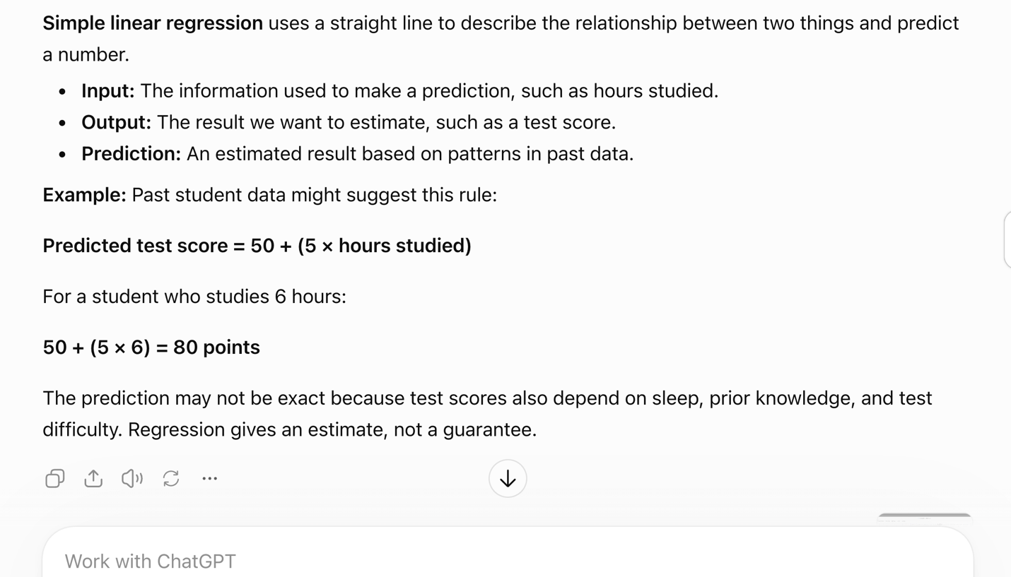
This prompt states my learning level, asks for definitions, and gives a specific example. It also asks about prediction limits and sets a word limit, making the answer focused and easier to understand.

- SQL
I am a beginner studying data analytics. Explain what SQL is in simple English define SELECT, FROM, and WHERE. Show one example using a Courses table with Course Name and Enrollment Count to find courses with more than 200 students. Explain each line of the query.
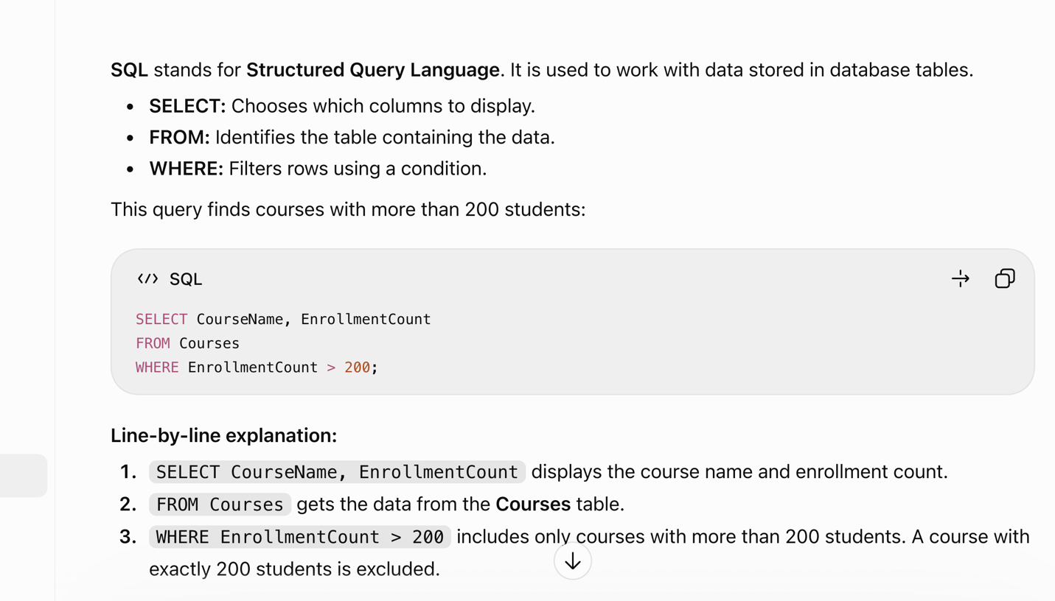
This prompt explains my learning level and names the SQL commands I want to understand.
It gives specific tables and conditions for the example. Asking for a line-by-line explanation helps me understand how the query works.
- Create a Dataset.
Create a function dataset for beginner Excel practice with exactly 10 rows of data. Include product name, Units Sold, and Unit Price in US dollars. Use whole numbers between 10 and 100 for Units Sold, and prices between $5 and $50. Include no missing values. Format the dataset as a table with column headings.
Here is a fictional dataset with 10 data rows, plus the header row.

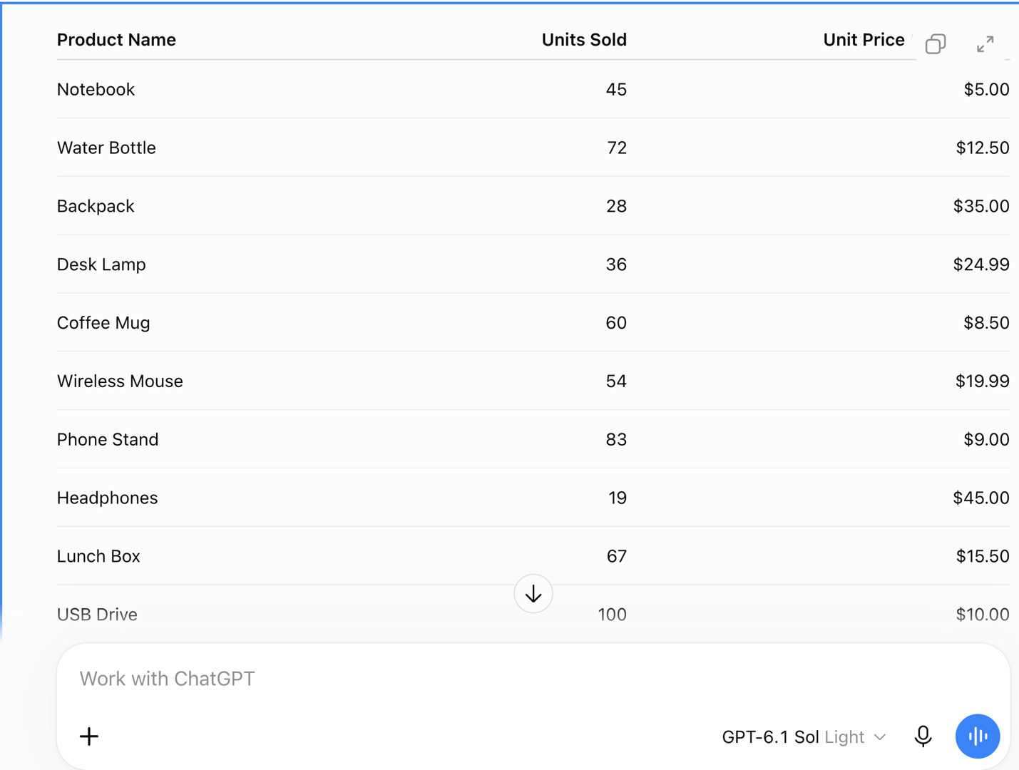
This prompt explains the purpose of the dataset and specifies exactly 10 data rows. It names the columns, sets number ranges, and identifies the currency. It also requests no missing values and a table format, making the data easier to use in Excel.

