

Understanding Quality Control (QC)



Contents
Tutorial Information 2
Tutorial learning objectives 2
An introduction to Quality Control filtering as applied by MGnify 2
What are MGnify QC steps? 3
Finding Quality Control information about samples on the MGnify website 4
Exercises 5

Tutorial Information
Course description | This tutorial provides an introduction to the Quality Control (QC) filtering steps of microbiome data as used on the MGnify (formely EBI Metagenomics) resource. You will learn about the requirement for QC filtering, the different steps applied to filter sequencing data prior to analysis and understand the QC display.  Filtering sequences from host organism will also be explored
Course level | Suitable for graduate-level scientists and above, who have not used MGnify before
Pre-requisites | Basic knowledge of biology and basic knowledge of Unix
Subject area | Data management and Sequence Analysis
Target audience | Scientists interested in metagenome analysis
Resources required | Internet access (a current browser such as the latest version of Firefox, Chrome or Safari), FASTQC and other publicly available tools
Approximate time needed | 40 mins

Tutorial learning objectives
After completing this course, you should:
- understand how MGnify applies quality control filtering prior to perform analysis of metagenomic data sets
- know where to find and how to interpret QC filtering summary for samples on the MGnify website
- understand how to filter host sequences from dataset

An introduction to Quality Control filtering as applied by MGnify
The MGnify resource (formely EBI Metagenomics) provides taxonomy and functional analysis of metagenomics, metatranscriptomic and amplicon data sets. These data sets originate from parallel sequencing (NGS) and contain often millions of sequences that need to be filtered prior to being analysed in order to remove low quality and non-informative sequences. Quality Control (QC) filtering is essential to ensure that only information-containing data are fed to the analysis pipeline (garbage in, garbage out !).

What are MGnify QC steps?
MGnify QC filtering is comprised of three steps:
- Trimming: to remove trim low quality ends
- Quality filtering: sequences with more than 10 % of undetermined nucleotides (“N”) are removed
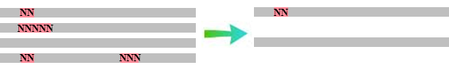

- Read length filtering: a threshold of 100 nucleotides is currently applied

Note that this schema refers to the latest versions of the MGnify pipeline (version 2.0 and above). For version 1.0, in addition, the QC pipeline included, after the length filtering a clustering step, to reduce the redundancy in the submitted reads, and a masking step, where low-complexity regions (small repeats) were removed.

Finding Quality Control information about runs on the MGnify website
Quality control summary of samples within projects on the MGnify website (wwwint.ebi.ac.uk/metagenomics/beta) can be accessed by clicking on the Quality control tab found toward the top of any Run page (see Figure 1 below).
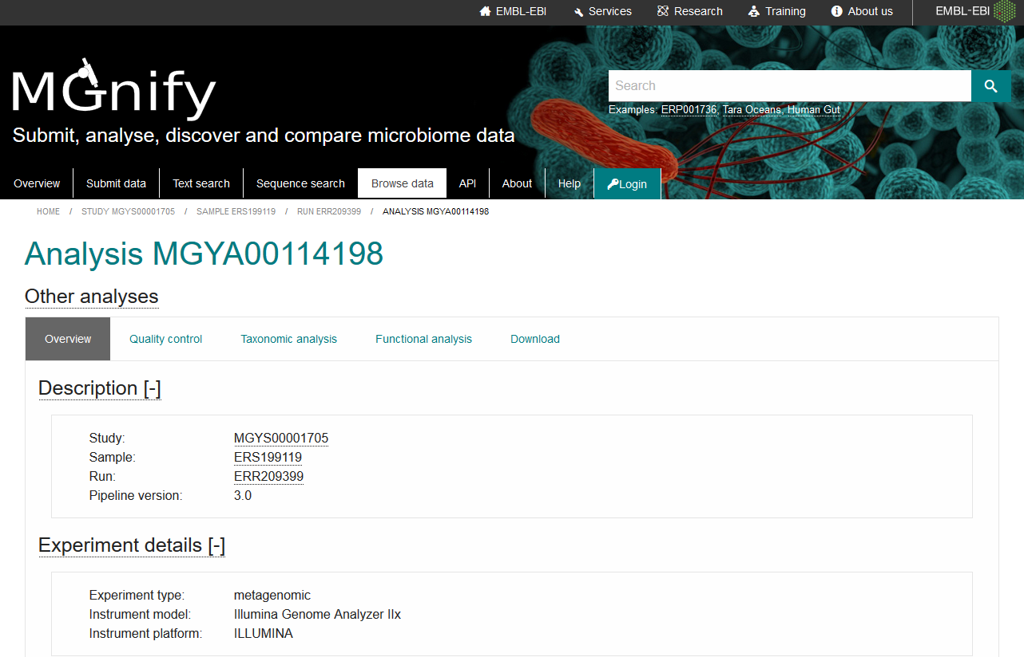
Quality Control tab
Figure 1. A Quality Control tab can be found towards the top of each sample page.
Clicking on this tab brings up a page displaying QC information. The page contains 3 sections since the version_3.0 of the pipeline (Figure 2). Runs analysed with earlier versions will only have the top section. This section displays a bar chart to represent the number of sequences remaining after each step.
The second section presents the length and GC distribution of the reads having passed the MGnify QC, as histogram and bar charts. The last section shows the nucleotide distribution from the beginning to up to 500 nucleotides across all reads having passed the MGnify QC. All charts are interactive and respective values are displayed when the pointer is positioned above the charts.
The information provided in these graphs allows users to investigate the quality of their runs and identify eventual issues. Note that the nucleotide distribution histogram presented in figure 2 is from a WGS run. Figure 3 presents what is typically obtained for 16S amplicon runs.

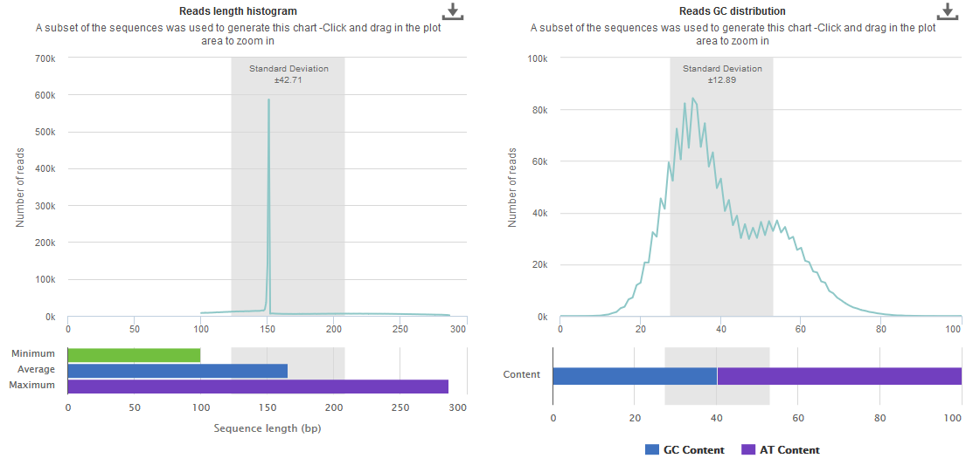
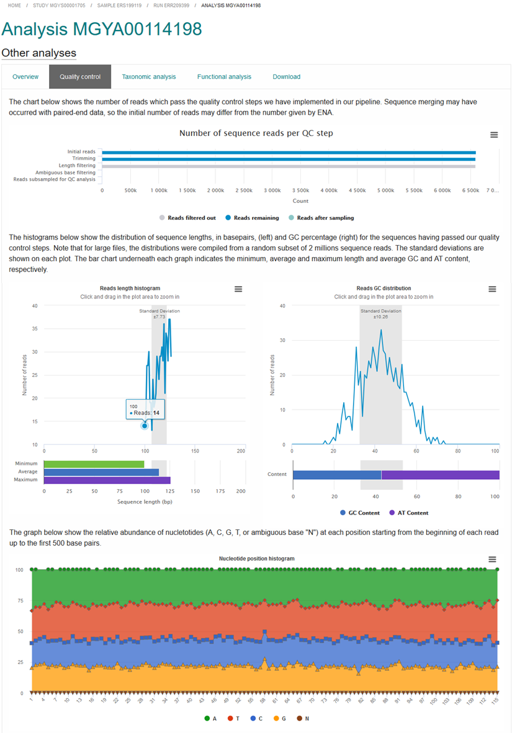
Figure 2. Quality Control information as shown on the MGnify website.
Note that in the top section, when the number of reads is superior to 2 million, a supplementary bar is displayed (in green) to indicate that the next QC representations were generated using a random subsample of the run.

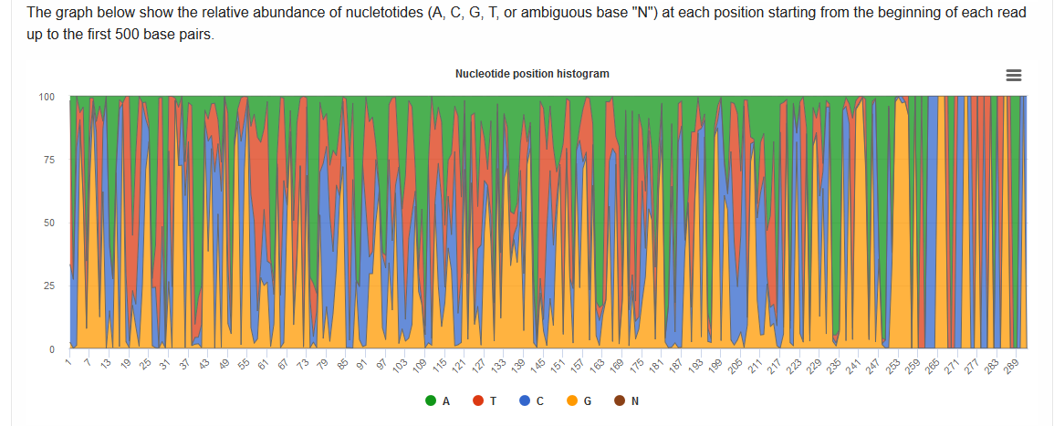
Figure 3. Typical nucleotide distribution histogram for amplicon run as shown on the MGnify website.

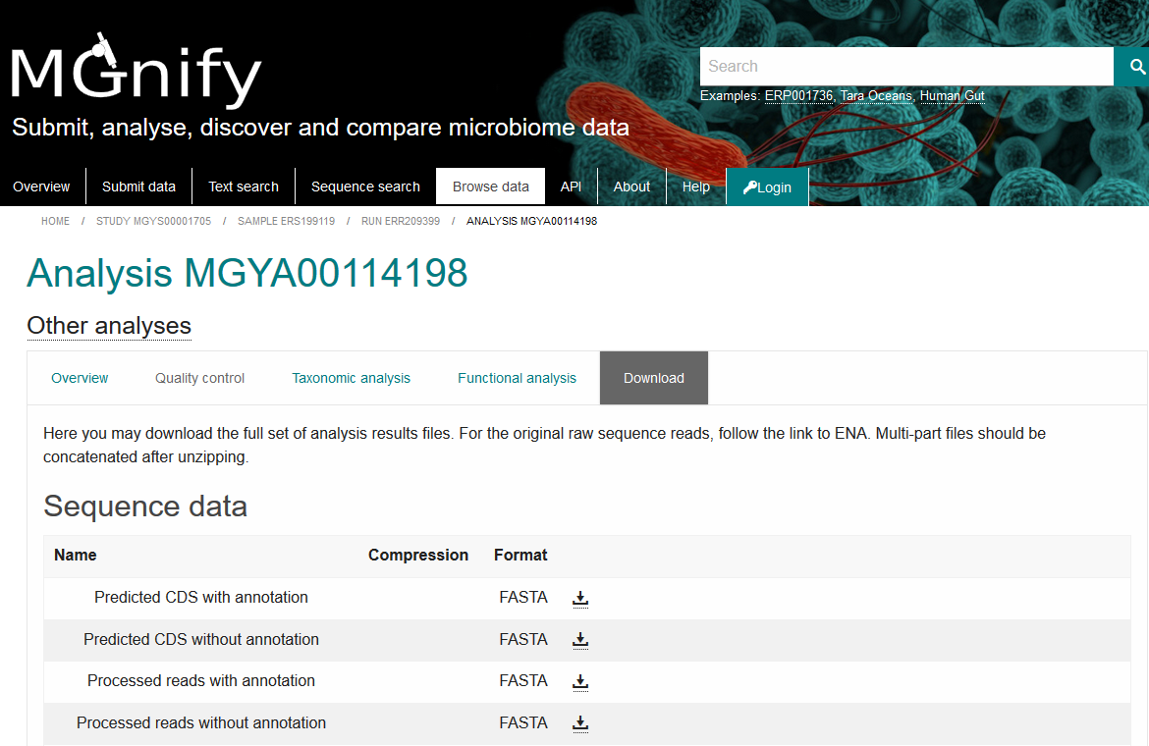
Download tab
Figure 4. Each run has a download tab, where the full set of sequences, analyses, summaries and raw data can be downloaded. The ‘Processed nucleotide reads’ file include all sequences having passed the QC step.

Exercises
In this exercise, we will investigate the result of the MGnify QC steps on a metagenomic datasets obtained from water collected on the sea surface in the Atlantic ocean. We will perform some of the QC steps on this dataset to illustrate their effects. Then we will investigate the effect of removing host sequences.
All instructions are decomposed step by step and indicated by the pictogram .
The dataset will be investigating is the run ERR770961 corresponding to a WGS sequencing of a filtered bucket of water (sample ERS667571).
More details on this project and samples could be obtained from the MGnify page (Study MGYS00000462 / ENA project ERP009703 ‘Ocean Sampling Day (OSD) 2014: amplicon and metagenome sequencing study from the June solstice in the year 2014’). You can read about it in your spare time. For now, you just have to know that this dataset was submitted as paired-end files obtained following Illumina MiSeq sequencing.
In order to complete this exercise in time, we will work on a random subsample of one of the submitted file, ERR770961_1.fastq. The ERR770961_1_ext.fastq contains about a 100th of the number of sequences of the original file (30,000 vs 2,990,018).
I- Visualising the ERR770961_1_ext.fastq file
In order to visualise the subsampled sequence file, we will now use a quality control viewer called FASTQC (freely available at http://www.bioinformatics.babraham.ac.uk/projects/fastqc/) (It is already installed on your machine but you could install it freely on any computer running Java).
FASTQC has been added to your path, meaning that you can call it by entering fastqc (alternatively, you could also call it by using the path to its installation).
Type ‘fastqc’ in a terminal window. Open ‘ERR770961_ext_1.fastq’ file located in the ‘QC_session’ folder (File/Open). Upon loading the file, basic statistic for this file is displayed. Take a moment to familiarise yourself with the other menu items, ignoring the colour codes in front of their names.
 For this practical, we will only use information in the Basic Statistics, Per base sequence quality, Per sequence quality scores and Sequence Length Distribution.
 Question 1: After having looked through these menu items, what could you say about this file ? Comment on its (1) length distribution and (2) read quality.
II- Performing QC steps on the ERR770961_1_ext.fastq file
Now we will perform QC steps on this file using a package named Trimmomatic. This package is written in the programming language Java however no knowledge of Java is necessary to run it. All steps are decomposed below. More explanations can be found in the Trimmomatic manual (http://www.usadellab.org/cms/uploads/supplementary/Trimmomatic/TrimmomaticManual_V0.32.pdf). A summary version is also available at: http://www.usadellab.org/cms/?page=trimmomatic.
Trimmomatic is able to perform Illumina adapters, quality and length trimming, 3 steps that are integral part of a QC.
The quality trimming will be perform using the “LEADING” and “TRAILING” options to remove low quality bases from the start and end of reads, respectively. In addition, we will use the “SLIDINGWINDOW” option which scans the reads with an n-base wide sliding window and cutting them if the average quality per base drops below a defined quality value.
The length trimming step will filter out reads with lengths shorter than a specified value using the “MINLEN” option.
Open a terminal window and navigate to the shared drive ‘QC_session’ folder. List the files in this folder:
cd ~/QC_session
ls
The Trimmomatic executable has been added to your path mining that you can call it directly by typing ‘trimmomatic’ (alternatively, you can provide the path to the executable and prefix the call, below, by java -jar). To perform the quality trimming, we will choose a minimum value of 8 (out of possible 40) for the “LEADING” and “TRAILING” options and a length of 4 and minimum quality value of 15 for the “SLIDINGWINDOW”. For the length selection step, we will choose a minimum value of 100 nt. These values are the ones used within the EBI Metagenomics pipeline.
In interest of time, we will perform these 2 steps with one command on only one of the paired-end files. Please navigate to the folder where the files are located and type or copy the line below in your terminal window:
trimmomatic SE -phred33 ~/QC_session/ERR770961_1_ext.fastq ~/QC_session /ERR770961_1QL.fastq LEADING:8 TRAILING:8 SLIDINGWINDOW:4:15 MINlEN:100
where “-phred33” indicate the quality encoding, “ERR770961_1_ext.fastq” is the input file and “ERR770961_1QL.fastq” is the output file.
Question 2: What was the impact of the 2 QC steps on the ERR770961_1_ext.fastq file?
III- Filtering host sequences from the ERR770961 dataset
Samples are susceptible to be contaminated by the collector during the collection and susbsequent handling. And, of course, any ‘Host-associated’ samples are very likely to contain host DNA. These contaminant sequences are likely to lead to errors in the taxonomy and functional annotations.
It is therefore important to be able to remove these sequences. The approach we will follow in this brief tutorial is to use the freely-available software deconseq (http://deconseq.sourceforge.net/index.html). This tool identifies sequence(s) with significant similarities to a reference database and output a set of ‘contaminant’ sequences and a set of ‘clean’ sequences.
In this tutorial, we will use a database composed of the latest version of the human chromosome assemblies as available at the NCBI server. To ensure better accuracy, we will use the set where alll small repeat regions have been masked (i.e. replaced by stretches of ‘N’).
In the interest of time, I have precompiled this reference database for this tutorial however I gave the full instructions to generate your own database of interest at the end of this handout. We will also perform the filtering on a subset of ERR770961_1_ext.fastq containg 200 sequences for the same reason.
Open a terminal window and navigate to the shared drive QC folder. List the files in this folder:
cd ~/QC_session
ls
copy or paste the following command to call the script:
perl deconseq-standalone-0.4.3/deconseq.pl -f <path to ERR770961_1_100.fastq> -dbs hsref -out_dir <path to output Filtered_deconseq directory> -id ERR770961_filtered -c 90
typing ‘ls -ltr' will list the newly generated files within the newly created Filtered_deconseq directory. They should be two fasta files: one containing the ‘contaminated’ sequences and one containing the ‘not-contaminated’ ones.
ls –ltr Filtered_deconseq
we will an unix command to look at the number of sequences identified as being from human (we could also use FASTQC):
cat Filtered_deconseq/ERR770961_filtered_cont.fastq | grep -c '^@ERR'
(this command will count the number of reads (lines starting with @ERR))
Question 3: What was the impact of the host filtering filtering on the number of sequences in ERR770961_1_100.fastq?
Question 4: What could you deduce about this sample?
IV- Comparing the taxonomy before and after filtering for host sequences from the ERR770961 dataset
Taxonomic results for the pre-filtered dataset is availble on MGnify website. They can be download as tabulated or machine-readable ‘OTUs, reads and taxonomic assignments’ files. In addition, we provide an interactive Krona chart (https://github.com/marbl/Krona/wiki) that allow users to zoom in on the feature of interest.
We will compare the SSU Krona chart for with ERR7709611_ext.fastq with the one for ERR7709611_filtered.fastq. I have generated the the html files supporting the Krona charts for both of these, however I have also provided detailed instructions allowing you to easily generate them yourself in the ‘How_to_generate_Krona_plot’ file provided in the QC session folder.
Question 5: What can you say about the impact of the host sequence filtering on the taxonomic diversity of the ERR770961 dataset?
Instructions to generate the database use in this tutorial:
- Download the human sequences to filter out:
To download the masked human chromosome sequences:
for i in {{1..12},X,Y,MT}; do wget ftp://ftp.ncbi.nih.gov/genomes/Homo_sapiens/Assembled_chromosomes/seq/hs_ref_GRCh38.p12_chr"$i".mfa.gz ; done
- Concatenate the fasta sequences into one filet:
cat hs_ref_GRCh38.p12_chr* > hs_ref_GRCh38.mfa.gz
- Decompress the fasta file:
bsub -q production-rh7 gzip -d hs_ref_GRCh38.mfa.gz
- Obtained deconseq from https://sourceforge.net/projects/deconseq/files/ and decompress the download:
tar –xjf deconseq-standalone-0.4.3.tar.gz
- Ensure you have the correct version of bwa:
The resulting ‘deconseq-standalone-0.4.3’ folder contains a number of files including bwa64, to run deconseq on Windows, and bwaMAC, to run deconseq on Apple Mac computer.
For Linux and other operating system, you need to download bwa from http://sourceforge.net/projects/bio-bwa/files/bwa-0.5.9.tar.bz2/download and follow the instructions provided at https://sourceforge.net/projects/deconseq/files/.
- Then run this instruction from within the bwa-0.5.9 directory:
./bwa index -p hs_chr_masked -a bwtsw ‘path to hs_ref_GRCh38.mfa’ > out.txt 2>&1 &
Note: you can list the bwa options to understand this call better by simply calling:
./bwa

