The Priority SFDC Interface.
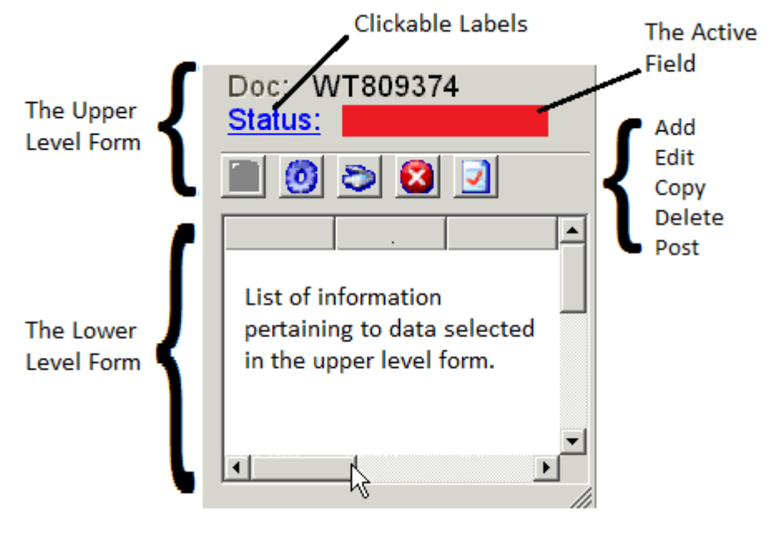
The Priority SFDC interface is a one-to-many screen, displaying header records in the upper level form with multiple related records shown in the lower level form. The current record is indicated by a red cursor, and navigation around the form is achieved with the device jog-wheel, or by clicking one of the hyper linked label controls to select a specific field. Data in the sub level may be edited / manipulated by using the buttons between the upper and lower level forms.

The Works Order Document (and other bar codes)
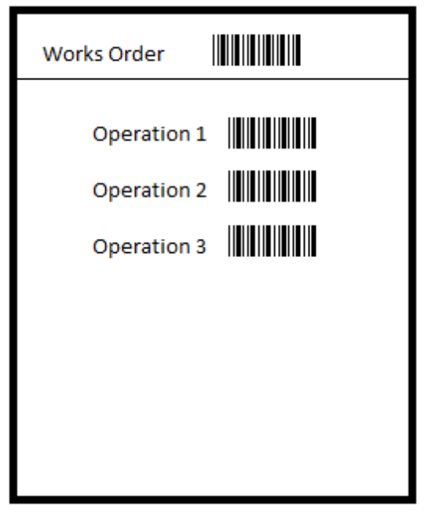
To facilitate the selection of the correct works order / operation in the upper level of the forms described in production reporting printed works orders from Priority will include both the bar code for the works order and bar codes relating the the operations specified by the part routing.

Additionally, work cell and warehouse/bin location bar codes should exist in the physical locations that they describe and workers should carry their own bar code identifiers.

Production Reporting
Issues to Kit / Inventory Control
Issues to kit and inventory control functions such as back-flushing the floor warehouse are primarily maintained from Priority and as such will not be replicated in full on the device.
This is similarly true for many of the many reporting functions that are available in Priority.

The Upper Level Form
Each of the upper level forms for this module will share the following fields, which will automatically populate these details on the sub level form.

Work Order Number
Scanned from the Works Order document
Part Name
Read only, based on the WO Number
Works Order Quantity
Read only, based on the WO Number
Operation
Defaults to the last un-fully reported operation in the routing
Alternatively operation may be scanned from the operation bar code on the Works Order documents
Work Cell
The location in which the operation is to be conducted.
This will default to the default work cell for the operation
Additionally the work cell may be manually overridden by scanning the work cell bar code from the wall of the work cell.
The Frozen Status (Stop Status Override)
If the status of the Works order is frozen then this field is populated with a STOP message. No further work is permitted in the sub-level until this flag is cleared.

The Sub Level forms
Depending on the option selected from the main menu screen the sub level form will be populated as follows:

Record Set Up
Lists users engaged in the set-up for this operation of the works order
Reporting workers must be logged in using the time and attendance procedures.
Reporting workers are added to the sub level form by scanning their user bar code.
Adding a worker to the record set-up sub level automatically records the current time as the start labour time of this user on this works order. The start labour time can be manually overridden.
Adding a worker to the record set-up sub level should simultaneously record the end labour time for that worker on any previously active works order
Reporting production on the operation being set-up will automatically record the End Labour Time on this works order for all reporting workers.

Run Machine
Enables the user to record start and end times of machines running the specified works order
Where no start time has been recorded the start time will default the machine start time to the current time
Where a start time is specified, but no end time exists this will default the machine end time to the current time
Start and end times for the specified works order may be input manually by selecting the sub-level item and clicking the edit button

Reporting Workers
Reporting workers must be logged in using the time and attendance procedures.
Reporting workers are added to the sub level form by scanning their user bar code.
Adding a worker to the reporting workers sub level automatically records the current time as the start labour time of this user on this works order. The start labour time can be manually overridden.
Adding a worker to the reporting workers sub level should simultaneously record the end labour time for that worker on any previously active works order
Reporting production on the last operation will automatically record the End Labour Time on this works order for all reporting workers.

Manual Issues
To allow for the manual issuance of raw materials to this works order
This procedure is to backstop the issue to kit functionality included within the desktop version of Priority.

Production Report
By default this sub form will contain reports for quantities for completed and Material Review Board.
Multiple additional “Reject” reports may be made, each listing both quantity rejected and a reason code for the rejection
Total items (Complete + Reject + MRB) reported for each operation may be no more that the total completed items for the previous operation

Rework
tbc

Time and attendance
Production reporting incorporates rules with regards worker log on / off
Workers must be signed in to be listed as a reporting worker on a works order
Worker sign off should populate end-times for any active production reports for that worker
Worker Sign in/out will be recorded under the Priority form “Work Hour Reporting”
Log in/out on the device application is primarily designed for application security and as such is not compliant with time and attendance reporting.
We propose the implementation of a separate mag-stripe system to integrate with Priority’s “Work Hour Reporting” functionality for this application.

Goods Receipt
We offer a number of good receipt transaction models with the Priority SFDC system. Many of these have been developed to handle complex goods receipt operations. These include handling part shipment, handling multiple purchase orders in a single shipment and differentiating between deliveries comprised of single items or boxed items with multiple quantities.
Described below is the most generic version of the Goods Receipt procedure for reference, but it is understood that this will likely be customised to meet specific customer requirements.

Upper Level Form
Purchase Order Number
Scanning the PO Bar code will automatically populate the undelivered items from the scanned purchase order onto the sub level form.
To Warehouse
The default warehouse into which to receive the items
To Bin
The default bin location into which to receive the items

Lower Level Form
Part
Populated when the purchase order is scanned this column contains the list of parts we are expecting to receive on the purchase order. Items that do not have a Quantity Received recorded against them will be left in the open status.
To Warehouse
This specifies the to warehouse for this item I.e. where the inventory will be listed. This will be automatically filled in based on the to warehouse in the upper level form.
To Bin
This specifies the to bin for this item I.e. where the inventory will be listed. This will be automatically filled in based on the to bin in the upper level form
Quantity Expected
The read-only quantity we are still expecting to receive of the part on this purchase order – it is possible to use this to prevent over booking by displaying a message when our received quantity is greater that the expected quantity
Quantity Received
The actual number of this item that we have received. This value can be incremented by repeatedly scanning the part bar code, or by using the built-in numeric keypad to specify a number we are receiving.

