Priority Mobile Setup and Installation
Emerge-IT

Contents
Priority Mobile Service (SOAP) Install 3
Troubleshooting SOAP service errors 9
Test Loading 17

Priority Mobile Service (SOAP) Install

Install Visual Studio 2005 copy at \\hannibal\APPLICATIONS\MS VISUAL STUDIO 2005 (note this takes a long time to install from new)
Download latest version of Mobile from:
ftp://simon.emerge-it.co.uk/Priority Mobile/Server/PriSOAP/PriSOAPSetup/Debug/PriSoap.RAR
Download and Save both files to desktop
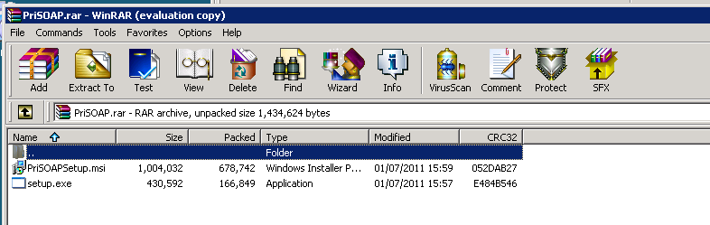

Run setup.exe – Click Next through all options
Priority SOAP Service is now installed, see screen below
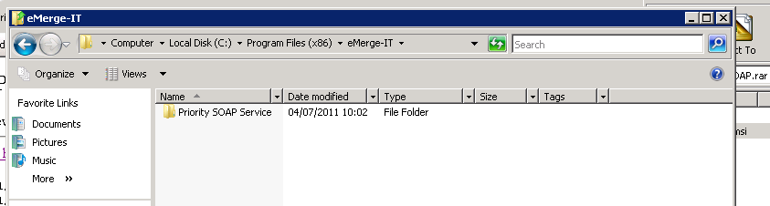

Installation of SOAP creates a folder Mobile (see below), Copy and Paste this folder into...
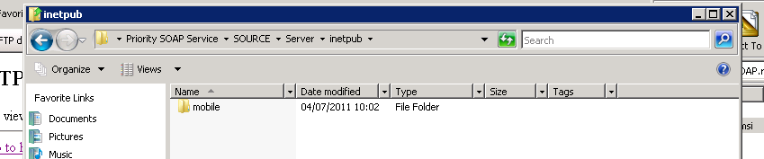

:C\inetpub (Below)
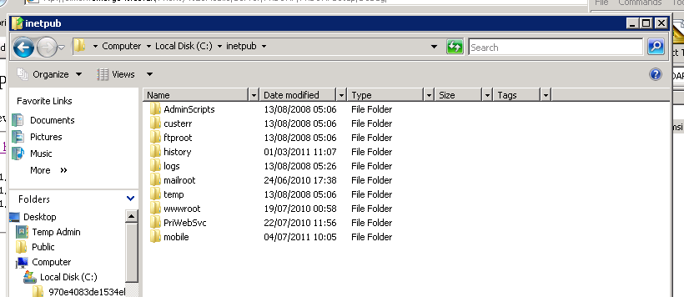

Setup Website configuration using Internet Information Services 7 (IIS7)
To download and install IIS7
http://learn.iis.net/page.aspx/28/installing-iis-7-on-windows-vista-and-windows-7/
Ensure you are able to browse to your local machine. 
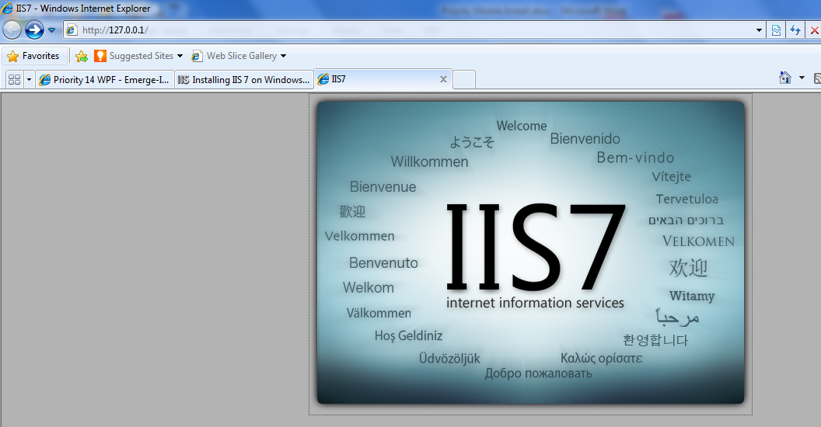
Run from Control Panel, Administrative Tools as below
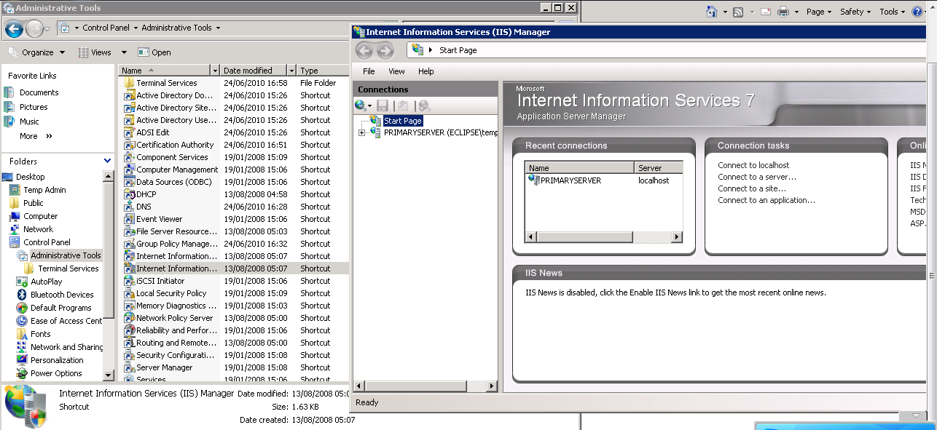
Expand PRIMARYSERVER tab
On Sites right click and Select – Add Web Site
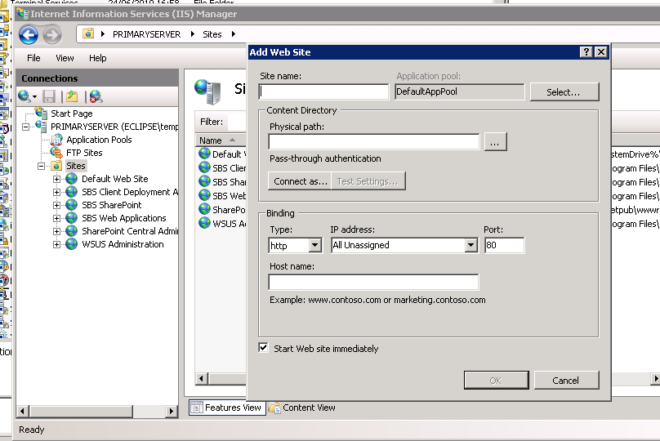
- Site Name - mobile
- Physical Path - C:\inetpub\mobile
- Port – 8080
- Host Name – Leave blank and unassigned this will then allow any in-bound connection on Port 8080 to be handled by the website.
- Click OK to create and run – Check to ensure the service is running before you go any further.
Register the SOAP Service to the Windows Event Log (administrator rights required for this)
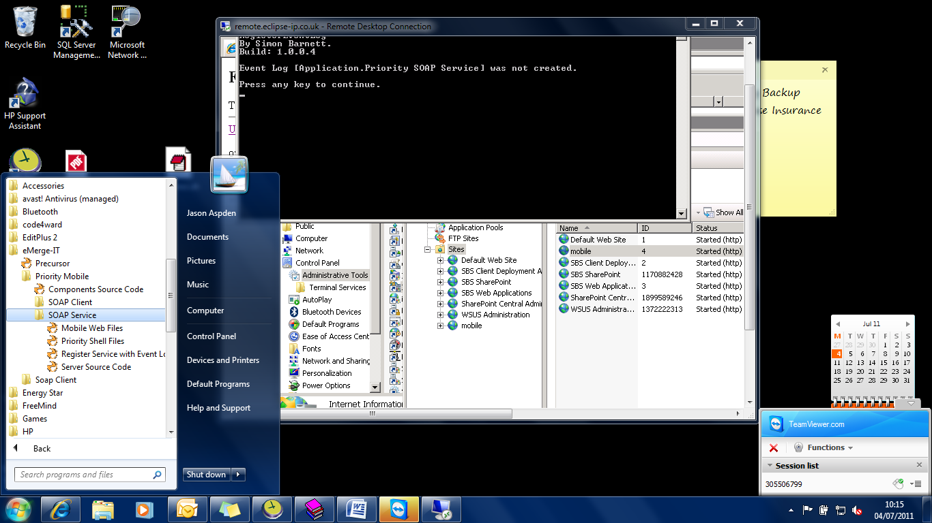

Drop down box shows all services registered with windows event log – Ensure PriLoad Client and PriProc are both registered.
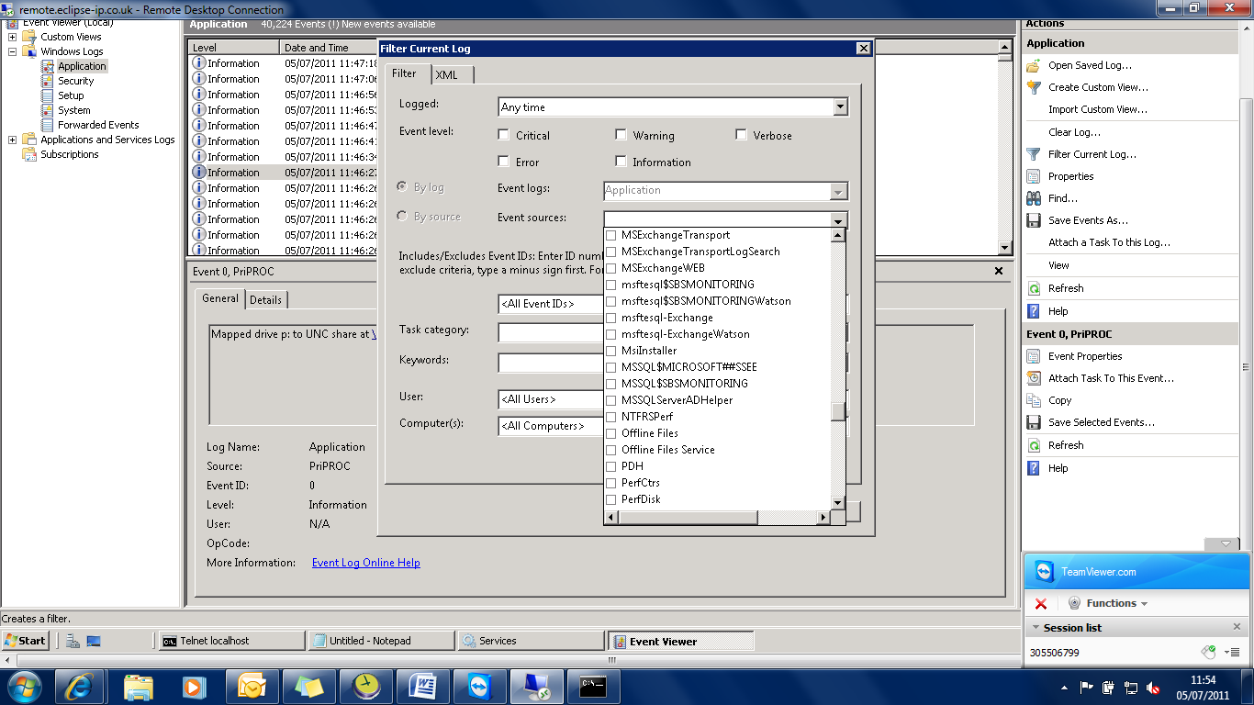

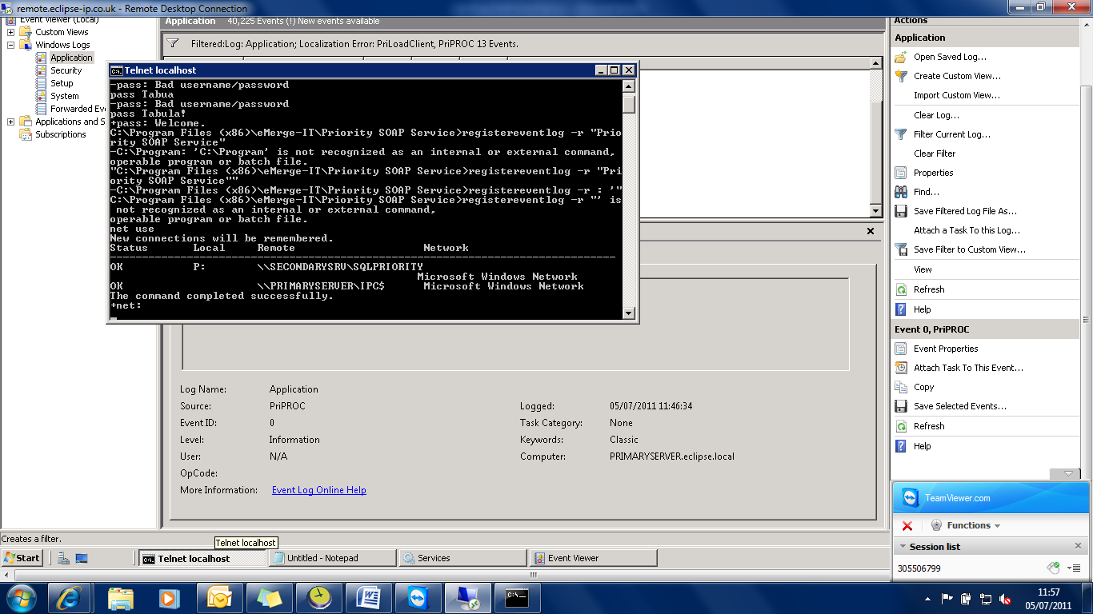

Go to host service address on port 8080 – the service should now be running, if so the following appears
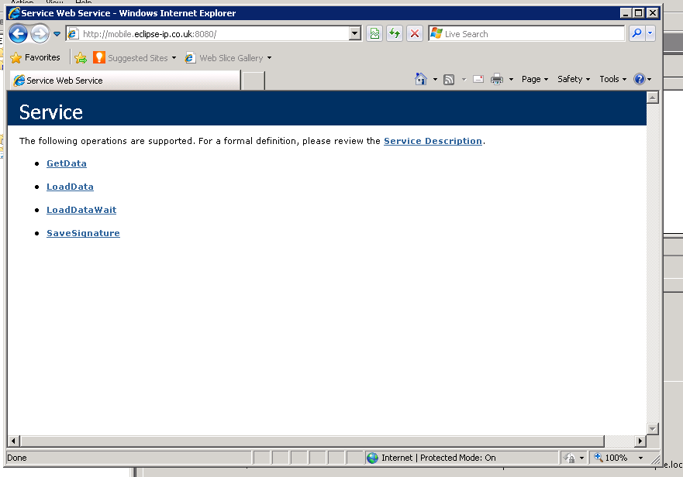

nslookup to check what IP address the host name resolves to.
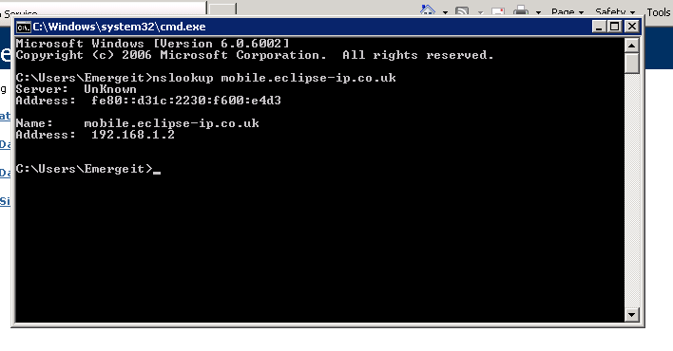

Use the config address (below) to enter Priority Mobile Console
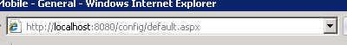
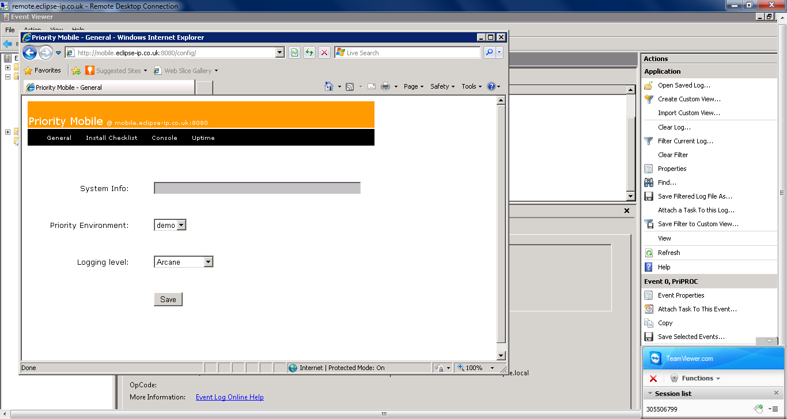
Run Install Checklist and click Test Configuration

Troubleshooting SOAP service errors
You will then need to troubleshoot any errors that appear.
To troubleshoot problems – Try adding http://localhost and *.”hostname” which will allow all protocols on all A records to be trusted. In the window below.
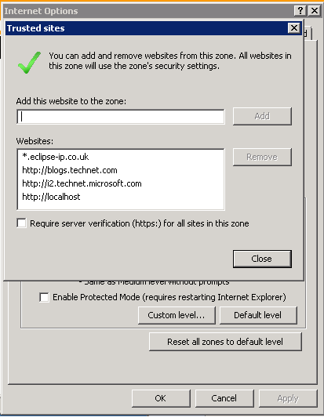

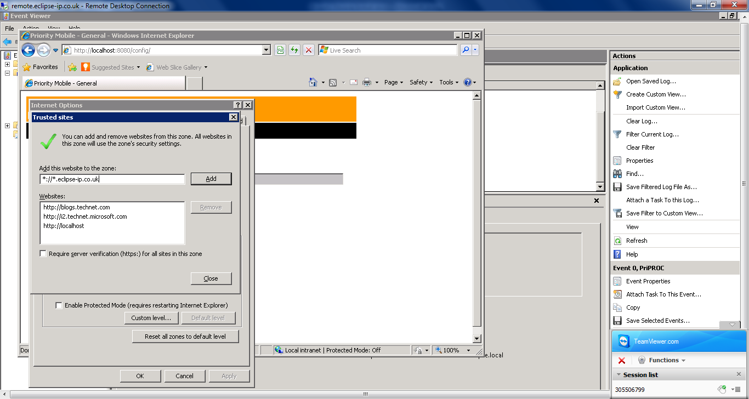

Click Refresh Environments which will show all environments (companies) that are available.
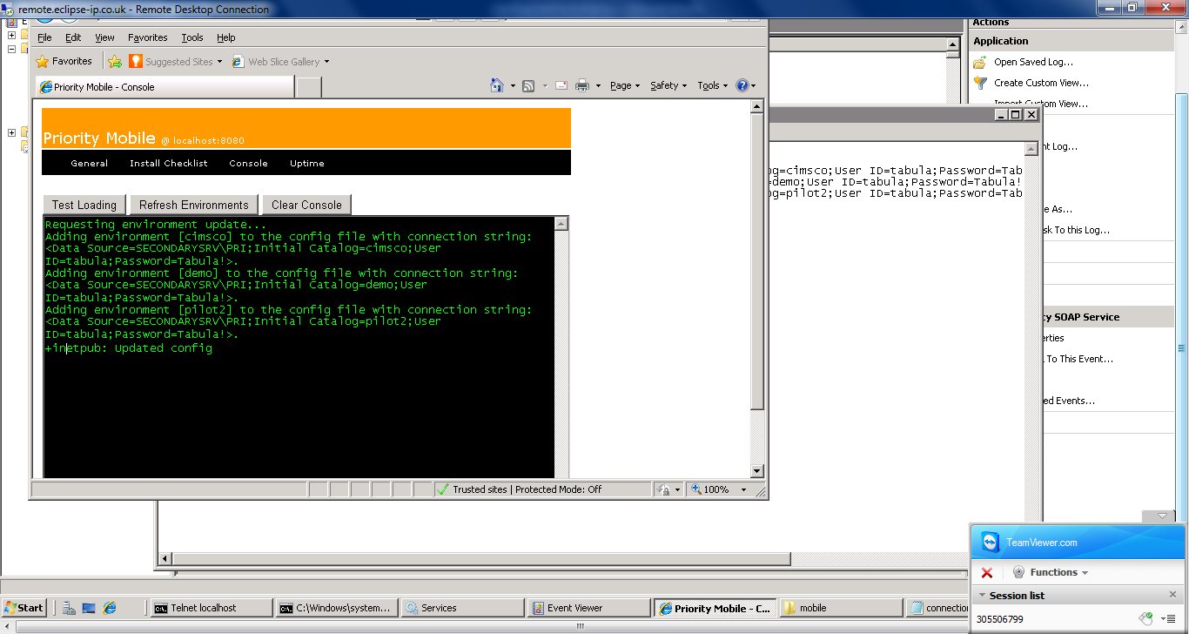

Environments information is found in inetpub/mobile (below)
The web config files (highlighted below) used by Priority Mobile refer (link) to the connections config files for environment details.
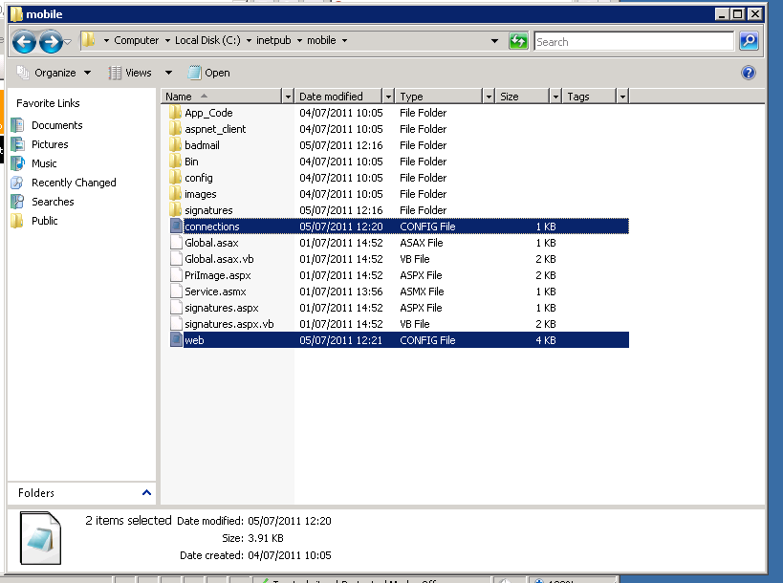
Connections Config file
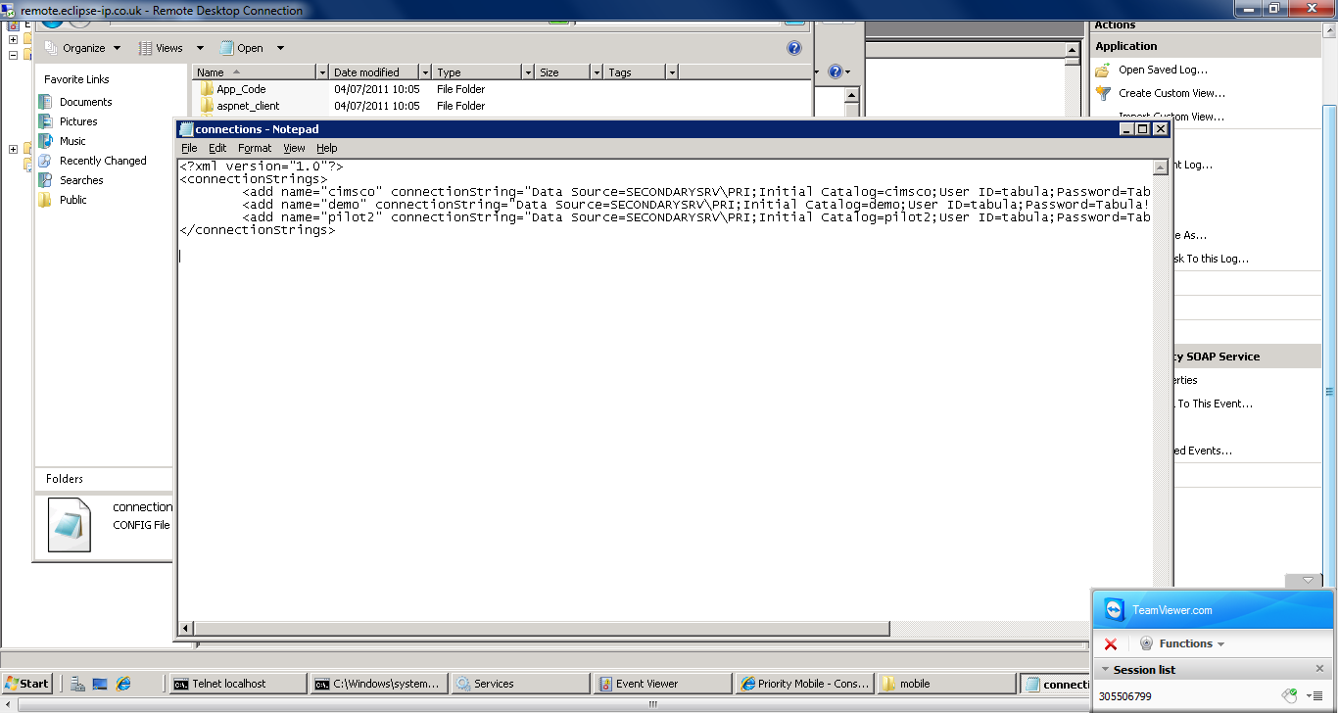
Badmail folder where errors are sent for debugging e.g. if an insert statement fails
Signatures folder is where all PDA signature information is sent
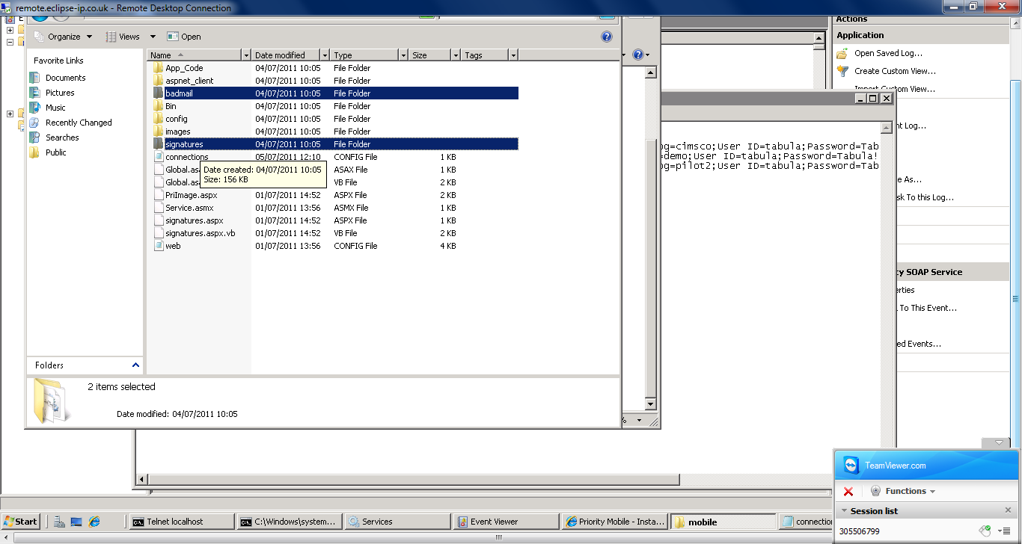

Set up permissions for Badmail, under security, goto Edit, Add, everyone (in object name), OK, set to modify tick box, apply
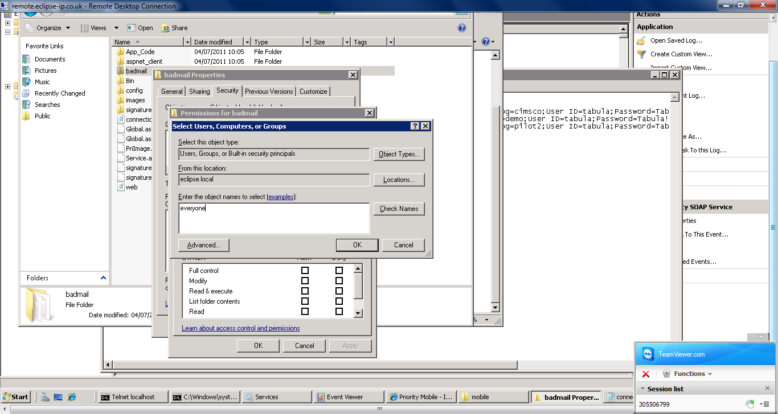

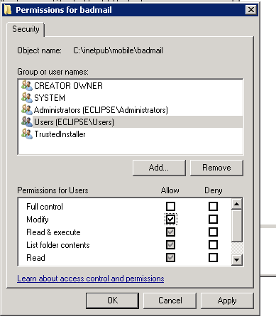

Priority Mobile environments will connect to the administrator account for each environment, sometimes the password will need changing as Mobile defaults to using Tabula!. See next two screen shots.
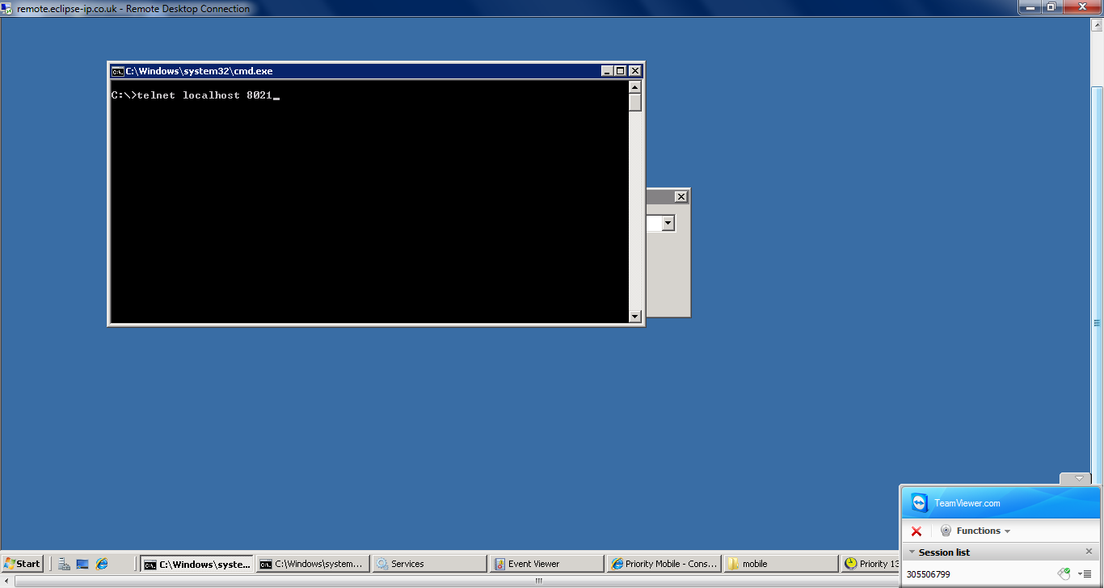

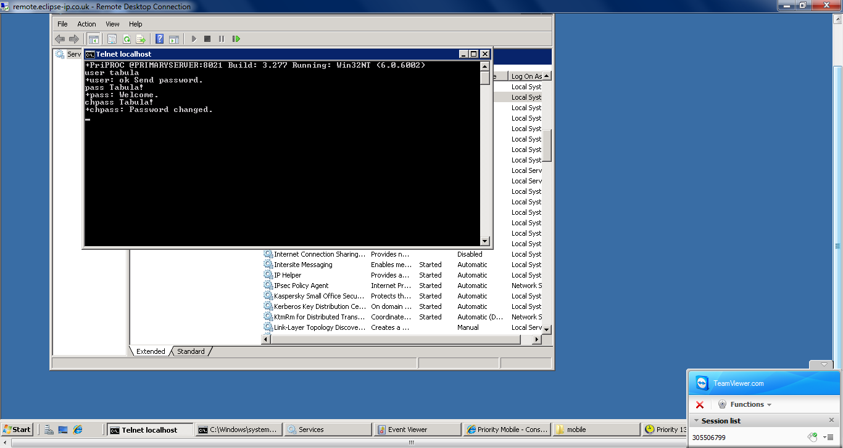

Test configuration now completed OK
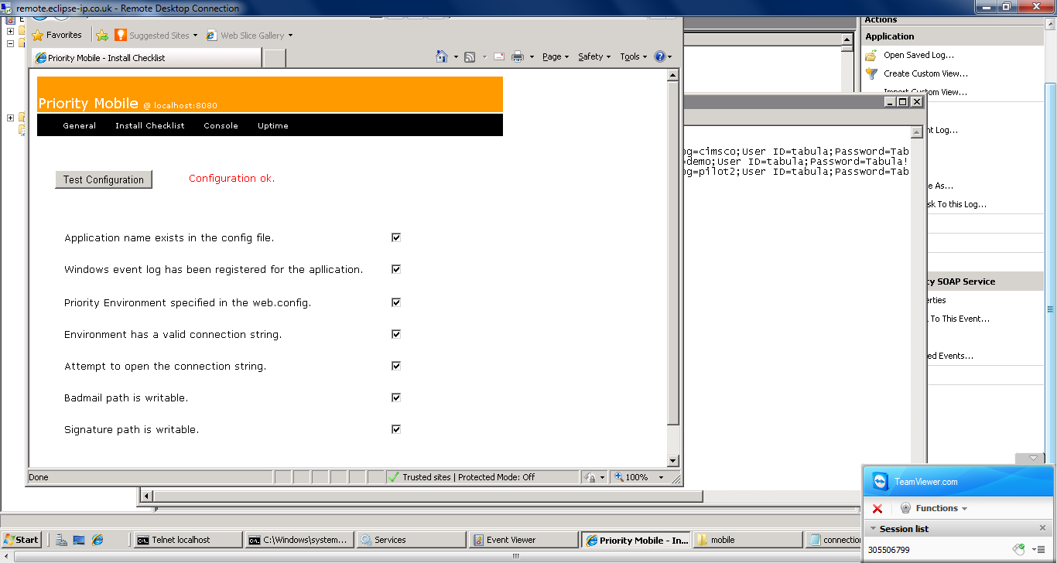

Check the company name against the database reference if required. To ensure you set the default company in the Priority Mobile Console Correctly.
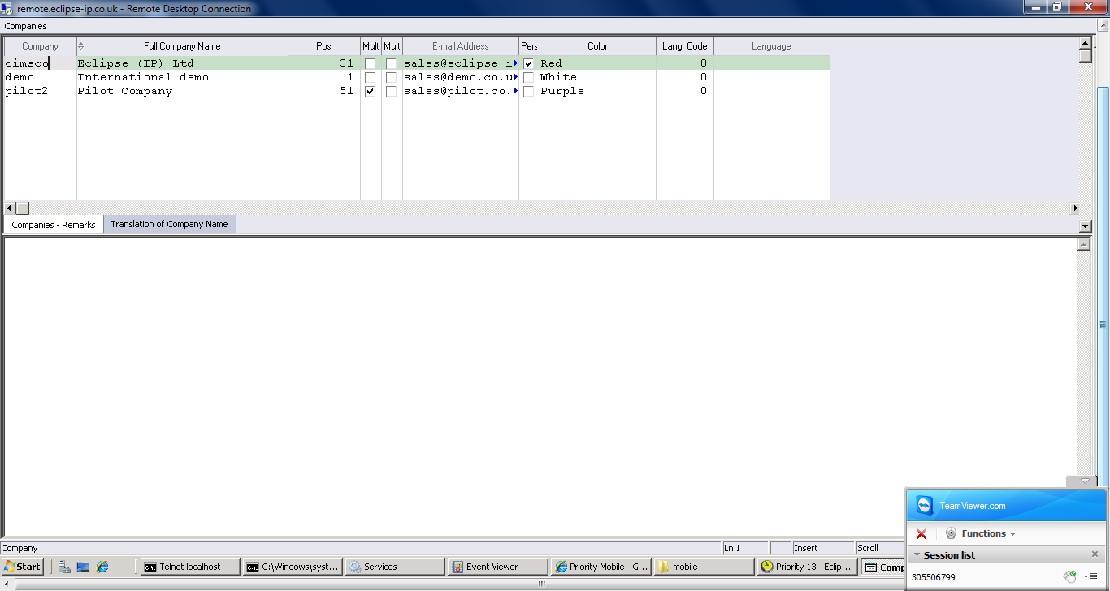

Test Loading
Priority Mobile Console – Test loading works by using a procedure called ZSFDC_TEST
- Create Table – ZSFDC_TEST
CREATE TABLE ZSFDC_TEST 'Connectivity Test' 1
USER (INT,13,'UserID')
CURDATE (DATE,14,'Date')
ORDINAL (INT,13,'Line number')
UNIQUE (CURDATE,USER,ORDINAL)
;

- Create Procedure ZSFDC_TEST
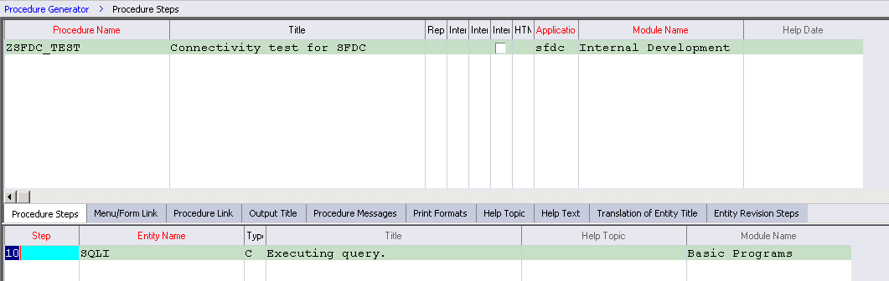
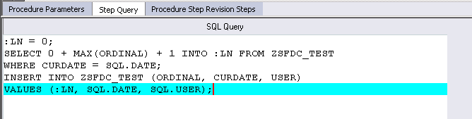
- Compile and run procedure
- SELECT * FROM ZSFDC_TEST
- Should see record just entered and loaded into the table.
- Empty table ZSFDC_TEST (DELETE FROM ZSFDC_TEST)

- Run Test Loading from Mobile Console
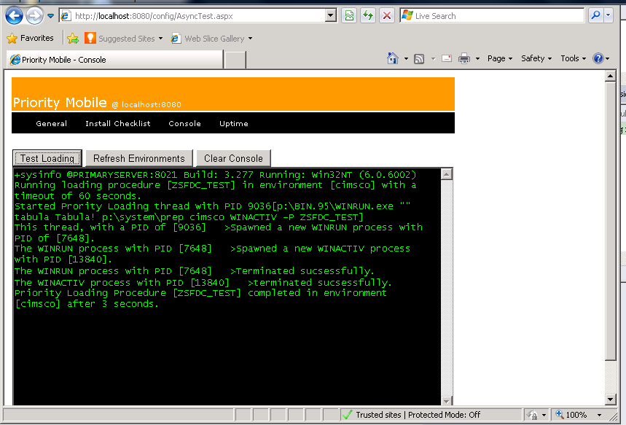
All OK, this has proved that the Web service will allow procedures in Priority

