World First.
Setup and Installation
Emerge-IT

World First Install Instructions 2
Internal Installation Instructions 2
Install the Soap Service 2
Install the binary files 2
Run the Priority Shell File 2
Configure the World First Login details 2
Modify the Procedures 3
Customer Installation Instructions 4
DNS Set-up 4
Priority Set-up 4
World First Operations 5
Get a rate 5
Make a bank transfer 5

World First Install Instructions

Internal Installation Instructions

Install the Soap Service
See separate document on the installation of the SOAP service.

Install the binary files
Download and install the set up from –
ftp://simon.emerge-it.co.uk/Priority%20Mobile/MerchServProviders/w1st.1.0.0.4.zip

This file needs to be installed into the priority folder as it needs to be available to all users (via their mapped Priority drive).

Run the Priority Shell File
Install the World First Shell File – {INSTALL_PATH}\Sh\WorldFirst.sh

Configure the World First Login details
Under company data enter the login details provided by World First. See figure below:

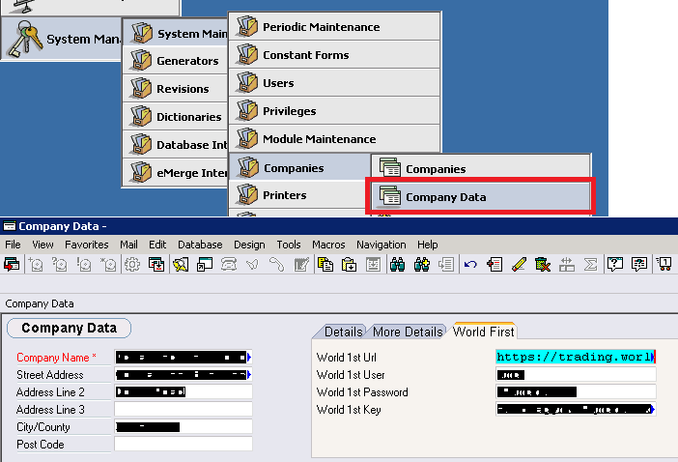

Modify the Procedures
Procedures installed by the Priority Shell File need to be modified to point to the \\PRIORITY server (see the figure below).
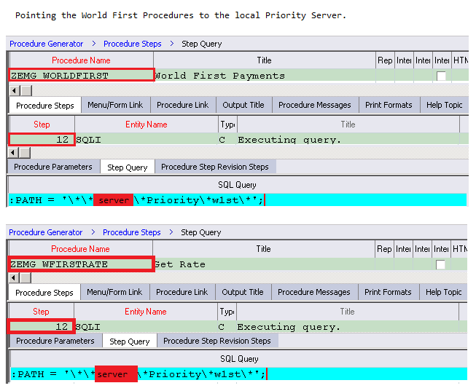

Customer Installation Instructions
The following tasks must be completed by the customer.

DNS Set-up
To allow the binary to connect to Priority a forward lookup zone of .soapsvc needs to be configured, with an A-record for “dns” (or just * - see figure below):

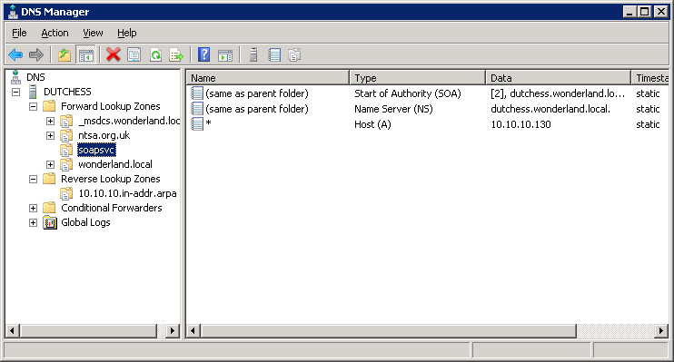

Priority Set-up
To enable payments via World First an account must be created for World First. Then create a bank account using the GL code you have created. See figure below.
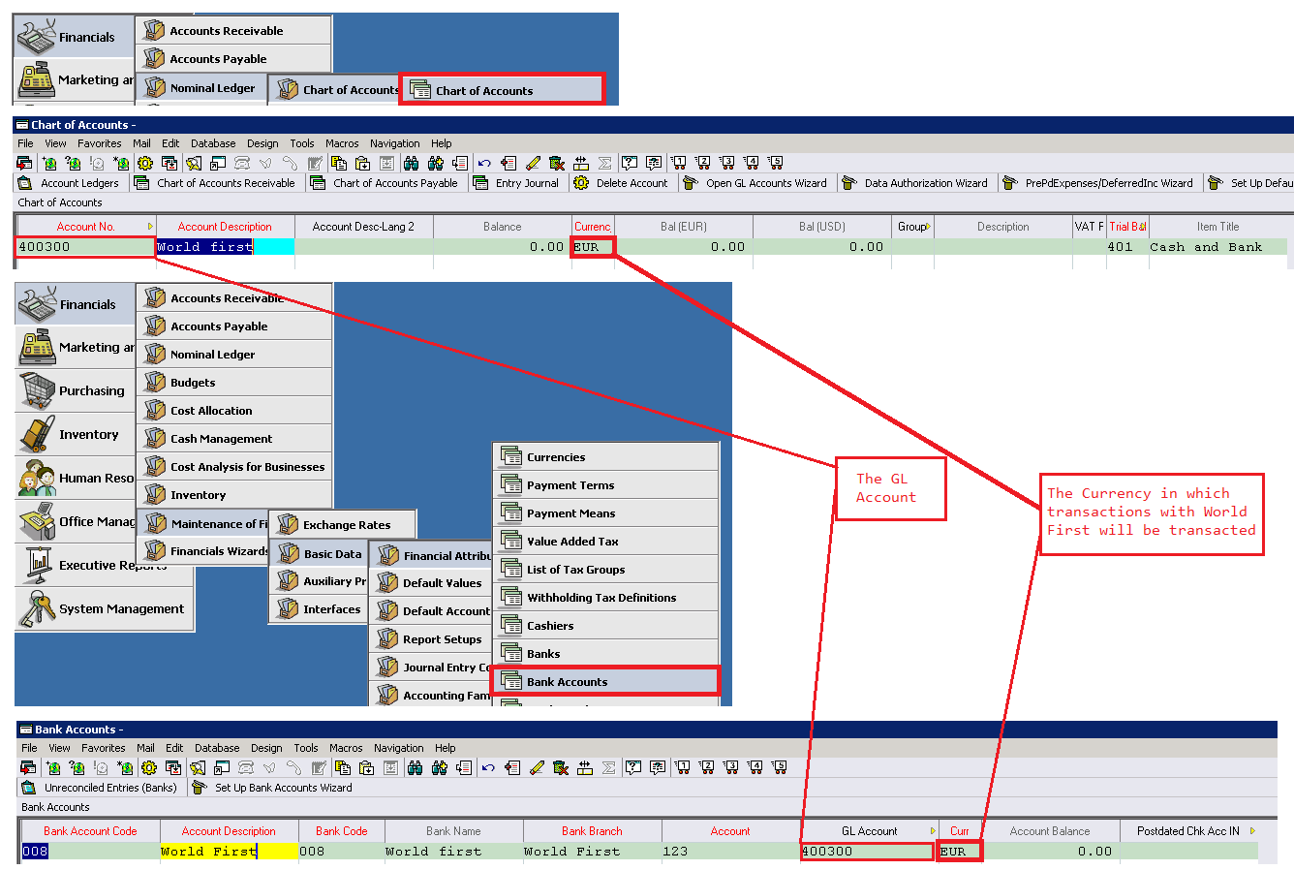

World First Operations

Get a rate

Make a bank transfer

