Priority Date Calculator
Since Priority calculates the date as the number of minutes since 01/01/88 is can be useful to know what that number is.
Once installed, this program will be in the start menu, and will 'remember' where it was placed on the desktop.
By Default the current date and time is shown as the Integer values of minutes since 1/1/1988. (13014036 in picture below).
Click on the gray box (see below) to drag and move the clock around the desktop.
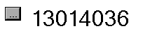
Right- click on the box to get the menu (see below)
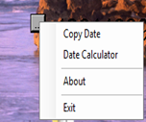
Select 'Copy Date' to put the current number into the clipboard.
Select 'Date Calculator' to enter a different date and time. See below.

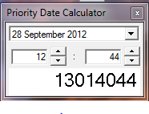
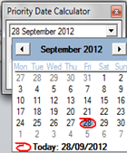

Use the arrow key beside the date to select a different date, or just overtype the date.
Right-click beside the number and select ‘Paste’ (see below) to paste a date in integer format from Priority into the calculator. This will give the date and time.
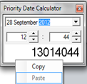
Example: 12487004 from Priority returns the date as below,
