FSM Executive Analytics Module
Architecture Feasibility & Implementation Endorsement | Design Review | 16 October 2026
Overall verdict: FEASIBLE TO IMPLEMENT. The architecture shown in the supplied infographic is technically coherent and compatible with the FSM target architecture. This endorsement applies to the architecture approach; it does not certify existing implementation, data-source availability, performance, or tested behavior.

1. Executive architectural decision
The proposed arrangement—React PWA presentation, authenticated FastAPI analytics API, analytics aggregation service, PostgreSQL operational records and daily summary, and scheduled background rollup—is a practical implementation pattern for the application. It fits the agreed React -> FastAPI modular monolith -> Supabase-hosted PostgreSQL deployment without introducing a new standalone analytics service or a second database.
Decision: Approve the HLD architecture concept for detailed technical design and subsequent implementation planning. Execution of code changes, migrations, tests, or deployment requires separate explicit authorization.

2. Architecture diagram — implementable topology
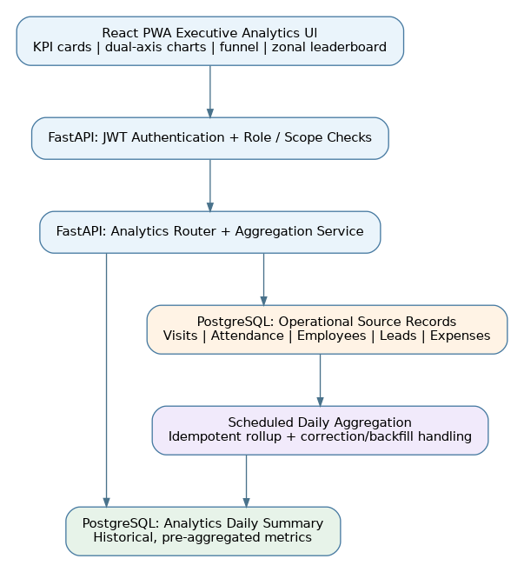
Diagram interpretation: the analytics service is part of the existing FastAPI backend. Daily summaries reduce repeat query costs for historical reporting; live source reads or explicitly refreshed summaries support fresher dashboard values.

3. Feasibility of the depicted layers
Layer in proposed infographic | Feasibility | Implementation condition
Executive React PWA dashboard | Feasible | Use the existing frontend for KPI cards, comparison charts, funnel and leaderboard.
FastAPI JWT, roles and analytics router | Feasible | Validate token and reporting scope server-side before supplying analytics results.
Analytics service + KPI aggregation | Feasible | Centralize metric computation and stable response contracts in a backend module.
PostgreSQL daily summary | Feasible | Choose a reporting grain and deterministic recomputation strategy.
APScheduler overnight rollup | Feasible with controls | Ensure jobs run once per deployment schedule; handle retries and historical corrections.
Operational table input | Feasible as a pattern | Source tables and metric definitions must exist and match production records.

4. How the implementation would work
1. The executive opens the analytics dashboard; React issues an authorized read request to the FastAPI analytics endpoint.
2. FastAPI validates identity, approved role and permitted geographic / organizational reporting scope.
3. The analytics service obtains available pre-aggregated historical metrics and recent operational values according to the freshness contract.
4. It calculates or assembles KPI cards, comparison series, funnel counts and zonal rankings, and returns one structured response.
5. A scheduled process recomputes daily summaries from qualifying operational records; repeated execution cannot double-count results.
6. Late changes and corrected records trigger explicit recomputation/backfill to keep summaries reconciled with source data.

5. Conditions to meet during detailed design
Design safeguard | Why it matters
Metrics contract | Definitions for strike rate, completed calls, funnel stages, expense burn, and zonal targets must be unambiguous.
Role and hierarchy scopes | Prevent unauthorized reporting access between employees, territories and zones.
Data freshness disclosure | A nightly-only summary is not real-time; specify which measures are current versus historical.
Idempotent rollup | Repeated schedules or retries must not inflate daily totals.
Corrections and backfills | Late visits, expense edits and status changes must be reflected in aggregates.
Query and index planning | Filtering by date and reporting scope must remain efficient for the expected volume.
Scheduler resilience | Define overlapping-job protection, failed-job retry and operational visibility.

