  - ORCA LABS / PRODUCT ENGINEERING

FSM & HRMS
Enterprise Architecture Report
Target architecture, business domain design, integration flows, client deployment model and refactoring approach
Architecture report | 15 October 2026
Purpose: communicate how the existing pharmaceutical field-force and HRMS application is structured today and how its API-first target architecture is intended to operate. This report is a planning document; it does not authorize code changes or migrations.
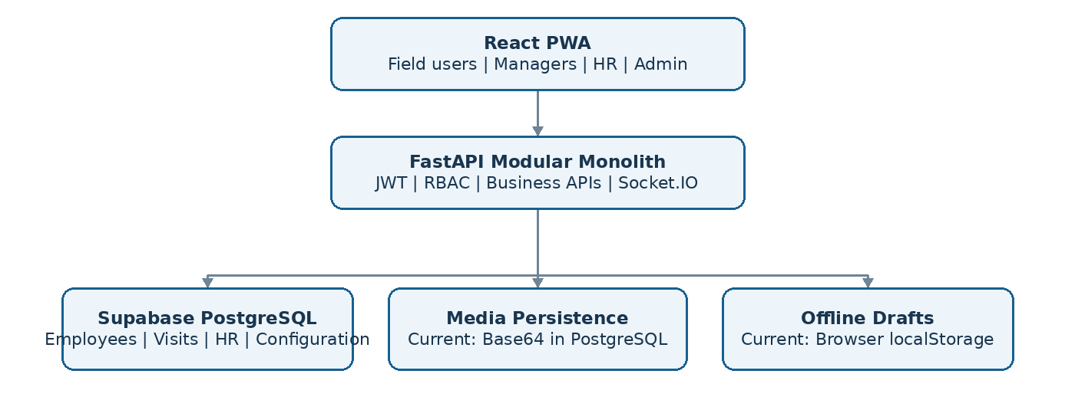
Figure 1. Application target topology and the currently identified media/offline persistence methods.

1. Executive overview
Orca Labs FSM combines field-force workflows used by medical representatives with web-based management and HR functions. The current frontend uses React 19, TypeScript and Vite PWA capabilities. The existing FastAPI backend handles credential checking and token issuance, while many other business operations are performed through direct frontend Supabase access. The target separates presentation from business authority: React PWA to FastAPI to Supabase-hosted PostgreSQL.
The objective is to preserve useful existing UI and operational flows, centralize security and domain rules in FastAPI, improve transactional correctness, and prepare repeatable isolated client deployments from a common product core.

2. Architecture at a glance
Layer | Technology / responsibility | Design intent
Presentation | React PWA, TypeScript | Views, forms, field capture, local drafts, typed API calls
Application | FastAPI modular monolith | Authentication, RBAC, workflows, validation, transactions, API contracts
Persistence | Supabase PostgreSQL | Employee and business records, roles, audit metadata, constraints
Media / evidence | Currently Base64 TEXT fields | Architecture represents existing persistence; storage evolution is evaluated separately
Realtime | Socket.IO / WebSockets | Authenticated event delivery and chat; durable records remain in database
Deployment | Separate FE/BE hosting; one backend instance per client initially | Environment isolation, repeatable configuration and controlled releases

3. Current application baseline
Audit references identify frontend modules for attendance and geofencing, doctor/chemist visits and daily call reports (DCR), field sessions, employee hierarchy, leave, payroll, advances, tasks, messaging, notifications, reporting and administration. Many frontend services call Supabase directly. The FastAPI backend has comparatively limited domain API coverage and its ORM inventory is incomplete relative to the migration scripts.
Observed characteristic | Architectural impact
FastAPI verifies employee login and checks stored password hashes | Retain existing backend authentication approach while verifying session lifecycle and fallback code paths
Client directly performs business data operations using Supabase SDK | Domain authorization and transactional boundaries are not consistently enforced by FastAPI
Attendance session numbers calculated in client code | Concurrent submissions can race without database-backed protections
Leave changes span multiple client-originated operations | Approvals and balances can become inconsistent without atomic writes
Images encoded as Base64 in PostgreSQL TEXT columns | Heavy rows, higher transfer/storage cost and complex proof retrieval
Offline pending images placed in browser localStorage | Limited storage and unproven durable synchronization
Real operational/employee records exist in pilot | Backups, compatibility, recovery and careful cutover are prerequisites

4. Target request and trust flow
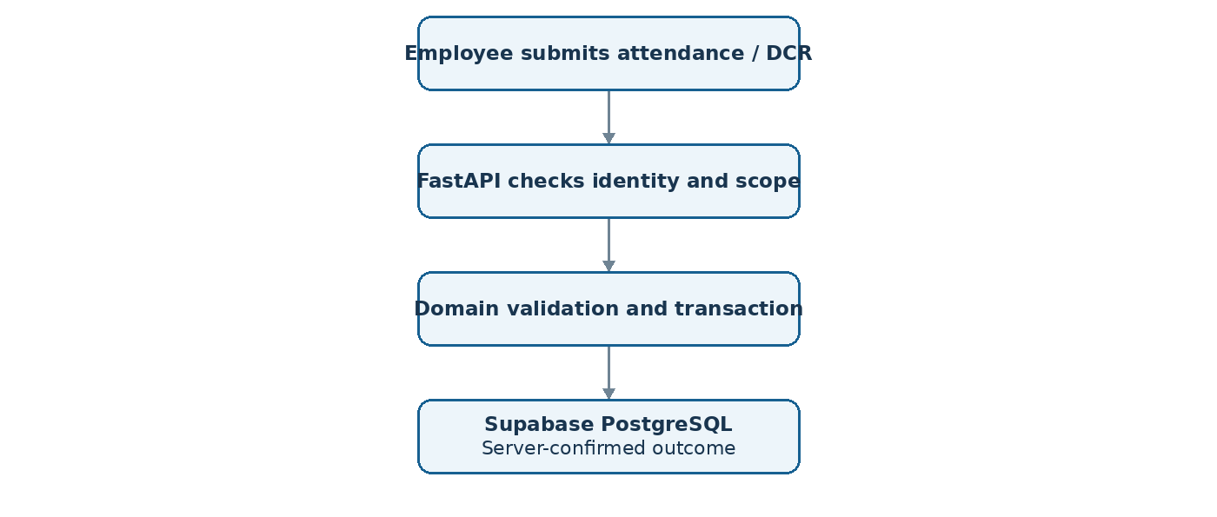
Figure 2. FastAPI becomes the authoritative boundary for every protected business operation.
A user action originates in a React view, passes through a domain hook and typed frontend API service, and reaches an authenticated FastAPI endpoint. FastAPI resolves the current employee, verifies role permissions and organizational scope, validates the business transition, performs an atomic PostgreSQL transaction, and returns a server-confirmed result. Client-visible flags or screen visibility are never sufficient as authorization.

5. FastAPI modular monolith design
One FastAPI application groups business functionality into explicit modules. Each module should own routes, request/response contracts, workflow services and persistence integration. Shared infrastructure supplies configuration, identity, permissions, audit events, error handling and logging. This keeps deployment simple while reducing unintended coupling.
Domain module | Responsibilities | Critical rules
Identity and access | Login, token validation, roles, permissions, session controls | Backend sole authority; hashed password verification; revoke disabled staff access
Employees and hierarchy | Profiles, manager reporting trees, territories and organizational scope | Restrict sensitive salary fields; derive subordinate access server-side
Attendance | Clock in/out, geofencing, regularization, sessions | Multi-session uniqueness, idempotency, concurrency and correction audit
Field operations / DCR | Rosters, field sessions, visits, proof associations | Employee ownership, valid visits, photo evidence linkage
Leave and payroll | Requests, approval chains, quotas, payroll periods | Atomic balance changes, period finalization and financial audit
Tasks and communication | Assignments, notifications, chat and recipient delivery | Assigned-recipient scope, durable messages, retry-safe events
Administration / reporting | Locations, policy settings, summaries, exports | Elevated permissions, scoped reporting and configuration audit

6. Authorization, roles and configuration
FastAPI remains the login authority, checking submitted credentials against hashed passwords in Supabase PostgreSQL. Role and permission assignments should be stored in the database so authorized administrators can configure access without changing application source code. Business scope is evaluated separately: permission to view attendance does not imply access to every employee. The hierarchy discussed in the audits includes BE/MR, RSM, ZSM, GM and administrative/HR responsibilities.
A typical request must satisfy identity validity, account status, role permission, record ownership or reporting scope, and workflow-specific policy. All permission changes should be attributable to an actor and time. Access tokens, refresh and revocation mechanisms require a consistent lifecycle; security-sensitive actions must not rely on cached UI state.

7. Attendance and leave architecture
Attendance supports multiple sessions per employee per day. The target data model should prevent duplicate session numbers and define active-session rules. Clock-in and clock-out must use backend transaction handling; retrying the same logical user action should not create extra records. Geofence evaluations use server-side policy checks but device GPS remains untrusted evidence.
Leave submission and approval depend on the organizational reporting chain and available leave quota. Approval, balance impact and status transition belong inside a single controlled transaction. Missed-punch changes require a review workflow and an audit trail. Attendance and payroll period closure should protect finalized financial calculations while allowing an explicit, audited correction pathway.
The supplied detailed attendance/leave specification provides candidate uniqueness, approval and freeze rules. Its illustrative SQL is not included as executable migration instructions: edge cases such as first concurrent clock-ins, annual leave entitlement periods, overlapping requests, cross-midnight shifts and attendance/leave coexistence must be resolved in the domain specification before migration.

8. Photos, media and selective offline behavior
The latest code excerpts describe camera capture through Canvas and JPEG Base64 data URLs. Attendance check-in photographs and field proof content are stored in PostgreSQL TEXT fields, with pending Base64 images queued in localStorage. This is the documented current baseline rather than an assertion that object storage is actively used for those records.
Selective offline operation means workers can capture limited field drafts and photographs during poor connectivity; the server remains responsible for accepting a final DCR/visit submission. Pending, failed and confirmed states should be visible, and a reconnect must not create duplicate visits. The reliability limits of existing localStorage behavior must be evaluated as part of the detailed offline design.
Supabase Storage is an available target option for future photo binaries, with database-stored object references and FastAPI-controlled permissions. Keeping Base64 in PostgreSQL is also technically possible; it has different costs for database growth, backup and bandwidth. The report does not presume that historical evidence has been migrated.

9. Realtime communication and background work
Socket.IO provides an authenticated realtime channel for chat and notification updates. The durable source of truth should remain the relevant database records; a WebSocket event should not be the only copy of important data. Channel membership must be checked server-side and clients require reconnect and missed-event recovery.
One backend instance per client minimizes initial operational complexity. If multiple application workers are later introduced, in-memory room state or broadcasts may no longer be sufficient; adapter/broker requirements should be based on the actual process topology. Background processing can handle long-running or retryable jobs, but the precise worker and queue technologies should be chosen from operational needs.

10. Master Core and per-client deployment
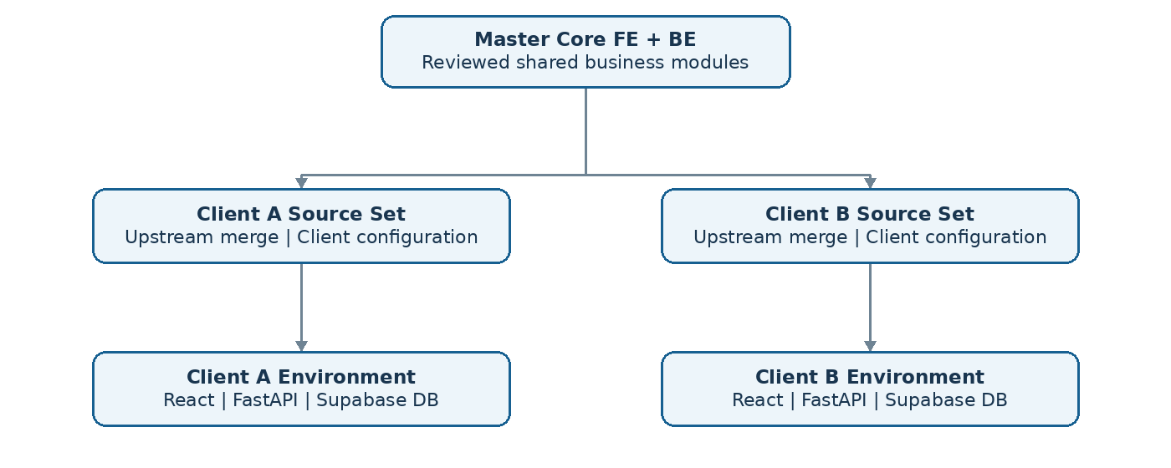
Figure 3. Master source distribution and isolated client runtime environments.
The intended operating model maintains a shared product source and separate customer environments. The current frontend/backend split can be preserved as two corresponding master repositories and client-specific repository copies. Direct Git upstream merges are the preferred update mechanism, with review and compatibility checks before a customer release.
Each customer environment should have its own frontend deployment, FastAPI deployment, Supabase database/project, credentials and storage access boundary. The setup process covers branding, initial administrator access, employee hierarchy, locations, business policies and enabled modules. A customer deployment must remain functional without a connection to the Master Core repository.
Core updates require a known source revision, a reviewed merge, configuration compatibility checks, a database migration assessment, a rollback path and controlled deployment. Customer differences should be expressed through configuration or designed extension points wherever practical, rather than modifying shared core files without boundaries.

11. Feature control and customer setup
A practical configuration model separates commercial entitlement (what a client is licensed to use), operational configuration (what is enabled in that environment) and role permission (who can use it). Database-managed feature configuration can support admin changes without a source-code release, while deployment settings remain suitable for hosting-specific configuration and secrets.
For example, enabling Payroll for a customer should not automatically grant every employee access to payroll. FastAPI checks the client entitlement and operational state, then the employee permission and scope. Historical data should not disappear merely because a module is disabled.

12. Refactoring and rollout approach
Sequence | Architectural work package | Exit evidence
0 | Verify real-data backups, active Supabase access paths, credentials and pilot usage | Recovery procedure and exposure assessment reviewed
1 | Complete FastAPI auth/session foundation, current-user identity and role/scope enforcement | Protected API requests consistently authorized
2 | Map contracts and migrate employee/hierarchy reads through backend | Frontend no longer performs direct employee-table business reads
3 | Move attendance, field sessions, DCR and proof associations to backend ownership | Validated workflows and retry-safe state changes
4 | Move leave, payroll, advances and approvals to transaction-safe services | Financial and HR invariants verified
5 | Integrate chat, notifications, media handling and selective offline drafts | Realtime and retry recovery behavior documented and verified
6 | Introduce client provisioning, configuration, upstream release process and isolation safeguards | Repeatable client setup and upgrade procedure
7 | Complete API cutover, verify data consistency and retire legacy direct browser business access | Production access boundary and operational continuity confirmed

These stages express dependencies rather than calendar deadlines. Security containment may need to proceed in parallel with the API migration, because abruptly revoking legacy public access could disrupt the pilot while frontend flows still depend on it.

13. Reliability, auditability and engineering quality
The application should record security-sensitive and business-significant actions with employee identity, event type, resource, timestamp, outcome, and correlation identifier. Logs must avoid raw credentials and confidential photo data. Attendance corrections, approvals, payroll actions and configuration changes need traceability. Availability targets should reflect single-instance risks, backup restore capability and controlled deployment practices.
Completion should be demonstrated with evidence: authenticated backend-only access, scoped authorization, absence of duplicate attendance sessions, consistent leave quotas, verified preservation of existing records, recoverable media, stable client deployment procedure, and logs sufficient to investigate incidents.

14. Implementation governance
This report is a design baseline. Engineering tasks require individually reviewed specifications, acceptance criteria, data compatibility checks and explicit authorization. Antigravity prompts remain read-only for analysis and documentation unless separately authorized. No application implementation, schema alteration, automated test execution or deployment is authorized by this report.
Source basis: Orca Labs FSM discovery, security, API-first migration, database/reliability and consolidation audit reports supplied in the project discussion; supplemented by user-provided details of FastAPI password hashing, image Base64 storage and the preferred architecture. Report terminology distinguishes observed existing behavior from proposed target system behavior.

