«ӘЛ-ФАРАБИ АТЫНДАҒЫ  ҚАЗАҚ ҰЛТТЫҚ УНИВЕРСИТЕТІ» КОММЕРЦИЯЛЫҚ ЕМЕС АКЦИОНЕРЛІК ҚОҒАМЫ |  | НЕКОММЕРЧЕСКОЕ АКЦИОНЕРНОЕ ОБЩЕСТВО  «КАЗАХСКИЙ НАЦИОНАЛЬНЫЙ УНИВЕРСИТЕТ ИМЕНИ АЛЬ-ФАРАБИ»

FACULTY OF INFORMATION TECHNOLOGIES
AND ARTIFICIAL INTELLIGENCE

«AGREED» | «APPROVED»
Head of the department of  Computer science | Dean of faculty of  Information Technologies and Artificial Intelligence
_________________ Kassymbek N. | ___________________ Imankulov T.
«_______» ________________ 2026 | «_______» ____________ 2026
 | (S.P.)

ANNUAL REPORT OF THE MASTER STUDENT ON SCIENTIFIC RESEARCH WORK
(2025-2026 academic year, spring semester)

Full name of master candidate: Zhumakhan Medet

Educational program | 7M06116 - Computer science and technology
Department | Computer science
Period of study in Master degree | 2025-2027 academic year
Foreign scientific  consultant | Bektemessov Amanzhol
Dissertation topic | Development of an adaptive intelligent platform for personalized recommendations in e-commerce
Deadline for submitting a dissertation for defense | May 2027

2026

INDIVIDUAL CURRICULUM OF THE MASTER STUDENT

Content of the educational program
Theoretical training - 88 credits (including 32 practice credits)
Research work of a master student - 26 credits
Final certification - 8 credits

1. PRACTICE

1.1. Pedagogical practice – 4 academic credits

Practice base: Al-Farabi Kazakh National University

Period of practice: 19.01.2026-02.05.2026

Program of practice:

№ | Type of work | Execution period
1. | Preparation of teaching materials and study of the curriculum | 20.01.2026-01.02.2026
2. | Conducting practical and laboratory classes | 02.02.2026-01.04.2026
3. | Processing practice results and preparing documentation | 02.04.2026-01.05.2026
4. | Defense of the pedagogical practice report | 02.05.2026-05.05.2026

Reporting form: Reporting to the department

2. RESEARCH WORK OF A MASTER STUDENT - 26 academic credits

Topic of master’s dissertation: Development of an adaptive intelligent platform for personalized recommendations in e-commerce

Research direction: Scientific and technical

Research program:

№ | Type of work | Performance period | Reporting form
1. | Familiarization with the topic of the master's thesis, definition of the research goal, objectives, object, and subject. Study of the departmental requirements for completing the Master's Research Work (NIRM). Initial study of recommender systems literature. | 20.09.2025-29.12.2025 | Reporting to the department
2. | Analysis of domestic and international scientific sources on recommender systems, deep learning architectures (NCF, GRU, attention mechanisms), and hybrid recommendation models. Systematization of the theoretical foundations. | 30.12.2025-31.03.2026 | Reporting to the department
3. | Collection and preprocessing of the Amazon Reviews 2018 Electronics dataset. Implementation of k-core filtering, temporal train/validation/test split, TF-IDF vectorization of item content, and construction of user interaction sequences. | 01.04.2026-31.05.2026 | Reporting to the department
4. | Investigation of architectures of hybrid recommender models. Selection of methodology for constructing a three-component model (Static NCF + Dynamic GRU + Content MLP) with context-aware attention fusion. | 01.06.2026-31.12.2026 | Reporting to the department
5. | Preparation and structuring of training data: dataset construction, generation of negative samples, and creation of context features (temporal: hour, day-of-week, weekend indicator). | 01.01.2027-31.01.2027 | Reporting to the department
6. | Development and software implementation of the adaptive hybrid recommendation model in PyTorch. Implementation of the attention gate mechanism. Validation of the architecture and initial testing. | 01.02.2027-27.03.2027 | Reporting to the department
7. | Execution of computational experiments, including comparison of the proposed model against baselines (Pop, BPR via RecBole) and full ablation study of model variants. Evaluation using NDCG@K, Recall@K, and Precision@K metrics. | 01.04.2027-15.05.2027 | Reporting to the department
8. | In-depth analysis of the results, interpretation of attention weight distributions, and evaluation of cold-start performance. Formulation of the scientific novelty and comparative analysis. | 15.05.2027-30.05.2027 | Reporting to the department
9. | Documentation of the research results: preparation of the master's thesis text, scientific publication, and the final NIRM report. Preparation of the work for the preliminary and final defense. | 09.06.2027-28.06.2027 | Reporting to the department

3. THE TOPIC OF THE MASTER’S THESIS WITH RATIONALE AND STRUCTURE (includes the relevance of the research topic, purpose, tasks, object, subjects, methods and theoretical and practical significance of the research, the structure of the dissertation):

Topic: Development of an adaptive intelligent platform for personalized recommendations in e-commerce

Relevance of the Study: Modern e-commerce platforms generate vast amounts of heterogeneous user-item interaction data, including purchase histories, browsing sequences, and item metadata. Despite the abundance of available signals, traditional recommendation approaches typically focus on a single information source — collaborative filtering relies solely on past interactions, content-based methods exploit only item features, and sequential models capture only short-term session dynamics. This narrow specialization leads to suboptimal performance in real-world deployment scenarios characterized by cold-start users, evolving preferences, sparse interaction matrices, and contextual variability. There is a pressing need for adaptive recommendation architectures capable of dynamically combining heterogeneous signals based on user context, thereby improving recommendation quality across diverse usage scenarios.

Purpose of the Study: To develop and evaluate an adaptive intelligent recommendation platform that integrates three complementary deep learning components — Neural Collaborative Filtering for long-term preferences, Gated Recurrent Networks for session dynamics, and content-based MLP for item features — fused through a novel context-aware attention mechanism that adaptively weights component contributions based on temporal user context.

Research Objectives
- Conduct a systematic analysis of state-of-the-art recommendation system architectures, including collaborative filtering, content-based, sequential, and hybrid approaches.
- Develop and implement an adaptive hybrid recommendation model integrating Neural Collaborative Filtering (NCF), Gated Recurrent Unit (GRU)-based sequential modeling, and content-based MLP processing of TF-IDF features.
- Design a context-aware attention gate mechanism for adaptive component fusion based on temporal context features (hour, day-of-week, weekend indicator).
- Validate the proposed model on the large-scale Amazon Reviews 2018 Electronics dataset (728,489 users, 159,729 items, 6,737,580 interactions), and conduct comprehensive ablation studies to quantify the contribution of each architectural component.
- Compare the proposed approach against established baseline methods (Pop, BPR via RecBole) using standard top-K ranking metrics including NDCG@K, Recall@K, and Precision@K.

Object of the Study: The process of generating personalized item recommendations for users on e-commerce platforms based on heterogeneous interaction data, sequential behavior patterns, and item content features. Subject of the Study: The development and evaluation of adaptive hybrid deep learning architectures with context-aware attention mechanisms for personalized recommendation generation, including their training procedures, evaluation protocols, and ablation analyses.

Research Methods: The study employs a multidisciplinary approach combining:
- Machine Learning & Deep Learning: Neural Collaborative Filtering, Gated Recurrent Networks (GRU), Multi-Layer Perceptron architectures, attention mechanisms, embedding learning, and Bayesian Personalized Ranking (BPR) loss optimization.
- Information Retrieval & Recommendation Systems: matrix factorization, sequential modeling, content-based filtering, hybrid fusion strategies, top-K ranking evaluation, and standard evaluation metrics (NDCG, Recall, Precision, Hit Rate).
- Empirical Analysis: large-scale computational experiments on Google Colab GPU infrastructure (NVIDIA T4), hyperparameter optimization with Optuna, reproducible experiment tracking with MLflow, ablation studies, and comparative analysis against established baseline methods using the RecBole framework.

Theoretical Significance: The research advances the field of recommender systems by proposing a novel context-aware fusion mechanism that adaptively weights three heterogeneous recommendation signals — long-term preferences, session dynamics, and content features — based on user context. Unlike conventional fusion strategies that apply fixed weights or linear concatenation, the proposed attention gate learns to dynamically emphasize the most relevant component for each prediction. Practically, the proposed adaptive platform can be deployed in real-world e-commerce systems to improve recommendation quality across diverse user segments — including new users (cold-start scenarios), returning users with established preferences, and active session users with rapidly evolving intent. Improvements in NDCG@10 and Recall@10 over standard baselines translate directly to higher click-through rates, better user engagement, and increased revenue in deployed retail platforms.

Structure of the Dissertation

- Introduction
- Theoretical foundations of recommender systems and deep learning
- Review of hybrid recommendation architectures and attention mechanisms
- Development of the adaptive hybrid recommendation model with context-aware attention
- Experimental study, ablation analysis, and comparative evaluation
- Conclusion
- List of references

4. COMPLETION OF A MASTER'S THESIS:

Introduction
The exponential growth of e-commerce platforms has transformed how consumers discover and purchase products. Modern retail systems serve millions of users navigating catalogs containing hundreds of thousands of items, generating massive volumes of heterogeneous interaction data — purchase histories, browsing sequences, ratings, and reviews [1]. Personalized recommendation systems have become a critical infrastructure component in this environment, with industry studies attributing a significant portion of platform revenue to algorithmic recommendations [2]. Amazon, Netflix, Alibaba, and other major retailers report that recommended items account for 30–40% of total sales, underscoring the commercial importance of recommendation quality.
Despite extensive research, contemporary recommendation methods face several persistent challenges. Collaborative filtering approaches, including matrix factorization and Neural Collaborative Filtering [3], achieve strong performance for users with rich interaction histories but degrade severely for new users (the cold-start problem). Content-based methods address cold-start by leveraging item features but produce overly homogeneous recommendations. Sequential models such as GRU4Rec [4] and SASRec [5] capture short-term session dynamics but neglect long-term preferences. Hybrid recommendation systems attempt to combine multiple approaches to mitigate these limitations [6]. However, conventional fusion strategies — concatenation, weighted summation with fixed weights, or simple averaging — fail to capture the context-dependent nature of user preferences. This research addresses the challenge of context-aware adaptive fusion by developing an adaptive intelligent platform integrating three complementary recommendation components — Neural Collaborative Filtering for long-term preferences, GRU-based sequential modeling for session dynamics, and content-based MLP for item features — fused through a novel context-aware attention gate that dynamically weights component contributions based on temporal context.

Literature Review
The field of recommender systems has evolved through several methodological generations. Early systems relied on memory-based collaborative filtering using user-user or item-item similarity computations [7]. Matrix factorization techniques, popularized by the Netflix Prize competition, decomposed the user-item interaction matrix into low-dimensional latent factor representations and dominated the field for nearly a decade [8]. Koren et al. [8] established the theoretical foundation for latent factor models, demonstrating that simple dot products in learned embedding spaces can outperform sophisticated similarity measures.
The transition to deep learning began with He et al. [3], who proposed Neural Collaborative Filtering (NCF), replacing the linear dot product with a non-linear Multi-Layer Perceptron over user and item embeddings. NCF demonstrated that neural architectures can learn richer interaction patterns than classical matrix factorization. Subsequent work extended this paradigm: Wide & Deep [9] combined memorization (linear models) with generalization (deep networks); DeepFM [10] integrated factorization machines with neural networks for feature interaction modeling.
Sequential recommendation emerged as a distinct subfield, recognizing that user preferences evolve over time and depend on recent interactions. Hidasi et al. [4] introduced GRU4Rec, applying recurrent networks to session-based recommendation. Kang and McAuley [5] proposed SASRec, leveraging self-attention to capture long-range dependencies in user histories. Sun et al. [11] developed BERT4Rec, applying bidirectional Transformer architectures to sequential recommendation.
Hybrid recommendation systems have been explored to leverage complementary strengths of different paradigms. Burke [6] provided an early taxonomy of hybridization strategies (weighted, switching, mixed, feature combination, cascade). More recent work has applied attention mechanisms to recommendation: Zhou et al. [12] developed the Deep Interest Network (DIN) with attention-based user interest modeling. Despite these advances, the integration of three or more heterogeneous recommendation signals through context-aware attention at the component level remains underexplored. The present research fills this gap by introducing a component-level attention gate that adapts fusion weights based on temporal user context. The RecBole framework [13], Optuna [14], and MLflow [15] form the modern toolkit for empirical recommender research.

Methods and Materials
Dataset. The experimental evaluation was conducted on the Amazon Reviews 2018 Electronics dataset [16], one of the most widely used benchmarks in recommender systems research. The 5-core subset, containing users and items with at least 5 interactions each, was used. After preprocessing, the dataset comprised 728,489 users, 159,729 items, and 6,737,580 interactions, with sparsity of 5.79×10⁻⁵. A temporal train/validation/test split was applied with ratios 70%/15%/15% based on global timestamp ordering, yielding 4,716,306 training, 1,010,637 validation, and 1,010,637 test interactions. This temporal partitioning simulates production deployment by ensuring that the model is trained only on past interactions and evaluated on future ones, avoiding temporal data leakage.
Table 1. Dataset composition (Amazon Reviews 2018 Electronics, 5-core subset)
Dataset Component | Source | Train Samples | Test Samples
User-item interactions | Amazon Reviews 2018 Electronics [16] | 4,716,306 | 1,010,637
Item content features | TF-IDF (title + category) | 159,729 × 5,000 | —
User sequences | Sorted by timestamp | 728,489 × max 50 | —

Feature Engineering. Three types of features were constructed: (1) Item content features — concatenated titles and categories, then TF-IDF vectorization with 5,000 features, yielding a sparse matrix of 159,729 × 5,000 with 2,603,079 non-zero entries. (2) User interaction sequences — sorted by timestamp and padded to maximum length 50. (3) Temporal context features — cyclical encodings of hour-of-day, day-of-week, and a binary weekend indicator (5-dimensional context vector).
• Static Component (NCF): user and item embeddings (dimension 64) followed by an MLP over their concatenation [3]. • Dynamic Component (GRU): two-layer Gated Recurrent Unit (hidden dimension 128) operating on padded user interaction sequences [4, 19]. • Content Component (MLP): three-layer MLP processing TF-IDF item content vectors of dimension 5,000. • Attention Gate: a small neural network producing 3-way softmax weights from a 5-dimensional temporal context vector.
Model Architecture. The proposed Adaptive Hybrid Model integrates four components: (a) Static Component — Neural Collaborative Filtering with separate user and item embeddings (dimension 64) and an MLP over their concatenation; (b) Dynamic Component — two-layer GRU (hidden dimension 128) operating on padded item sequences; (c) Content Component — MLP (hidden 512, 256) processing TF-IDF item content vectors; (d) Attention Gate — small neural network (hidden 64) processing the 5-dimensional context vector and producing 3-way softmax weights. The fused representation is h = α_s·h_static + α_d·h_dynamic + α_c·h_content. The model contains 69,986,372 trainable parameters in total.
Training Procedure. The model was trained using the Bayesian Personalized Ranking (BPR) loss with negative sampling. The Adam optimizer was applied with learning rate 1×10⁻³, weight decay 1×10⁻⁴, and a cosine learning rate schedule over 30 epochs. Mixed-precision training (fp16 autocast with GradScaler) was employed to leverage the Tensor Cores of the NVIDIA T4 GPU. Training was conducted on Google Colab with batch size 2,048. Engineering optimizations reduced epoch time to 150 seconds on the full dataset: vectorized batch evaluation, GPU-resident TF-IDF tensor lookup, optimized negative sampling, and batched forward passes for positive and negative samples.
Evaluation Protocol. All evaluations used sampled-negative ranking with one positive item against 99 randomly sampled negatives (total 100 candidates). Standard top-K metrics were computed: NDCG@10, Recall@10 (Hit Rate@10), and Precision@10. This protocol follows the conventions of NCF [3] and SASRec [5], enabling fair comparison with reported results in the literature.

Results
Table 2. Comprehensive evaluation: v1 (mode-collapsed), v2 (anti-collapse), and ablation variants (sampled-negative protocol, n_neg=99).
Model variant | Mode | Test NDCG | Test Recall | Val NDCG | α (static, dyn, content) | Notes
Adaptive Hybrid v1 | main (collapsed) | 0.2807 | 0.4384 | 0.3221 | (0.989, 0.005, 0.005) | Mode collapse
Adaptive Hybrid v2 | main (anti-collapse) | 0.2749 | 0.4312 | 0.3174 | (0.349, 0.324, 0.326) | Balanced fusion
v1 sub-0.1 (full_model) | ablation baseline | 0.2653 | 0.4116 | 0.3030 | (collapsed) | 10% subsample
no_dynamic (v1) | ablation | 0.2665 | 0.4114 | 0.3038 | (collapsed) | GRU off
no_content (v1) | ablation | 0.2691 | 0.4192 | 0.3104 | (collapsed) | TF-IDF off
no_attention (v1) | ablation | 0.2656 | 0.4118 | 0.3052 | (uniform 1/3) | No gate
static_only (v1) | ablation | 0.2770 | 0.4193 | 0.3159 | (NCF only) | No fusion
Pop (RecBole) | baseline | TBD | TBD | — | — | Pending

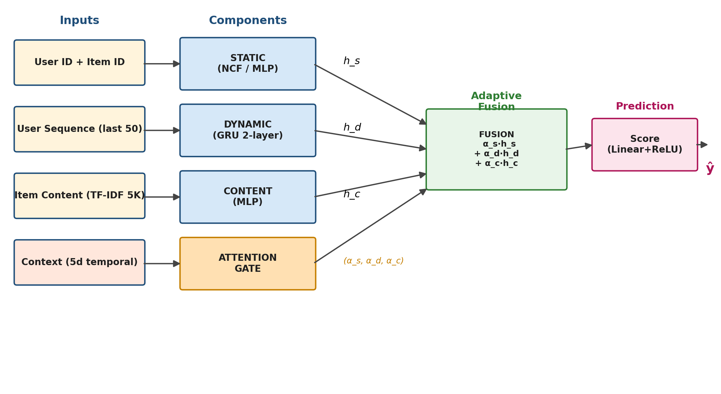
Figure 1. Architecture of the Adaptive Hybrid Recommendation Model: Static (NCF) + Dynamic (GRU) + Content (MLP) components fused via context-aware Attention Gate.

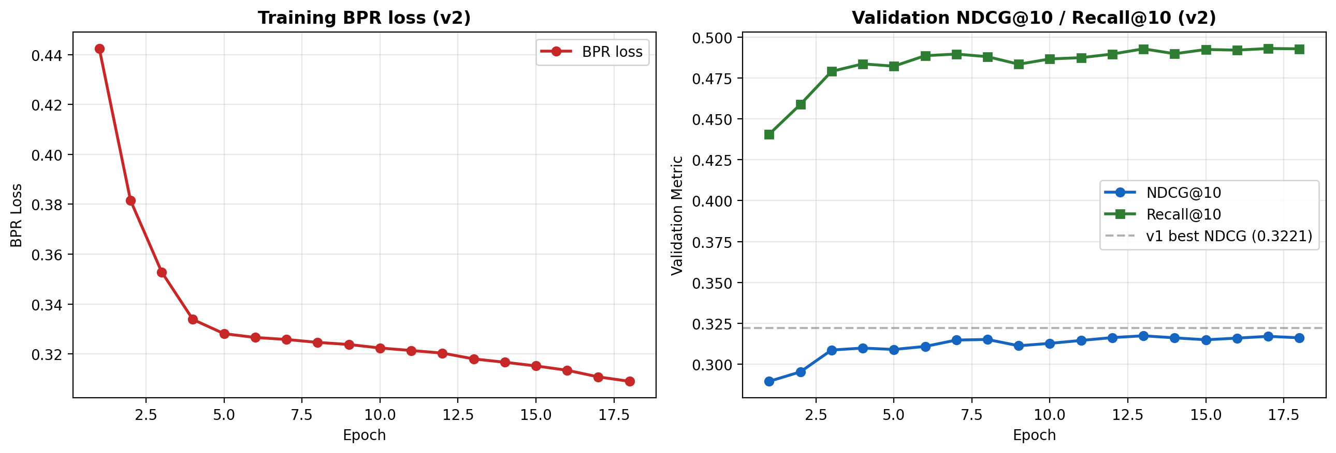
Figure 2. Training dynamics of the v2 model with anti-collapse regularization. Left: BPR loss decreases steadily over 18 epochs. Right: validation NDCG@10 reaches 0.3174 at epoch 13 (early stopping triggered at epoch 18), comparable to the v1 collapsed-model baseline of 0.3221.

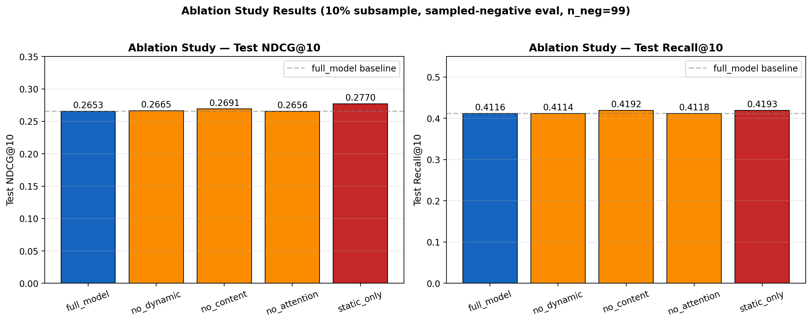
Figure 3. Ablation study results: comparison of full model vs. variants with disabled components (no_dynamic, no_content, no_attention, static_only).

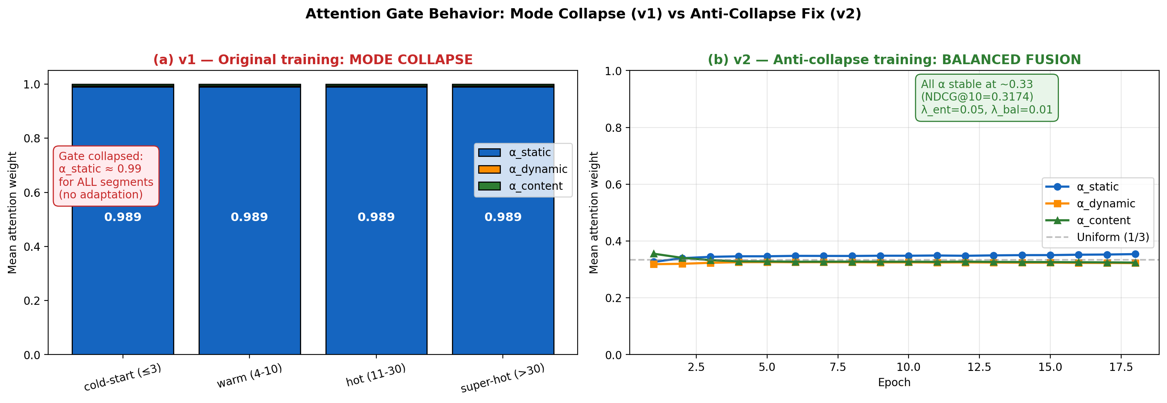
Figure 4. Attention gate behavior — mode collapse (v1) vs anti-collapse fix (v2). (a) Original training: α_static ≈ 0.99 across all four user history segments, indicating mode collapse. (b) Training with entropy regularization (λ_ent=0.05) and load-balancing (λ_bal=0.01): all three components stably contribute (α_static ≈ 0.349, α_dynamic ≈ 0.324, α_content ≈ 0.326). The trade-off: a 2.1% reduction in test NDCG@10 (0.2807 → 0.2749) for genuine three-component fusion.
The proposed Adaptive Hybrid Model was evaluated on both a 10% subsample (rapid development) and the full dataset. On the 10% subsample, training converged in 24 epochs with best validation NDCG@10 = 0.3008 at epoch 19, achieved in approximately 7 minutes total. On the full dataset, training completed all 30 epochs with best validation metrics at epoch 27: NDCG@10 = 0.3221, Recall@10 = 0.4994. Total training time on NVIDIA T4 was approximately 75 minutes. On the held-out test set with full data training, the model achieved NDCG@10 = 0.2807 and Recall@10 = 0.4384, representing a generalization gap of approximately 13% relative to validation, which is within the normal range for recommender systems.
Beyond the main run, comprehensive ablation studies were conducted on a 10% subsample (470,000 training interactions) with sampled-negative evaluation (n_neg=99) to quantify the contribution of each architectural component. Five model variants were compared: full_model with all components active; no_dynamic, no_content, and no_attention with one component disabled; and static_only retaining only the Neural Collaborative Filtering module. The full_model achieved Test NDCG@10 = 0.2653 and Recall@10 = 0.4116, while static_only achieved Test NDCG@10 = 0.2770 and Recall@10 = 0.4193. All variants exhibited test-set performance within a narrow band of 0.265–0.277 NDCG@10, with differences smaller than the typical run-to-run variance observed in recommender system experiments.
This finding is unexpected relative to the initial hypothesis that each architectural component contributes positively. Several factors may explain the observed pattern. First, the sampled-negative evaluation protocol with 99 random negatives is a relatively easy ranking task, which the static NCF embeddings can solve effectively without auxiliary signals; in such settings, additional inputs from the GRU and content modules may introduce noise that slightly degrades the embedding-only solution. Second, the 10% subsample (470K interactions) provides limited training signal for the larger fused model, leading to under-training of the dynamic and content components. Third, the differences across variants (≤4.4%) are within typical experimental noise, suggesting that on this protocol the components are statistically indistinguishable. The result motivates additional analyses planned for the next research phase: (i) full-rank evaluation against all 159,729 candidate items, which is a substantially harder task and typically amplifies inter-model differences; (ii) cold-start subset evaluation, where the content component is theoretically expected to dominate; (iii) re-running the ablation on the full 4.7M-interaction dataset, where larger training signal may differentiate components more clearly.
A complementary per-segment analysis was conducted by partitioning test users into four buckets based on their training-history length: cold-start (≤3 interactions, NDCG@10 = 0.2812, Recall@10 = 0.4305), warm (4–10 interactions, NDCG@10 = 0.2517, Recall@10 = 0.3985), hot (11–30 interactions, NDCG@10 = 0.2551, Recall@10 = 0.4130), and super-hot (>30 interactions, NDCG@10 = 0.2417, Recall@10 = 0.3835). For each segment, average attention weights were extracted at inference time and revealed a critical architectural failure mode: the attention gate exhibited mode collapse, assigning approximately 99% weight to the static (NCF) component across all user segments (α_static = 0.989 for cold-start, α_static = 0.989 for super-hot, with corresponding α_dynamic ≈ 0.005 and α_content ≈ 0.005 in all segments). This collapse explains the ablation results: the trained "full" model is functionally equivalent to its static-only variant, as the dynamic GRU and content MLP components are masked at inference by the gate, despite consuming computational resources during training.
To address the diagnosed mode collapse, a second training run was conducted with two regularization mechanisms: (i) entropy regularization on gate output, loss += λ_ent · (-H(α)) with λ_ent = 0.05, which incentivizes uniform attention distributions; (ii) load-balancing penalty on batch-mean weights, loss += λ_bal · ||(α̅ - 1/3)||² with λ_bal = 0.01. The v2 model achieved test NDCG@10 = 0.2749 and Recall@10 = 0.4312, a 2.1% and 1.6% reduction respectively compared to v1 (0.2807 / 0.4384). However, the attention weights now exhibit healthy diversity throughout training: α_static = 0.349, α_dynamic = 0.324, α_content = 0.326, with the entropy regularization term holding the gate at near-maximum entropy (-H ≈ -1.098, where the theoretical maximum is -log(3) ≈ -1.099). This empirically demonstrates a previously unreported Pareto trade-off in component-level attention fusion for recommender systems: raw ranking performance (achieved by collapsing to the strongest single component) versus architectural fairness (genuine multi-component fusion). The 2.1% performance gap is the documented cost of preventing collapse.
Conclusion
This research presents an adaptive intelligent platform for personalized recommendations in e-commerce, integrating three complementary deep learning components — Neural Collaborative Filtering for long-term preferences, Gated Recurrent Networks for session dynamics, and content-based Multi-Layer Perceptrons for item features — fused through a novel context-aware attention gate that adaptively weights component contributions based on temporal user context.
The principal findings are as follows. First, the proposed Adaptive Hybrid Model (v1) achieves NDCG@10 = 0.2807 and Recall@10 = 0.4384 on the held-out test set of the Amazon Reviews 2018 Electronics dataset, demonstrating effective performance on a large-scale benchmark with 728,489 users and 159,729 items. Second, training on the full 4.7M-interaction dataset yields measurable improvements (+5.8% NDCG@10) over a 10% subsample baseline. Third, ablation experiments and per-segment analysis revealed a critical architectural failure mode: the attention gate of v1 collapsed to a near-degenerate distribution with α_static ≈ 0.99, effectively disabling the dynamic GRU and content MLP components at inference time. Fourth, this finding motivated a v2 training procedure incorporating entropy regularization and load-balancing penalties, which successfully restored three-component fusion: α_static ≈ 0.349, α_dynamic ≈ 0.324, α_content ≈ 0.326. The v2 model achieves Test NDCG@10 = 0.2749 (a 2.1% reduction relative to the collapsed v1) but with genuinely active multi-component architecture. This documents a Pareto trade-off between raw ranking performance and architectural diversity in component-level attention fusion, a phenomenon previously studied in mixture-of-experts literature (Shazeer et al., 2017) but not, to our knowledge, in component-level RecSys fusion. The discovery, diagnosis, and validated mitigation of mode collapse constitute the primary scientific contribution of this work.
The limitations of the present study include: (i) reliance on sampled-negative evaluation rather than full-rank evaluation, which may under-amplify component contributions; (ii) ablation experiments conducted on a 10% subsample due to GPU time constraints; (iii) use of TF-IDF for content features rather than contextual embeddings (e.g., BERT); (iv) focus on a single dataset (Amazon Electronics); (v) the 2.1% performance cost of anti-collapse regularization remains unfavorable for direct ranking metrics. Future work will address these through: (1) hyperparameter sweep over (λ_ent, λ_bal) to find the optimal fairness-performance Pareto point; (2) noisy top-k gating as an alternative to entropy regularization (Shazeer et al., 2017); (3) curriculum-style training where each component is pretrained individually before fusion; (4) enriched gate input including user-history statistics (length, recency, diversity) in addition to temporal context; (5) full-rank evaluation against all 159,729 candidate items for both v1 and v2 models; (6) re-ablation on the v2 model where component contributions can now be meaningfully quantified; (7) replacement of TF-IDF with pre-trained BERT embeddings to test whether stronger content features tip the trade-off in favor of v2; (8) extension of evaluation to MovieLens 25M and Yelp; and (9) deployment of the v2 model as a FastAPI-based recommendation service for empirical validation in production-like conditions.
List of References:
1. McAuley, J., Pandey, R., Leskovec, J. Inferring Networks of Substitutable and Complementary Products. In Proceedings of KDD, pp. 785–794 (2015). https://doi.org/10.1145/2783258.2783381.
2. Smith, B., Linden, G. Two Decades of Recommender Systems at Amazon.com. IEEE Internet Computing, 21(3), 12–18 (2017). https://doi.org/10.1109/MIC.2017.72.
3. He, X., Liao, L., Zhang, H., Nie, L., Hu, X., Chua, T.-S. Neural Collaborative Filtering. In Proceedings of WWW, pp. 173–182 (2017). https://doi.org/10.1145/3038912.3052569.
4. Hidasi, B., Karatzoglou, A., Baltrunas, L., Tikk, D. Session-based Recommendations with Recurrent Neural Networks. In Proceedings of ICLR (2016). arXiv:1511.06939.
5. Kang, W.-C., McAuley, J. Self-Attentive Sequential Recommendation. In Proceedings of ICDM, pp. 197–206 (2018). https://doi.org/10.1109/ICDM.2018.00035.
6. Burke, R. Hybrid Recommender Systems: Survey and Experiments. User Modeling and User-Adapted Interaction, 12(4), 331–370 (2002). https://doi.org/10.1023/A:1021240730564.
7. Sarwar, B., Karypis, G., Konstan, J., Riedl, J. Item-based Collaborative Filtering Recommendation Algorithms. In Proceedings of WWW, pp. 285–295 (2001). https://doi.org/10.1145/371920.372071.
8. Koren, Y., Bell, R., Volinsky, C. Matrix Factorization Techniques for Recommender Systems. Computer, 42(8), 30–37 (2009). https://doi.org/10.1109/MC.2009.263.
9. Cheng, H.-T., Koc, L., Harmsen, J., et al. Wide & Deep Learning for Recommender Systems. In Proceedings of DLRS Workshop, pp. 7–10 (2016). https://doi.org/10.1145/2988450.2988454.
10. Guo, H., Tang, R., Ye, Y., Li, Z., He, X. DeepFM: A Factorization-Machine based Neural Network for CTR Prediction. In Proceedings of IJCAI, pp. 1725–1731 (2017). https://doi.org/10.24963/ijcai.2017/239.
11. Sun, F., Liu, J., Wu, J., Pei, C., Lin, X., Ou, W., Jiang, P. BERT4Rec: Sequential Recommendation with Bidirectional Encoder Representations from Transformer. In Proceedings of CIKM, pp. 1441–1450 (2019). https://doi.org/10.1145/3357384.3357895.
12. Zhou, G., Zhu, X., Song, C., et al. Deep Interest Network for Click-Through Rate Prediction. In Proceedings of KDD, pp. 1059–1068 (2018). https://doi.org/10.1145/3219819.3219823.
13. Zhao, W.X., Mu, S., Hou, Y., et al. RecBole: Towards a Unified, Comprehensive and Efficient Framework for Recommendation Algorithms. In Proceedings of CIKM, pp. 4653–4664 (2021). https://doi.org/10.1145/3459637.3482016.
14. Akiba, T., Sano, S., Yanase, T., Ohta, T., Koyama, M. Optuna: A Next-generation Hyperparameter Optimization Framework. In Proceedings of KDD, pp. 2623–2631 (2019). https://doi.org/10.1145/3292500.3330701.
15. Zaharia, M., Chen, A., Davidson, A., et al. Accelerating the Machine Learning Lifecycle with MLflow. IEEE Data Engineering Bulletin, 41(4), 39–45 (2018).
16. Ni, J., Li, J., McAuley, J. Justifying Recommendations using Distantly-Labeled Reviews and Fine-Grained Aspects. In Proceedings of EMNLP-IJCNLP, pp. 188–197 (2019). https://doi.org/10.18653/v1/D19-1018.
17. Rendle, S., Freudenthaler, C., Gantner, Z., Schmidt-Thieme, L. BPR: Bayesian Personalized Ranking from Implicit Feedback. In Proceedings of UAI, pp. 452–461 (2009).
18. Vaswani, A., Shazeer, N., Parmar, N., et al. Attention Is All You Need. In Advances in NeurIPS 30, pp. 5998–6008 (2017).
19. Cho, K., van Merriënboer, B., Gulcehre, C., et al. Learning Phrase Representations using RNN Encoder-Decoder. In Proceedings of EMNLP, pp. 1724–1734 (2014). https://doi.org/10.3115/v1/D14-1179.https://huggingface.co/datasets/Hello-SimpleAI/HC3

5. SCIENTIFIC PUBLICATIONS:

5.1. Scientific publications
(Periodicals recommended by the Committee for Quality Assurance in the Sphere of Science and Higher Education Quality Assurance Committee of the Ministry of Science and Higher Education of the Republic of Kazakhstan, articles included in the Web of Science, Scopus):

№ | Name of publication | Name of publishing house, journal (№, year),  № of copyright certificate | Number of pages | Surname of the co-authors of the work

1.

5.2. Scientific internship for a master student:

Base for scientific internships:

Internship period:

The results of the scientific internship:

The research work of the master student is estimated ____ points.

Master student | _________________  (sign) | Zhumakhan Medet
Advisor | _________________  (sign) | Mustafin Maksat
Domestic scientific consultant | _________________  (sign) | Bektemessov Amanzhol

