(Do not mind the different display and appearance

since all the logic of this test will work the same)

At the start of the game we choose the level of difficulty. Let’s see how code works choosing an easy level for better vision of reason and outcomes of our moves. All the mistake cases that will be shown below work the same for other levels.

1. We can see the easy level grid and question that wants us to type a number and its coordinate in form:

row column number.

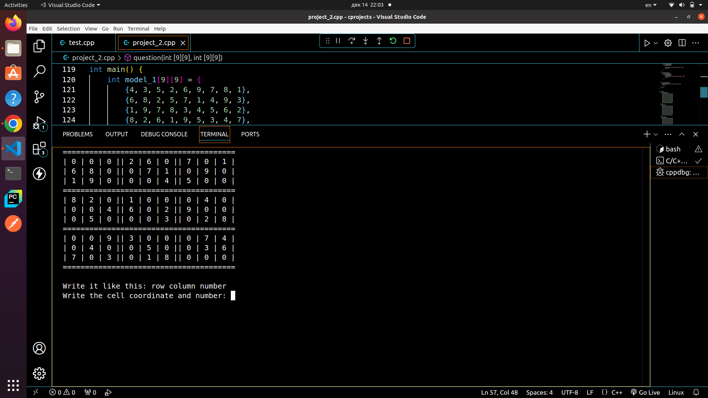

1. Here we can see that the cell at the top left corner(row 1 column 1) should contain 4 because two boxes below contain fours in a way that 4 is the only option. But let’s see

what happens if we type the number that already is in the

same row. For example 2 is not in the same column but it is

in the same row.

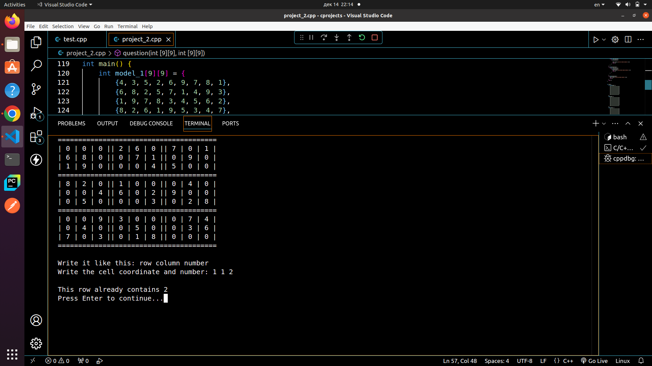

3)As we can see on the screen above, after we typed that

row 1 column 1 contains 2, the game says that “This row

already contains 2” and indeed in row 1 column 4 there is 2.

But what if we type row 1 column 1 contains 9.

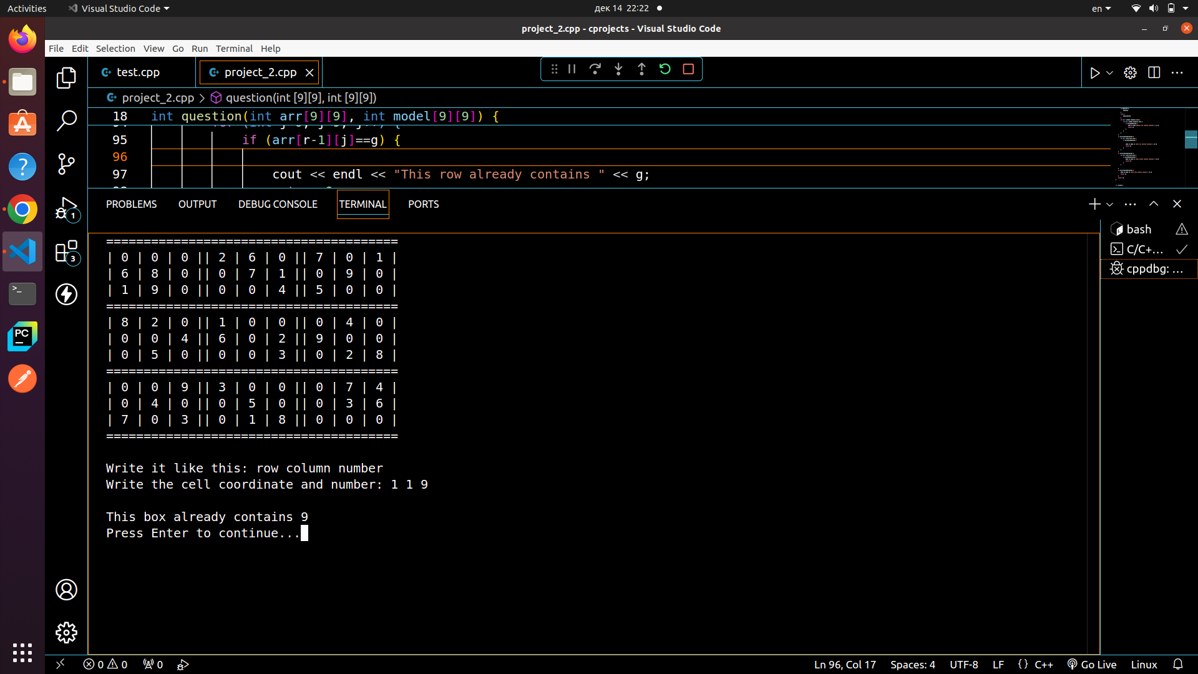

4)Now it says that “This box already contains 9” and this is

true because there is 9 in cell row 3 column 2 in the

same top left box. So let’s see what happens

when we type row 1 column 2 contains 5.

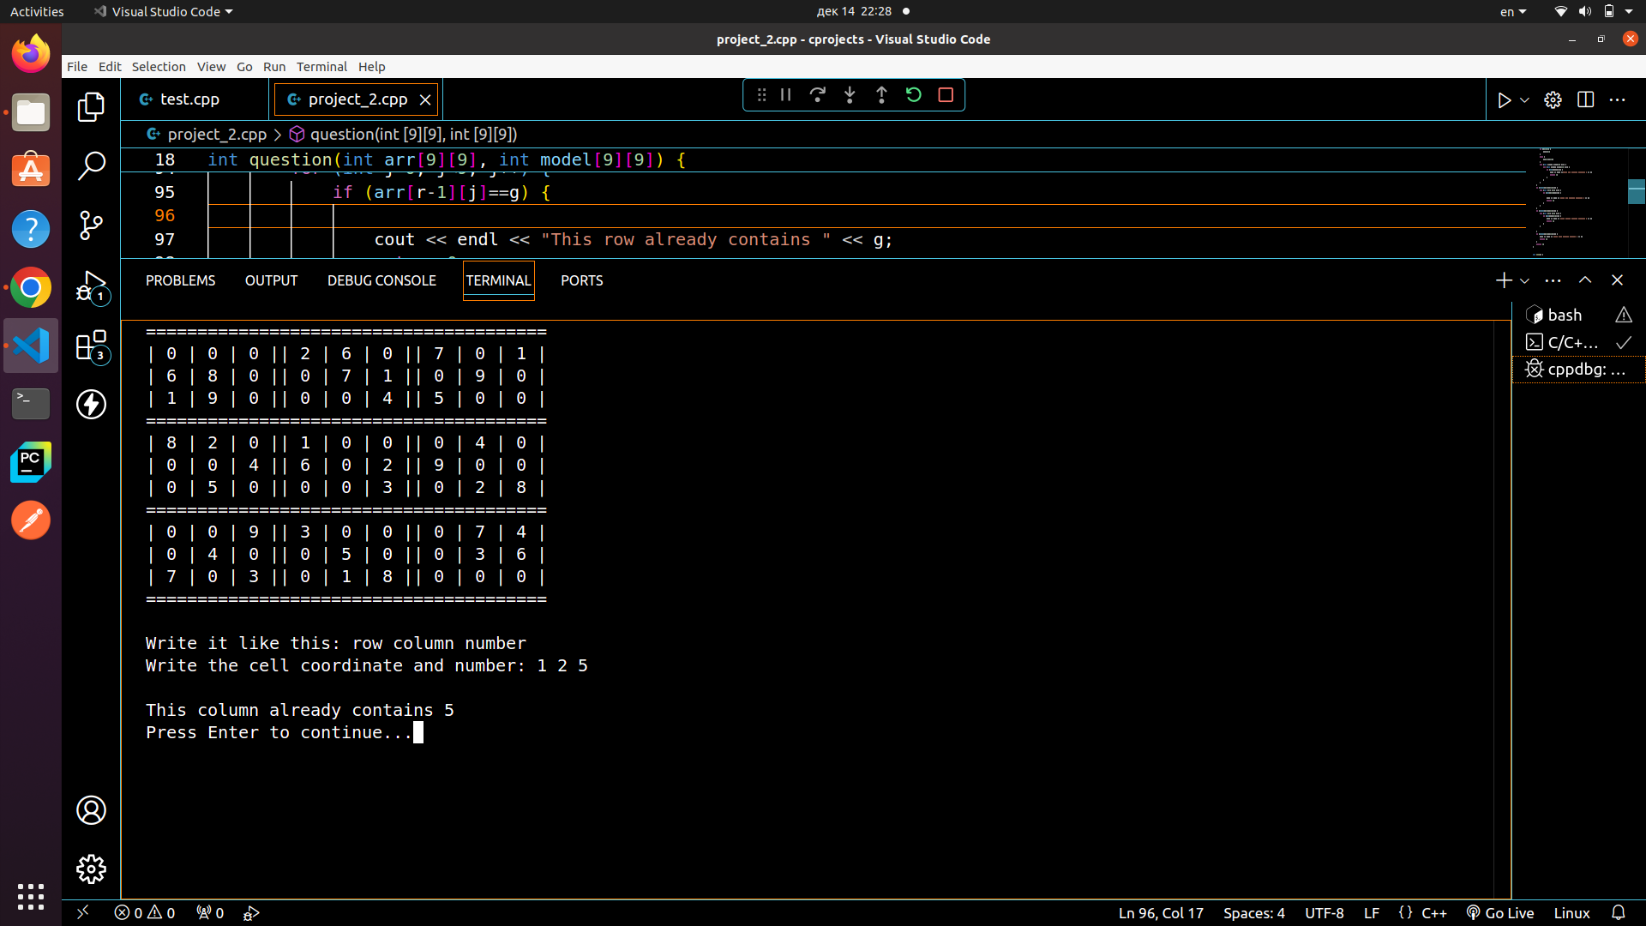

5)This time the game says that this column contains 5

and once again this is correct because there is 5 in cell

row 6 column 2. Now let’s try to give coordinate that is

bigger than grid’s length/height

also let’s try to put a number in cell that is already occupied

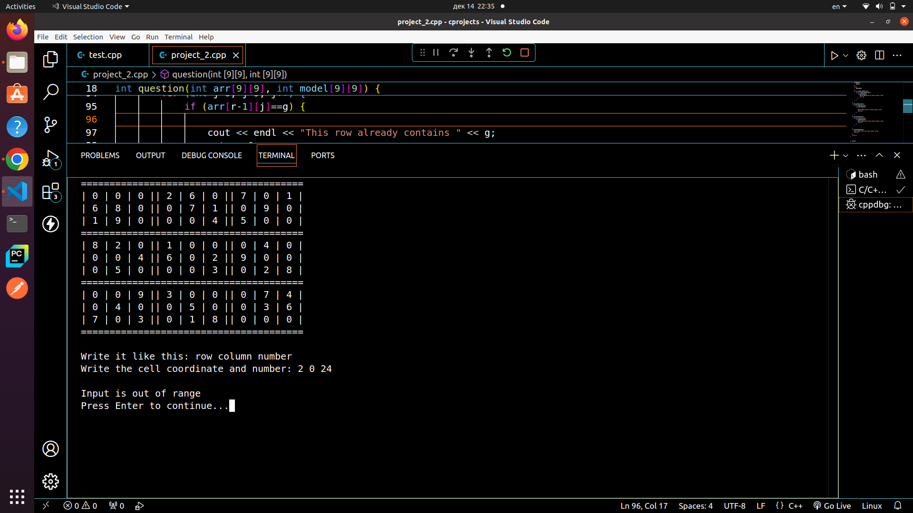

Input is out of range which is true because there is no 0

column and number can’t be bigger than 9. This will work in

all cases when row or column coordinate bigger then 9 or

less than 1 or the number is bigger then 9 or less than 1 or if

all of the digits are out of range.

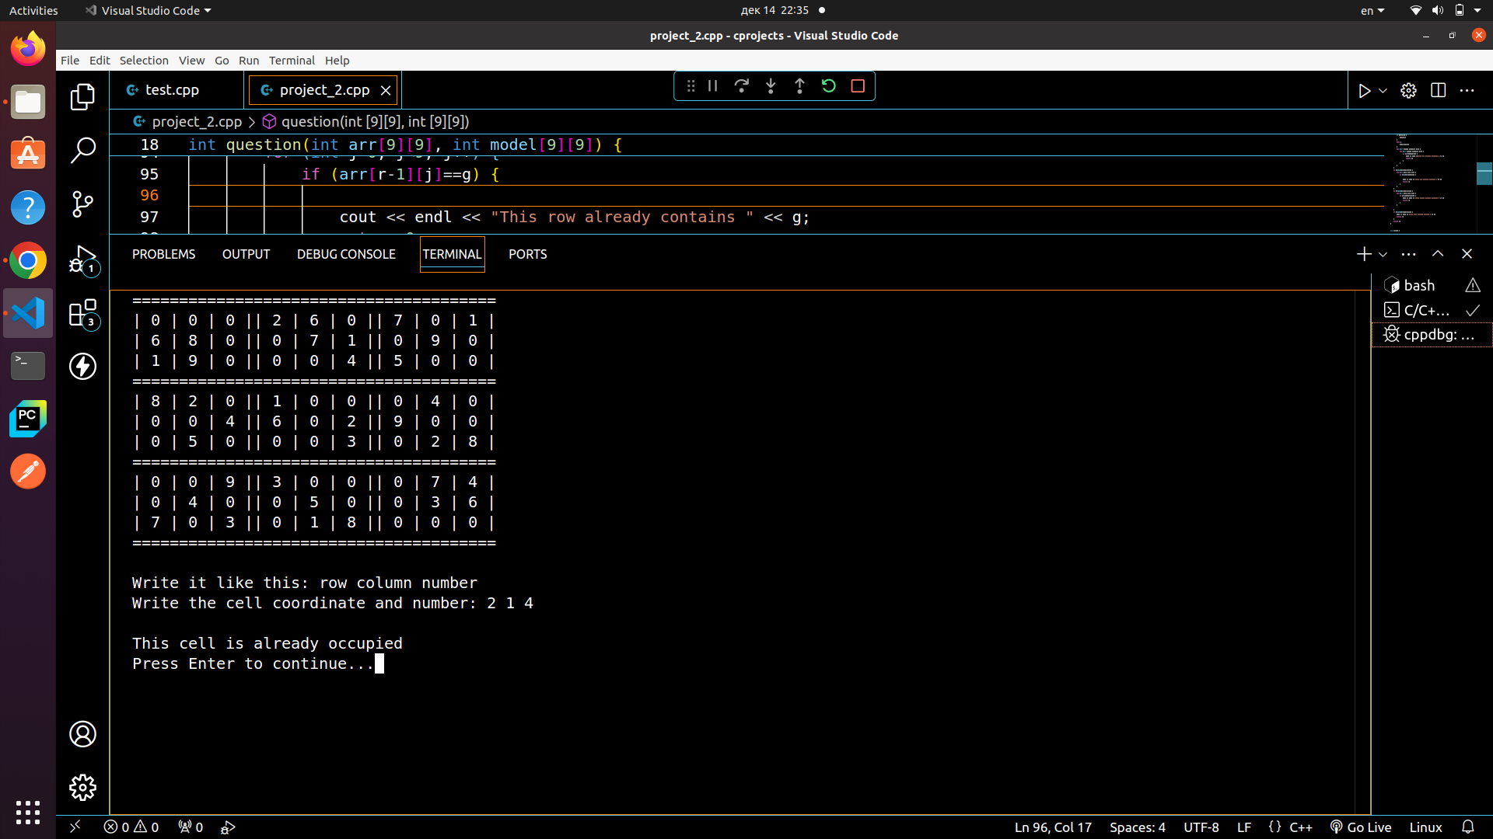

Here the mistake is that we tried to put a number in the cell

that was already occupied. The code checks if the cell is not

equal to zero. If it is then it’s free else it’s occupied and

the game will say about it.

6)In sudoku there are situations when one number can go

to more than one cell in the same box. In situations like that

player can guess the cell but in our case the game has only

one solution. So the game should also check this case

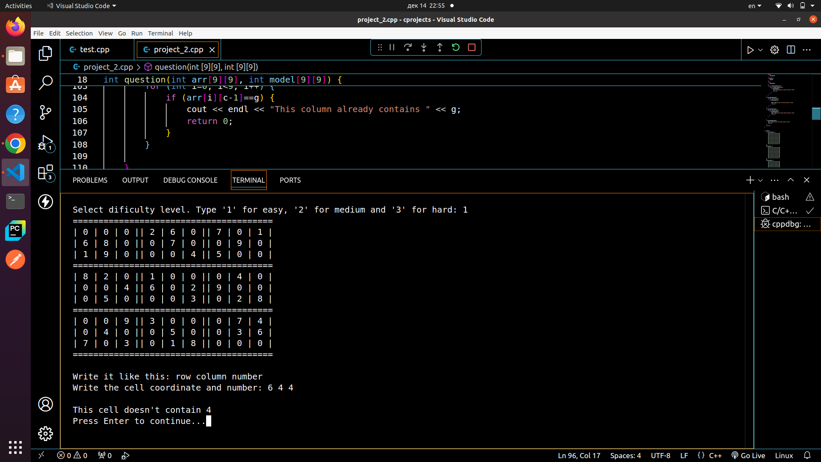

As we can see on the screen above number 4 can go to two

cells in the middle box because there are 4 in the left and

right boxes and no 4 below that can help us. So after a

guess: row 6 column 4 contains 4 - the game says that

“This cell doesn’t contain 4” which can be not obvious

but it is true. We can put 4 in row 9 column 4 because there

are fours on the left bottom and right bottom boxes that help

us to identify that 4 should go to row 9 column 4. After that

we can see why we guessed wrong.

7)After we checked every problem we can finally

put 4 in row 1 column 1. The game won’t say anything it will

just show us that our move was correct and we can continue

solving the puzzle

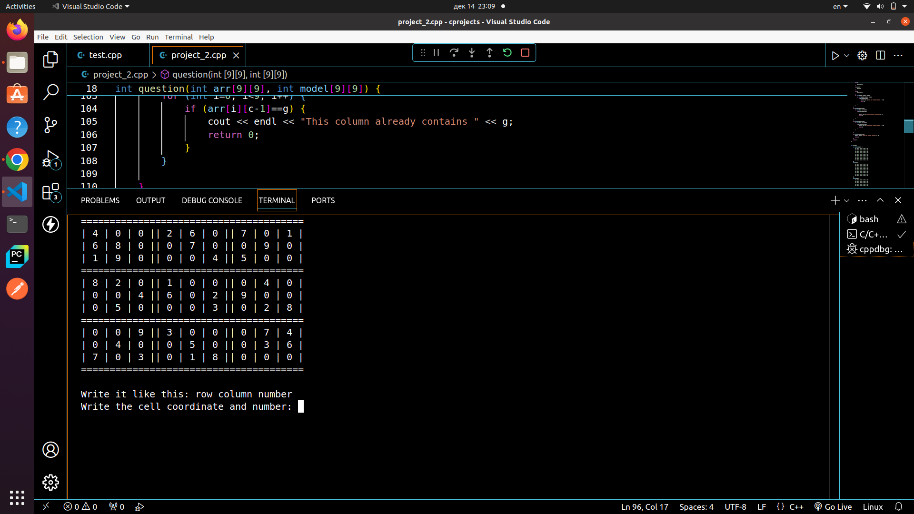

The cell at row 1 column 1 now contains 4 since we

correctly put it there. All of this checking will work for every

position and level of the game

Thank you for reading all that. I hope it helped to understand

the code and it’s logic and i apologise for not writing this as i

did this project. Thanks once again