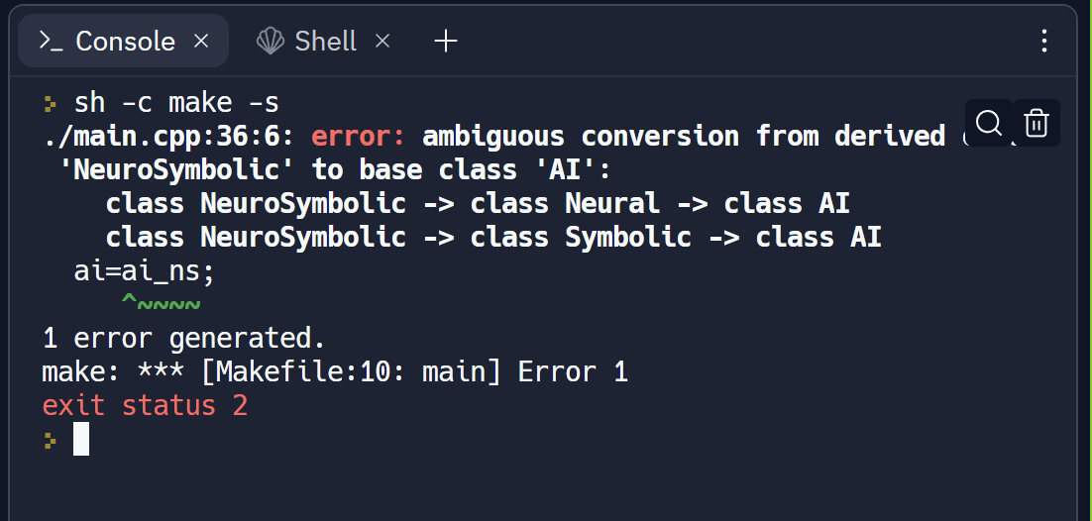

The given client code was not supported since the conversion from the derived class to the base class is ambiguous due to the multiple inheritance hierarchy.