WEB PROGRAMMING LAB

LAB 01

Name : Medha Chawla

Roll No. 55

Reg No. 220962340

Class: AI-ML

Section : A2

Q1.Write a simple poem and represent it as a web page. Give a title for the poem.

Make rhyming words in the poem as bold.

Code:

<!DOCTYPE html>

<html>

<head>

<title>LAB-1 question-1</title>

</head>

<body>

<h1><i>Twinkle Twinkle</i></h1>

<p>Twinkle twinkle little <b>star</b><br>How I wonder what you <strong>are</strong><br>

Up above the world so <b>high</b><br> Like a diamond in the <b>sky</b><br>

</p>

</body>

</html>

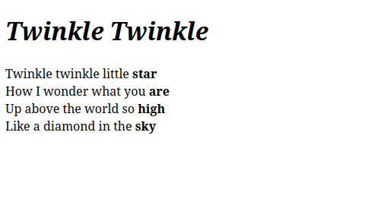

Q2. Assume you have brought a new car. Write down the list of additional

accessories you need for the car as an unordered list in HTML. Also, list the

travel plans on the car as an ordered list.

Code:

<!DOCTYPE html>

<html>

<head>

<title>LAB-1 question-2</title>

</head>

<body>

<h1>Additional accessories for car</h1>

<p>

<ul>

<li>Air Purifier</li>

<li>GPS</li>

<li>Seat cover</li>

<li>Air freshener</li>

<li>Phone Mount</li>

</ul>

</p>

<h1>Travel plans on the car</h1>

<p>

<ol>

<li>Mumbai</li>

<li>Nagpur</li>

<li>Delhi</li>

<li>Jaipur</li>

<li>Ahmedabad</li>

</ol>

</p>

</body>

</html>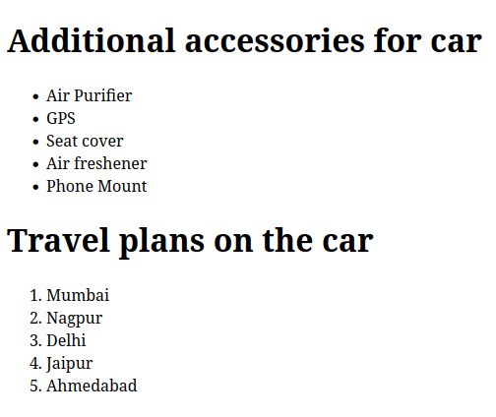

Q3. Complete the following website name “Share your Winter Vacation Videos”.

The required video files are located inside the compressed folder “Week 1

Assignment Files/Media/”.

Code:

<!DOCTYPE html>

<html>

<head>

<meta charset="UTF-8">

<meta name="viewport" content="width=device-width, initial-scale=1.0">

<title>LAB-1 question-3</title>

<link rel="stylesheet" href="q3styles.css">

</head>

<body>

<div class = "striped-gradient">

<h1><i>Share your Travels</i></h1>

</div>

<div class = "gradient">

<p>

<figure>

<h2><i>HTML5 Videos</i></h2>

<div class = "video-container">

<video width = "300" height = "300" controls>

<source src= "vid1.mp4" type="video/mp4">

</video>

<video width = "300" height = "300" controls>

<source src= "vid2.mp4" type="video/mp4">

</video>

<video width = "300" height = "300" controls>

<source src= "vid3.mp4" type="video/mp4">

</video>

</div>

</figure>

</p>

</div>

</body>

</html>

**q3styles.css**

* {

margin: 0;

padding: 0;

box-sizing: border-box;

}

.video-container {

display : flex;

justify-content: space-between;

gap: 1px;

max-width: 100%;

margin: 1px ;

}

.gradient {

background: none;

background: linear-gradient(to bottom, blue,lightblue, white);

margin: 0;

height: 100vh;

}

.striped-gradient {

background: repeating-linear-gradient(

45deg,

blue,

blue 25px,

black 25px,

black 50px);

}

h1,h2 {

color : white;

}

figure {

padding-left: 50px;

padding-right: 50px;

}

