**WEB PROGRAMMING LAB**

**LAB 02**

**Name : Medha Chawla**

**Roll No. 55**

**Reg No. 220962340**

**Class: AI-ML**

**Section : A2**

Q1. Design the student bio-data form using button, label, textbox, radio button, table and

checkbox using CSS.

**Q1.html**

<!DOCTYPE html>

<html>

<head>

<meta charset="UTF-8">

<meta name="viewport" content="width=device-width, initial-scale=1.0">

<title>Lab-2 Question-1</title>

<link rel="stylesheet" href="styles1.css">

</head>

<body>

<div class = "form-container">

<h1><b>Student Bio-data Form</b></h1>

<form action = "#" method = "post">

<table>

<tr>

<td><label for ="first-name">First Name:</label></td>

<td><input type ="text" id = "first-name" name = "first-name" required></td>

</tr>

<tr>

<td><label for ="last-name">Last Name:</label></td>

<td><input type ="text" id = "last-name" name = "last-name" required></td>

</tr>

<tr>

<td><label for ="dob">Date of Birth:</label></td>

<td><input type = "date" id="dob" name="dob" required></td>

</tr>

<tr>

<td><label>Gender:</label></td>

<td><div class="gender-options">

<label for="male">

<input type="radio" id="male" name="gender" value="male" required> Male

</label>

<label for="female">

<input type="radio" id="female" name="gender" value="female" required> Female

</label>

<label for="other">

<input type="radio" id="other" name="gender" value="other" required> Other

</label>

</div></td>

</tr>

<tr>

<td><label for = "email">Email Address:</label></td>

<td><input type = "email" id = "email" name = "email" required></td>

</tr>

<tr>

<td><label>Phone Number:</label></td>

<td><input type = "tel" id = "phone" name="phone" required></td>

</tr>

<tr>

<td><label for = "address">Address:</label></td>

<td><textarea id = "address" name = "address" rows = "4" required></textarea></td>

</tr>

<tr>

<td><label>Courses Enrolled:</label></td>

<td><div class="course-options">

<label for="course1">

<input type="checkbox" id="course1" name="courses" value="Math"> Math

</label>

<label for="course2">

<input type="checkbox" id="course2" name="courses" value="Science"> Science

</label>

<label for="course3">

<input type="checkbox" id="course3" name="courses" value="History"> History

</label>

<label for="course4">

<input type="checkbox" id="course4" name="courses" value="English"> English

</label>

<label for="course5">

<input type="checkbox" id="course5" name="courses" value="Art"> Art

</label>

</div></td>

</tr>

<tr>

<td><label for="photo">Upload Photo:</label></td>

<td><input type="file" id="photo" name="photo" accept="image/*" required></td>

</tr>

<tr>

<td colspan="2">

<button class = "submit-btn" type = "submit">Submit</button>

<button class = "reset-btn" type = "reset">Reset</button>

</td>

</tr>

</table>

</form>

</div>

</body>

</html>

**styles1.css**

/* General Styles */

body {

font-family: Arial, sans-serif;

background-color: #f4f4f4;

margin: 0;

padding: 0;

}

.form-container {

width: 50%;

margin: 50px auto;

background-color: lightgoldenrodyellow;

padding: 20px;

border-radius: 8px;

box-shadow: 0 4px 8px rgba(0, 0, 0, 0.1);

transition: transform 0.3s ease-in-out;

transform: scale(1.05);

}

h1 {

text-align: center;

color: #333;

}

form {

display: flex;

flex-direction: column;

}

label {

margin: 8px 0 4px;

font-size: 1.1em;

color: #333;

font-weight: bold;

}

input, select, textarea {

padding: 10px;

margin-bottom: 15px;

font-size: 1em;

border: 1px solid #ccc;

border-radius: 4px;

}

button {

padding: 12px 20px;

background-color: #4CAF50;

color: white;

border: none;

border-radius: 4px;

cursor: pointer;

font-size: 1em;

}

.submit-btn {

background-color: #f44336; /* Red */

}

.reset-btn {

background-color: #4CAF50;

}

.submit-btn:hover {

opacity: 0.5;

}

.reset-btn:hover {

opacity: 0.5;

}

input[type="file"] {

padding: 5px;

}

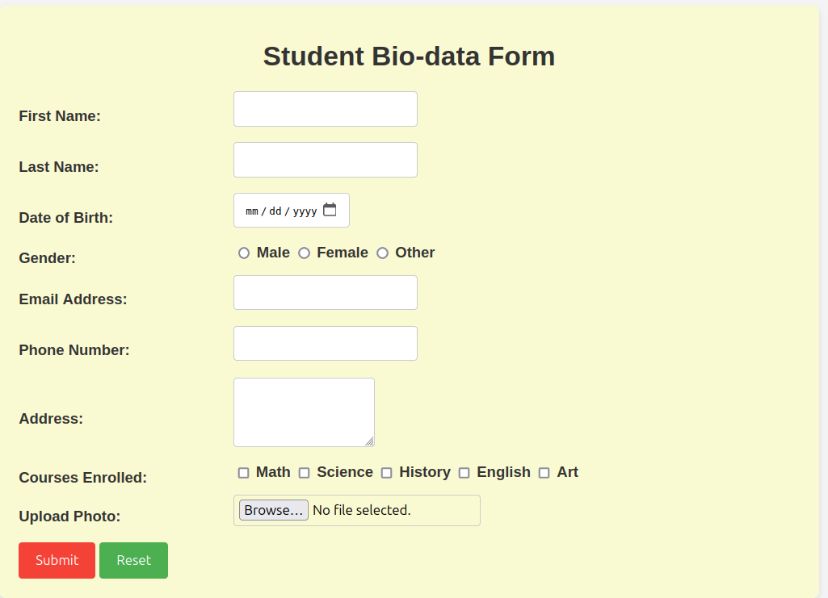

Q3. Create a web page using bootstrap as mentioned. Divide the page in to 2 parts top and

bottom, then divide the bottom into 3 parts and design each top and bottom part using

different input groups, input, badges, buttons and button groups. Make the design more

attractive using bootstrap.

**Q3.html**

<!DOCTYPE html>

<html lang="en">

<head>

<meta charset="UTF-8">

<meta name="viewport" content="width=device-width, initial-scale=1.0">

<title>Cookie Shop</title>

<!-- Bootstrap CSS -->

<link href="https://cdn.jsdelivr.net/npm/bootstrap@5.3.0-alpha1/dist/css/bootstrap.min.css" rel="stylesheet">

<!-- Bootstrap Icons -->

<link href="https://cdn.jsdelivr.net/npm/bootstrap-icons/font/bootstrap-icons.css" rel="stylesheet">

<link rel="stylesheet" href="styles3.css">

</head>

<body>

<!-- Top Section: Cookie Shop Header -->

<div class="container-fluid bg-dark text-white p-5">

<div class="row">

<div class="col-12 text-center">

<h1>Welcome to The Cookie Shop</h1>

<p class="lead">Freshly baked cookies for every taste! Explore our menu or log in to your account.</p>

<!-- Input Group in the Header Section -->

<div class="input-group justify-content-center my-4">

<input type="text" class="form-control" placeholder="Search for cookies..." aria-label="Search for cookies">

<button class="btn btn-light" type="button">Search</button>

</div>

<!-- Badges in the Header Section -->

<div class="badge-group">

<span class="badge bg-success m-1">New Arrivals</span>

<span class="badge bg-primary m-1">Best Sellers</span>

<span class="badge bg-danger m-1">Limited Time</span>

</div>

</div>

</div>

</div>

<!-- Bottom Section: Content Division -->

<div class="container mt-5">

<div class="row">

<!-- Left Column: Login Section -->

<div class="col-md-4 mb-4">

<div class="card shadow-sm">

<div class="card-body">

<h5 class="card-title">Login</h5>

<form action="#" method="post">

<div class="input-group mb-3">

<span class="input-group-text"><i class="bi bi-person"></i></span>

<input type="text" class="form-control" placeholder="Username" aria-label="Username">

</div>

<div class="input-group mb-3">

<span class="input-group-text"><i class="bi bi-key"></i></span>

<input type="password" class="form-control" placeholder="Password" aria-label="Password">

</div>

<button type="submit" class="btn btn-primary w-100">Login</button>

</form>

</div>

</div>

</div>

<!-- Center Column: Signup Section -->

<div class="col-md-4 mb-4">

<div class="card shadow-sm">

<div class="card-body">

<h5 class="card-title">Sign Up</h5>

<form action="#" method="post">

<div class="input-group mb-3">

<span class="input-group-text"><i class="bi bi-person-plus"></i></span>

<input type="text" class="form-control" placeholder="Username" aria-label="Username">

</div>

<div class="input-group mb-3">

<span class="input-group-text"><i class="bi bi-envelope"></i></span>

<input type="email" class="form-control" placeholder="Email" aria-label="Email">

</div>

<div class="input-group mb-3">

<span class="input-group-text"><i class="bi bi-key"></i></span>

<input type="password" class="form-control" placeholder="Password" aria-label="Password">

</div>

<button type="submit" class="btn btn-success w-100">Sign Up</button>

</form>

</div>

</div>

</div>

<!-- Right Column: Browse Menu Section -->

<div class="col-md-4 mb-4">

<div class="card shadow-sm">

<div class="card-body">

<h5 class="card-title">Browse Menu</h5>

<p>Check out our selection of freshly baked cookies!</p>

<ul class="list-group mb-3">

<li class="list-group-item d-flex justify-content-between align-items-center">

Chocolate Chip Cookie

<span class="badge bg-warning rounded-pill">New</span>

</li>

<li class="list-group-item d-flex justify-content-between align-items-center">

Oatmeal Raisin Cookie

<span class="badge bg-secondary rounded-pill">Popular</span>

</li>

<li class="list-group-item d-flex justify-content-between align-items-center">

Peanut Butter Cookie

<span class="badge bg-danger rounded-pill">Limited</span>

</li>

</ul>

<button class="btn btn-info w-100">View Full Menu</button>

</div>

</div>

</div>

</div>

</div>

<!-- Bootstrap JS and Popper.js (for Bootstrap components) -->

<script src="https://cdn.jsdelivr.net/npm/@popperjs/core@2.11.6/dist/umd/popper.min.js"></script>

<script src="https://cdn.jsdelivr.net/npm/bootstrap@5.3.0-alpha1/dist/js/bootstrap.min.js"></script>

</body>

</html>

**styles3.css**

/* General Page Styles */

body {

font-family: 'Arial', sans-serif;

background-color: #f4f4f4;

}

/* Top Section Styling */

.container-fluid.bg-dark {

background-color: #343a40 !important;

}

h1 {

font-size: 3rem;

font-weight: bold;

}

p.lead {

font-size: 1.2rem;

margin-top: 10px;

}

/* Input Group in the Header */

.input-group {

max-width: 600px;

margin: 0 auto;

}

.input-group .form-control {

border-radius: 0.375rem;

}

.input-group .form-control:focus {

border-color: #007bff;

box-shadow: 0 0 0 0.2rem rgba(38, 143, 255, 0.25);

}

.btn-light {

border-radius: 0.375rem;

}

/* Badge Group in the Header */

.badge-group {

margin-top: 15px;

}

.badge-group .badge {

font-size: 1rem;

margin: 0 5px;

}

/* Card Section Styling */

.card {

border: none;

border-radius: 10px;

box-shadow: 0 4px 10px rgba(0, 0, 0, 0.1);

transition: transform 0.2s ease-in-out;

}

.card:hover {

transform: scale(1.05);

}

.card-title {

font-size: 1.5rem;

font-weight: bold;

margin-bottom: 15px;

}

/* Login, Signup, and Menu Section */

.input-group-text {

background-color: #f8f9fa;

border-color: #ccc;

}

.input-group .form-control {

border-radius: 0.375rem;

border-color: #ccc;

}

.input-group .form-control:focus {

border-color: #007bff;

box-shadow: 0 0 0 0.2rem rgba(38, 143, 255, 0.25);

}

/* Buttons Styling */

.btn {

font-weight: bold;

padding: 12px;

border-radius: 0.375rem;

}

.btn-primary {

background-color: #007bff;

border: none;

}

.btn-primary:hover {

background-color: #0056b3;

}

.btn-success {

background-color: #28a745;

border: none;

}

.btn-success:hover {

background-color: #218838;

}

.btn-info {

background-color: #17a2b8;

border: none;

}

.btn-info:hover {

background-color: #138496;

}

/* Badge Styling */

.badge {

font-size: 0.9rem;

}

.badge.bg-warning {

background-color: #ffc107;

}

.badge.bg-secondary {

background-color: #6c757d;

}

.badge.bg-danger {

background-color: #dc3545;

}

/* Menu Styling */

.list-group-item {

font-size: 1rem;

padding: 15px;

}

.list-group-item .badge {

font-size: 1rem;

}

.list-group-item:hover {

background-color: #f8f9fa;

cursor: pointer;

}

/* Responsive Adjustments */

@media (max-width: 768px) {

.card-body {

padding: 1rem;

}

.container {

padding-left: 15px;

padding-right: 15px;

}

h1 {

font-size: 2.5rem;

}

.input-group .form-control,

.input-group-text,

.btn {

font-size: 0.9rem;

}

}

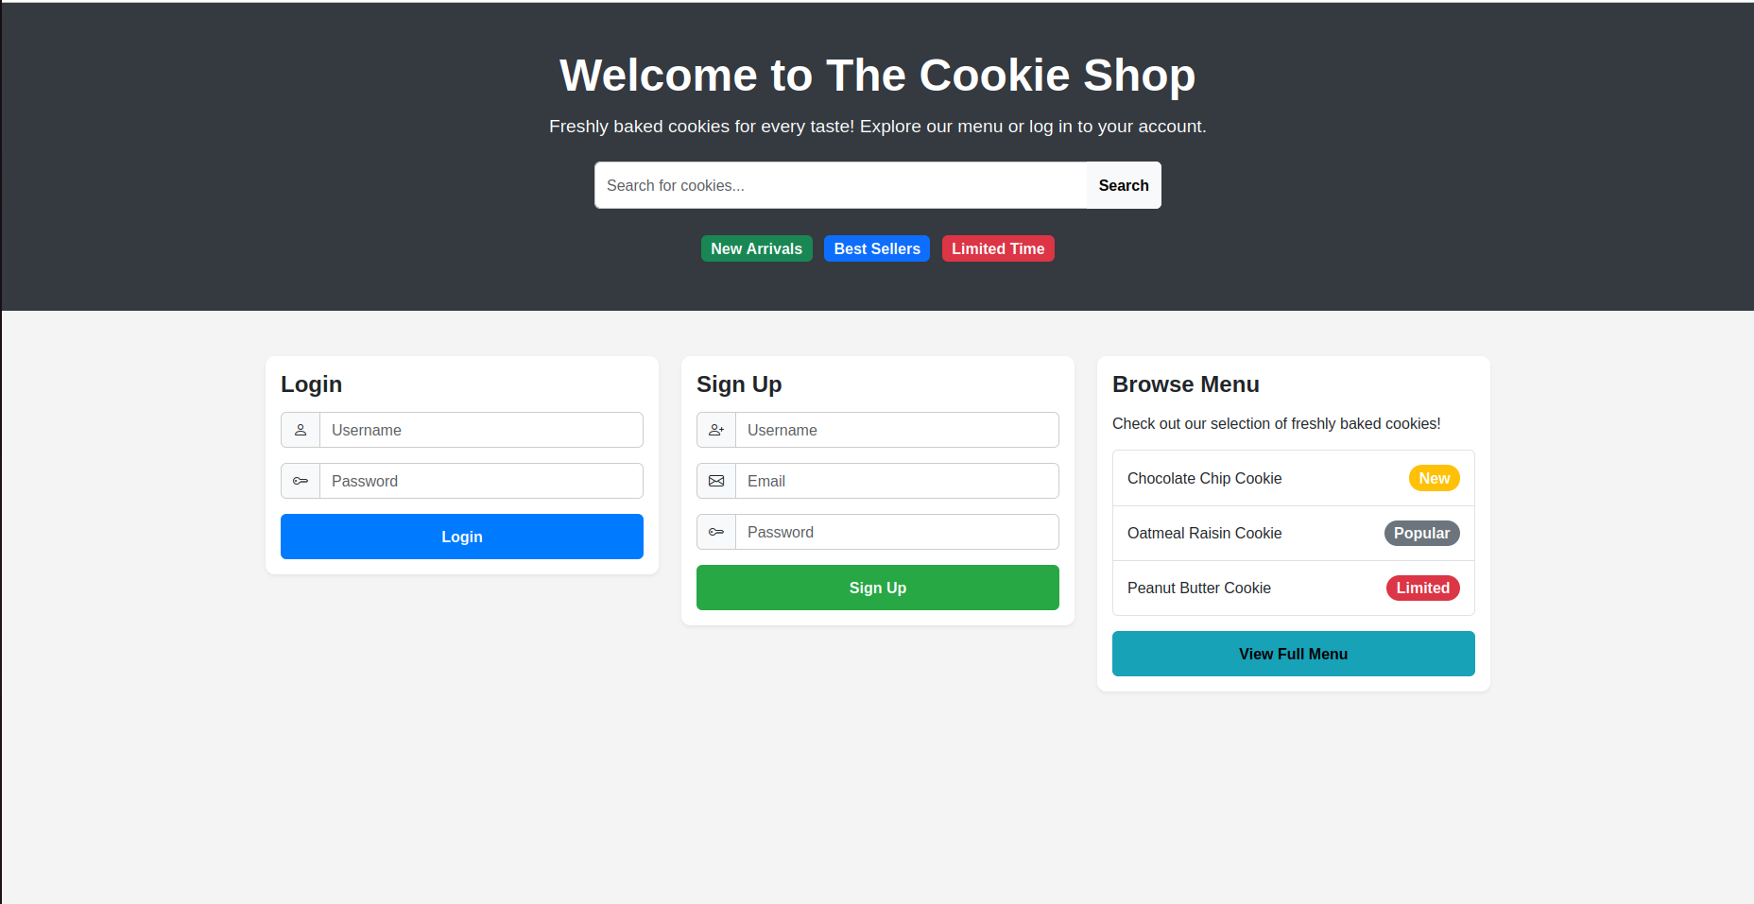  
  
**Q4.html**

<!DOCTYPE html>

<html lang="en">

<head>

<meta charset="UTF-8">

<meta name="viewport" content="width=device-width, initial-scale=1.0">

<title>Class Timetable</title>

<!-- Bootstrap CSS -->

<link href="https://cdn.jsdelivr.net/npm/bootstrap@5.3.0-alpha1/dist/css/bootstrap.min.css" rel="stylesheet">

<!-- Custom CSS -->

<link rel="stylesheet" href="styles4.css">

</head>

<body>

<!-- Header Section -->

<div class="container-fluid bg-dark text-white text-center py-5">

<h1 class="display-4">Class Timetable</h1>

<p class="lead">Your weekly class schedule from Monday to Saturday. Sunday is a holiday!</p>

</div>

<!-- Timetable Carousel Section -->

<div id="timetableCarousel" class="carousel slide" data-bs-ride="carousel">

<div class="carousel-inner">

<!-- Monday -->

<div class="carousel-item active">

<div class="container mt-4">

<h2 class="text-center">Monday</h2>

<table class="table table-bordered table-striped">

<thead class="table-dark">

<tr>

<th>Time</th>

<th>Subject</th>

</tr>

</thead>

<tbody>

<tr>

<td>8:00 AM - 9:00 AM</td>

<td>PCAP</td>

</tr>

<tr>

<td>9:00 AM - 10:00 AM</td>

<td>WP</td>

</tr>

<tr>

<td>10:00 AM - 11:00 AM</td>

<td>BDA</td>

</tr>

<tr>

<td>11:00 AM - 12:00 PM</td>

<td>EEFM</td>

</tr>

<tr>

<td>12:00 PM - 1:00 PM</td>

<td>OE</td>

</tr>

<tr>

<td>1:00 PM - 2:00 PM</td>

<td>Sports</td>

</tr>

</tbody>

</table>

</div>

</div>

<!-- Tuesday -->

<div class="carousel-item">

<div class="container mt-4">

<h2 class="text-center">Tuesday</h2>

<table class="table table-bordered table-striped">

<thead class="table-dark">

<tr>

<th>Time</th>

<th>Subject</th>

</tr>

</thead>

<tbody>

<tr>

<td>8:00 AM - 9:00 AM</td>

<td>PCAP</td>

</tr>

<tr>

<td>9:00 AM - 10:00 AM</td>

<td>WP</td>

</tr>

<tr>

<td>10:00 AM - 11:00 AM</td>

<td>BDA</td>

</tr>

<tr>

<td>11:00 AM - 12:00 PM</td>

<td>EEFM</td>

</tr>

<tr>

<td>12:00 PM - 1:00 PM</td>

<td>OE</td>

</tr>

<tr>

<td>1:00 PM - 2:00 PM</td>

<td>Sports</td>

</tr>

</tbody>

</table>

</div>

</div>

<!-- Wednesday -->

<div class="carousel-item">

<div class="container mt-4">

<h2 class="text-center">Wednesday</h2>

<table class="table table-bordered table-striped">

<thead class="table-dark">

<tr>

<th>Time</th>

<th>Subject</th>

</tr>

</thead>

<tbody>

<tr>

<td>8:00 AM - 9:00 AM</td>

<td>PCAP</td>

</tr>

<tr>

<td>9:00 AM - 10:00 AM</td>

<td>WP</td>

</tr>

<tr>

<td>10:00 AM - 11:00 AM</td>

<td>BDA</td>

</tr>

<tr>

<td>11:00 AM - 12:00 PM</td>

<td>EEFM</td>

</tr>

<tr>

<td>12:00 PM - 1:00 PM</td>

<td>OE</td>

</tr>

<tr>

<td>1:00 PM - 2:00 PM</td>

<td>Sports</td>

</tr>

</tbody>

</table>

</div>

</div>

<!-- Thursday -->

<div class="carousel-item">

<div class="container mt-4">

<h2 class="text-center">Thursday</h2>

<table class="table table-bordered table-striped">

<thead class="table-dark">

<tr>

<th>Time</th>

<th>Subject</th>

</tr>

</thead>

<tbody>

<tr>

<td>8:00 AM - 9:00 AM</td>

<td>PCAP</td>

</tr>

<tr>

<td>9:00 AM - 10:00 AM</td>

<td>WP</td>

</tr>

<tr>

<td>10:00 AM - 11:00 AM</td>

<td>BDA</td>

</tr>

<tr>

<td>11:00 AM - 12:00 PM</td>

<td>EEFM</td>

</tr>

<tr>

<td>12:00 PM - 1:00 PM</td>

<td>OE</td>

</tr>

<tr>

<td>1:00 PM - 2:00 PM</td>

<td>Sports</td>

</tr>

</tbody>

</table>

</div>

</div>

<!-- Friday -->

<div class="carousel-item">

<div class="container mt-4">

<h2 class="text-center">Friday</h2>

<table class="table table-bordered table-striped">

<thead class="table-dark">

<tr>

<th>Time</th>

<th>Subject</th>

</tr>

</thead>

<tbody>

<tr>

<td>8:00 AM - 9:00 AM</td>

<td>PCAP</td>

</tr>

<tr>

<td>9:00 AM - 10:00 AM</td>

<td>WP</td>

</tr>

<tr>

<td>10:00 AM - 11:00 AM</td>

<td>BDA</td>

</tr>

<tr>

<td>11:00 AM - 12:00 PM</td>

<td>EEFM</td>

</tr>

<tr>

<td>12:00 PM - 1:00 PM</td>

<td>OE</td>

</tr>

<tr>

<td>1:00 PM - 2:00 PM</td>

<td>Sports</td>

</tr>

</tbody>

</table>

</div>

</div>

<!-- Saturday -->

<div class="carousel-item">

<div class="container mt-4">

<h2 class="text-center">Saturday</h2>

<table class="table table-bordered table-striped">

<thead class="table-dark">

<tr>

<th>Time</th>

<th>Subject</th>

</tr>

</thead>

<tbody>

<tr>

<td>8:00 AM - 9:00 AM</td>

<td>PCAP</td>

</tr>

<tr>

<td>9:00 AM - 10:00 AM</td>

<td>WP</td>

</tr>

<tr>

<td>10:00 AM - 11:00 AM</td>

<td>BDA</td>

</tr>

<tr>

<td>11:00 AM - 12:00 PM</td>

<td>EEFM</td>

</tr>

<tr>

<td>12:00 PM - 1:00 PM</td>

<td>OE</td>

</tr>

<tr>

<td>1:00 PM - 2:00 PM</td>

<td>Sports</td>

</tr>

</tbody>

</table>

</div>

</div>

</div>

<!-- Timetable Carousel Controls -->

<button class="carousel-control-prev" type="button" data-bs-target="#timetableCarousel" data-bs-slide="prev">

<span class="carousel-control-prev-icon" aria-hidden="true"></span>

<span class="visually-hidden">Previous</span>

</button>

<button class="carousel-control-next" type="button" data-bs-target="#timetableCarousel" data-bs-slide="next">

<span class="carousel-control-next-icon" aria-hidden="true"></span>

<span class="visually-hidden">Next</span>

</button>

</div>

<!-- Bootstrap JS and Popper.js (for Bootstrap components) -->

<script src="https://cdn.jsdelivr.net/npm/@popperjs/core@2.11.6/dist/umd/popper.min.js"></script>

<script src="https://cdn.jsdelivr.net/npm/bootstrap@5.3.0-alpha1/dist/js/bootstrap.min.js"></script>

</body>

</html>

**styles4.css**

/* General Page Styles */

body {

font-family: 'Arial', sans-serif;

background-color: #f0f8ff;

margin: 0;

padding: 0;

color: #333;

}

/* Header Section */

.container-fluid.bg-dark {

background-color: #007bff !important; /* Bright Blue */

color: white;

padding: 50px 0;

}

h1.display-4 {

font-size: 3rem;

font-weight: bold;

text-shadow: 2px 2px 4px rgba(0, 0, 0, 0.5);

}

p.lead {

font-size: 1.2rem;

margin-top: 10px;

font-style: italic;

}

/* Timetable Table Styling */

.table {

font-size: 1rem;

border: 1px solid #ddd;

margin-top: 30px;

background-color: #ffffff;

}

.table th, .table td {

text-align: center;

padding: 15px;

font-weight: bold;

}

.table-striped tbody tr:nth-of-type(odd) {

background-color: #eaf0fa; /* Light Blue */

}

.table-striped tbody tr:nth-of-type(even) {

background-color: #f9f9f9; /* Light Gray */

}

.table-dark {

background-color: #343a40;

color: white;

}

.table-bordered {

border: 1px solid #ddd;

}

table th {

font-size: 1.1rem;

background-color: #28a745; /* Green background for headers */

color: white;

}

table td {

font-size: 1rem;

background-color: #f8f9fa;

color: #343a40;

}

/* Carousel Section */

.carousel-item {

padding-bottom: 40px;

}

.carousel-control-prev-icon,

.carousel-control-next-icon {

background-color: #343a40;

}

.carousel-control-prev, .carousel-control-next {

width: 5%;

}

/* Centering the table and heading within each carousel item */

.container.mt-4 {

max-width: 800px;

margin: 0 auto;

}

/* Carousel Navigation */

.carousel-control-prev-icon, .carousel-control-next-icon {

background-color: #007bff; /* Matching with header */

border-radius: 50%;

}

/* Timetable Day Titles */

h2.text-center {

font-size: 2rem;

font-weight: bold;

margin-top: 30px;

text-decoration: underline;

color: #ff6347; /* Tomato red color for days */

}

/* For the entire carousel container */

#timetableCarousel {

margin-top: 50px;

}

/* Time Slot Background Colors */

.table td:first-child {

background-color: #f1c40f; /* Yellow for time slots */

color: white;

font-weight: bold;

}

/* Holiday (Sunday) Section */

.carousel-item:last-child {

background-color: #f8f9fa;

}

.carousel-item:last-child h2.text-center {

color: #ff4500; /* Orange-red for Sunday */

}

/* Mobile Responsiveness */

@media (max-width: 768px) {

.container-fluid.bg-dark {

padding: 30px 0;

}

h1.display-4 {

font-size: 2rem;

}

p.lead {

font-size: 1rem;

}

.carousel-item {

padding-bottom: 30px;

}

.table th, .table td {

padding: 10px;

}

.table th {

font-size: 1rem;

}

.table td {

font-size: 0.9rem;

}

}

/* Active Carousel Item */

.carousel-item.active {

background-color: #d1ecf1; /* Light Blue for active days */

}

/* Zebra Striping for Classes */

.table-striped tbody tr:nth-child(odd) {

background-color: #b3d9f7; /* Lighter blue */

}

.table-striped tbody tr:nth-child(even) {

background-color: #f9f9f9; /* Light Gray */

}

