**WP LAB (WEEK 3)**

**Name: Medha Chawla**

**Roll. No. 55**

**Reg. No. 220962340**

**Section: A2**

**Date: 23/01/25**

**q1.html**

<!DOCTYPE html>

<html lang="en">

<head>

<meta charset="UTF-8">

<meta name="viewport" content="width=device-width, initial-scale=1.0">

<title>Online Quiz</title>

<link rel="stylesheet" href="q1styles.css">

</head>

<body>

<div class="quiz-container">

<h1>Online Quiz</h1>

<form id="quizForm">

<div class="question" id="question1">

<p>1. What is the capital of France?</p>

<input type="radio" name="q1" value="A"> A) Paris<br>

<input type="radio" name="q1" value="B"> B) London<br>

<input type="radio" name="q1" value="C"> C) Berlin<br>

<input type="radio" name="q1" value="D"> D) Madrid<br>

</div>

<div class="question" id="question2">

<p>2. What is 5 + 3?</p>

<input type="radio" name="q2" value="A"> A) 6<br>

<input type="radio" name="q2" value="B"> B) 7<br>

<input type="radio" name="q2" value="C"> C) 8<br>

<input type="radio" name="q2" value="D"> D) 9<br>

</div>

<div class="question" id="question3">

<p>3. Who wrote 'Romeo and Juliet'?</p>

<input type="radio" name="q3" value="A"> A) William Shakespeare<br>

<input type="radio" name="q3" value="B"> B) Charles Dickens<br>

<input type="radio" name="q3" value="C"> C) Jane Austen<br>

<input type="radio" name="q3" value="D"> D) Mark Twain<br>

</div>

<div class="question" id="question4">

<p>4. What is the square root of 64? (Numeric Answer)</p>

<input type="number" id="q4" name="q4" min="0" step="1"><br>

</div>

<button type="button" onclick="submitQuiz()">Submit Quiz</button>

<button type="reset" class="reset-btn">Reset Quiz</button>

</form>

<div id="result" class="result"></div>

</div>

<script src="q1script.js"></script>

</body>

</html>

**q1styles.css**

body {

font-family: Arial, sans-serif;

background-color: #f0f4f8;

display: flex;

justify-content: center;

align-items: center;

height: 100vh;

margin: 0;

}

.quiz-container {

background-color: #fff;

padding: 20px;

border-radius: 10px;

box-shadow: 0 4px 8px rgba(0, 0, 0, 0.1);

width: 450px;

text-align: center;

border: 3px solid #e5e5e5;

}

h1 {

color: #333;

font-size: 24px;

margin-bottom: 20px;

color: #ff6f61;

}

.question {

text-align: left;

margin-bottom: 20px;

padding-left: 10px;

}

input[type="radio"], input[type="number"] {

margin-right: 10px;

}

button {

padding: 12px 20px;

background-color: #28a745;

color: white;

border: none;

border-radius: 5px;

cursor: pointer;

margin-top: 20px;

margin-right: 10px;

}

button:hover {

background-color: #218838;

}

.reset-btn {

background-color: #ffc107;

}

.reset-btn:hover {

background-color: #e0a800;

}

.result {

margin-top: 20px;

font-size: 18px;

font-weight: bold;

}

.correct {

color: green;

}

.incorrect {

color: red;

}  
  
**q1script.js**function submitQuiz() {

// Get the form and the selected answers

const form = document.getElementById('quizForm');

const answers = {

q1: 'A',

q2: 'C',

q3: 'A',

q4: 8

};

let score = 0;

// Check each question

for (let i = 1; i <= 3; i++) {

const selectedAnswer = form.querySelector(`input[name="q${i}"]:checked`);

if (selectedAnswer && selectedAnswer.value === answers[`q${i}`]) {

score++;

}

}

// Validate numerical question

const q4Answer = parseInt(form.querySelector('#q4').value);

if (!isNaN(q4Answer) && q4Answer === answers.q4) {

score++;

}

// Display the result

const resultDiv = document.getElementById('result');

if (score === 4) {

resultDiv.textContent = "You scored 4 out of 4! Perfect!";

resultDiv.classList.add('correct');

resultDiv.classList.remove('incorrect');

} else if (score === 3) {

resultDiv.textContent = "You scored 3 out of 4. Great job!";

resultDiv.classList.add('correct');

resultDiv.classList.remove('incorrect');

} else if (score === 2) {

resultDiv.textContent = "You scored 2 out of 4. Keep it up!";

resultDiv.classList.add('correct');

resultDiv.classList.remove('incorrect');

} else {

resultDiv.textContent = "You scored less than 2. Better luck next time!";

resultDiv.classList.add('incorrect');

resultDiv.classList.remove('correct');

}

}

// Reset the result message when the form is reset

const resetBtn = document.querySelector('.reset-btn');

resetBtn.addEventListener('click', function() {

const resultDiv = document.getElementById('result');

resultDiv.textContent = '';

});  
  
  
**SNAPSHOT**

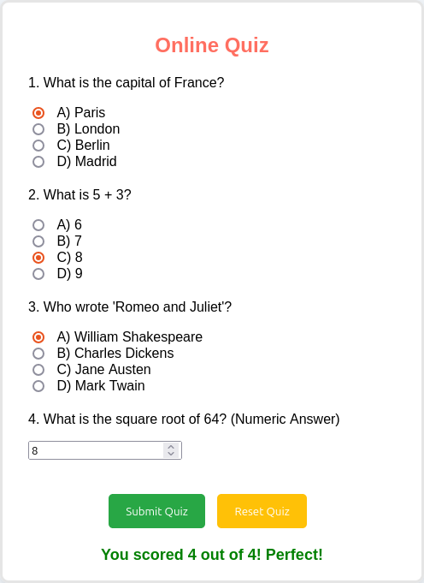  
  
  
  
  
  
  
  
  
  
  
  
  
  
  
  
  
  
  
  
  
  
  
  
  
  
  
  
  
  
**q2.html**

<!DOCTYPE html>

<html lang="en">

<head>

<meta charset="UTF-8">

<meta name="viewport" content="width=device-width, initial-scale=1.0">

<title>Dynamic Clock with Greetings</title>

<link rel="stylesheet" href="q2styles.css">

</head>

<body>

<div class="container">

<div id="greeting" class="greeting"></div>

<div id="clock" class="clock"></div>

</div>

<script src="q2script.js"></script>

</body>

</html>  
  
**q2styles.css**\* {

margin: 0;

padding: 0;

box-sizing: border-box;

}

body {

font-family: 'Arial', sans-serif;

display: flex;

justify-content: center;

align-items: center;

height: 100vh;

background-color: #f5f5f5;

color: #fff;

overflow: hidden;

}

.container {

text-align: center;

position: relative;

z-index: 1;

border-radius: 15px;

padding: 20px;

box-shadow: 0 4px 8px rgba(0, 0, 0, 0.3);

background-color: rgba(0, 0, 0, 0.6); /* Semi-transparent dark background */

width: 300px;

height: 200px;

}

.clock {

font-size: 48px;

font-weight: bold;

color: #fff;

margin-top: 20px;

padding: 10px;

border: 2px solid #fff;

border-radius: 10px;

background-color: rgba(0, 0, 0, 0.5); /* Dark background for clock */

}

.greeting {

font-size: 24px;

font-weight: 500;

margin-bottom: 20px;

}

.morning {

background-image: url('https://www.w3schools.com/w3images/mountains.jpg');

background-size: contain;

background-repeat: no-repeat;

background-position: center;

}

.afternoon {

background-image: url('https://www.w3schools.com/w3images/forest.jpg');

background-size: contain;

background-repeat: no-repeat;

background-position: center;

}

.evening {

background-image: url('https://www.w3schools.com/w3images/lights.jpg');

background-size: contain;

background-repeat: no-repeat;

background-position: center;

}

.night {

background-image: url('https://www.w3schools.com/w3images/rocks.jpg');

background-size: contain;

background-repeat: no-repeat;

background-position: center;

}  
  
**q2script.js**function updateTimeAndGreet() {

const date = new Date();

const hours = date.getHours();

const minutes = date.getMinutes();

const seconds = date.getSeconds();

const timeString = `${padZero(hours)}:${padZero(minutes)}:${padZero(seconds)}`;

document.getElementById('clock').textContent = timeString;

let greeting = '';

let backgroundClass = '';

if (hours >= 6 && hours < 12) {

greeting = "Good Morning!";

backgroundClass = 'morning';

} else if (hours >= 12 && hours < 18) {

greeting = "Good Afternoon!";

backgroundClass = 'afternoon';

} else if (hours >= 18 && hours < 21) {

greeting = "Good Evening!";

backgroundClass = 'evening';

} else {

greeting = "Good Night!";

backgroundClass = 'night';

}

document.body.className = backgroundClass;

// Display greeting in a small box

document.getElementById('greeting').textContent = greeting;

}

function padZero(num) {

return num < 10 ? `0${num}` : num;

}

setInterval(updateTimeAndGreet, 1000); // Update every second

**SNAPSHOT**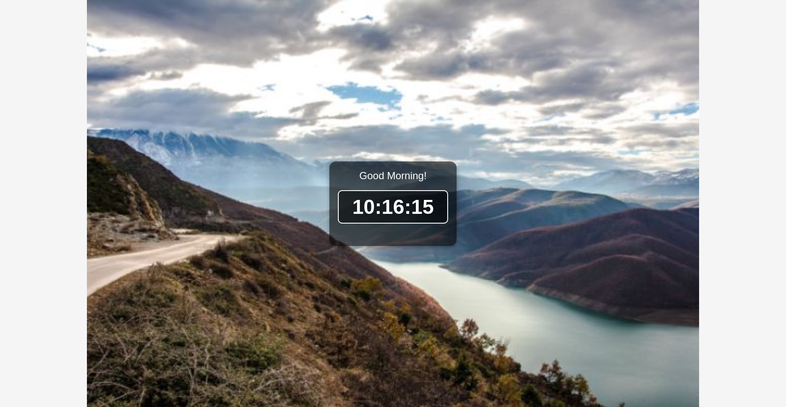

**q3.html**<!DOCTYPE html>

<html lang="en">

<head>

<meta charset="UTF-8">

<meta name="viewport" content="width=device-width, initial-scale=1.0">

<title>Grade Calculator</title>

<link rel="stylesheet" href="q3styles.css">

</head>

<body>

<div class="container">

<h1>Student Grade Calculator</h1>

<div class="form-container">

<label for="subject1">Subject 1 Marks:</label>

<input type="number" id="subject1" placeholder="Enter marks" required>

<label for="subject2">Subject 2 Marks:</label>

<input type="number" id="subject2" placeholder="Enter marks" required>

<label for="subject3">Subject 3 Marks:</label>

<input type="number" id="subject3" placeholder="Enter marks" required>

<label for="subject4">Subject 4 Marks:</label>

<input type="number" id="subject4" placeholder="Enter marks" required>

<button id="calculateBtn">Calculate Average & Grade</button>

<div id="result">

<p id="averageText"></p>

<p id="gradeText"></p>

</div>

</div>

</div>

<script src="q3script.js"></script>

</body>

</html>  
  
**q3styles.css**\* {

margin: 0;

padding: 0;

box-sizing: border-box;

}

body {

font-family: 'Arial', sans-serif;

background: linear-gradient(45deg, #ff8c00, #ff2a68);

color: white;

display: flex;

justify-content: center;

align-items: center;

height: 100vh;

text-align: center;

}

.container {

background: rgba(0, 0, 0, 0.7);

padding: 30px;

border-radius: 15px;

box-shadow: 0 5px 15px rgba(0, 0, 0, 0.5);

width: 350px;

}

h1 {

margin-bottom: 20px;

font-size: 28px;

color: #fff;

}

.form-container {

display: flex;

flex-direction: column;

gap: 15px;

}

label {

font-size: 16px;

margin-bottom: 5px;

color: #fff;

}

input {

padding: 10px;

font-size: 16px;

border: 2px solid #ff2a68;

border-radius: 5px;

outline: none;

background-color: #fff;

color: #333;

}

button {

padding: 12px;

background-color: #ff2a68;

color: white;

font-size: 18px;

border: none;

border-radius: 8px;

cursor: pointer;

transition: background-color 0.3s;

}

button:hover {

background-color: #ff8c00;

}

#result {

margin-top: 20px;

font-size: 18px;

font-weight: bold;

}

#averageText {

margin-bottom: 10px;

}

#gradeText {

color: #ff8c00;

}

.invalid {

color: red;

}  
  
**q3script.js**document.getElementById('calculateBtn').addEventListener('click', function() {

// Get the input marks

let subject1 = parseFloat(document.getElementById('subject1').value);

let subject2 = parseFloat(document.getElementById('subject2').value);

let subject3 = parseFloat(document.getElementById('subject3').value);

let subject4 = parseFloat(document.getElementById('subject4').value);

// Check for invalid input (e.g., non-numeric values or empty input)

if (isNaN(subject1) || isNaN(subject2) || isNaN(subject3) || isNaN(subject4)) {

alert('Please enter valid numbers for all subjects.');

return;

}

// Calculate the average marks

let average = (subject1 + subject2 + subject3 + subject4) / 4;

// Display the average

document.getElementById('averageText').textContent = `Average: ${average.toFixed(2)}`;

// Determine the grade

let grade = '';

if (average > 90) {

grade = 'A';

} else if (average > 80) {

grade = 'B';

} else if (average > 70) {

grade = 'C';

} else if (average > 60) {

grade = 'D';

} else {

grade = 'F';

}

// Display the grade

document.getElementById('gradeText').textContent = `Grade: ${grade}`;

});  
  
**SNAPSHOT**

