**Web Programming Lab -5**

**Name: Medha Chawla**

**Roll No: 55**

**Reg No: 220962340**

**Date: 13/02/2025**

q1. Create a web form which allows the teacher to enter the student details like name,

date of birth, address, contact number, email id and marks of English, Physics and

Chemistry. After filling all the information and on clicking submit button, details

should be added to a textarea displayed on the same page. Display the total

percentage of marks obtained in a label.

**Ques1.html**

<!DOCTYPE html>

<html lang="en">

<head>

<meta charset="UTF-8">

<meta name="viewport" content="width=device-width, initial-scale=1.0">

<title>Student Details Form</title>

<style>

body {

font-family: Arial, sans-serif;

background-color: #f4f4f4;

margin: 0;

padding: 0;

}

.container {

width: 50%;

margin: 50px auto;

background-color: #fff;

padding: 20px;

border-radius: 8px;

box-shadow: 0 0 10px rgba(0, 0, 0, 0.1);

}

h2, h3 {

text-align: center;

}

form {

display: flex;

flex-direction: column;

}

label {

margin: 5px 0;

}

input, textarea {

margin-bottom: 10px;

padding: 8px;

border: 1px solid #ccc;

border-radius: 4px;

}

button {

padding: 10px;

background-color: #28a745;

color: #fff;

border: none;

border-radius: 4px;

cursor: pointer;

}

button:hover {

background-color: #218838;

}

#studentDetails {

width: 100%;

height: 150px;

margin-top: 10px;

padding: 10px;

border: 1px solid #ccc;

border-radius: 4px;

resize: none;

}

#percentageLabel {

display: block;

text-align: center;

font-size: 1.5em;

margin-top: 10px;

}

</style>

</head>

<body>

<div class="container">

<h2>Enter Student Details</h2>

<form id="studentForm">

<label for="name">Name:</label>

<input type="text" id="name" name="name" required>

<label for="dob">Date of Birth:</label>

<input type="date" id="dob" name="dob" required>

<label for="address">Address:</label>

<textarea id="address" name="address" required></textarea>

<label for="contact">Contact Number:</label>

<input type="tel" id="contact" name="contact" pattern="[0-9]{10}" required>

<label for="email">Email ID:</label>

<input type="email" id="email" name="email" required>

<label for="english">English Marks:</label>

<input type="number" id="english" name="english" min="0" max="100" required>

<label for="physics">Physics Marks:</label>

<input type="number" id="physics" name="physics" min="0" max="100" required>

<label for="chemistry">Chemistry Marks:</label>

<input type="number" id="chemistry" name="chemistry" min="0" max="100" required>

<button type="submit">Submit</button>

</form>

<h3>Student Details:</h3>

<textarea id="studentDetails" readonly></textarea>

<h3>Total Percentage:</h3>

<label id="percentageLabel">0%</label>

</div>

<script>

document.getElementById('studentForm').addEventListener('submit', function(event) {

event.preventDefault();

// Retrieve form values

const name = document.getElementById('name').value;

const dob = document.getElementById('dob').value;

const address = document.getElementById('address').value;

const contact = document.getElementById('contact').value;

const email = document.getElementById('email').value;

const englishMarks = parseFloat(document.getElementById('english').value);

const physicsMarks = parseFloat(document.getElementById('physics').value);

const chemistryMarks = parseFloat(document.getElementById('chemistry').value);

// Calculate total marks and percentage

const totalMarks = englishMarks + physicsMarks + chemistryMarks;

const percentage = (totalMarks / 300) * 100;

// Prepare student details for display

const studentDetails = `

Name: ${name}

Date of Birth: ${dob}

Address: ${address}

Contact Number: ${contact}

Email ID: ${email}

English Marks: ${englishMarks}

Physics Marks: ${physicsMarks}

Chemistry Marks: ${chemistryMarks}

Total Marks: ${totalMarks}

Percentage: ${percentage.toFixed(2)}%

`;

// Display student details and percentage

document.getElementById('studentDetails').value = studentDetails;

document.getElementById('percentageLabel').textContent = `${percentage.toFixed(2)}%`;

});

</script>

</body>

</html>

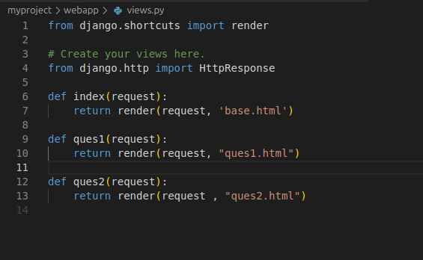

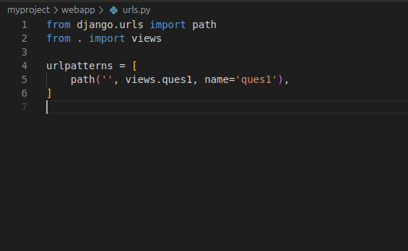  
  
  
  
  
  
  
  
  
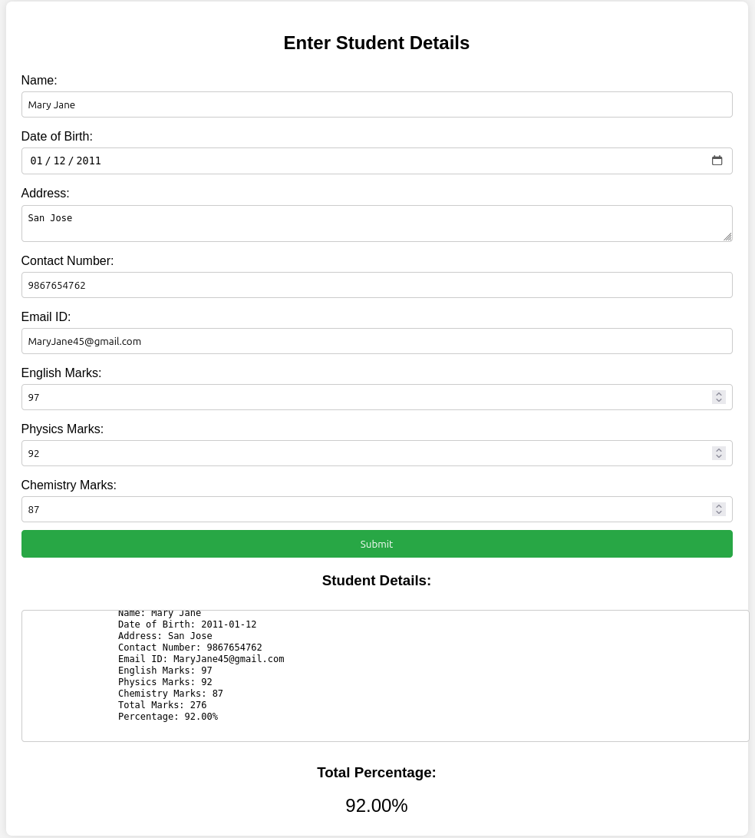  
  
  
  
  
  
q2. Create a web form with employee ids in dropdown list. Use a textbox for accepting

date of joining. Add a button named “Am I Eligible for Promotion”. On clicking

the button, if he has more than 5 years of experience, then display “YES” else

“NO” in the label control.

**Ques2.html**

<!DOCTYPE html>

<html lang="en">

<head>

<meta charset="UTF-8">

<meta name="viewport" content="width=device-width, initial-scale=1.0">

<title>Employee Promotion Eligibility</title>

<style>

body {

font-family: Arial, sans-serif;

background-color: #f4f4f4;

margin: 0;

padding: 0;

}

.container {

width: 50%;

margin: 50px auto;

background-color: #fff;

padding: 20px;

border-radius: 8px;

box-shadow: 0 0 10px rgba(0, 0, 0, 0.1);

}

h2 {

text-align: center;

}

form {

display: flex;

flex-direction: column;

}

label {

margin: 5px 0;

}

select, input[type="date"], button {

margin-bottom: 10px;

padding: 8px;

border: 1px solid #ccc;

border-radius: 4px;

}

button {

background-color: #007bff;

color: white;

cursor: pointer;

}

button:hover {

background-color: #0056b3;

}

#eligibilityLabel {

text-align: center;

font-size: 1.5em;

margin-top: 10px;

}

</style>

</head>

<body>

<div class="container">

<h2>Check Promotion Eligibility</h2>

<form id="eligibilityForm">

<label for="employeeId">Employee ID:</label>

<select id="employeeId" name="employeeId" required>

<option value="">Select Employee ID</option>

<option value="E001">E001</option>

<option value="E002">E002</option>

<option value="E003">E003</option>

<option value="E004">E004</option>

<option value="E005">E005</option>

</select>

<label for="doj">Date of Joining:</label>

<input type="date" id="doj" name="doj" required>

<button type="submit">Am I Eligible for Promotion?</button>

</form>

<label id="eligibilityLabel"></label>

</div>

<script>

document.getElementById('eligibilityForm').addEventListener('submit', function(event) {

event.preventDefault();

const doj = new Date(document.getElementById('doj').value);

const currentDate = new Date();

const experienceInMilliseconds = currentDate - doj;

const experienceInYears = experienceInMilliseconds / (1000 * 60 * 60 * 24 * 365.25);

const eligibilityLabel = document.getElementById('eligibilityLabel');

if (experienceInYears > 5) {

eligibilityLabel.textContent = 'YES';

eligibilityLabel.style.color = 'green';

} else {

eligibilityLabel.textContent = 'NO';

eligibilityLabel.style.color = 'red';

}

});

</script>

</body>

</html>

