**Name: Medha Chawla**

**Roll No. 55**

**Reg No. 220962340**

**week 6 Lab work**

from django.shortcuts import render

def magazine_cover(request):

context = {}

if request.method == 'POST':

context['image'] = request.POST.get('image')

context['bg_color'] = request.POST.get('bg_color')

context['font_size'] = request.POST.get('font_size')

context['font_color'] = request.POST.get('font_color')

context['font_family'] = request.POST.get('font_family')

context['message'] = request.POST.get('message')

return render(request, 'index.html', context)  
  
  
  
{% load static %}

<!DOCTYPE html>

<html lang="en">

<head>

<meta charset="UTF-8">

<title>Magazine Cover Generator</title>

<link rel="stylesheet" type="text/css" href="{% static 'coverapp/styles.css' %}">

</head>

<body>

<div class="container">

<h1>Magazine Cover Generator</h1>

<form method="post">

{% csrf_token %}

<div class="form-group">

<label for="image">Select Cover Image:</label>

<select name="image" id="image">

<option value="cover1.jpg">Cover 1</option>

<option value="cover2.jpg">Cover 2</option>

<option value="cover3.jpg">Cover 3</option>

</select>

</div>

<div class="form-group">

<label for="bg_color">Background Color:</label>

<input type="color" id="bg_color" name="bg_color" value="#ffffff">

</div>

<div class="form-group">

<label for="font_size">Font Size (px):</label>

<input type="number" id="font_size" name="font_size" value="24">

</div>

<div class="form-group">

<label for="font_color">Font Color:</label>

<input type="color" id="font_color" name="font_color" value="#000000">

</div>

<div class="form-group">

<label for="font_family">Font Family:</label>

<select name="font_family" id="font_family">

<option value="Arial, sans-serif">Arial</option>

<option value="'Times New Roman', serif">Times New Roman</option>

<option value="'Courier New', monospace">Courier New</option>

</select>

</div>

<div class="form-group">

<label for="message">Magazine Title/Message:</label>

<input type="text" id="message" name="message" placeholder="Enter your magazine title/message" required>

</div>

<button type="submit">Generate Cover</button>

</form>

{% if message %}

<!-- Magazine Cover Display -->

<div class="magazine-cover" style="background-color: {{ bg_color }};">

<img src="{% static 'coverapp/images/' %}{{ image }}" alt="Magazine Cover Image">

<div class="cover-text" style="font-size: {{ font_size }}px; color: {{ font_color }}; font-family: {{ font_family }};">

{{ message }}

</div>

</div>

{% endif %}

</div>

</body>

</html>

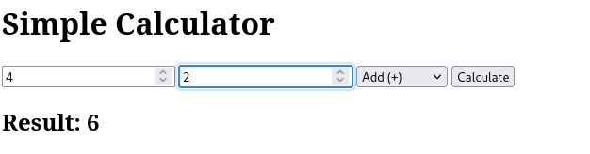  
  
  
from django.shortcuts import render

def magazine_cover(request):

context = {}

if request.method == 'POST':

context['image'] = request.POST.get('image')

context['bg_color'] = request.POST.get('bg_color')

context['font_size'] = request.POST.get('font_size')

context['font_color'] = request.POST.get('font_color')

context['font_family'] = request.POST.get('font_family')

context['message'] = request.POST.get('message')

return render(request, 'index.html', context)  
  
  
  
  
{% load static %}

<!DOCTYPE html>

<html lang="en">

<head>

<meta charset="UTF-8">

<title>Magazine Cover Generator</title>

<link rel="stylesheet" type="text/css" href="{% static 'coverapp/styles.css' %}">

</head>

<body>

<div class="container">

<h1>Magazine Cover Generator</h1>

<form method="post">

{% csrf_token %}

<div class="form-group">

<label for="image">Select Cover Image:</label>

<select name="image" id="image">

<option value="cover1.jpg">Cover 1</option>

<option value="cover2.jpg">Cover 2</option>

<option value="cover3.jpg">Cover 3</option>

</select>

</div>

<div class="form-group">

<label for="bg_color">Background Color:</label>

<input type="color" id="bg_color" name="bg_color" value="#ffffff">

</div>

<div class="form-group">

<label for="font_size">Font Size (px):</label>

<input type="number" id="font_size" name="font_size" value="24">

</div>

<div class="form-group">

<label for="font_color">Font Color:</label>

<input type="color" id="font_color" name="font_color" value="#000000">

</div>

<div class="form-group">

<label for="font_family">Font Family:</label>

<select name="font_family" id="font_family">

<option value="Arial, sans-serif">Arial</option>

<option value="'Times New Roman', serif">Times New Roman</option>

<option value="'Courier New', monospace">Courier New</option>

</select>

</div>

<div class="form-group">

<label for="message">Magazine Title/Message:</label>

<input type="text" id="message" name="message" placeholder="Enter your magazine title/message" required>

</div>

<button type="submit">Generate Cover</button>

</form>

{% if message %}

<!-- Magazine Cover Display -->

<div class="magazine-cover" style="background-color: {{ bg_color }};">

<img src="{% static 'coverapp/images/' %}{{ image }}" alt="Magazine Cover Image">

<div class="cover-text" style="font-size: {{ font_size }}px; color: {{ font_color }}; font-family: {{ font_family }};">

{{ message }}

</div>

</div>

{% endif %}

</div>

</body>

</html>

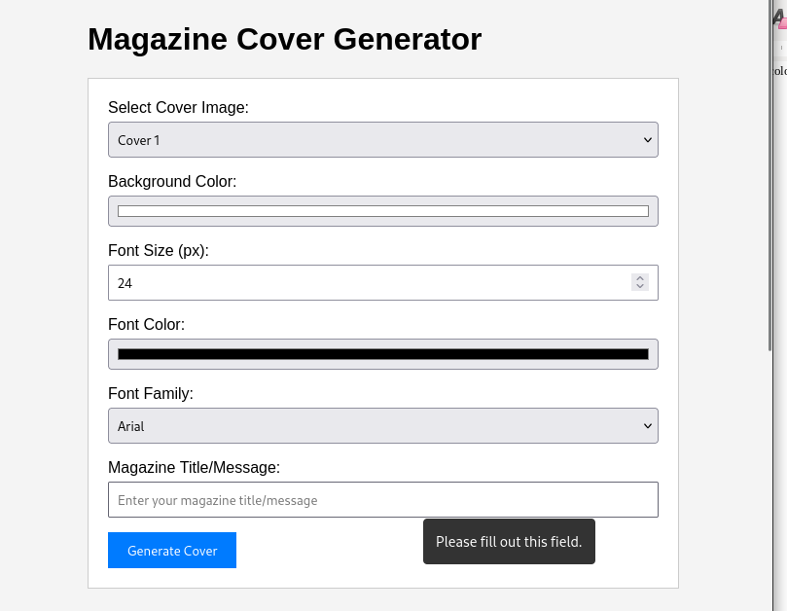  
  
  
  
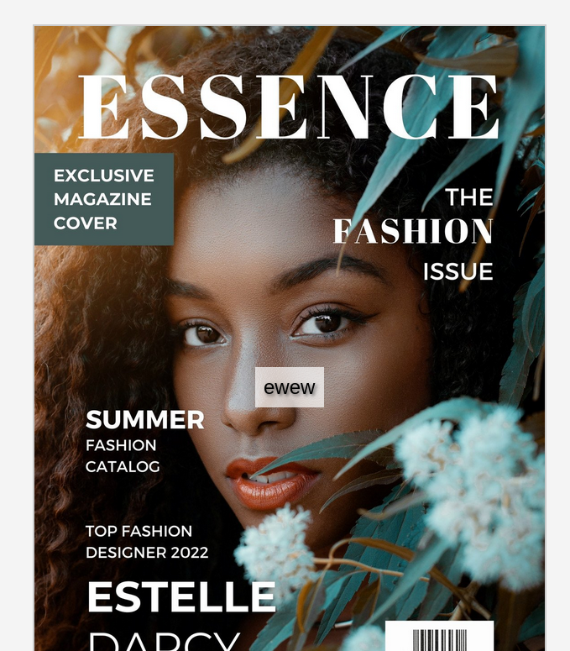from django.shortcuts import render

def home(request):

return render(request, 'home.html')

def metadata(request):

return render(request, 'metadata.html')

def reviews(request):

return render(request, 'reviews.html')

def publisher(request):

return render(request, 'publisher.html')  
  
  
{% load static %}

<!DOCTYPE html>

<html lang="en">

<head>

<meta charset="UTF-8">

<title>Book Information</title>

<link rel="stylesheet" href="{% static 'bookinfo/styles.css' %}">

</head>

<body>

<h1>Welcome to the Book Information Page</h1>

<!-- Display the book cover -->

<img src="{% static 'bookinfo/images/book_cover.jpg' %}" alt="Book Cover" style="width:300px;height:auto;">

<!-- Navigation links -->

<nav>

<ul>

<li><a href="{% url 'metadata' %}">Metadata</a></li>

<li><a href="{% url 'reviews' %}">Reviews</a></li>

<li><a href="{% url 'publisher' %}">Publisher Info</a></li>

</ul>

</nav>

</body>

</html>

{% load static %}

<!DOCTYPE html>

<html lang="en">

<head>

<meta charset="UTF-8">

<title>Metadata</title>

<link rel="stylesheet" href="{% static 'bookinfo/styles.css' %}">

</head>

<body>

<h1>Book Metadata</h1>

<p><strong>Title:</strong> The Great Adventure</p>

<p><strong>Author:</strong> Jane Doe</p>

<p><strong>ISBN:</strong> 123-4567890123</p>

<p><strong>Published:</strong> 2025</p>

<a href="{% url 'home' %}">Back to Home</a>

</body>

</html>

