**WEEK-8 LabWork**

**Name: Medha Chawla**

**Roll No: 55**

**Reg No: 220962340**

**Date: 27/02/2025**

Q1.Develop a web application using Django framework to demonstrate the transfer of

multiple parameters between web pages. User should be presented with a dropdown

list containing car manufacturers, a text box which takes model name of the

manufacturer and a submit button. On submitting the web page, the user is forwarded

to a new page. This new page should display the selected car manufacturer name and

the model name.

**car_form.html**  
  
<!DOCTYPE html>

<html lang="en">

<head>

{%load static%}

<meta charset="UTF-8">

<meta name="viewport" content="width=device-width, initial-scale=1.0">

<title>Select Car Manufacturer</title>

<link rel="stylesheet" type="text/css" href="{% static 'css/styles.css' %}">

</head>

<body>

<h1>Select Car Manufacturer and Model</h1>

<form method="POST">

{% csrf_token %}

<label for="manufacturer">Select Manufacturer:</label>

<select name="manufacturer" id="manufacturer">

<option value="Toyota">Toyota</option>

<option value="Honda">Honda</option>

<option value="Ford">Ford</option>

<option value="BMW">BMW</option>

<option value="Tesla">Tesla</option>

</select><br><br>

<label for="model_name">Enter Model Name:</label>

<input type="text" id="model_name" name="model_name" required><br><br>

<button type="submit">Submit</button>

</form>

</body>

</html>

**display.html**  
  
  
<!DOCTYPE html>

<html lang="en">

<head>

{%load static%}

<meta charset="UTF-8">

<meta name="viewport" content="width=device-width, initial-scale=1.0">

<title>Car Selection</title>

<link rel="stylesheet" type="text/css" href="{% static 'css/styles.css' %}">

</head>

<body>

<h1>Your Car Selection</h1>

<p><strong>Manufacturer:</strong> {{ manufacturer }}</p>

<p><strong>Model Name:</strong> {{ model_name }}</p>

</body>

</html>

**styles.css**  
  
/* styles.css */

body {

font-family: Arial, sans-serif;

background-color: #f4f4f9;

color: #333;

margin: 0;

padding: 0;

}

h1 {

text-align: center;

color: #4CAF50;

margin-top: 30px;

}

form {

background-color: #fff;

border: 1px solid #ddd;

padding: 20px;

width: 300px;

margin: 0 auto;

border-radius: 8px;

box-shadow: 0 4px 8px rgba(0, 0, 0, 0.1);

}

label {

font-size: 16px;

display: block;

margin-bottom: 8px;

}

select, input[type="text"] {

width: 100%;

padding: 10px;

margin-bottom: 20px;

border: 1px solid #ddd;

border-radius: 4px;

font-size: 14px;

}

button {

background-color: #4CAF50;

color: white;

padding: 10px 15px;

border: none;

border-radius: 4px;

cursor: pointer;

font-size: 16px;

width: 100%;

}

button:hover {

background-color: #45a049;

}

p {

font-size: 18px;

text-align: center;

color: #333;

}

**views.py**

from django.shortcuts import render

from django.http import HttpResponse

# View to display the form

def car_form(request):

if request.method == 'POST':

manufacturer = request.POST.get('manufacturer')

model_name = request.POST.get('model_name')

return render(request, 'app1/display.html', {'manufacturer': manufacturer, 'model_name': model_name})

return render(request, 'app1/car_form.html')

# View to display the selected car and model

def display_car(request):

manufacturer = request.GET.get('manufacturer')

model_name = request.GET.get('model_name')

return HttpResponse(f"Car Manufacturer: {manufacturer}<br>Model Name: {model_name}")

**app1/urls.py**

from django.urls import path

from . import views

urlpatterns = [

path('', views.car_form, name='car_form'),

path('display/', views.display_car, name='display_car'),

]

**myproject/urls.py**

from django.contrib import admin

from django.urls import path, include

urlpatterns = [

path('admin/', admin.site.urls),

path('', include('app1.urls')),

]

**snapshots**

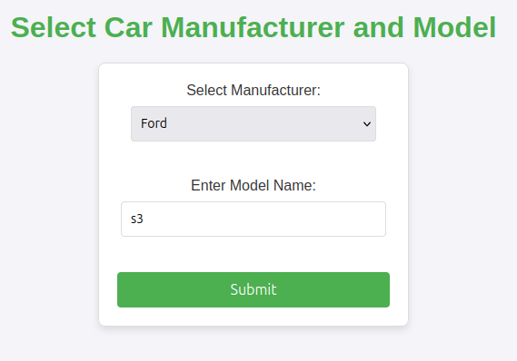

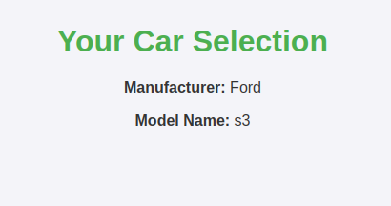  
  
  
  
  
  
  
  
  
  
  
  
  
  
Q2.Create a page firstPage.html with two TextBoxes [Name, Roll], DropDownList

[Subjects], and a button. Create another page secondPage.html with a label and a

button. When the user clicks the button in first Page, he should be sent to the second

page and display the contents passed from first page in the label. The button in second

page should navigate the user back to firstPage. Use Django sessions to transfer

information.

**FirstPage.html**  
  
<!DOCTYPE html>

<html lang="en">

<head>

{%load static%}

<meta charset="UTF-8">

<meta name="viewport" content="width=device-width, initial-scale=1.0">

<title>First Page</title>

<link rel="stylesheet" type="text/css" href="{% static 'css/styles.css' %}">

</head>

<body>

<h1>Enter Details</h1>

<form method="POST">

{% csrf_token %}

<label for="name">Name:</label>

<input type="text" id="name" name="name" required><br><br>

<label for="roll">Roll Number:</label>

<input type="text" id="roll" name="roll" required><br><br>

<label for="subject">Subject:</label>

<select name="subject" id="subject" required>

<option value="Math">Math</option>

<option value="Physics">Physics</option>

<option value="Chemistry">Chemistry</option>

<option value="Biology">Biology</option>

</select><br><br>

<button type="submit">Submit</button>

</form>

</body>

</html>

**secondPage.html**

<!DOCTYPE html>

<html lang="en">

<head>

{%load static%}

<meta charset="UTF-8">

<meta name="viewport" content="width=device-width, initial-scale=1.0">

<title>Second Page</title>

<link rel="stylesheet" type="text/css" href="{% static 'css/styles.css' %}">

</head>

<body>

<h1>Your Details</h1>

<p><strong>Name:</strong> {{ name }}</p>

<p><strong>Roll Number:</strong> {{ roll }}</p>

<p><strong>Subject:</strong> {{ subject }}</p>

<form method="get" action="{% url 'first_page' %}">

<button type="submit">Go Back to First Page</button>

</form>

</body>

</html>

**styles.css**  
  
  
/* styles.css */

body {

font-family: Arial, sans-serif;

background-color: #f4f4f9;

color: #333;

margin: 0;

padding: 0;

text-align: center;

}

h1 {

text-align: center;

color: #4CAF50;

margin-top: 30px;

}

form {

background-color: #fff;

border: 1px solid #ddd;

padding: 20px;

width: 300px;

margin: 0 auto;

border-radius: 8px;

box-shadow: 0 4px 8px rgba(0, 0, 0, 0.1);

}

label {

font-size: 16px;

display: block;

margin-bottom: 8px;

}

select, input[type="text"] {

width: 90%;

padding: 10px;

margin-bottom: 20px;

border: 1px solid #ddd;

border-radius: 4px;

font-size: 14px;

}

button {

background-color: #4CAF50;

color: white;

padding: 10px 15px;

border: none;

border-radius: 4px;

cursor: pointer;

font-size: 16px;

width: 100%;

}

button:hover {

background-color: #45a049;

}

**views.py**

from django.shortcuts import render, redirect

from django.http import HttpResponse

# View to display the first page with form

def first_page(request):

if request.method == "POST":

name = request.POST.get('name')

roll = request.POST.get('roll')

subject = request.POST.get('subject')

# Save data to session

request.session['name'] = name

request.session['roll'] = roll

request.session['subject'] = subject

# Redirect to second page

return redirect('second_page')

return render(request, 'session_app/firstPage.html')

# View to display the second page with data

def second_page(request):

# Retrieve data from session

name = request.session.get('name')

roll = request.session.get('roll')

subject = request.session.get('subject')

if not name or not roll or not subject:

return HttpResponse("No data available. Please submit the form first.")

return render(request, 'session_app/secondPage.html', {'name': name, 'roll': roll, 'subject': subject})

**session_app/urls.py**

from django.urls import path

from . import views

urlpatterns = [

path('', views.first_page, name='first_page'),

path('first/', views.first_page, name='first_page'),

path('second/', views.second_page, name='second_page'),

]

**session_project/urls.py**

from django.contrib import admin

from django.urls import path, include

urlpatterns = [

path('admin/', admin.site.urls),

path('', include('session_app.urls')),

]

**snapshots**

