WP Week-4 Assignment  
  
Q1. Implement the bouncing ball using animate() function.

<!DOCTYPE html>

<html lang="en">

<head>

<meta charset="UTF-8">

<meta name="viewport" content="width=device-width, initial-scale=1.0">

<title>Bouncing Ball Animation</title>

<script src="https://code.jquery.com/jquery-3.6.0.min.js"></script>

<style>

body {

display: flex;

justify-content: center;

align-items: center;

height: 100vh;

background-color: #f4f4f4;

margin: 0;

}

.container {

position: relative;

width: 300px;

height: 400px;

border: 2px solid black;

overflow: hidden;

}

.ball {

position: absolute;

width: 50px;

height: 50px;

background-color: red;

border-radius: 50%;

left: 50%;

transform: translateX(-50%);

}

</style>

</head>

<body>

<div class="container">

<div class="ball"></div>

</div>

<script>

$(document).ready(function() {

function bounce() {

$(".ball").animate({ top: "350px" }, 800, "swing", function() {

$(".ball").animate({ top: "0px" }, 800, "swing", bounce);

});

}

bounce();

});

</script>

</body>

</html>

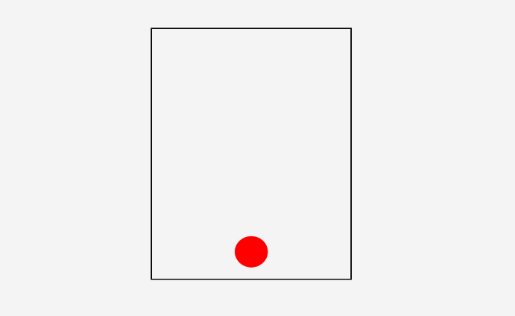

Q2. Write a web page which displays image and show the sliding text on the image.

<!DOCTYPE html>

<html lang="en">

<head>

<meta charset="UTF-8">

<meta name="viewport" content="width=device-width, initial-scale=1.0">

<title>Sliding Text on Image</title>

<script src="https://code.jquery.com/jquery-3.6.0.min.js"></script>

<style>

body {

display: flex;

justify-content: center;

align-items: center;

height: 100vh;

background-color: #f4f4f4;

margin: 0;

}

.image-container {

position: relative;

width: 500px;

}

.image-container img {

width: 100%;

display: block;

}

.text-overlay {

position: absolute;

bottom: -50px;

left: 50%;

transform: translateX(-50%);

background-color: rgba(0, 0, 0, 0.6);

color: white;

padding: 10px 20px;

font-size: 20px;

white-space: nowrap;

}

</style>

</head>

<body>

<div class="image-container">

<img src="https://th.bing.com/th/id/OIP.Y2C49ZpFqa1h8RDBoM0MKQHaE8?rs=1&pid=ImgDetMain" alt="Sample Image">

<div class="text-overlay">Welcome to My Website</div>

</div>

<script>

$(document).ready(function() {

$(".text-overlay").animate({ bottom: "100px" }, 1000);

});

</script>

</body>

</html>  
  
