**OUTPUT**

**1**.THE USER HAS TWO OPTIONS-

* TO CHECK ALL THE PC’S WHICH ARE WORKING/SWITCHED ON IN THE LAB
* TO SELECTIVELY CHECK THE PC’S BY

TYPING THEIR IP ADDRESSES

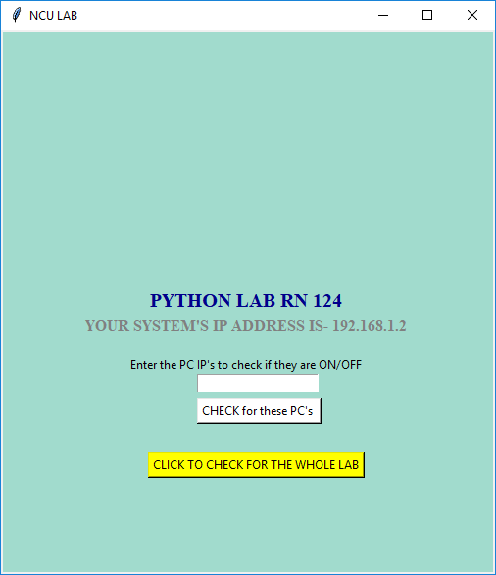

**2**.TO CHECK FOR **ALL** THE 30 PC’s IN OUR LAB

(Where Red mark shows the FAULTY PC’s and the Green mark shows the WORKING PC’s)

NOTE that the number labellings correspond to the last 8 bits of the IP ADDRESS.

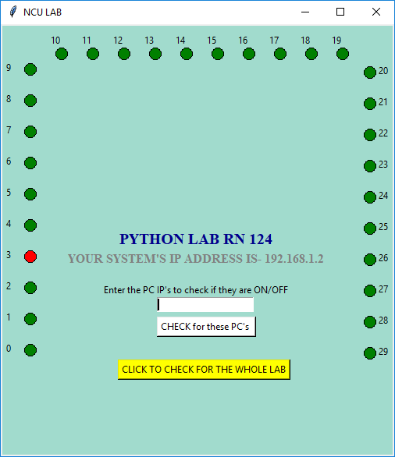

**3**.TO **SELECTIVELY** CHECK,

We typed the IP ADDRESSES OF THE SYSTEMS separated by a comma in the text box and then pressed the button- “check for these PC’s”.

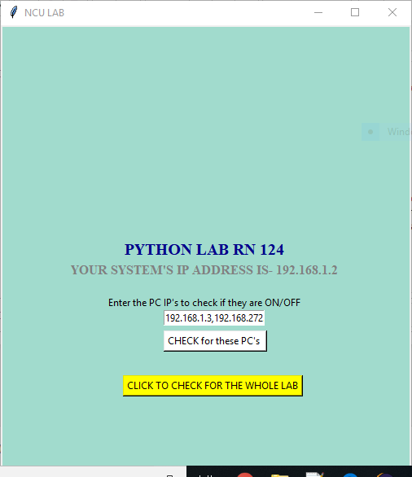

**4.**THE REQUIRED PC’s INFORMATION IS SHOWN.

(Green-if it is working,

Red-if it is faulty,

White-if we didn’t ask to check for it)

Also, if the user entered a **wrong IP** by mistake-(If the digits exceed 255 or it does not follow the IP address format),

an **error message saying “INVALID IP FORMAT”** along with the address is shown to the user while the right IP’s with their information are shown.

