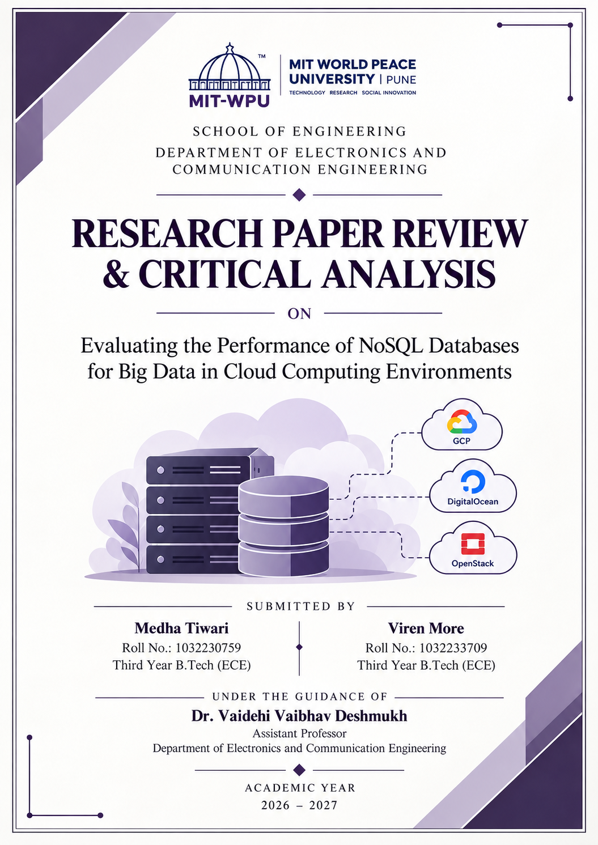

PART I: STRUCTURED PAPER EVALUATION

1. Title of the Paper
Evaluating the Performance of NoSQL Databases for Big Data in Cloud Computing Environments

2. Authors
Ahmet E. Topcu, Aimen M. Rmis, Yehia I. Alzoubi, Ali O. Çibikdiken, Dababrata Chowdhury, Ersin Elbasi, Mohamed Abdel-Maguid, and Salem Almadhun.

3. Journal Name & Citation Details
Journal: HighTech and Innovation Journal
Volume: 6, Issue 3 | Pages: 808–830 | Year: 2025
DOI: 10.28991/HIJ-2025-06-03-05

4. Problem Statement Stated in the Paper
The growing volume of structured, semi-structured, and unstructured data has increased the need for scalable database systems in cloud environments. Although NoSQL databases provide flexible data models and distributed storage capabilities, their performance can vary depending on the database architecture, workload, dataset size, and cloud infrastructure. The paper addresses the need for systematic empirical comparisons of MongoDB and Riak KV across different cloud platforms to help guide database and deployment selection.

5. Methods Used to Solve the Problem Statement
The authors developed a benchmarking framework to compare two distinct NoSQL database systems:
- Cross-Cloud Infrastructure: MongoDB and Riak KV were evaluated across Google Cloud Platform (GCP), DigitalOcean, and OpenStack.
- Standardized Workloads: The study utilized the Yahoo Cloud Serving Benchmark (YCSB) to generate controlled read-heavy, update-heavy, and scan-heavy operations.
- Performance Metrics: The evaluation measured throughput and latency across different workloads, dataset sizes, and cloud configurations, with scalability considered as a key performance factor.
- Decision-Support Model: The raw empirical data was synthesized into a decision-tree model to guide users in selecting optimal configurations based on workload requirements.

6. Advantages of Methods
Evaluating database performance across multiple cloud environments provides a broader comparison than testing on a single local machine. Using the standardized YCSB framework supports consistent workload generation and facilitates comparison across configurations. Comparing MongoDB, a document-oriented database, with Riak KV, a key-value store, also helps illustrate how different database systems perform under the tested workloads. The decision-tree model translates the experimental findings into practical guidance for database and cloud-platform selection. However, differences in infrastructure configurations may still influence the results.

7. Disadvantages of Methods
The study is limited by testing only two database systems, omitting wide-column (Cassandra) or graph (Neo4j) architectures. Although YCSB provides standardized workloads, the selected tests do not establish how the databases perform on complex, application-specific operations such as MongoDB’s $lookup joins or $group aggregations. These operations could be evaluated in future research to determine performance under document-processing and analytical workloads. The study also does not establish how the tested configurations would perform in containerized deployments such as Docker and Kubernetes.

8. Applications of the Problem Statement Stated
The findings directly inform the architectural design of scalable backend systems and big data pipelines. It is highly relevant for applications handling semi-structured JSON records, document metadata, or high-velocity IoT telemetry. Additionally, it aids enterprise engineering teams in cloud infrastructure planning, allowing them to balance computing resources against application responsiveness.

9. Future Scope to Improve the Method
Future research should expand to include more complex aggregation workloads, transactions, and vector-search queries for AI systems. Furthermore, evaluating database performance in serverless and event-driven architectures (e.g., behind message queues) would provide deeper insight into modern deployment overhead.

PART II: COMPREHENSIVE PAPER SUMMARY & ACADEMIC REFLECTION

1. Introduction and Contextual Objective
As the volume of structured and unstructured data generated by modern applications grows, NoSQL databases have become essential for flexible, distributed storage. However, database performance varies drastically depending on architecture, query types, and the underlying cloud host. Topcu et al. (2025) investigate this problem by comparing MongoDB and Riak KV across multiple cloud platforms. The study’s objective is to evaluate performance under varying workloads, providing a data-driven foundation for database selection rather than relying on industry assumptions.

2. Experimental Methodology
The researchers evaluated MongoDB and Riak KV across GCP, DigitalOcean, and OpenStack. Utilizing the YCSB framework, they generated controlled operational profiles—including read-heavy, update-heavy, and scan-heavy workloads—across progressively larger dataset sizes. The study focused on measuring throughput (operations per second) and latency (execution time), providing a structured comparison of how different deployment configurations handle escalating data demands.

3. Primary Results & Technical Findings
The main findings of the evaluation include:
- Throughput and Latency: MongoDB achieved strong throughput and latency results in the tested configurations, particularly on Google Cloud. The findings indicate that performance depends on the database, workload, and deployment environment, rather than database choice alone.
- Scan-Intensive Workloads: Riak KV exhibited higher latency in certain scan-intensive tests. This is consistent with the differences between key-value and document-oriented data models, although the experiments do not establish that MongoDB will perform better for every complex query.
- Cloud Infrastructure: MongoDB on Google Cloud showed strong overall performance across the evaluated configurations, although the best-performing configuration varied for some individual workloads. These results indicate that database performance depends on the interaction between the database system, workload, and deployment environment. They do not establish that Google Cloud will outperform other providers in every scenario.

4. Critical Limitations Analysis
While useful, the study has several limitations. It evaluates only MongoDB and Riak KV, leaving other NoSQL architectures outside the comparison. Its reliance on YCSB also means that the results do not establish how the databases perform on every application-specific operation, such as complex aggregation pipelines or multi-stage document transformations. These are relevant areas for further testing, particularly for document-processing applications. The experiments use virtual-machine deployments and do not establish how the same configurations would perform in containerized environments such as Docker and Kubernetes. Although the paper compares selected cloud VM prices, a broader analysis of total operating costs—including storage, data transfer, management, and workload-dependent resource consumption—would provide a more complete picture of production cost-effectiveness.

5. Application to the Proposed DBMS Academic Project
These findings provide a strong empirical starting point for evaluating MongoDB as the database layer for our proposed NoSQL Document Intelligence Engine. Our system will process documents, extract AI metadata, and store entities and sentiment scores in a structured format. MongoDB’s document-oriented model is inherently suited for storing nested arrays, and its indexing features support complex querying.
However, because the original study did not benchmark AI document-intelligence workloads or multi-stage aggregations, its findings support treating MongoDB as a strong architectural candidate rather than conclusively proven for our specific use case. Application-specific performance—such as aggregation pipeline latency and schema validation overhead—must be validated independently through our project’s execution.

6. Reflection on AI-Assisted Literature Review
AI-assisted tools significantly improve the efficiency of literature reviews by rapidly identifying relevant research, organizing dense methodologies, and connecting technical findings to practical engineering applications. However, utilizing AI does not replace the necessity of critically examining the original source.
Summaries can easily overstate findings or conflate general technical theory with the specific empirical results demonstrated in an experiment. This review reinforced the importance of manually verifying methodologies, limitations, and citations. Ultimately, AI serves as a powerful support tool, but final architectural interpretations must remain grounded in the original paper and rigorous engineering judgment.

REFERENCE
Topcu, A. E., Rmis, A. M., Alzoubi, Y. I., Çibikdiken, A. O., Chowdhury, D., Elbasi, E., Abdel-Maguid, M., & Almadhun, S. (2025). Evaluating the Performance of NoSQL Databases for Big Data in Cloud Computing Environments. HighTech and Innovation Journal, 6(3), 808–830. https://doi.org/10.28991/HIJ-2025-06-03-05

