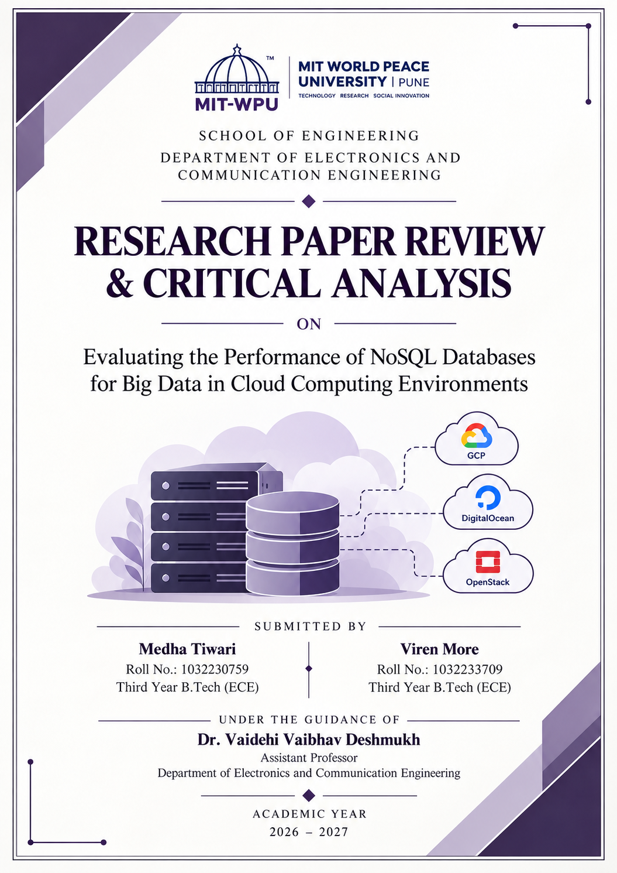

PART I: STRUCTURED PAPER EVALUATION

1. Title of the Paper
Evaluating the Performance of NoSQL Databases for Big Data in Cloud Computing Environments

2. Authors
Ahmet E. Topcu, Aimen M. Rmis, Yehia I. Alzoubi, Ali O. Çibikdiken, Dababrata Chowdhury, Ersin Elbasi, Mohamed Abdel-Maguid, and Salem Almadhun.

3. Journal Name & Citation Details
Journal: HighTech and Innovation Journal
Volume: 6, Issue 3
Pages: 808–830
Year: 2025
DOI: 10.28991/HIJ-2025-06-03-05

4. Problem Statement Stated in the Paper
The rapid growth of cloud computing, web applications, and data-intensive services has created a need for databases that can efficiently manage large volumes of data. Traditional relational databases remain useful for many applications, but certain big data workloads can benefit from the flexible data models and distributed architecture offered by NoSQL databases.
However, choosing the right NoSQL database is not always straightforward. Different database systems use different approaches to storing and retrieving information, and their performance can vary depending on the workload, dataset size, hardware resources, and cloud environment in which they operate.
The paper addresses the need for a systematic comparison of NoSQL database performance across different cloud platforms. Selecting an unsuitable database or deployment configuration can result in higher query latency, reduced throughput, inefficient resource utilization, and increased operating costs.
The central problem is therefore to understand how different NoSQL database systems perform under varying workloads and cloud configurations, so that developers and system architects can make more informed decisions when designing scalable data-intensive applications.

5. Methods Used to Solve the Problem Statement
To investigate this problem, the authors developed a benchmarking framework to compare the performance of two NoSQL database systems across different cloud environments.
- Cross-cloud infrastructure: MongoDB and Riak KV were evaluated across Google Cloud Platform (GCP), DigitalOcean, and OpenStack. This allowed the authors to examine how the database and its deployment environment affected performance.
- Standardized workload generation: The study used the Yahoo Cloud Serving Benchmark (YCSB), a framework designed to evaluate database performance under controlled workloads. The workload profiles included read-heavy, update-heavy, read-only, and scan-heavy operations.
- Database comparison: MongoDB was used as an example of a document-oriented database, while Riak KV represented a key-value database. Comparing these systems provided insight into the performance differences between two distinct NoSQL approaches.
- Performance metrics: The study evaluated throughput, latency, and scalability under different workloads and dataset sizes. Resource utilization was also considered to understand the computational demands associated with database operations.
- Decision-support model: The results were used to develop a decision-tree model intended to help users select suitable database and cloud configurations according to their workload requirements.
Overall, the methodology provides a structured way to compare database performance. However, the conclusions must be interpreted in the context of the particular databases, workloads, and infrastructure configurations tested.

6. Advantages of Methods
One of the main strengths of the methodology is that it evaluates database performance across multiple cloud environments rather than relying on a single local machine. This makes the study more relevant to applications that depend on distributed infrastructure.
The use of YCSB is another advantage because it provides a standardized approach to generating database workloads. This makes the performance comparison more systematic and helps researchers reproduce similar experiments.
The study also considers multiple performance indicators instead of focusing only on query speed. Throughput, latency, and scalability provide different perspectives on how a database behaves under increasing workloads.
Another useful aspect is the comparison between MongoDB and Riak KV. Since the two systems follow different data-storage approaches, their evaluation helps demonstrate why database selection should depend on the workload rather than on popularity alone.
Finally, the decision-tree model gives the study a practical dimension. Instead of presenting benchmark results only as theoretical observations, the authors attempt to translate them into guidance for database selection.
However, cross-cloud testing does not automatically eliminate infrastructure bias. Differences in virtual machine specifications, storage, networking, and configuration must also be considered when interpreting the results.

7. Disadvantages of Methods
Despite its useful methodology, the study has several limitations.
First, the evaluation focuses on only two database systems: MongoDB and Riak KV. Although this provides a comparison between document-oriented and key-value databases, it does not represent the full range of NoSQL technologies. Other systems, such as Apache Cassandra and Neo4j, could be included in future studies to examine wide-column and graph database architectures.
Second, the use of YCSB provides standardized workloads, but these workloads do not fully represent every real-world application. In particular, the benchmark profiles described in the study do not adequately evaluate complex, multi-stage analytical operations such as MongoDB aggregation pipelines, joins using $lookup, or transformations using $unwind and $group.
Third, the results may be influenced by differences in cloud configurations. Processor capacity, memory, storage performance, network conditions, database versions, and indexing strategies can all affect performance. Without sufficiently controlled configurations, it can be difficult to determine how much of the observed difference comes from the database itself and how much comes from the underlying infrastructure.
Another limitation is that the study’s reported performance results do not establish that one cloud provider will always outperform another. The findings apply to the configurations and workloads evaluated, and additional testing would be needed before generalizing them to other deployments.
Finally, the study could be extended by evaluating modern containerized deployments, such as Docker and Kubernetes, and by measuring cost alongside performance. These additions would provide a more complete picture of how NoSQL systems behave in practical production environments.

8. Applications of the Problem Statement Stated
The findings of this study are relevant to the design of scalable backend systems, cloud-based applications, and big data processing pipelines.
For example, an application that handles large numbers of user requests may need a database that offers low latency and high throughput. Similarly, an IoT platform collecting continuous sensor readings may require a database capable of handling frequent writes while maintaining acceptable query performance.
The study is also relevant to applications that store semi-structured information, such as JSON records, user activity data, and document metadata. MongoDB’s document-oriented model may be suitable for such applications, although its suitability must be evaluated against the actual query patterns and performance requirements.
Another application is cloud infrastructure planning. Comparing database performance across deployment environments can help developers understand the relationship between database configuration, available computing resources, and application responsiveness.
The results can therefore serve as a starting point for database selection. However, the best solution will depend on the application’s data structure, consistency requirements, expected workload, scalability needs, and budget.

9. Future Scope to Improve the Method
Future research could expand the comparison by including a wider range of NoSQL database systems, such as Apache Cassandra, Couchbase, and Neo4j. This would provide a broader understanding of the differences between document, key-value, wide-column, and graph databases.
Another improvement would be to evaluate more complex workloads, including multi-stage aggregation pipelines, transactions, concurrent analytical queries, and operations involving relationships between records. These tests would help determine whether the observed performance differences also apply to more demanding applications.
The experiments could also be extended to containerized and serverless environments. Evaluating database performance in Docker, Kubernetes, and event-driven architectures would provide insight into the additional effects of deployment overhead and network communication.
Future studies could further investigate vector-search workloads and AI-assisted data-processing systems. However, these should be treated as additional research directions rather than capabilities established by the present benchmark.
Finally, the framework could include cost-per-operation, resource consumption, and performance variability across repeated experiments. Such measurements would make it easier to compare database configurations in terms of both efficiency and practical operating cost.

PART II: COMPREHENSIVE PAPER SUMMARY & ACADEMIC REFLECTION

1. Introduction and Contextual Objective
The growth of cloud computing, Internet of Things (IoT) devices, and online services has significantly increased the amount of data that modern applications need to manage. This data may be structured, semi-structured, or unstructured, and its volume can increase rapidly as more users and devices interact with digital systems.
NoSQL databases have become an important option for applications that require flexible data models and distributed storage. However, not every NoSQL database is suitable for every workload. Performance can vary depending on the database architecture, the type of queries being executed, the size of the dataset, and the cloud environment.
The paper by Topcu et al. (2025) investigates this problem by comparing MongoDB and Riak KV across multiple cloud platforms. Its objective is to evaluate their performance under different workloads and provide practical guidance for selecting suitable database and cloud configurations.
The study is useful because it approaches database selection as an engineering decision that should be supported by measured performance rather than assumptions alone.

2. Experimental Methodology
The authors evaluated MongoDB and Riak KV across three cloud environments: Google Cloud Platform, DigitalOcean, and OpenStack.
They used the Yahoo Cloud Serving Benchmark (YCSB) to generate controlled database workloads. The evaluation covered different operation patterns, including read-heavy, update-heavy, read-only, and scan-heavy workloads, with varying dataset sizes.
The primary metrics included throughput, which indicates the number of operations completed over a period of time, and latency, which measures the time required to complete an operation. The study also considered scalability and resource utilization.
This methodology allows the authors to compare database performance across several deployment configurations. However, the results must be understood in the context of the selected database systems and benchmark workloads. Standardized workloads improve consistency, but they cannot represent every possible application scenario.

3. Primary Results & Technical Findings
The study reports that MongoDB deployed on Google Cloud Platform achieved the strongest overall performance among the evaluated configurations, with higher throughput and lower latency in the tested read and write operations. Riak KV generally showed higher latency, particularly for scan-intensive workloads.
The main findings can be summarized as follows:
- Throughput and latency: MongoDB performed well in the evaluated workloads, particularly in the GCP configuration. These findings suggest that the combination of database architecture and deployment environment can significantly influence application performance.
- Scan-intensive workloads: The study reported higher latency for Riak KV in scan-heavy operations. This illustrates the importance of considering query patterns when selecting a database. Key-value systems are often optimized for retrieving values through keys, while document databases can provide additional querying and indexing capabilities. Actual performance, however, depends on the query, indexes, configuration, and implementation.
- Cloud infrastructure: The GCP configuration produced the strongest overall results in the reported evaluation. This highlights the importance of cloud infrastructure when deploying databases. However, the results do not establish that GCP will always outperform DigitalOcean or OpenStack under every configuration.
- Practical database selection: The decision-tree model developed by the authors attempts to translate benchmark findings into guidance for selecting a database and cloud configuration. This is useful as a decision-support approach, although the recommendations should be applied within the limits of the tested systems and workloads.
Overall, the study demonstrates that database performance should be evaluated under representative conditions. It does not establish a universal ranking of all NoSQL databases or cloud platforms.

4. Critical Limitations Analysis
Although the paper provides a useful comparison of NoSQL database performance, several limitations should be considered when interpreting its findings.
The first limitation is the restricted range of database systems. Comparing MongoDB and Riak KV provides insight into document and key-value approaches, but it does not establish how other database architectures would perform under the same conditions.
The second limitation concerns workload coverage. YCSB is useful for standardized benchmarking, but the tested profiles do not fully represent complex application-level operations. For example, a document-processing system may need to perform multi-stage aggregations, filter nested fields, group extracted entities, or combine related records. These operations require additional testing before conclusions can be drawn about their performance.
A further concern is the influence of cloud configuration. Differences in computing resources, storage, networking, indexing, and database settings can affect benchmark results. Therefore, the observed performance differences should not be attributed to a single factor unless that factor has been isolated experimentally.
The study could also provide a more complete view of deployment efficiency by incorporating operating costs, repeated trials, and variability in the measured results. In addition, evaluating containerized environments would help determine whether the findings remain consistent in modern application deployments.
These limitations do not invalidate the study. Instead, they define the scope within which its findings should be applied and identify opportunities for further research.

5. Application to the Proposed DBMS Academic Project
The findings provide a useful starting point for evaluating MongoDB as the database layer for the proposed NoSQL Document Intelligence Engine. The system is intended to process documents, extract useful information, and store results such as entities and sentiment scores in a structured format.
MongoDB’s document-oriented model can be a suitable option for storing records containing nested fields and arrays. Its indexing and aggregation features may also be useful when retrieving and analyzing extracted information.
However, the original study does not directly benchmark document-intelligence workloads or establish that MongoDB will outperform other databases for every operation required by this system. Its findings therefore support considering MongoDB as a candidate rather than treating its suitability as conclusively proven.
A more direct evaluation would involve creating representative test documents and measuring insertion time, query latency, throughput, and resource consumption under different levels of concurrent access. We could also compare indexed and non-indexed queries and evaluate aggregation pipelines involving extracted entities and sentiment scores.
These experiments would help determine whether MongoDB meets the proposed system’s actual requirements. This approach uses the paper as a basis for architectural decision-making while recognizing that application-specific performance must be validated independently.

6. Reflection on AI-Assisted Literature Review
AI-assisted tools can make literature reviews more efficient by helping identify relevant research, organize technical concepts, and develop an initial understanding of complex methodologies. They can also help connect research findings to practical engineering applications.
However, using AI does not remove the need to examine the original research paper. Summaries can omit important qualifications, overstate findings, or confuse general technical knowledge with results demonstrated by a particular experiment.
This review highlights the importance of checking author details, publication information, methodology, and conclusions against the original source. It is equally important to distinguish between what the researchers actually demonstrated and what can only be proposed as a possible application or direction for future work.
The critical analysis also shows that technical knowledge is necessary when evaluating research. For example, understanding the limitations of standardized benchmarks makes it possible to identify workloads that require additional testing.
Overall, AI can support the literature-review process, but the final interpretation must remain grounded in the original paper and careful technical reasoning. A useful research review should not simply summarize results; it should evaluate the strength of the evidence, recognize its limitations, and explain how the findings can be applied responsibly.

REFERENCE
Topcu, A. E., Rmis, A. M., Alzoubi, Y. I., Çibikdiken, A. O., Chowdhury, D., Elbasi, E., Abdel-Maguid, M., & Almadhun, S. (2025). Evaluating the Performance of NoSQL Databases for Big Data in Cloud Computing Environments. HighTech and Innovation Journal, 6(3), 808–830. https://doi.org/10.28991/HIJ-2025-06-03-05

