Technical Task Brief

Energy Technologies Researcher (KTP)

November 2024

# Summary

Create a load flow simulation using any open-source tool(s) of your choice and present the results with a short video.

# Specification

|  |  |  |
| --- | --- | --- |
| **Element** | **Quantity** | **Notes** |
| Three phase source | 2 | * 11 kV, 50 Hz * No internal impedance |
| Bus | 6 | * With voltage measurement |
| LV Load | 2 | * Connected downstream of transformers * Set to any reasonable value |
| HV Load | 2 | * Connected upstream of transformers * Set to any reasonable value |
| Transformer | 2 | * Ratio 11 kV: 0.4 kV * Set rating and impedances to any reasonable value * With power measurement |
| RL line | As necessary | * With current measurement * Set impedance to any reasonable value |
| Switch | 1 | * Changes LV network topology configuration |

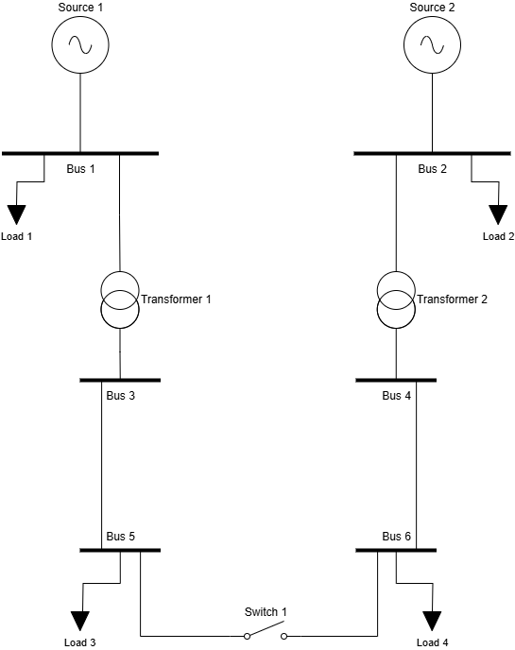

# Task Description

1. Create the electricity distribution network model shown above, using any programming based open-source tool(s) of your choice (not including demo versions of commercial software, or GUI based tools).
2. Run two load flow simulations, one for each topology configuration (switch open and switch closed).
3. Export the bus voltages, line currents, and transformer powers in a tabular format.

# Stretch Task (optional)

If time permits, consider extending the simulation with one or more of the following.

* Apply a load profile to one or more of the loads.
* Add a renewable generator to one of the low voltage buses (e.g. solar PV).
* Present the results in chart format.
* Assign x and y coordinates to the network elements and present the results in singe line diagram format or geospatial format.
* Export model in an interchange format, import it using a different open-source tool, and compare load flow results between the two.

# Submission Instructions

* Complete the task independently, by following the official documentation, tutorials, and examples provided by your chosen open-source tool(s).
* Manage your code development using a version control system (e.g. git), and share a link to it with the interview panel (e.g. via Github / Gitlab, or zip file with full commit history).
* Prepare a short video presentation (up to 10 minutes) clearly explaining how the task was achieved, including an overview of the code developed, and share a link to it with the interview panel (e.g. via Loom, Youtube, or Dropbox).

# Interview panel email addresses

* [dudleyms@lsbu.ac.uk](mailto:dudleyms@lsbu.ac.uk)
* [brownr16@lsbu.ac.uk](mailto:brownr16@lsbu.ac.uk)
* [pardis.sheikhzadeh@advanced-infrastructure.co.uk](mailto:pardis.sheikhzadeh@advanced-infrastructure.co.uk)
* [seungbong.lee@advanced-infrastructure.co.uk](mailto:seungbong.lee@advanced-infrastructure.co.uk)