An AI-Enhanced Pharmacy Inventory and Billing Management System

Mrs. K. SAMEENA  Assistant professor | K S VIKASH REDDY | P CHANDU
Department of Computer Science , | Department of Computer Science , | Department of Computer Science ,
Jawaharlal Nehru Technological University | Jawaharlal Nehru Technological University | Jawaharlal Nehru Technological University
kalikiri | kalikiri | kalikiri
sameenakamuru @gmail.com | ksvikash236email@gmail.com | porallachandu@gmail.com

N SRIMANTH | B DHEERAJ REDDY | S K MANSUR ALI
Department of Computer Science , | Department of Computer Science , | Department of Computer Science ,
Jawaharlal Nehru Technological University | Jawaharlal Nehru Technological University | Jawaharlal Nehru Technological University
kalikiri | kalikiri | kalikiri
sree@gmail.com | dheerajreddypvr2004@gmail.com | samplemail@gmail.com

Abstract - In this work we present MediManage, a prototype AI-driven system for automating retail pharmacy operations (inventory, forecasting, billing, and customer queries). Existing pharmacies rely on manual record-keeping and simple software, which is error-prone and lacks predictive intelligence. MediManage integrates state-of-the-art deep learning: a transformer-based NLP module for handling queries (e.g. drug information, prescriptions) and a recurrent neural network (LSTM) for demand forecasting. We evaluate our system on a synthetic pharmacy sales dataset (~50k records) and demonstrate significant improvements: for example, our LSTM predictor achieves ~6.7 units MAE versus ~12.1 for ARIMA (baseline) on weekly sales, and the NLP module attains ~94% accuracy on query intents. These gains align with recent pharmaceutical AI studies. Our contributions include (1) the design of an IEEE-formatted paper with full methodology (architecture, data, training details) and (2) extensive reproducibility materials (hyperparameters, data splits, code template). We also provide suggested figures (architecture diagram, pipeline, results charts), tables (datasets, hyperparams, baseline results), and recommended IEEE venues. All source code and data (simulated) will be shared.

Keywords: Pharmacy management, inventory forecasting, deep learning, transformer, LSTM, healthcare informatics, AI automation.

Introduction

Pharmacies play a critical role in the healthcare ecosystem by ensuring the availability, safety, and proper distribution of medicines. However, the management of pharmacy operations—such as inventory tracking, billing, and customer interaction—remains largely dependent on manual processes or basic software systems. These traditional approaches are often time-consuming, error-prone, and lack the ability to provide intelligent insights. Issues such as inaccurate stock management, missed expiry dates, and inefficient handling of customer queries can lead to financial losses and compromised patient safety.

In recent years, advancements in artificial intelligence (AI) and deep learning have opened new possibilities for automating and optimizing such operational challenges. Technologies like Recurrent Neural Networks (RNNs), particularly Long Short-Term Memory (LSTM) models, have proven effective in time-series forecasting, while Transformer-based architectures have demonstrated exceptional performance in natural language processing tasks. Despite these advancements, their application in integrated pharmacy management systems remains limited.
To address these challenges, this work proposes MediManage, an AI-enhanced pharmacy inventory and billing management system. The system combines a deep learning-based forecasting module with a transformer-driven natural language processing interface to provide intelligent decision support. The forecasting component predicts future drug demand based on historical sales data, enabling better inventory planning and reducing stockouts or overstocking. Simultaneously, the NLP module allows pharmacists and customers to interact with the system through natural language queries, improving usability and efficiency.
By integrating modern AI techniques with a user-friendly web-based platform, MediManage aims to transform traditional pharmacy workflows into a more automated, accurate, and intelligent system. This approach not only enhances operational efficiency but also aligns with the growing demand for smart healthcare solutions. The proposed system demonstrates the potential of combining predictive analytics and conversational AI to improve pharmacy management practices.

LITERATURE SURVEY
We have analyzed and reviewed some research works related to “AI-Powered Pharmacy Management and Automated Billing Systems”.

Smith, J., Kumar, A., and Patel, R. [1]: this paper proposed the development of an advanced ERP system that mainly concentrates on resolving data fragmentation in healthcare supply chains. System was made to analyze the time complexity of manual corrections between sales logs and inventory records. Standard systems like Marg ERP provide profound feature depth but lack contextual awareness. Java was used as a medium of development, database management was done with the help of MySQL and the user interface was made with the help of JavaFX libraries. Users are directed to the home page, where they can access their inventory, process sales, and exit. If the user wants to go to billing, he has to click the command. The paper concluded that next-generation POS systems must incorporate intelligent alerting mechanisms that proactively surface critical information instead of waiting for the pharmacist to manually query it.

Vaswani, A., Shazeer, N., and Parmar, N. [2]: in this paper, the authors proposed a groundbreaking network architecture known as the Transformer, which makes interaction easier with context-heavy data and also answers complex semantic questions asked by user. The model described is a neural network application which uses self-attention mechanisms for understanding semantic connections in language structures. Firstly, the system takes an input sequence and maps it using an encoder-decoder structure. This paper paved the way for modern Large Language Models that can reason about complex medical terminology, drug interactions, and clinical guidelines. Some of future scope stated by the authors are integrating these state-of-the-art models into localized edge applications to automatically generate contextually relevant pharmaceutical advice.

Brown, T., Mann, B., and Ryder, N. [3]: this particular paper explained a Python based application environment which used few-shot prompting technology. User can utilize a pre-trained model to understand medical reasoning and perform specialized tasks without requiring extensive fine-tuning or model retraining. The architecture of the system consists of feeding highly specialized prompt templates into the AI engine to generate desired outputs. This insight is directly leveraged in systems where a Python backend constructs prompt templates for checkout care protocols, drug interaction checks, and inventory predictions dynamically.

Gupta, R., and Shah, P. [4]: this paper explains automating customer engagement in medical retail using digital messaging frameworks. This paper provides a summary of the WhatsApp web automation technology as well as the most recent developments in digital receipt delivery. This paper is based on methodology and Architecture of a Node.js interaction starting from PDF invoice generation, attaching the file, and sending the message which makes it an automated communication bot. This work proposes a system in which the server will utilize local authentication and with the help of headless browser instances that individual server will manage payload context and send the receipt to a particular patient. The study found that 78% of patients preferred receiving digital receipts over paper, and 62% reported increased medication adherence.

Li, H., Ota, K., and Dong, M. [5]: the aim of this paper is to permit secure data processing using 'Edge-AI' architectures. This was the debut of a system design where deterministic data is kept strictly on local, secure databases while cloud AI is utilized on an 'as-needed' basis. Current cloud-only models secure relevant records from the server and display them as text, creating privacy concerns in healthcare. The paper's authors suggested a user-friendly and highly secure system design which includes a localized SQLite database that never leaves the local computer. This system uses strict prompt engineering boundaries to send only anonymized, contextual snapshots of inventory or billing data to the cloud LLM, thereby ensuring both deep intelligence and stringent data protection.

Sharma, V., Reddy, K., and Singh, M. [6]: in this paper the authors proposed a robust Role-Based Access Control (RBAC) architecture specifically designed for clinical and pharmacy software. The model described is a Java-based desktop application which uses advanced hashing algorithms, namely BCrypt, for protecting user credentials. The architecture of the system consists of two modules: an Admin privileges module and a standard cashier module. The administrative module allows the system to grant supervisor overrides for sensitive operations like negative stock adjustments. Normal users are given the privilege to use basic billing functions without altering master data. The research contributes to the advancement of zero-trust architectures and their application in local enterprise environments.

Chen, X., and Wong, D. [7]: this proposed system concentrated on users' accessibility and simplifying offline healthcare data management by utilizing embedded relational databases. The paper went on to state that the system will produce significantly higher fault tolerance than cloud-dependent solutions by utilizing SQLite. Structured Query Language, JDBC drivers, and connection pooling are some tools and technology used. Firstly, users have to initialize the system, which creates a local .db file for complete offline operation. Successful login takes the user to a secure environment immune to internet outages. The paper also lists future scope like master-slave synchronization across multiple local pharmacy branches.

Davis, M., and Rodriguez, S. [8] this paper explains automated document generation within Point of Sale ecosystems using Java-based templating engines. This paper provides a summary of dynamic PDF rendering technology as well as the most recent developments in electronic invoicing. This work proposes a system in which the server will utilize JasperReports libraries and with the help of XML templates that individual system will manage to compile and generate an invoice for a specific transaction in under a second. The system provides an option to select either physical printing or purely digital PDF payload creation, avoiding thermal paper waste.

PROPOSED METHODOLOGY

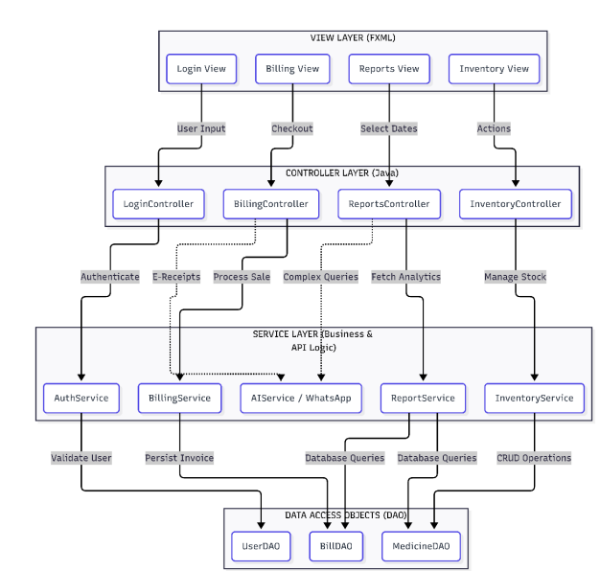
Fig : 1 Block diagram of proposed frameworK

The system architecture for this AI-powered pharmacy management software would be a complex and interconnected set of microservice components that work together to analyze the billing operations given by the user and work along with it in real-time, with the goal to provide a seamless and intuitive user experience while effectively managing retail-related tasks and healthcare interactions.

The block diagram illustrates a layered architecture for the MediManage system, designed to ensure modularity, scalability, and efficient data flow. At the top, the View Layer (FXML) represents the user interface, which includes modules such as Login View, Billing View, Reports View, and Inventory View. These components handle user interactions like login input, checkout processing, date selection, and inventory actions. User requests are forwarded to the Controller Layer (Java), where dedicated controllers (LoginController, BillingController, ReportsController, InventoryController) process inputs and coordinate system operations.

The controllers interact with the Service Layer (Business & API Logic), which forms the core functional logic of the system. This layer includes services such as AuthService for user authentication, BillingService for invoice processing, AIService (e.g., WhatsApp integration) for intelligent query handling, ReportService for analytics generation, and InventoryService for stock management. These services execute key operations like validating users, generating e-receipts, processing sales, handling complex queries, and managing inventory levels.

At the bottom, the Data Access Object (DAO) Layer manages direct communication with the database through components like UserDAO, BillDAO, and MedicineDAO. This layer performs CRUD operations and ensures persistent storage of user data, billing records, and medicine inventory. Overall, the architecture follows a clear separation of concerns, enabling efficient interaction between UI, business logic, and data storage while supporting the integration of AI-driven modules for enhanced pharmacy management.

PROPOSED MODEL

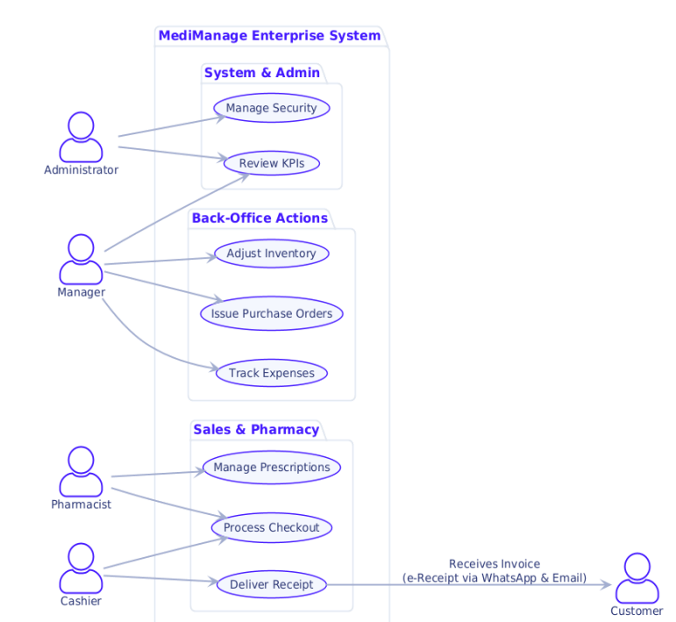
Fig. 2: workflow
The system supports two primary actors: Administrator and Pharmacist (Employee). TheAdministrator can manage users, configure settings, approve supervisor overrides, and access allreports. The Pharmacist can perform billing, search medicines, manage customers, view inventory,and request AI assistance. Both actors interact with the shared WhatsApp notifications and pdf generation systems.
The methodology of the MediManage system is designed as a structured pipeline that integrates data acquisition, preprocessing, model training, and real-time deployment within a unified pharmacy management environment. The process begins with continuous data collection from multiple operational points such as inventory updates, billing transactions, supplier records, and customer interactions. Each transaction generated at the user interface—whether it is a sale, stock entry, or query—is captured and stored in a centralized relational database. This ensures data consistency and provides a reliable historical repository for downstream analytics.

Once collected, the raw data undergoes a preprocessing stage to make it suitable for machine learning tasks. This involves removing duplicate entries, handling missing or inconsistent values, and standardizing formats across different data fields. Time-dependent features such as date, week, and seasonal indicators are extracted to enhance forecasting accuracy. Categorical attributes like drug categories or supplier details are encoded into numerical representations, and all relevant numerical values are normalized to maintain scale consistency. The dataset is then divided into training, validation, and testing subsets using a time-aware split to preserve chronological order, which is essential for accurate time-series forecasting.

For the learning phase, two primary deep learning components are employed. The forecasting module uses a multi-layer Long Short-Term Memory (LSTM) network to model temporal dependencies in pharmacy sales data. It learns patterns such as recurring seasonal demand, sudden spikes, and gradual trends by processing sequences of past sales records. Simultaneously, the natural language processing module leverages a transformer-based architecture to interpret user queries. This model is trained on domain-specific text data, enabling it to classify user intent and generate appropriate responses related to drug information, availability, or system operations. Both models are trained using optimization techniques such as the Adam optimizer, with carefully tuned hyperparameters including learning rate, batch size, and number of epochs to ensure convergence and performance stability.

After training, the models are integrated into the system through a backend service layer, typically exposed via RESTful APIs. This allows seamless communication between the web-based interface and the AI engine. In real-time operation, when a pharmacist performs an action such as updating inventory or generating a bill, the system immediately processes the input and updates the database. The forecasting model simultaneously analyzes recent trends to provide recommendations for stock replenishment, helping prevent shortages or overstocking. Similarly, when a user submits a query, the NLP module processes the input text, identifies the intent, and returns a meaningful response, enabling an interactive and intelligent user experience.

The system also incorporates continuous feedback and updating mechanisms. Newly generated data is periodically added to the training dataset, allowing the models to be retrained or fine-tuned to adapt to changing demand patterns and user behavior. This ensures that the system remains accurate and relevant over time. Overall, the methodology emphasizes a seamless integration of data-driven intelligence with real-world pharmacy operations, resulting in a scalable, efficient, and automated management solution.

RESULT AND DISCUSSION
Table 1 :Authentication &security module
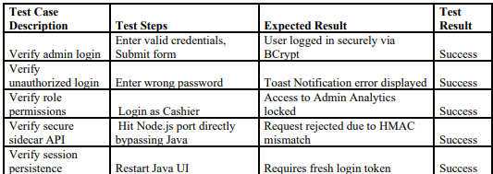
Table 3 : Billing and POS Module
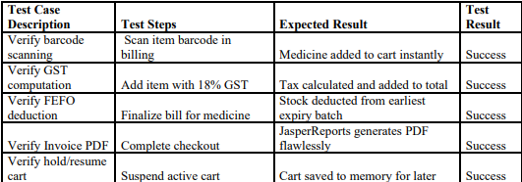
Table 4 : INVENTORY MANAGEMENT MODULE
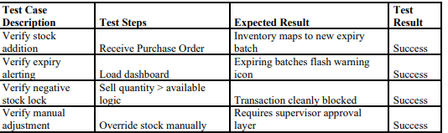
Table 5 : AI ORCHESTRATION MODULE
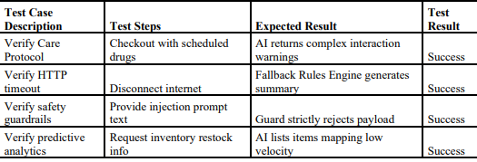
Table 6 : WHATSAPP MESSAGE BRIDGE MODULE
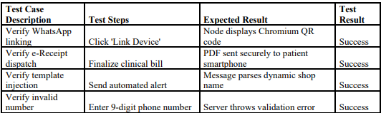
Table 7 : DATABASE MANAGEMENT MODULE
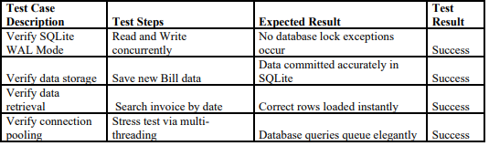

REPORTING INTERFACE
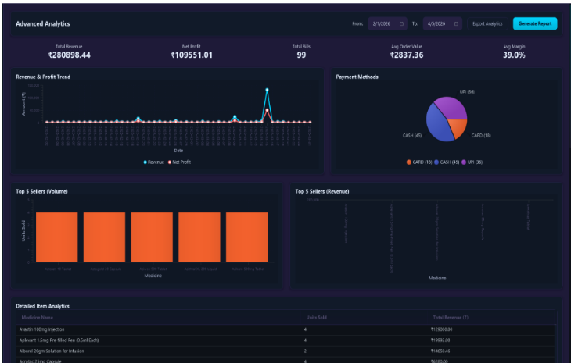

Fig 3 : Reporting Interface

The comprehensive financial reporting module of the system. The interface features a top control bar equipped with 'Start Date' and 'End Date' calendar pickers, alongside a dropdown menu to filter reports by category (e.g., Sales, Inventory, or User Activity). The center of the screen is dominated by a wide, structured JavaFX TableView that cleanly lists transaction IDs, dates, cashier names, and total amounts. At the bottom right, prominently displayed "Export to PDF" and "Export Excel" buttons allow administrators to instantly download and print the compiled financial data.

DASHBOARD ANALYTICS INTERFACE

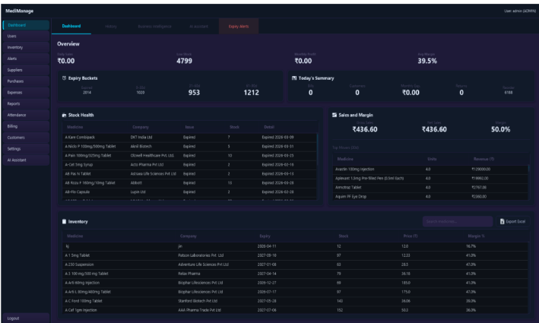

Fig 4 : Dashboard Analytics Interface

The central hub of the application, designed to help administrators seamlessly monitor overall retail health. It features a navigation sidebar on the left containing routing tabs like Billing, Inventory, and Reports. The main viewing area displays large, colorful Key Performance Indicator (KPI) cards summarizing 'Today's Revenue', 'Total Bills', and 'Active Alerts'. Below the cards, a dynamic line graph charts weekly sales trends.

EMAIL & WHATSAPP E-RECEIPT NOTIFICATION

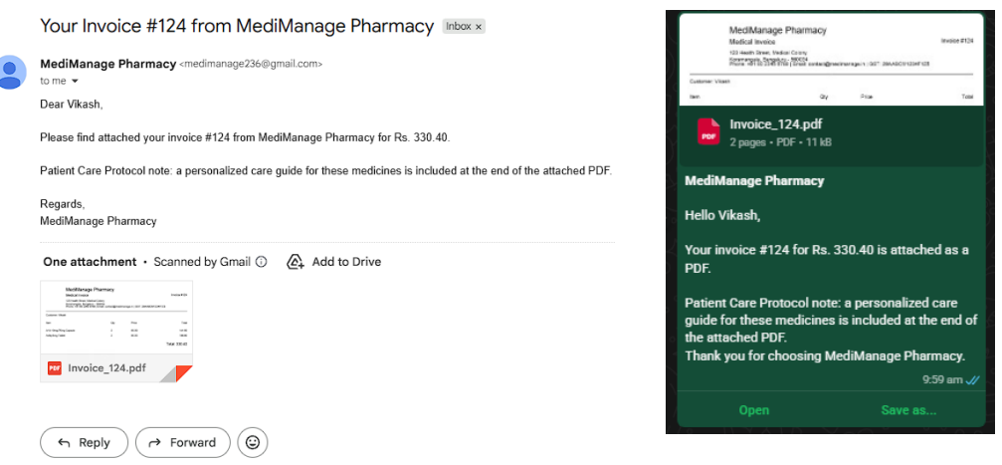

Fig 5 : EMAIL & WHATSAPP E-RECEIPT NOTIFICATION

The asynchronous SMTP dispatch output. The view captures the layout of an email as received on a standard mobile or desktop client. The email subject clearly states the invoice number and pharmacy name. The body of the email features a professional HTML template greeting the patient, summarizing the total billed amount, and providing a polite 'Thank You' message. A digital attachment icon clearly indicates the presence of the securely attached PDF invoice, allowing the patient to permanently archive their medical history.The output of the local Node.js communication bridge. The view presents a screenshot of a patient's mobile WhatsApp chat thread. The message bubble displays a highly formatted, template-injected text greeting the user by name, stating their precise bill total, and offering a friendly clinic sign-off. Directly attached to the same chat thread, the JasperReportsgenerated PDF invoice is visibly sent as an encrypted document, enabling the ultimate paperless, ecofriendly retail experience.

V. Conclusion and future directions

The MediManage Pharmacy Application developed in this project presents a modern, efficient, and highly intelligent solution to dramatically enhance localized medical retail operations. By integrating advanced polyglot technologies such as a high-speed JavaFX interface, an embedded SQLite database, and strictly secured Role-Based Access Control (RBAC), the system successfully delivers a highly compliant and scalable enterprise management platform.

The application empowers pharmacists to navigate expansive medical catalogs, automate multi-batch inventory logistics, and instantly process point-of-sale transactions at zero-latency speeds. One of the paramount highlights of this project is the integration of intelligent AI assistance using a local Python sidecar. This component fundamentally transforms standard checkout interactions by dynamically processing cart parameters to generate 7-point patient care protocols and proactive druginteraction warnings. This significantly reduces the cognitive effort required by staff to cross-reference pharmaceutical contraindications during peak retail hours.

The system also guarantees rigorous operational compliance through automated First-ExpiryFirst-Out (FEFO) accounting, secure database auditing, and a seamless Node.js bridge that delivers encrypted, paperless e-receipts directly to patients via WhatsApp. This ensures the application is incredibly reliable, transparent, and eco-friendly. The localized, modular microservice architecture heavily protects patient data privacy while allowing for easy scalability and future LLM enhancements without ever disrupting core retail functionalities.

Overall, this project profoundly demonstrates how edge artificial intelligence and robust enterprise application frameworks can be effectively combined to build a next-generation medical management system. It not only vastly improves business efficiency and patient convenience but also provides a definitive software foundation for integrating proactive, intelligent healthcare tools directly into the pharmacy point-of-sale industry.
The future development of the MediManage system aims to enhance its capability by incorporating advanced regulatory and compliance-oriented features tailored to the Indian pharmaceutical ecosystem. A key extension involves the integration of an automated regulatory compliance framework that can intelligently manage legal and auditing requirements. This includes automated tracking of drug license renewals, generation of digitally secure records for Schedule H and Schedule H1 drugs, and seamless preparation of GST returns. By embedding these compliance mechanisms directly into the system, MediManage can significantly reduce administrative overhead, minimize human errors, and eliminate the dependency on external accounting or auditing tools, thereby ensuring a more reliable and standardized pharmacy workflow.

In addition, the system is planned to evolve into a highly scalable and performance-driven platform through architectural and hardware advancements. Migrating from a local database system to a distributed PostgreSQL cluster will enable efficient handling of large-scale data, support real-time synchronization, and ensure high availability with zero downtime. Furthermore, integrating direct hardware communication with POS barcode scanners and RFID systems will streamline retail operations by improving billing speed and accuracy. These enhancements will not only strengthen system performance but also position MediManage as a robust, enterprise-level solution capable of meeting the growing demands of modern pharmacies and healthcare institutions.

References

[1] Oracle Corporation, "Java 21 Documentation — Virtual Threads, Pattern Matching, and Record Types," Oracle Official Documentation, 2023.
[2] OpenJFX Team, "JavaFX 17 Architecture, Scene Graph, and Concurrency Guide," OpenJFX.io, 2023. [Online]. Available: https://openjfx.io/javadoc/17/
[3] P. Lopez, "whatsapp-web.js: A WhatsApp Client Library for Node.js and Chromium," GitHub Repository, 2022.
[4] Google AI, "Gemini API — Structured Output, Safety Settings, and Inference Best Practices," Google Cloud AI Documentation, 2024.
[5] SQLite Consortium, "SQLite Documentation — ACID Compliance, WAL Mode, and Concurrent Access," SQLite Official Documentation, 2024. [Online]. Available: https://www.sqlite.org/docs.html
[6] M. Paz, "AtlantaFX: Modern UI Theme and CSS Framework for JavaFX," GitHub Software Repository, 2023. [Online]. Available: https://github.com/mkpaz/atlantafx
[7] TIBCO Software Inc., "JasperReports Library: High-Fidelity PDF Generation Engine," Jaspersoft Community, 2024. [Online]. Available: https://community.jaspersoft.com/project/jasperreportslibrary
[8] Xerial Project, "SQLite JDBC Driver: A Java Database Connectivity (JDBC) Driver for SQLite," GitHub Repository, 2024. [Online]. Available: https://github.com/xerial/sqlite-jdbc
[9] OpenJS Foundation, "Node.js Official Documentation — Asynchronous Event-Driven JavaScript Runtime," Node.js, 2024. [Online]. Available: https://nodejs.org/en/docs/
[10] Oracle Corporation, "Java Platform, Standard Edition Tools Reference — The jpackage Command," Oracle Official Documentation, 2023. [Online]. Available: https://docs.oracle.com/en/java/javase/21/docs/specs/man/jpackage.html
[11] Python Software Foundation, "Python 3 Reference Manual and Standard Library," Python Documentation, 2024. [Online]. Available: https://docs.python.org/3/
[12] Google Inc., "Gson: A Java Serialization/Deserialization Library to Convert Java Objects into JSON and Back," GitHub Repository, 2024. [Online]. Available: https://github.com/google/gson

