MediManage
Pharmacy Management and Medical Billing Desktop System
Research Documentation and Systems Architecture Report
Version 6.0.0

Department of Computer Science and Engineering
JNTUA College of Engineering, Kalikiri
Jawaharlal Nehru Technological University, Ananthapur

Submitted by
K S Vikash Reddy (22KA1A0521)
N Srimanth (22KA1A0525)
B Dheeraj Reddy (22KA1A0534)
S K Mansur Ali (22KA1A0537)
P Chandu (23KA5A0502)

Head of Department: Dr. Shaik Naseera, B.E., M.Tech., Ph.D., Professor and HOD
Guide: Mrs. K. Sameena, M.Tech. (Ph.D.), Assistant Professor (Ad-hoc)
Academic Year 2025-2026

Abstract and Scholarly Contribution
MediManage is a desktop-first pharmacy management system designed to improve the safety, accuracy, and operational efficiency of small to medium retail pharmacies. The project positions itself at the intersection of transactional integrity, user-centered workflow design, and intelligent decision support. Its computational core is a layered JavaFX application paired with an embedded SQLite store, ensuring offline resilience and predictable performance. Two adjacent microservices extend the core: a Python-based AI engine for care protocol generation and analytics, and a Node.js bridge for WhatsApp-based customer communication. The system emphasizes atomic billing, consistent stock governance, role-based access control, and extensible reporting pipelines. The expected impact is reduced operational error, faster checkout cycles, and stronger auditability, without requiring cloud dependence or specialized infrastructure.
Keywords: pharmacy management, transactional systems, JavaFX, SQLite, AI assistance, offline-first architecture

Table of Contents
(Use Word's update fields function to generate the table of contents.)

1. Operational Context and Problem Formulation
Retail pharmacy operations are constrained by safety-critical inventory handling, high-frequency point-of-sale transactions, and regulatory audit requirements. Manual or semi-digital practices often fail to maintain accurate stock levels, leading to expired medicines, billing disputes, and weak traceability. Cloud-native solutions address some of these issues but introduce dependence on connectivity and centralized infrastructure. MediManage responds to this problem space with a local-first system that combines reliable transactional updates with an interface optimized for rapid data entry and minimal training overhead.

2. Research Objectives and Scope Delimitation
The project is guided by four objectives: (1) ensure transaction-safe billing and inventory updates; (2) unify customer, prescription, and procurement records into a consistent data model; (3) provide decision support through analytics and AI-derived care protocols; and (4) maintain operability in offline or low-connectivity settings. The scope includes billing, inventory, customers, prescriptions, suppliers, reporting, and messaging workflows. Excluded from the current scope are full multi-site synchronization, public marketplace integrations, and third-party payment gateways, which are positioned as future research extensions.

3. Methodological Foundation and Design Principles
MediManage adopts a layered MVC paradigm to separate presentation, orchestration, and persistence. The design enforces explicit boundaries between UI state, service-level business logic, and database access. This decoupling reduces defect propagation, supports incremental feature development, and creates a stable seam for future backend evolution. Architectural decisions are documented in formal ADRs, including a validated pathway for migration from pure SQLite to hybrid storage backends without requiring controller rewrites.
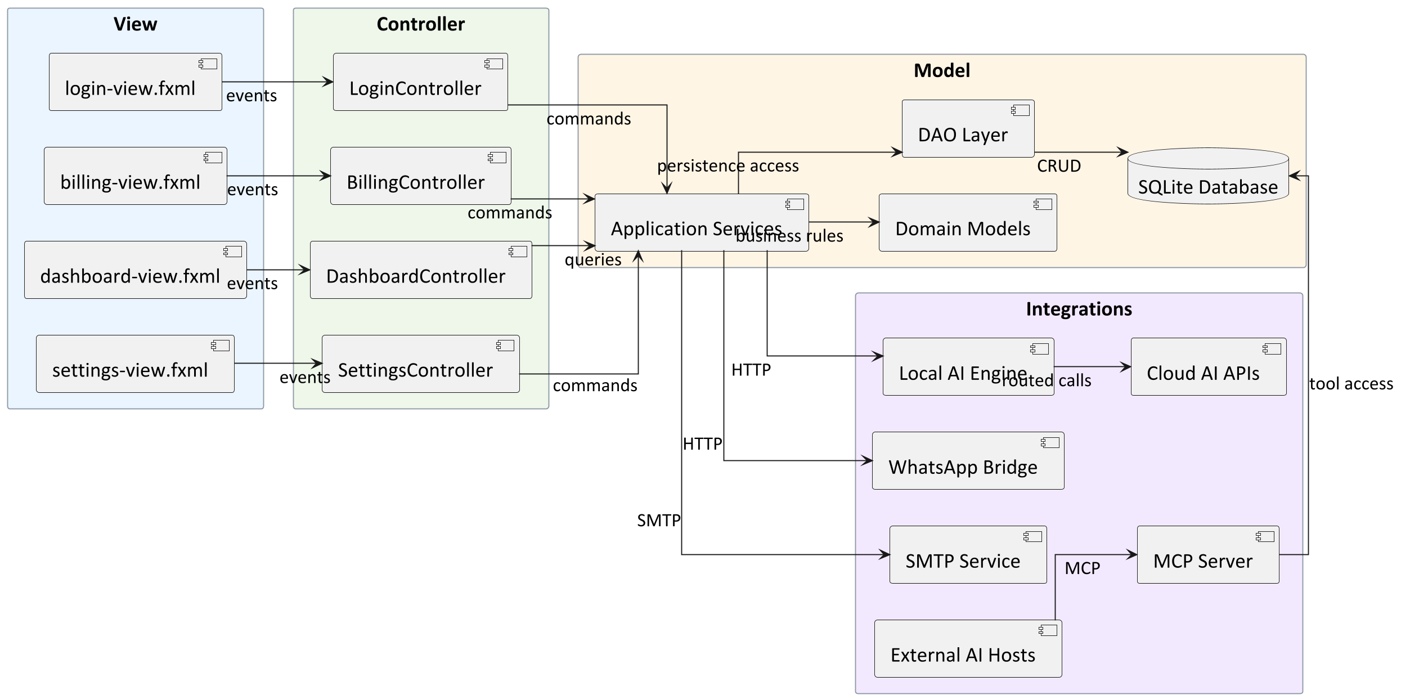
Figure 1. Layered MVC strategy with service boundaries
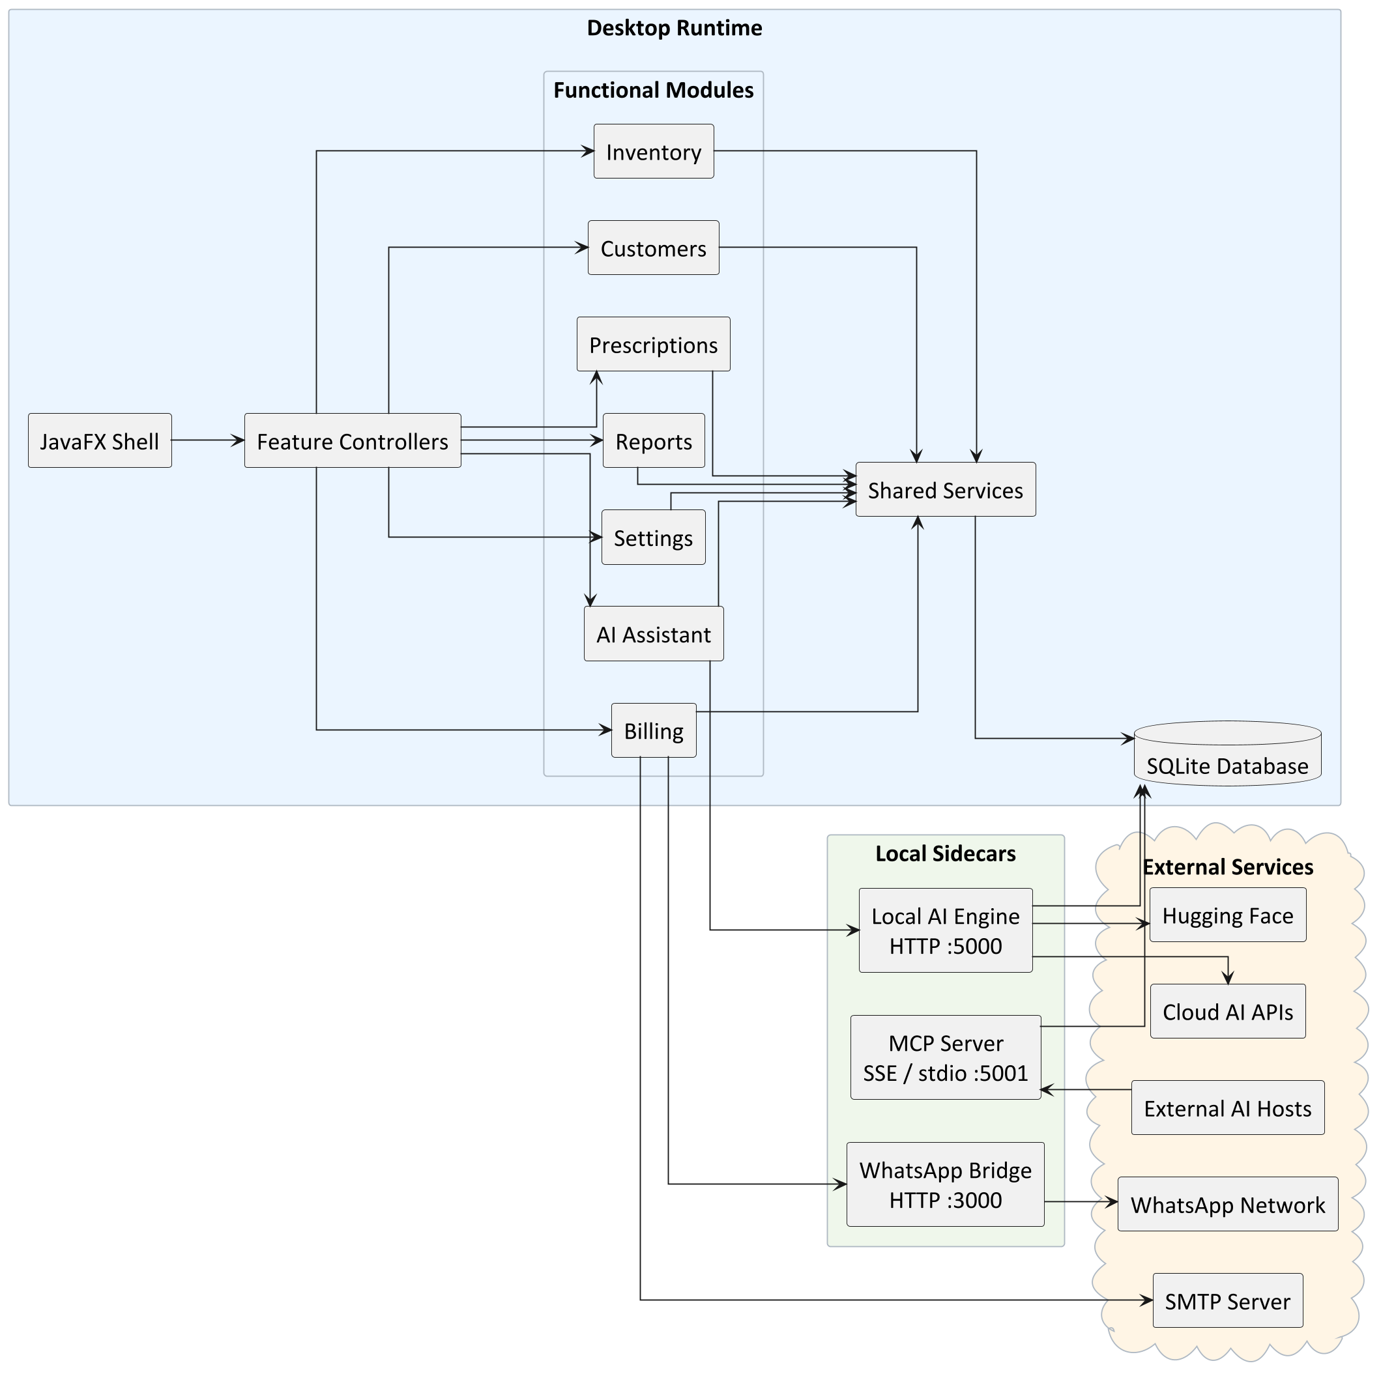
Figure 2. Module decomposition and subsystem boundaries

4. Subsystem Topology and Role Separation
The system is organized into four cooperative strata: the JavaFX presentation layer, an application service layer, a persistence layer composed of DAOs and schema migration logic, and external microservices. This topology reduces coupling, improves fault isolation, and enables optional components such as AI inference and WhatsApp dispatch to degrade gracefully without disrupting core operations.
Layer | Responsibilities
Presentation | User interaction, navigation, data binding, input validation
Application Services | Billing logic, reporting pipelines, inventory workflows, AI routing
Persistence | SQL access, schema migration, transactional integrity, indexing
External Integrations | AI microservice, WhatsApp bridge, SMTP delivery

5. Workflow Semantics and Transactional Guarantees
The billing pipeline is the system's most time-critical path. The workflow begins with medicine lookup by barcode or name, followed by cart aggregation, GST computation, and checkout. Checkout executes as a single ACID transaction that inserts bill headers, persists line items, updates stock quantities, records payment splits, and applies loyalty or credit adjustments. Failure in any step triggers rollback, thereby preventing inconsistent stock or orphaned invoices. This model is reinforced by schema constraints and runtime checks in DAO methods.
Inventory governance is maintained through explicit stock tables, adjustments for returns or damages, and expiry metadata. The schema supports reorder thresholds and optional multi-location extensions, enabling both immediate operational visibility and future scaling. Prescriptions, procurement, and attendance modules extend the system beyond point-of-sale into a broader pharmacy ERP context.
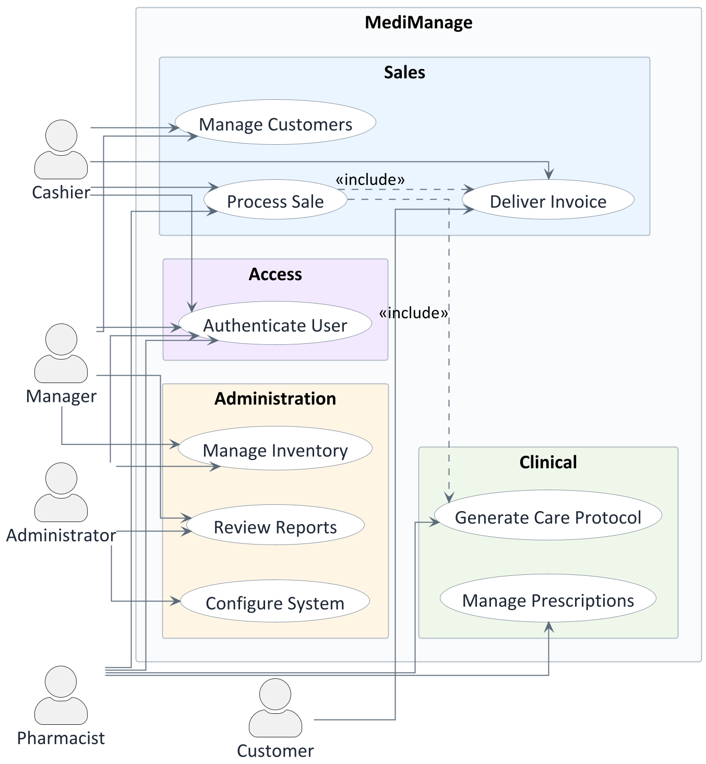
Figure 3. Use case coverage for pharmacy workflows
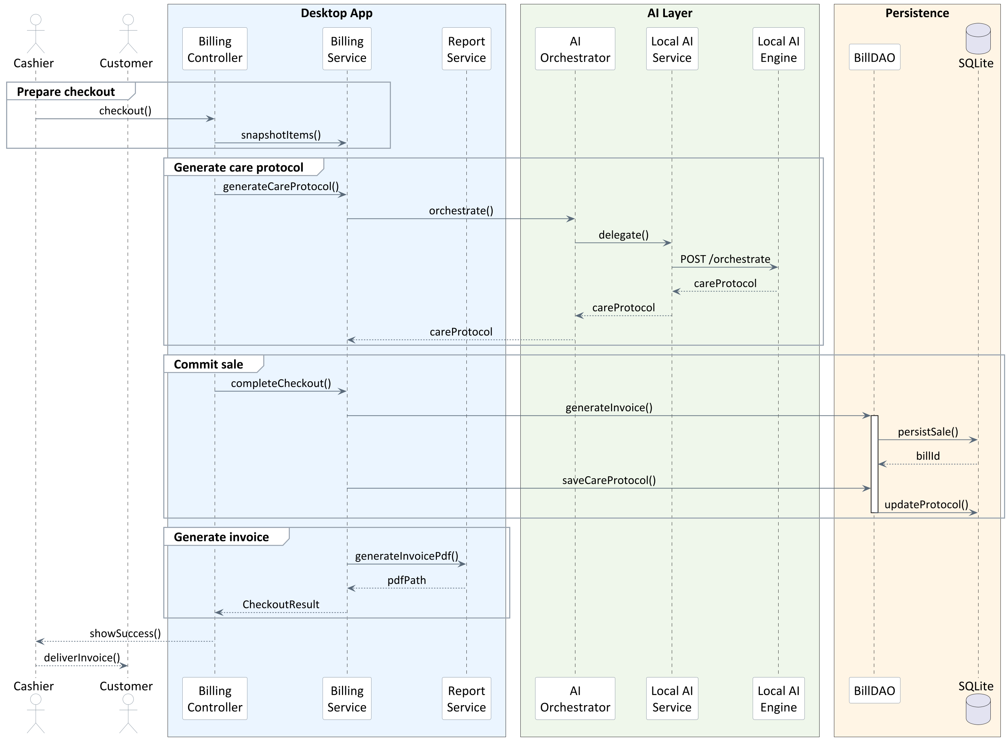
Figure 4. Billing and system interaction sequence
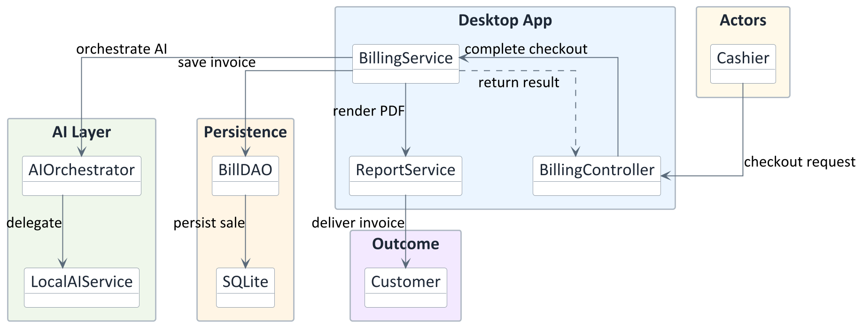
Figure 5. Collaboration among actors and services

6. Persistence Model, Schema Evolution, and Integrity Controls
SQLite is configured with WAL journaling and synchronous NORMAL mode to balance durability and throughput for local workloads. Schema initialization uses migration-safe logic that checks for existing columns before applying ALTER TABLE statements, minimizing risk when deploying to legacy environments. The schema is normalized around medicine, billing, customer, and supplier entities, with indexes optimized for high-frequency queries such as name search, expiry detection, and temporal sales reporting.
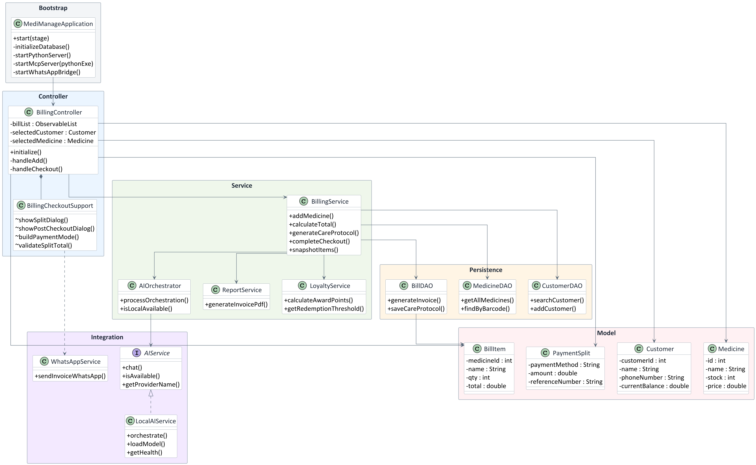
Figure 6. Core data model and entity relationships

7. Indexing Strategy and Query Optimization
Index design prioritizes query patterns critical to pharmacy operations: medicine name lookup, expiry filtering, daily sales ranges, and bill-item associations. The schema also includes composite indexes for anomaly tracking and report scheduling to support analytics dispatch workflows. These indexes directly reduce UI latency during high-volume interactions.
Index | Table | Columns
idx_users_username | users | username
idx_medicines_name | medicines | name
idx_medicines_active_name | medicines | active, name
idx_medicines_company | medicines | company
idx_medicines_expiry | medicines | expiry_date
idx_stock_medicine | stock | medicine_id
idx_bills_date | bills | bill_date
idx_bills_customer | bills | customer_id
idx_bill_items_bill | bill_items | bill_id
idx_bill_items_medicine | bill_items | medicine_id
idx_customers_phone | customers | phone
idx_expenses_date | expenses | date
idx_inventory_adjustments_medicine | inventory_adjustments | medicine_id
idx_inventory_adjustments_type_date | inventory_adjustments | adjustment_type, occurred_at
idx_anomaly_action_tracker_week | anomaly_action_tracker | week_start_date, timezone_name
idx_anomaly_action_tracker_status_due | anomaly_action_tracker | closure_status, due_date
idx_report_dispatch_schedule_next_run | analytics_report_dispatch_schedules | active, next_run_at
idx_report_dispatch_schedule_channel | analytics_report_dispatch_schedules | channel, recipient
idx_message_templates_key | message_templates | template_key
idx_medicines_generic | medicines | generic_name
idx_prescriptions_customer | prescriptions | customer_id
idx_prescriptions_status | prescriptions | status
idx_prescriptions_status_date | prescriptions | status, prescribed_date DESC
idx_ai_prompt_registry_active | ai_prompt_registry | prompt_key, is_active, version_number DESC
idx_ai_prompt_registry_history | ai_prompt_registry | prompt_key, version_number DESC

8. Data Dictionary and Entity Specifications
This section provides a structured data dictionary derived directly from the project schema. Each table is described in terms of columns, types, constraints, and inferred semantics. The dictionary is organized to support auditability, onboarding, and future schema evolution analysis.

8.1 users
Column | Type | Constraints | Description
user_id | INTEGER | PRIMARY KEY AUTOINCREMENT | Identifier for application user (staff account)
username | TEXT | UNIQUE NOT NULL | Operational classification or state
password | TEXT | NOT NULL | Application data field
role | TEXT | DEFAULT 'STAFF' | Operational classification or state

8.2 medicines
Column | Type | Constraints | Description
medicine_id | INTEGER | PRIMARY KEY AUTOINCREMENT | Identifier for medicine catalog entry
name | TEXT | NOT NULL | Application data field
generic_name | TEXT | - | Application data field
company | TEXT | - | Application data field
price | REAL | NOT NULL | Monetary value
expiry_date | TEXT | - | Timestamp or date value used for auditing or sequencing
active | INTEGER | DEFAULT 1 | Boolean flag controlling behavior
barcode | TEXT | - | External identifier used for integration or compliance
supplier_id | INTEGER | - | System identifier or reference key
purchase_price | REAL | DEFAULT 0.0 | Monetary value
reorder_threshold | INTEGER | DEFAULT 10 | Application data field

8.3 stock
Column | Type | Constraints | Description
stock_id | INTEGER | PRIMARY KEY AUTOINCREMENT | System identifier or reference key
medicine_id | INTEGER | UNIQUE | Foreign key to medicines.medicine_id
quantity | INTEGER | NOT NULL CHECK (quantity >= 0) | Quantity measure

8.4 customers
Column | Type | Constraints | Description
customer_id | INTEGER | PRIMARY KEY AUTOINCREMENT | Identifier for customer profile
name | TEXT | NOT NULL | Application data field
email | TEXT | - | Contact or communication field
phone | TEXT | - | Contact or communication field
address | TEXT | - | Contact or communication field
nominee_name | TEXT | - | Application data field
nominee_relation | TEXT | - | Application data field
insurance_provider | TEXT | - | Application data field
insurance_policy_no | TEXT | - | Application data field
diseases | TEXT | - | Application data field
photo_id_path | TEXT | - | Application data field
current_balance | REAL | DEFAULT 0.0 | Application data field
loyalty_points | INTEGER | DEFAULT 0 | Application data field

8.5 bills
Column | Type | Constraints | Description
bill_id | INTEGER | PRIMARY KEY AUTOINCREMENT | System identifier or reference key
customer_id | INTEGER | - | Foreign key to customers.customer_id
user_id | INTEGER | - | Foreign key to users.user_id
total_amount | REAL | - | Monetary value
bill_date | TEXT | DEFAULT CURRENT_TIMESTAMP | Timestamp or date value used for auditing or sequencing
payment_mode | TEXT | DEFAULT 'CASH' | Operational classification or state
ai_care_protocol | TEXT | - | AI related metadata
subscription_enrollment_id | INTEGER | - | System identifier or reference key
subscription_plan_id | INTEGER | - | System identifier or reference key
subscription_discount_percent | REAL | DEFAULT 0.0 | Application data field
subscription_savings_amount | REAL | DEFAULT 0.0 | Monetary value
subscription_approval_reference | TEXT | - | Application data field
location_id | INTEGER | - | System identifier or reference key

8.6 bill_items
Column | Type | Constraints | Description
item_id | INTEGER | PRIMARY KEY AUTOINCREMENT | System identifier or reference key
bill_id | INTEGER | - | Foreign key to bills.bill_id
medicine_id | INTEGER | - | Foreign key to medicines.medicine_id
quantity | INTEGER | - | Quantity measure
price | REAL | - | Monetary value
total | REAL | - | Monetary value
subscription_discount_percent | REAL | DEFAULT 0.0 | Application data field
subscription_discount_amount | REAL | DEFAULT 0.0 | Monetary value
subscription_rule_source | TEXT | - | Application data field
price_override | REAL | - | Monetary value
override_reason | TEXT | - | Application data field
override_by_user_id | INTEGER | - | System identifier or reference key

8.7 expenses
Column | Type | Constraints | Description
expense_id | INTEGER | PRIMARY KEY AUTOINCREMENT | System identifier or reference key
category | TEXT | NOT NULL | Application data field
amount | REAL | NOT NULL | Monetary value
date | TEXT | NOT NULL | Timestamp or date value used for auditing or sequencing
description | TEXT | - | Free form text or narrative field

8.8 inventory_adjustments
Column | Type | Constraints | Description
adjustment_id | INTEGER | PRIMARY KEY AUTOINCREMENT | System identifier or reference key
medicine_id | INTEGER | NOT NULL | Foreign key to medicines.medicine_id
adjustment_type | TEXT | NOT NULL | Application data field
quantity | INTEGER | NOT NULL CHECK (quantity > 0) | Quantity measure
unit_price | REAL | NOT NULL DEFAULT 0.0 | Monetary value
root_cause_tag | TEXT | - | Application data field
notes | TEXT | - | Free form text or narrative field
occurred_at | TEXT | NOT NULL DEFAULT CURRENT_TIMESTAMP | Timestamp or date value used for auditing or sequencing
created_by_user_id | INTEGER | - | Foreign key to users.user_id

8.9 anomaly_action_tracker
Column | Type | Constraints | Description
action_id | INTEGER | PRIMARY KEY AUTOINCREMENT | System identifier or reference key
week_start_date | TEXT | NOT NULL | Timestamp or date value used for auditing or sequencing
week_end_date | TEXT | NOT NULL | Timestamp or date value used for auditing or sequencing
timezone_name | TEXT | NOT NULL | Timestamp or date value used for auditing or sequencing
alert_type | TEXT | NOT NULL | Application data field
severity | TEXT | NOT NULL | Application data field
metric_value | TEXT | - | Application data field
threshold_rule | TEXT | - | Application data field
alert_message | TEXT | - | Application data field
owner_user_id | INTEGER | - | Foreign key to users.user_id
due_date | TEXT | - | Timestamp or date value used for auditing or sequencing
closure_status | TEXT | NOT NULL DEFAULT 'OPEN' | Application data field
closed_at | TEXT | - | Timestamp or date value used for auditing or sequencing
created_at | TEXT | NOT NULL DEFAULT CURRENT_TIMESTAMP | Timestamp or date value used for auditing or sequencing
updated_at | TEXT | NOT NULL DEFAULT CURRENT_TIMESTAMP | Timestamp or date value used for auditing or sequencing

8.10 analytics_report_dispatch_schedules
Column | Type | Constraints | Description
schedule_id | INTEGER | PRIMARY KEY AUTOINCREMENT | System identifier or reference key
channel | TEXT | NOT NULL | Application data field
recipient | TEXT | NOT NULL | Application data field
report_format | TEXT | NOT NULL | Application data field
frequency | TEXT | NOT NULL | Application data field
timezone_name | TEXT | NOT NULL | Timestamp or date value used for auditing or sequencing
filter_start_date | TEXT | - | Timestamp or date value used for auditing or sequencing
filter_end_date | TEXT | - | Timestamp or date value used for auditing or sequencing
supplier_filter | TEXT | - | Application data field
category_filter | TEXT | - | Application data field
active | INTEGER | NOT NULL DEFAULT 1 | Boolean flag controlling behavior
next_run_at | TEXT | NOT NULL | Timestamp or date value used for auditing or sequencing
last_run_at | TEXT | - | Timestamp or date value used for auditing or sequencing
last_status | TEXT | - | Application data field
last_error | TEXT | - | Application data field
created_by_user_id | INTEGER | - | Foreign key to users.user_id
created_at | TEXT | NOT NULL DEFAULT CURRENT_TIMESTAMP | Timestamp or date value used for auditing or sequencing
updated_at | TEXT | NOT NULL DEFAULT CURRENT_TIMESTAMP | Timestamp or date value used for auditing or sequencing

8.11 message_templates
Column | Type | Constraints | Description
template_id | INTEGER | PRIMARY KEY AUTOINCREMENT | System identifier or reference key
template_key | TEXT | UNIQUE NOT NULL | Application data field
subject | TEXT | - | Application data field
body_template | TEXT | NOT NULL | Free form text or narrative field
updated_at | TEXT | DEFAULT CURRENT_TIMESTAMP | Timestamp or date value used for auditing or sequencing

8.12 prescriptions
Column | Type | Constraints | Description
prescription_id | INTEGER | PRIMARY KEY AUTOINCREMENT | System identifier or reference key
customer_id | INTEGER | - | Foreign key to customers.customer_id
customer_name | TEXT | NOT NULL | Application data field
doctor_name | TEXT | - | Application data field
status | TEXT | DEFAULT 'PENDING' | Operational classification or state
prescribed_date | TEXT | DEFAULT CURRENT_TIMESTAMP | Timestamp or date value used for auditing or sequencing
notes | TEXT | - | Free form text or narrative field
medicines_text | TEXT | - | Application data field
ai_validation | TEXT | - | AI related metadata

8.13 ai_prompt_registry
Column | Type | Constraints | Description
prompt_version_id | INTEGER | PRIMARY KEY AUTOINCREMENT | System identifier or reference key
prompt_key | TEXT | NOT NULL | AI related metadata
version_number | INTEGER | NOT NULL | Application data field
template_text | TEXT | NOT NULL | Application data field
change_type | TEXT | NOT NULL | Application data field
change_note | TEXT | - | Application data field
rolled_back_from_version | INTEGER | - | Application data field
is_active | INTEGER | NOT NULL DEFAULT 0 | Application data field
changed_by_user_id | INTEGER | - | Foreign key to users.user_id
created_at | TEXT | NOT NULL DEFAULT CURRENT_TIMESTAMP | Timestamp or date value used for auditing or sequencing

8.14 subscription_plans
Column | Type | Constraints | Description
plan_id | INTEGER | PRIMARY KEY AUTOINCREMENT | System identifier or reference key
plan_code | TEXT | NOT NULL UNIQUE | Application data field
plan_name | TEXT | NOT NULL | Application data field
description | TEXT | - | Free form text or narrative field
price | REAL | NOT NULL DEFAULT 0.0 | Monetary value
duration_days | INTEGER | NOT NULL DEFAULT 30 | Application data field
grace_days | INTEGER | NOT NULL DEFAULT 0 | Application data field
default_discount_percent | REAL | DEFAULT 0.0 | Application data field
max_discount_percent | REAL | NOT NULL DEFAULT 0.0 | Application data field
minimum_margin_percent | REAL | NOT NULL DEFAULT 0.0 | Application data field
status | TEXT | NOT NULL DEFAULT 'ACTIVE' | Operational classification or state
auto_renew | INTEGER | NOT NULL DEFAULT 0 | Boolean flag controlling behavior
requires_approval | INTEGER | NOT NULL DEFAULT 0 | Boolean flag controlling behavior
created_by_user_id | INTEGER | - | Foreign key to users.user_id
created_at | TEXT | NOT NULL DEFAULT CURRENT_TIMESTAMP | Timestamp or date value used for auditing or sequencing

8.15 payment_splits
Column | Type | Constraints | Description
split_id | INTEGER | PRIMARY KEY AUTOINCREMENT | System identifier or reference key
bill_id | INTEGER | NOT NULL | Foreign key to bills.bill_id
payment_method | TEXT | NOT NULL | Application data field
amount | REAL | NOT NULL | Monetary value
reference_number | TEXT | - | External identifier used for integration or compliance
created_at | TEXT | NOT NULL DEFAULT CURRENT_TIMESTAMP | Timestamp or date value used for auditing or sequencing

8.16 held_orders
Column | Type | Constraints | Description
hold_id | INTEGER | PRIMARY KEY AUTOINCREMENT | System identifier or reference key
customer_id | INTEGER | - | Foreign key to customers.customer_id
user_id | INTEGER | - | Foreign key to users.user_id
items_json | TEXT | NOT NULL | Application data field
total_amount | REAL | NOT NULL DEFAULT 0.0 | Monetary value
notes | TEXT | - | Free form text or narrative field
status | TEXT | NOT NULL DEFAULT 'HELD' | Operational classification or state
held_at | TEXT | NOT NULL DEFAULT CURRENT_TIMESTAMP | Timestamp or date value used for auditing or sequencing
recalled_at | TEXT | - | Timestamp or date value used for auditing or sequencing

8.17 receipt_settings
Column | Type | Constraints | Description
setting_id | INTEGER | PRIMARY KEY AUTOINCREMENT | System identifier or reference key
pharmacy_name | TEXT | NOT NULL DEFAULT 'MediManage Pharmacy' | Application data field
address_line1 | TEXT | - | Application data field
address_line2 | TEXT | - | Application data field
phone | TEXT | - | Contact or communication field
email | TEXT | - | Contact or communication field
gst_number | TEXT | - | External identifier used for integration or compliance
logo_path | TEXT | - | Application data field
footer_text | TEXT | DEFAULT 'Thank you for your purchase!' | Application data field
show_barcode_on_receipt | INTEGER | NOT NULL DEFAULT 1 | Application data field
updated_at | TEXT | NOT NULL DEFAULT CURRENT_TIMESTAMP | Timestamp or date value used for auditing or sequencing

8.18 suppliers
Column | Type | Constraints | Description
supplier_id | INTEGER | PRIMARY KEY AUTOINCREMENT | System identifier or reference key
name | TEXT | NOT NULL | Application data field
contact_person | TEXT | - | Application data field
phone | TEXT | - | Contact or communication field
email | TEXT | - | Contact or communication field
address | TEXT | - | Contact or communication field
gst_number | TEXT | - | External identifier used for integration or compliance
active | INTEGER | NOT NULL DEFAULT 1 | Boolean flag controlling behavior
created_at | TEXT | NOT NULL DEFAULT CURRENT_TIMESTAMP | Timestamp or date value used for auditing or sequencing
updated_at | TEXT | NOT NULL DEFAULT CURRENT_TIMESTAMP | Timestamp or date value used for auditing or sequencing

8.19 purchase_orders
Column | Type | Constraints | Description
po_id | INTEGER | PRIMARY KEY AUTOINCREMENT | System identifier or reference key
supplier_id | INTEGER | NOT NULL | Foreign key to suppliers.supplier_id
order_date | TEXT | NOT NULL DEFAULT CURRENT_TIMESTAMP | Timestamp or date value used for auditing or sequencing
expected_delivery | TEXT | - | Application data field
status | TEXT | NOT NULL DEFAULT 'DRAFT' | Operational classification or state
total_amount | REAL | NOT NULL DEFAULT 0.0 | Monetary value
notes | TEXT | - | Free form text or narrative field
created_by_user_id | INTEGER | - | Foreign key to users.user_id
updated_at | TEXT | NOT NULL DEFAULT CURRENT_TIMESTAMP | Timestamp or date value used for auditing or sequencing

8.20 purchase_order_items
Column | Type | Constraints | Description
poi_id | INTEGER | PRIMARY KEY AUTOINCREMENT | System identifier or reference key
po_id | INTEGER | NOT NULL | Foreign key to purchase_orders.po_id
medicine_id | INTEGER | NOT NULL | Foreign key to medicines.medicine_id
ordered_qty | INTEGER | NOT NULL | Application data field
received_qty | INTEGER | NOT NULL DEFAULT 0 | Application data field
unit_cost | REAL | NOT NULL | Monetary value

8.21 employee_attendance
Column | Type | Constraints | Description
attendance_id | INTEGER | PRIMARY KEY AUTOINCREMENT | System identifier or reference key
user_id | INTEGER | NOT NULL | Foreign key to users.user_id
date | TEXT | NOT NULL | Timestamp or date value used for auditing or sequencing
total_hours | REAL | - | Monetary value
notes | TEXT | - | Free form text or narrative field

8.22 locations
Column | Type | Constraints | Description
location_id | INTEGER | PRIMARY KEY AUTOINCREMENT | System identifier or reference key
name | TEXT | NOT NULL | Application data field
address | TEXT | - | Contact or communication field
phone | TEXT | - | Contact or communication field
location_type | TEXT | NOT NULL DEFAULT 'PHARMACY' | Application data field
active | INTEGER | NOT NULL DEFAULT 1 | Boolean flag controlling behavior
created_at | TEXT | NOT NULL DEFAULT CURRENT_TIMESTAMP | Timestamp or date value used for auditing or sequencing

8.23 location_stock
Column | Type | Constraints | Description
location_stock_id | INTEGER | PRIMARY KEY AUTOINCREMENT | System identifier or reference key
location_id | INTEGER | NOT NULL | Foreign key to locations.location_id
medicine_id | INTEGER | NOT NULL | Foreign key to medicines.medicine_id
quantity | INTEGER | NOT NULL DEFAULT 0 | Quantity measure
min_stock | INTEGER | NOT NULL DEFAULT 5 | Application data field
updated_at | TEXT | NOT NULL DEFAULT CURRENT_TIMESTAMP | Timestamp or date value used for auditing or sequencing

8.24 stock_transfers
Column | Type | Constraints | Description
transfer_id | INTEGER | PRIMARY KEY AUTOINCREMENT | System identifier or reference key
from_location_id | INTEGER | NOT NULL | Foreign key to locations.location_id
to_location_id | INTEGER | NOT NULL | Foreign key to locations.location_id
medicine_id | INTEGER | NOT NULL | Foreign key to medicines.medicine_id
quantity | INTEGER | NOT NULL | Quantity measure
status | TEXT | NOT NULL DEFAULT 'PENDING' | Operational classification or state
requested_by | INTEGER | - | Foreign key to users.user_id
requested_at | TEXT | NOT NULL DEFAULT CURRENT_TIMESTAMP | Timestamp or date value used for auditing or sequencing
completed_at | TEXT | - | Timestamp or date value used for auditing or sequencing

9. Security, Privacy, and Access Governance
MediManage employs role-based access control, with administrative permissions restricted to privileged roles. Passwords are hashed using BCrypt with a defined work factor, and legacy plaintext values are supported for migration compatibility. Sensitive secrets, including SMTP credentials and AI provider keys, are secured using Windows DPAPI through a local secure store. These mechanisms collectively reduce exposure risk while maintaining usability in offline environments.

10. Intelligence Augmentation and AI Orchestration
The AI subsystem operates as a Python microservice that exposes endpoints for model download, orchestration, and inference. The Java layer includes an orchestrator that enforces rate limiting, maintains an LRU cache, and supports routing between local and cloud providers. The AI pipeline is designed to degrade gracefully: a rules-based care protocol engine is invoked when AI responses are unavailable or unsafe. This maintains continuity in pharmacy guidance generation and supports ethical deployment constraints.

11. Communication and Interoperability Layer
MediManage integrates external communication through a Node.js WhatsApp bridge. The bridge manages QR-based authentication and provides endpoints for message and PDF delivery. In the desktop application, messages are templated using database-stored content, sanitized, and dispatched asynchronously to preserve UI responsiveness. A parallel SMTP pipeline enables invoice delivery via email.

12. Human Factors and Interface Ergonomics
The UI is designed for rapid task completion and low cognitive load. Controls are grouped by workflow stage, and JavaFX bindings provide reactive updates across tables, forms, and dashboards. The following placeholders indicate required visual evidence to accompany the narrative.
==[INSERT SCREENSHOT OF LOGIN SCREEN HERE]==(highlighed with colour and size)
==[INSERT SCREENSHOT OF DASHBOARD OVERVIEW HERE]==(highlighed with colour and size)
==[INSERT SCREENSHOT OF BILLING AND CART VIEW HERE]==(highlighed with colour and size)
==[INSERT SCREENSHOT OF INVENTORY MANAGEMENT VIEW HERE]==(highlighed with colour and size)
==[INSERT SCREENSHOT OF CUSTOMER MANAGEMENT VIEW HERE]==(highlighed with colour and size)
==[INSERT SCREENSHOT OF REPORTS AND ANALYTICS VIEW HERE]==(highlighed with colour and size)
==[INSERT SCREENSHOT OF SETTINGS AND AI CONFIGURATION VIEW HERE]==(highlighed with colour and size)
==[INSERT SCREENSHOT OF INVOICE PDF OUTPUT HERE]==(highlighed with colour and size)

13. Verification Strategy and Test Coverage
The project includes unit and integration tests covering billing integrity, DAO operations, role policies, AI input safety, and storage concurrency. Maven Surefire is configured to fail builds when no tests are detected, preserving baseline quality gates. The test suite emphasizes high-risk paths such as invoice generation, loyalty adjustments, and stock decrement behavior under concurrent access.

14. Evaluation Methodology and Comparative Analysis
A formal evaluation framework is required to validate system benefits beyond anecdotal evidence. This report proposes a multi-dimensional evaluation protocol, grounded in pharmacy operations research and software quality metrics.
14.1 Proposed Metrics and Instrumentation
Key performance and reliability metrics include: checkout latency (time from cart finalization to invoice creation), stock accuracy (difference between system stock and physical count), billing error rate (number of corrected invoices per 100 transactions), and data completeness (percentage of bills with linked customer and payment metadata). Logging hooks and report exports can be used to collect these metrics without interrupting operations.
14.2 Comparative Baselines
Two baselines are recommended for comparison. The first is manual ledger or spreadsheet workflows, which typically exhibit higher latency and lower auditability. The second is cloud-first pharmacy software, which provides centralized analytics but is sensitive to connectivity and operational cost. MediManage is expected to outperform manual systems in accuracy and speed while matching or exceeding cloud systems in reliability under limited network conditions.
14.3 Reliability and Resilience Assessment
Reliability can be evaluated through controlled failure injection, including forced AI service downtime, messaging service unavailability, and simulated database contention. The system should continue core billing and inventory operations under these scenarios, with graceful degradation of auxiliary services.
14.4 Ethical and Safety Evaluation
AI-generated care protocols must be validated for safety and alignment with pharmacy guidelines. A review protocol should compare AI suggestions to standard care references and document deviations. The fallback rules engine provides a baseline that can be used as a safety comparison benchmark.

15. Limitations, Risks, and Future Research Directions
Current deployment is optimized for single-site usage with optional in-memory concurrency testing. Multi-site synchronization, role-based audit logging, and formal regulatory compliance audits are potential expansions. The AI subsystem could be extended to drug interaction detection, personalized adherence reminders, and predictive inventory forecasting. Future work should also include usability studies, performance profiling under high transaction loads, and longitudinal impact assessment on billing error reduction.

16. Conclusion
MediManage represents a comprehensive, research-aligned pharmacy management platform that balances transactional correctness, human-centered workflow design, and intelligent augmentation. Its layered architecture, migration-aware data model, and robust billing pipeline provide a stable foundation for real-world adoption. The inclusion of AI and messaging services introduces differentiated value while preserving offline resilience. The system is positioned as a strong final-year project with clear pathways for future research and production enhancement.

References
- SQLite Documentation: https://www.sqlite.org/docs.html
- JavaFX Documentation: https://openjfx.io
- JasperReports Library: https://community.jaspersoft.com/project/jasperreports-library
- AtlantaFX Theme: https://github.com/mkpaz/atlantafx
- MediManage ADR 0001: SQLite First, Hybrid-Ready Storage Path
- MediManage Project Source (local): C:\Users\ksvik\IdeaProjects\MediManage
Powered by AI - OpenAI Codex

