GRADUATION PROJECT
MediPass+
Requirements Gathering
Stakeholder analysis, user stories and use cases, functional and non-functional requirements
Document details
Track | DEPI, Full Stack .NET
Deliverable | D3 Requirements Gathering (due 16 Oct 2026)
Repository | https://github.com/MediPass-Plus/MediPassPlus
Related document | Project Planning and Management (D1)

Team
# | Name
1 | Waleed Ahmed Korashy Abdo (Team Leader)
2 | Ahmed Gamal Khairy Hassan
3 | Azza Ibrahim Ali Shaban
4 | Nagham Ahmed Elsayed Elsorady
5 | Arwa Mahmoud Sayed Hussien
6 | Hend Abdelnaser Rashad Elsadany

1. Introduction

1.1 Purpose
This document specifies the requirements of MediPass+. It identifies the stakeholders and their needs, describes how users interact with the system through user stories and use cases, and lists the functional and non-functional requirements. It is the basis for the design, implementation and testing of the system.

1.2 Product overview
MediPass+ is a web platform that keeps a patient's medical history in one place and keeps it private. A patient books an appointment with a doctor. When the patient arrives, the doctor starts the visit and the patient approves access on their own phone by scanning a QR code. Only then can the doctor see the patient's history, and only for that visit. When the visit ends, the doctor's access ends too. The patient can always see their own history, can see who looked at it and when, and can end a doctor's access at any moment.
The system has four kinds of user: patient, doctor, clinic staff and admin. The scope, plan, timeline and risks are described in the Project Planning and Management document.

1.3 Document conventions

Identifiers
Prefix | Meaning | Example
SH-nn | Stakeholder | SH-01
US-nn | User story | US-20
UC-nn | Use case | UC-11
FR-xxx-nn | Functional requirement; xxx is the module code: ACC accounts, BKG booking, STF staff and admin, ACS visit access, REC medical record, PRV privacy, CHT chat | FR-ACS-02
NFR-xxx-nn | Non-functional requirement; xxx is the category code: PRF performance, SEC security, PRI privacy, USA usability, REL reliability, MNT maintainability and compatibility | NFR-SEC-05

Priorities
Priority | Meaning
Must | Needed for the first complete version. The system is not accepted without it.
Should | Important, but the system still works without it. It is done when the Must items are done.
Could | Stretch item. It is started only when all Must and Should items are done.
Requirements are written as shall statements. The word shall marks a requirement, and should marks a recommendation.

1.4 Assumptions, constraints and dependencies

Assumptions
- Patients have a smartphone with a camera and an internet connection. Doctors and clinic staff work on a computer with a current browser.
- Each doctor and each clinic staff member belongs to one clinic.
- Visits take place in person at the clinic.
- Every user has a valid email address.
- Medicines are entered by the doctor as text (name and dose).

Constraints
- The implementation is due on 30 Nov 2026 and the final delivery on 4 Dec 2026.
- The system is a responsive web application: Angular frontend, ASP.NET Core Web API, SQL Server.
- Only free tools and free hosting plans are used.
- The team has six members who work remotely in one-week sprints.

Dependencies
- The browser camera needs HTTPS (or localhost) to scan the QR code.
- GitHub, GitHub Actions and Jira are used for source control, build and tracking.
- The free hosting plan must support SQL Server and HTTPS for a hosted demo. Otherwise the demo runs locally or in Docker.

1.5 Summary of requirements
Item | Total | Must | Should | Could
User stories | 36 | 28 | 6 | 2
Use cases | 24 | 21 | 2 | 1
Functional requirements | 63 | 49 | 8 | 6
Non-functional requirements | 40 | - | - | -

2. Stakeholder analysis

2.1 Stakeholder register
ID | Stakeholder | Type | Description and interest
SH-01 | Patients | External, primary user | People who book visits and own the medical history. They want easy booking, control over who sees their data, and access to their own history.
SH-02 | Doctors | External, primary user | Medical staff who see patients and record diagnoses. They need the complete history during the visit and a clear, legitimate way to get access.
SH-03 | Clinic staff | External, primary user | Receptionists and assistants who run the schedule. They need quick scheduling tools and should not carry the responsibility of medical data.
SH-04 | Clinic management | External, customer | Owners or managers who decide to use the system and manage the clinic's accounts. They want fewer scheduling mistakes, the trust of their patients and control over staff access.
SH-05 | Platform administrators | Internal, operator | They manage clinics, doctor and staff accounts and follow the use of the system. They must not see medical data.
SH-06 | Project team | Internal | The six members who design, build, test and document the system. They want a clear scope, a realistic schedule and maintainable code.
SH-07 | Instructor and DEPI evaluators | External, academic | They evaluate the project against the DEPI guidelines. They expect complete documents on time, a sound architecture, security and a working demonstration.
SH-08 | Data protection and health authorities | External, regulator | Bodies that regulate personal and health data, for example Egypt's Personal Data Protection Law (Law No. 151 of 2020). They expect lawful and secure handling of personal data. The system is a graduation prototype that applies privacy by design; a formal legal review is not part of the project.
SH-09 | Hosting and third-party providers | External, supplier | Providers of hosting, GitHub, Jira and open-source libraries. Free plans and licences must be respected.

2.2 Needs and expectations
Stakeholder | Key needs | Expectations (success criteria) | Related requirements
Patients | Privacy and control; fast booking; own history at any time; transparency about access | Approval in a few taps; a list of who viewed the record; data stays private | FR-ACS-03, FR-ACS-09, FR-PRV-03, NFR-USA-03
Doctors | Complete history during the visit; quick access; easy recording of the diagnosis | Access within 30 seconds; no search through other patients; one place for the history | FR-ACS-01 to 05, FR-REC-02 to 04, NFR-PRF-03
Clinic staff | Scheduling tools; marking arrivals; bookings by phone | Only name, phone, time and status are shown | FR-STF-01 to 05
Clinic management | Reliable schedules; patient trust; control over accounts | Accounts can be created and deactivated; staff cannot read medical data | FR-STF-06, FR-STF-07, FR-PRV-06
Platform administrators | Account management; usage counts | Simple screens; no access to medical data | FR-STF-06 to 09
Project team | Clear scope; parallel work on modules; maintainable code | Layered code, automatic build and tests, documented API | NFR-MNT-01 to 05
Instructor and DEPI evaluators | All guideline deliverables; sound architecture; security; working demo | Documents on time; core flow demonstrated; test reports | NFR-MNT-03, NFR-SEC-11
Data protection authorities | Secure handling of personal data; minimum data; traceability | Encryption, role and grant checks, audit log | NFR-SEC-01 to 11, NFR-PRI-01 to 05
Hosting and third-party providers | Fair use of free plans; HTTPS | Demo stays within plan limits | NFR-SEC-01, NFR-MNT-05

2.3 Influence and interest
The grid places each stakeholder by their power over the project and their interest in it. It decides how closely we involve each group.
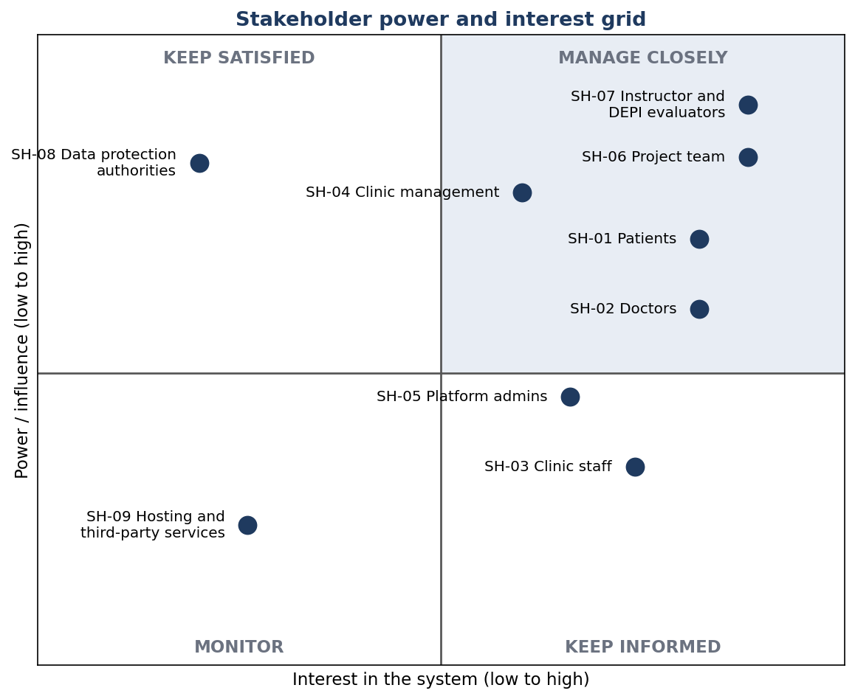
Figure 1. Stakeholder power and interest grid.
Stakeholder | Power | Interest | Strategy | How we engage
SH-07 Instructor and DEPI evaluators | High | High | Manage closely | Sprint review demos, document submissions on the guideline dates, feedback used in the next sprint
SH-06 Project team | High | High | Manage closely | Sprint ceremonies, Jira board, peer review
SH-01 Patients | High | High | Manage closely | Pilot with at least 8 people outside the team; usability observation
SH-02 Doctors | High | High | Manage closely | Pilot and feedback on the visit flow and the history screens
SH-04 Clinic management | High | Medium | Manage closely | Demonstrate the separation of staff and medical data and the account management
SH-08 Data protection authorities | High | Low | Keep satisfied | Privacy by design: encryption, grants, audit log, data minimisation, documented in the design
SH-05 Platform administrators | Low | High | Keep informed | Administration section of the user manual
SH-03 Clinic staff | Low | High | Keep informed | Staff section of the user manual; feedback on the schedule screens
SH-09 Hosting and third-party providers | Low | Low | Monitor | Check plan limits and licences by Sprint 3

3. User stories and use cases

3.1 Actors
Actor | Description | Main goals
Patient | A person who uses the clinics and owns a medical record | Book visits, approve access, see own history, control access
Doctor | A medical professional of one clinic | See the schedule, get access during a visit, record diagnosis and prescription
Clinic staff | A receptionist or assistant of one clinic | Manage slots, book for patients, mark arrivals
Admin | An administrator of the platform | Create clinics and accounts, deactivate accounts, follow usage
Registered user | Abstract actor: any of the four actors above after logging in | Log in, manage the profile

3.2 User stories
Each story has acceptance criteria that tell us when it is done. The priorities follow Section 1.3.

Accounts and login
ID | User story | Acceptance criteria | Priority
US-01 | As a patient, I want to register with my email and a password, so that I can book visits and keep my history. | Email is unique; password has at least 8 characters with a letter and a digit; the account is created as a patient with an empty medical record. | Must
US-02 | As a registered user, I want to log in and out securely, so that only I can use my account. | Correct credentials give access; after 5 wrong attempts the account is locked for a period; logging out ends the session. | Must
US-03 | As a registered user, I want to view and edit my profile, so that my details stay correct. | Name and phone can be changed; changes are saved and shown immediately. | Should
US-04 | As a registered user, I want to change my password, so that I can keep my account safe. | The current password is required; the new password follows the password rules. | Should

Clinics and booking
ID | User story | Acceptance criteria | Priority
US-05 | As a patient, I want to search clinics and doctors by specialty and name, so that I can find a suitable doctor. | Results are paged; each result shows the doctor, specialty and clinic. | Must
US-06 | As a patient, I want to see the free slots of a doctor, so that I can choose a convenient time. | Only future, unbooked slots are shown. | Must
US-07 | As a patient, I want to book a slot, so that I have a confirmed appointment. | The slot becomes unavailable at once; two patients cannot book the same slot; the appointment status is Booked. | Must
US-08 | As a patient, I want to cancel or reschedule my appointment, so that I can change my plans. | Allowed only before the visit starts; the old slot becomes free again. | Must
US-09 | As a patient, I want to see my upcoming and past appointments, so that I know my plans and my visit history. | The list shows date, doctor, clinic and status. | Must
US-10 | As a doctor, I want to see my schedule for a day, so that I can prepare for the visits. | Appointments are shown in time order with the patient's name. | Must
US-11 | As a doctor, I want to see which patients have arrived, so that I can call the next one in. | Appointments with status CheckedIn are highlighted. | Should

Clinic staff and admin
ID | User story | Acceptance criteria | Priority
US-12 | As clinic staff, I want to create and remove time slots for the doctors of my clinic, so that patients can book them. | Staff can manage only doctors of their own clinic; slots of one doctor cannot overlap. | Must
US-13 | As clinic staff, I want to book an appointment for a patient who calls or walks in, so that every patient can get a visit. | The booking follows the same slot rules as a booking made by the patient. | Must
US-14 | As clinic staff, I want to mark a patient as arrived, so that the doctor knows the patient is in the clinic. | Only appointments of today can be marked; the status becomes CheckedIn. | Must
US-15 | As clinic staff, I want to see only the basic details of an appointment, so that I can do my work without reading medical data. | Staff screens show name, phone, time and status and nothing medical. | Must
US-16 | As an admin, I want to create clinics, doctor accounts and staff accounts, so that clinics can start using the system. | Each doctor and staff account belongs to one clinic; the new user can log in with the given details. | Must
US-17 | As an admin, I want to deactivate and reactivate accounts, so that I can stop misuse. | Deactivated users cannot log in; their data is kept. | Must
US-18 | As an admin, I want a dashboard with counts, so that I can follow the use of the system. | Shows users per type, clinics and appointments per status; no medical data. | Should

Visit access
ID | User story | Acceptance criteria | Priority
US-19 | As a doctor, I want to start a visit and show a QR code, so that the patient can give me access. | Only for my own appointment that is today and checked in; the QR code is valid for 2 minutes. | Must
US-20 | As a patient, I want to scan the QR code with my phone and approve, so that I decide who opens my record. | The app shows the doctor's name before approval; approval creates an access grant for this visit only. | Must
US-21 | As a patient, I want to reject a request I did not expect, so that nobody gets access by mistake. | Rejecting creates no grant and is written to the audit log. | Should
US-22 | As a patient, I want a 6-digit code in my app when the camera does not work, so that I can still give access. | The code is valid for 5 minutes; a new code replaces the old one. | Must
US-23 | As a doctor, I want to type the code the patient tells me, so that I can get access without a camera. | After 5 wrong attempts the code is locked. | Must
US-24 | As a patient, I want to end a doctor's access at any moment, so that I stay in control. | Access stops immediately; later requests from the doctor are refused. | Must
US-25 | As a doctor, I want to complete the visit, so that the visit is closed and the access ends in a controlled way. | The status becomes Completed; access ends 15 minutes later at the latest and never lasts more than 2 hours. | Must

Medical record
ID | User story | Acceptance criteria | Priority
US-26 | As a doctor, I want to see the full history of the patient during the visit, so that I can make a better decision. | Diagnoses, prescriptions and reports of all earlier visits and doctors are shown; without an active grant nothing is shown. | Must
US-27 | As a doctor, I want to record a diagnosis, so that it becomes part of the patient's permanent history. | It is saved against the current appointment and cannot be deleted. | Must
US-28 | As a doctor, I want to add prescriptions to a diagnosis, so that the patient knows which medicines to take. | Each prescription has a medicine name, a dose and optional notes. | Must
US-29 | As a patient or a doctor, I want to upload a report or scan, so that it is stored with the history. | Only PDF, JPEG and PNG up to 10 MB; a doctor can upload only during an active grant. | Must
US-30 | As a patient, I want to see my complete history at any time, so that I know my diagnoses and medicines. | All diagnoses, prescriptions and reports are shown, newest first. | Must
US-31 | As a patient, I want to download my reports, so that I can keep my own copy. | Download works only for the owner of the report. | Should

Privacy
ID | User story | Acceptance criteria | Priority
US-32 | As a patient, I want to see who viewed my record and when, so that I can detect misuse. | The list shows user, action and time for every access, newest first. | Must
US-33 | As a patient, I want my diagnosis text stored encrypted, so that a leaked database does not reveal my diagnoses. | The diagnosis text in the database is not readable. | Must
US-34 | As a patient, I want clinic staff and admins to be unable to open my record, so that my data stays between me and my doctor. | Any request from these users to a medical endpoint is refused, and this is covered by tests. | Must

Chat (stretch)
ID | User story | Acceptance criteria | Priority
US-35 | As a patient, I want to chat with my doctor or with the clinic, so that I can ask questions without calling. | Doctor chat only when an appointment exists; messages arrive in real time. | Could
US-36 | As clinic staff, I want to answer messages in the clinic inbox, so that patients get administrative answers. | The inbox accepts text only and shows a warning not to send medical information. | Could

3.3 Use case diagrams
The use cases are shown in four UML diagrams. The chat use case UC-23 is a stretch item and is not drawn.
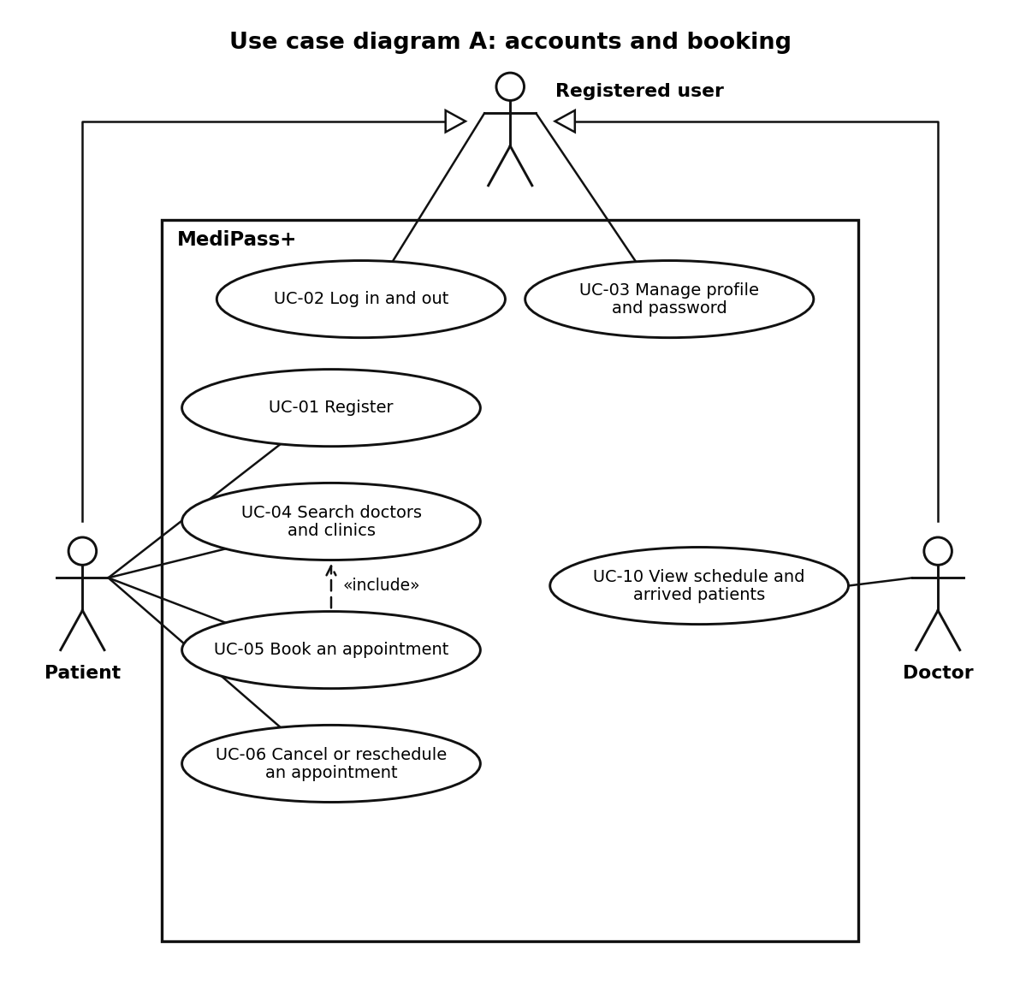
Figure 2. Use case diagram A: accounts and booking.
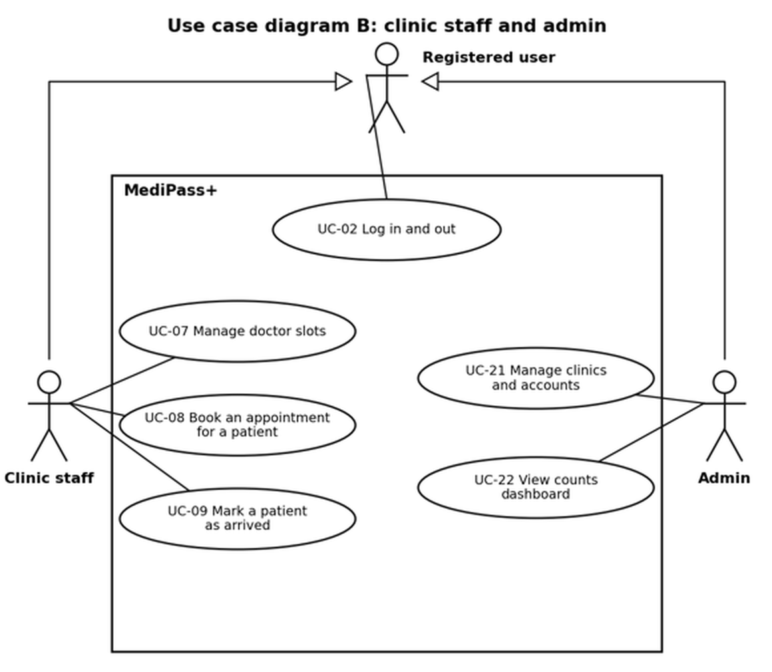
Figure 3. Use case diagram B: clinic staff and admin.
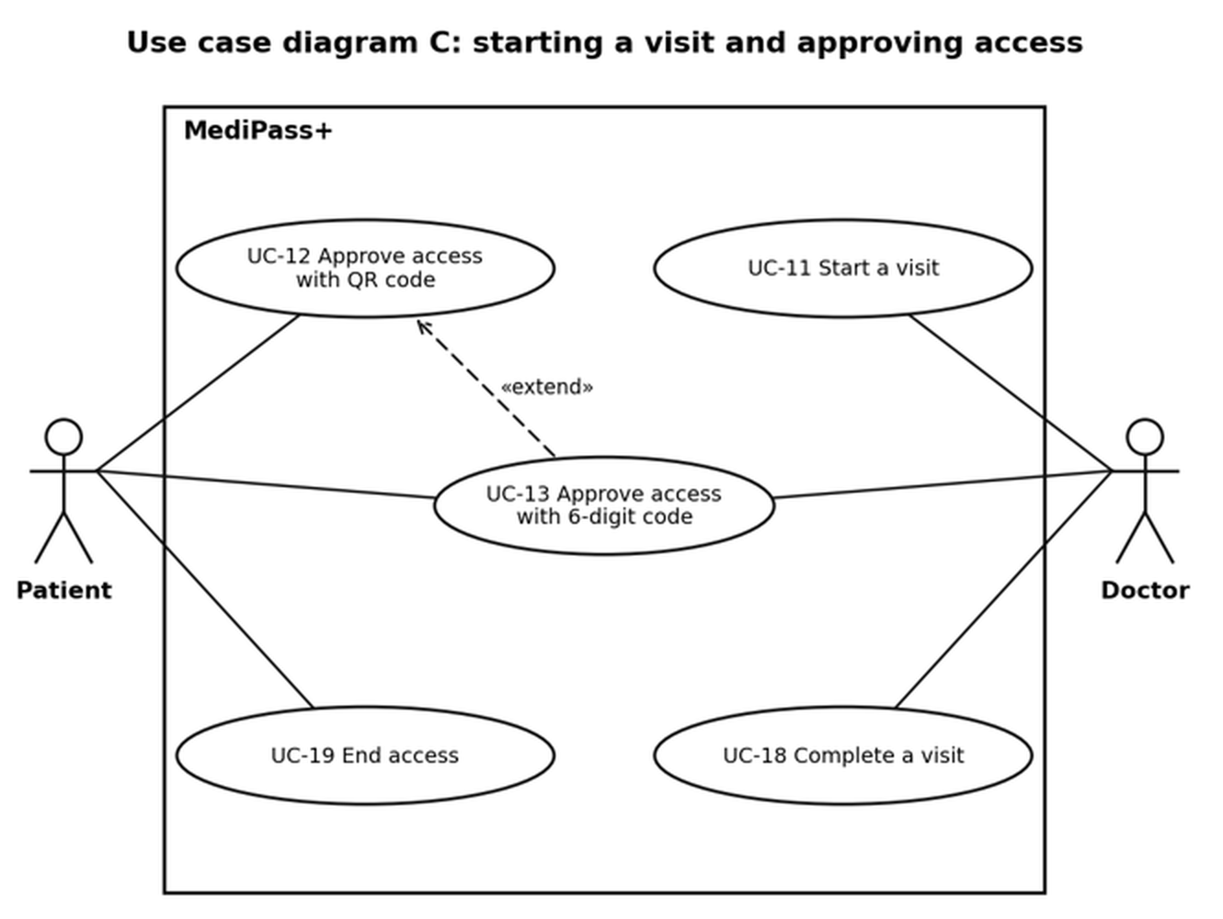
Figure 4. Use case diagram C: starting a visit and approving access. UC-13 extends UC-12.
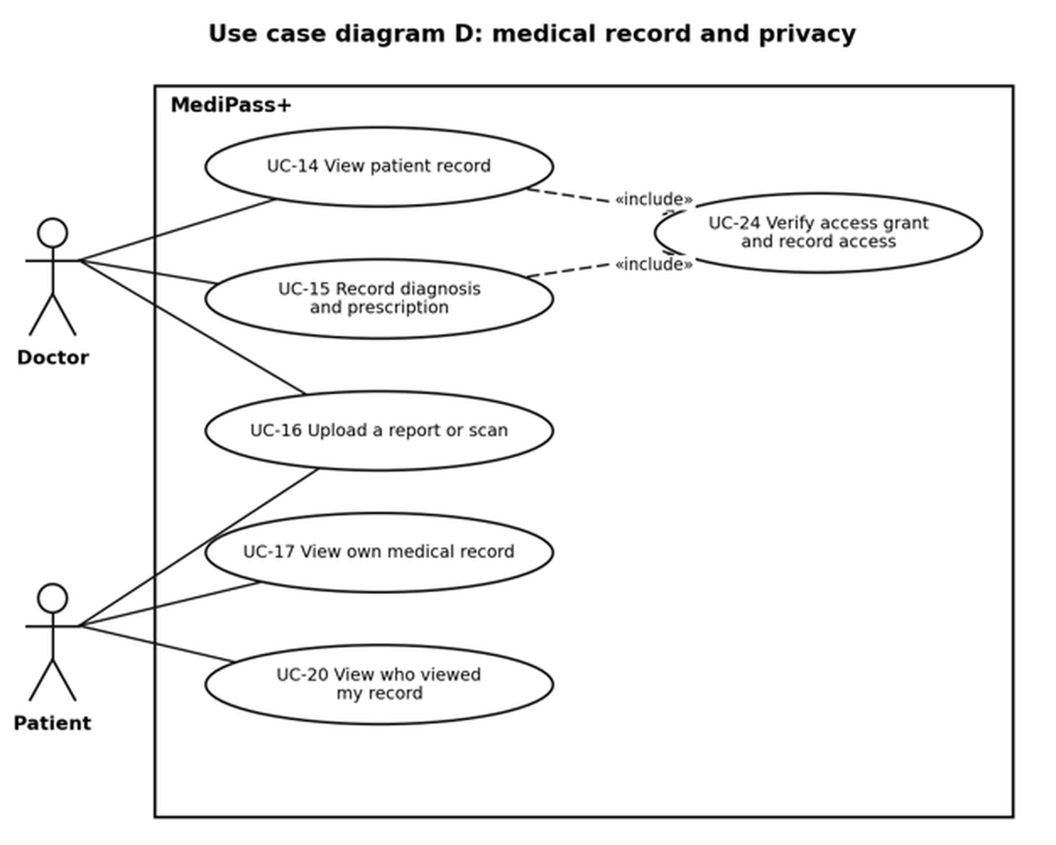
Figure 5. Use case diagram D: medical record and privacy. UC-14 and UC-15 include UC-24.

3.4 Use case catalogue
ID | Use case | Primary actor | User stories | Priority
UC-01 | Register | Patient | US-01 | Must
UC-02 | Log in and out | All registered users | US-02 | Must
UC-03 | Manage profile and password | All registered users | US-03, US-04 | Should
UC-04 | Search doctors and clinics | Patient | US-05 | Must
UC-05 | Book an appointment | Patient | US-06, US-07 | Must
UC-06 | Cancel or reschedule an appointment | Patient | US-08, US-09 | Must
UC-07 | Manage doctor slots | Clinic staff | US-12 | Must
UC-08 | Book an appointment for a patient | Clinic staff | US-13, US-15 | Must
UC-09 | Mark a patient as arrived | Clinic staff | US-14, US-15 | Must
UC-10 | View schedule and arrived patients | Doctor | US-10, US-11 | Must
UC-11 | Start a visit | Doctor | US-19 | Must
UC-12 | Approve access with QR code | Patient | US-20, US-21 | Must
UC-13 | Approve access with 6-digit code (extends UC-12) | Patient, Doctor | US-22, US-23 | Must
UC-14 | View patient record | Doctor | US-26 | Must
UC-15 | Record diagnosis and prescription | Doctor | US-27, US-28 | Must
UC-16 | Upload a report or scan | Patient, Doctor | US-29 | Must
UC-17 | View own medical record | Patient | US-30, US-31 | Must
UC-18 | Complete a visit | Doctor | US-25 | Must
UC-19 | End access | Patient | US-24 | Must
UC-20 | View who viewed my record | Patient | US-32 | Must
UC-21 | Manage clinics and accounts | Admin | US-16, US-17 | Must
UC-22 | View counts dashboard | Admin | US-18 | Should
UC-23 | Chat with doctor or clinic | Patient, Doctor, Clinic staff | US-35, US-36 | Could
UC-24 | Verify access grant and record access (included by UC-14 and UC-15) | System | US-26, US-33, US-34 | Must

3.5 Use case descriptions
The most important use cases are described in detail. They cover the login, the booking, the arrival of the patient, the whole access flow and the administration.

UC-02 Log in and out
Field | Description
Primary actor | Any registered user
Goal | Use my own account securely.
Preconditions | The account exists and is active.
Trigger | The user opens the login page.
Main flow | 1. The user enters email and password.  2. The system checks the credentials.  3. The system issues an access token and a refresh token.  4. The system opens the start page for the kind of user.
Alternative flows | A1. Wrong credentials: an error message is shown and the failed attempt is counted.  A2. Fifth failed attempt: the account is locked for a period.  A3. Account deactivated: login is refused with a message.
Postconditions | The user has an active session, or the account is locked.
Related requirements | FR-ACC-04, FR-ACC-05, FR-ACC-06, FR-PRV-07

UC-05 Book an appointment
Field | Description
Primary actor | Patient
Goal | Get a confirmed appointment with a doctor.
Preconditions | The patient is logged in and the doctor has free slots.
Trigger | The patient wants to see a doctor.
Main flow | 1. The patient searches for a doctor (UC-04).  2. The patient opens the doctor and sees the free slots.  3. The patient selects a slot and confirms.  4. The system marks the slot as booked and creates the appointment with status Booked.  5. The system shows a confirmation.
Alternative flows | A1. The slot was taken in the meantime: a message is shown and the list is refreshed.  A2. The slot is in the past or the doctor is inactive: the booking is refused.
Postconditions | The appointment exists with status Booked and the slot is unavailable.
Related requirements | FR-BKG-01, FR-BKG-02, FR-BKG-03, FR-BKG-09

UC-09 Mark a patient as arrived
Field | Description
Primary actor | Clinic staff
Goal | Tell the doctor that the patient is in the clinic.
Preconditions | Staff is logged in; the appointment is today, belongs to the staff's clinic and has status Booked.
Trigger | The patient arrives at the clinic.
Main flow | 1. Staff opens today's schedule of the clinic.  2. Staff selects the appointment.  3. Staff marks the patient as arrived.  4. The system sets the status to CheckedIn and shows it on the doctor's schedule.
Alternative flows | A1. The appointment is not today: the action is refused.  A2. The appointment belongs to another clinic: it is not visible and the request is refused.
Postconditions | The appointment has status CheckedIn.
Related requirements | FR-STF-03, FR-STF-04, FR-STF-05

UC-11 Start a visit
Field | Description
Primary actor | Doctor
Goal | Ask the patient for access to the medical record.
Preconditions | The doctor is logged in; the appointment is the doctor's own, today, with status CheckedIn.
Trigger | The patient is in front of the doctor.
Main flow | 1. The doctor opens the appointment and selects Start visit.  2. The system checks the appointment (own, today, CheckedIn).  3. The system creates an access request with a random token and stores only its hash. The token is valid for 2 minutes.  4. The system shows the QR code on the doctor's screen.  5. The doctor waits for the patient to approve.  6. When the patient has approved, the system shows Access granted and opens the record.
Alternative flows | A1. The QR code expires: the doctor starts again and gets a new code.  A2. The patient's camera does not work: continue with UC-13.  A3. The patient rejects the request: the doctor sees a message and no access is created.
Postconditions | An access request exists and, after approval, an access grant is active.
Related requirements | FR-ACS-01, FR-ACS-02

UC-12 Approve access with QR code
Field | Description
Primary actor | Patient
Goal | Allow my doctor to see my record for this visit only.
Preconditions | The patient is logged in on a phone and has an appointment that is in progress; the doctor shows a valid QR code.
Trigger | The doctor asks the patient to scan the QR code.
Main flow | 1. The patient opens Scan in the app and scans the QR code.  2. The system checks the token: not expired, not used, belongs to the patient's appointment.  3. The app shows: Allow Dr. X to see your record for this visit?  4. The patient taps Approve.  5. The system creates the access grant, marks the token as used and writes an audit entry.  6. The app shows that access was approved.
Alternative flows | A1. The token is invalid or expired: an error is shown and the doctor starts again.  A2. The patient taps Reject: no grant is created and the rejection is written to the audit log.  A3. The token belongs to another patient: the request is refused.
Postconditions | An access grant is active for this doctor, this patient and this appointment.
Related requirements | FR-ACS-03, FR-ACS-04, FR-ACS-06

UC-13 Approve access with 6-digit code
Field | Description
Primary actor | Patient, Doctor
Goal | Give access when the QR code cannot be scanned (extends UC-12).
Preconditions | The doctor has started the visit; scanning is not possible.
Trigger | The patient selects Show code.
Main flow | 1. The patient selects Show code in the app.  2. The system generates a 6-digit code, valid for 5 minutes, and stores only its hash.  3. The patient tells the code to the doctor.  4. The doctor enters the code.  5. The system checks the code.  6. The system creates the access grant and writes an audit entry.
Alternative flows | A1. Wrong code: the attempt counter increases.  A2. Five wrong attempts: the code is locked and the patient must request a new one.  A3. The code has expired: the patient requests a new one.
Postconditions | An access grant is active.
Related requirements | FR-ACS-05

UC-14 View patient record
Field | Description
Primary actor | Doctor
Goal | See the full medical history during the visit.
Preconditions | An active access grant exists for this doctor and appointment.
Trigger | The doctor opens Medical history.
Main flow | 1. The doctor opens Medical history.  2. The system verifies the access grant (UC-24).  3. The system loads the diagnoses, prescriptions and reports of all earlier visits and decrypts the text.  4. The system writes an audit entry.  5. The system shows the history, newest first, with paging.
Alternative flows | A1. No grant, or the grant has ended or expired: the request is refused (403) and no data is returned.
Postconditions | The access is recorded in the audit log.
Related requirements | FR-REC-02, FR-PRV-01, FR-PRV-02

UC-15 Record diagnosis and prescription
Field | Description
Primary actor | Doctor
Goal | Add the result of the visit to the permanent history.
Preconditions | An active access grant exists.
Trigger | The doctor finishes the examination.
Main flow | 1. The doctor selects Add diagnosis and enters the description.  2. The doctor adds one or more prescriptions (medicine name, dose, notes).  3. The doctor saves.  4. The system verifies the grant (UC-24), encrypts the text, stores it with the appointment and writes an audit entry.
Alternative flows | A1. The grant ended while the doctor was typing: nothing is saved and the doctor is told.  A2. Validation error: the fields with errors are marked.
Postconditions | The diagnosis and prescriptions are part of the permanent record.
Related requirements | FR-REC-03, FR-REC-04, FR-REC-09

UC-16 Upload a report or scan
Field | Description
Primary actor | Patient, Doctor
Goal | Store a report or scan with the medical history.
Preconditions | A patient is logged in, or a doctor has an active grant.
Trigger | The user selects Upload.
Main flow | 1. The user selects a file.  2. The system checks the type (PDF, JPEG, PNG) and the size (at most 10 MB).  3. For a doctor, the system verifies the grant (UC-24).  4. The system stores the file privately under a random name and links it to the record.  5. The system writes an audit entry.
Alternative flows | A1. Wrong type or too large: the upload is refused with a message.
Postconditions | The report is part of the medical record.
Related requirements | FR-REC-05, FR-REC-06

UC-18 Complete a visit
Field | Description
Primary actor | Doctor
Goal | Close the visit and let the access end.
Preconditions | The visit is in progress.
Trigger | The doctor has finished.
Main flow | 1. The doctor selects Complete visit.  2. The system sets the appointment status to Completed.  3. The system sets the end of the access grant to 15 minutes from now.  4. The system shows a confirmation.
Alternative flows | A1. The doctor forgets to complete the visit: the grant ends after 2 hours at the latest.
Postconditions | The appointment is Completed and the access will end.
Related requirements | FR-ACS-07, FR-ACS-08

UC-19 End access
Field | Description
Primary actor | Patient
Goal | Stop a doctor's access at once.
Preconditions | An access grant is active.
Trigger | The patient decides to end the access.
Main flow | 1. The patient opens the current access.  2. The patient selects End access.  3. The system ends the grant immediately with the reason PatientEnded.  4. The system writes an audit entry.  5. The next request of the doctor is refused.
Alternative flows | A1. The grant has already ended: the app shows that no access is active.
Postconditions | The grant is ended.
Related requirements | FR-ACS-09

UC-20 View who viewed my record
Field | Description
Primary actor | Patient
Goal | Check who accessed my record.
Preconditions | The patient is logged in.
Trigger | The patient opens Who viewed my record.
Main flow | 1. The patient opens the page.  2. The system loads the audit entries of the patient's own record.  3. The system shows user, action and time, newest first, with paging.
Alternative flows | A1. There are no entries yet: a message says so.
Postconditions | None.
Related requirements | FR-PRV-03

UC-21 Manage clinics and accounts
Field | Description
Primary actor | Admin
Goal | Prepare clinics and control who can use the system.
Preconditions | The admin is logged in.
Trigger | The admin opens Administration.
Main flow | 1. The admin chooses an action: create a clinic, create a doctor account, create a staff account, or deactivate or reactivate an account.  2. The admin enters the data.  3. The system validates and saves.  4. The system shows a confirmation.
Alternative flows | A1. Email already used: an error is shown.  A2. The admin tries to deactivate their own account: refused.
Postconditions | The clinic or account is created or its state is changed.
Related requirements | FR-STF-06, FR-STF-07

UC-24 Verify access grant and record access
Field | Description
Primary actor | System (included by UC-14 and UC-15)
Goal | Make sure only a doctor with an active grant reaches medical data.
Preconditions | A request arrives at a medical endpoint.
Trigger | Every request to a medical endpoint.
Main flow | 1. The system identifies the doctor and the appointment.  2. The system looks up the access grant in the database.  3. The system checks that the grant is not ended, not expired and not older than 2 hours.  4. The system allows the request.  5. The system writes an audit entry.
Alternative flows | A1. The grant is missing, ended or expired: the request is refused with 403.
Postconditions | The access is allowed and recorded, or refused.
Related requirements | FR-PRV-01, FR-PRV-02, FR-ACS-10

4. Functional requirements
Each requirement refers to the user story or use case it comes from, so that every story can be traced to a requirement.

4.1 Accounts and login (ACC)
ID | Requirement | Priority | Source
FR-ACC-01 | The system shall allow a person to register as a patient with name, email, phone and password. | Must | US-01, UC-01
FR-ACC-02 | The system shall require a unique email and a password of at least 8 characters with a letter and a digit. | Must | US-01
FR-ACC-03 | The system shall support four kinds of user: patient, doctor, clinic staff and admin. Patients register themselves; the other accounts are created by an admin. | Must | US-01, US-16
FR-ACC-04 | The system shall authenticate users with email and password and issue a short-lived access token and a refresh token. | Must | US-02, UC-02
FR-ACC-05 | The system shall lock an account for a period after 5 consecutive failed logins. | Must | US-02
FR-ACC-06 | The system shall let users log out, which revokes the refresh token. | Must | US-02
FR-ACC-07 | The system shall let users view and edit their profile. | Should | US-03, UC-03
FR-ACC-08 | The system shall let users change their password after entering the current password. | Should | US-04, UC-03
FR-ACC-09 | The system shall enforce role-based authorization on the server for every endpoint. | Must | US-34
FR-ACC-10 | The system shall store passwords only as salted hashes. | Must | US-02
FR-ACC-11 | The system should offer email confirmation and password reset by email. | Could | US-02

4.2 Clinics and booking (BKG)
ID | Requirement | Priority | Source
FR-BKG-01 | The system shall let patients search clinics and doctors by specialty and name, with paging. | Must | US-05, UC-04
FR-BKG-02 | The system shall show the free future slots of a doctor. | Must | US-06
FR-BKG-03 | The system shall let a patient book a free slot and shall make the slot unavailable at once. Two bookings of the same slot shall be impossible. | Must | US-07, UC-05
FR-BKG-04 | The system shall let a patient cancel an appointment before it starts and shall free the slot again. | Must | US-08, UC-06
FR-BKG-05 | The system shall let a patient reschedule an appointment to another free slot. | Should | US-08, UC-06
FR-BKG-06 | The system shall show a patient their upcoming and past appointments with status. | Must | US-09
FR-BKG-07 | The system shall show a doctor their schedule and the patients who have arrived. | Must | US-10, US-11, UC-10
FR-BKG-08 | The system shall manage the appointment status (Booked, CheckedIn, InVisit, Completed, Cancelled) and shall allow only valid transitions. | Must | US-14, US-19
FR-BKG-09 | The system shall refuse bookings of past slots and of slots of inactive doctors. | Should | US-07

4.3 Clinic staff and admin (STF)
ID | Requirement | Priority | Source
FR-STF-01 | The system shall let clinic staff create and remove time slots of the doctors of their own clinic. Slots of one doctor shall not overlap. | Must | US-12, UC-07
FR-STF-02 | The system shall let clinic staff book an appointment for a patient. | Must | US-13, UC-08
FR-STF-03 | The system shall let clinic staff mark a patient as arrived on the day of the appointment (status CheckedIn). | Must | US-14, UC-09
FR-STF-04 | The system shall return to clinic staff only the patient's name, phone, appointment time and status. | Must | US-15
FR-STF-05 | The system shall limit clinic staff to the data of their own clinic. | Must | US-12
FR-STF-06 | The system shall let an admin create clinics, doctor accounts and staff accounts. | Must | US-16, UC-21
FR-STF-07 | The system shall let an admin deactivate and reactivate accounts. Deactivated users shall not be able to log in. | Must | US-17, UC-21
FR-STF-08 | The system shall show an admin a dashboard with the number of users per type, clinics and appointments per status. | Should | US-18, UC-22
FR-STF-09 | The system shall give an admin no access to medical data. | Must | US-34

4.4 Visit access (ACS)
ID | Requirement | Priority | Source
FR-ACS-01 | The system shall let a doctor start a visit only for their own appointment that is today and has status CheckedIn. | Must | US-19, UC-11
FR-ACS-02 | The system shall create a QR code that contains a random 128-bit token. The token shall be valid for 2 minutes, usable once and tied to one appointment and one doctor. Only its hash shall be stored. | Must | US-19, UC-11
FR-ACS-03 | The system shall let a logged-in patient scan the QR code and shall show the doctor's name and ask for approval. | Must | US-20, UC-12
FR-ACS-04 | The system shall create an access grant when the patient approves and shall create none when the patient rejects. | Must | US-20, US-21, UC-12
FR-ACS-05 | The system shall offer a 6-digit code as a fallback. The patient requests the code in the app, it is valid for 5 minutes, the doctor enters it, and it is locked after 5 wrong attempts. | Must | US-22, US-23, UC-13
FR-ACS-06 | The system shall tie every access grant to one doctor, one patient and one appointment. | Must | US-20
FR-ACS-07 | The system shall end an access grant when the visit is completed (after at most 15 minutes), after 2 hours at the latest, or when the patient ends it. | Must | US-24, US-25, UC-18, UC-19
FR-ACS-08 | The system shall let a doctor complete a visit, which sets the status to Completed. | Must | US-25, UC-18
FR-ACS-09 | The system shall let a patient end an access at any moment, with immediate effect. | Must | US-24, UC-19
FR-ACS-10 | The system shall give doctors no way to list or search patients. A record can be reached only through an appointment. | Must | US-26, UC-24
FR-ACS-11 | The system shall require a new approval for every visit. An ended grant shall never be reused. | Must | US-25

4.5 Medical record (REC)
ID | Requirement | Priority | Source
FR-REC-01 | The system shall create one medical record for each patient when the patient registers. | Must | US-01
FR-REC-02 | The system shall show a doctor with an active grant the complete history (diagnoses, prescriptions, reports) from all earlier visits and doctors, with paging. | Must | US-26, UC-14
FR-REC-03 | The system shall let a doctor with an active grant record a diagnosis for the current appointment. | Must | US-27, UC-15
FR-REC-04 | The system shall let a doctor add one or more prescriptions to a diagnosis, each with medicine name, dose and optional notes. | Must | US-28, UC-15
FR-REC-05 | The system shall let a patient, and a doctor with an active grant, upload reports and scans as PDF, JPEG or PNG up to 10 MB. | Must | US-29, UC-16
FR-REC-06 | The system shall check the type and size of every uploaded file and store it privately under a random name. | Must | US-29
FR-REC-07 | The system shall let a patient see their complete history at any time. | Must | US-30, UC-17
FR-REC-08 | The system shall let a patient download their own reports, and a doctor open reports only with an active grant. | Should | US-31
FR-REC-09 | The system shall keep diagnoses and prescriptions permanently. Entries shall not be deleted; corrections are added as new entries. | Should | US-27
FR-REC-10 | The system shall refuse every read or write of medical data by a doctor whose grant has ended. | Must | US-24, US-26

4.6 Privacy and audit (PRV)
ID | Requirement | Priority | Source
FR-PRV-01 | The system shall check in the database, on every request to a medical endpoint, that an active access grant exists. | Must | US-26, US-34, UC-24
FR-PRV-02 | The system shall write an audit entry for every read and write of medical data (user, patient, action, data type, time, IP address). | Must | US-32, UC-24
FR-PRV-03 | The system shall let a patient see the audit entries of their own record, newest first, with paging. | Must | US-32, UC-20
FR-PRV-04 | The system shall store the diagnosis text encrypted. | Must | US-33
FR-PRV-05 | The system shall serve report files only through an endpoint that checks ownership or an active grant. There shall be no public file links. | Must | US-31, US-34
FR-PRV-06 | The system shall refuse every request of clinic staff and admin accounts to a medical endpoint. | Must | US-34
FR-PRV-07 | The system shall limit the rate of login attempts, QR scans and code entries. | Must | US-02, US-22
FR-PRV-08 | The system shall not write medical content into logs. Logs shall contain identifiers only. | Should | US-33

4.7 Chat (CHT), stretch
ID | Requirement | Priority | Source
FR-CHT-01 | The system shall let a patient start a conversation with a doctor (only if an appointment exists) or with the clinic inbox. | Could | US-35, UC-23
FR-CHT-02 | The system shall deliver messages in real time and keep the conversation history. | Could | US-35
FR-CHT-03 | The system shall let clinic staff read and answer the clinic inbox. | Could | US-36
FR-CHT-04 | The clinic inbox shall accept text only and shall warn patients not to send medical information. | Could | US-36
FR-CHT-05 | The system shall make a doctor conversation visible only to the doctor and the patient. | Could | US-35

5. Non-functional requirements
The measures are the values we check at the end of the project. They are consistent with the KPIs in the Project Planning and Management document.

5.1 Performance (PRF)
ID | Requirement | Measure | Verification
NFR-PRF-01 | Read endpoints (search, history) shall respond quickly. | 95% of requests under 300 ms with 20 concurrent users. | Load script, Postman
NFR-PRF-02 | Write endpoints (booking, diagnosis) shall respond quickly. | 95% of requests under 500 ms with 20 concurrent users. | Load script, Postman
NFR-PRF-03 | The visit approval shall be fast. | From Start visit to the doctor having access in under 30 seconds. | Timed demo
NFR-PRF-04 | Lists shall be paged. | Default page size 20, maximum 50. | Inspection, API tests
NFR-PRF-05 | The system shall handle the expected load of the demo. | At least 20 users at the same time without errors. | Load script

5.2 Security (SEC)
ID | Requirement | Measure | Verification
NFR-SEC-01 | All communication shall be encrypted. | HTTPS only; no plain HTTP in the demo environment. | Inspection
NFR-SEC-02 | Passwords shall be protected. | Salted hash with ASP.NET Core Identity; no plain text anywhere. | Code review, database check
NFR-SEC-03 | Tokens shall be short-lived. | Access tokens expire after 15 minutes; refresh tokens have a limited lifetime and can be revoked. | Unit and integration tests
NFR-SEC-04 | QR tokens and codes shall be unguessable and not stored in clear. | Cryptographically secure random values; only hashes stored. | Code review, unit tests
NFR-SEC-05 | Diagnosis text shall be encrypted at rest. | Encrypted with Data Protection; keys stored outside the repository. | Database query, inspection
NFR-SEC-06 | Input shall be validated and queries shall be safe. | Validation on every write endpoint; parameterised queries only. | Unit tests, code review
NFR-SEC-07 | Browser access shall be restricted. | CORS limited to the Angular origin; security headers set. | Inspection
NFR-SEC-08 | Secrets shall never be in source control. | 0 secrets found by a repository scan before the code submission. | Repository scan
NFR-SEC-09 | File uploads shall be restricted. | Allowed types PDF, JPEG, PNG; at most 10 MB; random stored names. | Integration tests
NFR-SEC-10 | Every medical endpoint shall be protected by role and grant checks. | 100% of medical endpoints have a negative test. | Authorization test suite
NFR-SEC-11 | The system shall resist common web attacks. | 0 critical findings in the OWASP Top 10 self-review. | Checklist review

5.3 Privacy (PRI)
ID | Requirement | Measure | Verification
NFR-PRI-01 | Medical data shall be visible only to the patient and, during an active grant, to the doctor. | 0 successful requests without a grant in the tests. | Authorization test suite
NFR-PRI-02 | Access shall be limited in time. | A grant ends at most 15 minutes after the visit is completed and never lasts more than 2 hours. | Integration tests
NFR-PRI-03 | The audit log shall not be changeable by users. | No endpoint modifies or deletes audit entries. | Inspection, API tests
NFR-PRI-04 | The system shall use data minimisation. | Staff screens show only name, phone, time and status; logs contain identifiers only. | Inspection
NFR-PRI-05 | Patients shall be able to see all access to their record. | 100% of reads and writes appear in Who viewed my record. | Audit log checks in the tests

5.4 Usability (USA)
ID | Requirement | Measure | Verification
NFR-USA-01 | The interface shall be responsive. | Works from 360 px screen width upwards on current mobile and desktop browsers. | Manual test on devices
NFR-USA-02 | Registering and booking shall be easy. | A new patient registers and books in under 3 minutes without help in the pilot. | Pilot observation
NFR-USA-03 | Approving access shall be simple for the patient. | At most 3 taps from the QR scan to the approval. | Inspection, demo
NFR-USA-04 | Messages shall be clear. | Plain-language error messages; validation message next to the field. | Inspection
NFR-USA-05 | Patients shall find the privacy functions. | 90% of pilot testers find Who viewed my record and end an access without help. | Pilot observation
NFR-USA-06 | The interface shall follow basic accessibility rules. | Labelled form fields, sufficient colour contrast, keyboard navigation. | Checklist review
NFR-USA-07 | The interface language shall be English. | All screens and messages in English. | Inspection

5.5 Reliability and availability (REL)
ID | Requirement | Measure | Verification
NFR-REL-01 | The system shall be available when needed. | Uptime of 99% or more during test and demo windows. | Health check monitoring
NFR-REL-02 | The system shall be free of server errors in normal use. | HTTP 5xx under 1% of requests. | Serilog logs
NFR-REL-03 | State changes shall be consistent. | Booking, grant creation and grant ending are transactional; a slot cannot be booked twice (unique constraint). | Concurrency and integration tests
NFR-REL-04 | Errors shall be handled in one place. | Consistent error format; no stack traces to users. | Inspection, API tests
NFR-REL-05 | Data shall be protected against loss. | A database backup before every release and every migration. | Checklist
NFR-REL-06 | The system shall expose its health. | A /health endpoint reports the state of the API and the database. | Demo

5.6 Maintainability and compatibility (MNT)
ID | Requirement | Measure | Verification
NFR-MNT-01 | The code shall be layered. | Separate Domain, Application, Infrastructure and API projects; no dependency from Domain on other layers. | Code review
NFR-MNT-02 | The core logic shall be tested. | Unit test coverage of 50% or more in the Domain and Application layers. | Coverage report
NFR-MNT-03 | The API shall be documented. | Every endpoint documented in Swagger/OpenAPI, including the JWT scheme. | Inspection
NFR-MNT-04 | Changes shall be checked automatically. | Build and tests run on every pull request; main always builds; every merge reviewed. | GitHub Actions history
NFR-MNT-05 | The system shall be portable. | Runs locally and in Docker; configuration through environment variables. | Demo
NFR-MNT-06 | The web app shall work in current browsers. | Latest two versions of Chrome, Edge and Firefox; Chrome on Android and Safari on iOS for QR scanning (camera needs HTTPS). | Manual test

6. Traceability
The table links each module to its user stories, use cases and requirements. The Source column of each functional requirement gives the exact story or use case.
Module | User stories | Use cases | Functional requirements | Main non-functional requirements
Accounts and login | US-01 to US-04 | UC-01 to UC-03 | FR-ACC-01 to 11 | NFR-SEC-02, 03; NFR-USA-02
Clinics and booking | US-05 to US-11 | UC-04 to UC-06, UC-10 | FR-BKG-01 to 09 | NFR-PRF-01, 02, 04; NFR-REL-03
Clinic staff and admin | US-12 to US-18 | UC-07 to UC-09, UC-21, UC-22 | FR-STF-01 to 09 | NFR-SEC-10; NFR-PRI-04
Visit access | US-19 to US-25 | UC-11 to UC-13, UC-18, UC-19 | FR-ACS-01 to 11 | NFR-SEC-04; NFR-PRI-02; NFR-PRF-03
Medical record | US-26 to US-31 | UC-14 to UC-17 | FR-REC-01 to 10 | NFR-SEC-05, 09; NFR-PRI-01
Privacy and audit | US-32 to US-34 | UC-20, UC-24 | FR-PRV-01 to 08 | NFR-SEC-01 to 11; NFR-PRI-03, 05
Chat (stretch) | US-35, US-36 | UC-23 | FR-CHT-01 to 05 | NFR-PRF-01

