GRADUATION PROJECT
MediPass+
Project Planning and Management
Patient history, privacy and controlled access
Project details
Track | DEPI, Full Stack .NET
Way of working | Agile Scrum with one-week sprints, tracked in Jira
Repository | https://github.com/MediPass-Plus/MediPassPlus
Technology | ASP.NET Core Web API, EF Core, SQL Server, Angular

Team
# | Name
1 | Waleed Ahmed Korashy Abdo (Team Leader)
2 | Ahmed Gamal Khairy Hassan
3 | Azza Ibrahim Ali Shaban
4 | Nagham Ahmed Elsayed Elsorady
5 | Arwa Mahmoud Sayed Hussien
6 | Hend Abdelnaser Rashad Elsadany

1. Project proposal

1.1 Overview
MediPass+ is a web platform that keeps a patient's medical history in one place and keeps it private. A patient books a doctor. When they arrive, the doctor starts the visit and the patient approves access on their own phone by scanning a QR code. Only then can the doctor see the patient's history, and only for that visit. When the visit ends, the doctor's access ends too. The patient can always see their own history, can see who looked at it and when, and can end a doctor's access at any moment.
The idea was inspired by two early concepts our team explored, a clinic verification system and a pharmacy finder, and was developed into a platform focused on the privacy of the patient history. The main effort goes into the back end (ASP.NET Core), with a simple Angular frontend on top.

1.2 The problem
- Doctors often see a patient without knowing what happened in earlier visits. Past diagnoses, prescriptions and lab reports sit on paper or with another doctor.
- A medical history is some of the most sensitive data a person has. With paper files or shared spreadsheets, anyone in the clinic can open it, and nobody can say who looked at it.
- Clinics need staff to handle the schedule, but those staff should not be able to read patients' medical data.

1.3 Objectives
- Build a secure ASP.NET Core backend with a clean structure that we can explain and defend in front of the instructor.
- Make sure a doctor can open a patient's record only during a visit the patient approved, and not afterwards.
- Keep one permanent medical history per patient, shared across doctors and visits.
- Give the patient control and visibility: a list of who viewed the record, and a way to end access.
- Have the whole flow working by the deadline: book, approve by QR, diagnose, view, end access.

1.4 Scope

Scope of the system
Items marked as stretch are the first ones we drop if we fall behind.
Module | Must have | Stretch
Accounts and login | Registration and login, short-lived JWT access tokens with refresh tokens, four kinds of user with server-side checks, hashed passwords, account lockout | Email confirmation and password reset by email (the email can be written to the log instead of sent)
Clinics and booking | Clinics, doctors, doctor time slots, booking, cancelling and rescheduling. Clinic staff manage slots, book for patients and mark arrivals | A calendar view for doctors
Visit access (the privacy core) | Doctor starts the visit and shows a QR code. The patient scans it with the app and approves. A 6-digit code works if the camera fails. The approval creates an access grant for that visit only. The grant ends when the visit is completed, when time runs out, or when the patient ends it | Notify the patient the moment a doctor asks for access
Medical record | While the grant is active the doctor sees the full history, adds a diagnosis and prescription (medicine name and dose as text), and uploads or views reports and scans. The patient sees their own history at any time | Search inside the history
Privacy layer | Audit log of every read and write, a "Who viewed my record" page for the patient, diagnosis text stored encrypted, reports served only through a checked endpoint, rate limiting on login and on QR and code attempts | Two-factor login for doctors
Admin | Manage clinics, doctors and staff accounts, activate or deactivate accounts, simple counts dashboard. The admin cannot see medical data | Charts
Chat | Nothing in the must-have list | Text chat between a patient and a doctor or the clinic inbox, only if everything else is done
Platform | Validation, error handling, logging, Swagger, CORS, paging, health check, automatic build and tests | Full integration tests, load testing

1.5 Users and who can see what
The system has four kinds of user. The main rule is that scheduling data and medical data are kept apart. Clinic staff run the schedule but can never open a medical record. The admin manages accounts but cannot open a medical record either.
Action | Patient | Clinic staff | Doctor | Admin
Search doctors, book, cancel, reschedule | Own | Own clinic
Manage doctor slots |  | Yes | Own
See patient name, phone, appointment time |  | Minimum only | Own appointments
Mark a patient as arrived |  | Yes
Start a visit and show the QR code |  |  | Yes
Scan the QR and approve access | Yes
View the medical history | Own, any time | No | Only while a grant is active | No
Add diagnosis and prescription |  | No | Only while a grant is active | No
Upload or open reports and scans | Own | No | Only while a grant is active | No
See who viewed the record | Own
End a doctor's access | Yes
Manage clinics, doctors, staff |  |  |  | Yes

Our decision on past diagnoses: once a visit is over, the doctor cannot see anything of that patient any more, not even the diagnoses they wrote themselves. Every visit needs a new approval. The patient always sees everything. The rule is simple to explain and simple to test.

1.6 How a doctor gets access
The QR code on its own does not protect anything. It only carries a message from the doctor's screen to the patient's phone. The protection comes from the access grant that the server creates after the patient approves, and that the server checks again on every request.
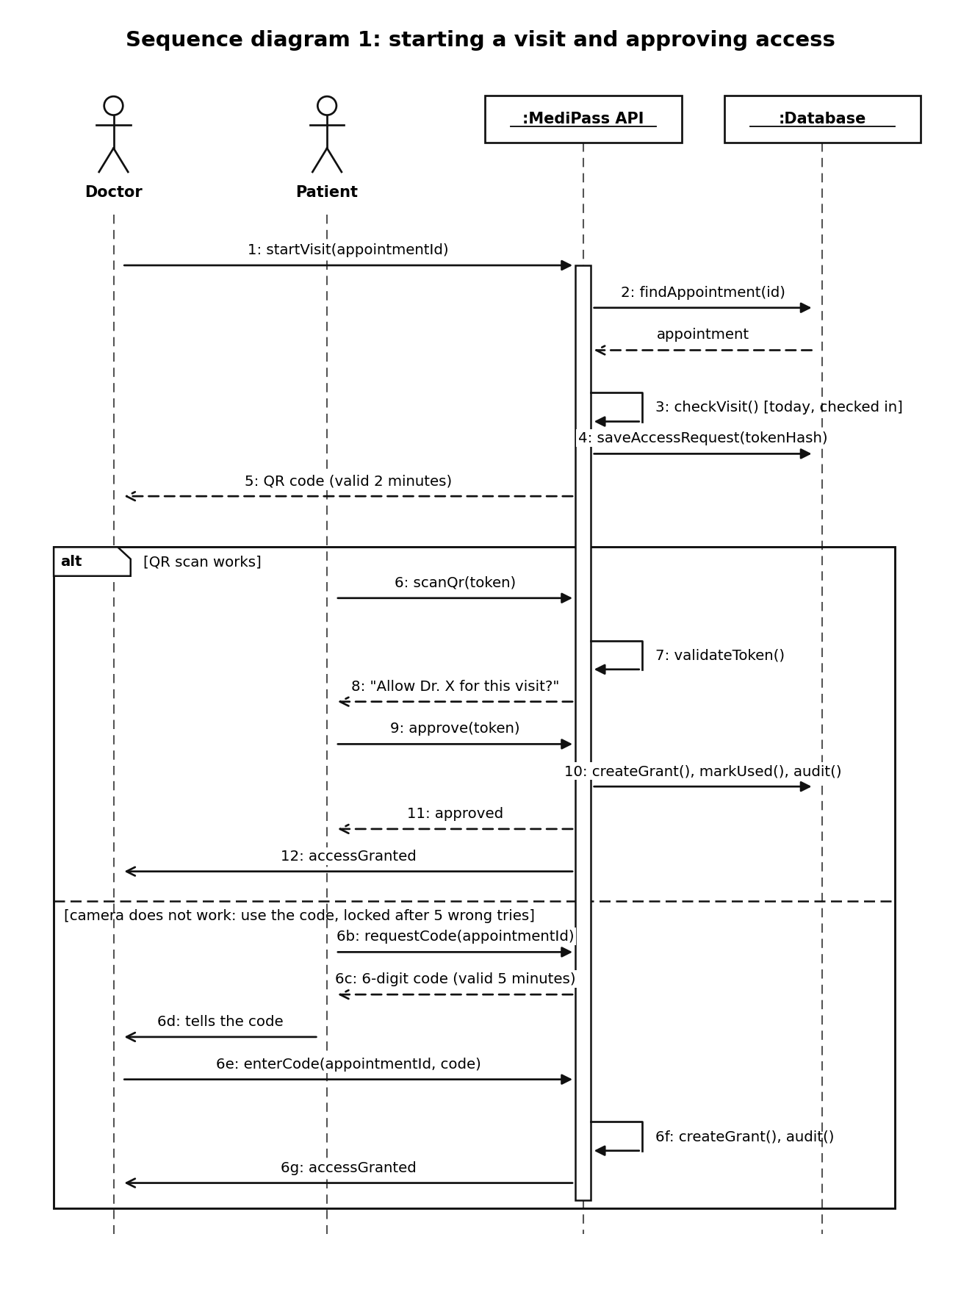
Figure 1. Sequence diagram: the doctor starts the visit and the patient approves access (QR code, with the 6-digit code as a fallback).
We chose to show the QR on the doctor's screen and scan it with the patient's phone, and not the other way round. The patient is already logged in on the phone, so the approval comes from their own account. They have to be in the room to scan it. Phone cameras scan far better than the webcams on clinic computers, and nobody has to type a code.
- QR token: random (128 bits), valid for 2 minutes, usable once, tied to one appointment and one doctor, and stored only as a hash.
- 6-digit code (fallback): the patient's app shows it and the doctor types it. It is valid for 5 minutes and is locked after 5 wrong tries.
- Access grant: one doctor, one patient, one appointment. It ends when the doctor marks the visit completed (plus 15 minutes to finish notes), after at most 2 hours, or when the patient ends it.
- Checked every time: every medical endpoint looks up the grant in the database. We do not trust a claim inside the token, so cutting off access works immediately.
- No searching: a doctor has no way to list or search patients. The only path to a record is through an appointment.
- Everything is recorded: each read and write goes into the audit log, and the patient can open that log.
- Files and text: reports are never public links. They are served by an endpoint that checks the grant. Diagnosis text is stored encrypted.
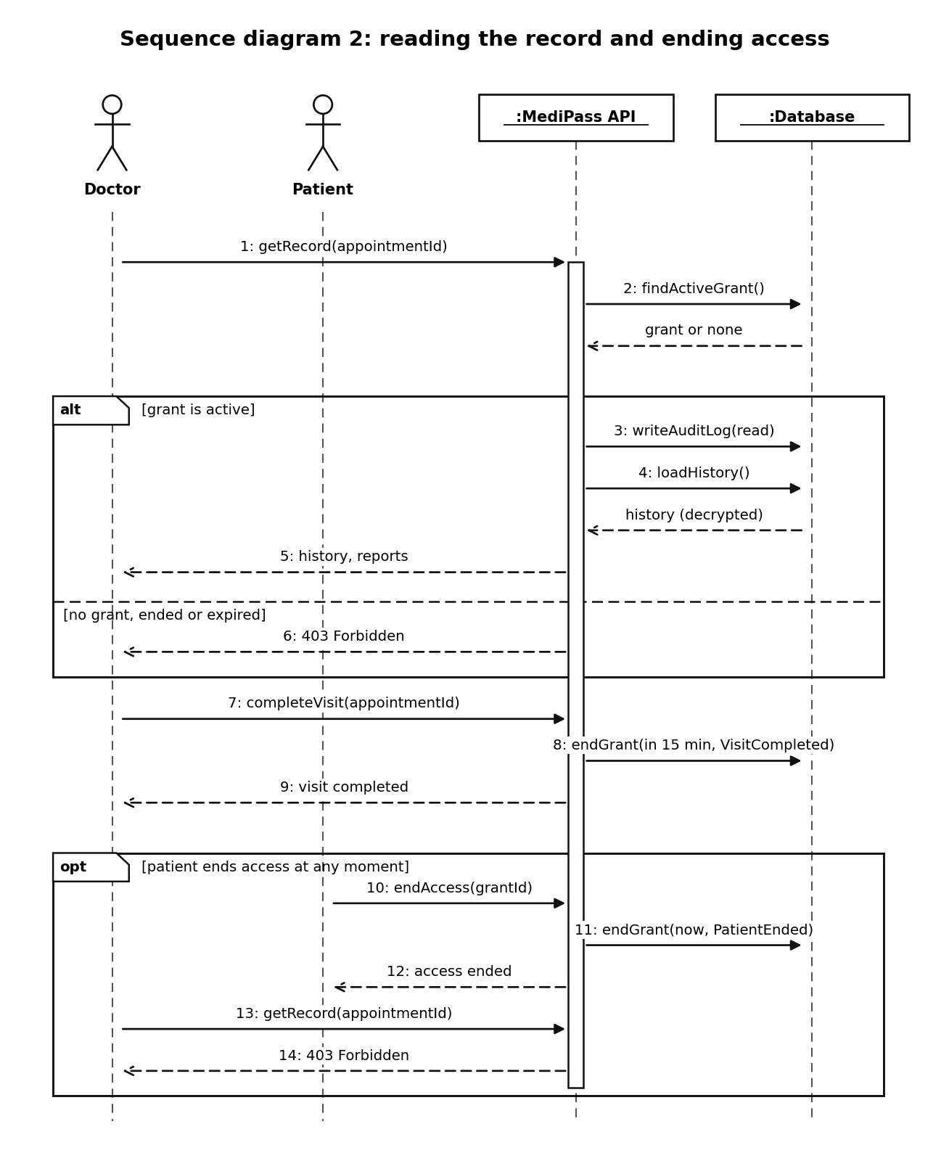
Figure 2. Sequence diagram: reading the record, completing the visit, and the patient ending access.
What this cannot do: it cannot stop a doctor from taking a screenshot or notes of what they were allowed to see, and it cannot protect against someone who controls the whole server. It limits access, records it and shows it to the patient. We will say this openly in the defense.

1.7 What makes the project strong
- The history is never lost. Every diagnosis, prescription and report is stored in one record per patient, so a new doctor sees earlier visits instead of starting from zero.
- The history is protected, not just stored. A doctor can open it only during a visit the patient approved, and clinic staff and admins never can.
- The patient is in control. They can see every access to their record and can end it.

1.8 Architecture and technology
We chose a modular monolith built in layers (Clean Architecture). It is one ASP.NET Core API, split into modules inside. Microservices would add security, messaging and deployment overhead that is not justified for a team of six within this schedule. A modular monolith keeps the code organised and can be split later.
- The privacy checks live in one place, the Application layer, and every medical endpoint goes through them. That is easier to test and easier to explain than checks spread over many controllers.
- All modules share one SQL Server database, with a separate schema for each: identity, clinical, access, records and audit.
Part | What we use
Backend | ASP.NET Core Web API (C#), EF Core, SQL Server
Login and access | ASP.NET Core Identity with JWT (access and refresh tokens) and policy-based authorization
Visit access | QRCoder to create the QR image on the server; a camera scanner library in Angular; random tokens stored as hashes
Encryption | ASP.NET Core Data Protection for diagnosis text; HTTPS everywhere
Frontend | Angular, responsive, kept simple. The phone camera needs HTTPS (or localhost) to work
Quality tools | Serilog, FluentValidation, xUnit, Swagger/OpenAPI, GitHub Actions
Hosting | Local or Docker for the demo. MonsterASP.NET free hosting only if it supports SQL Server and HTTPS

Basics every web application needs
- One place that handles errors, validation on every endpoint that writes data, and logging with correlation IDs but no medical content (only IDs).
- Swagger documentation with JWT, CORS limited to our Angular app, paging on every list, and a health check endpoint.
- EF Core migrations and a seed script in the repository, no secrets in the code, file type and size checks, and automatic tests on every pull request.

1.9 Component diagram
The UML component diagram below shows the main parts of the API and what they depend on. The medical record service never touches the database or the files directly. It goes through the access grant checker, the audit service, the encryption service, the file storage service and the data access component.
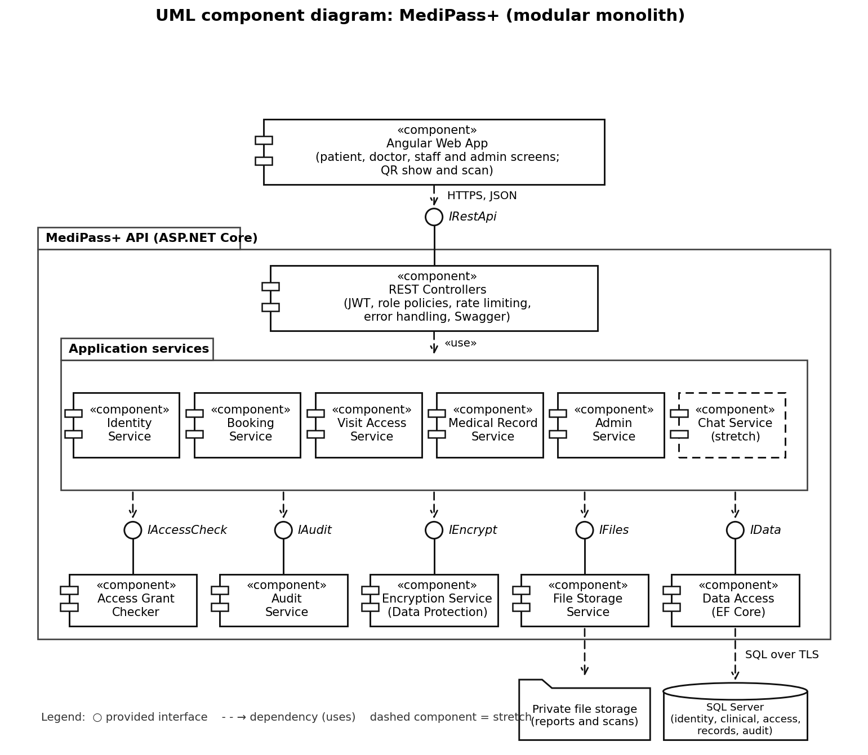
Figure 3. UML component diagram. Circles are provided interfaces, dashed arrows are dependencies, and the dashed component is a stretch item.

1.10 Class diagrams
We drew the classes in standard UML. Each class has three compartments: the name at the top, the attributes in the middle written as visibility name: type [multiplicity] = default, and the operations at the bottom written as visibility name(parameters): return type. A minus sign means private and a plus sign means public. Abstract classes have an italic name, and enumerations are marked with a stereotype. The hollow triangle is inheritance, the filled diamond is composition and the hollow diamond is aggregation.
Patient, Doctor, ClinicStaff and Admin inherit from the abstract class ApplicationUser, which holds the login data. Clinic staff have no association with any of the medical record classes. That missing link is what keeps medical data away from them. We split the diagram into three parts so it stays readable on paper. The complete diagram is also saved as one image file.

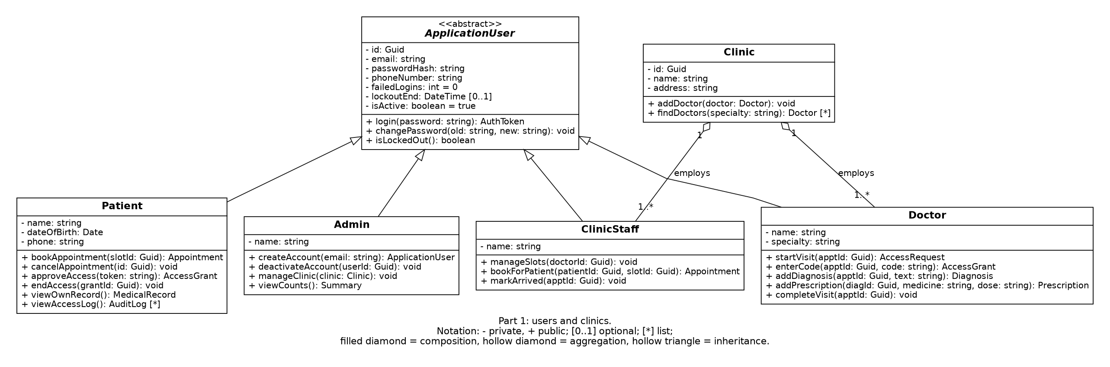
Figure 4. Class diagram, part 1: users and clinics.

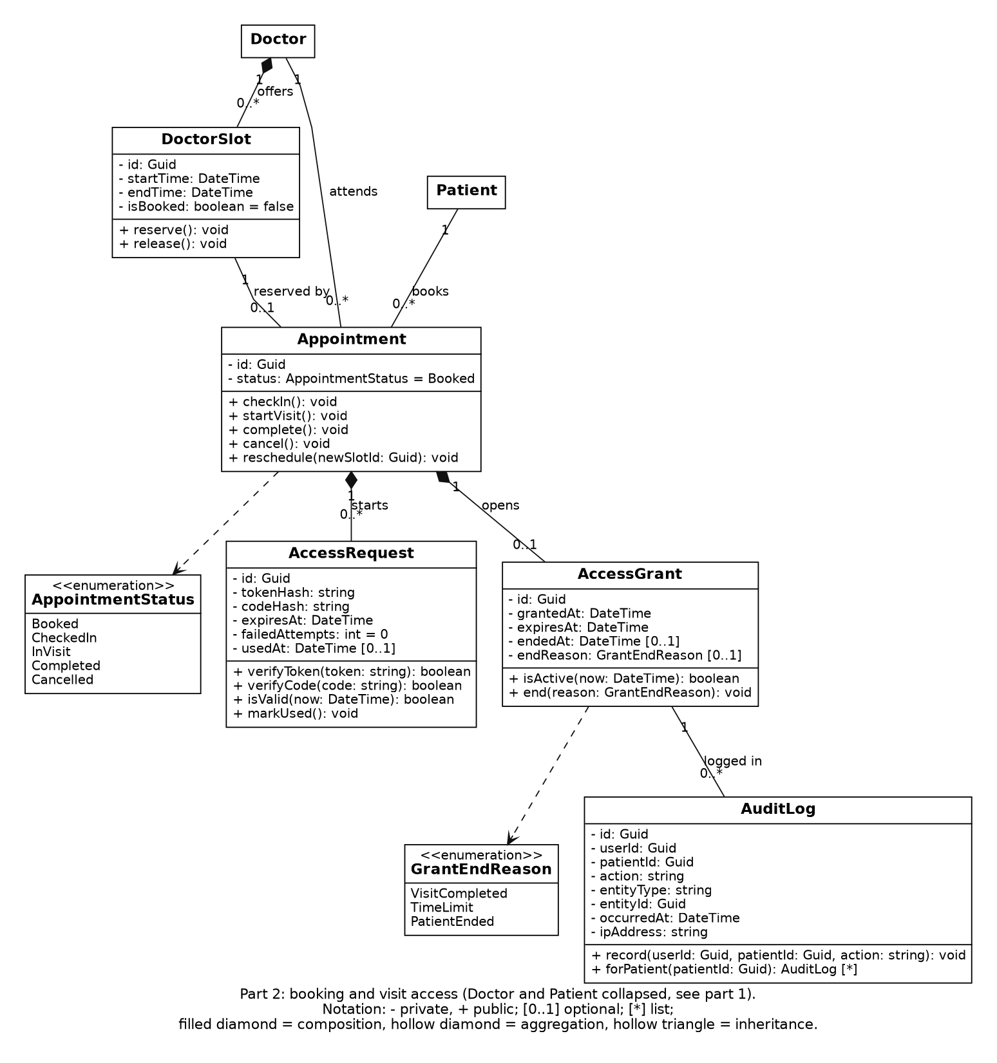
Figure 5. Class diagram, part 2: booking and visit access. Doctor and Patient are collapsed here, see part 1.
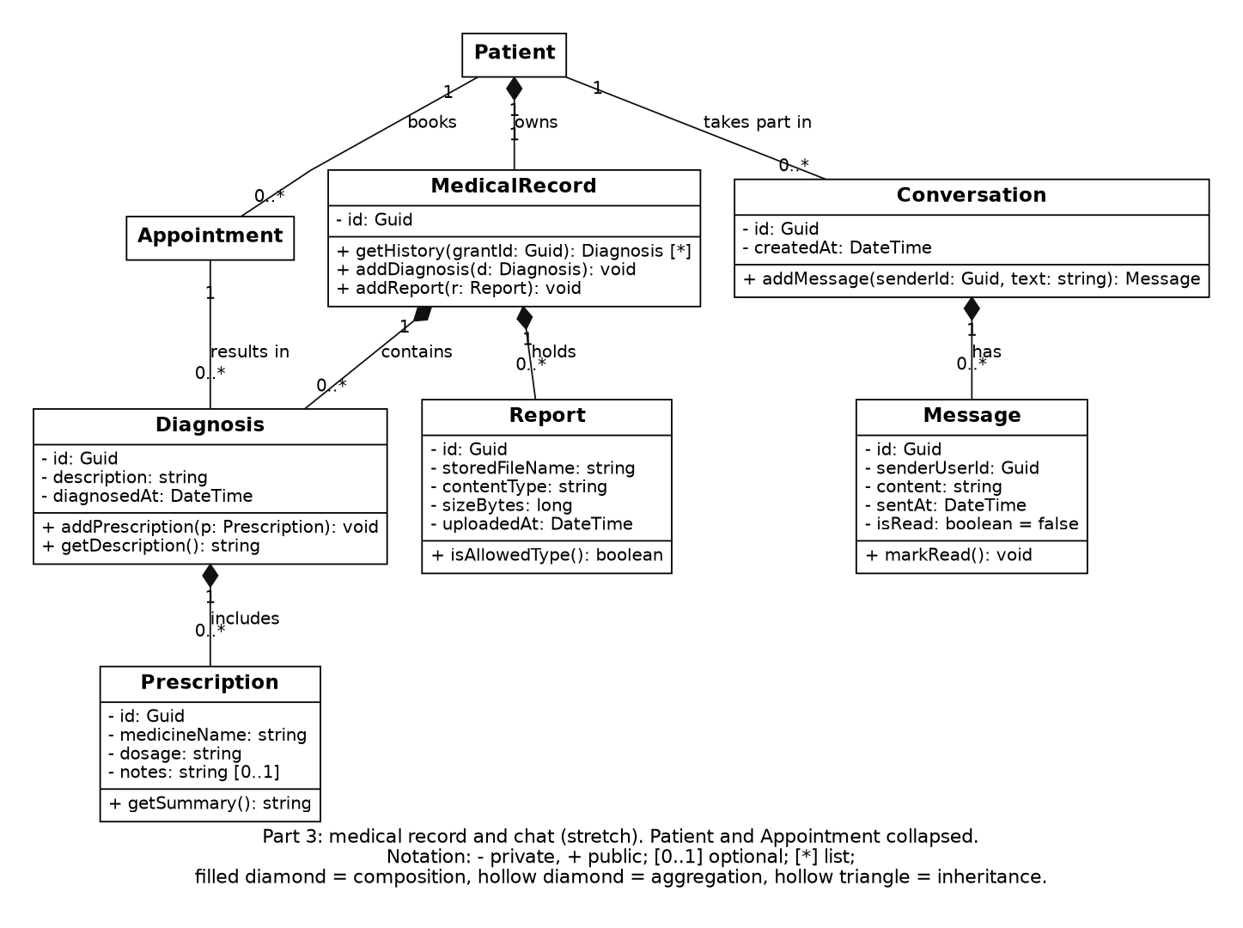
Figure 6. Class diagram, part 3: medical record and chat (stretch). Patient and Appointment are collapsed.

2. Project plan

2.1 Methodology
The project follows Agile Scrum with one-week sprints that run from Friday to Friday: 16 Oct, 23 Oct, 30 Oct, 6 Nov, 13 Nov, 20 Nov, 27 Nov and 4 Dec. Short sprints give early feedback on progress and problems. The work is tracked on a Jira Scrum board.

Planning principles
- Parallel module development. Each member owns one back-end module for the whole project, so all six modules progress in every sprint.
- Contract first. In Sprint 1 the team agrees the entities and the API contracts in Swagger. Until two modules are integrated they work against stubs of each other, and the real integration happens in Sprint 4.
- Core before extras. All must-have features are finished by 20 Nov. Sprint 6 (20 to 27 Nov) is reserved for testing and contingency, and stretch items are started only when every must-have item is done.

Sprint ceremonies
- Sprint planning on Friday, about 45 to 60 minutes: select stories, estimate them and write acceptance criteria.
- Daily standup: what I did, what I will do, and blockers. A written update in Jira or the group chat is accepted when a live call is not possible.
- Sprint review on Friday, about 30 minutes: each member demonstrates the working software of their module.
- Retrospective on Friday, about 20 minutes: what went well, what did not, and one improvement.
- Weekly technical sync, about 30 minutes: design questions, API contracts and code review.

Definition of done
A task is done when the reviewed pull request is merged, the build passes, the endpoint is documented in Swagger, the logic has unit tests, and the Jira ticket is moved to Done.

2.2 Sprint plan
Sprint | Dates | Goal | Expected result at the sprint review
Sprint 0 | 6 to 16 Oct | Planning, requirements and setup | Planning, Literature Review and Requirements documents submitted; Jira board and GitHub repository ready; technical design of every module
Sprint 1 | 16 to 23 Oct | Foundation | Solution structure, build pipeline, database schema and API contracts agreed; the first endpoints of every module; build passing
Sprint 2 | 23 to 30 Oct | Core endpoints | Login with roles; clinics, doctors, slots; staff and admin account management; QR token creation; diagnosis and prescription endpoints; audit log and access grant checker
Sprint 3 | 30 Oct to 6 Nov | Main flow per module | Booking; patient approval and access grant; history read; Who viewed my record; design documents submitted on 6 Nov
Sprint 4 | 6 to 13 Nov | Integration | Real access grant check in every medical endpoint; 6-digit code fallback; appointment status flow; report upload; encryption; Angular screens connected
Sprint 5 | 13 to 20 Nov | Privacy and completion | Grant ending rules, audit coverage, secure file access, rate limiting, admin counts. All must-have features finished
Sprint 6 | 20 to 27 Nov | Testing and contingency | Integration and security tests, bug fixing, anything that slipped; chat only if everything else is done
Sprint 7 | 27 Nov to 4 Dec | Delivery | Implementation submitted on 30 Nov; testing, deployment, user manual, presentation and practice demo; final submission on 4 Dec

2.3 Milestones
ID | Date | Milestone | Completion criteria
M1 | 16 Oct 2026 | Planning documents submitted | Project Planning and Management, Literature Review and Requirements Gathering uploaded to GitHub; Jira board and repository ready
M2 | 23 Oct 2026 | Foundation ready | Solution structure, schema and API contracts agreed; build pipeline passing; first endpoints of every module
M3 | 6 Nov 2026 | Design documents submitted | System Analysis and Design uploaded; the main flow of each module works against stubs; QR scanning tested on a phone
M4 | 20 Nov 2026 | Core features complete | Whole visit flow works end to end: book, approve with QR, diagnose, view, end access; all privacy features in place
M5 | 27 Nov 2026 | Testing complete | Integration and security tests pass; no open critical bugs
M6 | 30 Nov 2026 | Implementation submitted | Source code, README and deployment instructions or link uploaded
M7 | 4 Dec 2026 | Final delivery | Presentation, test reports, user manual and technical documentation submitted

2.4 Project deliverables
The deliverables follow the DEPI documentation guidelines. All of them are uploaded to the project's GitHub repository.
ID | Deliverable | Description | Due date | Format
D1 | Project Planning and Management | Project proposal, project plan with Gantt chart, task assignment and roles, risk assessment, KPIs | 16 Oct 2026 | Document
D2 | Literature Review | Feedback and evaluation, suggested improvements, final grading criteria | 16 Oct 2026 | Document
D3 | Requirements Gathering | Stakeholder analysis, user stories and use cases, functional and non-functional requirements | 16 Oct 2026 | Document
D4 | System Analysis and Design | Problem statement, use case, architecture, ERD and schema, DFD, sequence, activity, state and class diagrams, wireframes, UI guidelines, deployment and component diagrams | 6 Nov 2026 | Document with diagrams
D5 | Implementation | Source code in GitHub with branches and commit history, README, API documentation (Swagger), executable or deployment link | 30 Nov 2026 | Repository and deployment
D6 | Final Presentation, Testing and Reports | Test plan, test cases and bug reports, user manual, technical documentation, project presentation, optional demo video, project infographic | 4 Dec 2026 | Documents and presentation (PPT/PDF)

2.5 Resource allocation

Human resources
Resource | Allocation
Six team members | Equal share of the back-end work: one back-end module per member for the whole project (see Section 3.2)
Each member, in addition | The Angular screens, unit and integration tests, and documentation of their own module; peer review of one other module; participation in all sprint ceremonies
Shared final-week duties | Test plan, user manual, technical documentation, deployment, demo script and final presentation, one duty per member (see Section 3.3)

Tools and environments
Tool or environment | Purpose
Jira (Scrum board) | Backlog, sprints, task assignment, burndown and velocity
GitHub and GitHub Actions | Source control, pull requests, protected main branch, automatic build and tests
Visual Studio or VS Code, .NET SDK, Angular CLI | Development
SQL Server (Express, LocalDB or Docker) | Database
Swagger and Postman | API documentation and testing
draw.io or PlantUML, Figma | UML diagrams and wireframes
Local machine and Docker (hosted demo if the hosting plan supports SQL Server and HTTPS) | Demo environment

Effort distribution
Type of work | Share of effort
Back-end modules (accounts, clinic, visit access, record, privacy, admin) | about 50%
Angular frontend | about 15%
Documents and reports required by the guidelines | about 15%
Testing and security | about 15%
Planning and meetings | about 5%
Sprint capacity is calibrated after Sprint 1 from the measured velocity.

2.6 Version control and tracking
- The main branch is protected and must always build. Work happens on feature branches named feature/{module}-{jira-id}-{short-description}. Every merge needs a pull request, at least one approval and a passing build, and uses squash merge.
- At the end of each sprint main is tagged (sprint-1, sprint-2, and so on) to give a known point for rollback and demo.
- Commit messages start with the Jira ticket, for example: MP-14 add appointment booking endpoint.
- Jira epics: Accounts and Identity, Clinics and Booking, Clinic Staff and Admin, Visit Access, Medical Record, Privacy and Audit, Infrastructure, Testing and Documents. Workflow: Backlog, To Do, In Progress, In Review, Testing, Done. Labels: mvp, stretch, backend, frontend, security, docs.

2.7 Timeline (Gantt chart)
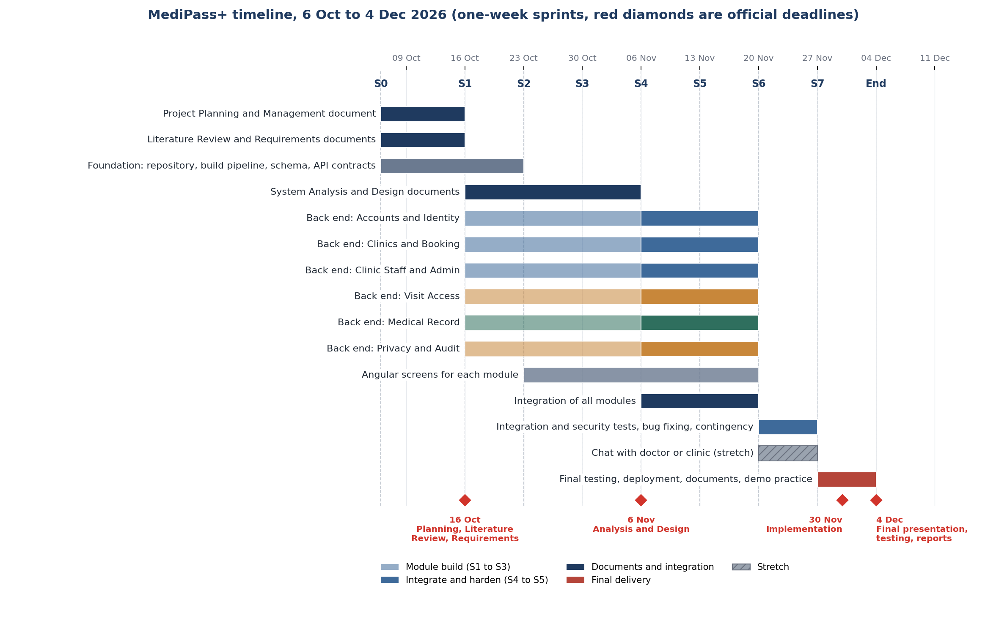
Figure 7. Timeline by sprint. The red diamonds are the official deadlines from the DEPI documentation guidelines.

3. Task assignment and roles

3.1 Team organisation
Waleed Ahmed Korashy Abdo is the team leader. The leader coordinates sprint planning and the communication with the instructor, while the technical work is shared equally between the six members. Each member owns one back-end module for the whole project and is responsible for its Angular screens, tests and documentation. Each member also reviews the module of another member.
The modules are built in parallel against API contracts that are agreed in Sprint 1, so every member works asynchronously in every sprint and nobody has to wait for another module before the integration in Sprint 4.

3.2 Module ownership and peer review
Back-end module | Owner | Peer reviewer | Main responsibilities
Visit Access | Waleed Ahmed Korashy Abdo | Ahmed Gamal Khairy Hassan | Access request, QR token, 6-digit code, access grant and its ending rules
Privacy and Audit | Ahmed Gamal Khairy Hassan | Azza Ibrahim Ali Shaban | Audit log, access grant checker, encryption, secure files, rate limiting
Accounts and Identity | Azza Ibrahim Ali Shaban | Nagham Ahmed Elsayed Elsorady | Registration, login, JWT, roles, lockout, account profile
Clinics and Booking | Nagham Ahmed Elsayed Elsorady | Arwa Mahmoud Sayed Hussien | Clinics, doctors, slots, booking, appointment status flow
Medical Record | Arwa Mahmoud Sayed Hussien | Hend Abdelnaser Rashad Elsadany | Diagnosis, prescription, history, reports and scans
Clinic Staff and Admin | Hend Abdelnaser Rashad Elsadany | Waleed Ahmed Korashy Abdo | Staff schedule tools, account management, counts dashboard

Duties shared by everyone: a daily standup update, a demo of their own module at every sprint review, a peer review of the assigned module, unit and integration tests for their own module, and the documentation section for their own module.

3.3 Responsibilities and tasks per member
In Sprint 1 every member also takes one part of the shared foundation: solution structure (Waleed), build pipeline and logging (Ahmed), Swagger with JWT and the API contract document (Azza), database context and seed script (Nagham), validation and error handling (Arwa), Angular workspace and routing (Hend). Tasks are adjusted at each sprint planning according to the sprint results.

Waleed Ahmed Korashy Abdo
Responsible for: Visit Access module (back end), its Angular screens, tests and documents.
Sprint | Back end (own module) | Angular, tests and documents
S0 | Technical design of the access request and grant (token size, hashing, expiry) | User stories for visit access; Project Planning and Management document
S1 | Entities AccessRequest and AccessGrant, migration, grant status design | Shared foundation: solution structure and branch rules; API contract for start visit and approve
S2 | Doctor start-visit endpoint; QR token creation (random, stored as a hash, valid 2 minutes) | Angular screen that shows the QR code; unit tests for the token rules
S3 | Patient approve endpoint; creation of the access grant; token usable once | Angular scan and approve screen with a camera test on a phone; class diagram and component diagram for the design document
S4 | 6-digit code fallback with lockout after 5 wrong tries; link with the appointment status | Integration with the grant checker and the booking module; integration tests
S5 | Grant ending rules: visit completed (plus 15 minutes), 2-hour limit, patient ends access | Angular end access button; tests for every ending rule
S6 | Security and edge-case tests (expiry, reuse, wrong doctor); bug fixing | Peer review of the assigned module
S7 | Final test run of the module | Source code submission and README (shared duty); documentation section and presentation part for visit access

Ahmed Gamal Khairy Hassan
Responsible for: Privacy and Audit module (back end), its Angular screens, tests and documents.
Sprint | Back end (own module) | Angular, tests and documents
S0 | Technical design of the audit log and the access check interface | User stories for privacy and audit; Jira board and GitHub Actions setup
S1 | AuditLog entity and writer helper; IAccessCheck interface with a stub for other modules | Shared foundation: build pipeline and logging
S2 | Access grant checker that looks up the active grant in the database on every request | Unit tests for the checker; Angular access log page skeleton
S3 | Who viewed my record endpoint (reads the audit log of the patient) | Angular Who viewed my record page; deployment diagram and DFD for the design document
S4 | Encryption of diagnosis text with Data Protection; key handling | Integration with the medical record module; tests that the stored text is encrypted
S5 | Security headers, CORS, secrets handling, private file storage, rate limiting on login, QR and code attempts | Security self-review with the OWASP Top 10 checklist
S6 | Security and load tests; fixing the findings | Peer review of the assigned module
S7 | Final test run of the module | Deployment and build pipeline final check (shared duty); documentation section and presentation part for privacy and audit

Azza Ibrahim Ali Shaban
Responsible for: Accounts and Identity module (back end), its Angular screens, tests and documents.
Sprint | Back end (own module) | Angular, tests and documents
S0 | Technical design of the roles and the JWT setup | User stories for accounts and login; stakeholder analysis
S1 | ApplicationUser base class, register and login endpoints, JWT access and refresh tokens | Shared foundation: Swagger with JWT and the API contract document; Angular login and register pages
S2 | Role policies for the four kinds of user; refresh token endpoint | Unit tests for the validators; Angular route guards and token interceptor
S3 | Account lockout, password rules, profile and change-password endpoints; demo users in the seed script | Angular profile page; use case diagram and wireframes for the design document
S4 | Apply the role policies to the endpoints of every module | Integration tests for login and roles
S5 | Token lifetime review and refresh token rotation | Angular session expiry handling; tests
S6 | Authorization tests for all four kinds of user; bug fixing | Peer review of the assigned module
S7 | Final test run of the module | User manual compilation (shared duty); documentation section and presentation part for accounts

Nagham Ahmed Elsayed Elsorady
Responsible for: Clinics and Booking module (back end), its Angular screens, tests and documents.
Sprint | Back end (own module) | Angular, tests and documents
S0 | Technical design of the clinic, slot and appointment model | User stories for clinics and booking; non-functional requirements
S1 | Entities Clinic, Doctor, DoctorSlot and Appointment with the first migration | Shared foundation: database context and seed script
S2 | Clinic and doctor endpoints with search by specialty and paging; slot creation | Angular doctor search and slot list; unit tests
S3 | Booking, cancelling and rescheduling with the slot rules | Angular booking page; activity diagrams for the design document
S4 | Appointment status flow (Booked, CheckedIn, InVisit, Completed, Cancelled) used by the other modules | Angular patient appointments page; integration tests
S5 | Edge cases: double booking, past slots; paging and filtering review | Angular polish; tests
S6 | Integration tests for the flow from booking to visit; bug fixing | Peer review of the assigned module
S7 | Final test run of the module | Test plan (shared duty); documentation section and presentation part for clinics and booking

Arwa Mahmoud Sayed Hussien
Responsible for: Medical Record module (back end), its Angular screens, tests and documents.
Sprint | Back end (own module) | Angular, tests and documents
S0 | Technical design of the record, diagnosis and report model | User stories for the medical record; Literature Review contribution
S1 | Entities MedicalRecord, Diagnosis, Prescription and Report with the migration | Shared foundation: validation and error handling
S2 | Diagnosis and prescription endpoints against the stub of the access check | Angular doctor diagnosis form; unit tests
S3 | History read endpoint with paging and filtering; the patient's own history endpoint | Angular history views for doctor and patient; sequence and state diagrams for the design document
S4 | Switch to the real access grant check; report upload with file type and size checks | Integration tests: no grant, no data
S5 | Secure report download through a checked endpoint | Angular report upload and view; tests
S6 | Authorization and file access tests; bug fixing | Peer review of the assigned module
S7 | Final test run of the module | Technical documentation compilation (shared duty); documentation section and presentation part for the medical record

Hend Abdelnaser Rashad Elsadany
Responsible for: Clinic Staff and Admin module (back end), its Angular screens, tests and documents.
Sprint | Back end (own module) | Angular, tests and documents
S0 | Technical design of the staff and admin permissions | User stories for clinic staff and admin; Literature Review contribution
S1 | Entities ClinicStaff and Admin; seed data | Shared foundation: Angular workspace and routing
S2 | Admin endpoints to create and deactivate clinic, doctor and staff accounts | Angular admin account screens; unit tests
S3 | Clinic staff endpoints: manage doctor slots, book for a patient, mark arrival (limited to the own clinic, no medical fields) | Angular staff schedule page; ERD, schema and UI guidelines for the design document
S4 | Integration with the booking module and the role policies | Angular staff screens connected; integration tests
S5 | Admin counts dashboard endpoint | Angular dashboard; tests
S6 | Tests that staff and admin cannot read medical data and that staff stay inside their clinic; bug fixing | Peer review of the assigned module
S7 | Final test run of the module | Demo script (shared duty); documentation section and presentation part for staff and admin

4. Risk assessment and mitigation plan
Likelihood (L) and impact (I) are rated Low, Medium or High. The register is reviewed at every sprint retrospective.
ID | Risk | L | I | Mitigation | Owner
R1 | A mistake in the access grant logic leaves records open or locks doctors out | Medium | High | All checks live in one component used by every medical endpoint; a test for every rule; peer review of that code | Waleed
R2 | Schedule slippage in one or more modules | Medium | High | Sprint commitment tracked on the Jira burndown; stretch items dropped first; Sprint 6 reserved for contingency; the plan is adjusted at the sprint planning | All members
R3 | Scope creep | Medium | High | The scope table is the baseline; changes are discussed at sprint planning; stretch items start only after all must-have items are done | Waleed
R4 | Integration problems between modules that are built in parallel | Medium | High | API contracts agreed in Sprint 1; stubs until integration; integration in Sprint 4 with a shared build; weekly technical sync | All members
R5 | The phone camera needs HTTPS and may not work on the demo network | Medium | High | Test on a phone in Sprint 3; the 6-digit code is the fallback; local HTTPS certificate; recorded demo as a backup | Waleed
R6 | Encryption keys are lost or leaked | Low | High | Keys stored in user-secrets or environment variables, never in the repository; documented key restore procedure; demo data created by a seed script | Ahmed
R7 | The implementation deadline (30 Nov) is earlier than the final presentation (4 Dec) | Medium | Medium | Core features complete on 20 Nov; Sprint 6 for testing; deployment and README ready before 30 Nov | Waleed
R8 | Uneven availability of team members because of courses and other commitments | High | Medium | Asynchronous standup updates; Jira as the single place for tasks; weekly capacity check; equal module sizes so work can be rebalanced | All members
R9 | Merge conflicts, since six people work in one repository | Medium | Low | One branch per ticket; small pull requests; mandatory review; the build must pass before merge | All members
R10 | Security weaknesses: guessing of QR tokens or codes, weak JWT setup, unsafe file uploads | Medium | High | Random tokens stored as hashes with short expiry; attempt limits and rate limiting; secrets outside the code; allowed file types and sizes only | Ahmed
R11 | Medical data reaches the wrong user, such as clinic staff or the admin | Low | High | Server-side checks by role and by grant; staff objects without medical fields; negative tests; audit log | Hend
R12 | The free hosting plan does not support SQL Server or HTTPS | Medium | Medium | Check by Sprint 3; keep a local or Docker demo ready at all times | Ahmed
R13 | Knowledge about a module stays with one person | Medium | High | Peer review rotation; each module documented; decisions recorded in the repository | All members
R14 | Documents fall behind the code and a guideline deadline is missed | Medium | Medium | Document tasks in Jira with owners and dates (16 Oct, 6 Nov, 30 Nov, 4 Dec); each member documents their own module | All members

5. Key performance indicators (KPIs)
We will measure these in the test and demo environment with about 20 users at the same time, and look at them at every sprint review.

5.1 Privacy and access control
KPI | Target | How we measure it
Medical endpoints that check for an active grant, each with a negative test | 100% | Authorization test suite
Successful medical requests without an active grant | 0 | Tests with no grant, expired grant, ended grant, wrong doctor
Reads and writes of medical data that leave an audit entry | 100% | Audit log checks in the tests
Time for a grant to end after the visit is completed | 15 minutes or less | Integration test
QR token used once and valid for 2 minutes | 100% of tests pass | Unit and integration tests
Code fallback locked after wrong attempts | Locked after 5 wrong tries | Integration test
Diagnosis text stored encrypted in the database | 100% | Direct database query
Clinic staff and admin accounts that can read medical data | 0 | Authorization tests

5.2 Speed and reliability
KPI | Target | How we measure it
Response time of read endpoints (search, history) | 95% under 300 ms | Postman or a small load script in Sprints 6 and 7
Response time of write endpoints (booking, diagnosis) | 95% under 500 ms | Same
Time from "Start visit" to the doctor having access, in the demo | Under 30 seconds | Timed during the practice demo
Uptime during testing and the demo | 99% or higher | Health check endpoint, especially on 4 Dec
Server errors (HTTP 5xx) | Under 1% of requests | Serilog logs

5.3 Quality and security
KPI | Target | How we measure it
Unit test coverage of Domain and Application layers | 50% or more by Sprint 7 | Coverage report in the build
Open critical bugs at the final hand-in | 0 (high severity: 2 or fewer) | Jira bug list
Critical findings in our OWASP Top 10 self-review | 0 | Checklist in Sprint 6
Secrets committed to the repository | 0 | Repository scan before 30 Nov

5.4 Team and process
KPI | Target | How we measure it
Committed sprint points that get finished | 80% or more | Jira burndown
Velocity | Steady or rising after Sprint 2 | Jira velocity chart
Standup attendance | 90% or more | Jira or chat updates
Pull requests reviewed before merging | 100% | GitHub history
Build on main passing | 95% of the time or more | GitHub Actions
Merged pull requests per person per sprint | At least 1 | GitHub history
Members who own a back-end module with its own tests and have reviewed another member's module | 6 out of 6 | Jira assignments and GitHub reviews
Guideline documents handed in by their deadline | 100% (16 Oct, 6 Nov, 30 Nov, 4 Dec) | GitHub commit dates

5.5 Product and user adoption
KPI | Target | How we measure it
Whole flow works (book, approve, diagnose, view, end access) | By the Sprint 5 review | Live walkthrough
Kinds of user with a working demo (patient, clinic staff, doctor, admin) | 4 out of 4 | Checklist in the Sprint 7 practice demo
Invited testers who register and make a first booking | 70% or more | Pilot with at least 8 people outside the team
Testers who manage to find "Who viewed my record" and end an access | 90% or more | Watching them try it
Tester satisfaction | 4 out of 5 or more | Short survey

