RAMOTSHERE MOILOA SUB-DISTRICT
TECHNOLOGY
TERM 4 EXAMINATIONS
NOVEMBER 2018
GRADE 8

MARKS: 100
DURATION: 1H30 min
NAME OF LEARNER:___________________________________
CLASS:____________________________________________

INSTRUCTIONS
- Answer all questions.
- Write neatly and legibly.
- All the answers should be written in the spaces provide in the question paper.
- Follow instructions promptly.
- All the drawings should be in pencil, neat and fully labeled.
- Coloured pencils may be used only for shading where such is required.
- This question paper consists of 15 pages.

Question 1 (Multiple choice)

Four possible answers are given. Circle the letter of the correct one.

  - Shell structures support the load from ...
- Inside
- Outside
- Both inside and outside
- Neither inside nor outside (1)

  - Bending as part of structural failure is usually caused by lack of...
- Strength
- Stiffness
- Stability
- Hardness (1)

1.3
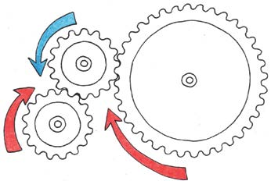
B
C
A
In the gear system above, if B is a driver and C driven, both gears will rotate in the...
- Same direction
- Opposite directions
- Different directions
- Anticlockwise direction (1)

  - To increase the speed in a gear system, the driver gear should be...
- Smaller than the driven gear
- Bigger than the driven gear
- Same size as the driven gear
- Faster than the driven gear (1)

1.5 Bio-degradable materials are...
A. Environmentally friendly as they easily decompose
B. Cannot decompose
C. None of the above
D. All of the above (1)

1.6 One of the negative impacts of plastics scattered in our environment is that...
A. If eaten by animals, they could die.
B. They make the environment clean
C. They are expensive to buy
D. Some do decompose (1)

1.7 Use the circuit in the Figure below to answer the question that follows.
B. Switch
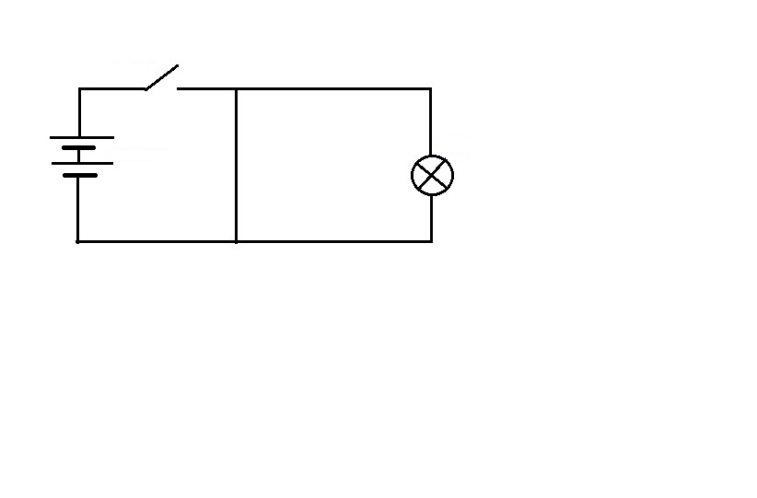
C. Lamp
A. Battery
When the switch is closed …
A. The bulb will glow bright
B. The bulb will not glow
C. The bulb will burn
D. The bulb will glow bright for some times then go off (1)

1.8 The connection in question 1.7 above is called...
A. Closed circuit
B. Short circuit
C. Electric short
D. All of the above (1)

1.9 A 3volts battery is connected in series with a single pole single throw (SPST) closed switch and a bulb. The output in this circuit is a...
A. Battery
B. Switch
C. Glowing bulb
D. Connecting wires. (1)

1.10 The process in 1.9 is
A. The pressing of a switch
B. The glowing of a bulb
C. The flowing of current through the circuit
D. The connection of a battery. (1)
[10]

Question 2

2.1 Which of the following statements are TRUE and which are FALSE? Just write true or false in the space provided at the end of each question.
2.1.1 A Buttress can be used to support the wall of a dam (1)

____________________

2.1.2 One of the disadvantages of modern technology is that it can cause fatal accidents or even dearth. (1)

____________________

2.1.3 Two switches in an OR gate are connected in series. (1)

_____________________

2.1.4 The liquid that allow current to flow through in electro chemical cells is called electrolyte (1)
____________________

2.1.5 Only men should work in mines as the job is hard as per gender equity. (1)

__________________

2.1.6 Asbestoses is a disease caused by dust from mines. (1)

__________________

2.2 Match the type of force in column A with its name in column B. Just write the letter of the appropriate name in column C next to its force. (4)

COLUMN A | COLUMN B | COLUMN C
1. 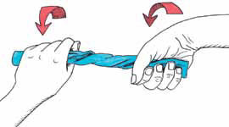 |  | - Compression  - Torsion  - Shear  - Heat  - Tension
2. 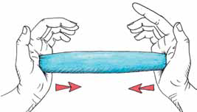
3.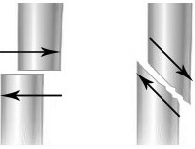
or
4.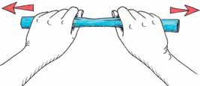

[10]

Question 3

3.1 A certain company was allocated a tender to build RDP houses in your area. One of the specifications of the tender was that the structure of the roof frame should be made very strong as tiles would be used. A total of 30 houses were to be built. In a mission to save costs, the contractor came up with a roof structure that is shown in FIGURE 1 below. You are now tasked to do inspection and provide the contractor with a plan to improve his roof structures for such to meet the expected standard.

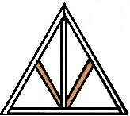
C
A
B
FIGURE 1: Roof frames
D

3.1.1 What are the names of members labeled:- (4)
A ____________________________________
B ____________________________________
C ____________________________________
D ____________________________________

3.1.2 What is likely to happen to the structural member labeled A if the tiles laced on top of it becomes too heavy and overcome the strength of such a member? (2)

_______________________________________________________________________

_______________________________________________________________________

3.1.3 To solve the problem in 3.1.2 above, Queen post could be mounted parallel to the strcural member labeled B. Draw such queen posts on Figure 1 above. (2)

__________________________________________________

3.1.4 The other method to solve the problem in 3.1.2 would be to change the tiles as they are ussualy very heavy and expensive. Which material would you use to replace the roof tiles? (1)

____________________________________________________________

3.1.5 Which structural failure is likely to happen to this structure due to lack of:- (3)

- Strength ___________________________________________

- Stiffness (Rigidity) _____________________________________

- Stability ___________________________________________

3.2 After heavy rainfall, the river between the village and town became wide and the bigger bridge had to be built for people and motorists to cross over. A contractor constructed the type of bridge shown in Figure 2 below.

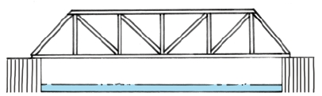
FIGURE 2: A Bridge

3.2.1 What is the name of bridge shown in Figure 2 above? (1)

_____________________________________________________________

3.2.2 Which method was used to strengthen this bridge? (1)

___________________________________________________________________

[14]

Question 4

4.1 Look at the picture of plastic bag in Figure 3 below and answer the questions that follow.

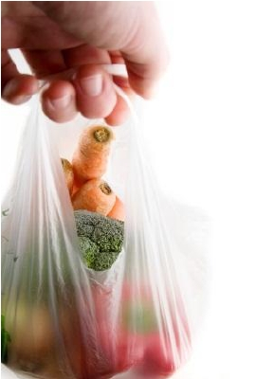
FIGURE 3: PLASTIC BAG

4.1.1 Which material is biodegradable between plastic and paper? (1)

_____________________________________________________

4.1.2 Give a reason for your answer in 4.1.1 above (2)

_____________________________________________________________________

_____________________________________________________________________

4.1.3 Is it a good or a bad idea for shops to sell plastic bags and not give them for free? Give a reason for your answer. (2)

____________________________________________________________________

____________________________________________________________________

____________________________________________________________________

4.2 Companies that usually pour waste chemicals in rivers are usually given heavy fines if identified. Give two disadvantages of pouring these toxic chemicals in the rivers. (4)

- ______________________________________________________________________

______________________________________________________________________

- ______________________________________________________________________

______________________________________________________________________
[09]
Question 5

Figure 4 below shows a grand piano basic structure drawn in isometric view. Use it to answer the questions that follow.

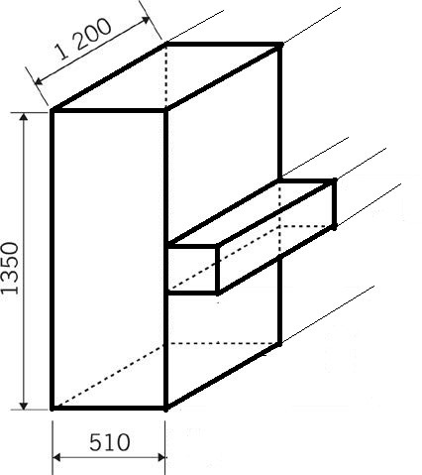
4
2
3
1
FIGURE 4: Basic structure of a Grand Piano
5.1 What are the names of the line types labeled 1 – 4 (4)

- _______________________________________________________________

- _______________________________________________________________

- _______________________________________________________________

- _______________________________________________________________
5.2 In the box provided below, draw the piano structure in 2 point perspective. (10)
R_{VP}
L_{VP}

[14]

Question 6

6.1 Give any two examples of wedges that we use in our everyday life. (2)
1. ___________________________________________
2. ___________________________________________
6.2 A picture of a shopping trolley below is an example of wheels and exiles that form part of complex machines that consists of combination of simple mechanisms. Study the operation of this trolley carefully to be able to answer the questions that follow.
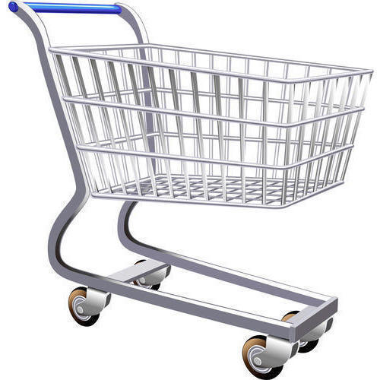
FIGURE 5: Shopping trolley
6.2.1 What would happen if we were to push the trolley without wheels? (2)
___________________________________________________________________
___________________________________________________________________
___________________________________________________________________
6.2.2 Would the mechanical advantage be good when the trolley is without wheels or with wheels? (1)
___________________________________________________________________

6.3 How can you improve the mechanical advantage of the class 1 lever in Figure 6 below? (2)
FIGURE 6: 1st Class lever
_________________________________________________________________________
_________________________________________________________________________
6.4 Figure 7 below shows the adult person trying to lift a small boy up without any success in a seesaw.
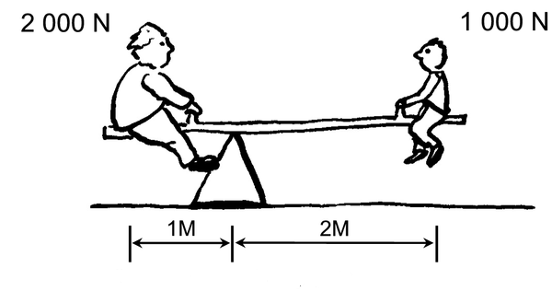
Effort Arm
Load Arm
FIGURE 7: An adult and a small boy on a seesaw
6.4.1 What makes it difficult for the man to lift the young boy up? (2)
_______________________________________________________________________
_______________________________________________________________________

6.4.2 Use the information that is supplied in Figure 7 to calculate mechanical advantage of this system. The formula is Ma = Effort arm (2) Load arm

6.4.3 Does this system give you a good mechanical advantage or not? Motivate your answer. (3)

Answer ____________________________________________________________

Motivation_________________________________________________________

__________________________________________________________________

6.5 State one positive impact of and one negative impact of mining the South Africans are experiencing at the moment. (2)

6.5.1 Positive impact

___________________________________________________________________

___________________________________________________________________

    - Negative impact

___________________________________________________________________

___________________________________________________________________

[16]

Question 7

7.1 Figure 7 below shows a man trying to illegally connect his house to the electric mains caught on camera.

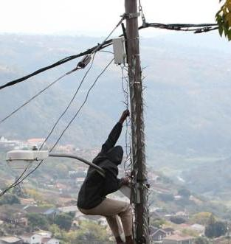

FIGURE 7: Illegal connection of electricity

7.1.1 Which two unsafe dangerous acts has this man committed? (4)

- ___________________________________________________________________

___________________________________________________________________

- ___________________________________________________________________

___________________________________________________________________

7.1.2 The man’s actions subject him to an electric shock. Explain your own understanding of an electric shock. (2)

___________________________________________________________________

___________________________________________________________________

7.1.3 For which two reasons do you think it is important for us to pay for electric energy and not steal it like this man is doing? (2)

- ___________________________________________________________

___________________________________________________________

- ___________________________________________________________

___________________________________________________________
7.2 The circuit diagram below demonstrates the connection of two switches in series controlling one bulb.
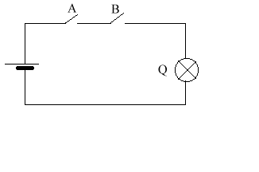

7.2.1 In digital electronics, when the switch is opened, it gives logic 0 and when it is closed, it gives logic 1. Indicate where the Bulb (Q) will be off (0) and where it will be on (1) with respect to the positions of both Switch A and Switch B in the truth table below. (4)
A | B | Q
0 | 0
0 | 1
1 | 0
1 | 1

    - Which type of a logic gate is formed by this circuit? (1)

______________________________________________________

7.3 What is the main disadvantage of connecting cells in parallel? (2)
________________________________________________________________________
________________________________________________________________________

7.4 Photovoltaic (Solar) cells are good alternative to chemical cells as the generation is free. They are still not commonly used as they come with some disadvantages. Name one of such disadvantages. (2)
________________________________________________________________________
________________________________________________________________________
[17]
Question 8
8.1 Use the gear system in Figure 9 below to answer the questions that follow.
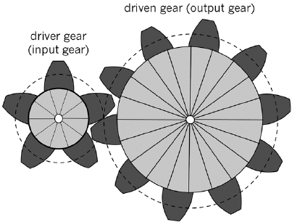
FIGURE 9: Gear system

8.1.1 Does this type of gear combination increase the speed or reduce the speed? (1)
_________________________________________________________

8.1.2 During rotation, the driver gear rotated clockwise and the driven gear anticlockwise. How would you make both the gears to rotate in the same direction? (2)
_____________________________________________________________________
_____________________________________________________________________
8.1.3 Calculate the gear ratio of this system. (2)

8.1.4 Make a graphical representation of the gear system in Figure 9 (5)

[10]
TOTAL = 100

