RAMOTSHERE MOILOA AREA OFFICE

TECHNOLOGY
MARCH 2017

TERM 1 TEST
GRADE 8

MARKS: 80
DURATION: 1H30 min
NAME OF LEARNER:___________________________________
CLASS:______________________________________________

INSTRUCTIONS
- Answer all questions.
- Write neatly and legibly.
- All the answers should be written in the spaces provide in the question paper.
- Follow instructions promptly.
- All the drawings should be in pencil, neat and fully labelled.

Question 1
1.1. Use the following diagram to answer the questions that follow: (9)
Horizon line V_{P}

a)
b)
c)
Horizontal line
 | LINE TYPE | DESCRIPTION AND APPEARANCE | NAME
e.g. |  | Feint chained line | Centre line
a) |  | 1.  (1) | 2.  (2)
b) |  | 3.  (1) | 4.  (2)
c) |  | 5.  (1) | 6.  (2)

1.2. A vertical line of a 3D Isometric rectangular block, is drawn perpendicular to the horizontal line. Draw the construction lines from both ends of the vertical line to the two vanishing points located on the horizon line. Now, follow the appropriate steps to complete the rectangular block. Shade the different sides of your block in different colours. (11)
Horizon line LV_{P} RV_{P}

Horizontal line
[20]

Question 2 STRUCTURES
2.1. Match column A with column C. Just write the letter of the matching bridge on column B. (6)
COLUMN A | COLUMN B | COLUMN C
1. 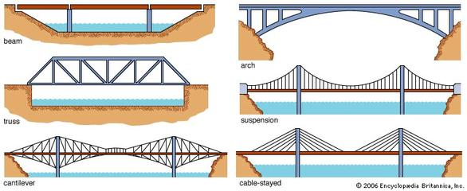 |  | A. Arch bridge
2.  |  | B. Suspension bridge
3.  |  | C. Cable stayed bridge
4.  |  | D. Beam bridge
5.  |  | E. Cantilever bridge
6.  |  | F. Truss bridge

2.2. Choose the correct answer from those given between brackets. Just write the correct answer on the space provided. (4)
2.2.1 For keeping the dam wall upright and firm, we can use (Guys; Buttresses)._______________
2.2.2 (Strut; Stay) is always mounted on the side of stress. _____________________
2.2.3 In a cable stayed bridge, the cables are suspended on a (Column, Beam). ________________
2.2.4 A (King post; Strut) is always mounted at right angle (perpendicular) with the tie beam.
_____________________
2.3 In a local farmstead, majority of houses are roofed with thatch. The problem of this area is that it is usually affected by draught and veld fires which burn the thatch as it easily burns. You are now tasked to change the roofing of these houses to the one that cannot be easily affected by fire and you choose to use the zinc corrugated pitched roof.
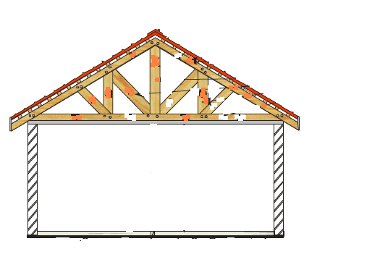
D
A
B
C
FIGURE 4: PITCHED ROOF CROSSECTIONAL AREA

2.3.1 Carefully read through the above scenario and with the help of FIGURE 4, formulate your own design brief to solve the existing problem. (3)
_____________________________________________________________________

_____________________________________________________________________

_____________________________________________________________________

_____________________________________________________________________

2.3.2 FIGURE 4 was drawn when the design for the solution was made. Write the names of the members labeled A – D on the spaces provided below. (4)

A. __________________________________________

B. __________________________________________

C.__________________________________________

D.__________________________________________

2.3.4 The foundation should be very strong to ensure that the house is stable. Which two materials would you use to ensure that the foundation is strong enough? (2)

____________________________________ and

____________________________________

2.4 Give a reason why structural members ______________________ (3)

4.2.1 Fracture ________________________________________________________

_________________________________________________________

4.2.2 Bend _________________________________________________________

_________________________________________________________

4.2.3 Topple over __________________________________________________

________________________________________________________

[ 20 ]

Question 3

Read the scenario and answer the questions that follow.
The human body is capable of a wide range of complex movements. These movements are necessary to perform our daily tasks. In most cases, when people design homes, they look at the human body and its movements within the house. Well-designed houses allow for comfortable movement in and out of the home as well as within the home. Within the home, fixed parts such as door-handles, staircase railings and steps are also designed to assist the human body in moving about comfortably.
When you get older and movement becomes more difficult, it is essential to live in a house that takes your physical limitations into consideration so that you can move about comfortably.
3.1 Mention three(3) possible needs of an elderly person in a wheelchair or with a walking frame with regards to accommodation(home). (6)

- _______________________________________________________________________________

_______________________________________________________________________________

- _______________________________________________________________________________

_______________________________________________________________________________

- _______________________________________________________________________________

_______________________________________________________________________________

3.2 Look at the pictures below and answer the questions that follow.

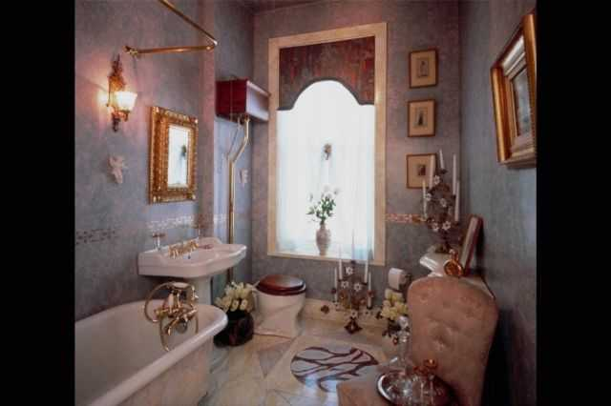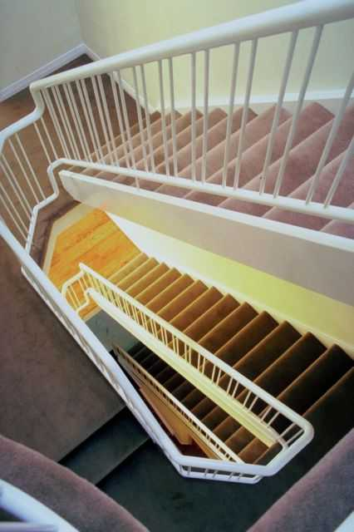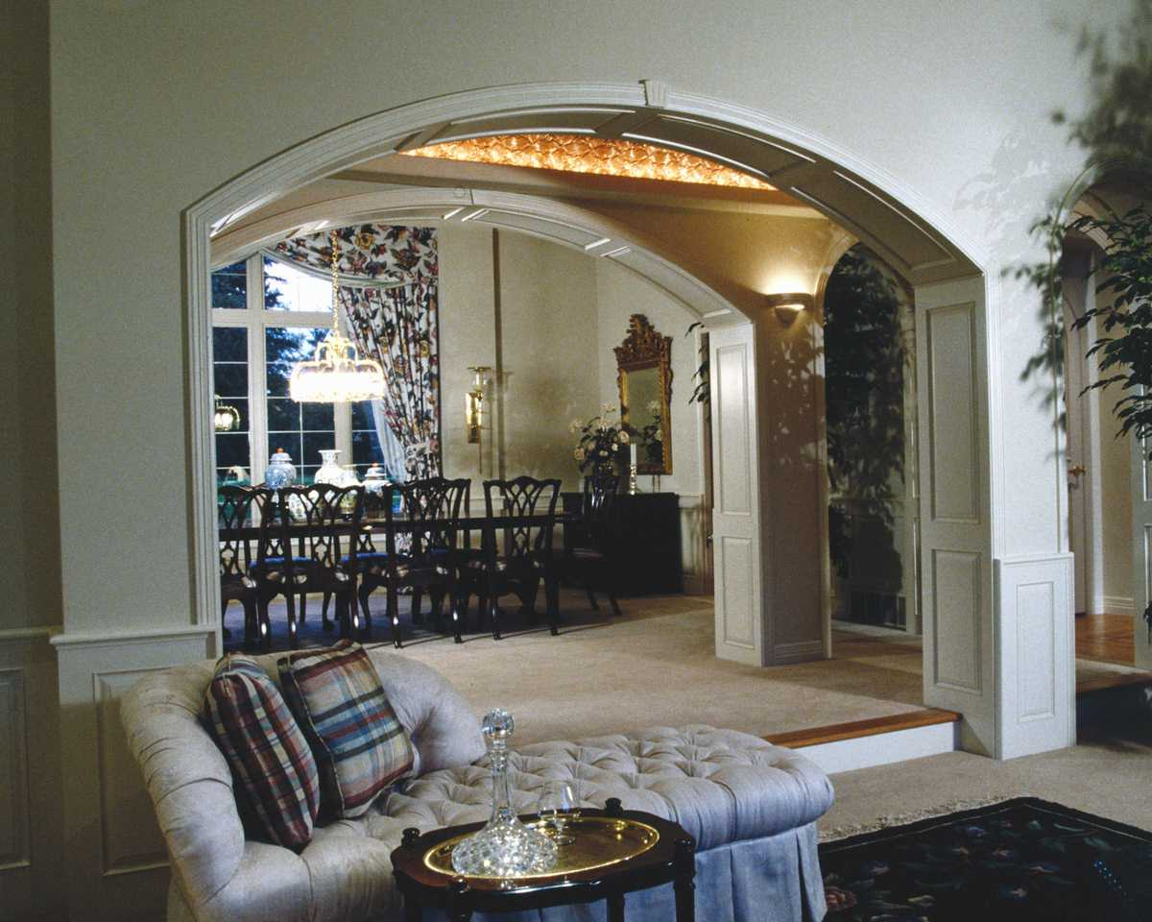
B
C
A

3.2.1 Identify the difficulties an elderly person using a wheelchair or walking frame would experience if s/he were living in this house. Identify ONE difficulty per room. Write your answers in the table below: (6)

A
Living room
B
Bathroom
C
Stairwell

3.2.2 List a possible improvement you could make to each area of this house to make it more suitable for an elderly person using a wheelchair or walking frame. (6)

A
Living room
B
Bathroom
C
Stairwell

[ 18 ]

Question 4

4.1. Give one use for each of the following types of gears. (4)
GEAR TYPE | USE
1. Bevel gears
2. Spur gears
3. Rack and pinion
4. Worm Gears

4.2 Use the diagram below to answer the questions that follow:
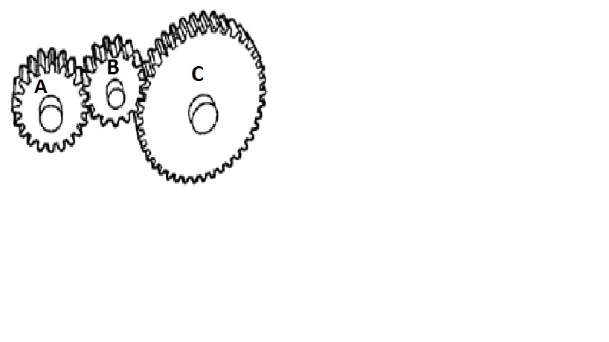
4.2.1 What is the name of a gear labelled B? (1)

__________________________________________________

4.2.2 What is the main function of this middle gear? (2)

____________________________________________________________________

___________________________________________________________________

4.2.3 If gear A was to rotate in a clockwise direction, what would be the direction of rotation of both Gear B and Gear C?

Gear B __________________________________________ (1)

Gear C __________________________________________ (1)

4.2.4 Why is the gear B made of a harder material than the other two gear? (2)

_____________________________________________________________________

_____________________________________________________________________

4.3 The picture below shows the two gears meshed together. The input gear has 15 teeth and output gear 45 teeth. Use this information to answer the questions that follow.

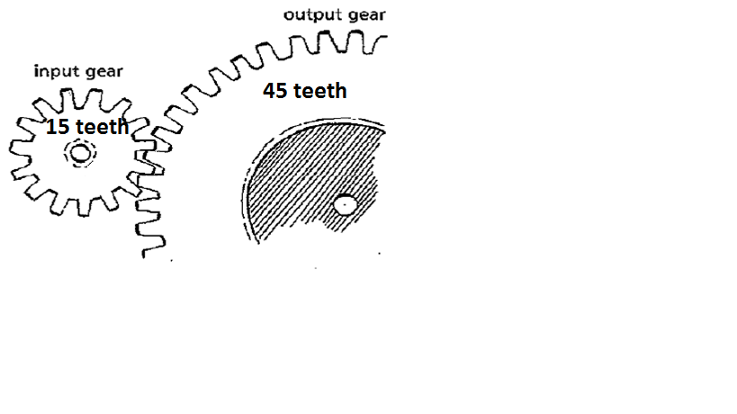

4.3.1 Calculate the gear ratio. (3)

Gear ratio =

4.3.2 Is this a gearing up or gearing down system?__________________________________ (1)

4.4 Which movement change is made by cams and cranks? (2)

________________________________________________________________________________

4.5 Define an "eccentric wheel". (2)

________________________________________________________________________________

________________________________________________________________________________

________________________________________________________________________________

4.6 Give only one practical use of a crank. ____________________________________________ (1)

[ 20 ]
TOTAL = 80

