**Books reviews**

**Description:**

**For users:**

Books reviews it is an web app that will be contained a group of Books ,but divided into categories such as novels and stories…etc. . as a user you will be able to see all information about the Book like the name , writer and description and reviews. Etc.

user can review books but he needs to sign in first . user can update and delete his own book reviews.

The user can never access into the desktop app as a user, he must be admin or employee.

**For admin:**

There will be a desk app for the admin to be able to add employee or delete an existed one , but the admin will be able to login in the web app and see all books reviews and he will be able to edit the reviews of any users in case there wrote the three bad words(fuck,shit,bith).

The admin can’t add an review on a book as an admin.

**For employees:**

On desk app Employee can add books or delete them.

the employee will be able to login in the web app and see all books reviews and he will be able to edit the reviews of any users in case there wrote the three bad words(fuck,shit,bith).

The employee can’t add an review on a book as an employee.

**Purpose of the application:**

Audience can search for books and see the reviews to help them which book they want to read but also be able to review them .

Show teachers how to we use inheritance classes.

**Target audience:**

Books worms; people who like reading.

**Gitlab link:**

<https://git.fhict.nl/I499087/booksreviews>

**wireframes of pages:**

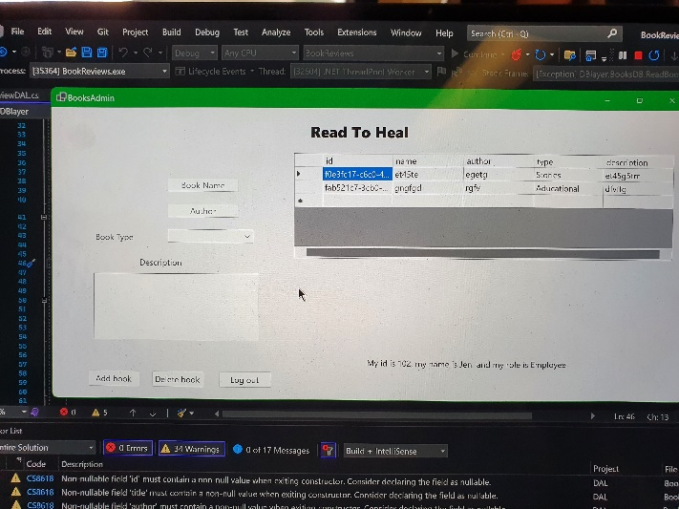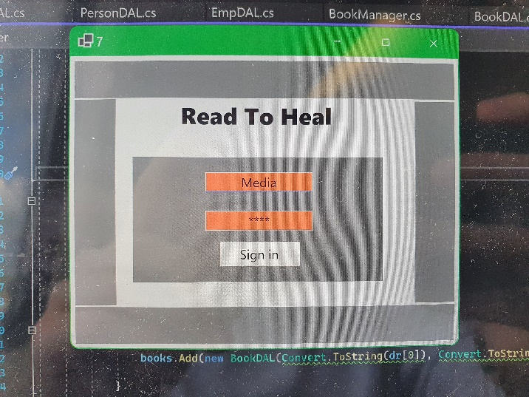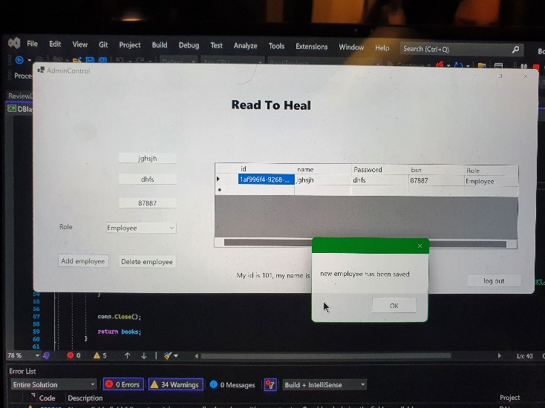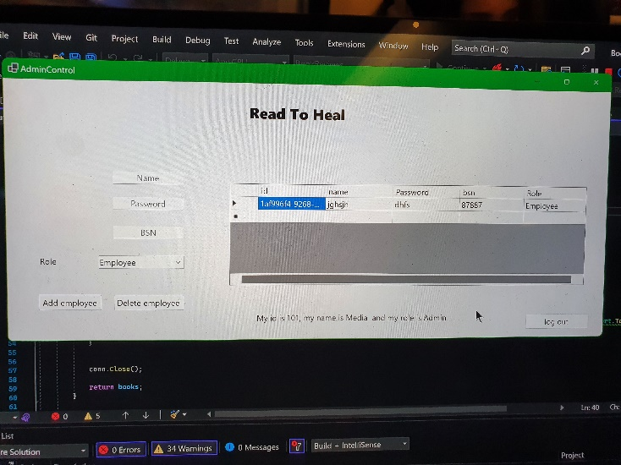

**Sitemap:**

