|  |
| --- |
| Media Lynx |
| Burndown & Velocity Report |
| IAB299 |

|  |
| --- |
| 23/10/2015 |

## Burndown Charts

**Sprint 1: 21/08/15 – 04/09/15**

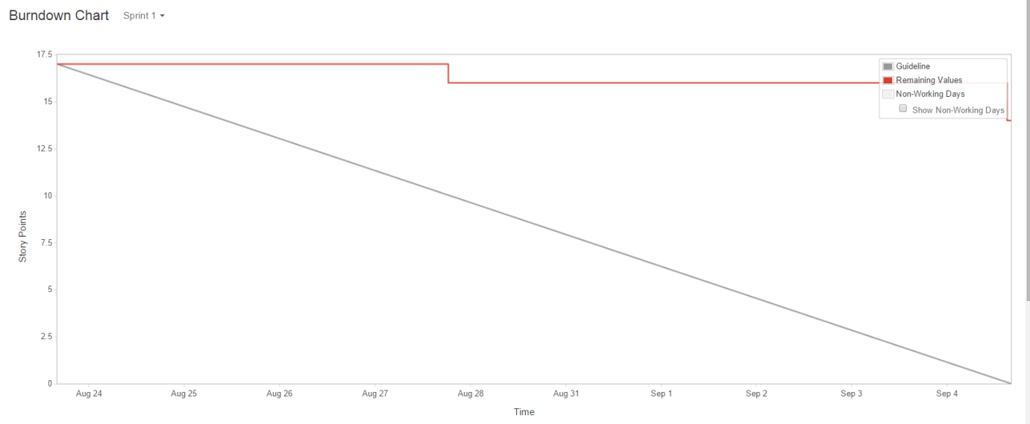

**Sprint 2: 04/09/15 – 18/09/15**

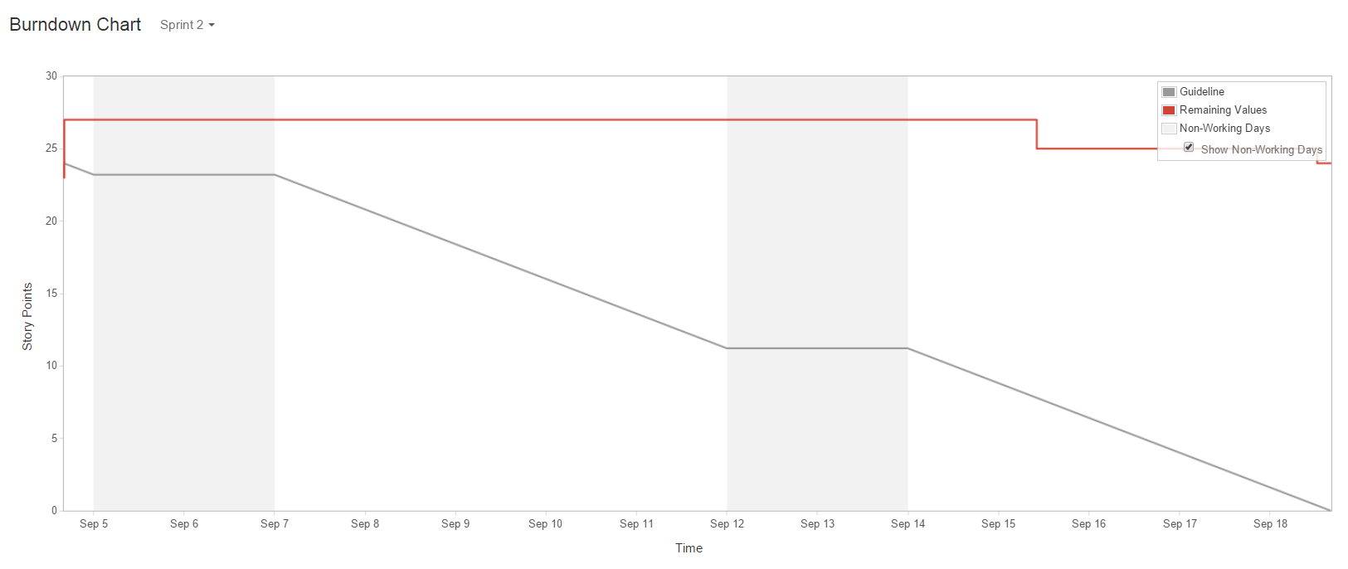

**Sprint 3: 18/09/15 – 09/10/15**

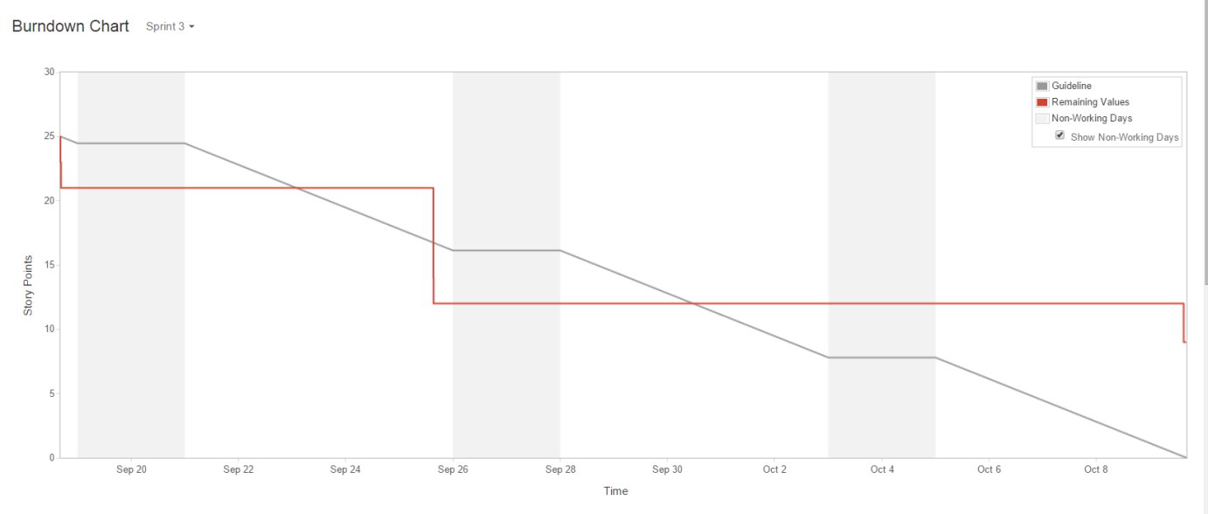

**Sprint 4 – 09/10/15 – 23/10/15**

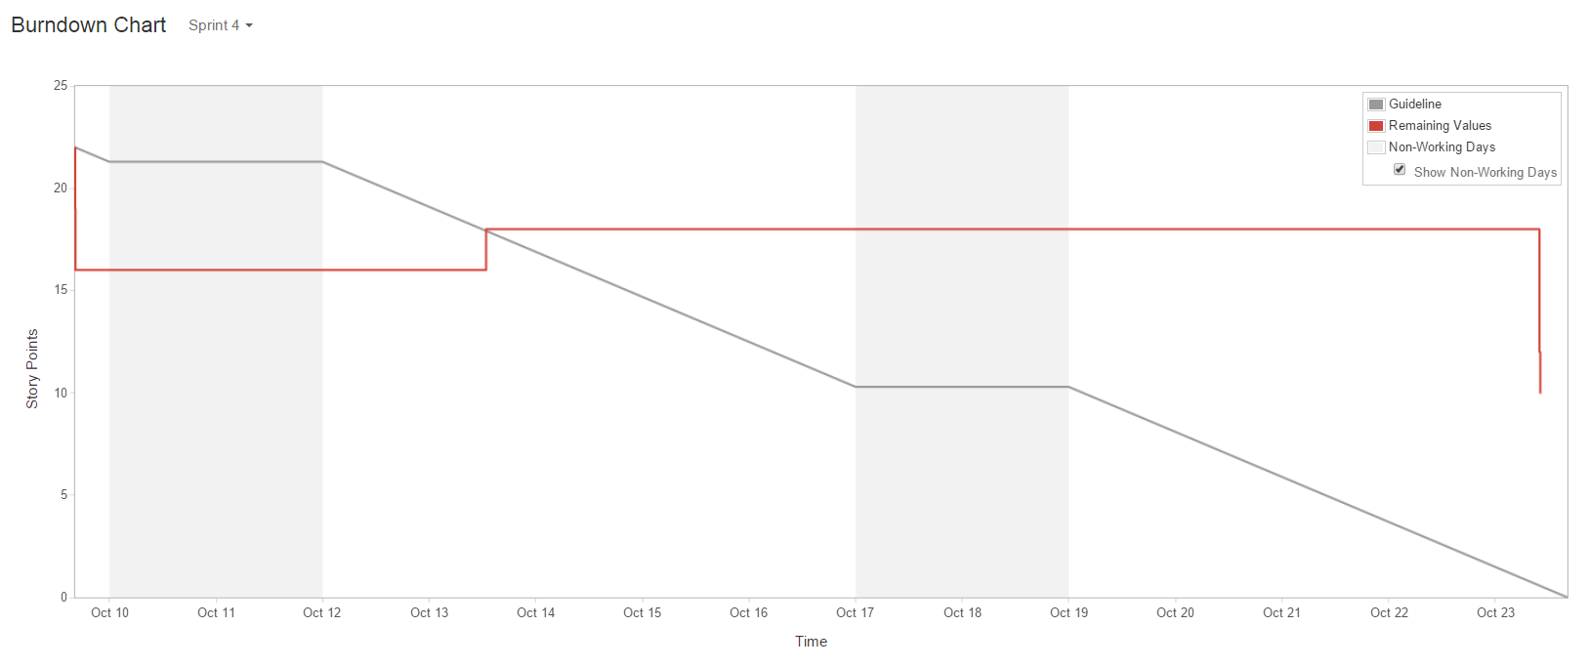

## Velocity Chart

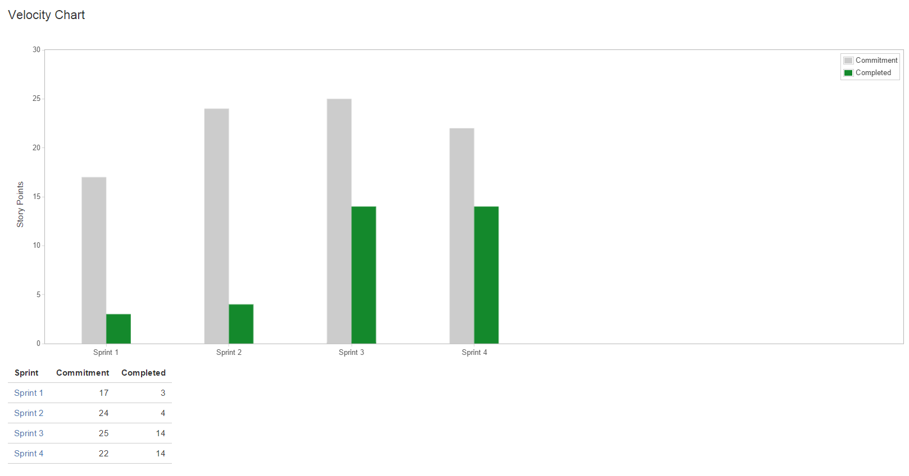

Our Burndown and Velocity charts show the progression of our team through Tuckman’s *forming–storming–norming–performing* model. By Week 6 we had begun development on the Media Vault project and I believe that our team was in the *norming* phase. By the third sprint, we had moved into the *performing* phase and we made significant progress with the development of core functionalities for our project. This allowed us to create a better plan for the fourth sprint, as we committed to less story points and completed as many story points as the previous sprint.