M3
USER GUIDE
Media Metadata Manager
User Guide
Documentation set of October 17, 2026
Based on Subler and MP42Foundation · For macOS 10.13 and later

Contents
About this guide 4
1. Concepts in one page 5
2. Installing and starting M3 7
2.1 Installing 7
2.2 Updating 7
2.3 First launch 8
3. The windows 9
3.1 The Editor (single-file window) 9
3.2 The Queue windows 12
3.3 Queue Options 18
3.4 Review sheets 19
3.5 Library scan window 22
3.6 Message log 25
4. Settings 26
General 26
Metadata 27
Sets 28
Filename 28
OCR 29
Advanced 29
Sources 29
Support 29
5. Media Intake in detail 30
5.1 Settings reference 31
5.2 What happens, step by step 32
5.3 Lossless merge 33
5.4 Safety guarantees 33
5.5 Media Locations: where finished files go 34
6. Common tasks 37
7. Metadata sources 39
8. Files and locations 42
9. Troubleshooting 43
10. Glossary 44

About this guide
This guide describes every window, menu and setting of Media Metadata Manager (M3) and walks through the common tasks. If you only want to get going, read the Getting Started Guide first and come back here for detail.
Conventions. Menu paths are written Menu → Item. Buttons and settings are shown in bold. File and folder names are shown in code style. Notes marked Tip are optional shortcuts; notes marked Important describe behavior that can affect your files.
Help inside the app. Choose Help → Media Metadata Manager Help to open this guide in the Help window, which has a search box. You can also open the Help menu and type in its search box to find a topic or a menu command; M3 points at the command in the menu. The ? button opens the section about the window you are in: it is the last item in the toolbar of the Queue, Editor and Settings windows (you can move it with Customize Toolbar in the Queue and Editor), in the title bar of the Welcome window, the Message log and the Queue’s review windows, beside the gear in the Library scan window, and in the top right corner of the Queue Options panel. Help also opens the Getting Started Guide, this guide as a PDF, What’s New, and Report an Issue.
Scope. M3 is a personal fork of the open-source Subler app. Everything Subler does — muxing and tagging MP4, M4V and MOV files, importing tracks from MKV and raw formats, chapters, subtitles, OCR of image subtitles — still works. This guide concentrates on what M3 adds: extra metadata sources, the Queue-based Intake workflow, lossless merging, naming rules, library scanning and the cleanup options.

1. Concepts in one page
Incoming Folder. A folder where downloads arrive. M3 can watch one or several of them.
Ready for Media Library. The staging folder where finished files and folders are placed. It is your last human checkpoint before the files reach a media server. M3 never writes into your final library itself.
Queue. An ordered list of jobs. There are two lists, the Movies Queue and the TV Shows Queue, shown as two tabs of one Queue window. Jobs run in the order shown, one at a time. By default the two lists take turns (see 5.1).
Row. One line in a Queue. A row is either a plain item (a single file you added by hand) or a release (a folder of files discovered by Intake that still needs naming, a metadata decision, or a merge).
Release. A folder that holds one title, either as one file or as several parts. A release moves through stages: waiting for naming, waiting for a metadata decision or merge order, merging, ready, done. A release stays the same row for its whole life.
Review sheet. A small panel that slides out of the Queue window when M3 needs a decision from you: Naming Review, Metadata Review or Merge Review. You open one by double-clicking a row or choosing Edit.
Provider. An online source of metadata and artwork, such as TheMovieDB, TheTVDB, Apple TV or the iTunes Store. Custom sources are providers you define yourself from a web API. Plugins are compiled providers added as bundles.
Set. A saved group of metadata fields that you can apply to a file in one step, for example a fixed rating or content advisory.
Naming rule. A template that builds a file name from the file’s tagged metadata, for example Title [Studio] (Year). Rules can be conditional.
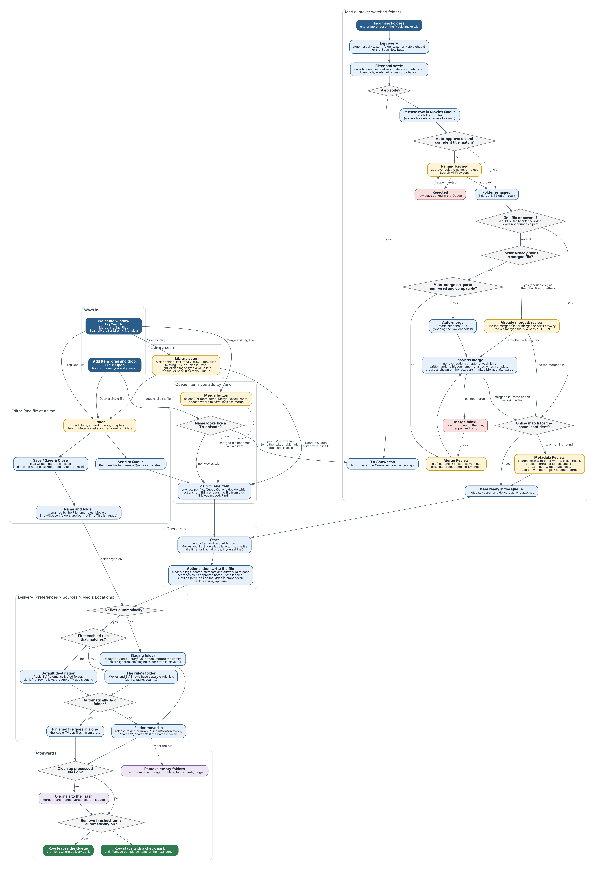
The complete flow of the app: every way in, the Editor, the Queue, Media Intake, delivery and cleanup. Yellow boxes are the moments where M3 asks for your decision.

2. Installing and starting M3
What you need. A Mac running macOS 10.13 or later (macOS 11 or later is recommended; a few interface details use newer system features) and an internet connection for metadata and artwork lookups.

2.1 Installing
- Download the latest zip from the Releases page of the project on GitHub (github.com/MediaMetadataManager/MediaMetadataManager).
- Unzip it and drag M3 into your Applications folder.
- The first time you open it, macOS may say it cannot verify the app. Open System Settings → Privacy & Security, scroll to the message about M3, click Open Anyway, and confirm. On older versions of macOS, right-click the app and choose Open instead. You only need to do this once.
You can also build M3 from source in Xcode; the project README has the instructions. The built app is the same normal Mac application.

2.2 Updating
Choose Media Metadata Manager → Check for Updates… to look for a newer version. M3 also checks for updates by itself about once a day and offers any it finds, with a short list of what changed. Accept the update and M3 downloads it, replaces itself and restarts.
M3 never takes updates from the original Subler; it uses this project’s own update feed only. Updating replaces the application only: your preferences, folders, keys and installed plugins stay where they are, so you do not need to set anything up again. To see which version you are running, open Media Metadata Manager → About.

2.3 First launch
On first launch you will see the Welcome window with three actions:
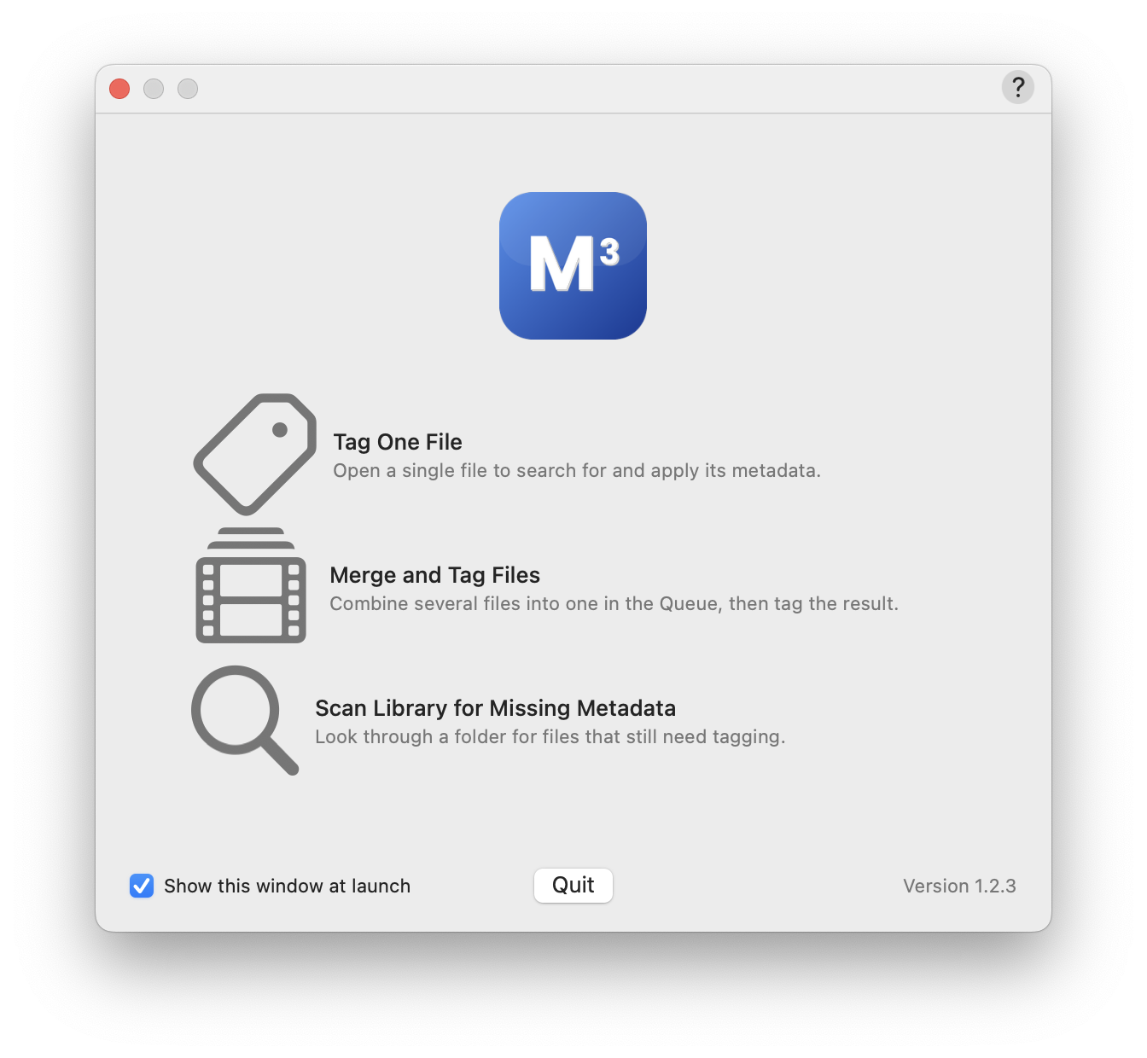
The Welcome window.
- Tag One File — open a single file to search for and apply its metadata.
- Merge and Tag Files — combine several files into one in the Queue, then tag the result.
- Scan Library for Missing Metadata — look through a folder for files that still need tagging.
Untick Show this window at launch to stop seeing it. You can choose what M3 does at launch under Settings → General → At Launch: show the open panel, show the main window, or show the Queue.

3. The windows

3.1 The Editor (single-file window)
Opening a file with File → Open…, from the Welcome window, or by double-clicking a Queue row’s Edit button shows the editor. It lists the file’s tracks, its chapters and its tags, and lets you change any of them.
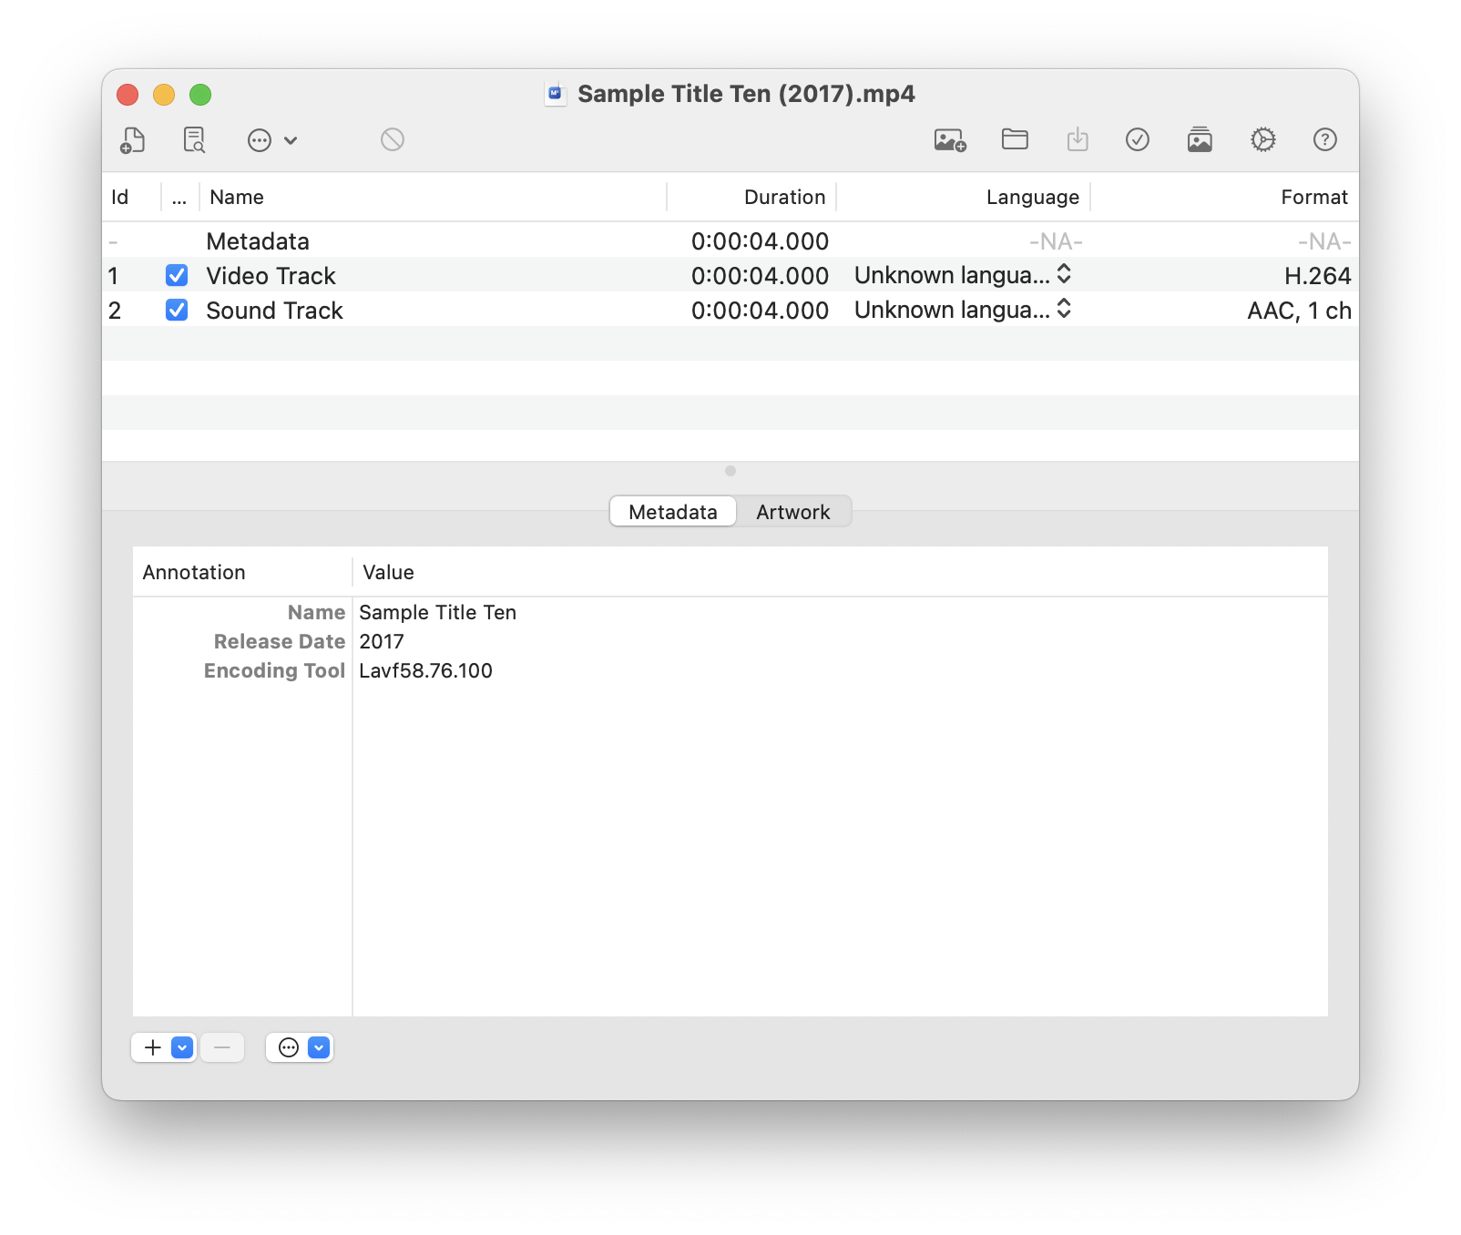
The Editor window.
Toolbar. The default toolbar contains:
Button | Action
Open | Open another file.
Save | Write your changes to the file.
Save & Close | Save and close the window in one step.
Search Metadata | Search the enabled providers and apply a result.
Send to Queue | Add the open document to the Queue instead of saving directly.
Queue | Show the Queue window.
Import / Delete / Action | Add a track from another file, remove the selected track, and a menu of track tasks (insert chapters at a fixed interval, organize alternate groups, clear or prettify track names, fix audio fallbacks, offset).
Settings | Open Settings.
You can change which buttons are shown, and whether they show icons, text or both, with View → Customize Toolbar… or by right-clicking the toolbar. Tip: if you customized the toolbar before an update, new buttons such as Save & Close appear in the Customize Toolbar sheet and can be dragged in.
Undo and redo. Every edit — tags, artwork, tracks, chapters — can be undone and redone with Edit → Undo / Redo. The window’s edited dot clears when you undo everything or save.

Searching for metadata
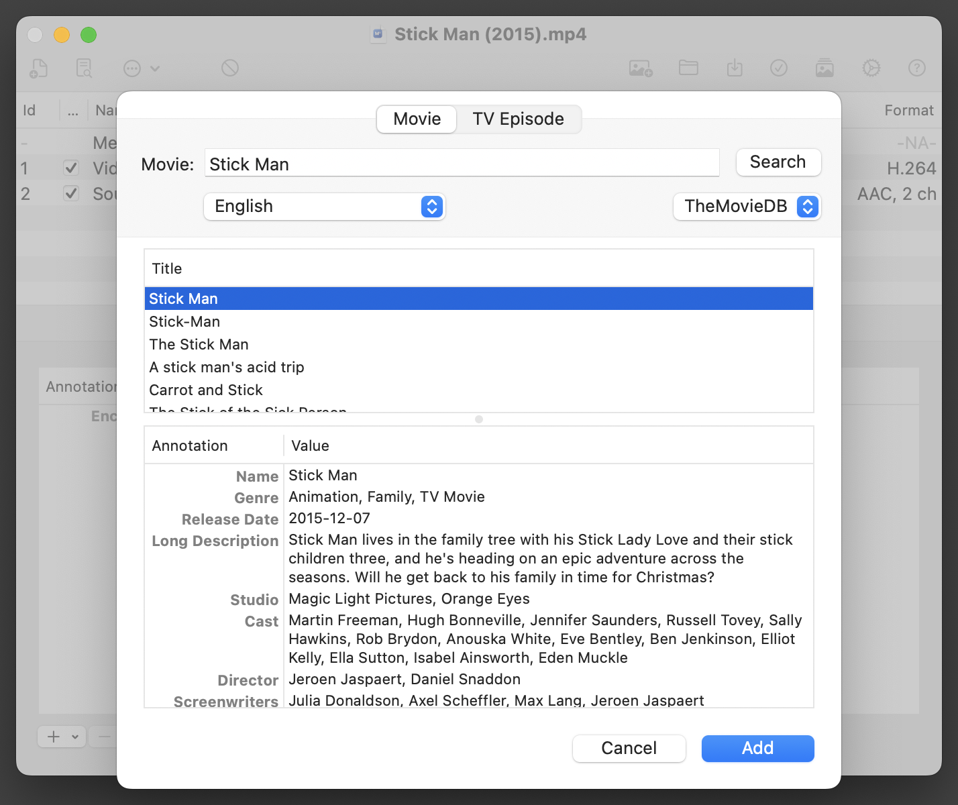
The Search Metadata sheet with a result previewed.
- Click Search Metadata. The title field is pre-filled from the file name, with release codes and quality tags removed.
- Results appear in a list. Select one to see its full metadata and artwork on the right. The first result is selected for you.
- Choose the artwork you want. Select All adds every available image; Load more artwork… fetches additional images.
- Click Add. Fields that changed are highlighted in the editor, with a tooltip, until you edit them by hand.
Important. If you save a movie that has no title tagged, M3 leaves its file name and folder alone. Run a metadata search first if you want the file renamed from its tags.

3.2 The Queue windows
Choose Window → Show Movies Queue or Window → Show TV Shows Queue, or click Queue in the editor’s toolbar. They all open the same Queue window, which has a Movies tab and a TV Shows tab; the menu item you chose decides which tab is showing. Each tab keeps its own list, the toolbar acts on the tab that is showing, and the window remembers its position and the last tab you used across launches. A TV show added by Intake opens its tab automatically. The Dock badge shows the combined number of waiting items.
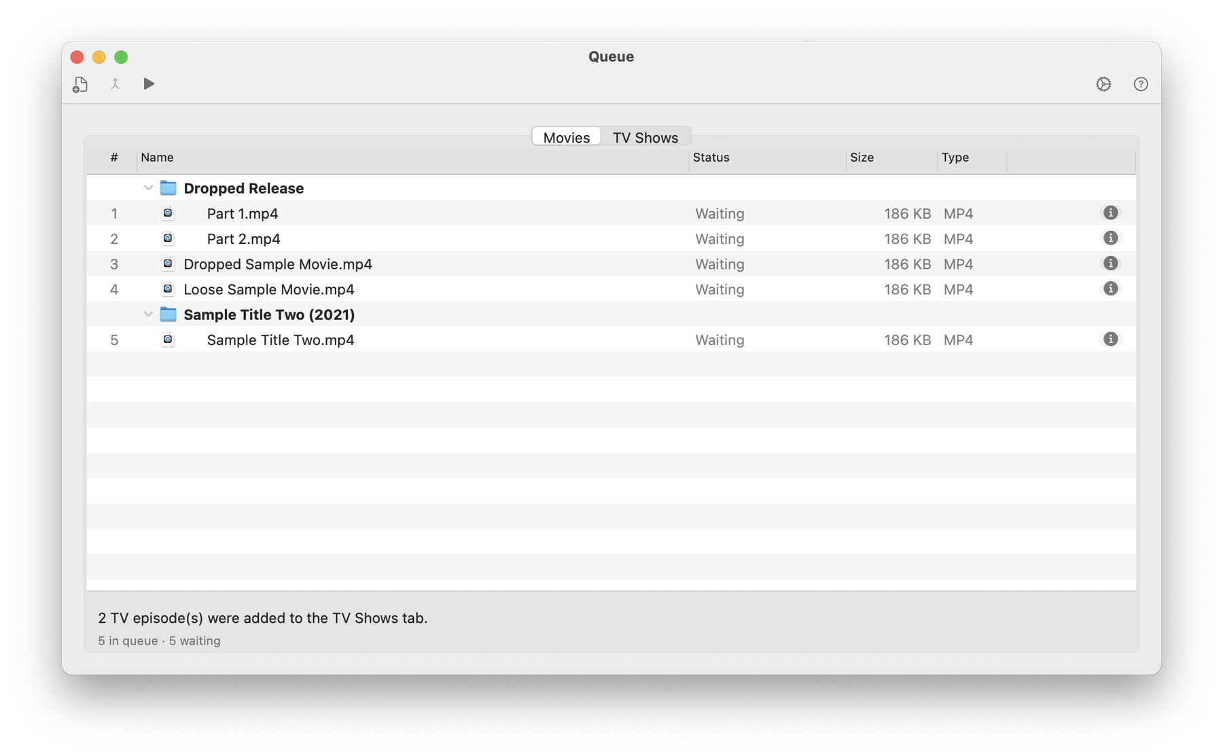
The Queue window with its Movies and TV Shows tabs, toolbar and columns.
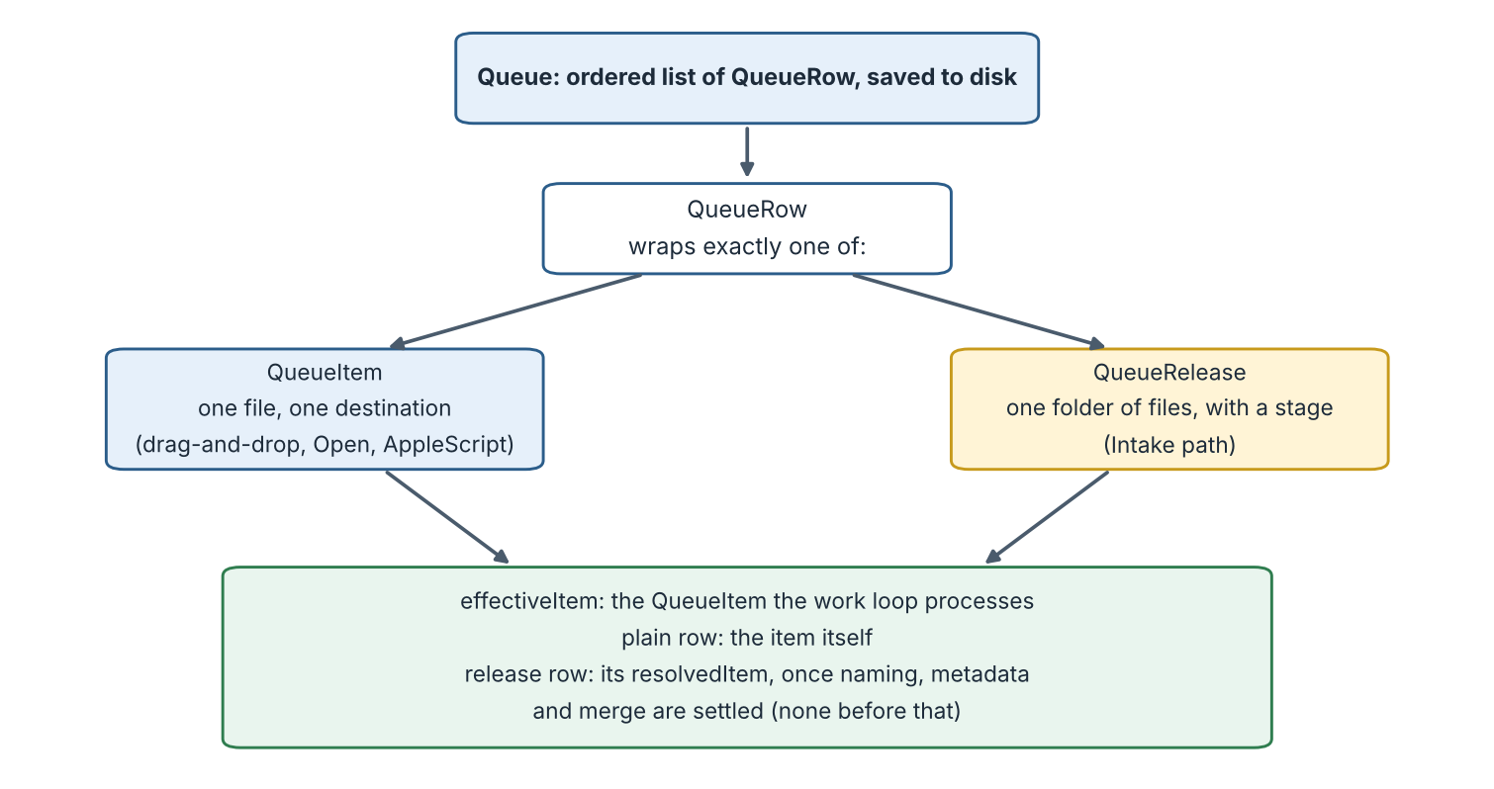
How a Queue row can be a plain item or a release, and what the work loop processes.
Toolbar. The default order, from the left, is Add Item, Merge, Start / Stop, flexible space, Settings.
Button | Action
Add Item | Add files or folders to the Queue by hand. Files added this way become plain items. Files are put on the tab they belong on: TV episodes on the TV Shows tab, everything else on the Movies tab (see Handle TV episodes in section 6).
Merge | Enabled when two or more not-yet-processed items are selected. Opens the Merge Review sheet, then asks where to save the merged file.
Start / Stop | Run or pause the Queue. Start asks how long to run: Until done, or a number of minutes. The file or merge in progress when the limit is reached always finishes; only the next one waits, and clicking Start again picks up where it left off.
Settings | Show or hide the Queue Options panel (see 3.3).
The toolbar’s display mode (icon, icon and text, or text only) also controls the Info and Edit buttons on each row and the progress display at the bottom of the window: with text shown, a percentage; with icons only, a progress bar.
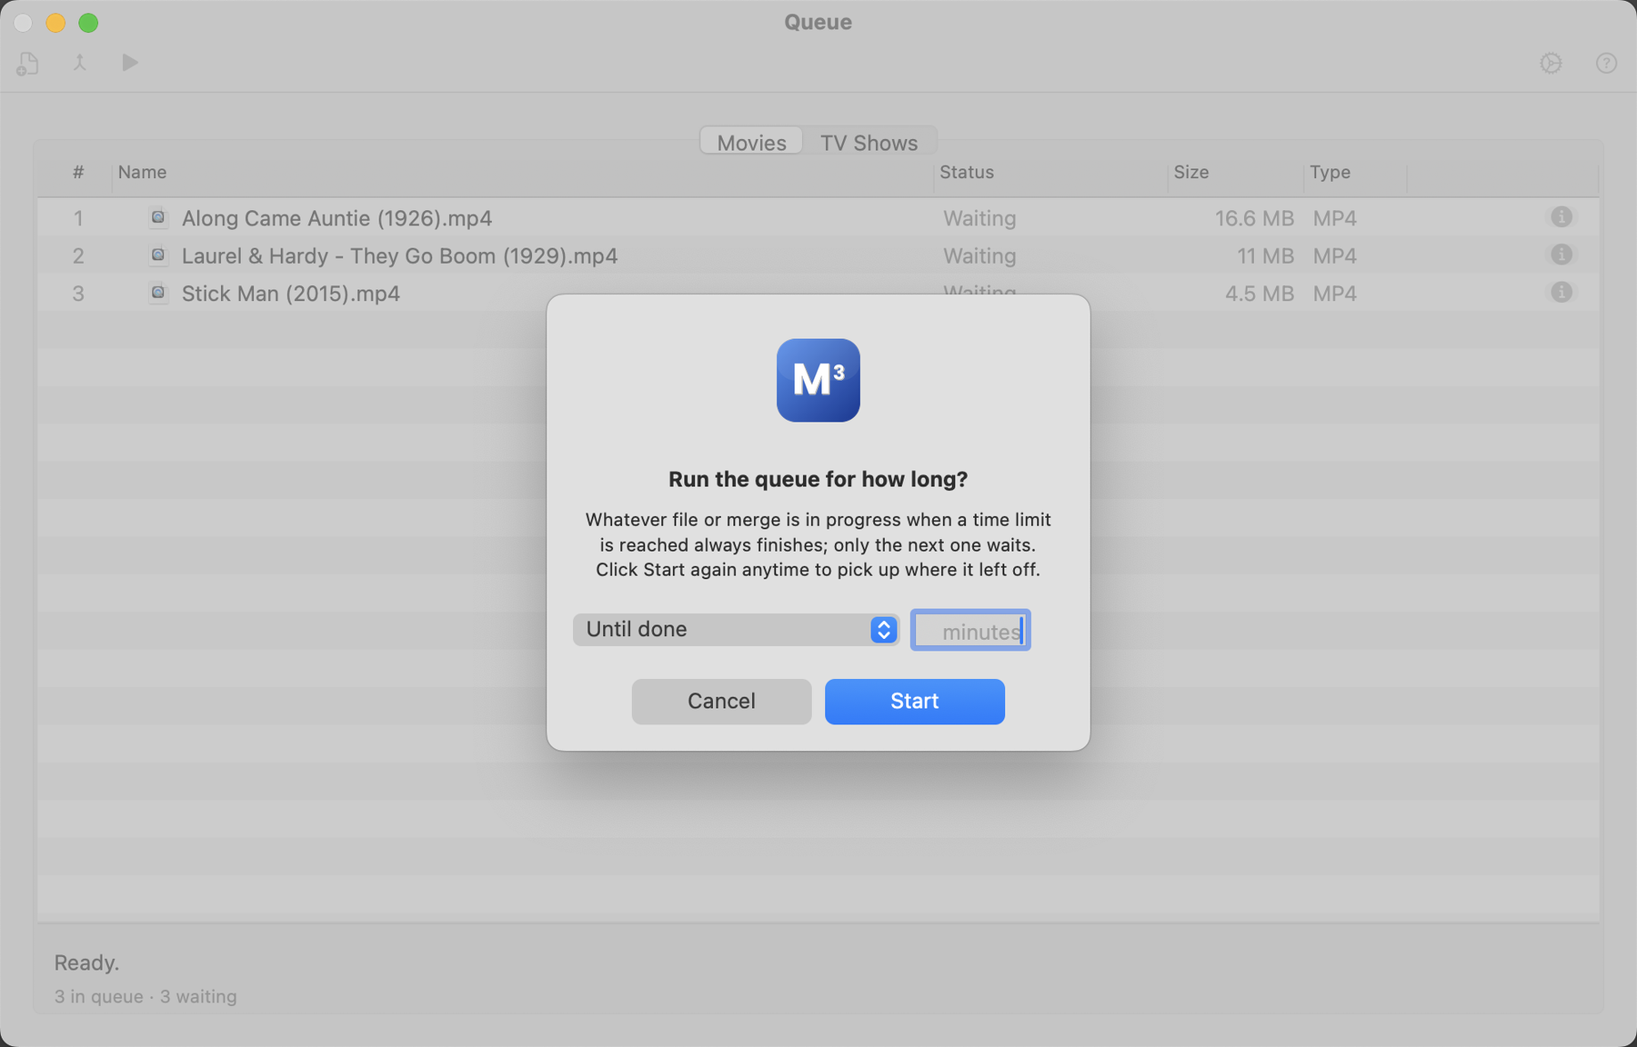
Start asks how long to run the Queue.
Columns. Each tab lists Name, Status, Size and Type. Click a column header to sort by it (A to Z, with numbers in names sorted as numbers) and click again to reverse. Drag the edge of a header to make a column wider or narrower, and drag a header to move the column; # stays at the far left and the buttons at the far right. Tag columns from a Library scan sort too, with files that have no value first. Sorting changes the order the files are processed in, can be undone with Edit → Undo, and rows can still be dragged. Files added from a folder stay under their folder.
Folders. A folder that is still waiting to be named or merged has a disclosure triangle. Click it, or press the Right and Left arrow keys on the selected folder, to list the files inside; Option-click opens or closes every folder at once. The listed files are for looking at only. While a folder is being merged, each of its files shows Merging in the Status column with a percentage, and the progress bar and status line at the bottom follow the merge.
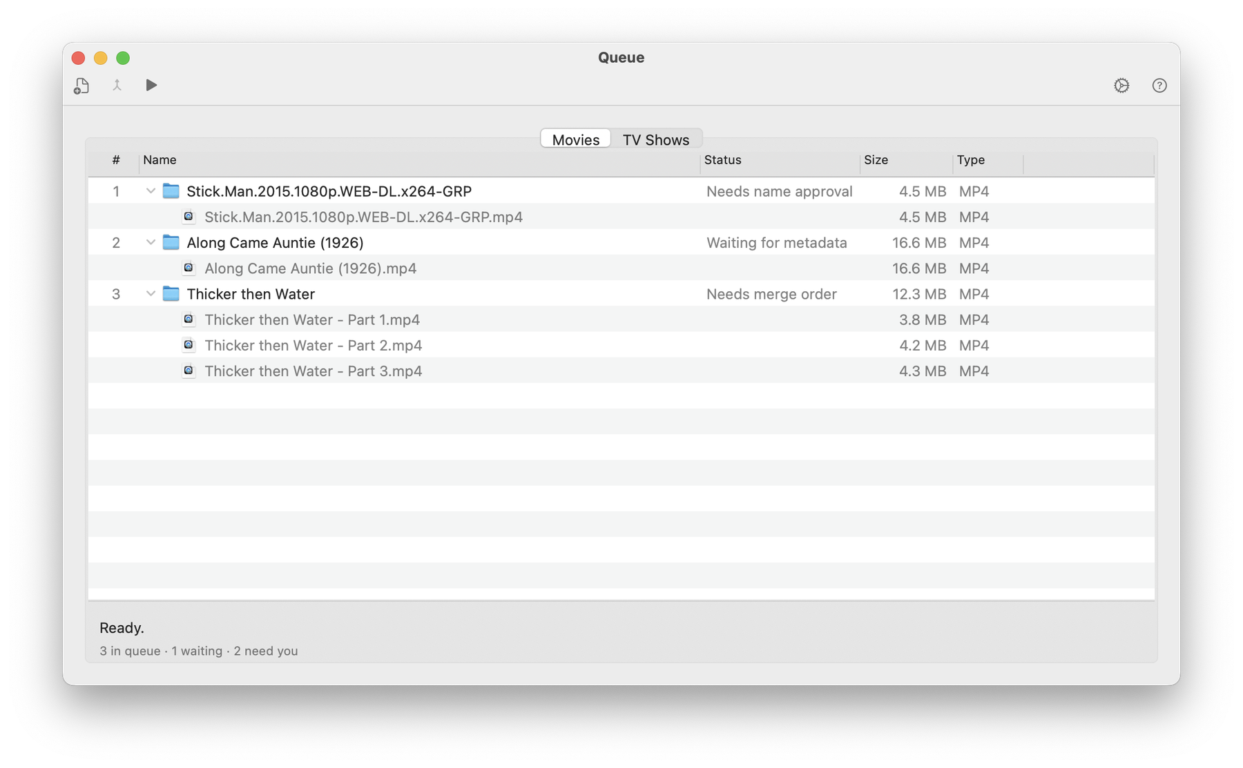
A folder row opened to show the files inside.
Rows. Each row shows a status icon and the name. On the right are two buttons:
- Info shows the item’s source, destination and the actions that will run.
- Edit opens the editor for that file, or the right review sheet for a release that is waiting for you.
Closing an editor window does not remove its row.
Row states for a release.
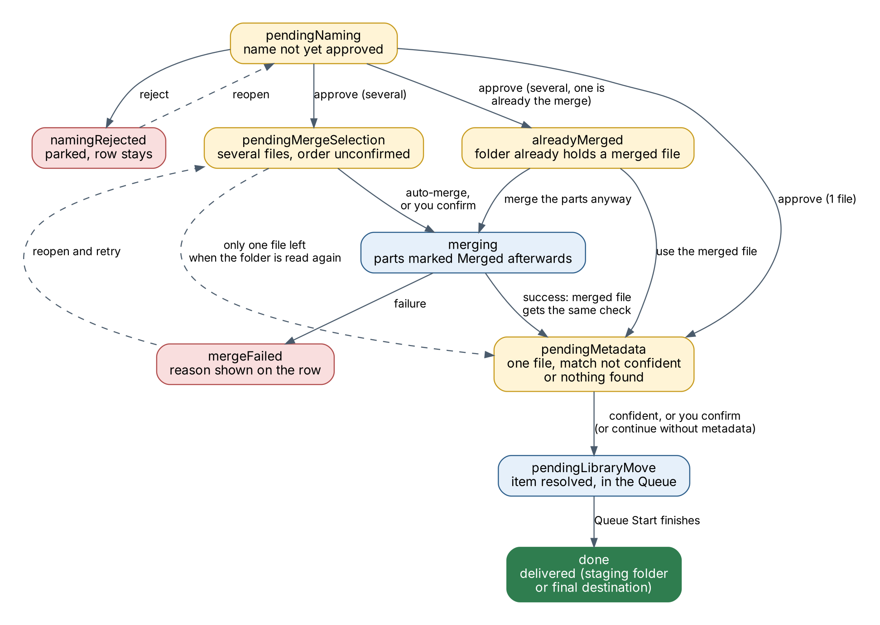
The stages of a release and the events that move it from one to the next.
State | Meaning | What to do
Waiting for naming | The folder was found; its name is not yet approved. | Double-click to open Naming Review.
Naming rejected | You rejected the suggested name. The row stays so nothing is lost. | Double-click to review again.
Waiting for metadata review | One file (or a merged file); the online match was not confident enough, or nothing was found. | Double-click to open Metadata Review.
Waiting for merge order | Several files; the order is not yet confirmed. | Double-click to open Merge Review.
Already merged: review | The folder already holds a merged file (one about as big as all the other files together), so M3 did not merge the parts again. | Double-click to use the merged file, or to merge the parts anyway (the existing merged file is kept and renamed with " - OLD" added).
Merging | The parts are being joined. | Wait; progress is shown on the row.
Merged | The parts of this folder have been merged; each part file shows Merged in the Status column. | Nothing; carry on with the merged file.
Merge failed | The parts could not be joined. The reason is shown in plain language. | Double-click, adjust the selection, retry.
Ready | A single file is ready to be written. | Click Start.
Done | The release has been delivered: to the staging folder, or with automatic delivery on, to its final destination. | Remove it with Remove completed items, or turn on Remove finished items from the Queue automatically.
Context menu. Right-click a row for Reveal in Finder, Edit…, Remove from queue and Remove completed items. You can also drag rows to change their order, and drop files or folders from Finder into the window. A dropped folder is grouped under its own folder row, exactly as with the Add button; a show folder that holds Season folders gets one group per Season folder. A dropped file is added as a single row. Episodes and movies are put on the tab they belong on, in the same way as with Add.

3.3 Queue Options
The Settings button reveals the options applied to items you add by hand and to released items as they are processed:
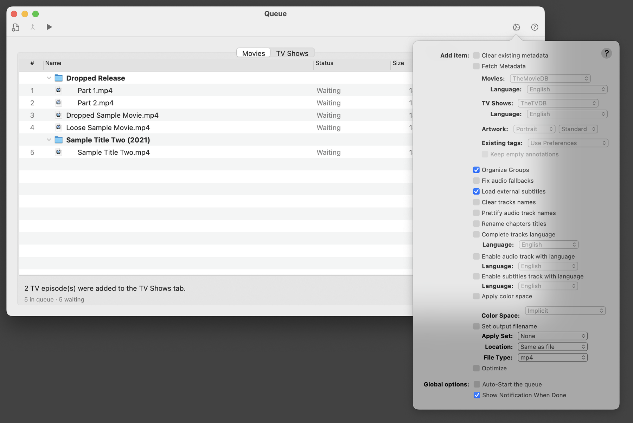
The Queue Options panel.
- Global options: Auto-Start the queue; Show Notification When Done (macOS asks permission the first time).
- Location and File Type (mp4 or m4v) for the output.
- Apply Set (applied after the online search, for hand-added files and Intake releases alike: the tags the Set fills in replace the searched values, and tags it leaves blank keep them), Fetch Metadata and the provider language for Movies and TV Shows, Artwork shape (Portrait, Landscape, Square or Rectangle), Existing tags (what the search does with tags a file already has: Use Settings, which follows Settings > Metadata, Fill missing only, Append (add artwork) or Overwrite; with the last three, Keep empty annotations can be ticked), and Set output filename.
- Track tidy-ups: Clear existing metadata, Rename chapter titles, Organize groups, Prettify audio track names, Fix audio fallbacks, Clear track names, Load external subtitles, Complete tracks language, Enable audio / subtitle track with language.
- Optimize and the color space options. Where a finished file goes is decided by the Media Locations tab (see 5.5), not by the Queue options.

3.4 Review sheets
Naming Review. Shows the original folder name, how many files it holds, and an editable suggested name. A local guess appears immediately; a background search of your enabled providers refines it unless you have started typing. Buttons:
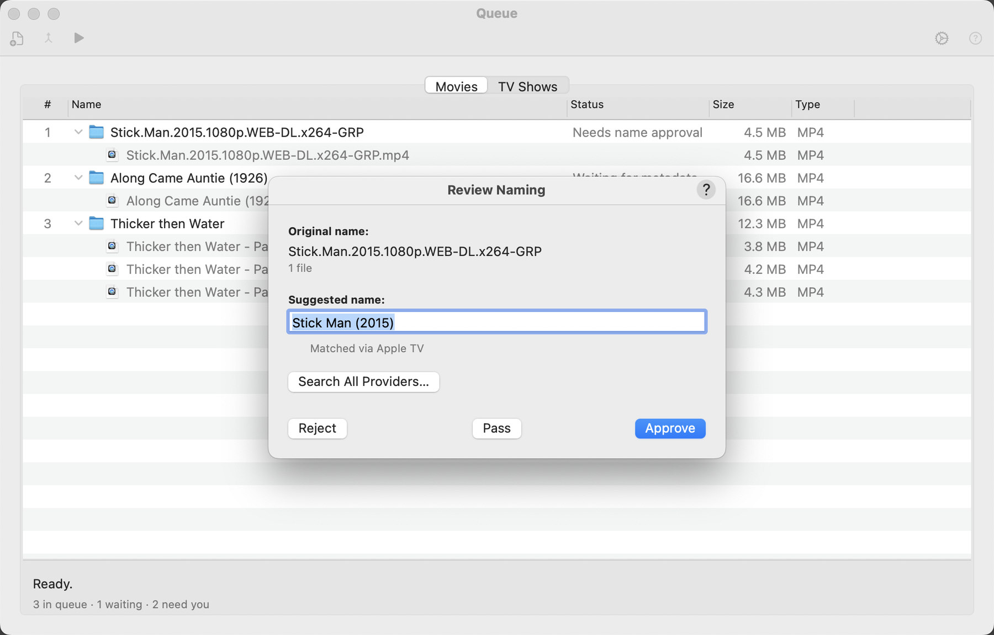
The Naming Review sheet.
- Approve renames the folder to the approved name.
- Reject parks the row without touching any file.
- Search All Providers… runs a second pass that shows one result from every enabled provider, so you can pick the correct one.
If Automatically approve high-confidence naming matches is on and the online title matches the file name exactly (and the years agree when both are known), the sheet approves itself after about a second. Typing in the field or clicking a button cancels that.
Metadata Review. Appears for a single-file release whose automatic match was not confident, or when the online search found nothing at all. It shows the match found and an artwork preview, with a Portrait / Landscape control that applies only to this release. If the match is wrong or missing, change the words in Search for and press Search (or Return), then pick the right entry from the list of results. Use This Match applies the entry you picked. If nothing can be found, Continue Without Metadata delivers the file as it is.
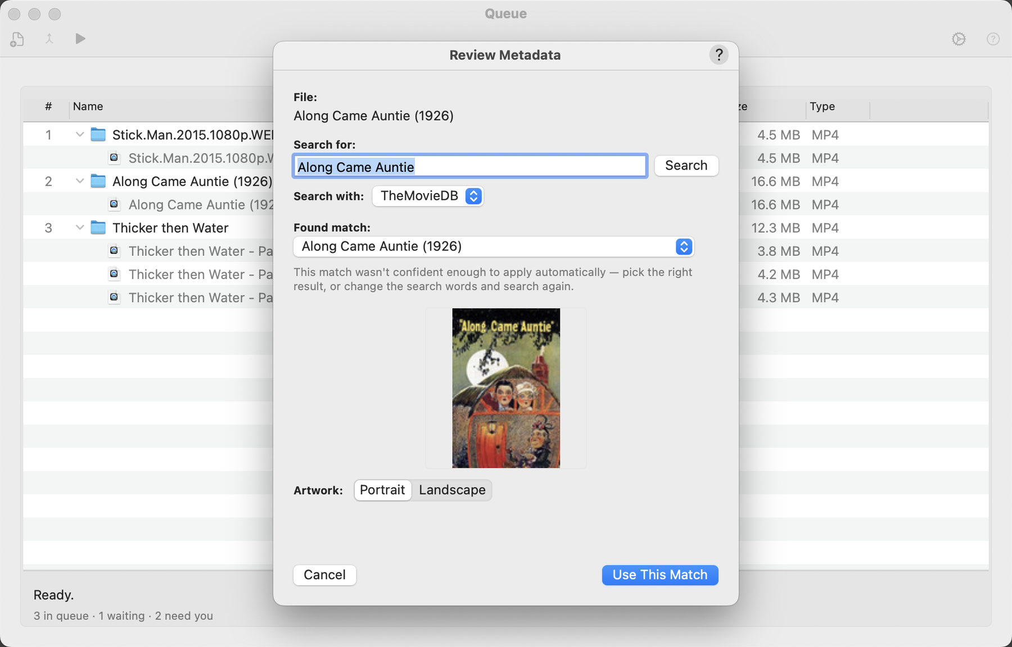
The Metadata Review sheet.
Merge Review. Lists the parts. Drag them into play order. The sheet starts in the order implied by the files’ own numbers (01, 02, Part 1, e1…). Confirming starts the merge.
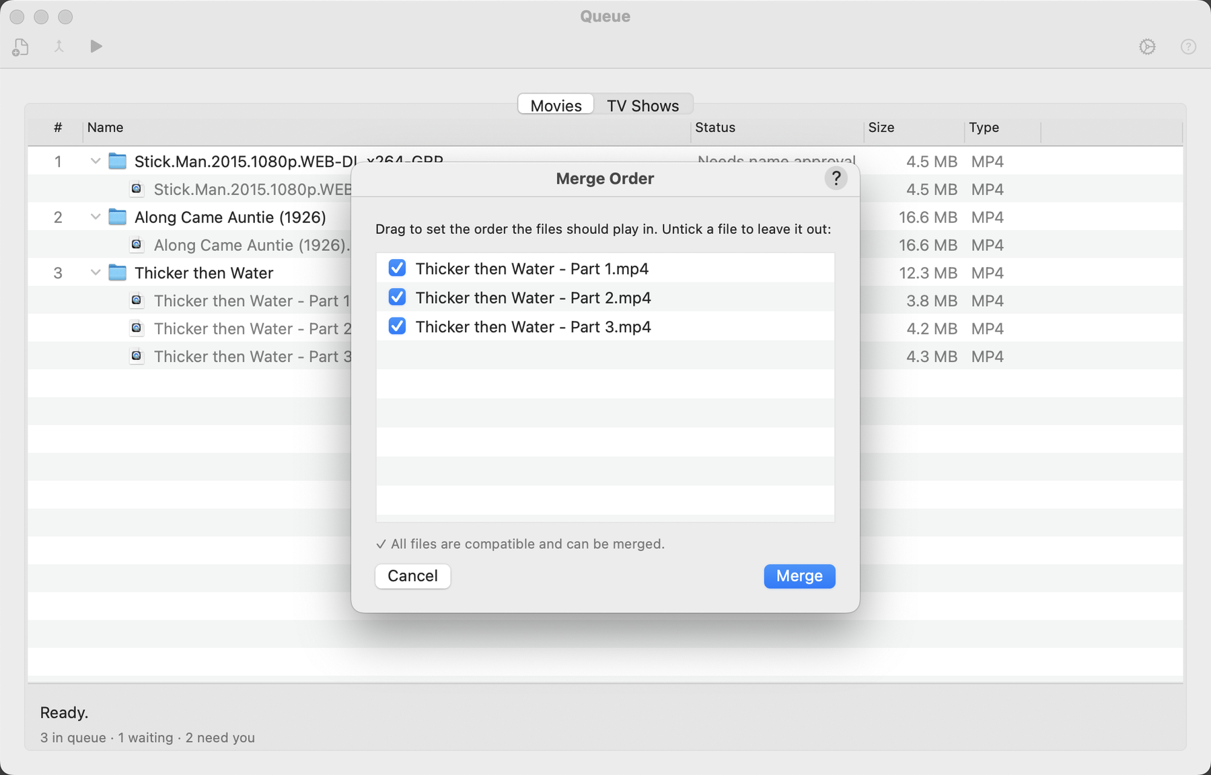
The Merge Review sheet.

3.5 Library scan window
Choose Scan Library for Missing Metadata on the Welcome window. Pick a folder and click Scan. M3 walks the folder for finished .mp4, .m4v and .mov files and lists those missing a Title or Release Date. The gear button lists other tags (Rating and Studio among them) that you can tick to look for as well. The table has a File column and one column for each tag being checked, showing the file’s value, or a red Missing. Drag the edge of a column heading to resize it, drag a heading to move it, and click a heading to sort by it (an arrow shows the direction; files with a missing value come first). The window can be made larger and remembers its size, and the order, widths and sort of the columns. Double-click a file to open it in the editor. The buttons along the bottom are Pause, Scan and Done. While a scan is running, Pause lets it finish the file it is reading and wait, with the files found so far in the list; the button then reads Resume and carries on from the same place. Scan reads Stop while a scan is running and ends it, keeping what was found. Clear (or right-click → Clear List) empties the list once files are loaded, keeping the folder so you can scan again; no file is changed. It is off while a scan is running, so press Stop first.
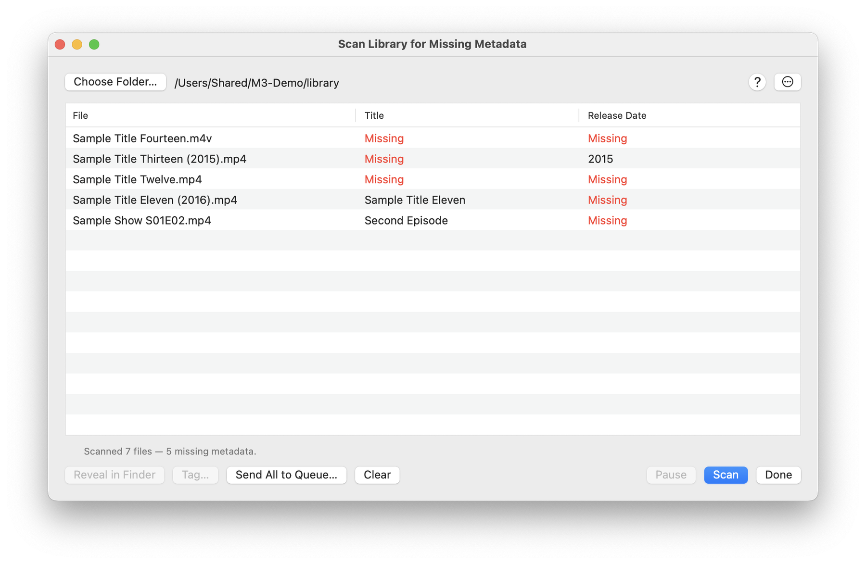
The library scan window.
To fix the gaps, right-click a tag cell and choose Edit…, type the value and press Return: it is written straight into that file (M3 keeps a copy of the file until the write has worked). Rating, artwork and other tags that are not plain text, numbers or dates are changed in the editor instead. To let the Queue find the metadata, select the files (Command-A selects all) and click Send Selected to Queue… (the button reads Send All to Queue… when nothing is selected), or right-click and choose Send to Queue for In-Place Edit…. M3 asks first. Each file is then edited where it sits: the Queue searches for its metadata and writes the tags into the file, with no copy and no move to your library. If Set output filename is on in the Queue options, the file is also renamed from its tags. The Queue shows the scan’s tag columns for these files, so you can watch the gaps being filled: each file starts with the values the scan found (a red Missing for a gap) and is read again when the Queue has finished it. The columns go away when no such file is left in the Queue. A scan on its own never changes a file; only these two commands do.
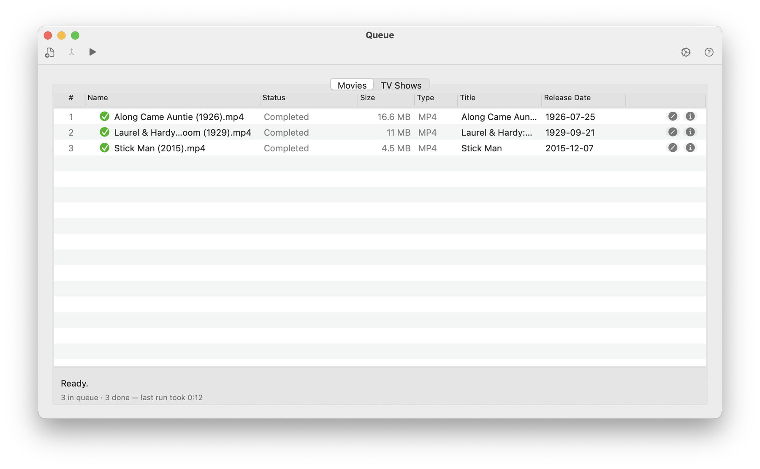
Files sent from the scan are edited where they sit.
The scan reads only each file’s tags, not its tracks or chapters, so it is light on the drive, and the status line names the file it is reading. The gear button next to Scan shows the two tags that are always checked (Title and Release Date) and a list of every other tag from Metadata; tick any of them to have the scan look for those too. Your choice is remembered. A file that cannot be read within 20 seconds is listed as Unreadable (timed out) and the scan carries on; if three files in a row cannot be read, the scan stops and tells you to check the drive. Slow reads are written to the message log.
Scanning a library server. If a plugin that connects to your own media server (a library server) is installed, a Source pop-up appears beside the folder button. Choose Folder… for the scan above, or the server’s name to compare what the server holds with your files. Click Scan: M3 asks the server for its list of movies, finds each file at the path the server gives, reads its tags and lists only the files where the server has something the file lacks. Those entries are shown in orange as Missing — server has: followed by the server’s value. A movie the server lists whose file is not at that path shows File not found; the server and this Mac must see the same path, so a drive shared from another computer has to be mounted here under the same path.
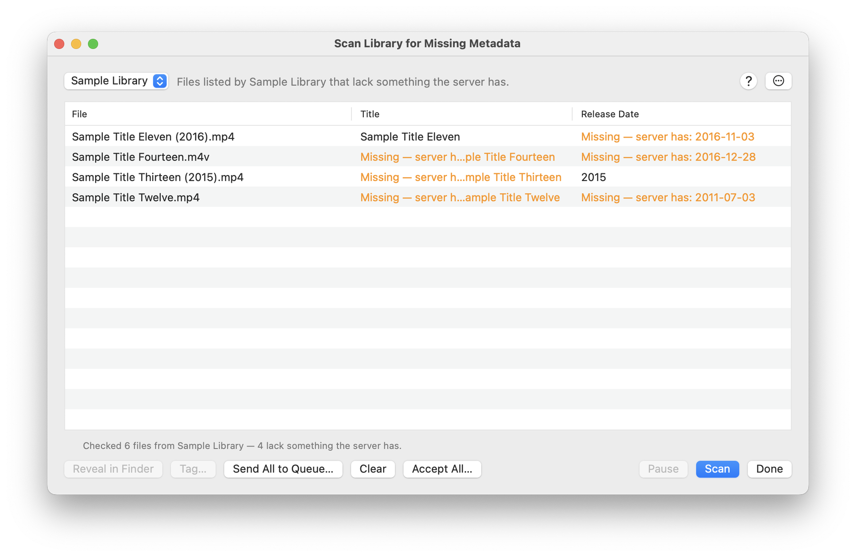
The library scan with a library server as the Source.
To fill the gaps, right-click an orange cell and choose Accept Server Value to write that one tag into the file. Choose Accept Server Values… to do it for the selected files, or click Accept Selected… at the bottom (Accept All… when nothing is selected). M3 asks first, writes only tags the file lacks, keeps a copy of each file until its write has worked, and takes a file off the list once the server has nothing more to give it. Cast, rating and cover cannot be typed in the table, so they stay orange; Send to Queue fills them: for each file the Queue loads the server’s own item by its id, with no search, and adds only the tags the file lacks. Edit… on an orange cell starts with the server’s value, so Return accepts it. Changing the Source empties the list.

3.6 Message log
Window → Show Message Log shows what M3 has been doing. It is the first place to look, and the thing to attach, when reporting a problem.
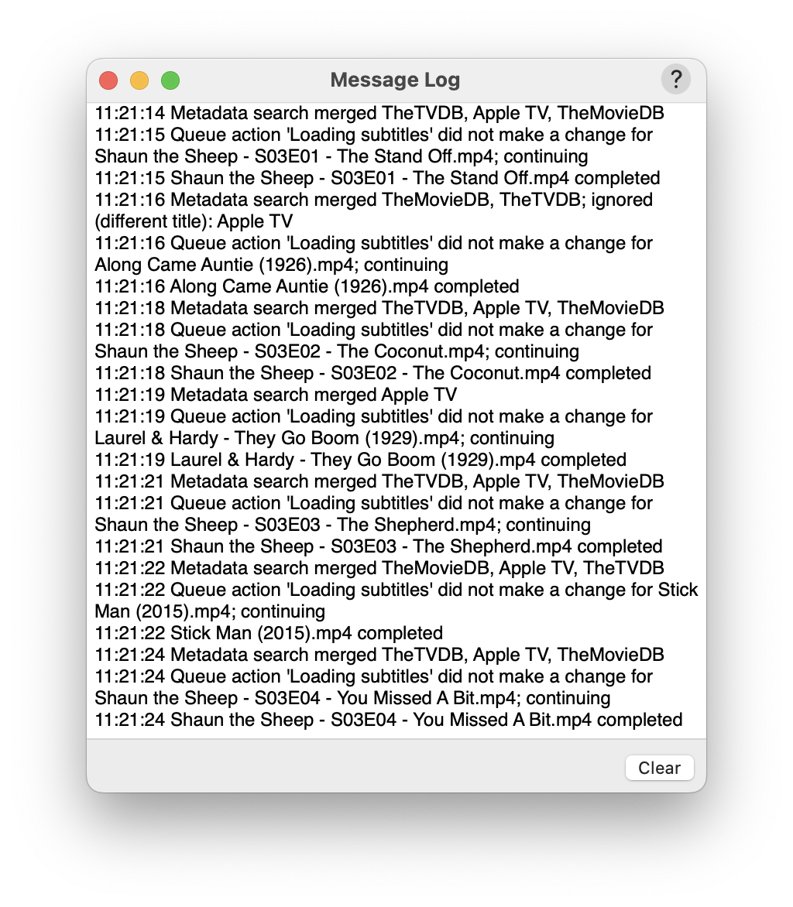
The Message Log.

4. Settings
Open Media Metadata Manager → Settings… (or the Settings toolbar button). On macOS 12 and earlier the menu item is called Preferences…. Tabs:

General
At-launch behavior, whether the window remembers its size, the default artwork position (Portrait or Landscape), chapter preview image position, log format, the ratings region to show (USA ratings are always shown), and privacy actions: Clear recent searches and Delete cached metadata.
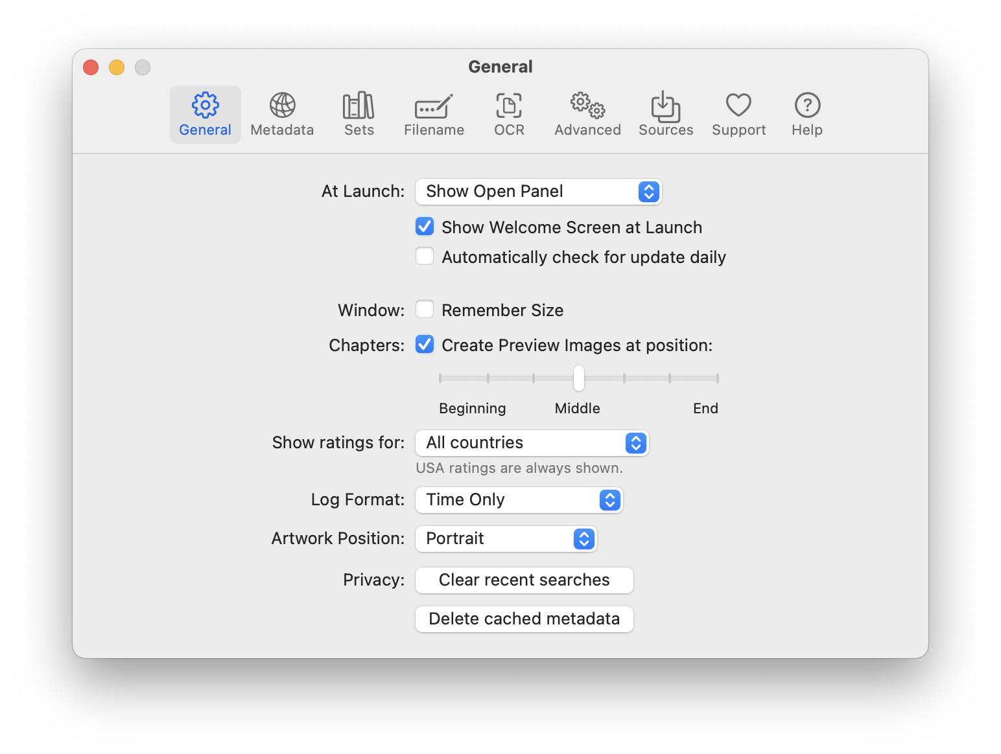
Settings > General.

Metadata
Choose which tags are shown for Movies and TV Shows and in what order. Below the list, Keep empty annotations keeps tags a search found but left blank, Overwrite existing metadata lets a search replace tags a file already has, and Append to existing metadata adds new cover art next to the art already there (the last two exclude each other; with neither ticked, only gaps are filled). The Queue follows these unless its own Existing tags option (see 3.3) says otherwise. Fill Series Description for sequels/parts copies the series description when a title ends in a number or in “Part…”.
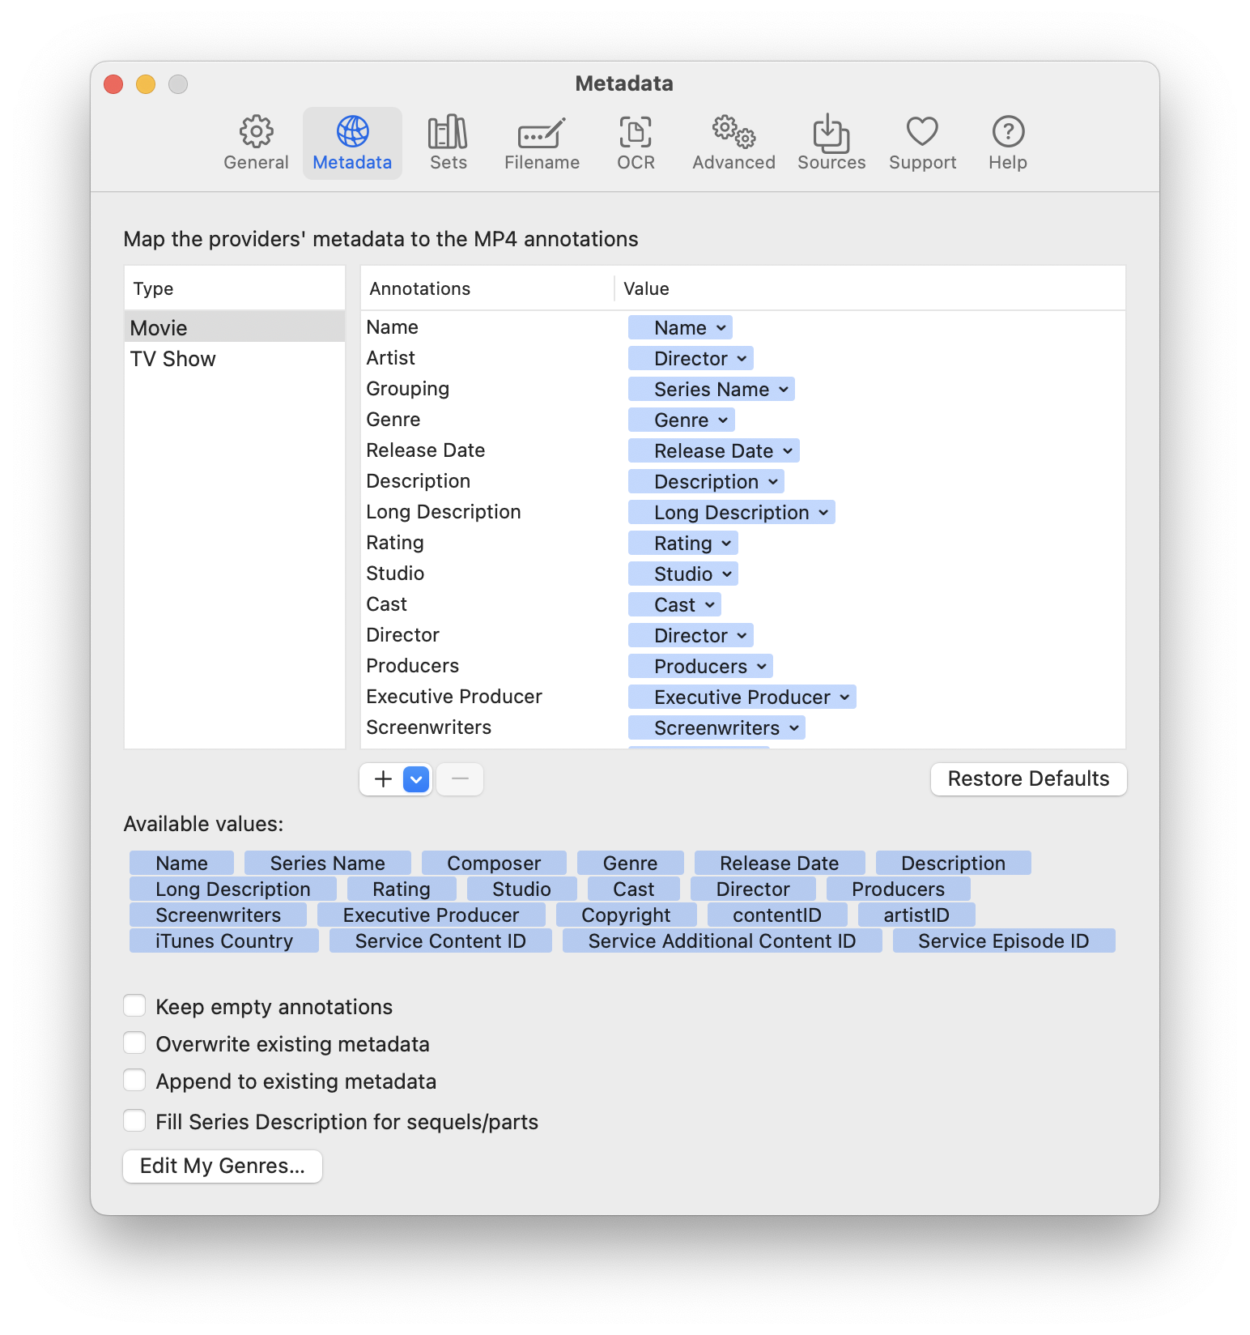
Settings > Metadata.

Sets
Create and edit Sets: saved groups of settings you can reuse. Metadata sets hold tag values (genre, studio, rating and so on) that can be applied to a file with one click; Queue sets hold a group of Queue options. Choose a set in the Queue options and it is applied to every item automatically, so sets can be a step in a workflow: add files and each one is tagged the same way as it is processed.

Filename
Naming rules decide the output file name. There is a rule list for Movies and one for TV Shows. Each rule is a template built from tokens (title, studio, year and so on) with optional conditions (If / And / Or a field has a value). The first matching rule wins; the Default rule is used when none matches. A rule can be switched off with its checkbox. Two extra options live here:
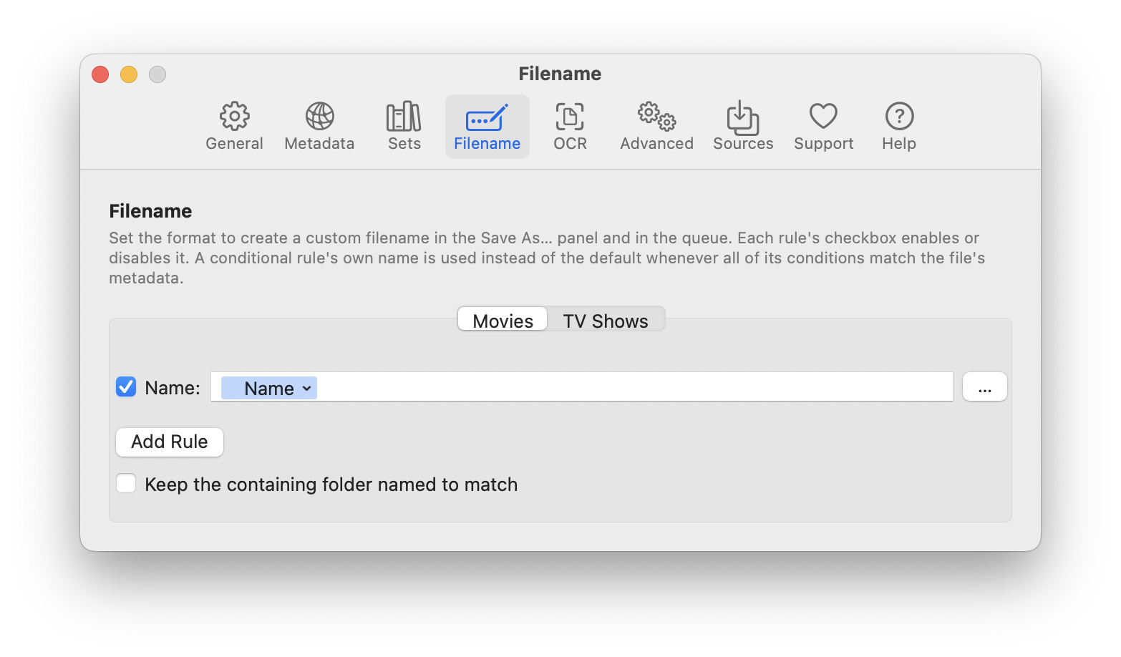
Settings > Filename: naming rules.
- Keep the containing folder named to match — after saving, rename a folder that holds only this one movie to the same name as the file.
- Organize into Show/Season folders (Apple TV style) — create Show/Season NN folders for TV episodes.
A movie with no title tagged is never renamed, whatever the rules say.

OCR
Download or remove the language data used to convert image-based subtitles to text.

Advanced
Audio conversion choices (AC-3, DTS, downmix, dynamic range control, bitrate), Force QuickTime Compatibility, Infer media characteristics, alternate-group organization and HEVC options.

Sources
Four sub-tabs:
- Providers — tick the built-in providers you want for Movies and for TV Shows. Installed plugins appear in the same list, each with a Configure… button where the plugin needs settings. Complete Content Search asks TheMovieDB to include its complete result set.
- Custom Sources — define your own providers (see section 7).
- Media Intake — the Intake workflow settings (see section 5).
- Media Locations — where finished files are delivered: the Apple TV Automatically Add folder as the default, rules by metadata, and the staging folder (see 5.5).

Support
Links to sponsor Media Metadata Manager through GitHub Sponsors and to the original Subler project, whose author Damiano Galassi created the app M3 is built on. The same two links are in a small dialog under Media Metadata Manager → Support…. Nothing pops up on its own, and the buttons only open a web page in your browser.

5. Media Intake in detail
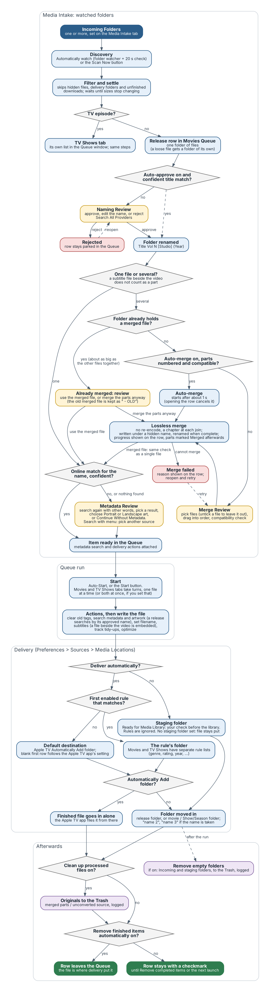
The Intake pipeline, from the watched folder to delivery. Yellow boxes are the moments where M3 asks for your decision.

5.1 Settings reference
All of these are in Settings → Sources → Media Intake. Hover over any option to see its tooltip.
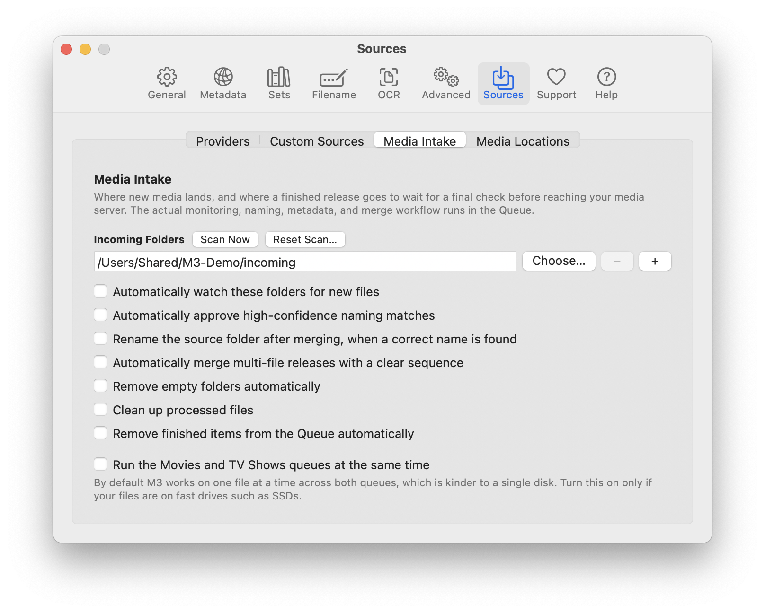
Settings > Sources > Media Intake.
Setting | Default | What it does
Incoming Folders (+ / −, Choose…) | none | The folders M3 looks in. Loose files are wrapped in a folder of their own; folders holding media (up to three levels down) become releases.
Scan Now | — | Looks in the Incoming Folders immediately and adds what it finds, even when watching is off, without waiting for files to settle. TV episodes go to the TV Shows Queue.
Reset Scan… | — | Forgets which files the scan has already taken in, then scans again. Use it when something sitting in an Incoming Folder is not being picked up, for example after you removed its row from the Queue. Anything already in a Queue is not duplicated.
Automatically watch these folders for new files | off | Watches the folders and also re-checks every 20 seconds. A new item is added once its files have stopped changing for about 10 seconds.
Automatically approve high-confidence naming matches | off | Approves the suggested name without a click when the online title matches exactly.
Rename the source folder after merging, when a correct name is found | off | After a manual Queue merge, renames the download folder to a correct release name found nearby (a cover image, the folder name, or a well-named video). Never overwrites an existing folder.
Automatically merge multi-file releases with a clear sequence | off | When every part carries a sequence number and the parts are compatible, merges after about a second instead of stopping at Merge Review. Opening the row in that second cancels it.
Remove empty folders automatically | off | After each Queue run and each editor save, moves empty folders inside the Incoming and Ready folders to the Trash and logs them. Folders touched in the last two minutes are left alone. The same cleanup can be run by hand with Window → Clean Up Empty Folders….
Clean up processed files | off | After a release is moved into Ready for Media Library, moves the original files it was made from (the parts that were merged, or the unconverted source when the Queue converted a file) to the Trash and logs them. The finished file is never touched. This applies to Queue runs only; it does not apply to a file you tag with Edit and Save (see 5.4).
Remove finished items from the Queue automatically | off | When a Queue run finishes, the rows with a checkmark are taken off the list. Only the rows are removed, never files. Failed rows and rows still waiting for you stay.
Run the Movies and TV Shows queues at the same time | off | Off: the two queues take turns, one file at a time, which is kinder to a single disk. On: each queue works by itself, so two files can be processed at once. Turn it on only if your files are on fast drives such as SSDs.
Ready for Media Library | none | Now set on the Media Locations tab (see 5.5), where it is the staging folder: finished files wait there for you to check them.
Automatically Add to Apple TV Folders |  | Now on the Media Locations tab (see 5.5), where it is the default destination.

5.2 What happens, step by step
- Discovery. M3 finds media files in the Incoming Folders. It ignores hidden files, packages, symbolic links, the Ready folder, and folders that still contain unfinished downloads (.part, .crdownload and similar). Anything it has already taken in, or that is already in a Queue, is skipped. A path is forgotten once the file is gone, so putting a file with the same name back later is treated as new.
- TV or movie. A name with a season and episode marker (for example S02E05 or 2x05) goes to the TV Shows Queue; everything else goes to the Movies Queue.
- Naming. M3 proposes Title Vol N [Studio] (Year). It understands uploader-stamped names such as 2026_Uploader_Title_Studio_720p and 03.10.2026_Uploader_Title_Studio_720p, and scene names such as Title.2023.1080p.WEB-DL.x264-GROUP. You approve, edit or reject, or it is approved automatically when you have chosen that option.
- Metadata or merge. One file: the online match is checked. Several files: the parts are checked for compatibility and ordered, merged, and then the merged file gets the same online match check as a single file. The merged file appears under its final name only when it is complete (a merge of a long movie can take ten minutes or more).
- Ready. The release becomes a normal Queue item with a metadata step and a move-to-library step attached.
- Start. The Queue writes the file, searches the provider you chose, applies artwork and tags, and then moves the whole release folder into Ready for Media Library. If a folder with that name already exists there, the new one is called name 2, name 3 and so on; nothing is overwritten.
- Cleanup (if enabled), then your final check in the Ready folder.

5.3 Lossless merge
Joining parts does not re-encode anything. M3 splices the compressed video and audio samples one after another and adds a chapter at each join, named after the source file.
Parts are merged only when they match: the same number of video, audio and subtitle tracks, the same codecs and time scales, and the same picture size. If they do not match, the merge is refused and the row explains which file differs and how. Nothing is partly merged. Incompatible parts need to be converted first.
Subtitle files. A subtitle file beside a video (.srt, .ass or .ssa) is not a part of the movie, so it never counts toward a merge. A folder holding one video and its subtitle file is a single file; the subtitles are embedded in the finished file. With Clean up processed files on, the subtitle files that were embedded are moved to the Trash with the other originals.
You can also merge by hand: select two or more items in the Queue and click Merge, or choose several files in File → Open… and answer Merge Into One File…. The merged file is written next to the parts by default.

5.4 Safety guarantees
- Intake only moves files and folders; it never deletes. Removal happens only through the two cleanup options, and only to the Trash.
- Tagging a single file with Edit and Save works in place. The tags are written into the file itself, the file may be renamed, and its folder is moved into Ready for Media Library. M3 does not keep a copy of the original and nothing is sent to the Trash, so the previous tags cannot be restored afterwards. If you want a backup, copy the file before you save. (Queue merges keep their parts unless you turn on Clean up processed files.)
- Cleanup actions are written to Removed Empty Folders.txt and Cleaned Up Processed Files.txt in ~/Library/Application Support/M3/.
- A failed move (disk full, drive disconnected) cleans up after itself and offers another location.
- Parts are kept after a merge unless you turn on Clean up processed files, so you can check the result before the originals are gone.

5.5 Media Locations: where finished files go
Settings → Sources → Media Locations decides where a finished file ends up. It has three parts.
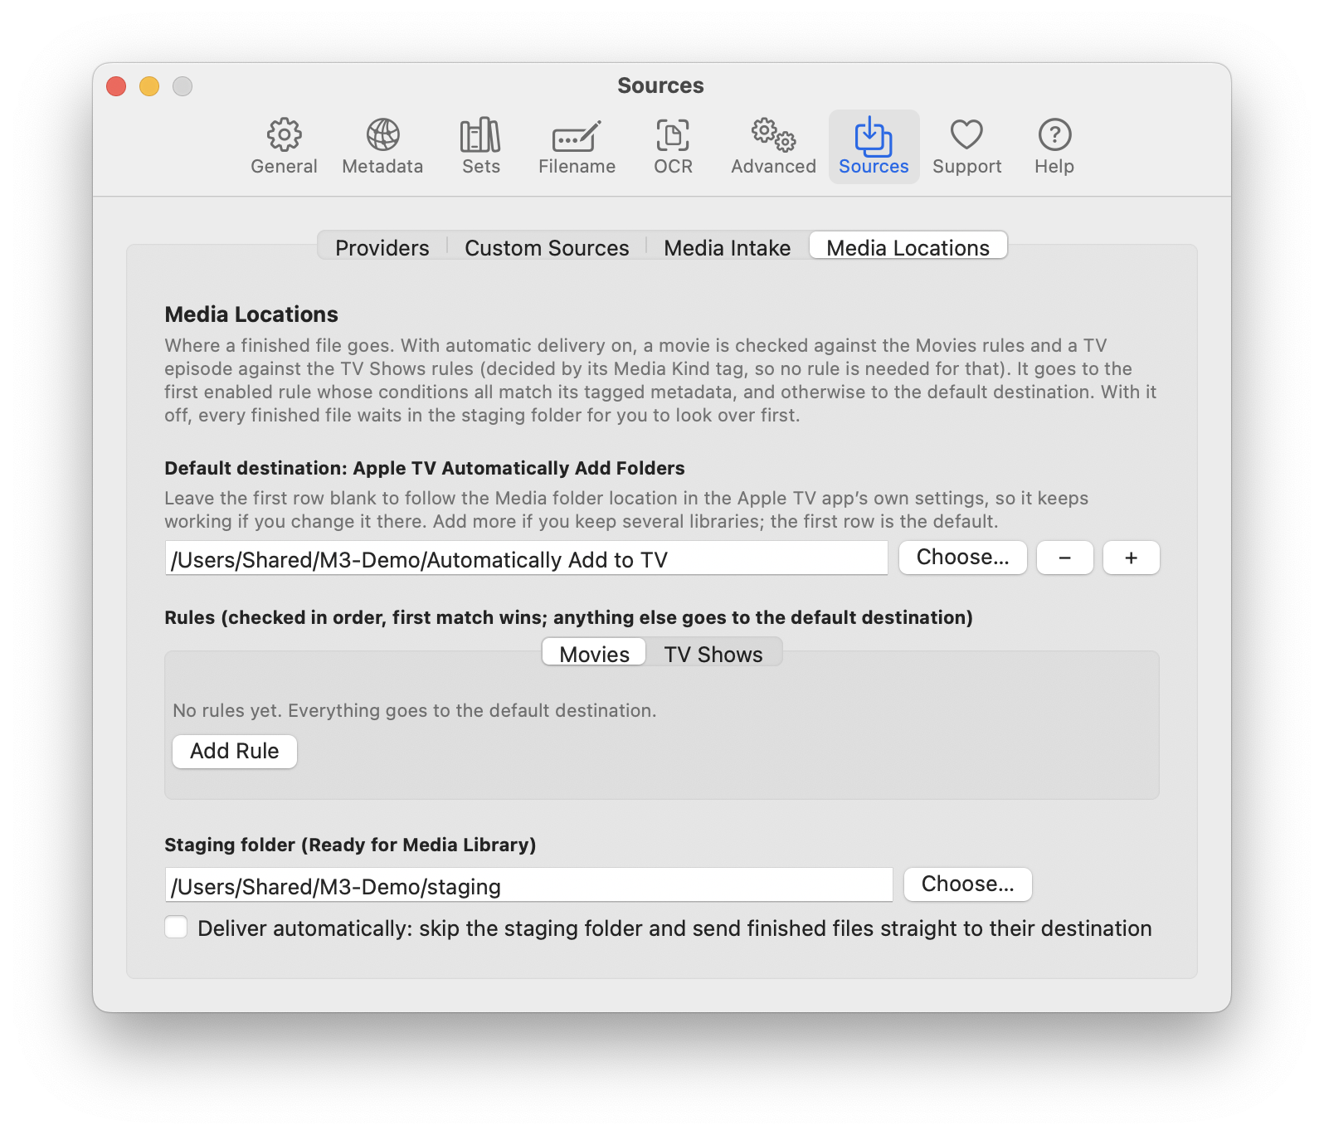
Settings > Sources > Media Locations.
Default destination: Apple TV Automatically Add Folders. The folder the Apple TV app watches and organizes itself. Leave the first row blank and M3 follows the Media folder location in the Apple TV app’s own settings (Settings → Files), read each time it is needed, so a library you move later is picked up without any change here; the folder it currently resolves to is shown greyed out in the first row. Type or choose a folder in the first row to override it, or add more rows with + if you keep several libraries (the first row is the default). If the Apple TV app is not set up, M3 falls back to the Music app’s setting and the usual locations. A file delivered straight into one of these folders is left alone instead of being wrapped in a folder of its own, because the app files it from there.
Rules. The Movies and TV Shows tabs each have an ordered list of rules for sending files somewhere other than the default.
Which list a file is checked against is decided by its Media Kind tag: a TV Show goes through the TV Shows rules and everything else, including a file with no Media Kind, through the Movies rules. You never need a rule that says Movie goes to Movies or TV Show goes to TV Shows; rules are only for choosing a different folder within a kind. In a rule, the Media Kind value list offers the same names as the Metadata tab (Movie, TV Show and so on).
- A rule has a checkbox (to turn it on or off), a Folder, and one or more conditions in the form If Genre is Documentary. Conditions use the same fields and wording as the Filename rules: conditions on different fields must all match (And), conditions on the same field match if any one does (Or).
- Rules are checked from the top. The first enabled rule that matches the file’s tagged metadata decides the folder. If none matches, the default destination is used.
- Add Rule adds a rule at the end of the list; Remove Rule deletes it. A rule with no folder is ignored.
- For the Rating field the value list follows Settings → General → Show ratings for (the chosen country plus the USA, or every country when set to All countries), limited to ratings that apply to movies or TV as appropriate; pick a value from the list so it matches exactly. Rules look at the metadata the file has when it is delivered, so a file with no genre tagged will not match a genre rule.
Staging folder (Ready for Media Library). Where finished files wait for you to look them over before they reach your library, and the setting that decides whether the rules are used at all.
- Deliver automatically is off by default. While it is off, every finished file goes to the staging folder, whatever the rules say, and you move it on yourself. This is the way to work while you are building trust in the system.
- Turn it on and finished files skip staging: they go from the watched folder straight to the first matching rule’s folder, or to the default destination. Folders that are Automatically Add folders receive the finished file alone; the originals stay behind (and go to the Trash if Clean up processed files is on).
- A new install creates the staging folder for you: Ready for Media Library inside your Movies folder. Change it here at any time; a folder you chose is never replaced, and one you clear is not put back.
- Files and folders that are already in the staging folder (or in another delivery destination) can be added to the Queue to be scanned and tagged again. They are updated in place: no second copy is made, the file is renamed by your Filename rules, and a movie’s folder is renamed to match.
- With it off and no staging folder set, finished files stay where they are.
The same choice applies everywhere a finished file is moved: Queue items, whole releases from Intake, and files saved from the editor.

6. Common tasks
Tag one file. Welcome window → Tag One File → Search Metadata → choose a result → Save & Close. The file is changed in place and moved to Ready for Media Library; no original is kept and nothing goes to the Trash.
Process a download automatically. Add the Incoming Folder, tick Automatically watch, optionally tick the auto-approve and auto-merge options. New downloads appear in the Queue; open any row that shows a waiting state; click Start.
Merge parts by hand. Add the parts to the Movies Queue, select them, click Merge, drag them into order, confirm, and choose where to save.
Handle TV episodes. Episodes found by Intake go to the TV Shows Queue. Turn on Organize into Show/Season folders under Settings → Filename to have them filed as Show/Season 01/…. Files you add by hand are sorted the same way: a file whose name has a season and episode marker (such as S02E05 or 2x05), or that sits in a Season folder, goes to the TV Shows tab, and any other file goes to the Movies tab, whichever tab you dropped it on. The status line says when files were moved to the other tab. A folder that holds both movies and episodes is split file by file, and a show folder with Season folders is added as one group per season. If M3 gets one wrong (a file named badly, say), open it with Edit… and change its media type there.
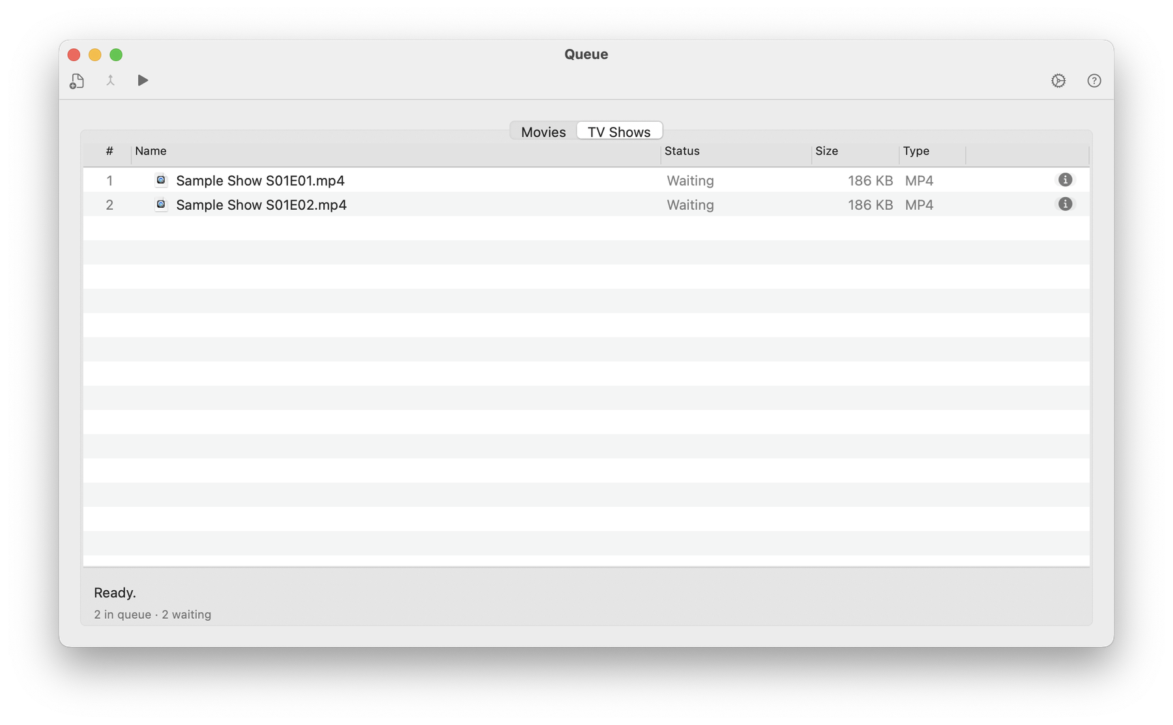
TV episodes added on the Movies tab are moved to the TV Shows tab, and the status line says so.
Find files that need tagging. Welcome window → Scan Library for Missing Metadata.
Undo a mistake. Before you save, use Edit → Undo in the editor. After Save or Save & Close a single file cannot be restored by M3, because it was edited in place; use your own backup. For files moved by the Queue’s cleanup options, open the Trash and choose Put Back.
Start over with a stuck download. Remove its row, make sure the file is in the Incoming Folder, and click Reset Scan….

7. Metadata sources
Built-in providers. TheMovieDB, TheTVDB, Apple TV and the iTunes Store. Each can be switched on or off separately for movies and TV in Settings → Sources → Providers. The Queue’s automatic lookup searches every enabled provider and merges the results of those that found the same title: the provider chosen in Queue Options is the primary one (its title, date, studio and rating are kept), blanks are filled in from the others, cast, genre and crew lists are combined, the longest description is kept, and artwork from all of them is pooled so the Artwork choice in General can be met. A provider that found a different title is ignored. The naming window consults every enabled provider in turn. When you edit a single file you choose the provider yourself.
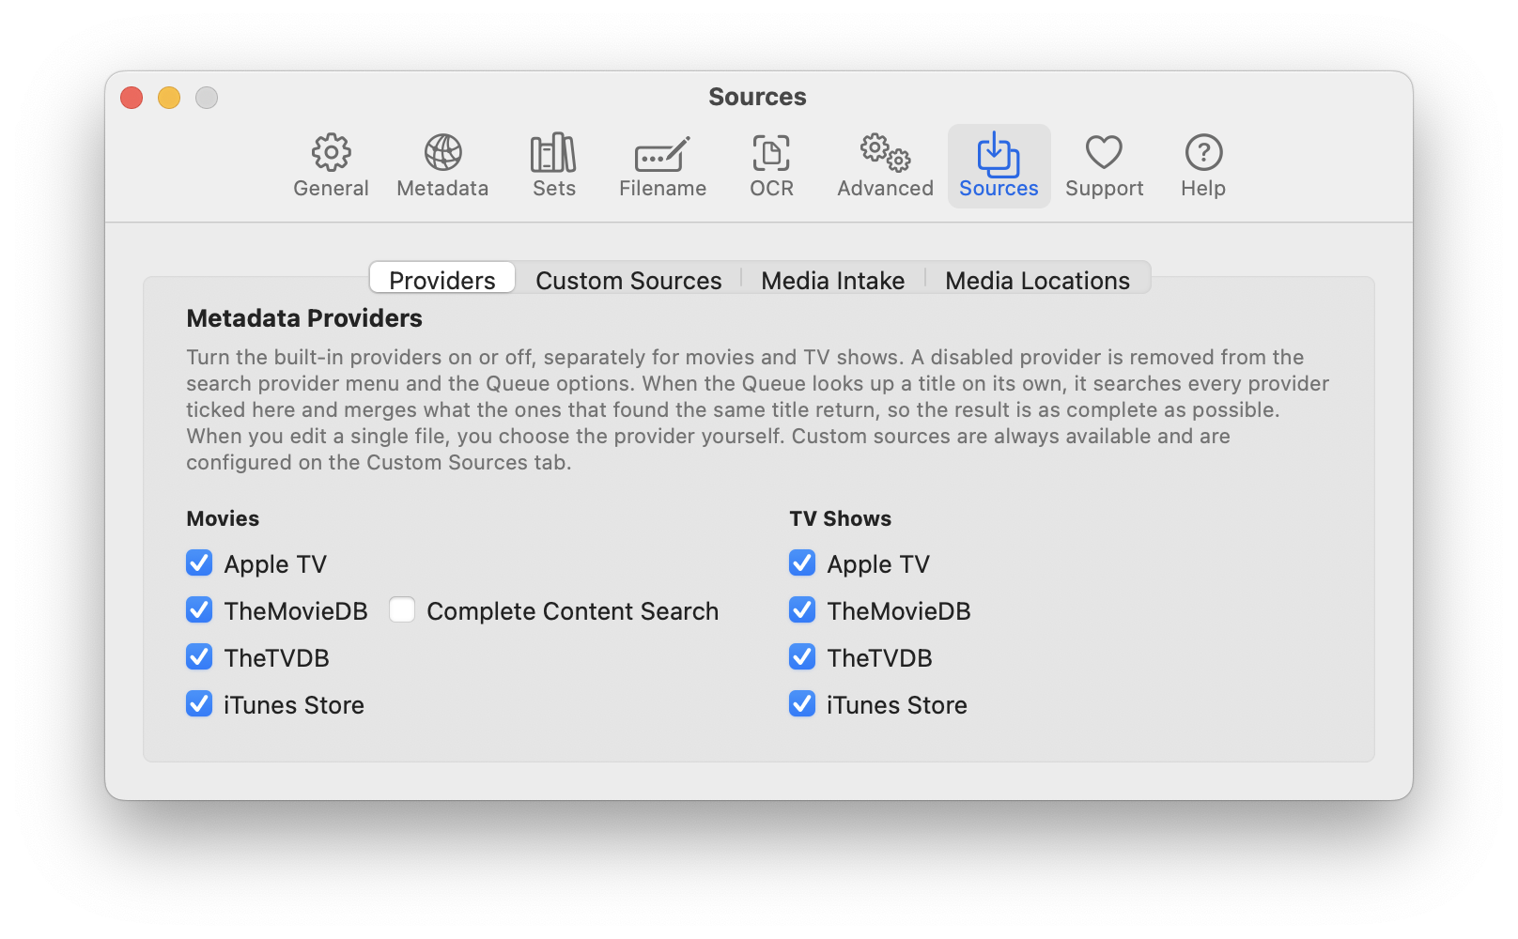
Settings > Sources > Providers.
Custom Sources. In Settings → Sources → Custom Sources, click + to define a source from a web API: a base address, a search address, a detail address, and a table that maps the API’s fields to M3’s tags. Each source opens in its own window. Requests time out rather than hang, and request and response bodies are written to the message log to help you debug a mapping. A new source that you close without entering anything is discarded, so clicking + several times never leaves empty “New Source” rows behind.
Plugins. A plugin is a compiled bundle placed in ~/Library/Application Support/M3/Plugins/ and loaded at launch. Plugins are never part of the app itself. To add one, drag its .bundle onto the Custom Sources list (or place it in that folder). M3 then asks whether to Restart Now or Later; plugins are loaded once, at launch, so a plugin is available after the restart. If the Queue is processing, a merge is running or a scan is in progress, M3 lists what is still running and offers Restart When Finished: it never interrupts that work, and restarts by itself as soon as the last of it is done. Removing a plugin works the same way. After the restart the plugin appears in Settings → Sources → Providers with its own checkbox, switched on by default, and an enabled plugin is used in searches like any built-in provider. A plugin that needs settings (a server address, a key) declares them itself, and the Configure… button next to it opens a form built from that declaration. A plugin can also declare itself a library server, which makes it a Source in the Library scan (section 3.5). M3 contains no built-in knowledge of any particular plugin. Your plugin settings are stored in your own preferences, not in the app, so updating M3 never removes them.
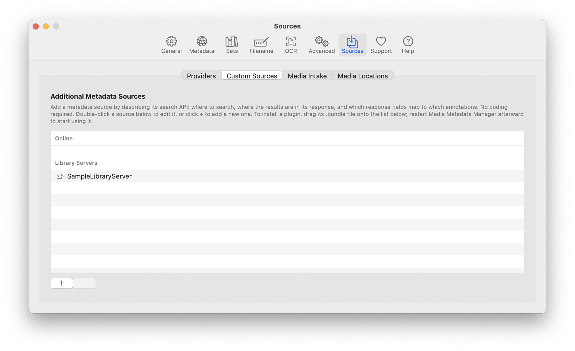
Settings > Sources > Custom Sources: the Online and Library Servers lists.
Online and library servers. Plugins come in two kinds, and Settings → Sources keeps them apart. A plugin that searches the web by title is an online source: it is listed in the Movies column of Providers, next to the built-in providers. A plugin for your own media server is a library server: it is listed in its own Library Servers column, and ticking it there also makes it a Source in the Library scan. In Custom Sources the list has an Online heading (your custom sources and the online plugins) and a Library Servers heading. Both the column and the headings appear only when a library server plugin is installed; without one, the Providers tab and the list look as they always have.
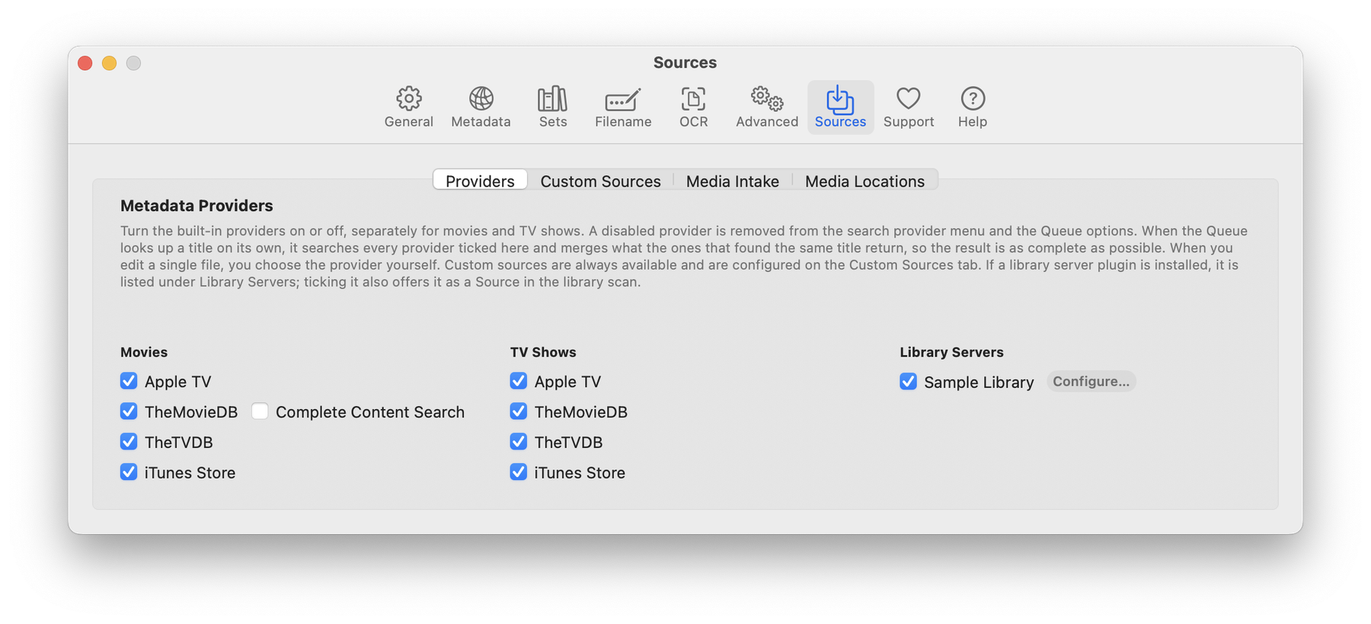
Settings > Sources > Providers with a library server installed.
A library server’s address and key. A plugin for your own media server needs two things from that server: its address and a key (also called an API key or token) that lets M3 read the library without your password. The address is the computer’s name or IP address followed by the server’s port, for example http://192.168.1.20:8096; use 127.0.0.1 when the server runs on this Mac. The server’s own dashboard or network settings show its address, and a browser pointed at it should show the server’s sign-in page. Create the key in the server’s administration pages (look for API keys or tokens), paste it into the plugin’s Configure… form (the field is hidden as you type), and keep it private: never put it in chat, e-mail or screenshots, and delete it on the server if it leaks. The plugin’s own documentation lists the exact steps for its server. If the library is on another computer or a NAS, mount it on this Mac so each file appears at the path the server reports; otherwise the Library scan shows File not found.

8. Files and locations
What | Where
Settings | the app’s standard macOS settings (~/Library/Preferences/, with the app’s identifier as the file name; macOS 12 and earlier call the window Preferences)
Queue state | ~/Library/Application Support/M3/ (movie queue and TV queue are separate files)
Sets, Queue presets, custom-source definitions | ~/Library/Application Support/M3/
Plugins | ~/Library/Application Support/M3/Plugins/
Cleanup logs | ~/Library/Application Support/M3/Removed Empty Folders.txt and Cleaned Up Processed Files.txt
Message log | Window → Show Message Log
M3 renamed its data folder from Subler to M3; an older folder is moved across automatically on first launch.

9. Troubleshooting
Problem | Cause and fix
A download is not picked up | It is still growing (wait or click Scan Now); its folder holds a .part file; the folder is not listed under Incoming Folders; or its path is inside the Ready folder.
A new file with an old name is ignored | Update to a build that forgets finished paths. In older builds the name had been remembered.
The folder name came out as [] () | The file was saved with no title tagged. Current builds leave such files alone; run Search Metadata before saving.
Naming Review finds no match | The title may include a performer or subtitle the provider does not use. Edit the name, or use Search All Providers….
Merge failed | Open the row and read the reason. Parts must share codecs, track layout and picture size.
Merge is greyed out | Select two or more items that have not been processed yet.
The toolbar is missing a button | Right-click the toolbar → Customize Toolbar… and drag it in.
Nothing happens on Start | The Queue is empty of items that are Ready. Releases waiting for naming, a metadata decision or a merge order are not run until you finish those steps.

10. Glossary
Alternate group — tracks that are alternatives of one another, such as audio languages. Artwork position — Portrait (tall poster) or Landscape (wide), used when choosing among available images. Chapter — a named marker in the timeline. Mux — to write tracks into one file container. Provider language — the language requested from an online source. Release — one title’s folder of files. Remux / lossless — repackaging without re-encoding, so quality is unchanged.
Media Metadata Manager is based on Subler by Damiano Galassi and contributors and on MP42Foundation. TMDb data is used under its terms; this product is not endorsed or certified by TMDb. See CREDITS.md.

