**BARROC- IT**

**Media-Group5**

**User manual**

**“Over 15 years of experience in creating web applications”**



**i**nhoud

Login 3

Development 4

Navigator 4

Customers 4

Projects 6

Add project 7

Comments 8

Finance 8

Navigator 8

Customers 9

Invoices 11

Add invoices 12

Comments 12

Sales 13

Navigator 13

Customers 13

Appointments 16

Comments 18

## Login

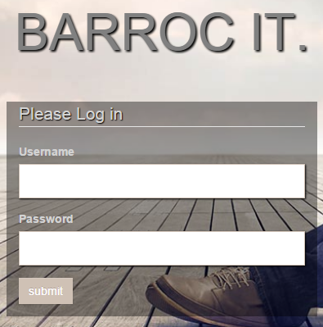

To login you need to enter your username in the top field and your password on the bottom field. After that you click on the submit button and you are logged in to your department.

## Development

### Navigator

http://i.gyazo.com/39134b5479a4c0439a07775beb6db46e.png

Home projects add project comments

In the navigator bar you can find some tabs:

* home
* projects
* add projects
* comments

If you want to go another part of the department you have to click on one of these tabs and then you go the to right page of the application.

In the navigator there is also one search bar, in the search you can find on the customers, number or the company. Search field you can find on the customers, number or the company.

Logout button: the logout button send us to the login page.

### Customers

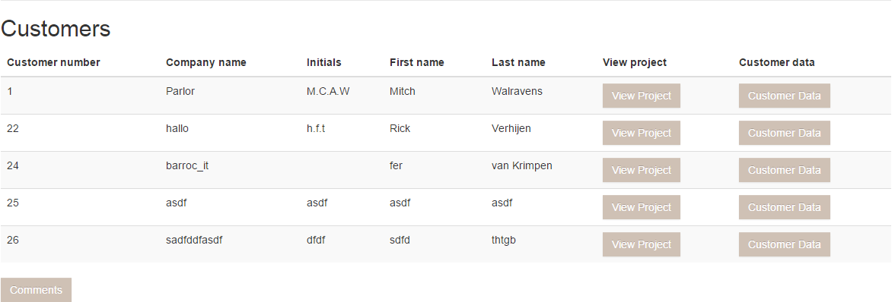

In the customer table you can this:

* klant nummer
* bedrijfsnaam
* initials
* first name
* last name

You see the customeres of that company

If you click on the button customer data, then you can see more information about the customere. You will see these fields:

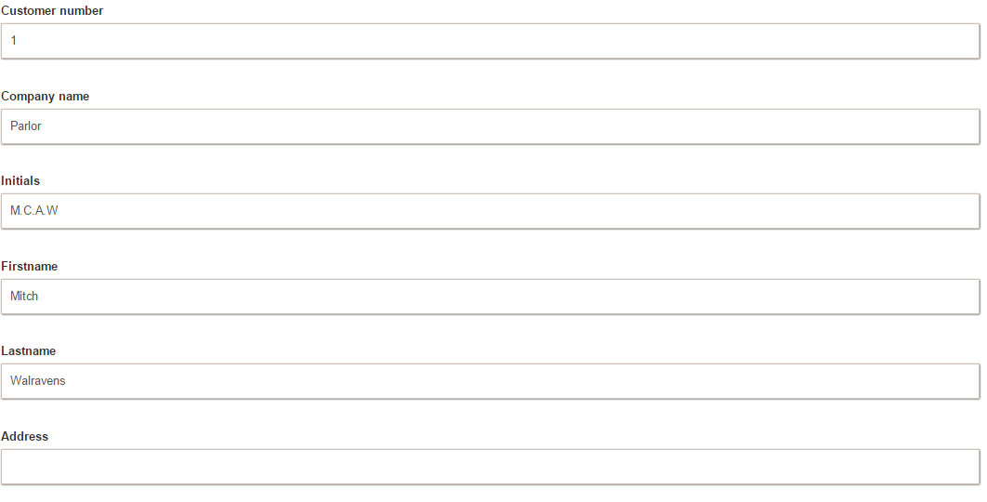

* customer number
* company name
* initials
* first name
* last name
* address
* zip code
* residence
* phone number
* email
* offer status
* date action
* applications

If you click on view project , you can see all project of that customer: there will be information about these fields:

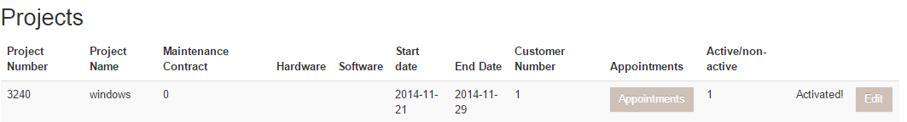

* project number
* project name
* maintenace contract
* hardware
* software
* start date
* end date
* customer number
* appointments

And is the project activated or not.

After this there is a button with edit and the user can edit these projects. If you want to save this you can click on the button Update.

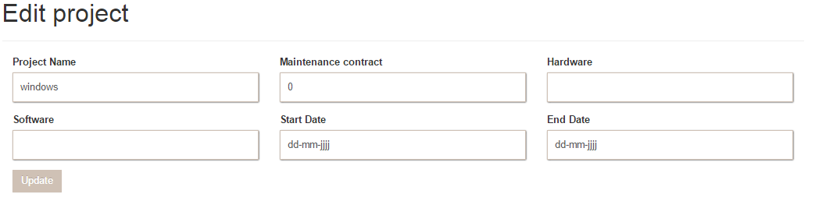

### Projects

On the project Page you can see this information about the projects:

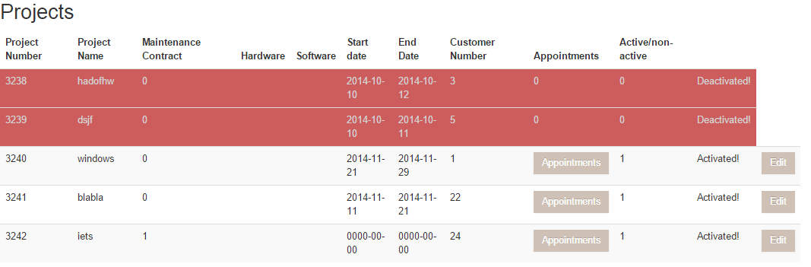

* project number
* project name
* maintenance contract
* hardware
* software
* start date
* end date
* customer number
* appointments
* active/nonactive

If the project is deactivated the project turns red and you can do nothing anymore about that project. When you click on the button appointments you can see if there are appointments for that project.

## Finance

### Navigator

http://i.gyazo.com/d42ce9eb1af44f40b8e6edf5817e3b91.png

Home, projects, add, project, comments

In the navigator you have the buttons:

* home
* invoices
* add invoices
* comments

If you want to go to another part of the department, you must click on the tab to go to the desired page.

In the navigtor you find the search function, with this function you can search on customers name’s, customer numbers and on the company name.

Logout button: The logout button sends you back to the login page

### Customers

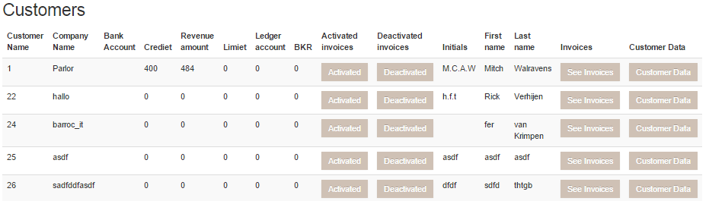

In the customer table you will find

* customer number
* company name
* bank account
* credit
* revenu amount
* limit
* ledger account
* BKR
* Activated invoices
* deactivated invoices
* initials
* first name
* last name
* invoices
* customer data

of all the customers you company has.

When you click on activated invoices at the desired customer , you see all the invoices that are activated of that specific customer with the next information of the invoice:



* Customer number
* Invoice number
* Amount
* Project number
* BTW(incl)
* Start Date
* Last Date
* Quantity
* Description
* Number
* Status
* Edit
* Remove

When you click on activated invoices at the desired customer , you see all the invoices that are deactivated, Here you find a table with the same information as the activated invoices.

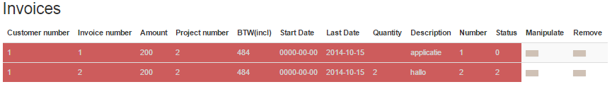

If you click on the 'See Invoices' button you will see all invoices for a specific customer. Here you find a table with the same information as the activated invoices.

## Sales

### Navigator

http://i.gyazo.com/a75d0b432025f7489ca34968089b42b9.png

These tabs are in the navigator:

* Home
* Appointments
* Comments

If you want to go to a part of the department you can click on the tab you would like to go.

There is also a search field in the navigator. You can search by customer number or company name.

And at last there is a Logout button who will send you to the login page.

### Customers

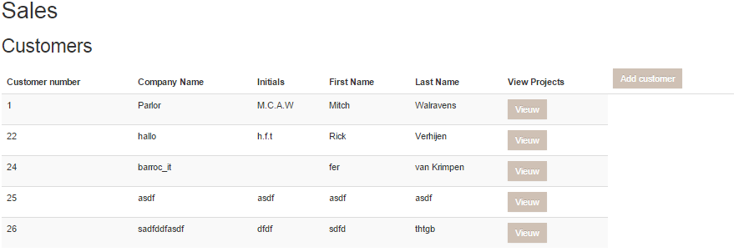

In the customer table you see

* klant nummer
* bedrijfsnaam
* initials
* first name
* last name

of all the customers.

With the button: add customer you can add a new customer. If you clicked on this buttons you will see the next fields

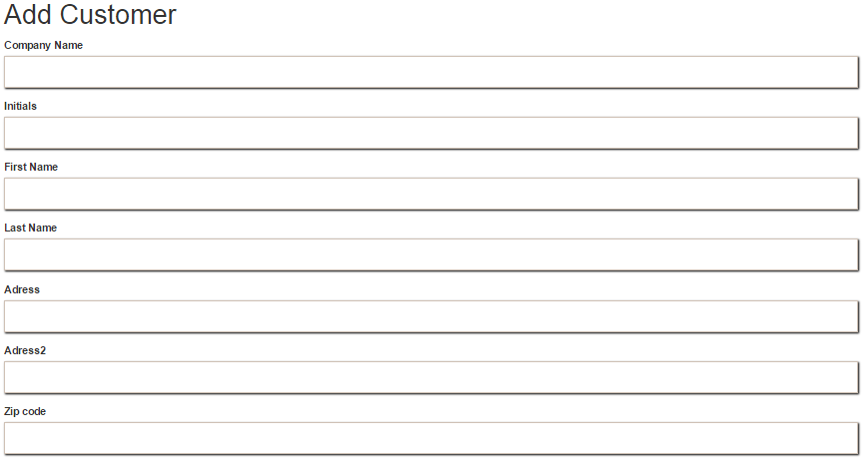

* Company Name
* Initials
* First Name
* Last Name
* Adress
* Adress2
* Zip code
* Zip code 2
* Residence
* residence2
* Phone Number
* Phone Number2
* Fax Number
* Email
* Bank account

If you click on the add button, the customer will be inserted in the customer table

If you click on “view projects” of the customer you see all the activated projects of that customers

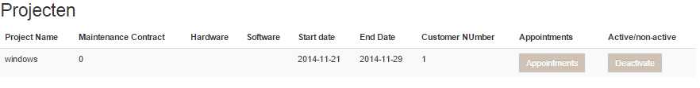

* project number
* project name
* maintenace contract
* hardware
* software
* start date
* end date
* customer number
* appointments
* active/non-active

.

In the fiels active/non-active you can activate and deactivate a project. When you click on appointments you can add a appointment.

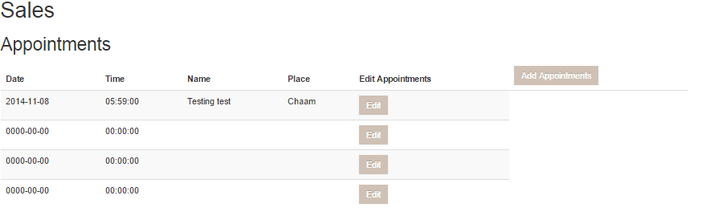

With the button “ADD” you insert the new appointment

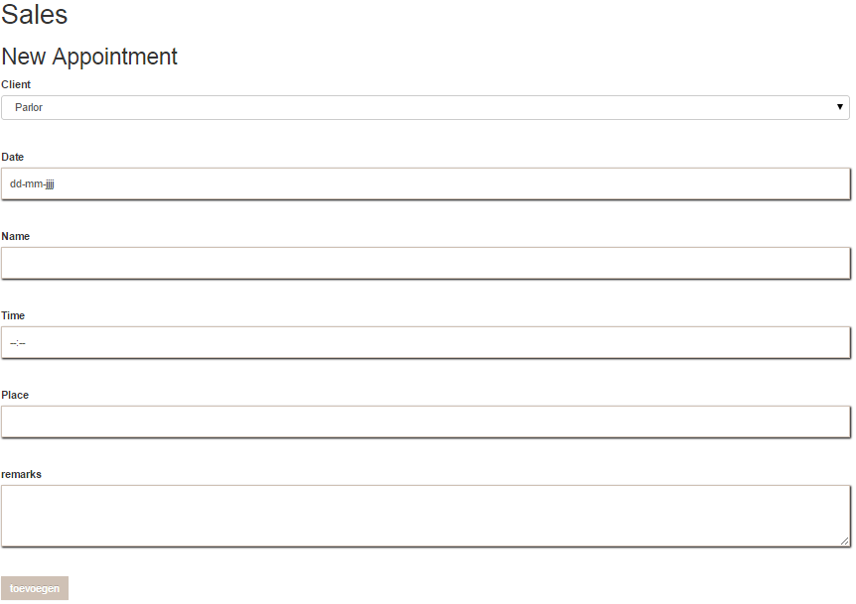

* Client
* Date
* Name
* Time
* Place
* Remarks

If the appointment is added, you can view it in the appointments tab.

In addition, there is a button to edit the appointment. On edit appointment page you can Edit that specific appointment with the following fields:

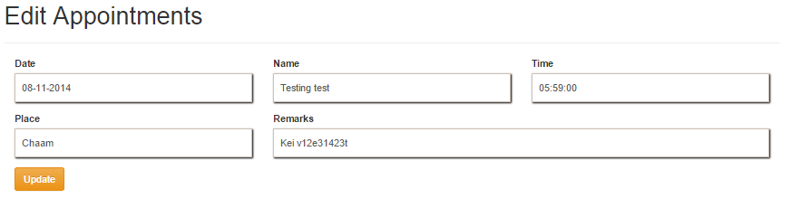

* Date
* Name
* Time
* Place
* Remarks

### If you've changed your dates you can save it by clicking the button update.

### Appointments

In de tab appointments ziet u een tabel met alle afspraken die er zijn gemaakt. In dit tabel is deze informatie van de afspraken te zien:



* Date
* Time
* Name
* Place
* Edit
* Appointments

You can edit the appointments with the edit button on the right side of the appointments. You will see this fields on the edit page:



* Date
* Name
* Time
* Place
* Remarks

You can update the appointment if you click on the update button.

And you can add a new appointment with the add appointment button.



* Client
* Date
* Name
* Time
* Place
* Remarks

### If the appointment is added, you can view it in the appointments tab.

### Comments

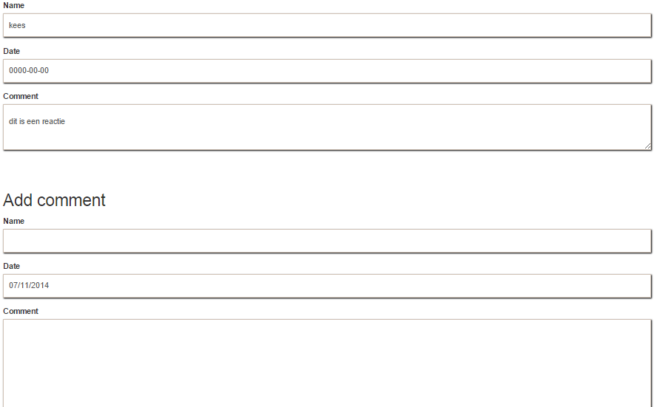

If you click on the comments button at the home page or the top of the navigator you come out on the comments page. You can see all the posted and even place a comment by filling in the fields name, date and comment.

Use the back button to return to homepage of the department where you work.