✈ BabiVoyage
Simplifying Air Travel Across West Africa

PROJECT PROPOSAL
Flight Booking Platform — RESTful API Backend

Prepared by | Mediane Ozeir
Role | Backend Developer Intern
Organization | BabiVoyage
Document Type | Internship Deliverable — Step 1
Date | 2026

Contents
1. Executive Summary 3
2. Problem Statement & Objectives 4
2.1 Problem Statement 4
2.2 Project Objectives 4
3. System Overview 5
3.1 User Roles 5
3.2 System Architecture Diagram 5
4. Core Features 7
4.1 Authentication & User Management 7
4.2 Flight Management 7
4.3 Booking Management 8
4.3.1 Booking Workflow 8
4.4 Passenger Management 9
5. API Module Breakdown 10
5.1 Authentication Endpoints 10
5.2 Flight Endpoints 10
5.3 Booking Endpoints 10
5.4 Passenger Endpoints 11
6. Technology Stack 12
7. Security Strategy 13
8. API Response Standards 14
8.1 Example API Request 14
8.2 Success Response Format 14
8.3 Error Response Format 14
8.4 HTTP Status Code Reference 15
8.5 Error Handling Strategy 15
9. Internship Deliverables Plan 16
10. Conclusion 17

1. Executive Summary

BabiVoyage is a RESTful API backend service designed to power a modern flight booking platform focused on West African air travel. The system provides a comprehensive set of secure, scalable endpoints enabling users to search and book flights, manage their reservations, and receive booking confirmations — all through a token-authenticated API.

This document outlines the architectural decisions, core feature set, API module breakdown, technology stack, and security strategy for the BabiVoyage backend. It serves as Deliverable 1 (Project Proposal) of the BabiVoyage internship program.

Platform Type: | RESTful API Backend
Framework: | Laravel 12 (PHP 8.2+)
Authentication: | Laravel Sanctum — Token-Based
Database: | MySQL (WAMP Server)
Architecture: | MVC — Model View Controller
Target Market: | West Africa Air Travel Passengers & Administrators

2. Problem Statement & Objectives

2.1 Problem Statement
Air travel booking across West Africa is often fragmented, requiring travelers to navigate multiple airline-specific systems with inconsistent experiences, limited real-time availability data, and no unified reservation management. BabiVoyage addresses this gap by providing a centralized, developer-friendly API that can power any frontend interface — web, mobile, or third-party integrations.

2.2 Project Objectives
- Build a secure, token-based authentication system for users
- Provide flight browsing and search capabilities with filtering
- Enable users to create, view, and cancel flight bookings
- Support multi-passenger bookings per reservation
- Deliver a fully documented, validated RESTful API
- Follow industry best practices: MVC, clean code, proper HTTP semantics

3. System Overview

The BabiVoyage backend is organized around five core domains. Each domain maps to a dedicated API module, controller, model, and set of routes. The system enforces strict input validation on all endpoints and returns standardized JSON responses.

Domain | Responsibility | Access Level
Authentication | User registration, login, logout, token management | Public / Authenticated
Users | Profile view and update | Authenticated
Flights | Browse, search, and admin CRUD for flights | Public / Admin
Bookings | Create, view, and cancel flight reservations | Authenticated
Passengers | Add and manage passengers per booking | Authenticated

3.1 User Roles
Role | Description | Capabilities
Guest | Unauthenticated visitor | Browse flights, register, login
User | Registered traveler | All guest actions + book flights, manage reservations, update profile
Admin | Platform administrator | All user actions + manage flights (create, update, delete), view all bookings

3.2 System Architecture Diagram
The following diagram illustrates the layered architecture of the BabiVoyage platform. Requests flow from client applications (web, mobile, or API tools) through the Laravel API layer, which handles routing, validation, business logic, and Eloquent ORM interactions. Laravel Sanctum manages authentication at the middleware level before requests reach protected controllers. All persistent data is stored in a relational MySQL database.
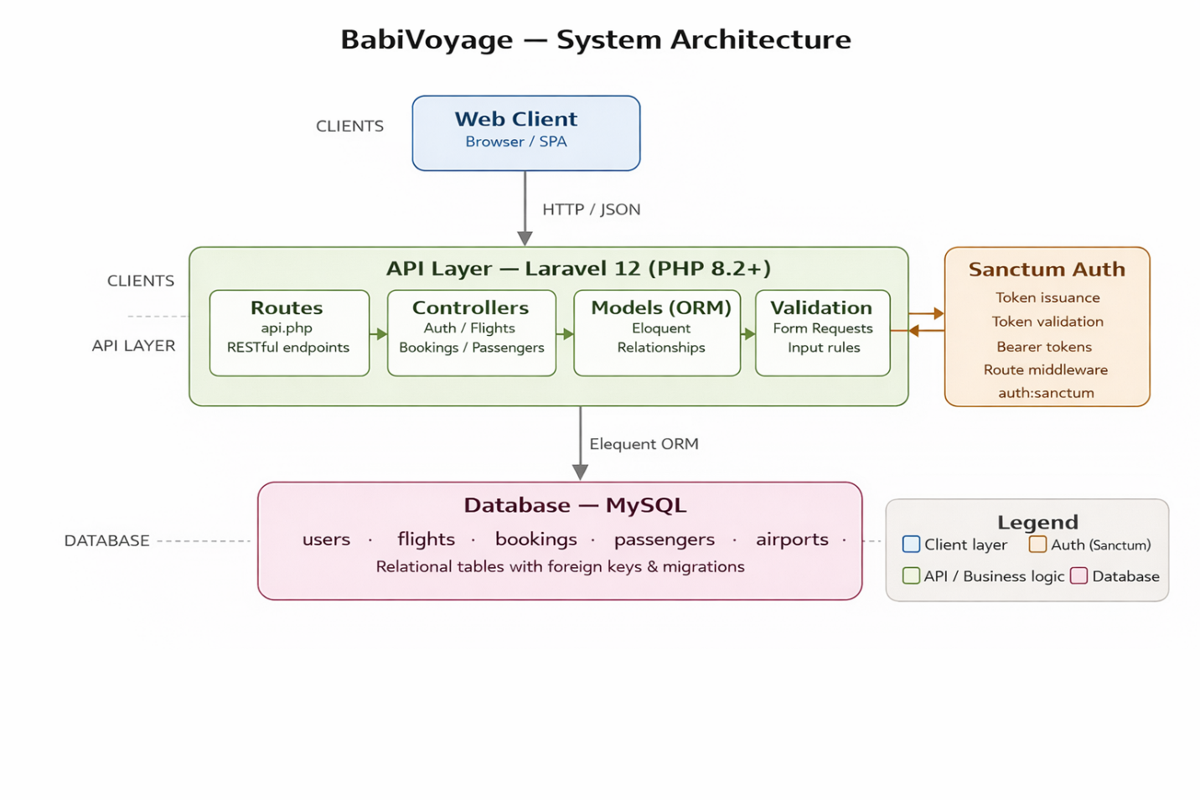
  - Figure 1 — High-level architecture of the BabiVoyage backend system

4. Core Features

4.1 Authentication & User Management
The authentication module handles all identity and access management for the platform. It uses Laravel Sanctum for stateless token-based authentication, making it suitable for both web and mobile frontends.

- User Registration: Accepts name, email, and password. Password is hashed using bcrypt before storage.
- User Login: Validates credentials, generates and returns a personal access token.
- User Logout: Revokes all active tokens for the authenticated user.
- Profile Management: Allows authenticated users to view and update their profile details.
- Token Security: All protected routes require a valid Bearer token in the Authorization header.

4.2 Flight Management
Flights represent the core resource of the platform. Admins manage flight records while users browse and search them.

- Flight Listing: Paginated list of all available flights with key details.
- Flight Details: Full details for a specific flight including price and available seats.
- Flight Search: Filter by origin, destination, departure date, and price range.
- Admin Create: Add new flight records with all required attributes.
- Admin Update: Modify existing flight details (price, schedule, seat count).
- Admin Delete: Remove flights that are cancelled or no longer available.

Each flight record stores the following key attributes:

Attribute | Type | Description
flight_number | String (unique) | Unique identifier code (e.g., BV-101)
airline | String | Name of the operating airline
origin | String | Departure city or airport code
destination | String | Arrival city or airport code
departure_at | DateTime | Scheduled departure date and time
arrival_at | DateTime | Scheduled arrival date and time
price | Decimal | Ticket price per passenger
total_seats | Integer | Total capacity of the flight
available_seats | Integer | Remaining bookable seats (auto-updated on booking)
status | Enum | scheduled | delayed | cancelled | completed

4.3 Booking Management
The booking module manages the full lifecycle of a flight reservation from creation to completion or cancellation.

- Create Booking: Authenticated user books a flight for one or more passengers. Seat availability is validated before confirmation.
- View My Bookings: Returns all bookings for the authenticated user with status and flight details.
- View Booking: Full details of a specific booking including passengers.
- Cancel Booking: User can cancel a confirmed booking. Seats are released back to the flight.

4.3.1 Booking Workflow
When a booking is created, the system validates seat availability before confirming the booking.

- If sufficient seats are available:
- The booking status is updated to CONFIRMED
- The number of available seats in the flight is reduced accordingly

- If the booking is cancelled:
- The status is updated to CANCELLED
- Reserved seats are released back to the flight

Attribute | Type | Description
user_id | FK → users | The user who made the booking
flight_id | FK → flights | The booked flight
booking_reference | String (unique) | Unique reference code (e.g., BV-2026-XXXXX)
seat_count | Integer | Number of seats booked
total_price | Decimal | Computed: seat_count × flight.price
status | Enum | confirmed | cancelled

4.4 Passenger Management
Each booking can include multiple passengers. Passenger information is stored independently from the user account, supporting group bookings.

- Add Passengers: Associate one or more passenger profiles with a booking.
- View Passengers: List all passengers for a specific booking.

Attribute | Type | Description
booking_id | FK → bookings | The booking this passenger belongs to
first_name | String | Passenger first name
last_name | String | Passenger last name
passport_number | String | Official travel document number
nationality | String | Passenger nationality
date_of_birth | Date | Used for age verification if required

5. API Module Breakdown

The following table provides a complete overview of all planned API endpoints, organized by module. All endpoints return JSON responses with appropriate HTTP status codes.

5.1 Authentication Endpoints
Method | Endpoint | Description | Auth Required
POST | /api/register | Register a new user account | No
POST | /api/login | Login and receive access token | No
POST | /api/logout | Logout and revoke current token | Yes
GET | /api/profile | Retrieve authenticated user profile | Yes
PUT | /api/profile | Update authenticated user profile | Yes

5.2 Flight Endpoints
Method | Endpoint | Description | Auth Required
GET | /api/flights | List all available flights (paginated) | No
GET | /api/flights/{id} | Get full details of a specific flight | No
GET | /api/flights/search | Search flights by filters | No
POST | /api/admin/flights | Admin: Create a new flight | Admin
PUT | /api/admin/flights/{id} | Admin: Update flight details | Admin
DELETE | /api/admin/flights/{id} | Admin: Delete a flight | Admin

5.3 Booking Endpoints
Method | Endpoint | Description | Auth Required
GET | /api/bookings | List all bookings for authenticated user | Yes
POST | /api/bookings | Create a new booking | Yes
GET | /api/bookings/{id} | Get details of a specific booking | Yes
PATCH | /api/bookings/{id}/cancel | Cancel a booking | Yes

5.4 Passenger Endpoints
Method | Endpoint | Description | Auth Required
GET | /api/bookings/{id}/passengers | List passengers for a booking | Yes
POST | /api/bookings/{id}/passengers | Add a passenger to a booking | Yes
DELETE | /api/bookings/{id}/passengers/{pid} | Remove a passenger from a booking | Yes

6. Technology Stack

Category | Technology | Justification
Framework | Laravel 12 | Industry-standard PHP framework, rapid API development
Language | PHP 8.2+ | Modern type-safe PHP with strong ecosystem
Authentication | Laravel Sanctum | Lightweight token auth for SPAs and mobile apps
Database | MySQL (WAMP Sever) | Reliable relational DB, strong foreign key support
ORM | Eloquent ORM | Expressive, relationship-aware database interaction
Validation | Laravel Form Requests | Clean separation of validation logic from controllers
API Testing | Postman | Industry-standard API documentation and testing
Version Control | Git + GitHub | Source control, collaboration, and deployment tracking
Architecture | MVC + RESTful | Clean separation of concerns, scalable structure

7. Security Strategy

- Password Hashing: All user passwords are hashed using bcrypt via Laravel's built-in Hash facade. Plain-text passwords are never stored.
- Token Authentication: Laravel Sanctum issues personal access tokens. Tokens are invalidated on logout, preventing reuse of compromised tokens.
- Input Validation: All API endpoints enforce strict validation rules using Laravel Form Requests, rejecting malformed or malicious input before it reaches business logic.
- Authorization Checks: Booking and passenger endpoints verify that the authenticated user owns the resource being accessed, preventing unauthorized data access.
- HTTP Status Codes: The API returns semantically correct HTTP codes (200, 201, 401, 403, 404, 422, 500) to allow clients to handle responses predictably.
- Environment Config: Sensitive credentials (database, keys) are stored in the .env file and excluded from version control via .gitignore.
- Rate Limiting: To avoid abuse (especially on sensitive endpoints like login), rate limiting is applied using Laravel’s throttle middleware. This helps reduce risks such as brute-force attacks.
- Input Sanitization: All incoming requests are carefully validated using Laravel Form Requests. This ensures that only properly formatted data is accepted and helps protect against common issues like invalid input or injection attempts.
- CSRF Protection: Since the API mainly relies on token-based authentication, CSRF is not a primary concern. However, if session-based features are added later, CSRF protection will be taken into account.

8. API Response Standards

All API responses follow a consistent JSON structure to allow frontend clients to handle success and error cases predictably.

8.1 Example API Request
POST /api/bookings
{
"flight_id": 12,

"passengers": [
{
"first_name": "Mediane",
"last_name": "Ozeir",
"passport_number": "A123456"
}

]
}

8.2 Success Response Format
{
"success": true,
"message": "Booking created successfully.",
"data": {"booking_reference": "BV-2026-12345"}
}

8.3 Error Response Format
{
"success": false,
"message": "Validation failed.",
"errors": { "email": ["The email has already been taken."] }
}

8.4 HTTP Status Code Reference
Code | Status | When Used
200 | OK | Successful GET, PUT, PATCH requests
201 | Created | Successful resource creation (POST)
401 | Unauthorized | Missing or invalid authentication token
403 | Forbidden | Authenticated but not authorized for the resource
404 | Not Found | Requested resource does not exist
422 | Unprocessable Entity | Validation failed — input errors returned
500 | Internal Server Error | Unexpected server-side error

8.5 Error Handling Strategy
- A global exception handler is used to ensure that all errors are returned in a consistent format across the application.
- All exceptions are transformed into consistent JSON responses following the defined API format.
- Validation errors return an HTTP 422 status code along with detailed messages for each problematic field.
- Authentication and authorization issues are handled using standard codes:
- 401 for unauthenticated requests
- 403 for unauthorized actions
- Any unexpected server errors are handled safely, returning a 500-status code without exposing internal system details

9. Internship Deliverables Plan

The following table maps each required internship deliverable to its implementation status and scope within this project.

# | Deliverable | Scope in This Project
1 | Project Proposal | This document — system overview, features, API modules
2 | Database Design (ERD) | Entities: users, flights, bookings, passengers + relationships
3 | Repository Setup | GitHub repo, Laravel project, folder structure
4 | Database Migrations | Migration files for all tables including pivot tables
5 | Eloquent Models | Model classes with relationships, fillable, and casts
6 | Registration API | POST /api/register with validation and password hashing
7 | Authentication API | POST /api/login, POST /api/logout via Sanctum tokens
8 | Postman Collection | All endpoints documented with request examples
9 | Validation | Form Request classes for all input-accepting endpoints
10 | BONUS: Admin Panel | Filament or Laravel Nova admin dashboard (if time permits)

10. Conclusion

BabiVoyage is a well-scoped, achievable backend project that covers the full spectrum of professional API development: authentication, resource management, relational data modeling, input validation, and security best practices.

By using Laravel 12 with Sanctum, Eloquent ORM, and MySQL, the project leverages a mature, industry-proven stack that is widely used in production environments. The architecture follows RESTful conventions and clean MVC separation, ensuring the codebase is maintainable, testable, and extensible.

This proposal establishes a clear foundation. Each subsequent deliverable will build directly on this design, progressively implementing the features described here from database schema through to fully documented API endpoints.

