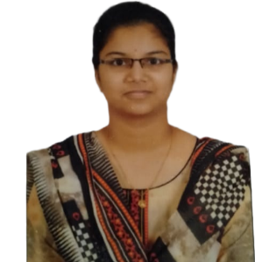**MEDIBOYINA ANITHA**

+918639271539 | [anithamediboyina112@gmail.com](mailto:anithamediboyina112@gmail.com) |



 [linkedin.com/in/mediboyina/](resume1.docx) |  [github.com/Mediboyina](certificates)

**EDUCATION**

* Electronics and Communications | Shri Vishnu Engineering College for Women, Bhimavaram. **CGPA: 9.02** | 2020-2024
* XII | Sri Chaitanya Junior College, Vijayawada. **CGPA: 9.75** | 2018-2020
* X | Ravindra Bharathi Public School, Gannavaram. **GPA :10.0** | 2018

**ACADEMIC PROJECTS**

* **VocabMaster**- Vocabulary learning tool with features such as word lookup,meaning addition and quiz functionality.

**Link**: [github.com/Mediboyina/VocabMaster](vocab_master)

* **Portfolio** responsivedesign using HTML, CSS and JavaScript.

**Link**: [anithaportfol.netlify.app/](../../../PORTFOLIO)

* **Speed detection and Vehicle tracking system-**It continuously monitors vehicle speed,instantly notifying a predefined number with the vehicle’s location and speed details when it exceeds a certain limit.

**TECHNICAL SKILLS**

* **Languages**: C, Java, Python, Javascript.
* **Tools**: MATLAB.
* **Front end**: HTML, CSS.

**CERTIFICATIONS**

* **Java Intern** | Oasis InfoByte|2023
* **Full Stack Web development course** **|** **HelpMeCode.dev** **|** 2022
* **HTML, JAVA Courses | Great Learning** **|** 2022
* **Python course | Coursera** **|** 2023
* **Java:** **Data Structures course** **|** **LinkedIn** **|** 2023

**EXTRA CURRICULAR ACTIVITIES**

* Implemented **ATM Interface** and **Library Management system** using Java as an Oasis Intern.
* Selected for Smart India Hackathon 2022, Internal Assessment round with a concept of **Intelligent Traffic System.**
* **Student Coordinator of Empathy Club** at college and conducted motivational classes to students.
* **Participated in** **C&DS (C and Data Structures) training program** at college Collaborated with Smart Interviews.

**STRENGTHS**

* Hard worker
* Self Learner
* Organized Person

**DECLARATION**

I here by declare that the above furnished details are true to the best of my knowledge.

Mediboyina Anitha