Managing Limbo Eagle Libraries

Limbo | Electrical

Ryan Chen

01/15/2021

Table of Contents

1.0 Overview/Function 2

2.0 Directions 3

2.1 Get access to GitHub repositories 3

2.2 Adding GTOREagleLib to Eagle library directory path 3

3.0 Contributing to GTOREagleLib 6

3.1 Finding Components on the Internet 6

3.2 Adding Downloaded Libraries to EAGLE 6

3.3 Adding the downloaded components to the GTOREagleLib 6

4.0 Revision History 7

# 1.0 Overview/Function

This guide will teach you about how to work on Autodesk Eagle schematics and boards using the Limbo Eagle libraries.

When designing devices for your project, make sure to pull from the repository before starting your work and pushing after adding a device to the library **immediately**. This way, we can avoid having to work with merge conflicts as much as possible.

# 2.0 Directions

## 2.1 Get access to GitHub repositories

Ask your team leads for access to the [DAQ repository](https://github.com/Georgia-Tech-Off-Road/DAQ) and the [GTOREagleLib repository](https://github.com/Georgia-Tech-Off-Road/GTOREagleLib).

## 2.2 Adding “Libraries_Eagle” folder to Eagle library directory path

For Eagle to recognize the “Libraries_Eagle” folder as a library, we need to change the directory for Eagle’s library in the settings.

On the control panel, navigate **Control Panel > Options > Directories**.

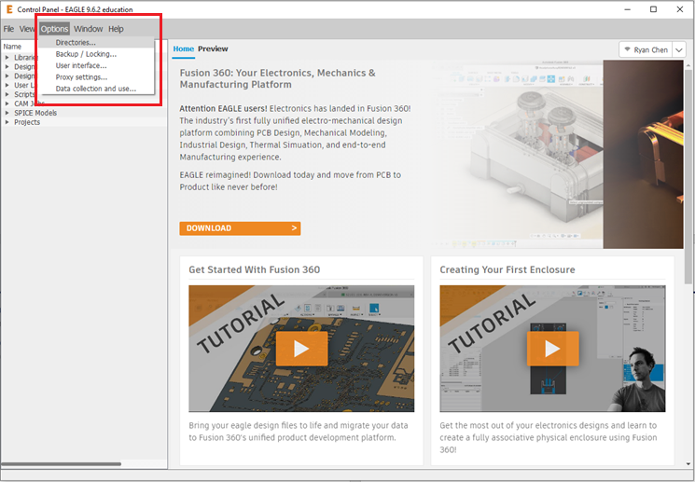

Then on the **Directories** window, click on the field next to libraries, and then click on **Browse…** to change the root directory of Eagle’s libraries.

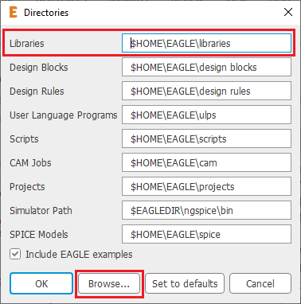

Next navigate the “Libraries_Eagle” folder in the Limbo repository and then click **Select Folder**. In this case, the folder is C:\Users\itsan\Documents\1GitRepositories\MedicalRobotics\Libraries_Eagle. The folder will be added *in addition* to your existing library directories.

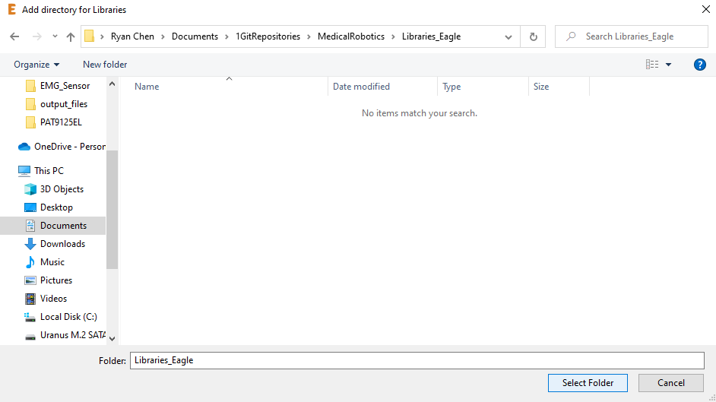

Now, you can look at your new GT Off-Road libraries in Eagle by returning to the **Control Panel** and looking under **Libraries > Libraries_Eagle**.

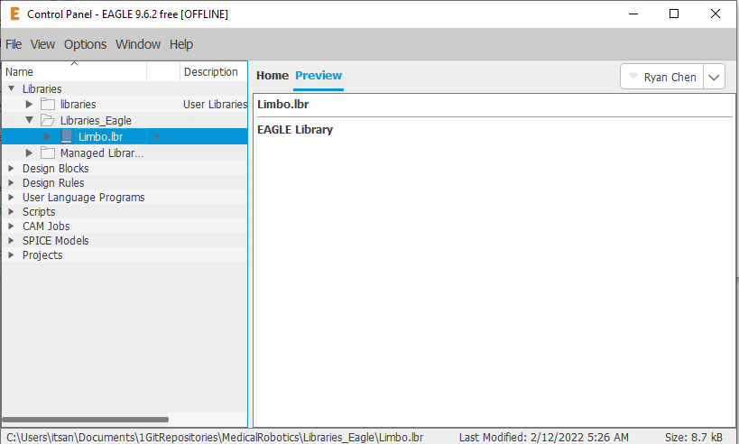

To use the parts in your schematics, right click the “Libraries_Eagle” folder and click “Use all” so that they will show up when you go to add parts.

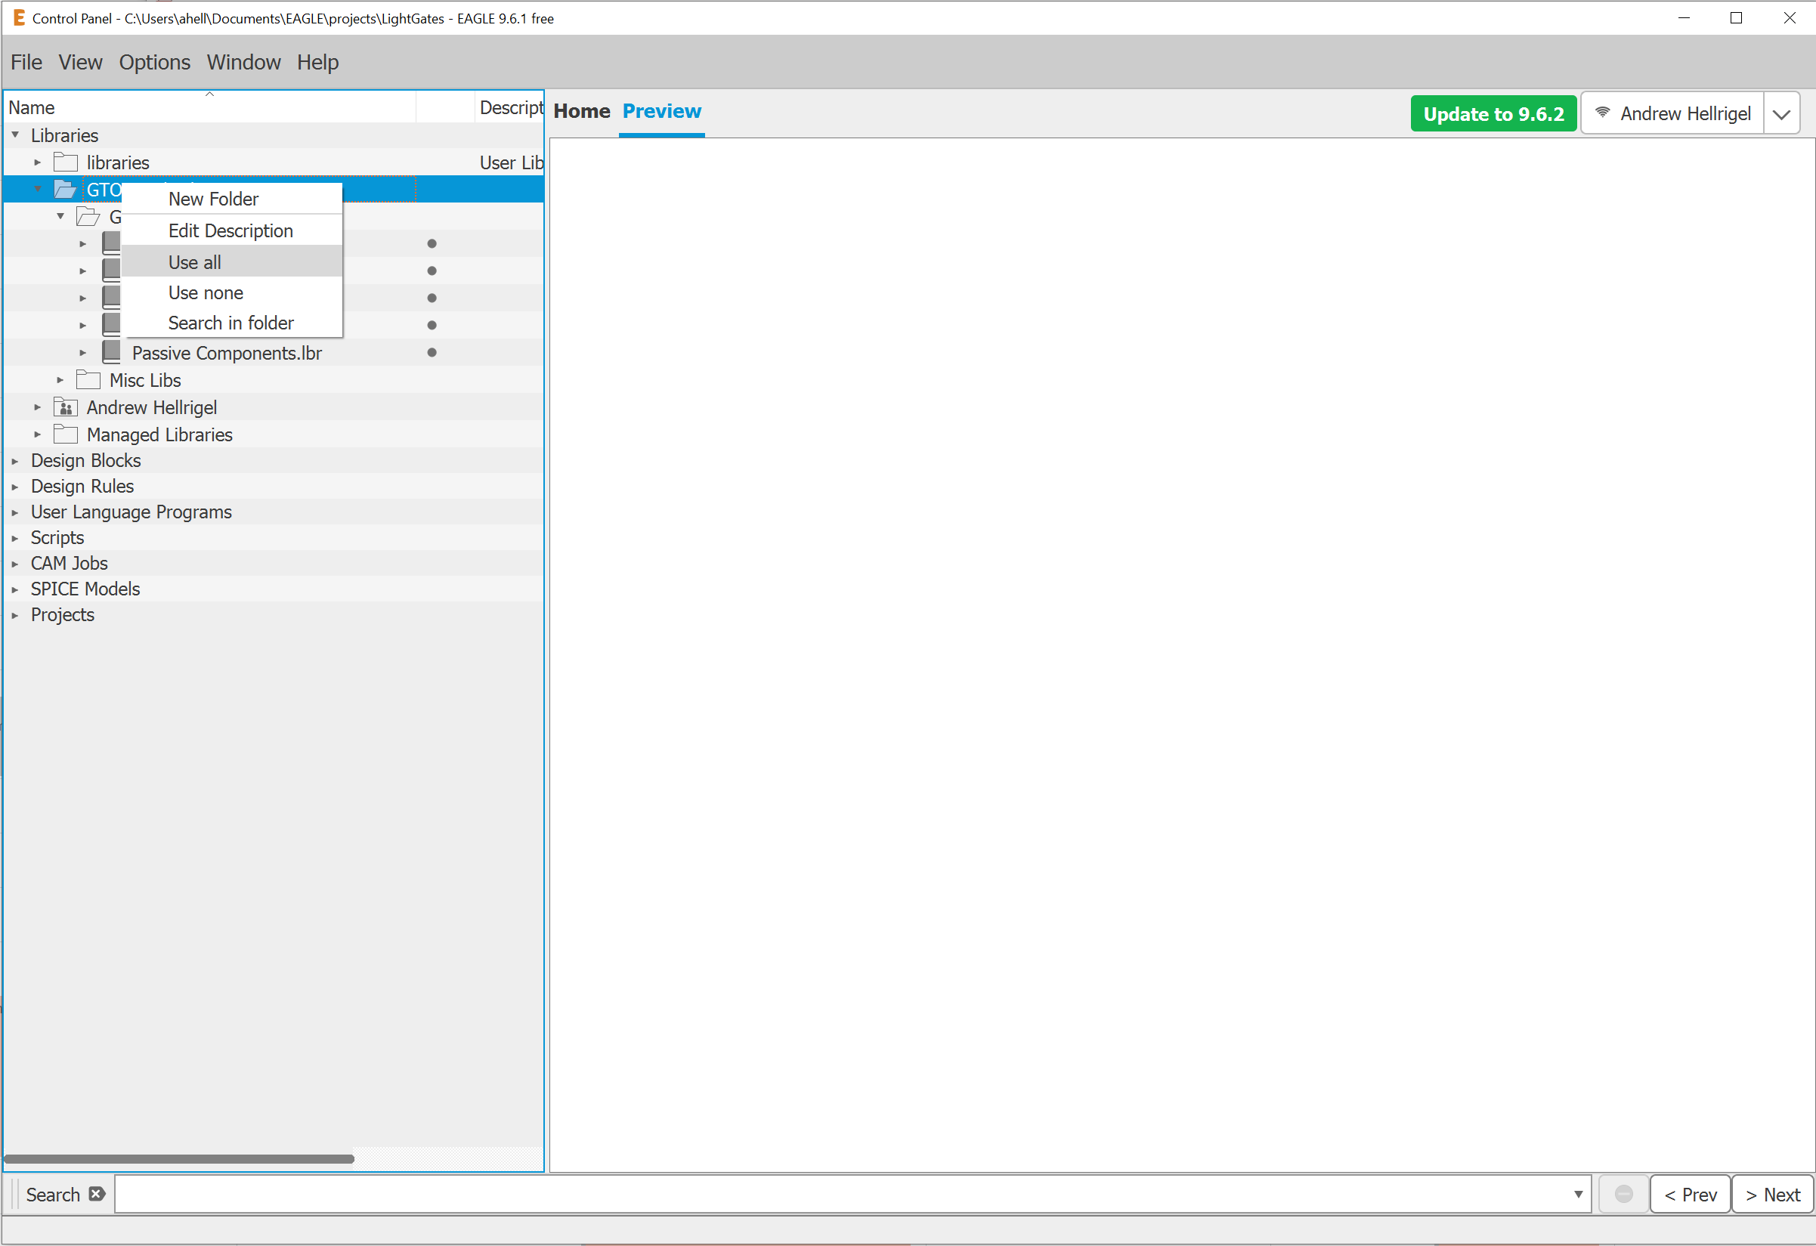

# 3.0 Contributing to GTOREagleLib

## 3.1 Finding components on the internet

There are many free tools to find symbols/footprints for various components and breakout boards on the internet. Component Search Engine is a good one although it requires you to make an account. However there are many others. For Eagle, all components come packaged in the form of a library and they have a .lbr extension. This is the file that you want.

## 3.2 Adding downloaded libraries to EAGLE

Once you have downloaded the library, you need to put it in the EAGLE libraries PATH. I generally just put the downloaded library in Documents>EAGLE>libraries. This way it will show up in the EAGLE control panel under the libraries folder.

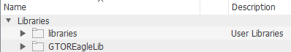

## 3.3 Adding the downloaded components to the GTOREagleLib

First determine what section of the Eagle Lib your component belongs in. Passive components are defined as components that don’t require a power source to function. Examples include resistors, inductors, capacitors, diodes, etc. Active components are those that do require a separate power source to function. Examples include transistors, op-amps, linear regulators, any IC that performs a logical function, etc. Breakout boards are footprints for separate components that come on their own PCB such as a motor driver or some sensors. Microcontrollers and connectors should be for the most part self-explanatory.

Once you have decided where you want your component to go, then make sure that the library that you just imported is active. If you imported the library to the default Eagle library folders, the easiest way to do this is just to right click the libraries folder and select “Use all”. The small dot to the right of the library name should turn green.

After the library is active you can now enter the library that you want to move the component too. If, for example, you are adding a resistor to the GTOREagleLib, then you will double click the GTOR – Passive Components library to open the library manager. Once in the library manager you can click “Add Device…” at the bottom left of the screen and then select “Import…”.

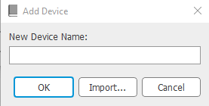

You can then find the library in the library manager that you previously made active. Then within that library select the component(s) that you want to add to the library and click “OK”. You should now see the device in the device editor window. You may now do File>Save and the component will have been added to the library. Don’t forget to push to Git!

# 4.0 Revision History

1/15/2021 (Ryan Chen) – Created the first revision for this document

6/18/2021 (Andrew Hellrigel) – Added information about how to contribute to the EAGLE Libraries; Edited information about the GitHub location.