System Deployment & Integration

- Technology Stack

Layer | Technology | Description
Frontend | React.js / HTML / CSS | User interface for interaction between patients and doctors
Backend | Node.js (Express.js) | Handles requests, manages sessions, and connects system components
Database | MySQL | Stores data for patients, doctors, sessions, and reports
AI Model | Python (Scikit-learn / TensorFlow) | AI model used for symptom analysis and disease prediction
APIs | RESTful API | Enables communication between frontend and backend
Deployment Platform | AWS / Render / Localhost | Platform used to deploy and run the system
Version Control | GitHub | Manages code versions and tracks development changes

- Deployment Diagram
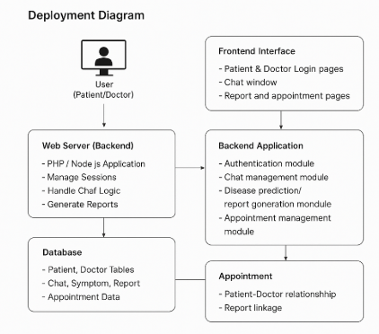

- Component Diagram
