How to generate the Ubiquity-Abundance Plot (Single Cohort Analysis)
The Ub-Ab plot describes the relationship between abundance and ubiquity. The core taxonomic members are define by the taxa that exceed a specified abundance and ubiquity. This is demarked by the red bull’s eye. The taxa that are considered in the core by this definition are colored and the remaining are greyed out for clarity. There are 3 core in this analysis.
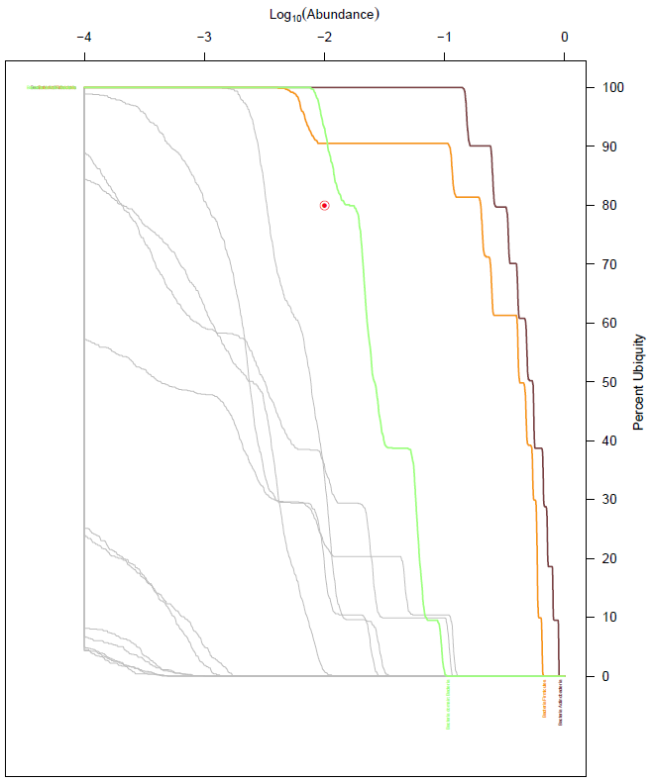

Direct command line invocation
First, generate the CDF values
Compute the CDF estimates for each taxon in the summary file.
- Go (cd) into “example_data” directory.
- Run script “Compute_CDFs.r” on the summary file.
lib/Compute_CDFs.r -i example_data/cohortB.phylum.summary_table.tsv
OUTPUT: example_data/cohortB.phylum.lin.log.cdf
Then, plot the CDF values
A few options are provided as examples:
- Generate plot without cutoffs, plotting all taxa in grey:
lib/Plot_CDFs.r -i example_data/cohortB.phylum.lin.log.cdf
OUTPUT : example_data/cohortB.phylum.lin.log.u0.00.a0.00000.pdf
- Generate plot by only drawing core members in grey:
lib/Plot_CDFs.r -i example_data/cohortB.phylum.lin.log.cdf -u 0.80 -a 0.01
OUTPUT : example_data/cohortB.phylum.lin.log.u0.80.a0.01000.pdf
example_data/cohortB.phylum.lin.log.u0.80.a0.01000.csv
- Generate plots, with colors:
In this example, first get the list of taxa you want to assign colors to in file “taxa.list”
- Assign colors to each of the taxa:
lib/Assign_Colors.r -i example_data/taxa.list
OUTPUT : example_data/taxa.list.colormap.pdf
example_data/taxa.list.colormap
- Use color map file to annotate the Ub-Ab plot:
lib/Plot_CDFs.r -i example_data/cohortB.phylum.lin.log.cdf \
-u 0.8 -a 0.01 -c example_data/taxa.list.colormap \
-o example_data/testPositive.phylum.lin.log.colorMap
OUTPUT : example_data/testPositive.phylum.lin.log.colorMap.u0.80.a0.01000.pdf
example_data/testPositive.phylum.lin.log.colorMap.u0.80.a0.01000.csv
Note: The -r option is available to set non-core taxa to grey. Otherwise, non-core taxa will not be drawn if the -u and -a options are greater than 0.

