How to Analyze Taxonomic Variation (Single Cohort Analysis)
In this example, we will try to understand the relationship between the abundance and the variance of each taxon. The mean abundance across all the samples in the cohort is on the x-axis and the standard deviation of the log(abundance) is along the y-axis. The larger the circles, the greater the ubiquity (prevalence) of the taxa across the cohort. Core taxa are supposed to be stable across all the samples in the cohort. If the core members are also expected to consist of highly abundant taxa, then they will be positioned on the bottom right of the plot.
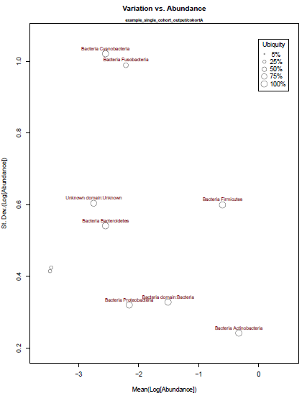

Direct command line invocation
lib/TaxonomicVariation.r -i example_data/cohortB.phylum.summary_table.tsv
OUTPUT: example_data/cohortB.phylum.pdf

