MEDIMESH - HOSPITAL MANAGEMENT SYSTEM
APPLICATION DOCUMENTATION

1. INTRODUCTION
MediMesh is a web-based hospital management application designed to simplify
day-to-day hospital operations. It brings patients, doctors, and hospital
administrators together on one platform where they can manage appointments,
view pharmacy stock, track ambulance availability, resolve complaints, and
communicate through a community forum.

The application is built using a microservices architecture, which means
instead of a single large application handling everything, the system is
divided into smaller, independent services. Each service is responsible for
one specific area of the hospital's operations. For example, one service
handles only appointments, another handles only the pharmacy, and so on.
These services work together behind the scenes to deliver a unified
experience to the user.

There are three types of users in MediMesh:

- Patients can register, book appointments with doctors, view available
medicines in the pharmacy, check ambulance availability, file complaints,
and participate in community discussions.

- Doctors can manage their professional profile, set their availability
status, review appointment requests from patients, approve or reject
those requests, and record patient health vitals.

- Administrators have full control over the system. They manage the
pharmacy inventory, the ambulance fleet, and user complaints. The admin
account is not created through registration. It is automatically set up
when the system starts for the first time.

The purpose of MediMesh is to replace manual, paper-based hospital workflows
with a digital solution that is faster, more organized, and accessible from
any web browser.

2. MICROSERVICES OVERVIEW
MediMesh is composed of nine services. Eight of them are backend services
that handle specific hospital functions. And one is the frontend, which
is the web page the user sees and interacts with.
Below is a description of each service and what it does.
2.1 USER SERVICE
The User Service manages patient profiles. While the Auth Service stores
basic account information like username and password, the User Service stores
additional patient details such as age, gender, blood group, home address,
phone number, and emergency contact information.

When a patient first accesses their profile, the service automatically
creates a blank profile for them, which they can then fill in and update.
This service also acts as a convenience layer for patients by allowing them
to fetch doctor listings, ambulance availability, and pharmacy stock through
a single point of access.
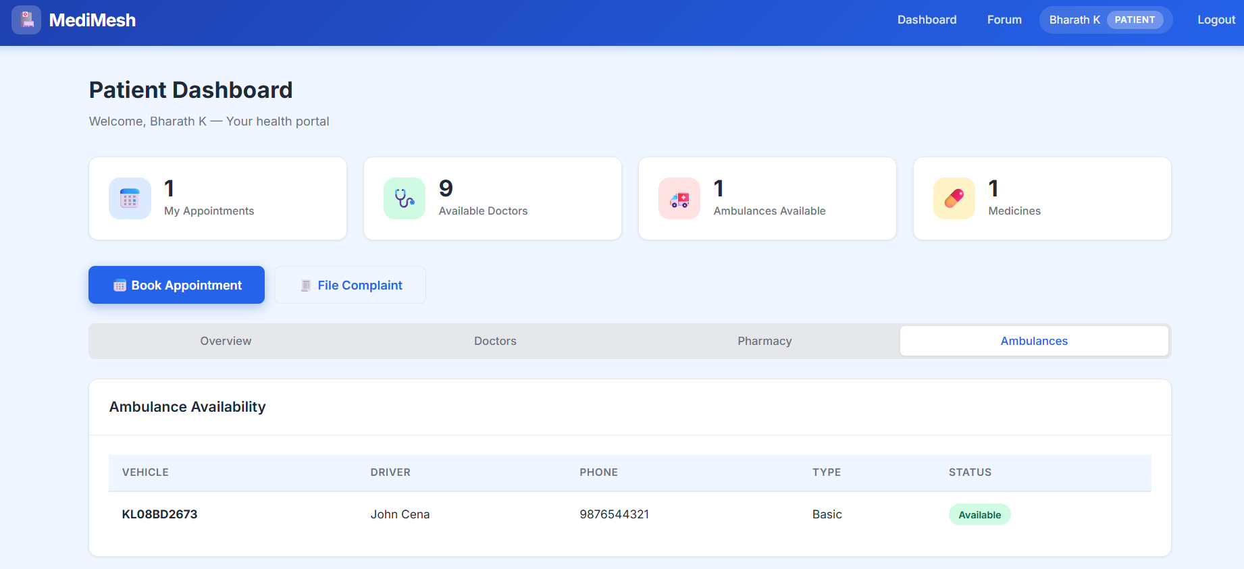

2.2 DOCTOR SERVICE

The Doctor Service manages doctor profiles. Each doctor has a profile that
includes their full name, specialization (such as Cardiology, Neurology, or
Pediatrics), years of experience, consultation fee, contact details, and
an availability status that indicates whether they are currently accepting
new appointments.

When the system starts for the first time, five default doctor profiles are
created automatically with different specializations. Doctors can update
their profiles at any time and toggle their availability on or off. Patients
can browse the full list of doctors along with their specializations and
fees to decide whom to book an appointment with.
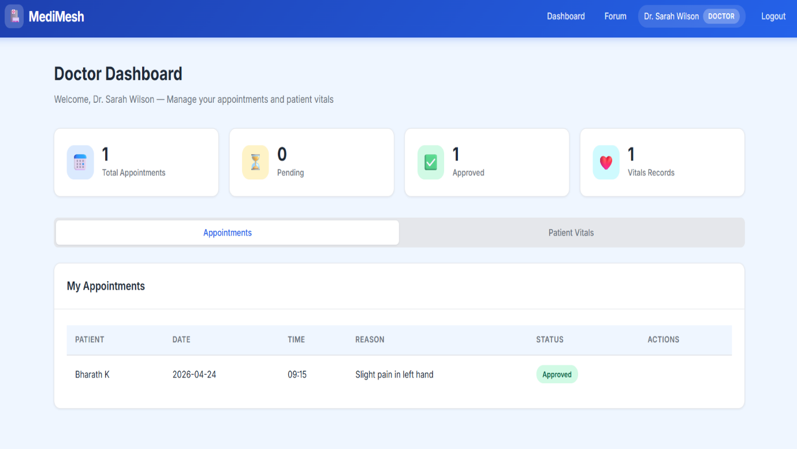

2.3 APPOINTMENT SERVICE

The Appointment Service handles the entire appointment lifecycle. Patients
create appointment requests by selecting a doctor, choosing a date and time,
and providing a reason for the visit. Each new appointment starts with a
status of "pending."

Doctors can view all appointment requests assigned to them. They can approve
or reject each request and optionally add notes (for example, asking the
patient to bring previous medical reports). Patients can see their
appointment history along with the current status of each appointment.
Administrators can view all appointments across the system.
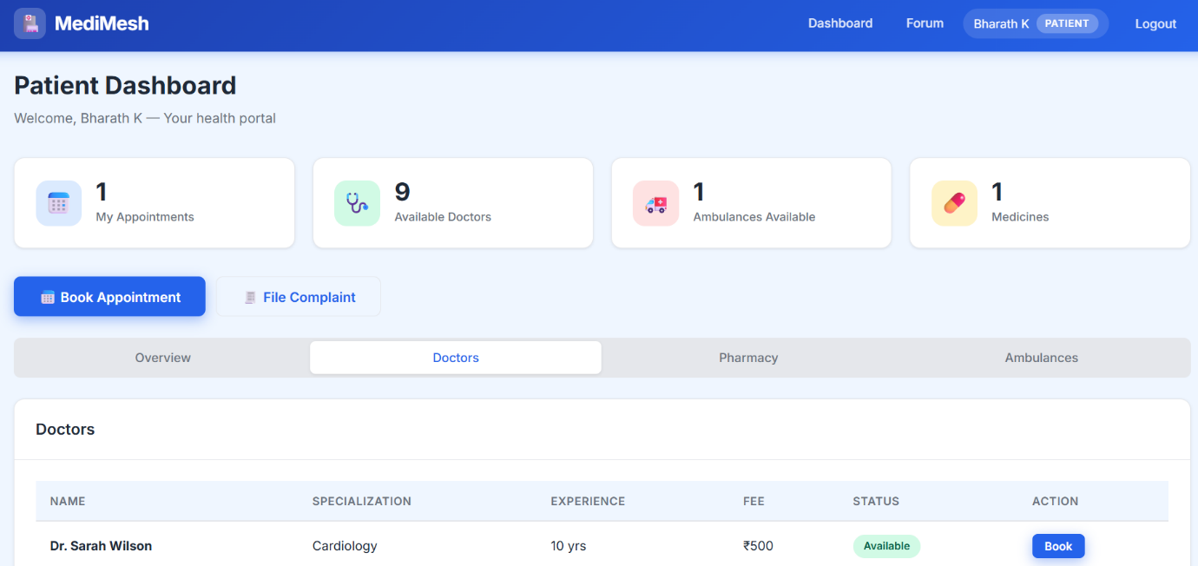

2.4 VITALS SERVICE

The Vitals Service is used to record and track patient health measurements.
Doctors use this service to record vitals such as blood pressure and heart
rate for patients they are treating. These records are stored with timestamps
so that a history of the patient's health measurements can be reviewed over
time.

This service is primarily used by doctors. They can create new vitals
entries, view existing records, and update them if corrections are needed.

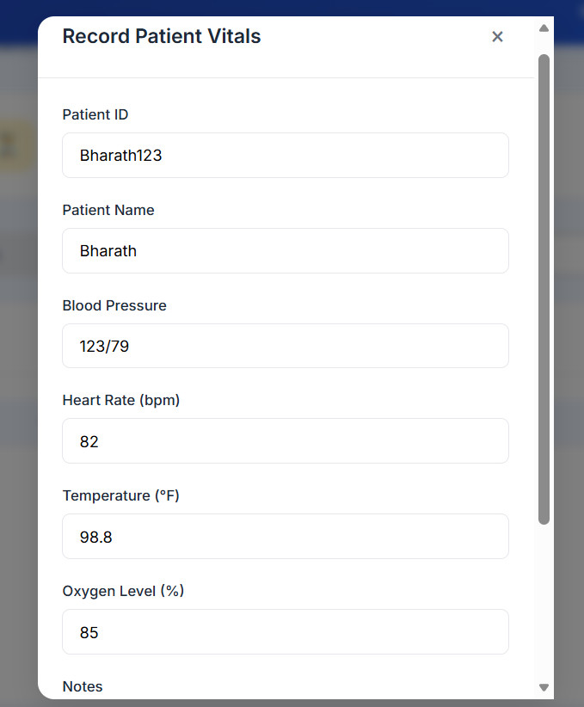

2.5 PHARMACY SERVICE

The Pharmacy Service manages the hospital's medicine inventory. Each medicine
entry in the system includes the medicine name, its category (such as
Analgesic, Antibiotic, or Supplement), the manufacturer name, price, current
stock quantity, expiry date, a short description, and whether the medicine
requires a prescription.

Only administrators can add new medicines, update existing entries, or
remove medicines from the catalogue. All authenticated users, including
patients and doctors, can browse the pharmacy inventory to check what
medicines are available and their current stock levels.
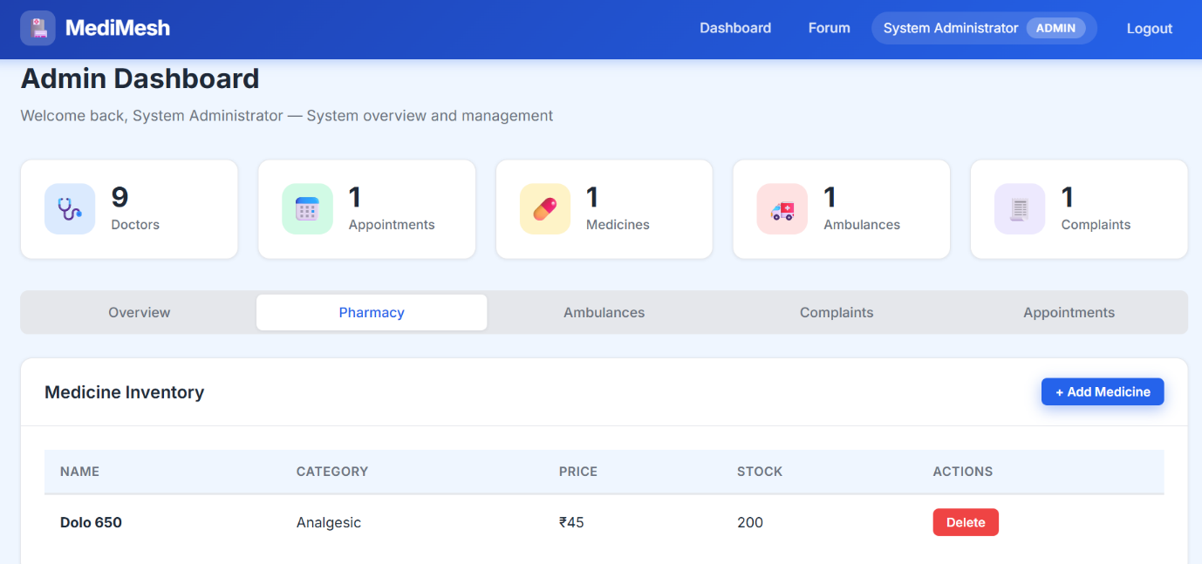

2.6 AMBULANCE SERVICE

The Ambulance Service tracks the hospital's ambulance fleet. Each ambulance
record includes the vehicle registration number, the assigned driver's name,
the driver's phone number, the type of ambulance, and its current status
(such as available or dispatched).

Administrators manage the ambulance fleet by adding new vehicles, updating
their details, or removing them from the system. Patients and other users
can view the list of ambulances and check which ones are currently available.
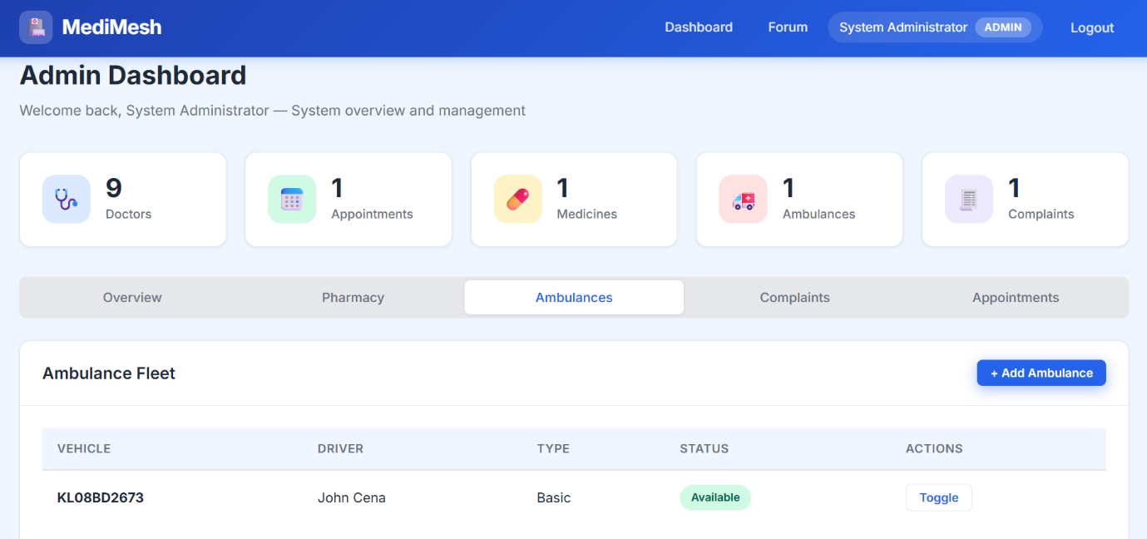

2.7 COMPLAINT SERVICE

The Complaint Service allows users to file complaints about hospital
services. Any logged-in user can submit a complaint by providing a subject,
a detailed description, and selecting a category. The available complaint
categories are Service, Staff, Facility, Billing, and Other.

Each complaint goes through a lifecycle. It starts as "open" when first
submitted. An administrator reviews the complaint, can mark it as
"in-progress" while it is being investigated, and finally marks it as
"resolved" or "closed" along with notes explaining the resolution. Users
can view the current status of their own complaints at any time.

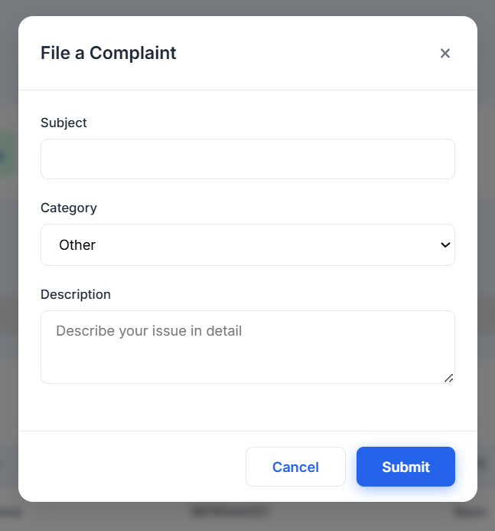

2.8 FORUM SERVICE

The Forum Service provides a community discussion space within the
application. All authenticated users, regardless of their role, can create
discussion posts, read posts by others, and like posts they find helpful.

Each post includes a title, content, optional tags, and displays the
author's name and role (so users can see if a post was written by a doctor,
patient, or administrator). Users can delete their own posts. Administrators
have the additional ability to delete any post if it violates guidelines.
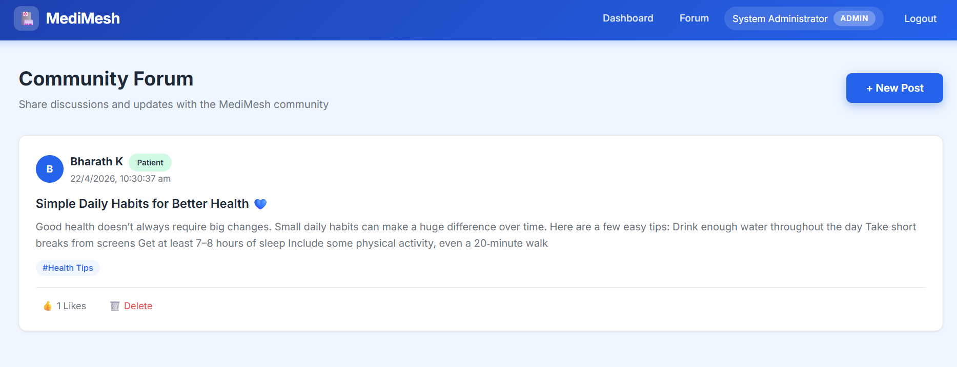

2.9 FRONTEND

The Frontend is the web interface that users see and interact with in their
browser. It is a single-page application, meaning the entire application
loads once and then updates dynamically as the user navigates between
different sections.

The frontend provides the following pages:

- A landing page that introduces MediMesh to visitors.
- A login page where users enter their credentials.
- A registration page where new patients and doctors can create accounts.
- A dashboard page that automatically shows different content based on
the user's role (patients see their appointments and available doctors,
doctors see their appointment requests and vitals, administrators see
a full system overview).
- A forum page where users participate in community discussions.

The frontend does not communicate directly with any backend service. All
its requests go through the BFF service, which handles the routing to the
appropriate backend.
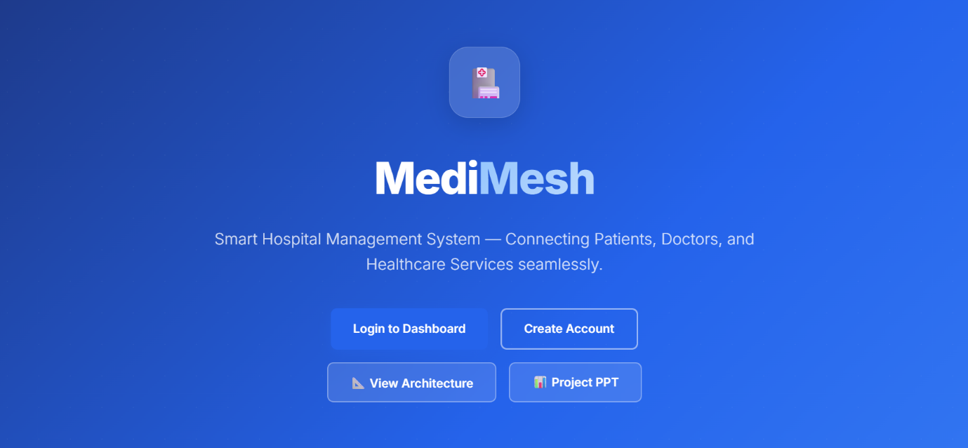

3. HOW THE APPLICATION WORKS (SIMPLIFIED)

When a user opens MediMesh in their browser, the following happens at a
high level:

1. The user sees the landing page and clicks on Login or Register.

2. If registering, the user fills in their details and selects their
role (patient or doctor). The system creates their account.

3. Upon login, the system verifies the credentials and sends back a
secure token. The browser stores this token and uses it for every
future request.

4. After login, the user is taken to their dashboard. The system
recognizes the user's role from the token and shows the appropriate
dashboard (patient, doctor, or admin).

5. When the user performs any action (booking an appointment, adding a
medicine, filing a complaint), the request flows from the browser
to the BFF service, then to the relevant backend service, then to
the database, and the response travels back along the same path.

6. The user's token expires after 24 hours. If the token expires or
becomes invalid, the system automatically logs the user out and
redirects them to the login page.

The key idea is that each backend service handles only one area of
responsibility. The BFF service acts as the single door through which all
requests pass. And the frontend is simply the visual layer that the user
interacts with.

4. SUMMARY

MediMesh is a hospital management system that digitizes core hospital
operations. It is divided into independent services, each handling a
specific function:

User Service - Patient profile management
Doctor Service - Doctor profile and availability management
Appointment Service - Appointment booking and approval workflow
Vitals Service - Patient health vitals recording
Pharmacy Service - Medicine inventory management
Ambulance Service - Ambulance fleet tracking
Complaint Service - User complaint filing and resolution
Forum Service - Community discussion forum
Frontend - Web-based user interface

Together, these services provide a complete hospital management solution
that is modular, scalable, and easy to maintain. Each service can be
updated or scaled independently without affecting the rest of the system.

