**Climbing Adventure**

***- Ease into the world of climbing by taking part in our awesome adventure! -***

Team members: <Chirvasa Matei> <Petrasuc Ana> <Grozea Tatiana>

-------------------------------------------------------------------------------------

Description

1. One paragraph about **why** this app:   
    This app aims to provide an immersive climbing experience, filled with tense moments that provide a sense of accomplishment. The main focus is creating a fun, realistic environment in which to experience the joy of climbing, be it scaling a mountain or a building.
2. One paragraph about **how** this app will achieve the why:  
    The app will be created using the OpenXR module of Unity, and the climbable surfaces will be imported from the Asset Store and adjusted accordingly or modeled by hand. In order to create a sense of accomplishment, losing your grip or balance will lead to the user’s progress being reset.
3. **What is different** compared to other solutions:  
    The app will combine the idea of a simplistic climbing game along with that of surpassing hand-crafted challenges in order to keep players engaged.

-------------------------------------------------------------------------------------

Similar products & Relevant Links(>=3)

**Name:** The Climb

**Url:** <https://www.theclimbgame.com>

**Relevant Features:**

- Grabbing

- Swinging

- Jumping

- Scalable, interesting environments

**Name:** VR Rock Climbing

**Url:** <https://store.steampowered.com/app/2142110/VR_Rock_Climbing/>

**Relevant Features:**

- Grabbing

**Name:** Adventure Climb VR

**Url:** <https://store.steampowered.com/app/1040430/Adventure_Climb_VR/>

**Relevant Features:**

- Grabbing

- Swinging

- Jumping

-------------------------------------------------------------------------------------

Main Features

* **PRINCIPAL MAIN VERY IMPORTANT FEATURE:**
* Climbing Mechanics & Haptic Feedback

*Description:*

Experience lifelike climbing through responsive hand controls and haptic feedback, providing a sense of texture, resistance, and immersion as users grasp different surfaces and feel the nuances of each climb. Haptic feedback is used to simulate real experiences, providing a tactile sensation of different textures and resistance levels, such as rocky surfaces, slick walls, or even metal bars.

* **Other features:**
* **Dynamic Environments**

*Description:*

Terrains and realistic environmental changes (such as day/night cycles, weather shifts, and altitude effects) to enhance immersion and keep challenges fresh.

* **Skill Progression System**

*Description:*

Gradual skill-building with levels that increase in complexity, helping users improve their climbing techniques and motivating them with milestones and achievements.

* **Guiding Tools**

*Description:*

Guidance tools, such as visual path suggestions or hint prompts, to make the experience accessible for both newcomers and experienced climbers.

-------------------------------------------------------------------------------------

User Journey Diagram - Step by step flow through app

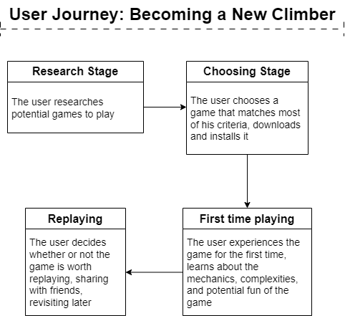

Moodboard (10+ images)

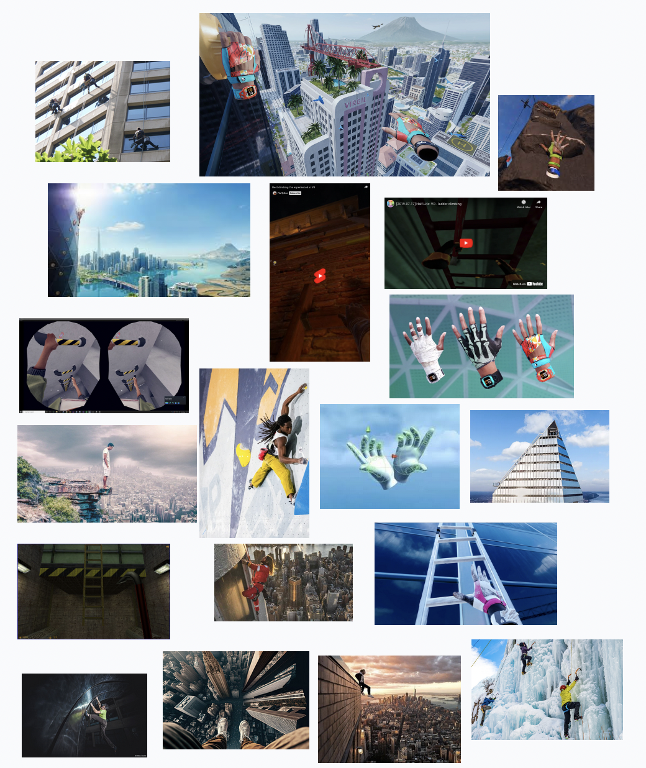

Technologies, Libraries, Assets - Links (>=5)

* [Unity](https://unity.com/)
* [OpenXR](https://www.khronos.org/openxr/)
* [Blender](https://www.blender.org/)
* [HapticSDK](https://haptx.com/sdk/)
* [Hill Rock Mountain Terrain Asset](https://assetstore.unity.com/packages/3d/environments/landscapes/hill-rock-mountain-terrain-282889)
* [Urban Skyscrapers Asset](https://assetstore.unity.com/packages/3d/environments/urban/urban-skyscrapers-289028)
* [Big Oak Tree Asset](https://assetstore.unity.com/packages/3d/vegetation/big-oak-tree-free-279431)
* [Prototyping Pack Asset](https://assetstore.unity.com/packages/3d/prototyping-pack-free-94277)