1. List all classrooms with a capacity greater than 50
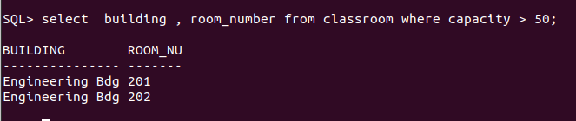
2.​ Find the names of I011 Duck Quackall instructors in the "Computer Science" department.
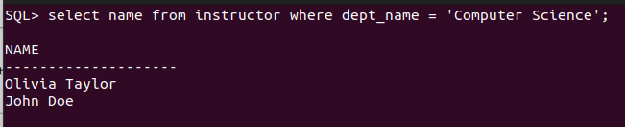
3.​ Retrieve the titles of all courses offered in the "Spring" semester of 2023.
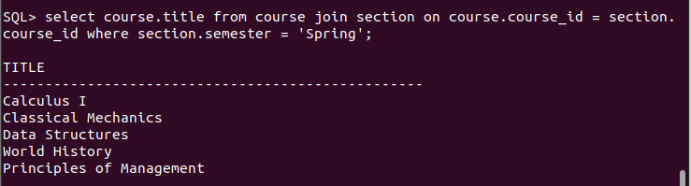

4.​ List all students I011 Duck Quackwho have taken more than 100 total credits.

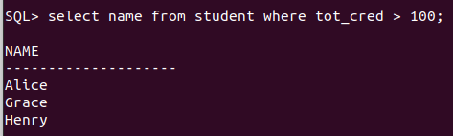

5.​ Find the names of all departments with a budget greater than ₹1,000,000.
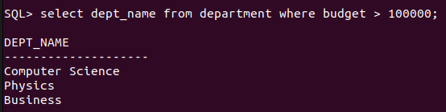

6.​ List all departments and their respective buildings.
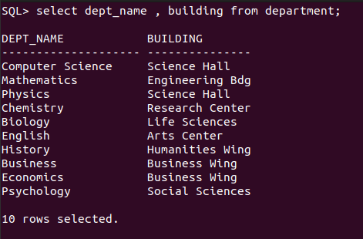

7.​ Find the names of all students enrolled in the "Physics" department.

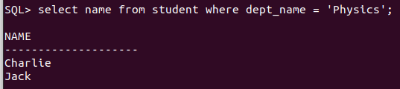

8.​ Retrieve the titles of all courses with 3 credits.

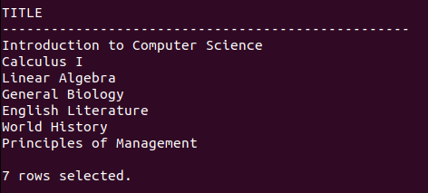

9.​ List all instructors who do not belong to any department.
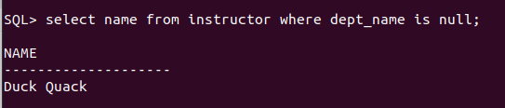

10.​Find the total number of classrooms in each building.

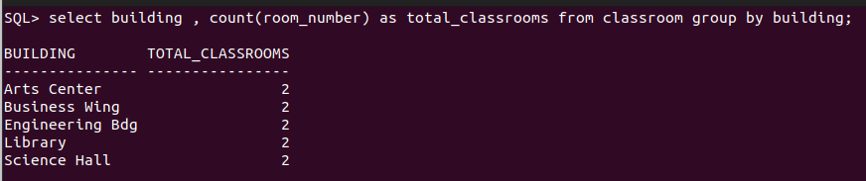
I011 Duck Quack

11.​List all courses taught by the instructor with ID "I001".

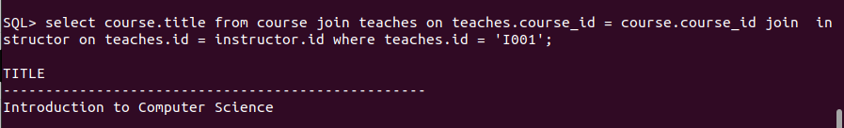

12.​Find the total number of students enrolled in each department.

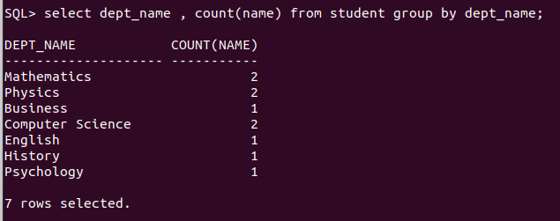

13.​Retrieve the names of students who have taken the course "CS-101" and received an
"A" grade.

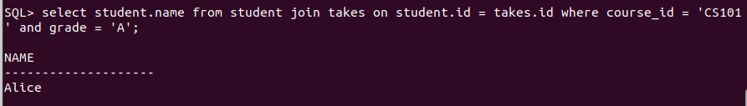

14.​List all instructors who earn a salary greater than ₹50,000.

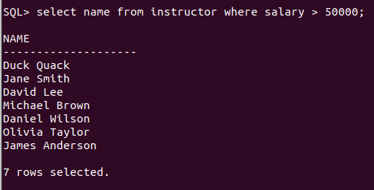

15.​Find the average salary of instructors in each department.

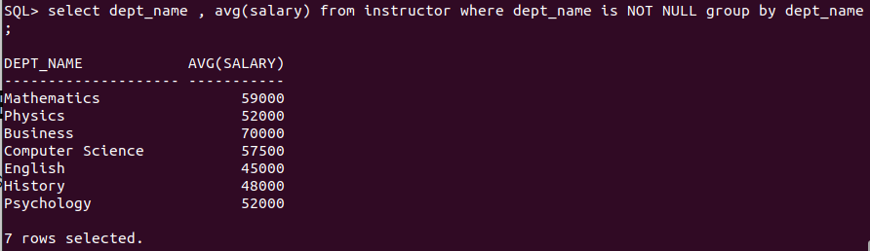

16.​Retrieve the names of students who have not been assigned an advisor.

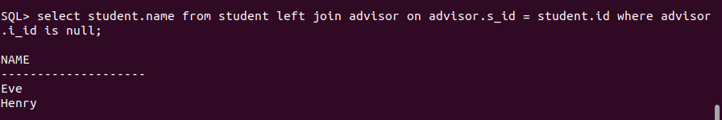

17.​List all courses that have "CS-101" as a prerequisite.

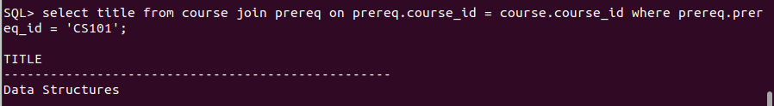

18.​Find the total number of sections taught in each building.

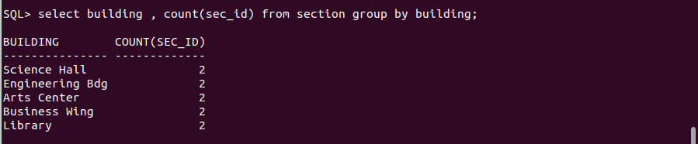
19.​Retrieve the names of students who have taken at least one course in the "Fall"
semester of 2023.

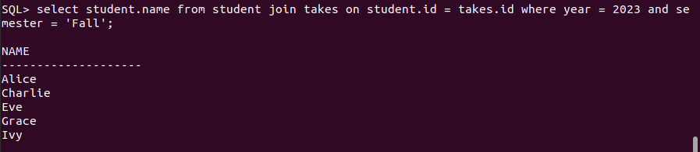

20.​List all classrooms that have not been assigned to any section.

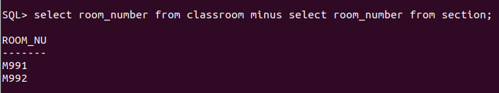

21.​List all courses offered by the "Mathematics" department.

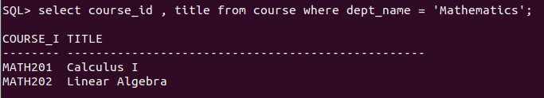

22.​Find the names of students who have taken courses in both "Fall" and "Spring"
semesters.

23.​Retrieve the names of instructors who have taught more than 5 sections.

24.​List all courses that have no prerequisites.

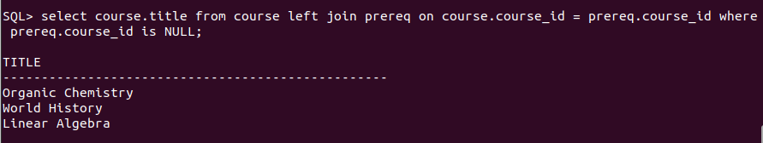

25.​Find the average number of credits taken by students in each department.

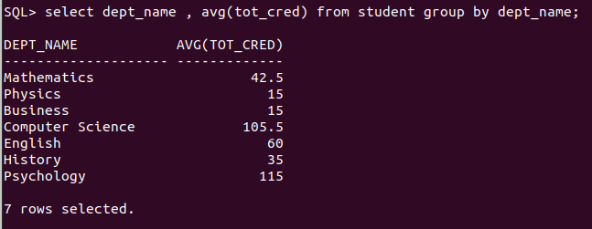

26.​Retrieve the names of students who have taken courses with the instructor "Jane Smith".

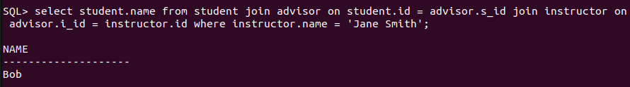

27.​List all sections that are held in the "Business Wing" building.

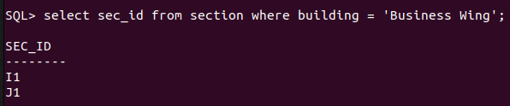

28.​Find the total budget allocated to all departments.

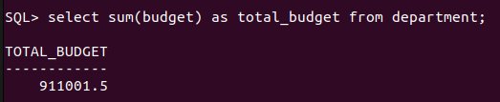

29.​Retrieve the names of students who have taken at least one course with a grade of "B".

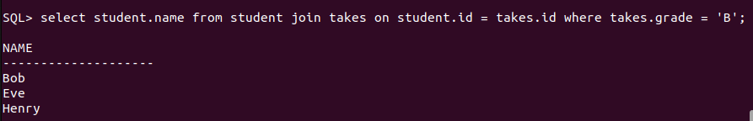

30.​List all instructors who have not taught any courses.

31.​Find the names of students who have taken all courses offered by the "Computer
Science" department.
32.​Retrieve the names of instructors who have taught every course in their department.
33.​List all students who have taken at least one course with every instructor in their
department.
34.​Find the courses that have the highest number of prerequisites.
35.​Retrieve the names of students who have taken the same course more than once.
36.​List all instructors who have taught in every semester (Fall, Winter, Spring, Summer) in
the year 2023.
37.​Find the departments where the average instructor salary is greater than the overall
average salary.

