MA611 – 2nd Semester MCA, 2024-2025
DATABASE SYSTEMS LAB
Assignment-1

Name : Vishal Sharma
Rollno. : 244CA061

1. List all classrooms with a capacity greater than 50
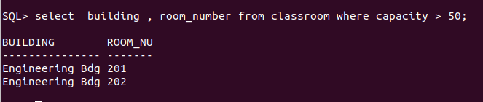
2.​ Find the names of I011 Duck Quackall instructors in the "Computer Science" department.
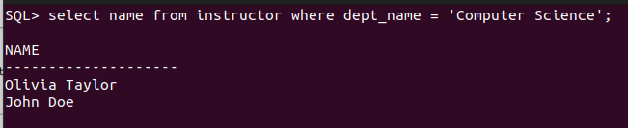
3.​ Retrieve the titles of all courses offered in the "Spring" semester of 2023.
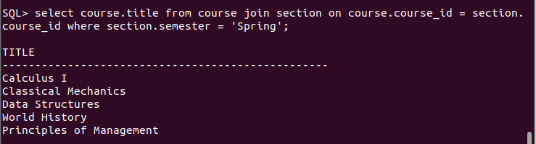

4.​ List all students I011 Duck Quackwho have taken more than 100 total credits.

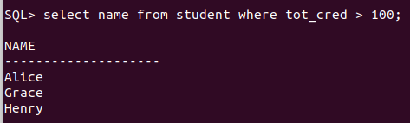

5.​ Find the names of all departments with a budget greater than ₹1,000,000.
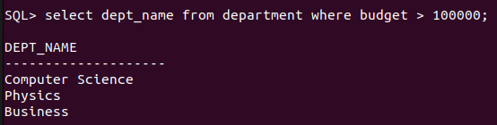

6.​ List all departments and their respective buildings.
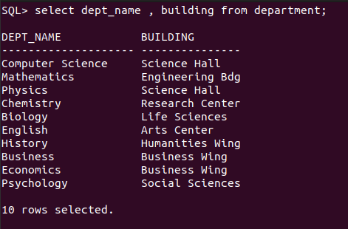

7.​ Find the names of all students enrolled in the "Physics" department.

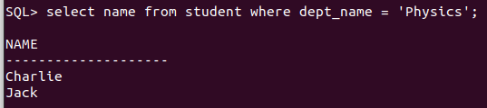

8.​ Retrieve the titles of all courses with 3 credits.

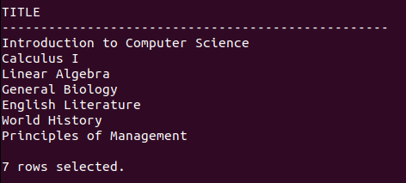

9.​ List all instructors who do not belong to any department.
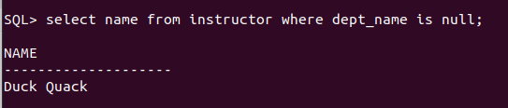

10.​Find the total number of classrooms in each building.

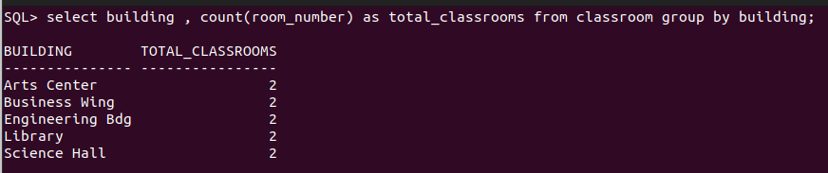

11.​List all courses taught by the instructor with ID "I001".

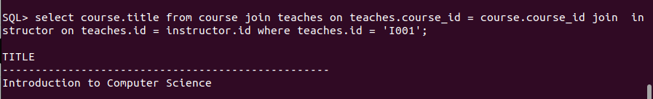

12.​Find the total number of students enrolled in each department.

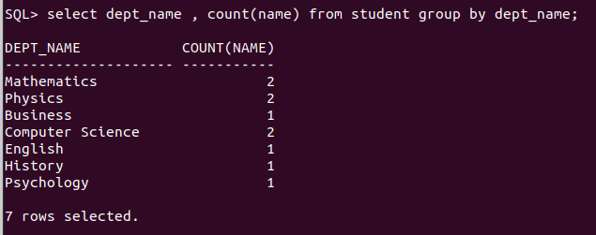

13.​Retrieve the names of students who have taken the course "CS-101" and received an
"A" grade.

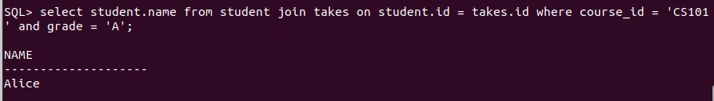
14.​List all instructors who earn a salary greater than ₹50,000.

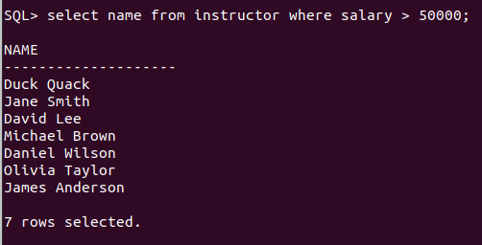

15.​Find the average salary of instructors in each department.

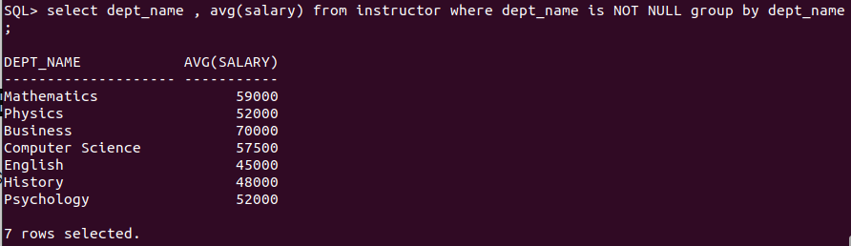

16.​Retrieve the names of students who have not been assigned an advisor.

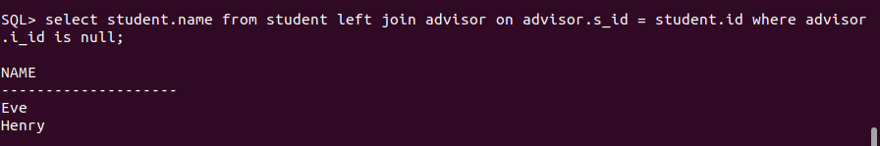

17.​List all courses that have "CS-101" as a prerequisite.

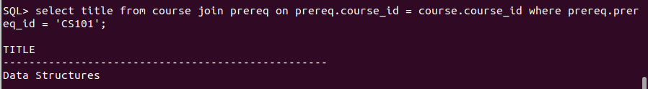

18.​Find the total number of sections taught in each building.

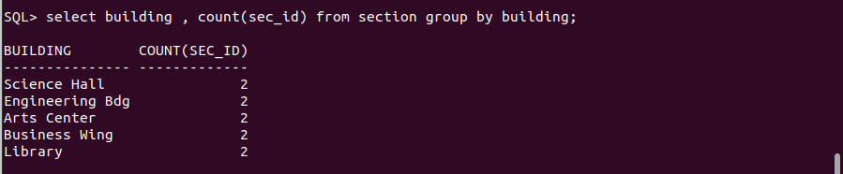

19.​Retrieve the names of students who have taken at least one course in the "Fall"
semester of 2023.

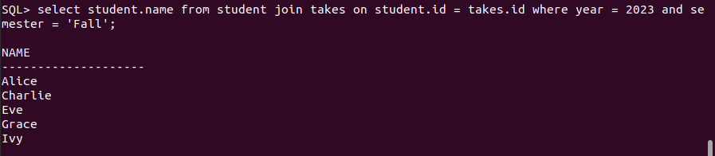

20.​List all classrooms that have not been assigned to any section.

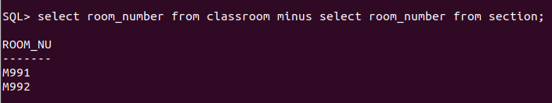

21.​List all courses offered by the "Mathematics" department.

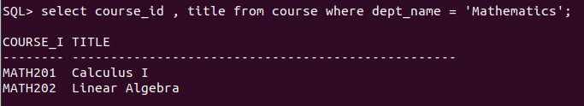

22.​Find the names of students who have taken courses in both "Fall" and "Spring"
semesters.

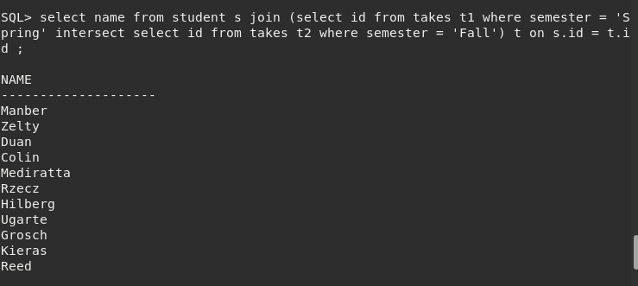
23.​Retrieve the names of instructors who have taught more than 5 sections.

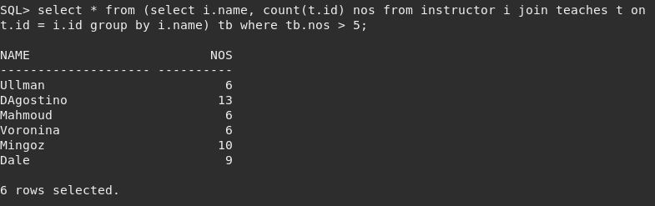

24.​List all courses that have no prerequisites.

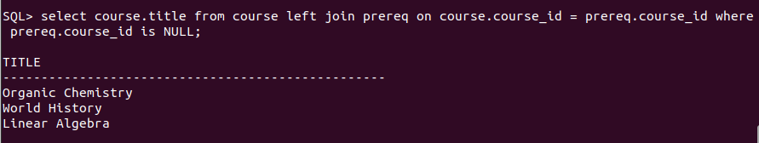

25.​Find the average number of credits taken by students in each department.

