The impact of aerobic exercise on a treadmill on the cardiovascular health of patients with implanted stents
Medisa Satara
Faculty of Information Technologies (FIT)
University “Džemal Bijedić”
Mostar, Bosnia and Herzegovina
medisa.satara@edu.fit.ba

Abstract - People with increasingly frequent chest pains and changes in their heart undergo procedures such as coronary angiography. A stent is a metal tube that helps blood vessels to expand. After the procedure, the person undergoes a postoperative process that includes exercise and a different diet that lead to a better, healthier and better quality of life. In this case, we will examine whether there is any risk from physical activity, and what impact the examination, which consists of going to the treadmill, as well as rehabilitation in the form of aerobic exercise, has on people after stent implantation.

Keywords— Coronary Angiography; aerobic exercise

I. INTRODUCTION
After a procedure or cardiac arrest, people participate in heart rehabilitation programs. People who undergo this program have a lower rate of re-hospitalization and a better quality of life. The effects of the rehabilitation program include improved mobility, endurance, increased strength and the ability to fully recover.[1]

People consider this intervention as an alarm that went off for a change in life habits, a desire for a healthier life, which includes regular exercise. After the procedure itself, a professional person is needed for personal safety. Exercise improves fitness and controls body weight, which helps in taking care of your stent. According to certain studies, rehabilitation gives very good results. These studies have shown that people who participate in rehabilitation have a better quality of life and a lower chance of developing a serious illness.

The first phase is a light walk, which after a certain time is combined with regular exercise. What the intensity of the exercise will be depends on the method and speed of recovery, the quality of life before the procedure, and the will that the person has after the procedure. First, we will show what research has shown so far regarding exercise after the procedure, whether it is safe, and what aerobic exercise actually is. At the end, a case study based on a real event was done.

II. CORONARY ANGIOGRAPHY
More and more people are suffering from heart disease today, so it is considered one of the most common causes of death in the world. That's why today there are treatments that "in time" check whether and how much arterial heart disease is present, one of them is coronary angiography, which embeds the stone through the arteries.

The heart is a muscular organ that pumps blood throughout the body. For the heart to perform its job efficiently, it needs a good supply of blood and oxygen. The heart receives its blood supply through blood vessels called coronary arteries.[6]

Coronary angiography is a procedure of imaging the blood vessels of the heart, which confirms the existence of tears in the arteries. The procedure is performed in laboratories surrounded by monitors with a real-time image that even the patient can follow.[2]

Coronary angiography is most commonly performed through the leg or through the arm, in full consciousness of the patient, who can even follow the process of introducing the metal rod on the screen itself.

III. RELATED WORKS
Research has shown that people undergoing rehabilitation after this procedure are able to lead a healthier lifestyle, work more, and reduce the possibility of a repeat arrest, and improve heart function.

Recent research included 5179 patients, showed no difference in mortality and cardiovascular disease rates in patients with optimal medical treatment and routine invasive approach, but showed an improvement in heart problems after revascularization. [3]

A lower rate of death or heart attacks in patients with stable angina pectoris (SAP) was not demonstrated in a 2014 meta-analysis. on that occasion, the effects of percutaneous coronary intervention (PCI) were investigated. In addition to the meta-analysis, PCI was compared with a sham procedure in patients with SAP, to compare the difference in symptoms and exercise capacity.[3]

IV. CARDIAC REHABILITATION
Cardiac rehabilitation, in addition to exercise, also includes support for changes in lifestyle habits and nutritional counseling. It includes training two to three times in seven days, and it starts after an agreement with a professional person.

A. Exercise after the procedure
Depending on the severity and complications during the procedure, after a certain time, it is possible for the person to continue with excercise or just start exercising. In his subconscious, man has a subject on his heart that he must take into account more about his life, his way of life, his diet, and even his way of thinking. Therefore, he considers this process a turning point in his life.

Cardiac rehabilitation gives quite good results, indicating that exercise is healthy, of course at the beginning with professional supervision. Exercising requires taking care of the stent, body weight, diet and movement, thus improving the quality of life compared to those who do not participate in this type of recovery. Under daily rehabilitation, regardless of the procedure that even a healthy person needs to apply, includes light walking. And what needs to be emphasized in particular is aerobic exercise, which is more and more frequent and gives good results for such people.

V. AEROBIC EXERCISE
In order for the muscles to move, oxygen is needed in the muscles, which provides strength for exercise. Power is generated by the body using stored carbohydrates and fats in combination with oxygen. So we come to the explanation of what the word "aerobic" means, which is "with oxygen". [8]

Aerobic exercise induces changes that are not physically visible, namely changes in the level of cells, tissues and organ levels, which affects the increase in the body's metabolism. Aerobic exercise disrupts homeostasis and causes significant changes in the cardiovascular, pulmonary, and neurovascular systems.. [6]

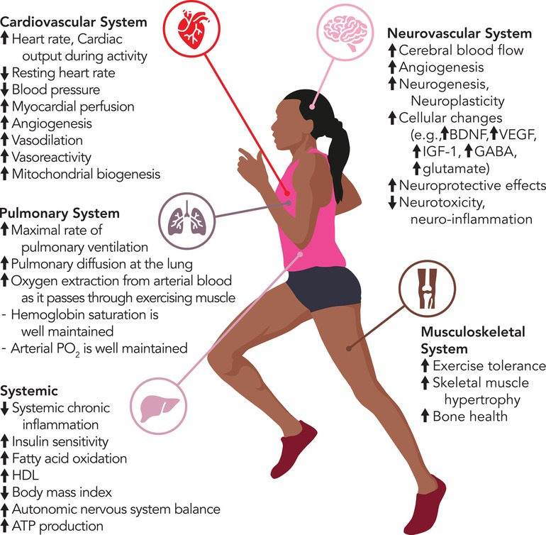

Figure 1 Aerobic exercise-induced changes in body systems

The process of aerobic exercise seems easy, however, it involves a large group of muscles, the exercises are repeated, and it can be continuously maintained, which also increases the heart rate. The muscles of the arms, legs and hips work at the same time. This process causes the reaction of shallow and deeper breathing, rapid heartbeats that promote greater blood flow to the muscles and lungs. Capillaries expand and oxygen flow is greater, and harmful products accumulated in the body are released.
The benefit of aerobic exercise in this case includes the effect of helping people to get rid of increased physical inflammation. Physical activity increases the level of cholesterol, reduces the load on the heart and improves heart function both in healthy people and in people in this condition.
The main goal of aerobic exercise is to improve oxygen delivery, changes in blood vessels, regulate inflammation, and improve human mobility. Aerobic exercise does not pose a threat to the physical endurance of the body.
Research on animals and humans has shown that long-term aerobic exercise has a positive effect on brain activity, an increase in different brain regions, as well as cerebral circulation, and an increase in maximum oxygen consumption in patients who have experienced a stroke.[4]

A. Benefits of aerobic exercise
Physical activity has multiple effects. It is important to note that it promotes a healthy lifestyle that includes aerobic exercise as part of rehabilitation. The main benefit of aerobic exercise is to improve health optimization in patients with heart disease.

Although coronary angiography is considered an easy procedure, it is not. If the symptoms before the procedure were accompanied by pain in the chest, heavy breathing, after the procedure this should decrease and enable better exercise. However, these exercises also include accompanying needs, such as a proper diet that includes food without fat, maintaining a certain body weight, then stopping the consumption of cigarettes and alcohol.

Also, exercise reduces a person's body weight. When we combine exercise and a healthy diet, we get the best possible way to prevent heart disease. Exercising reduces the calories taken into the body. Cigarette smoking is one of the main causes of heart disease, and research has shown that people who exercise regularly smoke cigarettes less or hardly at all. After the procedure, the person should be careful of viral diseases, and the immune system is activated by exercise itself. With each treatment, the heart gets stronger, so that it pumps blood more efficiently.
.
In order to increase the body's ability to use oxygen more efficiently, it is achieved through regular aerobic exercise. Regular aerobic exercise strengthens the heart muscle, which enables the heart to pump blood through the body more efficiently. With each strengthening of the heart, a greater delivery of oxygen to the muscles is achieved, the rapid heartbeat is reduced.[7]

Even if, before this procedure, a person was not physically active, did not do any exercises, even aerobic exercise, that will not prevent him from starting after this as if he had done it before. It is very important that this procedure does not affect the man in the sense that he is afraid to do any activities. It is necessary for a person to be active even in older years, which, in addition to affecting the heart, will also contribute to a lower risk of falls and injuries. As a result, the person will be in a much better mood, have a sharper mind and will have better thinking skills, which will enable them to take care of their health.

For people who have survived heart attacks, it is necessary to investigate procedures in the future that would prove the value of cardiac rehabilitation in reducing disability or mortality.[4]

B. Precautions for aerobic exercise
Excessive exercise can lead to certain injuries, due to which a person often gives up or is unable to do such or similar exercises as before. The intensity of the exercise increases gradually depending on the health problems or the previously performed procedure, and it increases depending on the feelings that the body itself provides to the person. In order to know if the intensity of the exercise is right, one of the ways to check is to talk while working. If he utters short sentences but continues to talk, that's a good intensity, and if he can't say more than a few words at once because he runs out of air, the intensity of the exercise is high.

In agreement with a professional person, aerobic exercises can be performed at home, which is more practical and gives more freedom for certain exercises.[4]

VI. CASE STUDY – RECOVERY AFTER STENT PLACEMENT

A. Introduction
This part presents a case study related to recovery after surgery, based on a real case. It is important to note that this is a 60-year-old person who has been physically active all his life, in the sense of constant physical work. This contributes to many health problems.

B. Research Objective
The aim of this study is the impact of aerobic exercise exactly one year after the procedure, followed by rehabilitation recovery, which includes care for the stent, proper nutrition and an almost equally active life, as before the procedure. The hypothesis of this research, which needs to be proven or disproved, is that aerobic exercise over the course of a year will be effective in reducing angular complaints.

C. Symptoms of the disease
The severity of the symptoms varies from person to person and appears gradually, progressing into permanent symptoms that give information that everything is not so good.

Disease symptoms:
• pressure in the chest area,
• pains in the shoulders, arms and jaw that occur in the case of narrowing of the arteries on the heart that prevent the flow of blood and oxygen to the heart.
• a feeling of shortness of breath in the case of a short or light walk.

D. Discussion
After the stent is installed, it is necessary to take care of it, with the help of antibiotics, the way of movement, until the body accepts the stent as part of it. The fact that 24 hours after the procedure is not allowed to move is often difficult for people, regardless of whether or not they were physically active before.

The recovery process involves a gradual warm-up with aerobic exercise. It allows the heart to move slowly. It is possible to overload the heart, until it adapts, so that it moves with a light walk to a higher speed, so that the heart beats adapt to the exercises. The best option for a quick and better recovery is regular aerobic exercise, which increases the heart rate and effort. The more often these exercises are done, the faster they will become more resistant, the blood vessels will also strengthen significantly, which reduces the chance of complications occurring again.

As part of the regular check-ups after the procedure, one of them is going to the tape for approximately 8.30 minutes. It is not necessary for a person to over-prepare for it, the most important thing is mental preparation, and in case of some fatigue, not to feel the need to give up during the examination. Of course, it is possible not to do the whole trip to the tape with the consent of the responsible person, if the person feels that it is not good for him.

When standing on the treadmill, heart rate is measured, ie electrodes are placed and blood pressure is measured a couple of times while walking on the treadmill. More precisely, stop the belt once or twice to measure the pressure before the very beginning and during the performance of the belt, and after.

The case study was made during the second regular examination after the procedure. Then the results during exercise on the treadmill were more visible, considering that the second regular examination is after one year from the procedure. A person has the opportunity to recover well enough and return to old life habits, improve the previous quality of life.

E. Results
A person, as already stated at the beginning, is a physical worker all his life. And this procedure did not prevent him from continuing where they left off after recovery. The person followed all the doctor's instructions for the previous year, he eats somewhat healthily, and a little differently, since we will take into account that the person also has sugar. Therefore, even before the procedure for a couple of years, the person does not consume sugar and adheres to the rules related to it. Takes regular walks in the evening hours after the last meal.

Arriving at the strip, the person felt tired, precisely because of that regular walk she had done the night before, and it was difficult to walk to the doctor's office, a journey of some 50 m. Walking on the treadmill lasts 8.30 minutes, it moves from a light speed to a higher one, with an interruption once for pressure measurement, and the examination lasts 20 minutes in total. During the tape, the person had normal blood pressure, as well as after the tape, and after the tape she moved better than before the tape.

F. Conclusion
In research, it was shown that walking on a treadmill from low to high speed helped a person recover physically. She was physically fitter and more dexterous after the exercise on the treadmill, in contrast to the beginning of the exercise itself. An investigation was carried out, what if in such a situation the journey on the track is extended? It was not a problem for the person, because after a certain time he got used to the faster walk, the pressure on the heart and chest was less and less, it was almost not felt at the end.

During this examination, the person must have an escort, because it is believed that after the exercise, he may feel bad and should not drive a car. However, in the course of this investigation, as previously stated, the person felt better after the exercise than before, and he felt well enough as a passenger. This research has shown that the hypothesis set at the beginning is positive.

VII. CONCLUSION
Through this work, we have discussed the very definition of the disease, the things that help in recovery and the precautionary measures when it comes to recovery. Coronary angiography is one of the more frequently performed procedures, which somehow prevents major health problems from occurring in time, but requires attention and recovery almost as if there were a bigger problem. No matter how physically active a person was before, after recovery it is necessary to be even more physically active. This does not mean that he will learn to do some other exercises again, but he should get used to them only with greater caution. Through an example on a real person, we were convinced of the impact of aerobic exercise before and after the procedure, and that it should continue to be applied whether the person is healthy or not.

REFERENCES
- "Post Stent Procedure: 5 Steps to Following an Exercise Plan." Carda Health, Carda Health, [Online]. Available: https://www.cardahealth.com/post/exercises-for-heart-patients-with-stents
[Accessed June 25, 2024]
- Dr Velicki. Šta je koronarografija i kako se procenjuje suženje [Online]. Available: https://drvelicki.com/razgovor/sta-je-koronarografija-i-kako-se-procenjuje-suzenje
[Accessed June 25, 2024]
- Al-Zubeidi, Maher, et al, Impact of a comprehensive cardiac rehabilitation programme versus coronary revascularisation in patients with stable angina pectoris: study protocol for the PRO-FIT randomised controlled trial [Online]. Available: https://bmccardiovascdisord.biomedcentral.com/articles/10.1186/s12872-023-03266-z
[Accessed June 25, 2024]
- Mann, D, "Exactly When You Can Exercise After Getting a Stent." Livestrong, 2023 [Online].
Available: https://www.livestrong.com/article/396274-when-can-you-exercise-after-stent-placement
[Accessed June 25, 2024]
- Koronarografija." Stetoskop.info, Stetoskop.info, [Online]. Available: https://www.stetoskop.info/metode-u-medicini/koronarografija ,
[Accessed June 25, 2024]
- Poddar, N., Sandhu, H. S., & Kaur, S. (2024). Mechanisms and benefits of cardiac rehabilitation in individuals with stroke: emerging role of its impact on improving cardiovascular and neurovascular health. Frontiers in Cardiovascular Medicine, [Online].Available: https://www.frontiersin.org/journals/cardiovascular-medicine/articles/10.3389/fcvm.2024.1376616/full
[Accessed June 25, 2024]
- MyDr, “Aerobic exercise: the health benefits”, [Online],
Available: https://mydr.com.au/sports-fitness/aerobic-exercise-the-health-benefits/ , [Accessed June 25, 2024]
- WebMD, “What Are Aerobic Exercises?” [Online]. Available: https://www.webmd.com/fitness-exercise/what-are-aerobic-exercises ,
[Accessed June 25, 2024]

