RESUME

Essential information

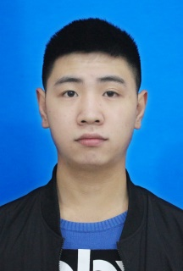

Name: Medivh

Nationality: Han

Telephone: 15084475688

Mailbox: 1104219457@qq.com

Address: Fengjie, Chongqing

Year of birth: 1997.09

Height: 171CM

Political outlook: League members

College: The University of Education

Education: Undergraduate

Educational background

20016.09-2020.06 The University of Education (undergraduate)

Major courses:

Tourism translation, English national society and culture, Computer-assisted translation, English and American Literature, Intercultural communication, Localization and translation, Japanese etc.

2017.02 Bansomedjchaopraya Rajabhat University (Training)

Accept the school's dean, lecturers to teach Chinese as a foreign language. Understand the level of local Chinese acceptance and the degree of Chinese fever. Learn the learning habits of local students and learn how to teach them Chinese.

2017.03 Thai Temple Primary School (teaching)

Teaching *Chinese as a foreign language* to students in grades 1-3 of the school. Learn about the learning habits of local primary schools from the classroom, learn from the teachings, and have a general understanding of the popularity of Chinese in Thailand.

Campus experience

Skill & Hobby

Self evaluation

The personality is cheerful and lively, good at dealing with people, strong learning ability, and can adapt to the new environment quickly.

Excellent cadre of the 2018 session of The University of Education；

Excellent cadre of the 2018 session of the School of Foreign Languages & Literature of The University of Education;

Mandarin second class A; Motor vehicle driving C1 certificate; Video production; Anime; Travel

Overseas experience

2017.09 School of Foreign Languages & Literatures, Minister of the propaganda department

Mainly responsible for offline promotion work, improve their skills and exercise their management and planning skills.