APARTMENT MANAGEMENT SYSTEM
Software Requirements Specification
Integrated Final SRS — Version 1.0 Draft
Prepared for: Software Engineering Tutorial
Prepared by: AMS Project Team
Date: 1 October 2026
Scope: One-building, offline-capable Windows desktop system
This document is the integrated SRS deliverable. It contains requirements, analysis, design, UML, data, interface, architecture, and issue models. The separate Testing Package, Deployment Readiness Checklist, and Final Presentation are outside this document.

Document Control
Item | Value
Document title | Apartment Management System — Software Requirements Specification
Document ID | AMS-SRS-001
Version | 1.0 Draft
Status | Integrated review draft
System scope | One local apartment building; offline core operation
Primary database | Microsoft SQL Server Express / local SQL Server
Owner | AMS Project Team

Revision History
Version | Date | Author | Description | Status | Reviewer / Approval
0.1 | 25 Jun 2026 | AMS Project Team | Initial project idea and SRS baseline | Draft | Instructor review pending
0.5 | 29 Sep 2026 | AMS Project Team | Requirements, data, diagrams, and architecture consolidation | Draft | Team review pending
1.0 | 1 Oct 2026 | AMS Project Team | Integrated SRS aligned with the Final Project Documentation Guide | Integrated draft | Instructor / stakeholder approval pending

Table of Contents
Section | Page
1. Introduction | 3
2. Overall Description | 4
3. System Features | 6
4. External Interface Requirements | 16
5. Other Nonfunctional Requirements | 18
6. Other Requirements | 19
7. SRS Traceability and Design References | 22
Appendix A – Glossary | 22
Appendix B – Analysis, Design, UML, Data, and Architecture Models | 24
Appendix C – Issues List | 37
Note: In Microsoft Word, right-click the table of contents and select “Update Field” to refresh page numbers.

1. Introduction

1.1 Purpose
This Software Requirements Specification defines the functional, nonfunctional, business, data, interface, architecture, and model requirements for the Apartment Management System (AMS). It establishes a common agreement between the project team and building stakeholders about what AMS shall do, how it shall behave, what information it shall manage, and which capabilities are outside Version 1.0.

1.2 Document Conventions
Normative requirements use the word “shall.” A requirement is testable when its expected behavior can be demonstrated, inspected, or measured. Priorities are Must Have, Should Have, Could Have, and Future Enhancement. Requirement identifiers are unique and use the following patterns: FR functional, NFR nonfunctional, BR business rule, IR interface, DR data, UC use case, US user story, AC acceptance criterion, and ISS issue.
Artifact | ID pattern | Example
Functional requirement | FR-### | FR-006
Nonfunctional requirement | NFR-### | NFR-004
Business rule | BR-### | BR-012
Interface requirement | IR-### | IR-008
Data requirement | DR-### | DR-004
Use case | UC-### | UC-003
User story | US-### | US-009
Acceptance criterion | AC-### | AC-011
Issue | ISS-### | ISS-004

1.3 Intended Audience and Reading Guidance
Audience | Primary use
Building Owner | Scope, oversight, reports, permissions, backup and restore
Building Manager | Daily operations, occupancy, rent, issues, parcels, dashboard
Operations Staff | Assigned maintenance and parcel operations
Developers / Designers | Requirements, interfaces, data model, architecture
Testers | Acceptance criteria, requirements, expected behavior
Instructor / Sponsor | Completeness, consistency, and project evaluation

1.4 Project Scope
AMS is a local-first Windows desktop application for one apartment building. It centralizes apartment and room information, tenant assignment history, rent periods and payments, maintenance issues, parcel receiving, user access, dashboard summaries, reporting, localization, and backup/restore operations.
In scope | Out of scope
Apartment, room, and occupancy management | Online payment gateways
Tenant registration, assignment, move-in/move-out history | Cloud synchronization and SaaS multi-tenancy
Rent periods, cash/docket payments, balances and corrections | Mobile applications
Maintenance issue logging, assignment, lifecycle and resolution | SMS, email, and push notification gateways
Parcel check-in, search, pickup and return | Multi-building enterprise deployment
Local authentication and role permissions | Internet-dependent core operations
Backup/restore, PDF reports, Arabic/English UI | Automated external banking integrations

1.5 References
Ref. | Reference
[1] | Software Engineering Tutorial, Final Project Documentation Guide, Eng. Rasheed Aldhaferi.
[2] | Software Engineering Tutorial, Lab Manual 1–10, Eng. Rasheed Aldhaferi.
[3] | Apartment Management System project brief and approved scope decisions.
[4] | Microsoft SQL Server documentation: transactions, backup, restore, and security guidance.
[5] | ISO/IEC/IEEE 29148 requirements-engineering principles, used as terminology guidance.

1.6 SRS Overview
Chapter 2 describes the system context and constraints. Chapter 3 defines the system features, functional requirements, user stories, acceptance criteria, and use cases. Chapter 4 defines external interfaces and screen behavior. Chapter 5 defines quality requirements. Chapter 6 defines business, data, reporting, audit, and special requirements. Chapter 7 provides design traceability. Appendix A defines terms; Appendix B contains diagrams, architecture, UI, data, and integration models; Appendix C records residual issues.

2. Overall Description

2.1 Product Perspective
AMS is a standalone desktop application that improves a paper- and spreadsheet-based apartment management process. Core operations are performed locally without an internet connection. The application includes a local SQL Server persistence layer, a role-aware user interface, business services, reporting, localization, audit logging, and a controlled backup/restore workflow.

2.2 Product Features
Feature ID | Feature | Description
F-001 | Apartment and room management | Create, update, archive, search, and filter apartments and rooms.
F-002 | Tenant assignment history | Register tenants and preserve apartment assignments over time.
F-003 | Rent and payment tracking | Create rent periods, record multiple payments, calculate balances and statuses.
F-004 | Maintenance management | Record, assign, filter, progress, resolve, cancel, and reopen issues.
F-005 | Parcel management | Check in, search, pick up, and return parcels.
F-006 | Authentication and authorization | Authenticate local users and enforce role permissions.
F-007 | Backup and restore | Create validated backups and safely restore database state.
F-008 | Reports and PDF export | Filter and export operational and financial reports as PDF.
F-009 | Localization | Switch visible labels and messages between Arabic and English.
F-010 | Dashboard and search | Summarize occupancy, rent, issues, parcels, and provide filters.

2.3 User Classes and Characteristics
User class | Skill / access | Main activities
Building Owner | Administrative; full permission | Manage users, approve corrections, backup/restore, reports, oversight
Building Manager | Operational; broad module access | Apartments, tenants, rent, maintenance, parcels, dashboard, reports
Operations Staff | Operational; restricted module access | Assigned maintenance, parcel receiving/pickup, searches
Tenant | Indirect beneficiary; no V1.0 login | Provides information, receives service and parcel handover

2.4 Operating Environment
- Windows 10 or Windows 11, 64-bit desktop environment.
- Microsoft SQL Server Express or approved local SQL Server instance.
- Keyboard, mouse, standard monitor, and optional local printer/PDF output.
- Local file system access for backup files and generated reports.
- No internet, web server, mobile device, SMS, email, or cloud service is required for core operation.

2.5 Design and Implementation Constraints
- The core system shall operate offline.
- Transactions shall preserve ACID behavior.
- V1.0 shall support one building.
- Passwords shall be stored as salted one-way hashes.
- Role permissions shall restrict sensitive operations.
- The system shall use a layered desktop monolith rather than distributed services.
- The system shall preserve historical tenant assignments and payment auditability.

2.6 User Documentation
The planned product documentation consists of a manager quick-start guide, an owner administration and backup/restore guide, field and status definitions, and contextual validation/help messages. These materials are referenced here as product expectations; they are not part of this SRS deliverable.

2.7 Assumptions and Dependencies
Type | Assumption / dependency | Impact if false
Assumption | The building has a stable set of apartment and room records. | Initial data setup must be corrected before operation.
Assumption | Owners define rent rates, due dates, and payment policies. | Rent calculations cannot be finalized.
Dependency | SQL Server Express/local SQL Server is installed and accessible. | Persistence and transactions are unavailable.
Dependency | The local machine has storage for database and backups. | Backup or reporting operations may fail.
Assumption | Arabic and English resource labels are supplied. | Incomplete localization reduces usability.

3. System Features
The following feature specifications define the observable V1.0 behavior. The full requirement register below is authoritative; summaries in feature sections must not introduce conflicting statuses or roles.

3.1 Functional Requirement Register
ID | Requirement statement | Priority | Source / actor | Feature | Story | AC | UC
FR-001 | The system shall allow an authorized manager to create an apartment with a unique unit number, block, floor, active flag, and description. | Must Have | Building Manager | Apartment management | US-001 | AC-001 | UC-005
FR-002 | The system shall allow an authorized manager to create and maintain rooms linked to an apartment, including room number, type, capacity, and status. | Must Have | Building Manager | Apartment management | US-001 | AC-002 | UC-005
FR-003 | The system shall calculate apartment occupancy as Vacant, Partially Occupied, Occupied, or Under Maintenance from active assignments, capacity, and maintenance state. | Must Have | Building Manager | Occupancy | US-002 | AC-003 | UC-001
FR-004 | The system shall create a tenant-apartment assignment with tenant, apartment, optional room, move-in date, and active assignment status. | Must Have | Building Manager | Tenant assignment | US-002 | AC-004 | UC-001
FR-005 | The system shall record move-out date and close an assignment while preserving the tenant and assignment history. | Must Have | Building Manager | Tenant assignment | US-002 | AC-005 | UC-001
FR-006 | The system shall search and filter apartments by unit number, occupancy status, active flag, room, and assigned tenant name. | Should Have | Building Manager | Search and filtering | US-006 | AC-006 | UC-005
FR-007 | The system shall calculate the expected rent for a rent period from the applicable historical rent configuration. | Must Have | Building Manager | Rent tracking | US-003 | AC-007 | UC-002
FR-008 | The system shall record a payment linked to a tenant, apartment, rent period, amount, date, method, and receipt reference. | Must Have | Building Manager | Payment tracking | US-003 | AC-008 | UC-002
FR-009 | The system shall classify a rent period as Pending, Partial, Paid, Overdue, or Overpaid using due date, expected amount, and valid payment totals. | Must Have | Building Manager | Payment tracking | US-003 | AC-009 | UC-002
FR-010 | The system shall calculate outstanding balance as expected amount minus valid payments and record any positive excess as an overpayment credit. | Must Have | Building Manager | Payment tracking | US-003 | AC-010 | UC-002
FR-011 | The system shall allow an authorized manager or owner to void or correct a payment only with a mandatory reason and immutable audit event. | Should Have | Manager / Owner | Payment audit | US-011 | AC-011 | UC-002
FR-012 | The system shall generate filtered rent roll, payment history, balance, maintenance, occupancy, and parcel reports and export them to PDF. | Should Have | Manager / Owner | Reporting | US-004 | AC-012 | UC-007
FR-013 | The system shall allow an authorized user to create a maintenance issue with apartment, reporting tenant, category, description, priority, and timestamp. | Must Have | Manager / Operations Staff | Maintenance | US-005 | AC-013 | UC-003
FR-014 | The system shall support maintenance statuses Open, Assigned, In Progress, Resolved, and Cancelled. | Must Have | Manager / Operations Staff | Maintenance | US-007 | AC-014 | UC-003
FR-015 | The system shall allow authorized users to assign, progress, resolve, cancel, and reopen issues according to the defined lifecycle and mandatory notes. | Should Have | Manager / Owner | Maintenance | US-007 | AC-015 | UC-003
FR-016 | The system shall filter maintenance issues by status, priority, category, apartment, assigned user, and date range. | Should Have | Manager / Operations Staff | Search and filtering | US-008 | AC-016 | UC-003
FR-017 | The system shall record parcel check-in details including tenant, courier, tracking number when supplied, received date, and storage location. | Must Have | Manager / Operations Staff | Parcel management | US-009 | AC-017 | UC-004
FR-018 | The system shall mark a parcel Picked Up only after pickup date and receiver confirmation are recorded, or Returned with a return reason. | Must Have | Manager / Operations Staff | Parcel management | US-009 | AC-018 | UC-004
FR-019 | The system shall search parcels by tracking number, tenant, status, received date, and pickup/return date. | Should Have | Manager / Operations Staff | Search and filtering | US-010 | AC-019 | UC-004
FR-020 | The system shall provide create, read, update, and archive operations for authorized records without hard-deleting audit-relevant history. | Must Have | Manager / Owner | CRUD and archive | US-012 | AC-020 | UC-005
FR-021 | The system shall authenticate local users using unique username, password, active status, and assigned role. | Must Have | All system users | Authentication | US-013 | AC-021 | UC-006
FR-022 | The system shall enforce role permissions for Owner, Manager, and Operations Staff and deny unauthorized operations. | Must Have | Building Owner | Authorization | US-014 | AC-022 | UC-006
FR-023 | The system shall allow an owner to create a database backup and validate and restore a selected compatible backup without silently overwriting the active database. | Must Have | Building Owner | Backup and restore | US-015 | AC-023 | UC-008
FR-024 | The system shall provide an Arabic/English interface toggle without changing stored business data. | Should Have | All users | Localization | US-016 | AC-024 | UC-009
FR-025 | The system shall display dashboard summaries for occupancy, outstanding rent, open issues, and uncollected parcels with drill-down filters. | Should Have | Manager / Owner | Dashboard | US-017 | AC-025 | UC-010

3.2 User Stories
Story ID | User story | Related requirements
US-001 | As a manager, I want to create apartments and rooms so that the building inventory is accurate. | FR-001–FR-002
US-002 | As a manager, I want to assign tenants and preserve move history so that occupancy is reliable. | FR-003–FR-005
US-003 | As a manager, I want to record multiple payments for a rent period so that balances are accurate. | FR-007–FR-010
US-004 | As an owner, I want filtered reports exported to PDF so that I can review operations. | FR-012
US-005 | As an operations user, I want to create and prioritize issues so that urgent repairs are visible. | FR-013–FR-014
US-006 | As a manager, I want to filter apartments so that I can find vacancies quickly. | FR-006
US-007 | As an authorized user, I want issue transitions and notes so that maintenance history is traceable. | FR-014–FR-015
US-008 | As a manager, I want to filter maintenance issues so that I can focus on overdue work. | FR-016
US-009 | As an operations user, I want to check in and complete parcel handovers so that deliveries are accountable. | FR-017–FR-018
US-010 | As an operations user, I want to search parcels so that I can locate a delivery quickly. | FR-019
US-011 | As an owner, I want corrected payments to retain audit information so that financial changes are accountable. | FR-011
US-012 | As a manager, I want to create, update, view, and archive records so that inactive information is retained without clutter. | FR-020
US-013 | As a user, I want local authentication so that protected records are not exposed. | FR-021
US-014 | As an owner, I want role permissions so that each user can perform only authorized actions. | FR-022
US-015 | As an owner, I want validated backup and restore so that records can be recovered safely. | FR-023
US-016 | As a user, I want to switch between Arabic and English so that the interface is understandable. | FR-024
US-017 | As a manager, I want dashboard summaries so that daily decisions are faster. | FR-025

3.3 Acceptance Criteria
AC ID | Requirement | Given / When / Then
AC-001 | FR-001 | Given an authenticated manager and an unused unit number, when valid apartment data is saved, then one active apartment record is created.
AC-002 | FR-002 | Given an active apartment, when a room with valid capacity is saved, then the room is linked and available for assignment.
AC-003 | FR-003 | Given active assignments and room capacity, when occupancy is recalculated, then the displayed status matches the defined occupancy rule.
AC-004 | FR-004 | Given a tenant and available capacity, when an assignment is saved, then the assignment and move-in date are stored atomically.
AC-005 | FR-005 | Given an active assignment, when a valid move-out date is recorded, then the assignment closes and remains in history.
AC-006 | FR-006 | Given apartment records, when a user filters by status or tenant, then only matching records appear.
AC-007 | FR-007 | Given a rent configuration effective for a period, when the period is opened, then expected rent equals the applicable configuration.
AC-008 | FR-008 | Given a valid tenant and rent period, when a positive payment is saved, then the payment is linked and receipt reference is stored.
AC-009 | FR-009 | Given expected rent, due date, and valid payments, when status is calculated, then the correct status is displayed.
AC-010 | FR-010 | Given a payment total exceeding expected rent, when balance is calculated, then the excess is recorded as credit.
AC-011 | FR-011 | Given an existing payment, when an authorized correction with reason is submitted, then the original remains auditable and the corrected balance is recalculated.
AC-012 | FR-012 | Given selected filters, when a report is exported, then the PDF contains only matching data and a generated timestamp.
AC-013 | FR-013 | Given a valid issue form, when saved, then an Open issue is created with category and priority.
AC-014 | FR-014 | Given an issue, when a valid transition occurs, then only an allowed status is stored.
AC-015 | FR-015 | Given an authorized user, when resolving/cancelling/reopening, then mandatory notes are enforced and history is recorded.
AC-016 | FR-016 | Given maintenance records, when filters are applied, then matching issues are displayed.
AC-017 | FR-017 | Given an existing tenant, when parcel data is saved, then a Received parcel is searchable.
AC-018 | FR-018 | Given a Received parcel, when pickup date and confirmation are entered, then it becomes Picked Up; return requires a reason.
AC-019 | FR-019 | Given parcel records, when tracking number or tenant filters are used, then matching parcels are listed.
AC-020 | FR-020 | Given an authorized user, when a record is archived, then it is hidden from default views but retained.
AC-021 | FR-021 | Given an active account, when valid credentials are submitted, then the user is authenticated; invalid credentials are rejected.
AC-022 | FR-022 | Given a role, when a protected action is attempted, then permission is enforced.
AC-023 | FR-023 | Given a compatible backup, when restore is initiated, then the backup is validated and restore does not silently overwrite the active database.
AC-024 | FR-024 | Given installed resources, when language changes, then visible labels update while stored values remain unchanged.
AC-025 | FR-025 | Given operational data, when the dashboard opens, then occupancy, rent, issues, and parcels are summarized and filterable.

3.4 Use Case List
ID | Name | Primary actor | Requirements
UC-001 | Register tenant and assign apartment | Manager | FR-001–FR-005
UC-002 | Record rent payment | Manager | FR-007–FR-011
UC-003 | Manage maintenance issue | Manager / Operations Staff | FR-013–FR-016
UC-004 | Check in, search, and complete parcel | Manager / Operations Staff | FR-017–FR-019
UC-005 | Manage apartments and rooms | Manager | FR-001, FR-002, FR-006, FR-020
UC-006 | Authenticate and authorize user | All users / Owner | FR-021–FR-022
UC-007 | Generate filtered PDF report | Manager / Owner | FR-012
UC-008 | Backup and restore database | Owner | FR-023
UC-009 | Switch interface language | All users | FR-024
UC-010 | View dashboard and search modules | Manager / Owner / Operations Staff | FR-006, FR-016, FR-019, FR-025

UC-001: Register Tenant and Assign Apartment
Field | Description
Goal | Create tenant and preserve a valid assignment history.
Primary actor | Building Manager
Preconditions | Authenticated; apartment and capacity exist.
Postconditions | Tenant and assignment saved; occupancy recalculated; audit event recorded.
Main flow | 1. Open registration 2. Enter tenant identity and contact details 3. Select active apartment and optional room 4. Enter move-in date 5. Validate uniqueness, capacity, and dates 6. Save tenant and assignment in one transaction 7. Display confirmation
Alternative flows | Existing tenant may receive a new historical assignment after the prior assignment is closed.
Exceptions | Missing data; unavailable capacity; move-in before prior move-out.
Related requirements | FR-001–FR-005; BR-001–BR-005

UC-002: Record Rent Payment
Field | Description
Goal | Record and classify a payment against a specific rent period.
Primary actor | Building Manager
Preconditions | Authenticated; tenant, apartment, and rent period exist.
Postconditions | Payment saved; balance/status recalculated; receipt reference available; audit event recorded.
Main flow | 1. Select tenant and rent period 2. Display expected rent and current balance 3. Enter amount, method, date, receipt reference 4. Validate amount, period, and duplicate receipt 5. Save payment transaction 6. Recalculate period status and balance 7. Show confirmation
Alternative flows | Multiple payments are allowed; partial and overpayment are retained.
Exceptions | Non-positive amount; duplicate receipt; closed period without authorization.
Related requirements | FR-007–FR-012; BR-006–BR-011

UC-003: Manage Maintenance Issue
Field | Description
Goal | Route an issue through the authoritative lifecycle.
Primary actor | Manager / Operations Staff
Preconditions | Authenticated; apartment exists.
Postconditions | Issue status and transition history are stored.
Main flow | 1. Create issue with category and priority 2. Save as Open 3. Assign to authorized staff 4. Start work to move In Progress 5. Record resolution and move Resolved, or record reason and Cancel 6. Optionally reopen with authorized explanation
Alternative flows | Critical issues are highlighted; reopening returns to Open.
Exceptions | Unauthorized transition; missing resolution/cancellation/reopen note.
Related requirements | FR-013–FR-016; BR-012–BR-016

UC-004: Check In, Search, and Complete Parcel
Field | Description
Goal | Record parcel receipt and accountable handover.
Primary actor | Manager / Operations Staff
Preconditions | Authenticated; tenant exists.
Postconditions | Parcel searchable with Received, Picked Up, or Returned status.
Main flow | 1. Enter tenant, courier, tracking, date, location 2. Save as Received 3. Search by tenant/tracking/status/date 4. Record pickup date and receiver confirmation, or return reason 5. Save final status
Alternative flows | Tracking number may be blank when courier does not supply one.
Exceptions | Unknown tenant; pickup without confirmation; return without reason.
Related requirements | FR-017–FR-019; BR-017–BR-018

UC-005: Manage Apartments and Rooms
Field | Description
Goal | Maintain inventory and archive inactive records.
Primary actor | Building Manager
Preconditions | Authenticated; user has apartment permission.
Postconditions | Apartment/room records are persisted and searchable.
Main flow | 1. Create or open apartment 2. Add or update rooms and capacities 3. Validate uniqueness and capacity 4. Save or archive record 5. Refresh occupancy and lists
Alternative flows | Archived records remain available to authorized history views.
Exceptions | Duplicate unit number; invalid room capacity; archive with active assignment without transfer.
Related requirements | FR-001, FR-002, FR-006, FR-020

UC-006: Authenticate and Authorize User
Field | Description
Goal | Protect the system and enforce role permissions.
Primary actor | All users; Owner administers users
Preconditions | Active local account exists.
Postconditions | Session established or access denied; security event logged.
Main flow | 1. Enter username and password 2. Hash and compare credentials 3. Load role permissions 4. Open role-specific dashboard 5. Log success/failure
Alternative flows | Owner may deactivate a user; offline recovery uses approved owner-controlled procedure.
Exceptions | Invalid credentials; inactive account; unauthorized action.
Related requirements | FR-021–FR-022; BR-019–BR-020

UC-007: Generate Filtered PDF Report
Field | Description
Goal | Produce a filtered operational report.
Primary actor | Manager / Owner
Preconditions | Authenticated; report data exists.
Postconditions | PDF saved to selected local path with filter summary and timestamp.
Main flow | 1. Select report type 2. Set filters 3. Preview result count 4. Generate PDF 5. Save or print locally
Alternative flows | Empty result sets produce a valid “no matching records” report.
Exceptions | Permission denied; invalid path; export failure.
Related requirements | FR-012; IR-007

UC-008: Backup and Restore Database
Field | Description
Goal | Recover database safely from a validated backup.
Primary actor | Building Owner
Preconditions | Authenticated owner; selected file accessible.
Postconditions | Backup metadata/audit recorded; restore completed or safely rejected.
Main flow | 1. Select backup destination or source 2. Create/validate backup 3. For restore, verify compatibility and create safety copy 4. Confirm restore 5. Restore in controlled transaction/process 6. Reopen application and validate data
Alternative flows | Restore is rejected if corrupt, incompatible, or not explicitly confirmed.
Exceptions | Insufficient storage; corrupt file; active database lock; permission failure.
Related requirements | FR-023; BR-021–BR-023

UC-009: Switch Interface Language
Field | Description
Goal | Change visible UI resources.
Primary actor | All authenticated users
Preconditions | Arabic and English resources installed.
Postconditions | Labels/messages update without data conversion.
Main flow | 1. Open settings 2. Select language 3. Reload labels and messages 4. Continue current workflow
Alternative flows | Missing translation falls back to English and is logged for review.
Exceptions | Unsupported language resource.
Related requirements | FR-024; BR-024

UC-010: View Dashboard and Search Modules
Field | Description
Goal | Summarize and navigate operational data.
Primary actor | Manager / Owner / Operations Staff
Preconditions | Authenticated; role determines cards/modules.
Postconditions | Dashboard shows current summaries and opens filtered lists.
Main flow | 1. Open dashboard 2. Calculate occupancy, rent, issues, parcels 3. Apply card/filter 4. Open detail list 5. Return to dashboard
Alternative flows | Operations Staff sees only permitted cards and modules.
Exceptions | Data unavailable; permission denied.
Related requirements | FR-006, FR-016, FR-019, FR-025

4. External Interface Requirements

4.1 User Interface Requirements
ID | Statement | Type | Priority | Related
IR-001 | The application shall provide a login screen with username, password, result message, and owner-controlled recovery guidance. | UI | Must | FR-021
IR-002 | The dashboard shall show role-appropriate navigation to occupancy, rent, issues, parcels, reports, users, settings, and backup/restore. | UI | Must | FR-022, FR-025
IR-003 | Forms shall display labels, required markers, allowed values, validation messages, and Save/Cancel actions. | UI | Must | FR-001–FR-023
IR-004 | Lists shall provide search, filter, sort, clear-filter, and visible result-count behavior where applicable. | UI | Should | FR-006, FR-016, FR-019
IR-005 | The interface shall support keyboard navigation and readable tabular lists. | UI | Should | NFR-004
IR-006 | The UI shall provide Arabic/English switching for supported labels and messages. | UI | Should | FR-024
IR-007 | The report screen shall support filters, preview, PDF generation, path selection, and export failure messages. | UI | Should | FR-012
IR-008 | The backup/restore screen shall show destination/source selection, validation result, confirmation, progress, and outcome. | UI | Must | FR-023
IR-009 | Unauthorized controls shall be hidden or disabled and direct unauthorized actions shall be rejected. | UI | Must | FR-022

4.2 Hardware Interface Requirements
- IR-010: The application shall support standard keyboard, mouse, monitor, and local printer/PDF output.
- IR-011: No specialized hardware is required for V1.0.
- IR-012: If removable media is used for backup, the application shall use the Windows file system and report storage errors clearly.

4.3 Software Interface Requirements
- IR-013: The application shall use Microsoft SQL Server Express/local SQL Server through a controlled repository/data-access layer.
- IR-014: The application shall use the Windows file system for backup files and generated PDF files.
- IR-015: No online service, payment API, SMS gateway, email service, or cloud API is required or assumed in V1.0.

4.4 Communication Interface Requirements
Core AMS operations shall not require network communication. If SQL Server is installed on the same machine, local database connectivity is permitted. Any future local-network or external integration shall be separately approved and shall not be assumed by V1.0.

4.5 Integration Specification
Source | Target | Trigger | Data | Response | Errors
User interface | Application services | User saves form | Validated field values | Success or validation result | Missing/invalid field
Application services | SQL Server | Create/update transaction | Entity values and audit metadata | Commit or rollback | Constraint/deadlock/storage error
Report service | PDF file / printer | User exports report | Filtered report rows and labels | PDF path or print output | Permission/path/export error
SQL Server | Backup file | Owner starts backup | Database schema and operational records | Backup completion | Storage/permission/corruption error
Backup file | SQL Server | Owner confirms restore | Compatible backup content | Restored database after validation | Corrupt/incompatible file; unsafe restore
Localization resources | UI | User changes language | Labels and messages | Visible UI refresh | Missing translation fallback

5. Other Nonfunctional Requirements
ID | Statement | Category | Priority | Source
NFR-001 | Dashboard shall open within 5 seconds with up to 10,000 active records. | Performance | Must | Owner
NFR-002 | A normal local transaction shall commit within 2 seconds after confirmation under supported hardware. | Performance | Must | Manager
NFR-003 | The system shall require authentication before protected data or operations are accessible. | Security | Must | Owner
NFR-004 | Passwords shall be stored using salted one-way hashes and never displayed or stored in plaintext. | Security | Must | Technical constraint
NFR-005 | Create, edit, archive, backup, restore, correction, and user-management actions shall be role restricted. | Security | Must | Owner
NFR-006 | A trained manager shall complete common workflows without technical support. | Usability | Must | Manager
NFR-007 | Labels, validation messages, status values, keyboard navigation, and save/cancel actions shall be consistent. | Usability | Should | Manager
NFR-008 | Core operations shall function without internet connectivity after installation. | Compatibility | Must | Scope
NFR-009 | The application shall run on supported 64-bit Windows 10/11 environments. | Compatibility | Must | Scope
NFR-010 | Committed transactions shall remain durable after normal restart or power interruption. | Reliability | Must | Owner
NFR-011 | Related updates shall use ACID-compliant transactions or equivalent safe boundaries. | Reliability | Must | Technical constraint
NFR-012 | Backup and restore shall provide clear success/failure results and shall not silently overwrite the active database. | Reliability | Must | Owner
NFR-013 | The design shall separate presentation, application/domain logic, and persistence responsibilities. | Maintainability | Should | Technical team
NFR-014 | Authentication, permission-sensitive actions, backup, restore, status changes, and payment corrections shall be auditable. | Auditability | Should | Owner
NFR-015 | Arabic/English resource coverage shall be complete for supported screens and messages before release. | Localization | Should | Users
NFR-016 | The system shall fail safely when a backup, restore, report, or database operation cannot complete. | Safety | Must | Owner

6. Other Requirements

6.1 Business Rules
ID | Rule | Related
BR-001 | Apartment unit numbers shall be unique within the building. | FR-001
BR-002 | Room numbers shall be unique within an apartment and capacity shall be a positive integer. | FR-002
BR-003 | Inactive apartments cannot receive new assignments. | FR-003–FR-004
BR-004 | An assignment move-out date must be on or after move-in date; closed assignments remain historical. | FR-004–FR-005
BR-005 | Only one active assignment for the same tenant/apartment/room interval may overlap. | FR-004–FR-005
BR-006 | Rent periods are monthly, due on the first day of the period unless an approved configuration says otherwise. | FR-007
BR-007 | Historical rent configurations remain effective for periods they govern; later changes do not rewrite closed periods. | FR-007
BR-008 | Multiple payments may be linked to one rent period; a payment cannot be linked to multiple periods. | FR-008
BR-009 | Payment status is Pending before due date with zero payment, Partial when valid payments are below expected, Paid when equal, Overpaid when above, and Overdue when due date has passed and balance remains. | FR-009–FR-010
BR-010 | Overpayments remain recorded as credit and cannot be silently discarded. | FR-010
BR-011 | Payment correction requires authorization, reason, timestamp, actor, and immutable audit event; original values remain retrievable. | FR-011
BR-012 | Issue priority values are Low, Medium, High, and Critical; Critical issues are highlighted. | FR-013
BR-013 | Issue lifecycle is Open → Assigned → In Progress → Resolved; Open/Assigned/In Progress may be Cancelled with reason. | FR-014–FR-015
BR-014 | Reopening Resolved or Cancelled requires authorized action and explanation and returns the issue to Open. | FR-015
BR-015 | Maintenance category is a controlled value with an Other option requiring description. | FR-013
BR-016 | Pickup requires pickup date and receiver confirmation; return requires return date and reason. | FR-017–FR-018
BR-017 | Tracking numbers are unique among active parcel records when supplied. | FR-017–FR-019
BR-018 | Archived records are hidden from default views but retained for authorized history and reporting. | FR-020
BR-019 | Only active users may authenticate; Owners manage roles and user activation. | FR-021–FR-022
BR-020 | Only Owners may restore a database; Managers may create backups only if explicitly granted permission. | FR-022–FR-023
BR-021 | A restore must validate file compatibility, create a safety copy, require confirmation, and record an audit event. | FR-023
BR-022 | Missing translations fall back to English and are logged for correction. | FR-024
BR-023 | Dashboard metrics shall use defined source entities and exclude archived records unless the user selects history. | FR-025

6.2 Data Requirements
AMS shall persist the entities below in SQL Server. Primary keys uniquely identify records; foreign keys preserve relationships; dates use ISO-compatible date/time values; money uses fixed decimal precision; required and controlled fields are validated before commit.
Entity | Required contents
Apartments | ApartmentID PK; UnitNumber unique; Block; FloorLevel; IsActive; OccupancyStatus; Description
Rooms | RoomID PK; ApartmentID FK; RoomNumber; RoomType; Capacity; Status
Tenants | TenantID PK; FullName; Phone; National/Reference ID where approved; Status
TenantApartmentAssignments | AssignmentID PK; TenantID FK; ApartmentID FK; RoomID FK optional; MoveInDate; MoveOutDate; Status
RentConfigurations | ConfigID PK; ApartmentID FK; RentAmount; EffectiveDate; EndDate optional
RentPeriods | PeriodID PK; ApartmentID FK; TenantID FK; PeriodMonth; PeriodYear; DueDate; ExpectedAmount; Status; CreditBalance
PaymentRecords | PaymentID PK; PeriodID FK; TenantID FK; ApartmentID FK; AmountPaid; PaymentDate; Method; ReceiptReference; Status
MaintenanceIssues | IssueID PK; ApartmentID FK; TenantID FK optional; Category; Description; Priority; Status; AssignedUserID; CreatedAt; ResolvedAt; Notes
Parcels | ParcelID PK; TenantID FK; CourierName; TrackingNumber; ReceivedDate; StorageLocation; Status; PickupDate; ReturnDate; Confirmation; Reason
Users | UserID PK; Username unique; PasswordHash; FullName; RoleID FK; IsActive; LastLoginAt
Roles | RoleID PK; RoleName unique
Permissions | PermissionID PK; PermissionName unique; RolePermission relation as needed
AuditEvents | AuditEventID PK; UserID FK; EventType; EntityType; EntityID; BeforeValue; AfterValue; Reason; CreatedAt
BackupMetadata | BackupID PK; FilePath; CreatedAt; Size; Hash/ValidationStatus; CreatedBy; RestoreStatus

6.3 Reporting Requirements
- Monthly rent roll shall include tenant, apartment, period, expected amount, paid amount, balance, and status.
- Payment history shall include receipt reference, method, correction status, and audit-relevant timestamps.
- Maintenance report shall support status, priority, category, apartment, assigned user, and date filters.
- Occupancy report shall show apartment, room, tenant assignment, and occupancy status.
- Parcel report shall show received, picked-up, returned, and uncollected parcels.
- PDF output shall include report title, filter summary, generation timestamp, page numbering, and a clear no-results message when applicable.

6.4 Audit Requirements
AuditEvents shall be created for successful and failed authentication, user activation/deactivation, role changes, payment correction/void, maintenance status transitions, parcel completion, backup, restore, archive, and permission-denied events. Audit records shall not be hard-deleted through normal application operations.

6.5 Archive Requirements
Archiving is a logical state, not physical deletion. Archived records remain referentially valid and available to authorized history and audit views. Default operational lists exclude archived records. A record with active dependents shall not be archived unless the application applies a defined transfer/closure rule.

7. SRS Traceability and Design References
This chapter connects requirements to the models in Appendix B. It is not the separate testing Requirement Traceability Matrix.
Requirements | Feature | Use cases | Screens | Data references | Design references
FR-001–FR-006 | Apartment / occupancy | UC-001, UC-005 | UI-002, UI-003 | ERD B.8; DD B.9 | Architecture B.5
FR-007–FR-012 | Rent / payment | UC-002, UC-007 | UI-006, UI-007 | ERD B.8; DD B.9 | Component B.6
FR-013–FR-016 | Maintenance | UC-003 | UI-008, UI-009 | ERD B.8; DD B.9 | State B.4; Component B.6
FR-017–FR-019 | Parcels | UC-004 | UI-010 | ERD B.8; DD B.9 | Component B.6
FR-020 | CRUD / archive | UC-005 | All module lists | DD B.9 | Architecture B.5
FR-021–FR-022 | Auth / roles | UC-006 | UI-001, UI-012 | Users/Roles B.8 | Architecture B.5
FR-023 | Backup / restore | UC-008 | UI-013 | BackupMetadata B.8 | Architecture B.5
FR-024 | Localization | UC-009 | UI-014 | Resource mapping B.10 | Architecture B.5
FR-025 | Dashboard | UC-010 | UI-002 | Metric mapping B.10 | Component B.6

Appendix A – Glossary
Term | Definition
ACID | Atomicity, Consistency, Isolation, Durability properties of transactions.
AMS | Apartment Management System.
Archive | Logical removal from default operational views while retaining the record.
Apartment | A residential unit managed by AMS.
Audit Event | Immutable record of a significant action or change.
Backup | Copy of database schema and operational records used for recovery.
CRUD | Create, Read, Update, and Archive/Delete operations; AMS uses archive instead of hard deletion for history.
Docket | A payment reference or receipt record used to identify a cash payment.
ERD | Entity-Relationship Diagram.
Localization | Adapting visible labels and messages to a language.
Overdue | A rent period past its due date with an unpaid balance.
Parcel | A delivery received for a tenant and tracked until pickup or return.
PDF | Portable Document Format used for report export.
Restore | Controlled replacement or recovery of database state from a validated backup.
Rent Period | A defined monthly billing interval associated with a tenant, apartment, and expected amount.
Room | A separately managed space within an apartment with capacity and status.
RTM | Requirement Traceability Matrix; a testing-package document linking requirements to tests.
SRS | Software Requirements Specification.
Tenant | A resident assigned to an apartment or room.
UAT | User Acceptance Testing.
UML | Unified Modeling Language.

Appendix B – Analysis, Design, UML, Data, and Architecture Models

B.1 Actor List
Actor | Description | Primary interactions
Building Owner | Administrative stakeholder | Users/roles, backup/restore, reports, payment corrections, oversight
Building Manager | Primary operational user | Apartments, tenants, rent, maintenance, parcels, dashboard, reports
Operations Staff | Restricted operational user | Assigned maintenance and parcel workflows
Tenant | Indirect beneficiary in V1.0 | Provides information and confirms parcel pickup; no direct login

B.2 Use-Case Diagram
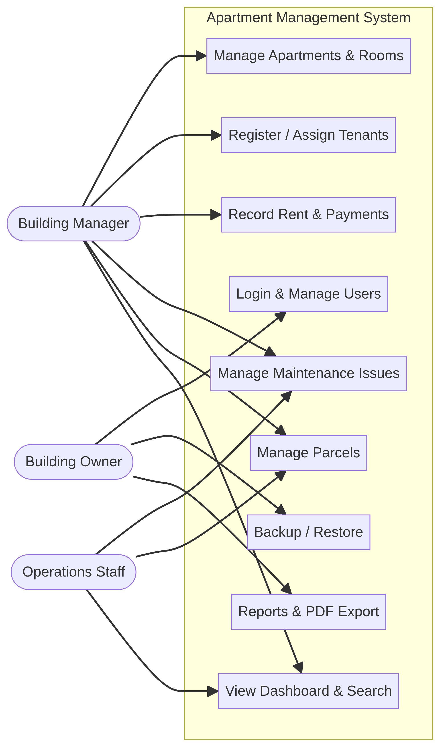
Figure B.1 — AMS use-case overview

B.3 Process / Activity Diagram
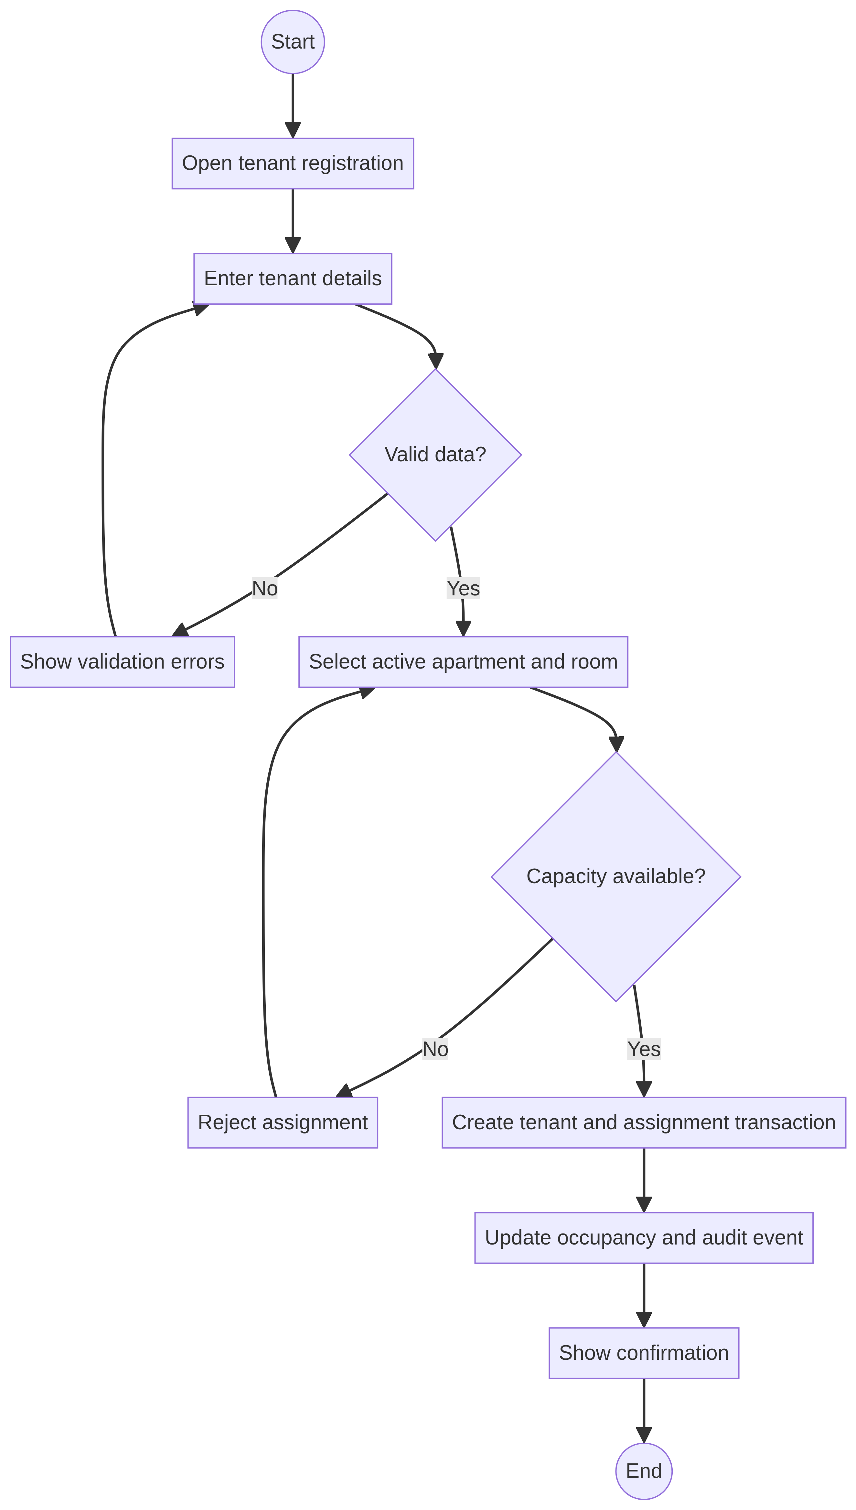
Figure B.2 — Tenant registration and assignment flow

B.4 Swimlane and State Models
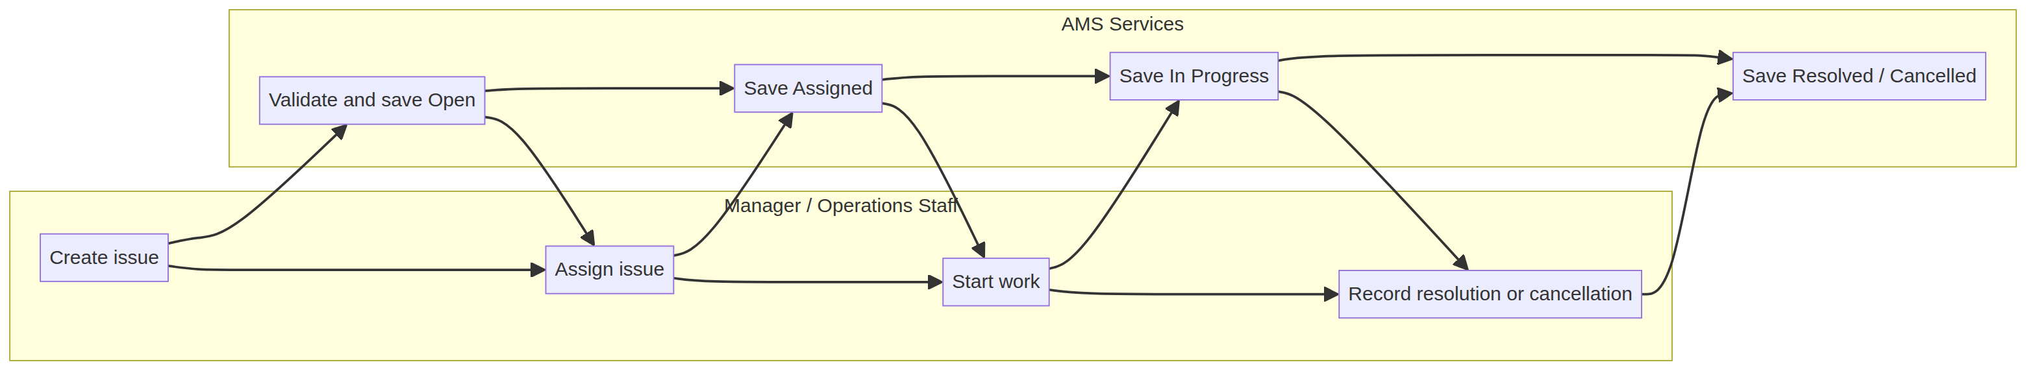
Figure B.3 — Maintenance responsibility flow
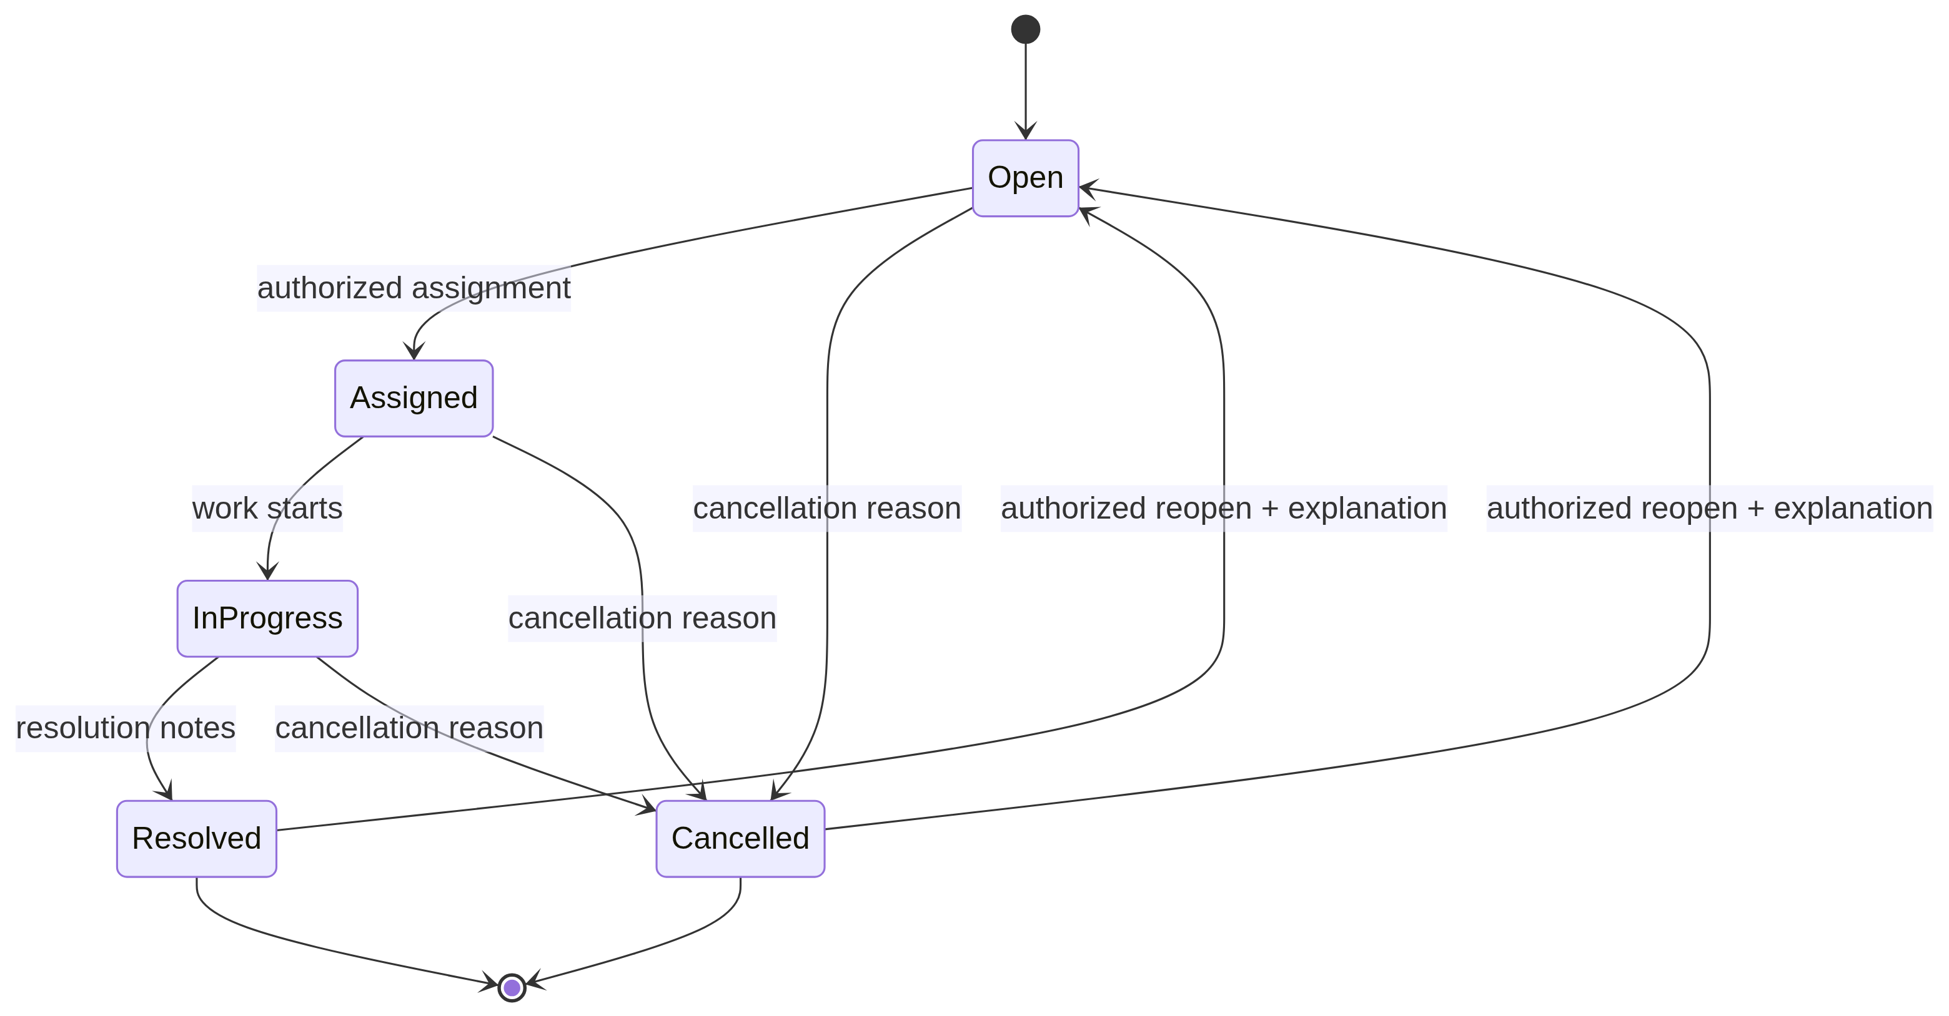
Figure B.4 — Authoritative maintenance lifecycle

B.5 High-Level Architecture Diagram
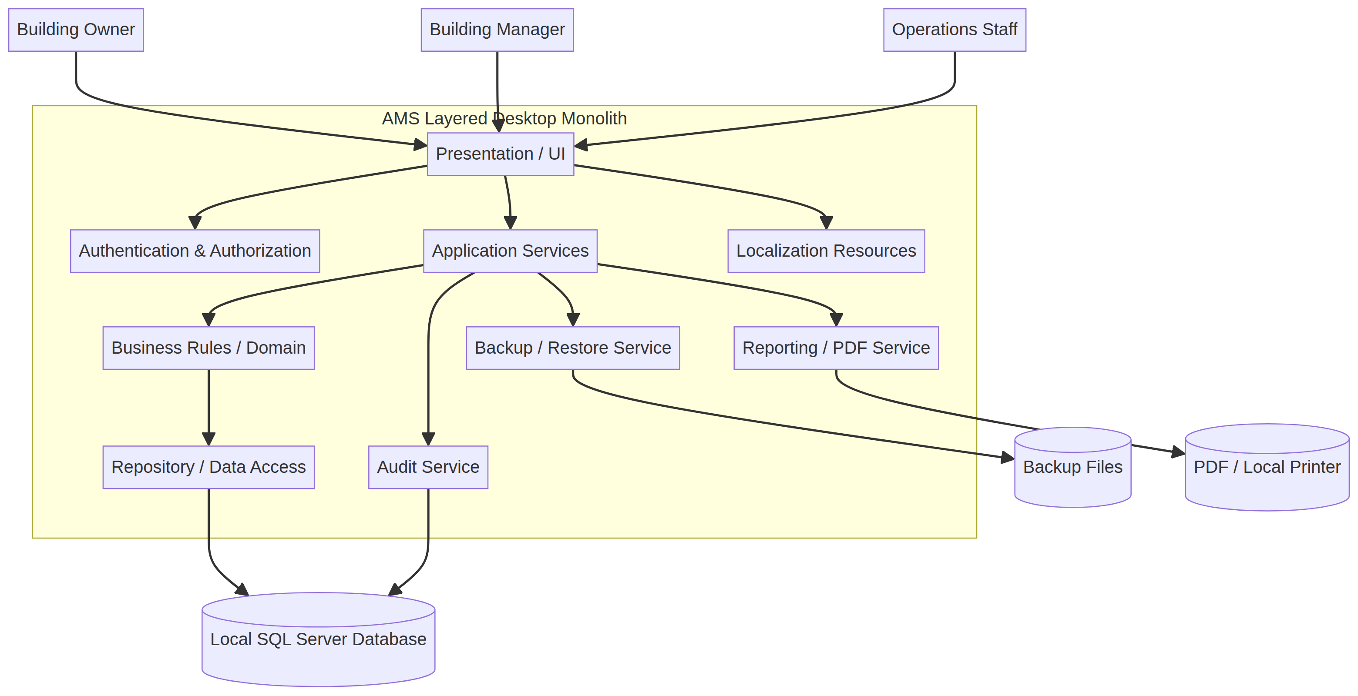
Figure B.5 — Layered offline desktop architecture
Architecture justification: a layered desktop monolith is appropriate for a one-building offline system because it keeps deployment simple, preserves clear separation of responsibilities, supports local ACID transactions, and avoids unnecessary network and operational complexity. A web/cloud or microservices architecture is not required for V1.0 because there is no cloud synchronization, no external integration, limited scope, and no independent service deployment requirement.

B.6 Component View
Component | Responsibility | Inputs | Outputs | Dependencies | Related
Authentication Service | Validate credentials and establish sessions. | Username/password | Session or denial | Users repository, hashing | FR-021, NFR-003–004
Authorization Service | Evaluate role permissions. | User, action, resource | Allow/deny | Roles, Permissions | FR-022, NFR-005
Apartment Service | Manage apartments, rooms, occupancy. | Apartment/room commands | Records and status | Repositories, domain rules | FR-001–006
Tenant Assignment Service | Create and close assignment history. | Tenant, apartment, room, dates | Assignment | Tenant/apartment repositories | FR-003–005
Rent & Payment Service | Create periods, save payments, calculate status and balance. | Period/payment command | Status, balance, receipt | SQL transactions, Audit | FR-007–011
Maintenance Service | Manage issue lifecycle and filters. | Issue command | Issue/status history | Authorization, Audit | FR-013–016
Parcel Service | Manage receipt, search, pickup, return. | Parcel command | Parcel status | Tenant repository, Audit | FR-017–019
Dashboard Service | Calculate summary metrics. | Filters and current date | Cards and drill-down | Module repositories | FR-025
Reporting/PDF Service | Create filtered PDF reports. | Report type/filters | PDF file | Repositories, PDF library | FR-012
Backup/Restore Service | Create, validate, and restore backups safely. | Path and confirmation | Backup/restore result | SQL Server, file system, Audit | FR-023
Localization Service | Load Arabic/English resources. | Language selection | Labels/messages | Resource files | FR-024
Audit Service | Record significant actions. | Event metadata | Audit event | AuditEvents repository | NFR-014
Repository/Data Access | Persist entities and transactions. | Commands/queries | Records/results | SQL Server | DR-001–DR-004

B.7 Design Patterns
Pattern | Use in AMS | Problem solved
Layered architecture | UI, services, domain, repository | Separates concerns and supports maintainability
Service layer | Module services coordinate workflows | Keeps UI thin and business operations reusable
Repository abstraction | Entity repositories over SQL Server | Isolates persistence and supports controlled transactions
MVVM/MVC-style UI | Screens bind to view models/controllers | Separates presentation state from business logic
Strategy | Report exporters and localization resources | Allows controlled output/resource variants
Resource-based localization | Arabic and English resource files | Changes visible language without changing stored data

B.8 Architecture Decision Records
ID | Decision | Chosen approach | Alternatives | Rationale | Consequences | Status
ADR-001 | Desktop vs web | Use offline Windows desktop. | Web/cloud | Matches one-building offline scope; simpler deployment. | No remote access in V1.0. | Accepted
ADR-002 | Database technology | Use local Microsoft SQL Server Express/local SQL Server. | SQLite, cloud DB | Provides ACID transactions and course-approved SQL Server scope. | Requires local installation/configuration. | Accepted
ADR-003 | Architecture style | Use layered desktop monolith. | Microservices, three-tier web | Clear separation with low operational complexity. | Single deployable application. | Accepted
ADR-004 | Password storage | Salted one-way hash. | Plaintext, reversible encryption | Protects credentials if files are exposed. | Offline recovery needs owner procedure. | Accepted
ADR-005 | Backup format | SQL Server backup file plus metadata. | Ad hoc CSV export | Preserves schema and operational records. | Restore requires compatible SQL Server. | Accepted
ADR-006 | Restore behavior | Validate, safety-copy, confirm, then restore. | Silent overwrite | Reduces destructive recovery mistakes. | Restore may require application restart/maintenance mode. | Accepted
ADR-007 | PDF export | Local report service generates PDF. | Online reporting service | Works offline and meets approved enhancement. | Printer/PDF library failure must be reported. | Accepted
ADR-008 | Localization | Resource-based Arabic/English labels. | Hard-coded translations | Supports consistent switching. | Translation coverage must be maintained. | Accepted
ADR-009 | Audit logging | Formal AuditEvents entity. | Text-only logs | Supports payment corrections and accountability. | Database growth requires retention policy. | Accepted

B.9 Architecture Risks and Mitigations
Risk | Description | Likelihood / impact | Mitigation
R-001 | Backup corruption | Medium / High | Validate checksums/metadata; retain multiple backups; test restore.
R-002 | Unsafe restore overwrites active database | Low / High | Safety copy, compatibility validation, explicit confirmation, owner-only restore.
R-003 | Offline password recovery failure | Medium / High | Document owner-controlled recovery and maintain emergency access procedure.
R-004 | Incomplete Arabic translation | Medium / Medium | Resource coverage checklist and English fallback with logging.
R-005 | Weak payment auditability | Low / High | Immutable AuditEvents, no hard delete, mandatory correction reason.
R-006 | Unauthorized role action | Medium / High | Central authorization service and permission-denied audit events.
R-007 | PDF export failure | Medium / Medium | Validate path, provide error, retain on-screen report view.
R-008 | Database growth | Low / Medium | Indexes, archive views, retention review, performance monitoring.
R-009 | Inconsistent historical tenant data | Medium / High | Assignment entity, date constraints, transaction boundaries, reconciliation report.

B.10 Screen Inventory
ID | Screen | Actors | Purpose | Entry | Exit | Requirements
UI-001 | Login | All users | Authenticate | Application start | Dashboard / recovery | FR-021
UI-002 | Dashboard | Owner / Manager / Ops | Summaries and navigation | Successful login | Module lists | FR-025
UI-003 | Apartment and room list | Manager | Search and manage inventory | Dashboard | Detail/form | FR-001,002,006
UI-004 | Tenant registration / assignment | Manager | Create tenant assignment | Apartment list | Confirmation/history | FR-004
UI-005 | Tenant history/details | Manager / Owner | View assignment history | Tenant list | Back / report | FR-005
UI-006 | Payment entry | Manager | Record payment | Rent module | Receipt/history | FR-007–010
UI-007 | Payment history/correction | Manager / Owner | Review/correct payment | Payment entry | Audit/history | FR-011
UI-008 | Maintenance issue list | Manager / Ops | Filter issues | Dashboard | Details/form | FR-016
UI-009 | Maintenance form/details | Manager / Ops | Create/progress/resolve | Issue list | Save/cancel | FR-013–015
UI-010 | Parcel check-in/search/pickup | Manager / Ops | Track parcel | Dashboard | Confirmation | FR-017–019
UI-011 | Reports/PDF | Manager / Owner | Filter/export reports | Dashboard | PDF/path | FR-012
UI-012 | Users and roles | Owner | Manage access | Dashboard | Save/deactivate | FR-021–022
UI-013 | Backup/restore | Owner | Create/validate/restore | Dashboard | Result/restart | FR-023
UI-014 | Settings/language | All users | Switch language | Dashboard | Updated UI | FR-024

B.11 UI Wireframes

UI-001 Login
Username [required]
Password [required]
[Sign in] [Language]
Error/recovery guidance

UI-002 Dashboard
Occupancy card | Outstanding rent card | Open issues card | Uncollected parcels card
[Search] [Filters] [Apartment] [Rent] [Issues] [Parcels] [Reports]

UI-004 Tenant assignment
Tenant fields [required]
Apartment dropdown [required] Room dropdown [optional] Move-in date [required]
[Save] [Cancel] | validation panel

UI-006 Payment entry
Tenant [required] Rent period [required] Expected / paid / balance
Amount [required] Method [required] Receipt reference [required]
[Save payment] [Cancel]

UI-009 Maintenance
Apartment | Category | Priority | Status | Assignee | Description
[Filter] [Assign] [Start] [Resolve] [Cancel] [Reopen]
Notes and validation messages

UI-010 Parcel
Tenant | Courier | Tracking | Received date | Location | Status
[Search] [Check in] [Pick up] [Return]

UI-011 Reports
Report type | Date range | Status | Apartment | Tenant
[Preview] [Export PDF] [Print] | result count and errors

UI-012 Users
Username | Full name | Role | Active
[Create] [Edit] [Deactivate] | unauthorized actions hidden

UI-013 Backup/restore
Backup destination/source | validation status | safety-copy notice
[Create backup] [Validate] [Restore] [Cancel]

UI-014 Settings
Language: [English / Arabic]
Resource status | [Apply] [Cancel]

B.12 UI Field Specifications
Field ID | Label | Type | Required | Allowed / validation | Error message | Database field | Req.
F-LOGIN-01 | Username | Text | Yes | Unique active user; 3–50 chars | Enter a valid username. | Users.  Username | FR-021
F-LOGIN-02 | Password | Password | Yes | Minimum policy length | Enter your password. | Users.  PasswordHash | FR-021
F-APT-01 | Unit number | Text | Yes | Unique within building | Unit number already exists. | Apartments.  UnitNumber | FR-001
F-ROOM-01 | Capacity | Integer | Yes | Greater than 0 | Capacity must be positive. | Rooms.  Capacity | FR-002
F-TEN-01 | Full name | Text | Yes | 2–120 chars | Enter tenant name. | Tenants.  FullName | FR-004
F-ASSIGN-01 | Move-in date | Date | Yes | Valid date; no invalid overlap | Move-in date conflicts with history. | Assignments.  MoveInDate | FR-004
F-PAY-01 | Amount | Decimal | Yes | Greater than 0; fixed precision | Enter a positive amount. | PaymentRecords.  AmountPaid | FR-008
F-PAY-02 | Receipt reference | Text | Yes for docket/cash policy | Unique when required | Receipt reference is duplicated. | PaymentRecords.  ReceiptReference | FR-008,011
F-MAINT-01 | Priority | Enum | Yes | Low/Medium/High/Critical | Select a priority. | MaintenanceIssues.  Priority | FR-013
F-MAINT-02 | Status | Enum | Automatic/restricted | Open/Assigned/In Progress/Resolved/Cancelled | Transition is not allowed. | MaintenanceIssues.  Status | FR-014,015
F-PARCEL-01 | Tracking number | Text | No | Unique when supplied | Tracking number is already active. | Parcels.  TrackingNumber | FR-017,019
F-REPORT-01 | Date range | Date range | Optional | Start <= end | Select a valid range. | Report filter | FR-012
F-BACKUP-01 | Backup path | File path | Yes | Writable and available | Select a writable location. | BackupMetadata.  FilePath | FR-023
F-LANG-01 | Language | Enum | Yes | English / Arabic | Language resource unavailable. | User setting | FR-024

B.13 Navigation Flow
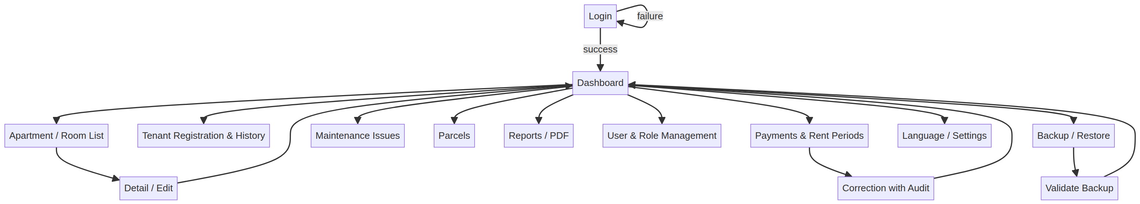
Figure B.6 — AMS navigation flow

B.14 Sequence Diagram
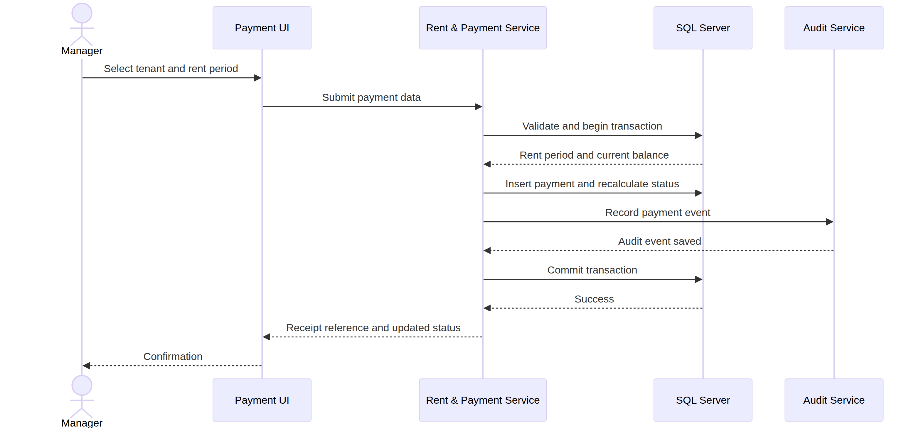
Figure B.7 — Payment recording sequence

B.15 ERD
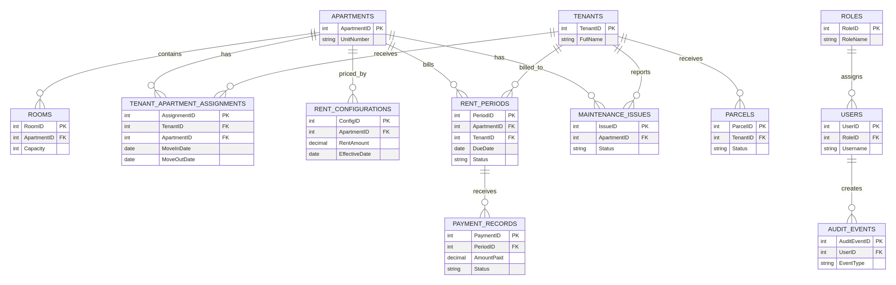
Figure B.8 — AMS entity-relationship model

B.16 Formal Data Dictionary
Entity | Field | Meaning | Type/format | Req. | Rules / validation | Related
Apartments | ApartmentID | Unique apartment identifier | INTEGER | Yes | PK; unique; Generated; positive | FR-001
Apartments | UnitNumber | Displayed unit number | VARCHAR(20) | Yes | Unique; Non-empty | FR-001
Apartments | IsActive | Whether unit accepts operations | BOOLEAN | Yes | TRUE/FALSE; Default TRUE | FR-003
Apartments | OccupancyStatus | Calculated occupancy | VARCHAR(30) | Yes | Vacant/Partially Occupied/Occupied/Under Maintenance; System calculated | FR-003
Rooms | RoomID | Unique room identifier | INTEGER | Yes | PK; Generated | FR-002
Rooms | ApartmentID | Owning apartment | INTEGER | Yes | FK Apartments; Must exist | FR-002
Rooms | Capacity | Maximum occupants | INTEGER | Yes | > 0; Positive integer | FR-002
Tenants | TenantID | Unique tenant identifier | INTEGER | Yes | PK; Generated | FR-004
Tenants | FullName | Legal resident name | VARCHAR(120) | Yes | 2–120 characters; Trimmed | FR-004
TenantApartment  Assignments | AssignmentID | Assignment history identifier | INTEGER | Yes | PK; Generated | FR-004–005
TenantApartment  Assignments | MoveInDate | Assignment start | DATE | Yes | Valid date; No overlap | FR-004
TenantApartment  Assignments | MoveOutDate | Assignment end | DATE | No | >= MoveInDate; Null while active | FR-005
Rent  Configurations | RentAmount | Historical monthly rent | DECIMAL(12,2) | Yes | > 0; Fixed precision | FR-007
Rent  Configurations | EffectiveDate | Rate start date | DATE | Yes | No conflicting rate; Valid date | FR-007
Rent  Periods | PeriodID | Billing period identifier | INTEGER | Yes | PK; Generated | FR-007
Rent  Periods | ExpectedAmount | Rent due for period | DECIMAL(12,2) | Yes | >= 0; Copied from configuration | FR-007
Rent  Periods | Status | Computed period status | VARCHAR(20) | Yes | Pending/Partial/Paid/Overdue/Overpaid; System calculated | FR-009
Payment  Records | PaymentID | Payment identifier | INTEGER | Yes | PK; Generated | FR-008
Payment  Records | AmountPaid | Payment amount | DECIMAL(12,2) | Yes | > 0; Fixed precision | FR-008
Payment  Records | ReceiptReference | Docket/receipt identifier | VARCHAR(80) | Conditional | Unique when required; Validated duplicate check | FR-008,011
Payment  Records | Status | Payment lifecycle | VARCHAR(20) | Yes | Recorded/Corrected/Voided; No hard delete | FR-011
Maintenance  Issues | IssueID | Issue identifier | INTEGER | Yes | PK; Generated | FR-013
Maintenance  Issues | Priority | Urgency | VARCHAR(15) | Yes | Low/Medium/High/Critical; Controlled values | FR-013
Maintenance  Issues | Status | Issue lifecycle | VARCHAR(20) | Yes | Open/Assigned/In Progress/Resolved/Cancelled; Transition rules | FR-014,015
Parcels | ParcelID | Parcel identifier | INTEGER | Yes | PK; Generated | FR-017
Parcels | Status | Parcel lifecycle | VARCHAR(20) | Yes | Received/Picked Up/Returned; Controlled values | FR-018
Users | Username | Login name | VARCHAR(50) | Yes | Unique; 3–50 chars | FR-021
Users | PasswordHash | Salted hash | VARCHAR(255) | Yes | Never plaintext; Hash policy | FR-021
Users | RoleID | Assigned role | INTEGER | Yes | FK Roles; Must exist | FR-022
Audit  Events | EventType | Audited action | VARCHAR(50) | Yes | Controlled event types; Required | NFR-014
Audit  Events | Reason | Reason for correction/reopen/restore | VARCHAR(500) | Conditional | Required for sensitive action; Required by rule | FR-011,015,023

B.17 Data Mapping
Source form / metric | Target entities | Mapped data | Calculation / behavior | Related
Tenant registration form | Tenants + TenantApartmentAssignments + optional Rooms | FullName, contact, apartment, room, move-in | Validate identity/capacity; save atomically | FR-004,005
Payment entry form | PaymentRecords + RentPeriods + AuditEvents | Tenant, period, amount, method, receipt | Recalculate status/balance; audit save | FR-007–011
Maintenance form | MaintenanceIssues + AuditEvents | Apartment, tenant, category, priority, description | Create Open; validate transitions | FR-013–016
Parcel form | Parcels + AuditEvents | Tenant, courier, tracking, dates, location | Received/Picked Up/Returned rules | FR-017–019
Dashboard metrics | Apartments, Assignments, RentPeriods, Issues, Parcels | Counts, balances, open/uncollected filters | Exclude archived by default; show timestamp | FR-025
PDF report | Filtered source entities | Report fields and filter summary | Generate PDF with timestamp/page numbers | FR-012

B.18 Integration Diagram / Local Exchanges
Because V1.0 has no online integrations, the integration model documents exchanges between the UI, local services, SQL Server, local files, PDF output, and localization resources. These exchanges are shown in the architecture and navigation diagrams and specified in Chapter 4.3–4.4.

Appendix C – Issues List
ID | Description | Status | Priority | Owner | Impact | Decision / resolution | Date | Related
ISS-001 | Confirm final payment receipt-reference policy for cash/docket payments. | Open | Medium | Owner | Affects payment validation and auditability. | Define required format before implementation. | 1 Oct 2026 | FR-008, FR-011
ISS-002 | Confirm approved maintenance category list. | Open | Medium | Owner / Manager | Affects issue classification. | Use controlled categories plus Other until approved. | 1 Oct 2026 | FR-013, BR-015
ISS-003 | Confirm backup retention count and removable-media policy. | Open | High | Owner | Affects recovery and security. | Use owner-approved local destination and documented retention. | 1 Oct 2026 | FR-023, NFR-012
ISS-004 | Confirm offline password-recovery procedure. | Open | High | Owner | Affects access continuity. | Document owner-controlled recovery without plaintext password storage. | 1 Oct 2026 | FR-021, NFR-004
ISS-005 | Confirm audit retention duration. | Open | Medium | Owner | Affects database growth and compliance. | Retain audit events for the project-defined operational period. | 1 Oct 2026 | NFR-014, DR-005
ISS-006 | Confirm exact PDF report templates required by instructor/stakeholder. | Open | Low | Manager / Owner | Affects report layout. | Current SRS defines fields and filters; templates can be finalized during UI review. | 1 Oct 2026 | FR-012

High-impact baseline decisions for tenant access, maintenance lifecycle, database technology, rooms, tenant history, payment periods, roles, backup/restore, and auditability are reflected in the body of this SRS. Appendix C contains only residual items requiring stakeholder confirmation.

