

**Bankers Algorithm Assignment**

**Name:** محمد مدحت محمد ابراهيم

**Code:** 1701287

**Sec:** 4

**Safty algorithm example:**

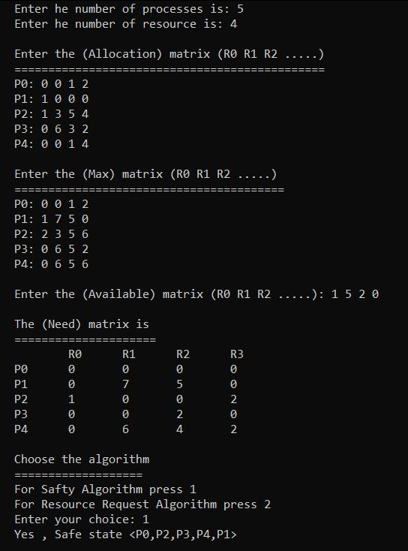

**Resource request algorithm example:**

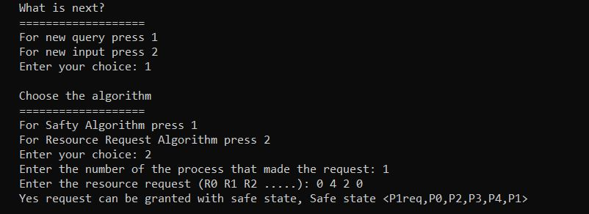

**Note:**

You do not need to close the program for new input or inquiry.

Just follow the instructions.

**Repository link:**

https://github.com/MedoOnlyOne/Bankers_Algorithm